Date :  27-02-2024

Yelp Business API  
Version: 1.0.0

# **Overview**

This is a fast scraper Yelp API, which gives real-time data from [yelp.com](http://yelp.com/);  
Ip Rotation; Occasional Changes are handled- backend.

Get Updated Business Lead from Millions of Results directly from [https://yelp.com](https://yelp.com/)  
• Ip Rotation Handled Backend  
• Occasional Changes will be fixed  
• Send concurrent Requests  
• Easy to Use  
• Super Fast

# **Getting Started**

## **Prerequisites**

* Volt Foundry
* [Rapid API Account](https://rapidapi.com/sorowerhossan01/api/yelp-business-api)
* X-RapidAPI-Key, X-RapidAPI-Host

## **Importing the adapter**

**To import the Data Adapter to Volt Foundry, do the following:**

1. Sign in to the  [HCL Foundry](https://manage.hclvoltmx.com/).
2. From the left navigation menu, select **API Management**.
3. In **API Management**, select **Custom Data Adapters**.

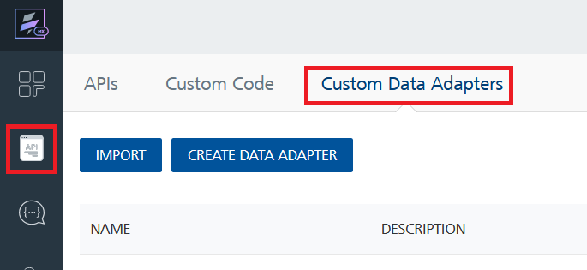

1. Click **IMPORT** to import a custom data adapter.

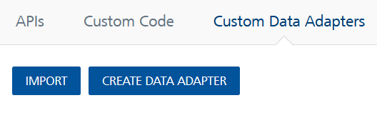

1. On the Import Data Adapter dialog box, click browser to import.

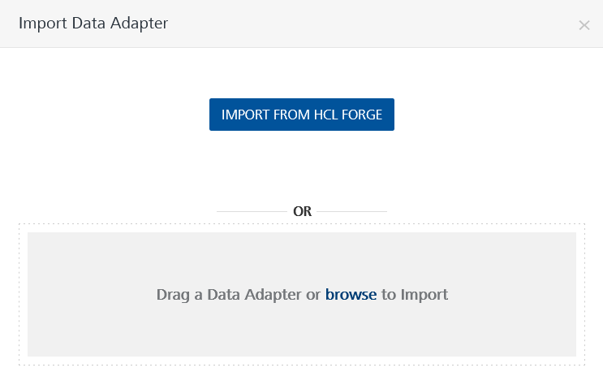

1. Select Yelp Business API zip file and click **IMPORT**.

After you import the data adapter, Volt Foundry opens a window that shows the metadata of the data adapter.

After you import the data adapter, you can view it on the Custom Data Adapters page and use it to create services on Volt Foundry.

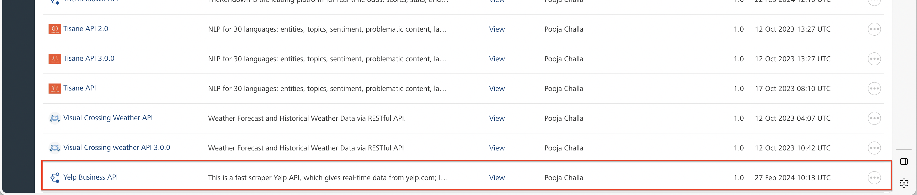

## **Creating an Integration service**

After you import the data adapter into Volt Foundry, you can use it to create an Integration Service.

Follow the given steps to create an Integration service using the Yelp Business API Adapter.

1. Sign in to the [HCL Foundry](https://manage.hclvoltmx.com/).
2. From the left navigation menu, select **API Management**.
3. In **API Management**, select **Integration**.

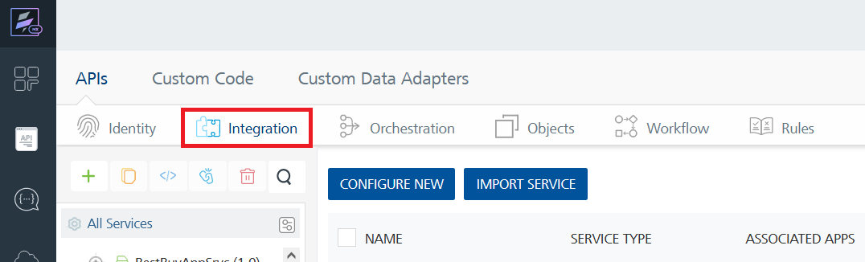

1. To create a new service, click the **+** button or the **CONFIGURE NEW** button.

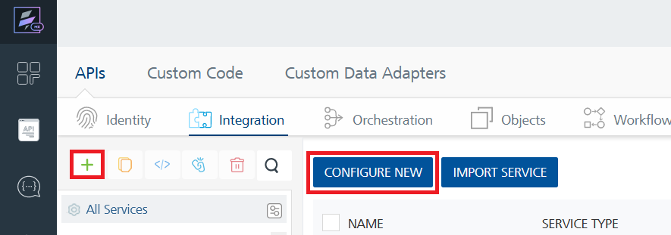

1. On the Service Definition tab, select the service type as Yelp Business API and click **SAVE**.

Alternatively, you can also create a Foundry app and create an Integration service inside it.

1. **Creating and Executing operations**

After you create an integration service, you can create and execute operations using the service.

#### **Creating an operation**

* In **API Management/Foundry app you created**, in the **Integration** section, select the service that you created.
* After you select the service, navigate to the **Operation List** tab.

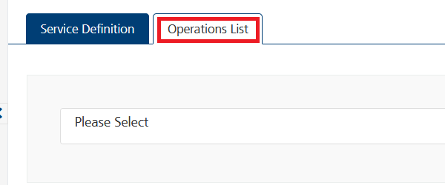

* From the drop down list, select an operation that you want to execute, and click **ADD OPERATION**.

#### **Executing an operation**

* From the **Operations List** tab, in the **Configured Operations** section, select the operation you want to execute.

* On the Operation Page, in the Request Input tab, enter a TEST VALUE for all the fields.

**Request Header:**

**Authorization:** X-RapidAPI-Key, X-RapidAPI-Host [in header]: API Key associated with your RapidAPI account, required for authentication. To get keys – Login in to [Rapid API Account](https://rapidapi.com/sorowerhossan01/api/yelp-business-api) -> You can view your keys.  
  
* Select a run-time environment and click **Save and Fetch Response** to get a response based on your inputs.

## **Publishing your application**

If you want to use the services in client applications, you need to publish an app to a run-time environment. You can create the service (as described above) in an application or import the service into an application and publish the application.

# **References**

## **Endpoint Documentation**

### **Request Input Parameters for Searchforbusinessesbytypeandlocation operation.**

| **Parameter** | **Type** | **Description** | **Required** |
| --- | --- | --- | --- |
| query | STRING | Type of business to search for (e.g., Coffee Shop) | REQUIRED |
| location | STRING | The location to search within (e.g., New York) | REQUIRED |
| page | STRING | The page number of results to retrieve | REQUIRED |

## **Request headers Parameters for Searchforbusinessesbytypeandlocation operation.**

| **Parameter** | **Description** |
| --- | --- |
| X-RapidAPI- Key(string) | [Required] [Header]API Key associated with your account. |
| X-RapidAPI-Host (string) | [Required] [Header]The host parameter specifies the domain name or IP address of the RapidAPI endpoint. In the context of the Yelp Business API, the default host is set to 'yelp-business-api.p.rapidapi.com'. This parameter is necessary for routing the request to the appropriate API endpoint. |

## **Response Output Parameters for Searchforbusinessesbytypeandlocation operation**

| **Field** | **Type** | **Description** |
| --- | --- | --- |
| SR | Integer | Search result identifier. |
| SearchQuery | String | The query used for the search. |
| SearchLocation | String | The location specified for the search. |
| PageRequested | String | The requested page number for pagination. |
| TotalPages | String | The total number of pages available for the search results. |
| SearchResultsLength | String | The number of results in the current response. |
| SearchResults | Array | An array containing details about each coffee shop found in the search. |

For each item in the **SearchResults** array:

| **Field** | **Type** | **Description** |
| --- | --- | --- |
| ranking | Integer | The ranking of the coffee shop, if applicable. Null if it's an advertisement. |
| isAD | Boolean | Indicates whether the result is an advertisement (true) or a regular coffee shop (false). |
| name | String | The name of the coffee shop. |
| businessURL | String | The URL of the business on Yelp. |
| categories | Array | An array containing categories related to the coffee shop. |
| priceRange | String | The price range of the coffee shop. |
| rating | Float | The average rating of the coffee shop. |
| reviewCount | Integer | The total number of reviews for the coffee shop. |
| neighborhoods | Array | An array containing the neighborhoods where the coffee shop is located. |
| phone | String | The phone number of the coffee shop. |
| website | String | The website URL of the coffee shop. |
| scrollablePhotos | Array | An array of scrollable photos related to the coffee shop. |
| longitudelatitude | Object | An object containing latitude and longitude coordinates of the coffee shop's location. Null if not available. |

## **Reference Document:** Refer this document[Yelp Business API - Rapid API](https://rapidapi.com/sorowerhossan01/api/yelp-business-api) for more information.

# **Revision History**

Adapter version 1.0.0:

## **Known Issues**

* No Known Issues

## **Limitations**

* No Limitations