Date : 1 Aug 2023

Work Order Data Model

version: 1.1

# **Overview**

The data model abstracts common work order fields and objects from the backend data source, allowing you to create a mobile/desktop web/tablet app which is decoupled from backend data sources. You can then map any data source to the app, without modifying the client side code.

## **Use case:**

The Work Order data model provides a quick start for building mobile/desktop web/tablet apps dealing with work orders data. Use the model to build apps for accepting new work orders, notifying a worker of a new work order and completing work orders. You can easily extend/ reduce/ modify the data model based on your needs. The data model backend is cloud storage and you can also map this to any backend data source.

## **Features**

### Quick reference app data model- Extend/ Reduce/ Modify based on your requirement.

* Easily map business objects and terms to back end data sources.
* Flexible to map with any back end data source

# **Map to any backend data source**

When you import the app data model into Foundry, the app data model is created as an object service. Using the Foundry console, you can modify the fields and relationships of the objects in the data model. For example, you can add new fields to objects and define new relationships between objects.

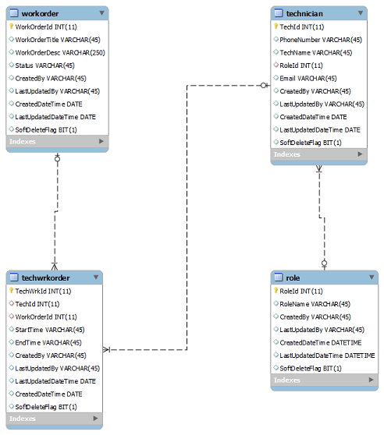

You can also map WorkOrder Data Model to any back-end data source. For example, if you are using Oracle database to store your WorkOrder details, using the Foundry console, you can connect WorkOrder Data Model with the Oracle database and map the fields of each object in the data model with the fields of the Oracle database.

The following sections help you use the Work Order Data Model:

## **Percentage of re-use:**

70% (Data can be customizable and customer need to implement UI by themselves).

# **Getting Started**

## **Prerequisites**

Before you start using the Work Order Data Model, ensure you have the following:

* A [HCL Foundry](https://manage.hclvoltmx.com/)
* Volt MX Iris

## **Importing the Work Order Data Model**

1. Log on to your [HCL Foundry](https://manage.hclvoltmx.com/). The Dashboard page appears by default.
2. In the left pane, click the **Apps** menu. The **Custom Apps** page appears.
3. Click **Import**. The **Import** dialog appears.  
   A screenshot of a computer

   Description automatically generated
4. Drag the zip file into the **Import App** dialog.

Alternatively, click **browse**. The **Open** dialog appears. Navigate to the location where you downloaded the data model (zip file) on your computer, select the zip file, and click **Open**. The zip file is selected, and the **Import App** dialog appears as shown in the following figure:

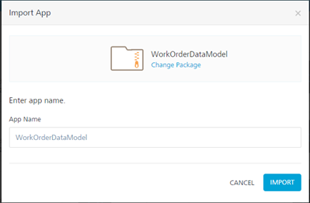

**Note:**If the selected component is not the one that you want to import, click Change Binary.

1. In the **App Name** box, the **WorkOrderDataModel** is displayed by default. You can change the name, if required.
2. Click **Import as new** to create a new Foundry app. If there is an app exists with the same app name and if you want to overwrite it, click **Overwrite existing app**.
3. Click **Import**. The **WorkOrderDataModel** app is listed on the **Custom Apps** page.

**Note:**If you changed the name in the App Name box, the app with the updated name is listed on the Custom Apps page.

**To import the data adapter zip file, do the following:**

# **VIEWING THE OBJECT SERVICE**

When you import WorkOrder App Data Model into Foundry, the app data model is created as an object service. In the object service, you can view all the objects of the data model and the default fields and relationships of each object.

**To view the object service, do the following:**

1. Log on to your [HCL Foundry](https://manage.hclvoltmx.com/). The **Dashboard** page appears by default.
2. In the left pane, click the **Apps** menu. The **Custom Apps** page appears.
3. Find and click the **WorkOrderDataModel** app. The **WorkOrderDataModel** page appears along with the **Configure Services** tab and the **Identity** sub-tab opened by default.

**Note:**If you changed the name of the app while importing the app data model, find and click the app name that you specified using the search box on the **Custom Apps** page.

1. Click the **Objects** sub-tab. The **Objects** sub-tab opens along with the **WorkOrderSchema** objectservice listed.  
   A screenshot of a computer

   Description automatically generated
2. Click **WorkOrderSchema**. The **Configure** page appears with all objects in the app data model.   
   A screenshot of a computer

   Description automatically generated

# **MAPPING WORK ORDER DATA MODEL WITH A BACK-END DATA SOURCE**

By default, the WorkOrder Data Model is mapped with the Foundry storage. You can easily decouple the app data model with the Foundry storage and map it with other back end data source.

**To map with a back end data source, do the following:**

1. On the **WorkOrderDataModel** page, Click the **Configure Services** tab, and then click **Objects** sub-tab. The **Objects** sub-tab opens along with the **WorkOrderSchema** object service listed.
2. Click the context menu icon of  **WorkOrderSchema** as shown in the following figure. The context menu opens.  
   A screenshot of a computer

   Description automatically generated
3. Click **Clone App Data Model**. A copy of WorkOrder Data Model is created and the **New Object Service** page appears.  
   A screenshot of a computer

   Description automatically generated
4. In the **Name** box, type a name for a copy of WorkOrder Data Model.
5. Click the context menu arrow to expand the **Endpoint Type** list. A drop-down list opens.
6. Select the required back end data source that you want to map and click **SAVE & CONFIGURE**.

# **mODIFYING WORK ORDER DATA MODEL**

The WorkOrder Data Model comes with a default set of objects. Every object in the data model contains a set of fields and a relationship with at least one object. The **WorkOrderSchema** object service allows you to modify the app data model as you require. Every object in the object service contains the following sections:

**Fields**

In the Fields section of an object, you can add new fields and edit and delete the fields associated with the object. Every object has a set of fields that you cannot edit or delete. For example, the **createdBy** and **CreatedDataTime** fields of the **Technician** object cannot be modified.

**Relationships**

In the Relationships section of an object, you can define new relationships with other objects and edit and delete existing relationships of the object.

For more information, refer to [Object Services](https://opensource.hcltechsw.com/volt-mx-docs/95/docs/documentation/Foundry/voltmx_foundry_user_guide/Content/Objectservices.html).

# **Publishing the App in VoltMX Foundry**

After adding the **Work Order Data Model** to your app and configuring the necessary configurations, you must publish the app to VoltMX Foundry. For more information, refer to [Publish a Project to VoltMX Foundry.](https://opensource.hcltechsw.com/volt-mx-docs/docs/documentation/Iris/iris_user_guide/Content/PublishVoltMXFoundryServicesApp.html)

# **Revision History**

App version 1.1

## **Known Issues**

## N/A

## **Limitations**

## N/A