Date :  18-10-2023

what3words api (1.0.0)

# Overview

The Convert to Coordinates API allows you to enter in 3 random words to then find out (in map form) which location these 3 words have been tagged to.

By using these Api endpoints, get exact address using these 3 words.

# Getting Started

## Prerequisites

* Volt Foundry

## Importing the adapter

**To import the Data Adapter to Volt Foundry, do the following:**

1. Sign in to the  [HCL Foundry](https://manage.hclvoltmx.com/).
2. From the left navigation menu, select **API Management**.
3. In **API Management**, select **Custom Data Adapters**.  
   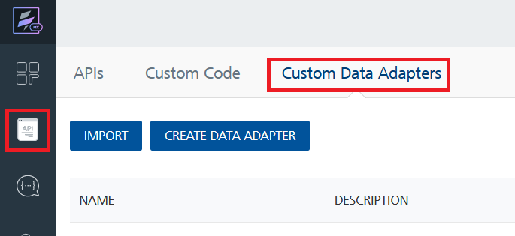
4. Click **IMPORT** to import a custom data adapter.  
   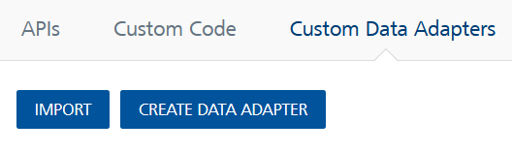
5. On the Import Data Adapter dialog box, click browser to import.  
   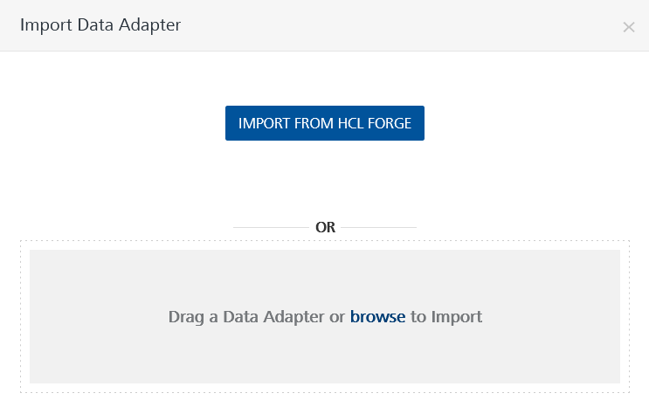
6. Select what3words zip file and click **IMPORT**.

After you import the data adapter, Volt Foundry opens a window that shows the metadata of the data adapter.

After you import the data adapter, you can view it on the Custom Data Adapters page and use it to create services on Volt Foundry.

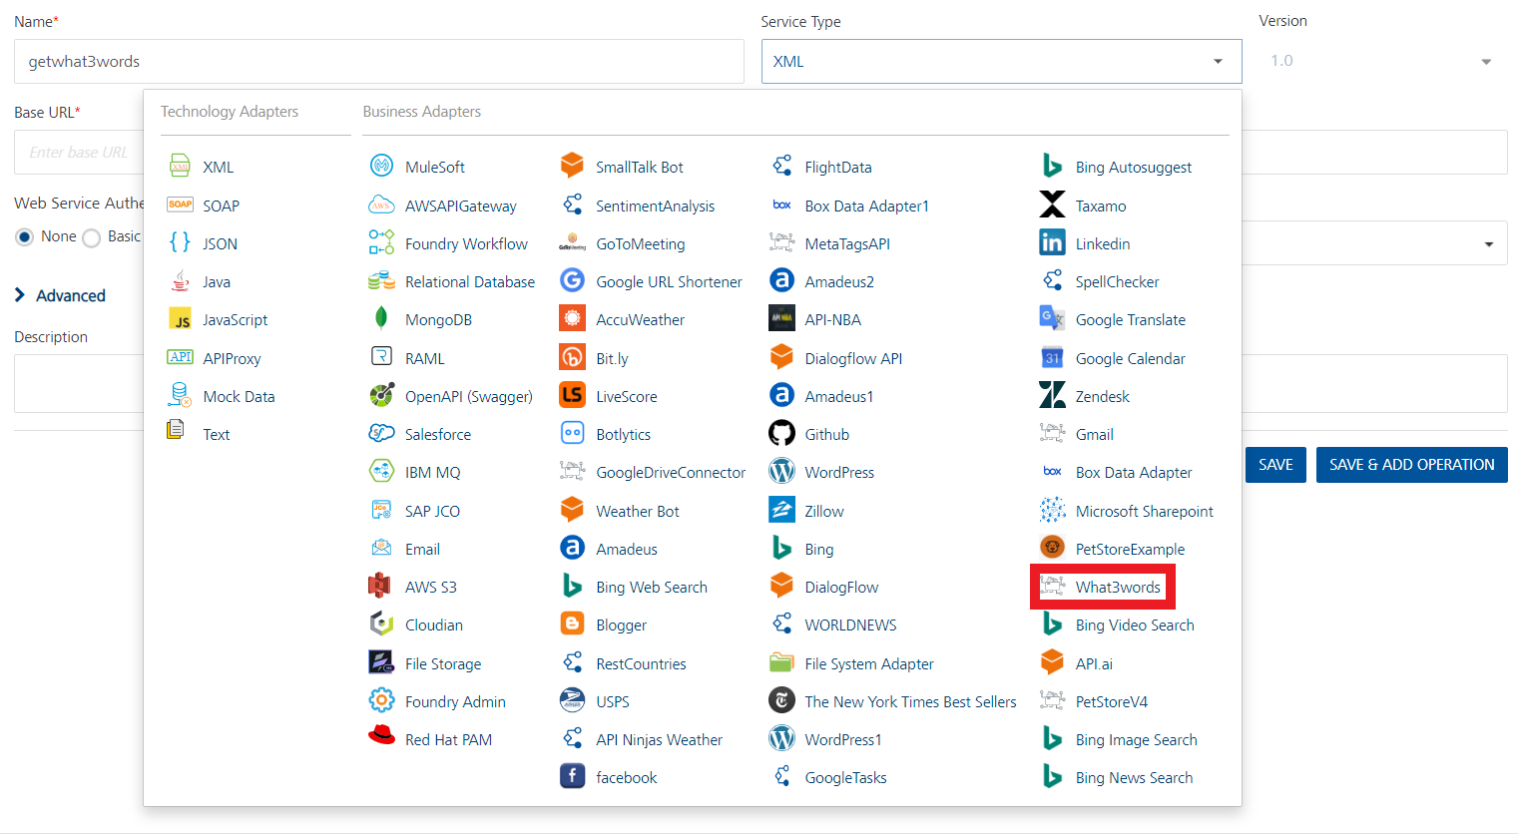

## [Creating an Integration service](javascript:void(0);)

After you import the data adapter into Volt Foundry, you can use it to create an Integration Service.

Follow the given steps to create an Integration service using the What3words Api Adapter.

1. Sign in to the [HCL Foundry](https://manage.hclvoltmx.com/).
2. From the left navigation menu, select **API Management**.
3. In **API Management**, select **Integration**.  
   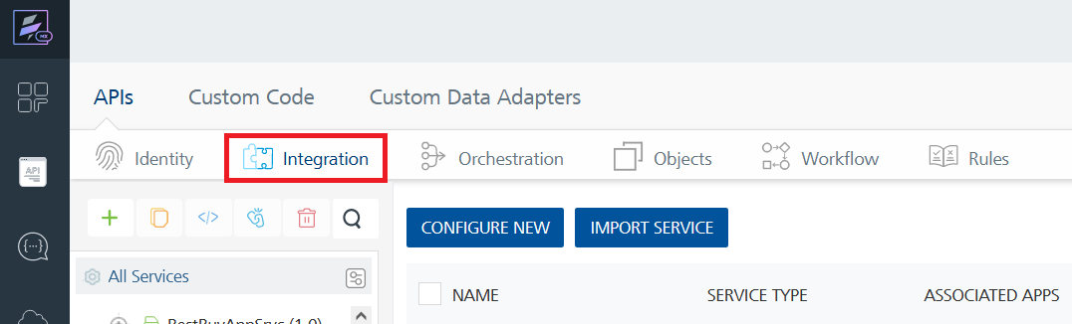
4. To create a new service, click the **+** button or the **CONFIGURE NEW** button.  
   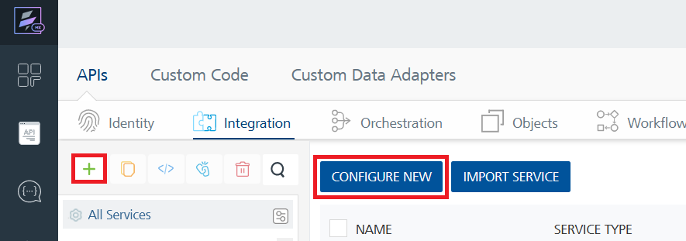
5. On the Service Definition tab, select the service type as What3words Api, and click **SAVE**.

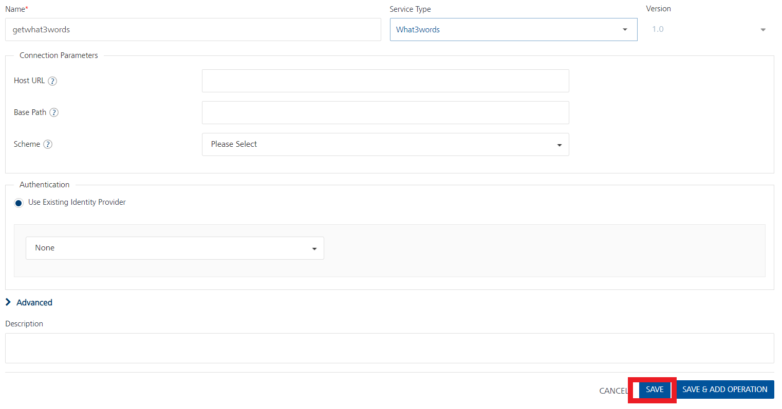

Alternatively, you can also create a Foundry app and create an Integration service inside it.

E. [Creating and Executing operations](javascript:void(0);)



After you create an integration service, you can create and execute operations using the service.

#### Creating an Operation

* In **API Management/Foundry app you created**, in the **Integration** section, select the service that you created.
* After you select the service, navigate to the **Operation List** tab.  
  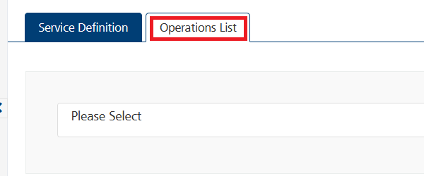
* From the drop down list, select an operation that you want to execute, and click **ADD OPERATION**.

#### Executing an Operation

* From the **Operations List** tab, in the **Configured Operations** section, select the operation you want to execute.

* On the Operation Page, in the Request Input tab, enter a TEST VALUE for all the fields.

* Select a run-time environment and click **Save and Fetch Response** to get a response based on your inputs.

## [Publishing your application](javascript:void(0);)

If you want to use the services in client applications, you need to publish an app to a run-time environment. You can create the service (as described above) in an application or import the service into an application and publish the application.

# References

## Endpoint Documentation

| **Endpoints** | **Input params-Type** | **Description** |
| --- | --- | --- |
| /convert-to-3wa | Key-string coordinates-number language-string format-string | converting the coordinates to 3 words address |
| /convert-to-coordinates | Key-string Name-string format-string | converting the 3 words to coordinates |
| /autosuggest | Key-string  input-string  focus-number  clip-to-country-string  clip-to-bounding-box-number  clip-to-circle-number  clip-to-polygon-number  input-type-string  language-string  prefer-land-boolean | AutoSuggest accepts either a full or partial 3 word address |
| /grid-section | Key-string bounding-box -number format-string | Returns a section of the 3m x 3m what3words grid for a bounding box. The bounding box is specified by lat,lng,lat,lng as south,west,north,east. You can request the grid in GeoJSON format, making it very simple to display on a map. |
| /available-languages | Key-string | Retrieves a list of all available 3 word address languages, including the ISO 3166-1 alpha-2 2 letter code, english name and native name. |

Top of Form

## These are List of all endpoints, input params and description/restriction of the fields in tabular format.

## Refer to this below link for more information about API endpoints.

## [Get started with the what3words API | what3words](https://developer.what3words.com/public-api)

## [API Reference Docs | what3words](https://developer.what3words.com/public-api/docs)

# Revision History

Adapter version 1.0.0:

## Known Issues

-

## Limitations

-