Date : 26-02-2024

web scraper Api

version: 1.0.0

Overview
The Web Scraper API provides web scraper services to retrieve HTML and plaintext data from any website URL.
The Web Scraper API enables developers to build applications that extract HTML and plaintext data from websites, facilitating tasks such as news aggregation, price monitoring for e-commerce, or gathering information for research purposes. It streamlines data acquisition processes, offering businesses valuable insights into market trends, competitor activities, and user behavior with minimal manual intervention.

Getting Started

Prerequisites
- Volt Foundry
- Api Ninjas Account
- API Key associated with your account.

Importing the adapter
To import the Data Adapter to Volt Foundry, do the following:
- Sign in to the HCL Foundry.
- From the left navigation menu, select API Management.
- In API Management, select Custom Data Adapters.
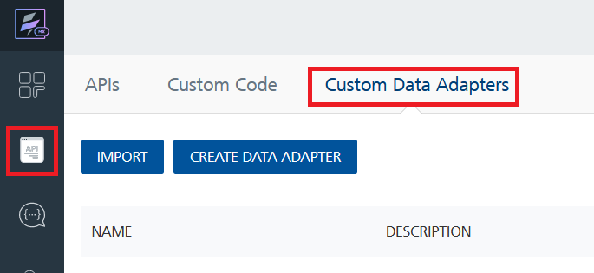
- Click IMPORT to import a custom data adapter.
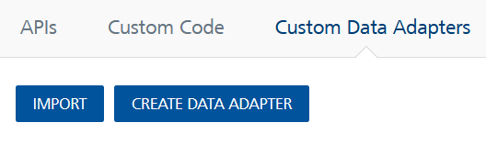
- On the Import Data Adapter dialog box, click browser to import.
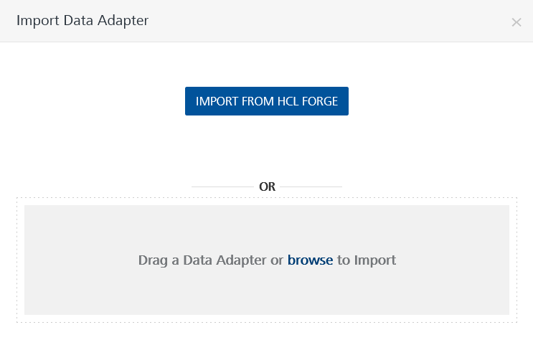
- Select Web Scraper API zip file and click IMPORT.
After you import the data adapter, Volt Foundry opens a window that shows the metadata of the data adapter.
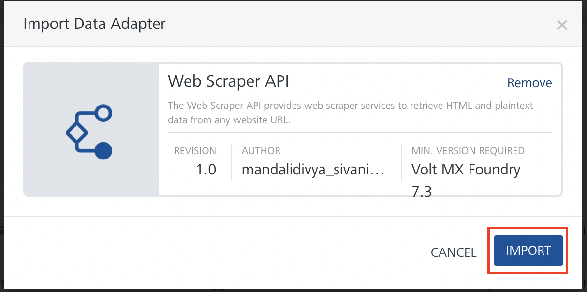
After you import the data adapter, you can view it on the Custom Data Adapters page and use it to create services on Volt Foundry.
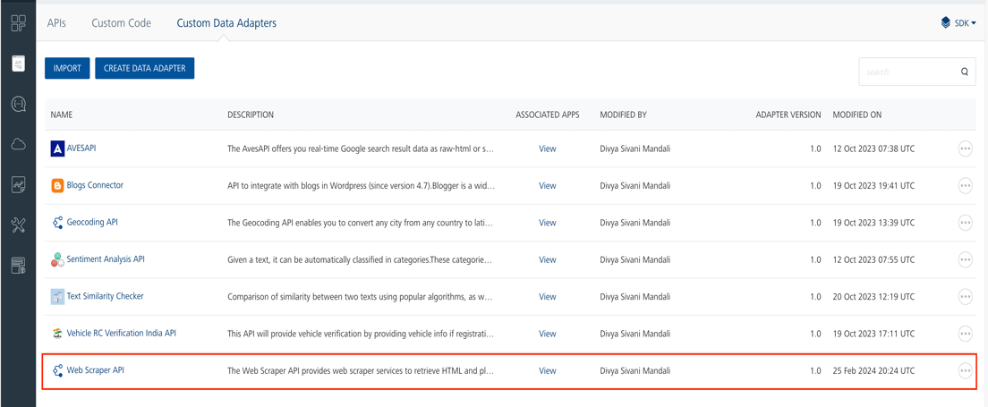

Creating an Integration service
After you import the data adapter into Volt Foundry, you can use it to create an Integration Service.
Follow the given steps to create an Integration service using the Web Scraper API Adapter.
- Sign in to the HCL Foundry.
- From the left navigation menu, select API Management.
- In API Management, select Integration.
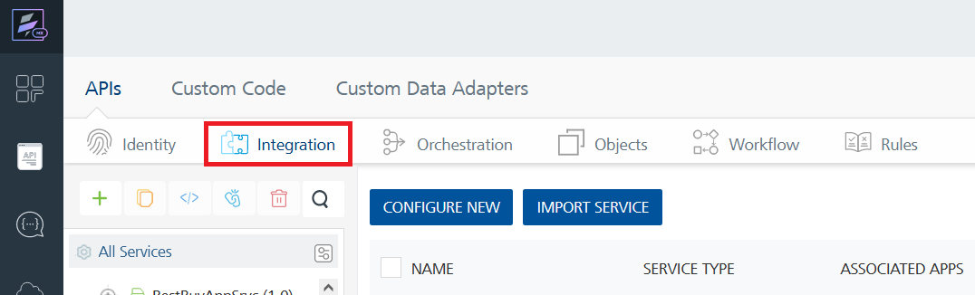

- To create a new service, click the + button or the CONFIGURE NEW button.
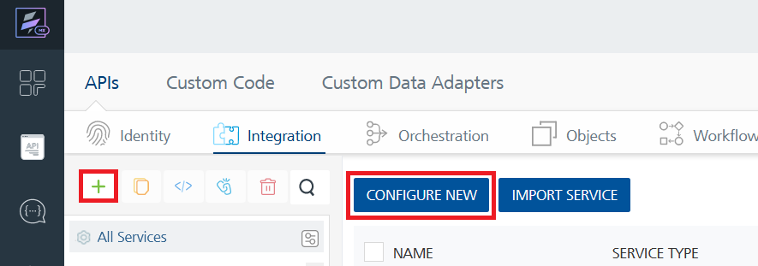
- On the Service Definition tab, select the service type as Web Scraper API, and click SAVE.
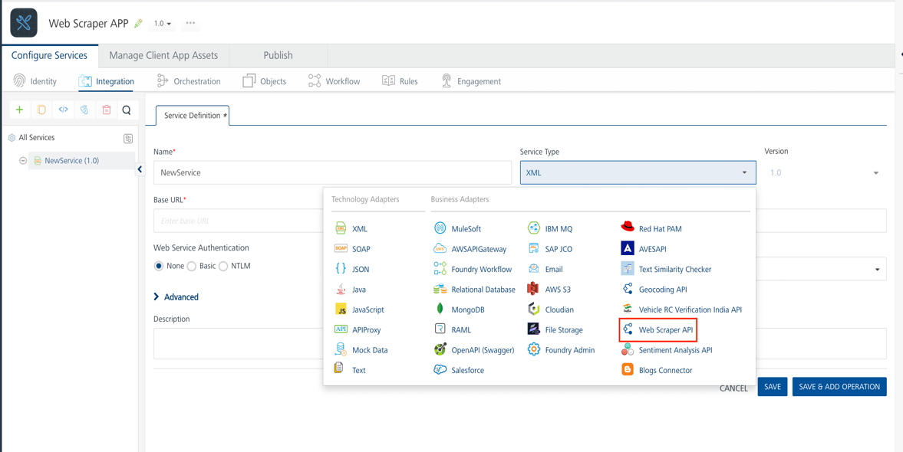

Alternatively, you can also create a Foundry app and create an Integration service inside it.

Creating and Executing operations
After you create an integration service, you can create and execute operations using the service.

Creating an Operation
- In API Management/Foundry app you created, in the Integration section, select the service that you created.
- After you select the service, navigate to the Operation List tab.
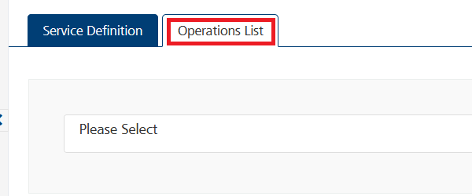
- From the drop-down list, select an operation that you want to execute, and click ADD OPERATION.
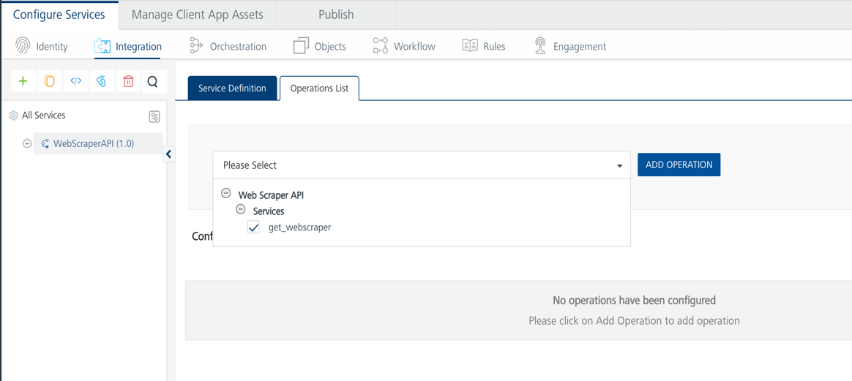

Executing an Operation
- From the Operations List tab, in the Configured Operations section, select the operation you want to execute.
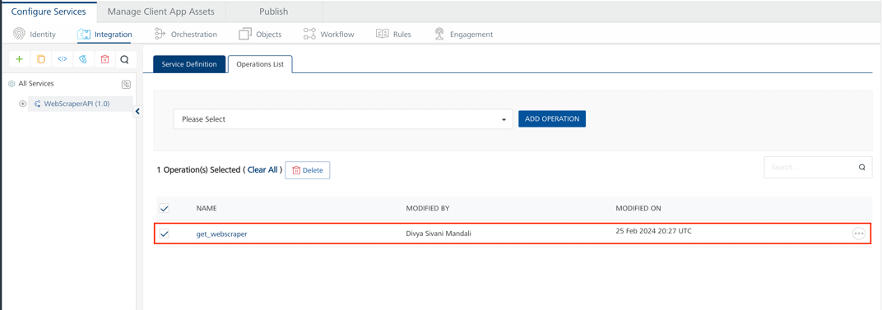
- On the Operation Page, in the Request Input tab, in the Body section, for the following parameters, specify the values in the respective boxes under the Test Value column.
Mandatory Parameters
  - X-Api-Key: API Key associated with your account.
To get api key – Login in to Api Ninjas Account -> Go to My Account-> API Statistics -> You can view your api key.
  - url: URL to scrape.
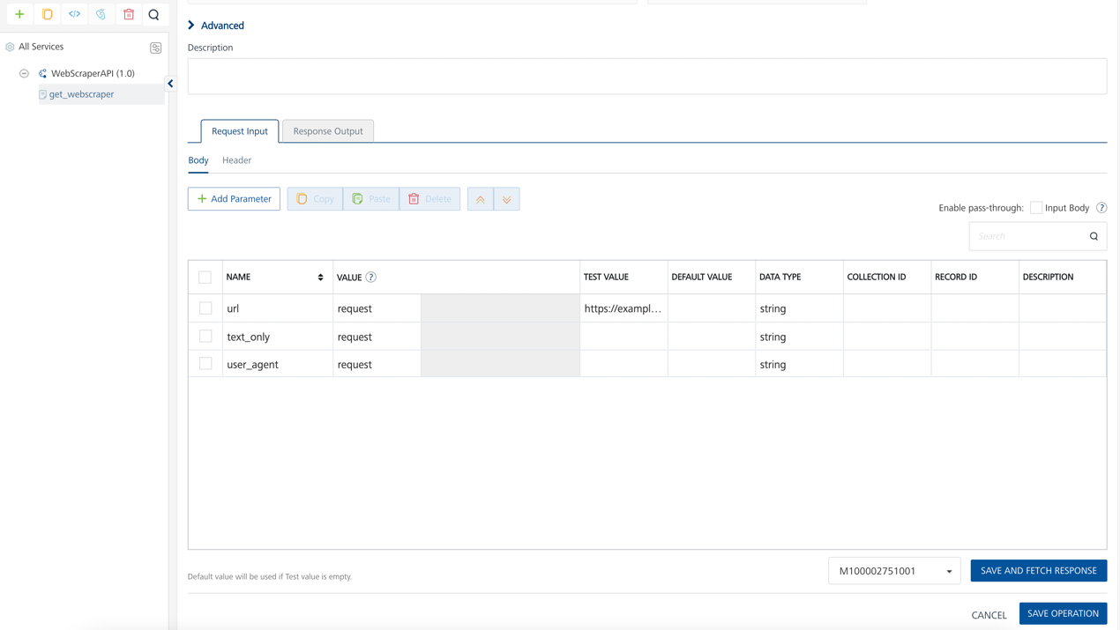
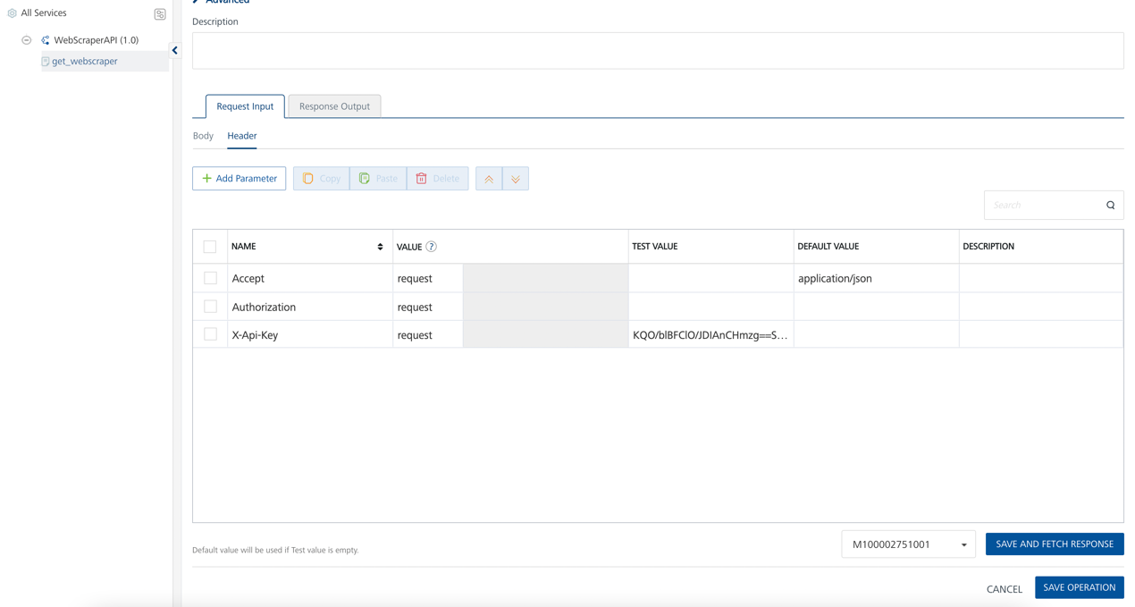

- Select a run-time environment and click Save and Fetch Response to get a response based on your inputs.
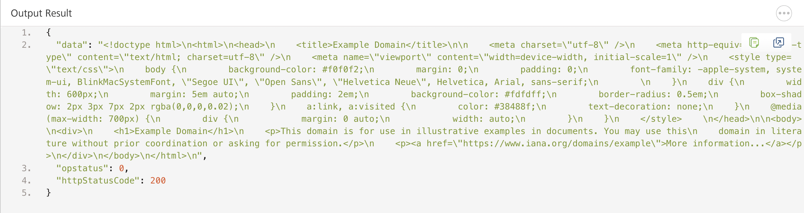

Publishing your application
If you want to use the services in client applications, you need to publish an app to a run-time environment. You can create the service (as described above) in an application or import the service into an application and publish the application.

References

Endpoint Documentation

Requests Input Parameters
Parameter | Description
X-Api-Key | [Required] [Header] API Key associated with your account.
url | [Required] URL to scrape.
text_only | [Optional] whether to only extract visible text (ignores HTML tags and metadata). Must be either true or false. Default is false.
user_agent | [Optional] User-Agent string to use in the request header.

Response Output Parameters

Object Property | Data Type | Description
data | String | The HTML content retrieved from the requested URL.

Reference Document: Web Scraper API - API Ninjas (api-ninjas.com)

Revision History
Adapter version 1.0.0:

Known Issues
- No Known Issues

Limitations
- No limitations

