Date :  13-10-2023

Weatherbit adapter (1.0.0)

# Overview

This is a simple weather adapter.

This is a simple weather adapter. It receives data from Weatherbit APIs, which then can be displayed or processed into weather information forecast. Currently this adapter can be used to get weather forecast for current day, historical weather details and weather forecasts. You can find more details about the Weatherbit APIs at https://www.weatherbit.io/api.

It makes it easy for you to call Weatherbit API.

It helps you develop use cases related to displaying current weather, historical weather and weather forecasts in a city within your apps.

# Getting Started

## Prerequisites

* Volt Foundry
* Register yourself at Weatherbit (https://www.weatherbit.io/account/create) and generate an API key.
* Click on “Sign Up”.

* Input your details and click on “Create Account” option.

* You will receive an email from Weatherbit to activate your account.

* Click on “Activate your Account”, to active your email address.

* Once your account is activated, login into your account. Fill in few details as shown in below screen shot to proceed to dashboard.

* You will see your API key on the dashboard. The API key is masked in the below screen shot.

## Importing the adapter

**To import the Data Adapter to Volt Foundry, do the following:**

1. Sign in to the  [HCL Foundry](https://manage.hclvoltmx.com/).
2. From the left navigation menu, select **API Management**.
3. In **API Management**, select **Custom Data Adapters**.  
   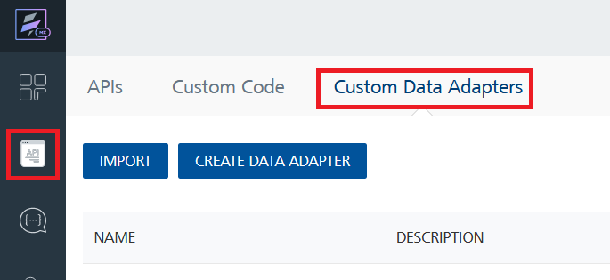
4. Click **IMPORT** to import a custom data adapter.  
   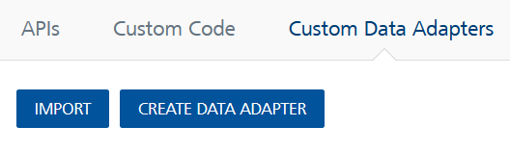
5. On the Import Data Adapter dialog box, click browser to import.  
   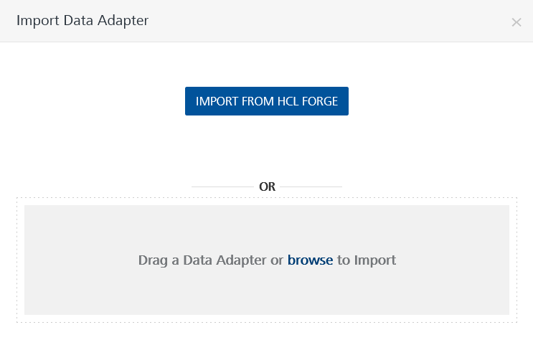
6. Select Weatherbit Adapter zip file and click **IMPORT**.

After you import the data adapter, Volt Foundry opens a window that shows the metadata of the data adapter.

After you import the data adapter, you can view it on the Custom Data Adapters page and use it to create services on Volt Foundry.

## [Creating an Integration service](javascript:void(0);)

After you import the data adapter into Volt Foundry, you can use it to create an Integration Service.

Follow the given steps to create an Integration service using the Weatherbit Adapter.

1. Sign in to the [HCL Foundry](https://manage.hclvoltmx.com/).
2. From the left navigation menu, select **API Management**.
3. In **API Management**, select **Integration**.  
   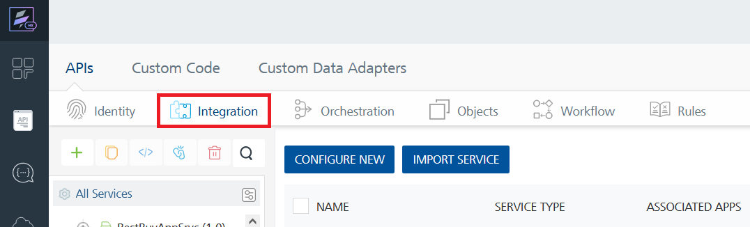
4. To create a new service, click the **+** button or the **CONFIGURE NEW** button.  
   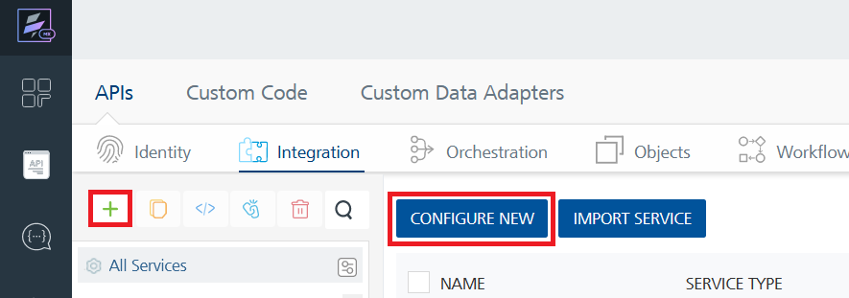
5. On the Service Definition tab, select the service type as Weatherbit Adapter, and click **SAVE**. A screenshot of a computer

   Description automatically generated A screenshot of a computer

   Description automatically generated

Alternatively, you can also create a Foundry app and create an Integration service inside it.

E. [Creating and Executing operations](javascript:void(0);)



After you create an integration service, you can create and execute operations using the service.

#### Creating an Operation

* In **API Management/Foundry app you created**, in the **Integration** section, select the service that you created.
* After you select the service, navigate to the **Operation List** tab.  
  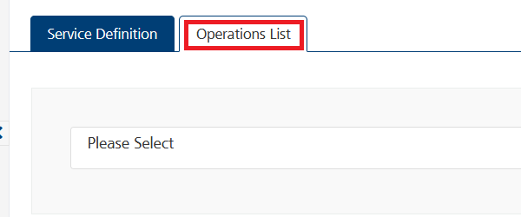
* From the drop down list, select an operation that you want to execute, and click **ADD OPERATION**.  
  A screenshot of a computer

  Description automatically generated

#### Executing an Operation

* From the **Operations List** tab, in the **Configured Operations** section, select the operation you want to execute.  
  A screenshot of a computer

  Description automatically generated
* On the Operation Page, in the Request Input tab, enter a TEST VALUE for all the fields.  
  A screenshot of a computer

  Description automatically generated A screenshot of a computer

  Description automatically generated A screenshot of a computer

  Description automatically generated
* Select a run-time environment and click **Save and Fetch Response** to get a response based on your inputs.  
  A screenshot of a computer

  Description automatically generated A screenshot of a computer

  Description automatically generated

## [Publishing your application](javascript:void(0);)

If you want to use the services in client applications, you need to publish an app to a run-time environment. You can create the service (as described above) in an application or import the service into an application and publish the application.

# References

## Endpoint Documentation

|  |  |  |  |
| --- | --- | --- | --- |
| **API** | https://api.weatherbit.io/v2.0/current?city=<City>&key=<API Key> | | |
| **Example** | https://api.weatherbit.io/v2.0/current?city=Hyderabad&key=<API Key> | | |
| **Input Parameters** | | | |
| city | | Required | City name. |
| key | | Required | Your unique API key (you can always find it on your Weatherbit account page under the "API key" tab) |

# Revision History

Adapter version 1.0.0:

## Known Issues

NA

## Limitations

NA