Date : 19-Oct-23

weather api.com (1.0.0)

Overview
- WeatherAPI.com provides access to free weather and geo data via a JSON restful API. It allows developers to create desktop, web and mobile applications using this data very easy. Weather api.com provides Real-time weather, forecast weather, Historical weather, astronomy, timezone, ip address location, future weather data.

Use case.
- "You can use the WeatherAPI.com to get Real-time weather,forecast weather, Historical weather, astronomy, timezone data”.

Getting Started

Prerequisites
Before you start using the Weatherapi.com data adapter, ensure you have the following:

- HCL Foundry
- Volt MX Iris
- An account with weather api.com and api key

Platforms Supported

Mobile

iOS

Android

Tablets

PWA

Importing the adapter
To import the Data Adapter to Volt Foundry, do the following:
- Sign in to the HCL Foundry.
- From the left navigation menu, select API Management.
- In API Management, select Custom Data Adapters.
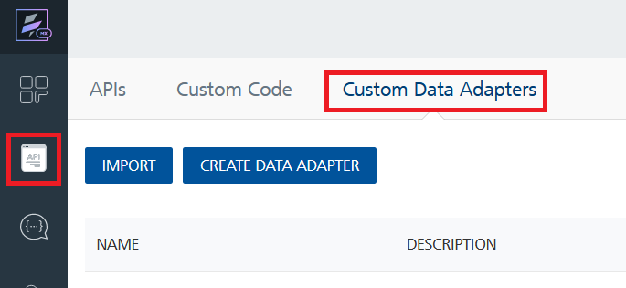
- Click IMPORT to import a custom data adapter.
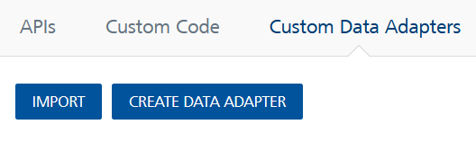
- On the Import Data Adapter dialog box, click browser to import.
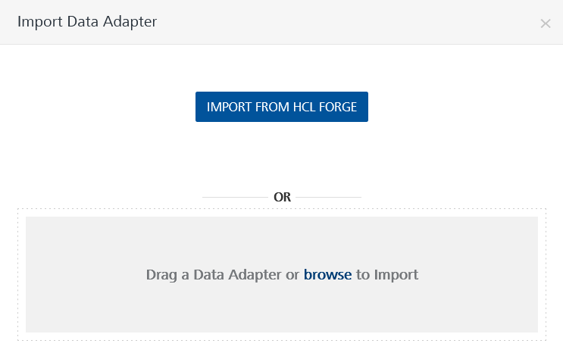
- Select Weatherapi.com data adapter zip file and click IMPORT.
After importing the data adapter, Volt Foundry opens a window that shows the metadata of the data adapter.

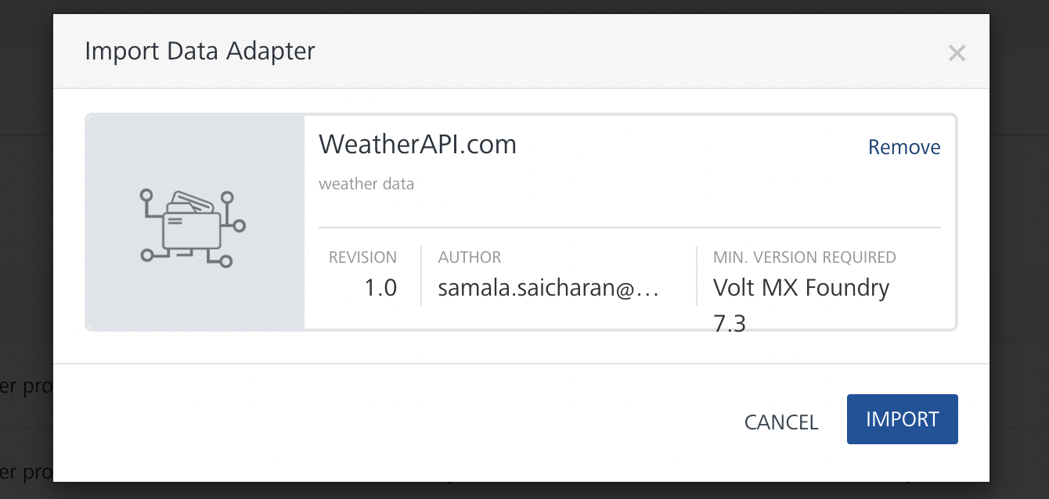
After you import the data adapter, you can view it on the Custom Data Adapters page and use it to create services on Volt Foundry.
After you add the data adapter to your Volt Foundry app. You can refer to the section below for more information.
Creating an Integration service
Follow the given steps to create an Integration service using the Weatherapi.com Data Adapter.
- Sign in to the HCL Foundry.
- From the left navigation menu, select API Management.
- In API Management, select Integration.
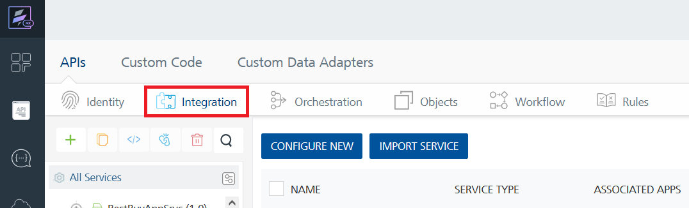
- To create a new service, click the + button or the CONFIGURE NEW button.
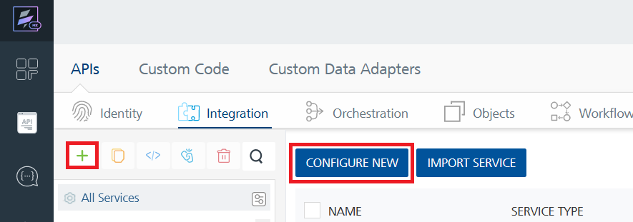
- On the Service Definition tab, select the service type as WORLD NEWS, and click SAVE.
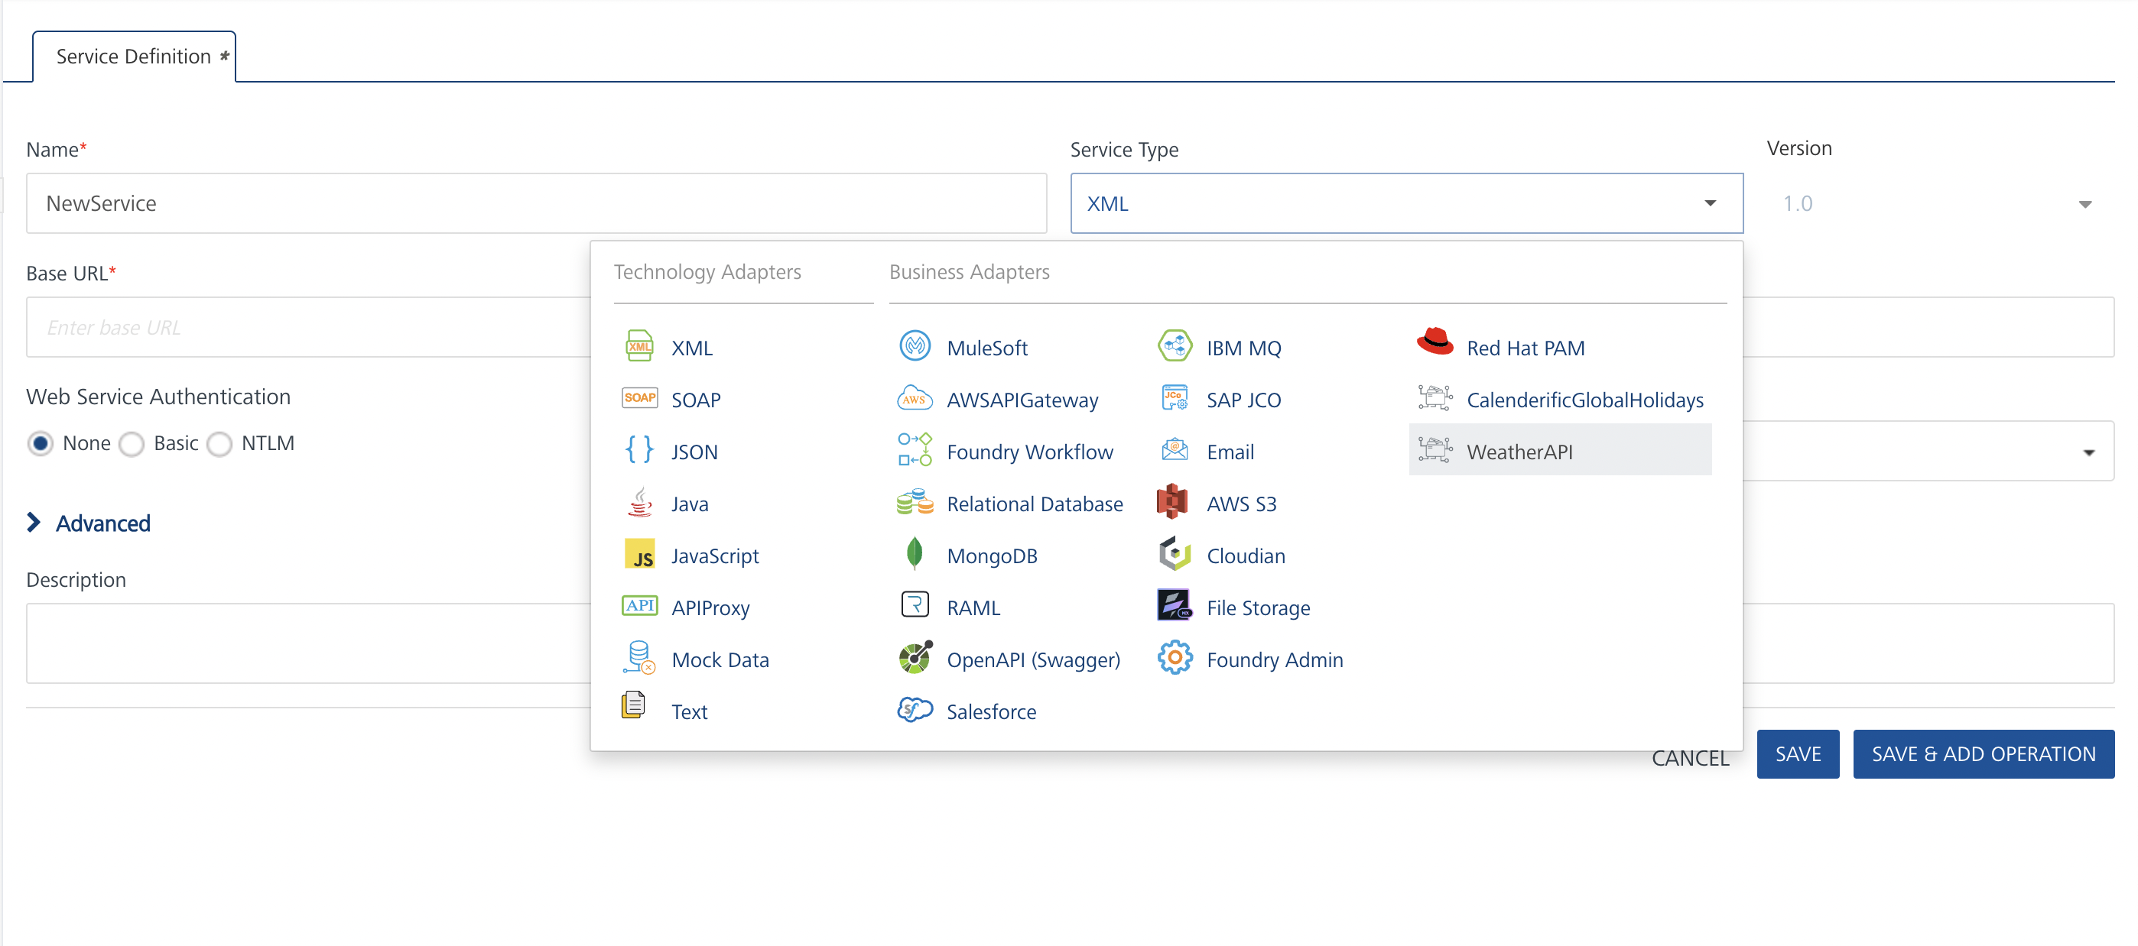
Creating and Executing operations
After you create an integration service, you can create and execute operations using the service.

Creating an operation
- In the API Management/Foundry app you created, in the Integration section, select the service that you created.
- After you select the service, navigate to the Operation List tab.
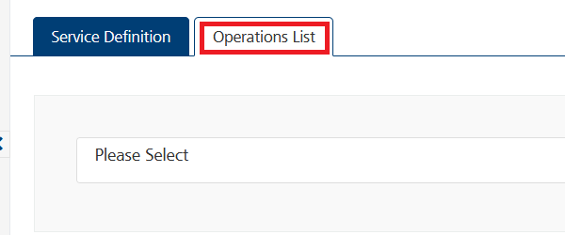
- From the drop-down list, select an operation that you want to execute, and click ADD OPERATION.
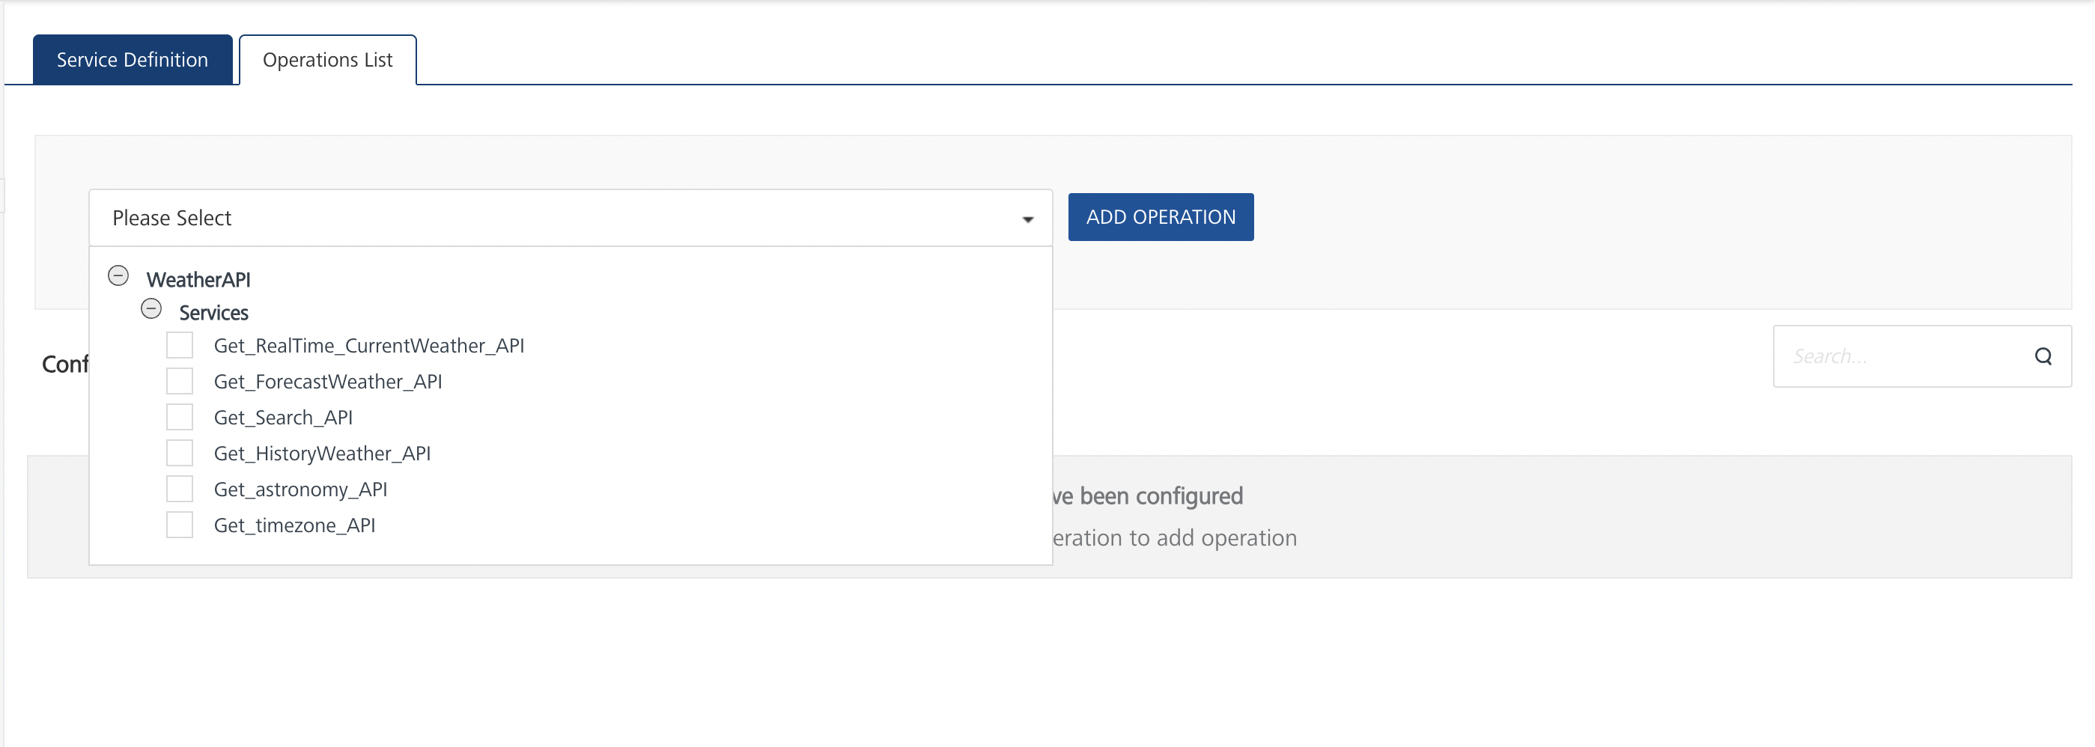

Executing an Operation
- From the Operations List tab, in the Configured Operations section, select the operation you want to execute.
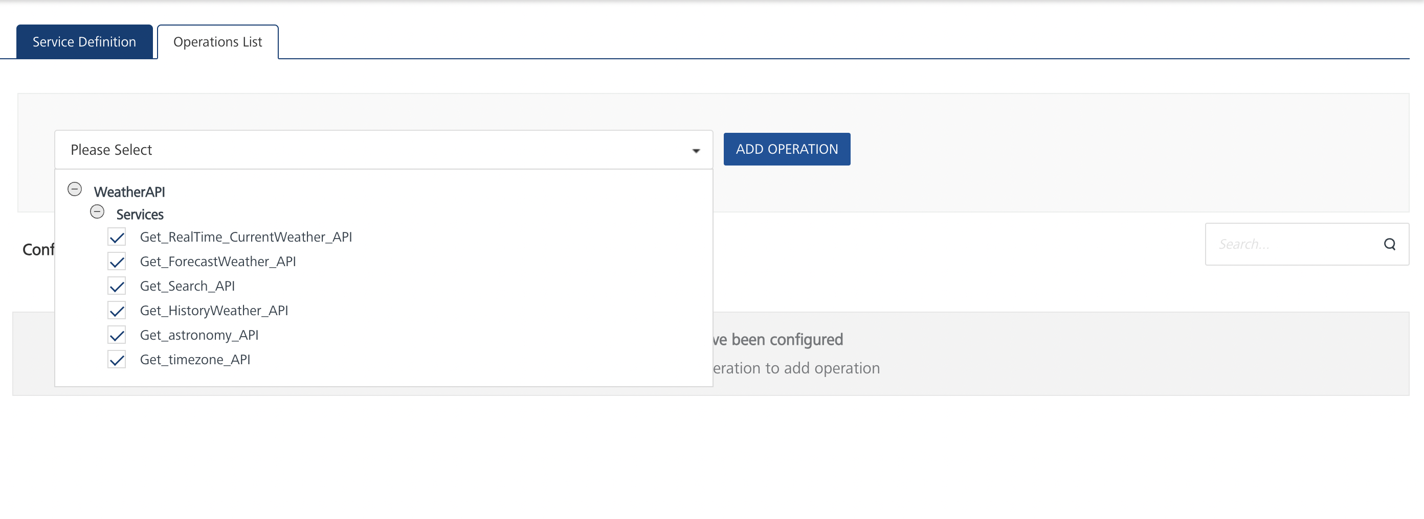
- On the Operation Page, in the Request Input tab, enter a TEST VALUE for all the fields.
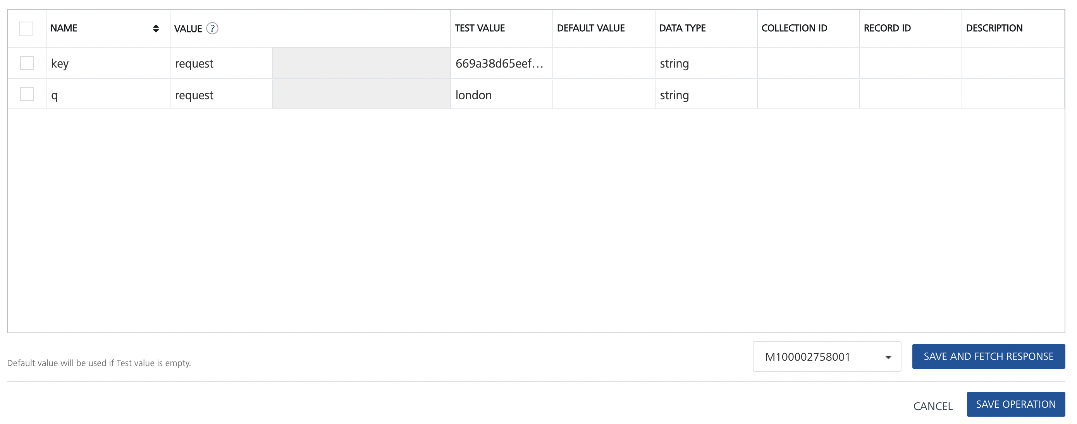

- Select a run-time environment and click Save and Fetch Response to get a response based on your inputs.
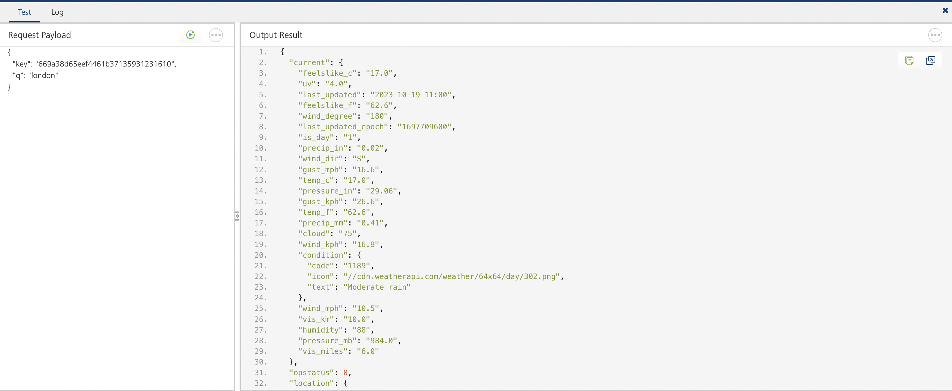

Publishing your application
If you want to use the services in client applications, you need to publish an app to a run-time environment. You can create the service (as described above) in an application or import the service into an application and publish the application.

References

Base url : http://api.weatherapi.com/v1

Endpoint Documentation
Endpoints | Input params-Type | Description
/current.json | Key(required)  q (required) | Current weather or realtime weather API method allows a user to get up to date current weather information in json and xml. The data is returned as a Current Object.  q =  - Latitude and Longitude (Decimal degree) e.g: q=48.8567,2.3508  - city name e.g.: q=Paris  - US zip e.g.: q=10001  - UK postcode e.g: q=SW1  - Canada postal code e.g: q=G2J  - metar:<metar code> e.g: q=metar:EGLL  - iata:<3 digit airport code> e.g: q=iata:DXB  - auto:ip IP lookup e.g: q=auto:ip  - IP address (IPv4 and IPv6 supported) e.g: q=100.0.0.1
/forecast.json | Key(required)  q (required)  days(required) | Forecast weather API method returns, depending upon your price plan level, upto next 14 day weather forecast and weather alert as json or xml. The data is returned as a Forecast Object.Retrieve the future weather data and gives hourly weather.  days parameter value ranges between 1 and 14. e.g: days=5
/search.json | Key(required)  q (required) | WeatherAPI.com Search API returns matching cities and towns as an array of Location object.
/history.json | Key(required)  q (required)  dt (required) | History weather API method returns, depending upon your price plan level, historical weather for a date on or after 1st Jan, 2010 as json and xml. The data is returned as a Forecast Object.  dt = yyyy-MM-dd format
/astronomy.json | Key(required)  q (required) | Astronomy API method allows a user to get up to date information for sunrise, sunset, moonrise, moonset, moon phase and illumination in json.
/timezone.json | Key(required)  q (required) | Time Zone API method allows a user to get up to date time zone and local time information in json.
/future.json | Key(required)  q (required)  dt (required) | Future weather API method returns weather in a 3 hourly interval in future for a date between 14 days and 300 days from today in the future.  dt = yyyy-MM-dd format
/ip.json | Key(required)  q (required) | IP Lookup API method allows a user to get up to date information for an IP address in json

These are List of all endpoints, input params of the fields in tabular format.

Refer the link for more information about API endpoints.

Revision History
Adapter version 1.0.0

