11th April 2023

Wallet(1.0.0)

Overview
A Wallet component to preview and add the pass into the iOS wallet app.

Use case

Passes generated from the backend will be adding to the iOS wallet app.

Percentage of re-use:
Approximate 90 % of reuse.

Features

- The component Wallet utilizes native frameworks to add the passes into the iOS wallet app from the base64 string or the . pkpass file.
- Uses NFI 3.0

Getting Started

Prerequisites
Before you start using the Wallet component, ensure the following:
- Volt MX Iris

Platforms Supported

Mobile - iOS

Tablets - iOS

Importing the component

You can import the Forge components only into the apps that are of the Reference Architecture type.

To import the Wallet component, do the following:

Open your app project in Volt MX Iris.
2. In the Project Explorer, click the Templates tab.
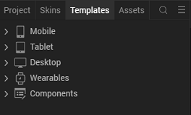
3.Right-click Components, and then select Import Component. The Import Component dialog box appears.
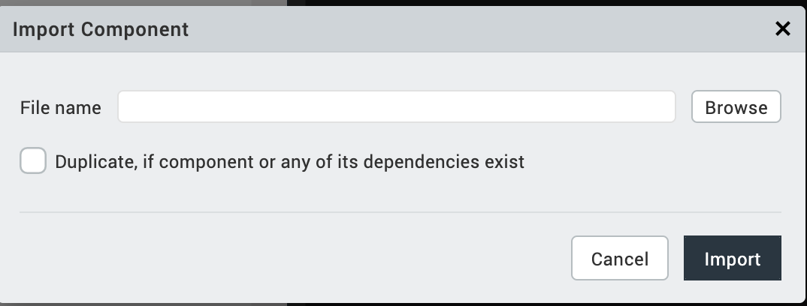
4.Click Browse to navigate to the location of the component, select the component, and then click Import. The component and its associated widgets and modules are added to your project.
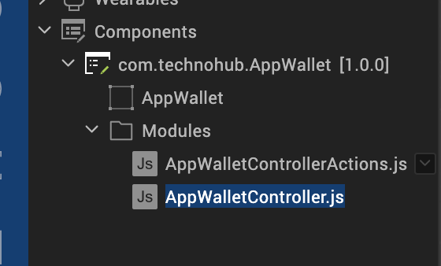

Once you have imported a component to your project, you can easily add the component to a form. For more information, refer Add a Component to a Form

Building and previewing the app
After performing all the above steps, you can build your app and run it on your device. For more information, you can refer to the Building and Viewing an Application section of the Volt MX User Guide.
You can then run your app to see the Scanner work in real time.

References

Dynamic Usage
You can also add Wallet component dynamically. To do so,
1. In the Project Explorer, on the Projects tab, click Controllers section to access the respective Form Controller. Create a method and implement the code snippet similar to the sample code mentioned below.

/* Creating Wallet component instance */

var Wallet = new com.technohub.AppWallet({
"height": "100%",
"id": "AppWallet",
"isVisible": true,
"left": "0dp",
"masterType": constants.MASTER_TYPE_USERWIDGET,
"isModalContainer": false,
"skin": "slFbox",
"top": "0dp",
"width": "100%",
"zIndex": 1,
"overrides": {
"Wallet": {
"right": "viz.val_cleared",
"bottom": "viz.val_cleared",
"minWidth": "viz.val_cleared",
"minHeight": "viz.val_cleared",
"maxWidth": "viz.val_cleared",
"maxHeight": "viz.val_cleared",
"centerX": "viz.val_cleared",
"centerY": "viz.val_cleared"
}
}
}, {
"overrides": {}
}, {
"overrides": {}
});

/*Adding the AppWallet component to a Form*/

this.view.add(Wallet);

},
In the code snippet, you can edit the properties of the component as per your requirement. For more information, see Setting Properties.
2. Save the file

Configuring Deployment Target
- From the left navigation menu, click Project Settings.
- In the Project Settings window, go to Native → iPhone/iPad.
- Under Target Versions, from the iOS Version list, select 11.0 or higher.
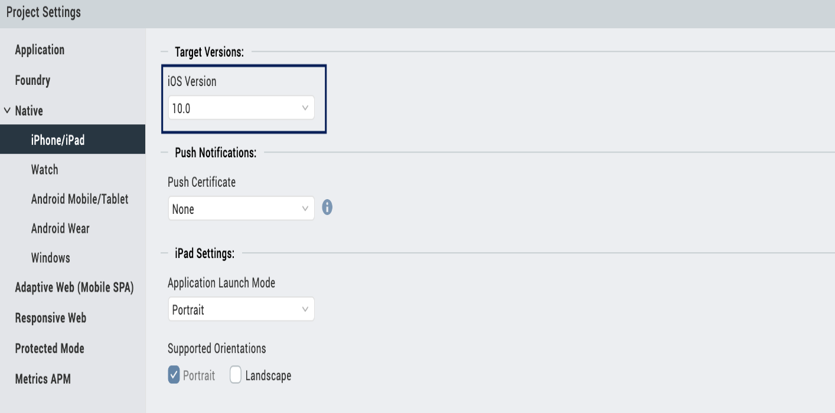

API

isPassLibraryAvailable

Description: | Checks passkit library is available in the iPhone device.
Syntax: | isPassLibraryAvailable()
Parameters: | None
Return Value: | None
Remarks: | NA.
Example: | this.view.AppWallet.isPassLibraryAvailable()

addPassFromBase64

Description: | Adds the pass from the base64 string.
Syntax: | addPassFromBase64(base64, completionHandler)
Parameters: | Base64 - String, completion Handler - Callback
Return Value: | None
Remarks: | NA.
Example: | this.view.AppWallet.addPassFromBase64 (base64, this.competionHandler)  competionHandler: function(data) {  }

addPassFromFile

Description: | Adds the pass from the .pkpass file, which is palced in the iphone/mainbundle folder.
Syntax: | addPassFromFile(fileName, completionHandler)
Parameters: | Filename - String, completion Handler - Callback
Return Value: | None
Remarks: | NA.
Example: | this.view.AppWallet.addPassFromFile(fileName, this.competionHandler)  competionHandler: function(data) {  }

getPasses

Description: | Gives all the passes objects added in the Wallet app. To get this function work, it passes capability must be added to the bundle identifier.
Syntax: | getPasses()
Parameters: | None
Return Value: | None
Remarks: | NA.
Example: | this.view.AppWallet.getPasses()

removePass

Description: | Removes the pass which is being passed as a parameter.
Syntax: | removePass(pass)
Parameters: | Pass – native PKPass object
Return Value: | None
Remarks: | NA.
Example: | this.view.AppWallet.removePass(pass);

getPassWithPassTypeIdentifierAndSerialNumber

Description: | Gets the native pass object with the identifier and the serial number
Syntax: | getPassWithPassTypeIdentifierAndSerialNumber(identifier, serialNumber)
Parameters: | Identifier – String – Pass identifier, Serial Number – String – Serial Number.
Return Value: | None
Remarks: | NA.
Example: | this.view.AppWallet. getPassWithPassTypeIdentifierAndSerialNumber (identifier, serialNumber);

addPasses

Description: | Adds multiple passes to the Wallet
Syntax: | addPasses([passes])
Parameters: | Passes – [PKPass] - multiple native passes objects
Return Value: | None
Remarks: | NA.
Example: | this.view.AppWallet.addPasses ([passes]);

App version 1.0.0:

Limitations

NA

Known Issue

NA

