13 June 2024

**Volt MX Foundry Custom Report Downloader**

**Version: 1.0.1**

# **Overview**

The custom report downloader is a utility component that allows users to download a custom (shared/ private) report as a CSV file without having to login to the Volt MX Foundry console. The component is a Java JAR that takes a few input parameters including username and password of Volt MX Foundry to run. This how-to documentation is provided along with source code to help a developer to understand how to use the component and if required to customize and enhance the utility for their specific requirements.

## **Use case:**

## The custom report downloader is a utility component that allows to download a custom (shared/ private) report as a CSV file without having to login to the Volt MX Foundry console.

## **Percentage of re-use:**

85-90%.

# **Getting Started**

## **Prerequisites**

Before you start using the **Volt MX Foundry Custom Report Downloader**, ensure the following:

• [HCL Foundry](https://manage.hclvoltmx.com/)

• Command Prompt/Terminal

**3. How to build the Jar**

1. Open a command prompt/Terminal. Navigate to the folder where the project exists.

For eg:

cd C:\<path-to-project>\CustomReports

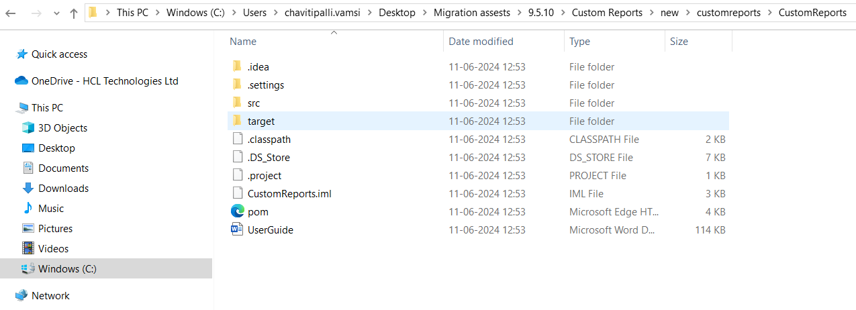

2. Download and install [Maven – Download Apache Maven](https://maven.apache.org/download.cgi). Set up the environment variables in our System.

3. Run the following command.

**mvn clean compile assembly:single**

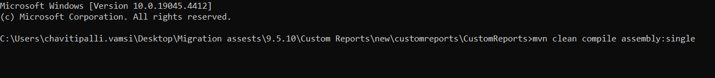

This will generate the **CustomReports.jar** in the **target** folder. That is the executable jar.

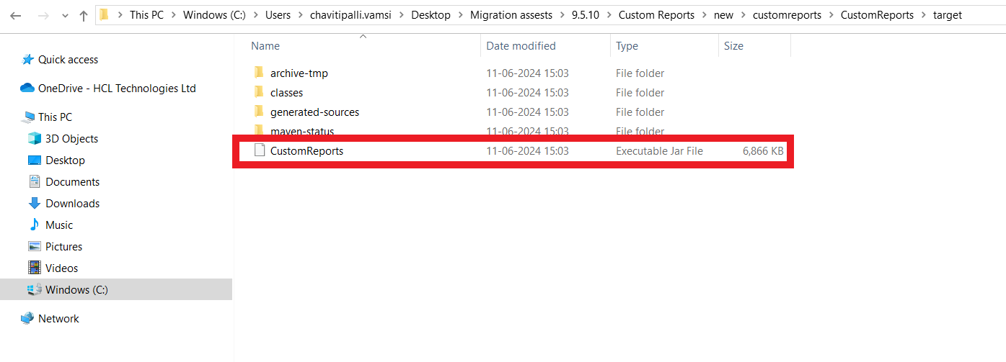

# **4. Configuring the Jar:**

1. Open the CustomReports.jar using any archive program like Winrar or WinZip. Navigate to /src/main/resources. You will find a properties file named credentials.properties.

E.g.: C:/<path-to-project>/CustomReports/src/main/resources.

2. Open that in any text editor. Modify the username and password fields to your Volt MX Foundry console credentials and save. Ensure that the properties file is updated post the changes in the jar.

**username**=<**useremail**> **// username@hcl.com  
password**=**<password> // password**

**account_id=<account_id> //Voltmx Foundry account Id**

# **5. Running the jar:**

1. Navigate to the target folder.

**cd target**

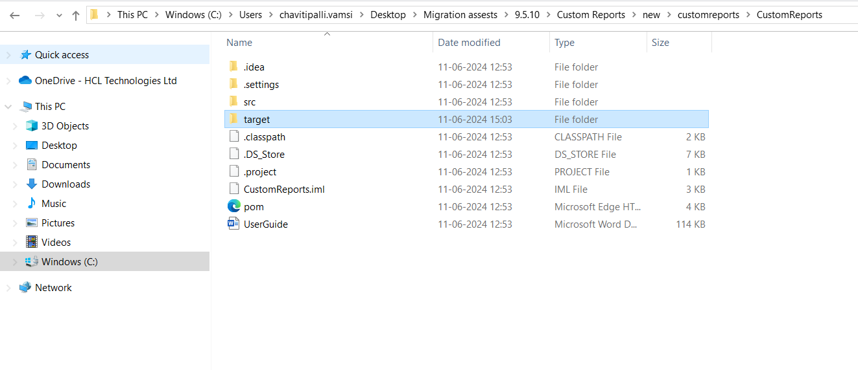



1. Execute the following command.

**java -jar CustomReports.jar "{Report-Name}" {input-controls-list} {report-type} {folder}**

**Report Name-** The name of the Report that you see in the console.

**Input-controls-list-** Comma separated list of input control keys and values.

{key1}={value1},{key2}={value2}…..

Put **na** if default controls are to be considered.

**Report-type –** custom, dashboard, funnel

**folder –** The folder in which the report resides. It can be either **private** or **shared**. If nothing is mentioned, it takes **shared** by default. Optional for dashboard and funnel

For E.g.:

1. For Single input Control

**java -jar CustomReports.jar "Demo Report" appname=test custom shared**

for any special character like <space>, -, @, /, will be substituted/replaced with a single underscore ( _ ) character in the file name.

E.g.: Demo Report changed considered as Demo_Report in VoltmX Foundry

1. For Multiple Input Controls

**java -jar CustomReports.jar "Demo Report" appname=test,channel=mobile custom shared**

1. For No input Controls or to use the default Input controls.

**java -jar CustomReports.jar "Demo Report" na custom shared**

1. To get funnel report

**java -jar CustomReports.jar “Event_Funnel_View” na funnel**

1. To get dashboard reports

**java -jar CustomReports.jar “ErrorSummaryTable” na dashboard**

**java -jar CustomReports.jar "RequestsPerServiceTable” startdate=2015-01-01,enddate=2017-07-05,appname=0All dashboard**

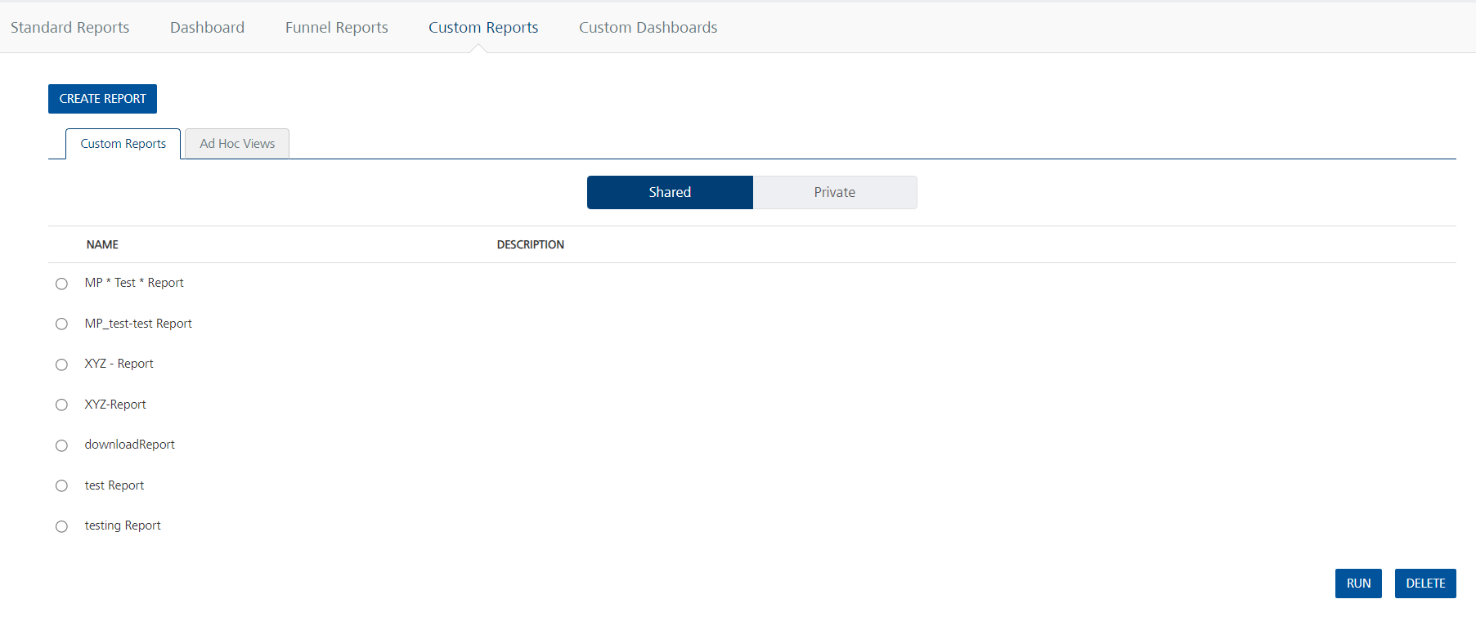

1. 3. A file with the name **report_name.csv** will be created.

For eg:

**6. How to know the input controls of the Report:**

Now comes the question – How do we know the input controls of that Report. It is very simple.

1. Log into the Volt MX Foundry console from a browser. Navigate to the Reports Section. Click on Custom reports. You will hopefully see the report you created and want to download.

2. Press F12 to open the developer Console. This will open up a Developer Console. Go to Network tab.

3. Now click on the report whose input controls are required. In the report you will find a network call made with the controls. Click on the request and then on Headers. Scroll Down till you find the QueryStringParameters . Under which you will a param filters.

All the values except page are your input control keys. Please have a look at the image below for reference.

4. Take those input controls and use them in the jar execution.

For e.g.:

java -jar CustomReports.jar "Shared Report" appname_1=”Retail Banking”,channel_1=Mobile custom shared

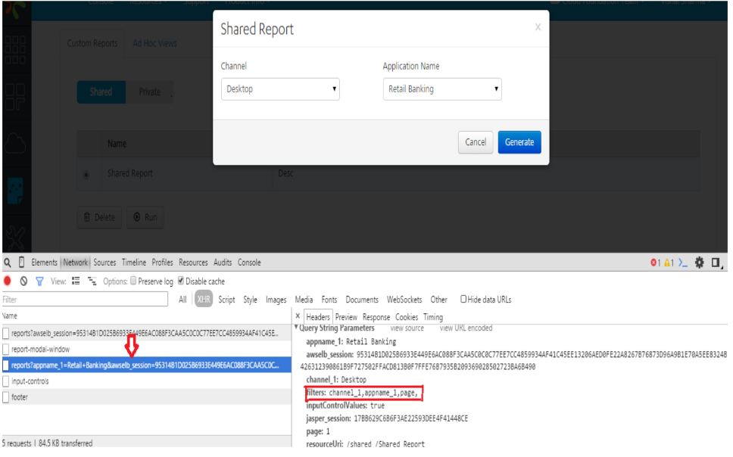

# **7. Revision History**

App version 1.0.1