Date: 14/08/2025

VOLT MX CHATBOT FRAMEWORK

VERSION: 1.0.1

OVERVIEW
Conversational interfaces are becoming fundamental in delivering a high fidelity customer experience in today’s applications. Bringing in highly engaging, natural and rich conversational experiences and thereby providing users with new ways to interact with applications. Conversational AI Frameworks encompassing chatbots offer natural experiences that can deliver immediate productivity gains, and provide access to proactive insights. Bringing a rich conversational experience into an application involves many underpinning technologies such as Artificial Intelligence (AI), Natural Language Processors (NLPs) and leveraging voice and text-based interfaces coupled with a robust strategy of building intelligence by integrating into back-end data services and other application components.
The Conversational AI Dev Toolkit combines the power of existing Chatbot Framework coupled with an extension Framework built on top of proven Foundry Orchestration Service Pipelining which can be leveraged to add in new conversational services such as Language Based AI Services, Text Analytics, Insights and Secondary Text Classifiers etc, to deliver rich experiences in the applications.
The Conversational AI Framework is a value-added framework, modeled as App-Group (App-Template), that can accelerate and make developing conversational applications easy and intuitive, significantly reducing the time-to-market. The framework contains properties, APIs that you can use to configure, connect to underpinning technologies such as NLPs, Speech-to-Text, Text-to-Speech and allows you to brand and write the new business logic or wire the existing logic to address the intents.

Use Case:
- Customer Support Automation
- Personalized Financial Advice
- Transaction Alerts and Fraud Detection

Features:
- Plug & Play of NLP Engines
  - NLP Connector Framework standardizing the NLP communication
  - Out-of-the-box support for Lex, LUIS and Dialog Flow, Wit.ai, and Microsoft Azure - QnA Maker NLP engines
  - Ability to build and Integrate new NLP Engines
- Extension Framework to add in new conversational services including
  - Language Based AI Services
  - Text Analytics
  - Secondary Text Classifiers
- Support for Voice based & Text based Interactions
  - Speech-To-Text, Text-To-Speech technologies
- Support for multi channel
  - UI Accelerator support
    - Native iOS and Android
    - SPA - Mobile Web and Desktop Web
- Extensible Chatbot Input and Output templates
  - Out-of-the-box support for PDFs, Links, Options, Locations, and Rich Text Templates.
- Standard bot integration services for apps consumption.
- Low-code Abilities
  - Configure, map and connect to NLPs
  - Configurable Input/ Output templates
  - Map intents to existing services/ business logic

Percentage of re-use:
Approximately 90% of reuse.

GETTING STARTED

Prerequisites

Before you start using the Volt MX Chatbot Framework, ensure the following:
- HCL Foundry
- Volt MX Iris

Platforms Supported
- Mobile
- iOS
- Android
- PWA

Importing the Component
You can import the Forge components only into the apps that are of the Reference Architecture type.
To import the Chatbot Framework Component to your current project, follow these steps:
- Open your app project in Volt MX Iris.
- In the Project Explorer, click the Templates tab.
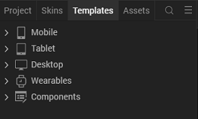
4. Right-click Components, and then select Import Component. The Import Component dialog box appears.
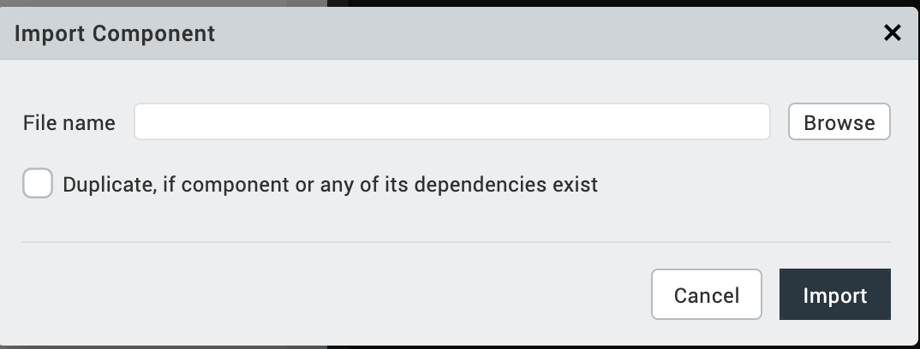
5. Click Browse to navigate to the location of the component, select the component, and then click Import. The component and its associated widgets and modules are added to your project.
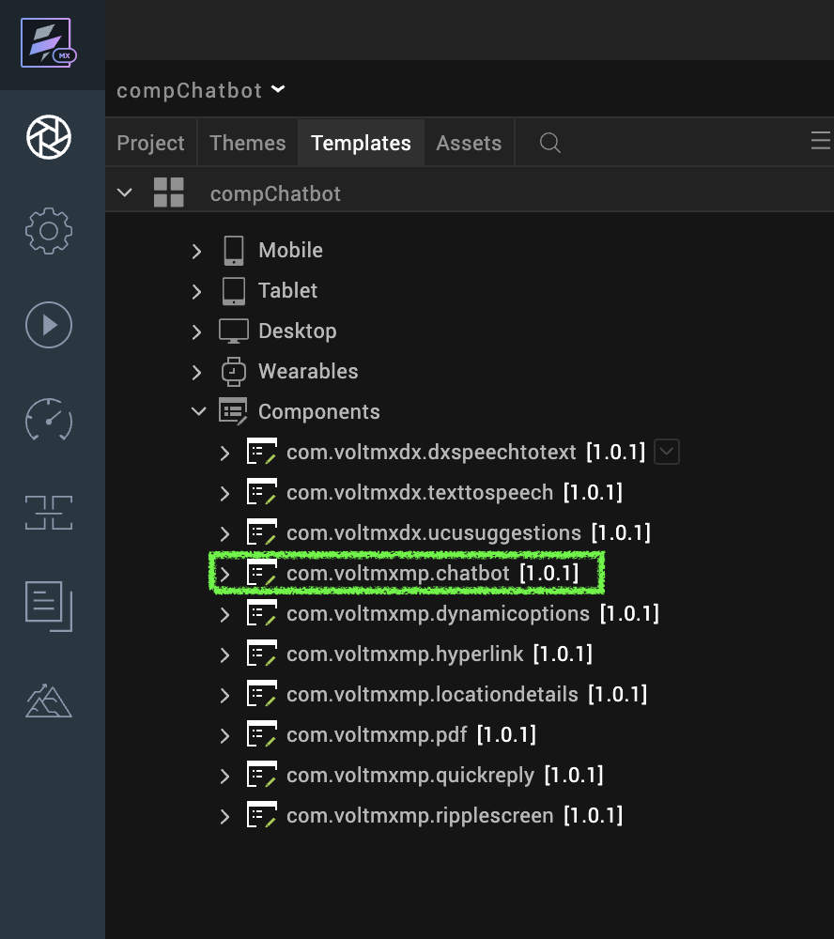

Once you have imported a component to your project, you can easily add the component to a form. For more information, refer Add a Component to a Form

Configuring Native Settings (Android)
To configure the native settings for Android, follow these steps:
- From the left navigation menu, click Project Settings.
- In the Project Settings window, go to Native → Android Mobile/Tablet.
- Set the READ_PHONE_STATE and RECORD_AUDIO permissions to true.
To set a permission to true, select the permission from the left panel, and then click Add.
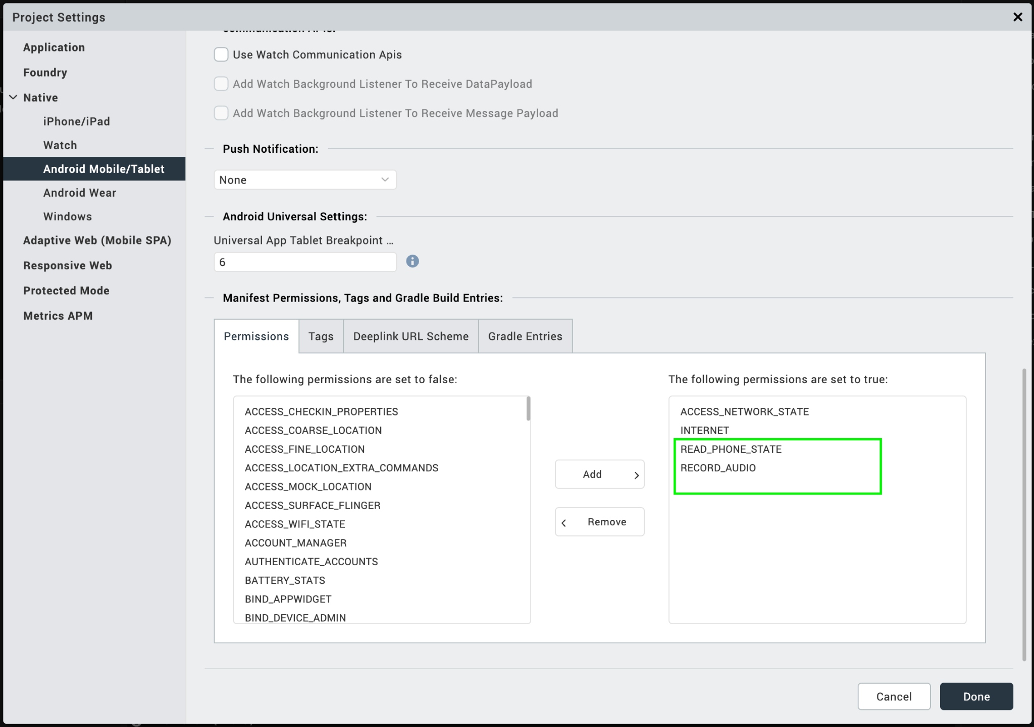

- In the Project Settings window, go to Native → Android Mobile/Tablet → Under Miscellaneous → select Use Google Play Location Services.
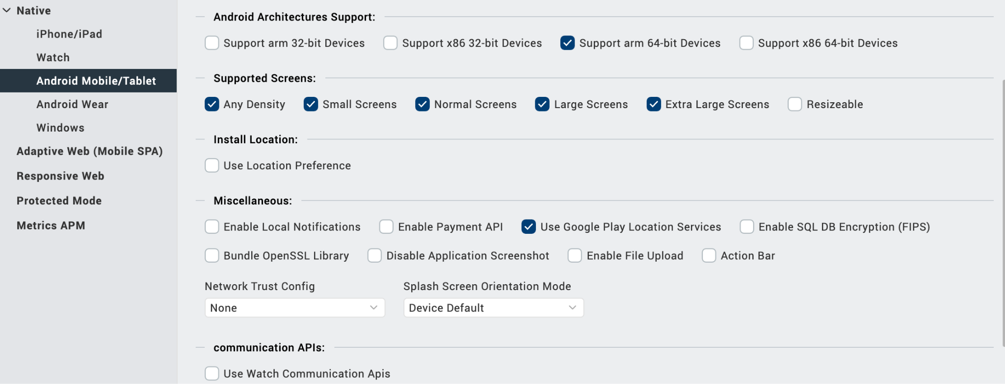
- Switch to the Tags tab.
- Add below code snippet at Project Settings/Android Mobile/Tablet/Manifest Permissions, Tags and Child tag entries under <manifest> tag/
<queries>
<intent>
<action
android:name="android.speech.RecognitionService"/>
</intent>
</queries>
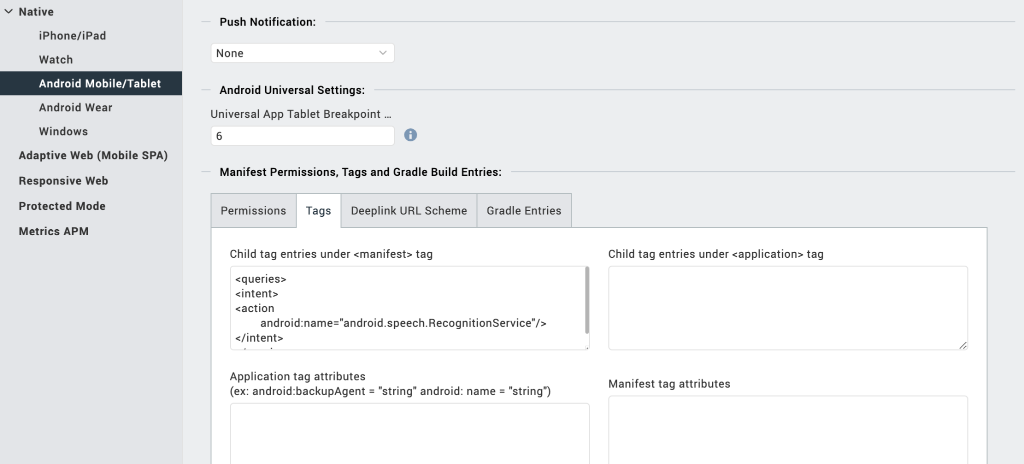

Configuring Native Settings (iOS)
To configure the native settings for iOS, follow these steps:
- From the Project explorer, go to Assets and expand Media.
- Right-click Common, and then select Resource Location. Volt MX Iris opens the common resources folder in a file explorer.
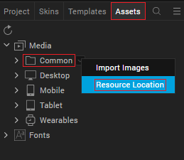
- Open the infoplist_configuration.json file with a text or code editor.
- At the end of the file, type the following code. You can change the description based on your preference.
{
"NSSpeechRecognitionUsageDescription":"VoltMXDxChatbot",
"NSMicrophoneUsageDescription":"VoltMXDxChatbot",
"NSAppTransportSecurity" :
{
"NSAllowsArbitraryLoads" : true
}
}

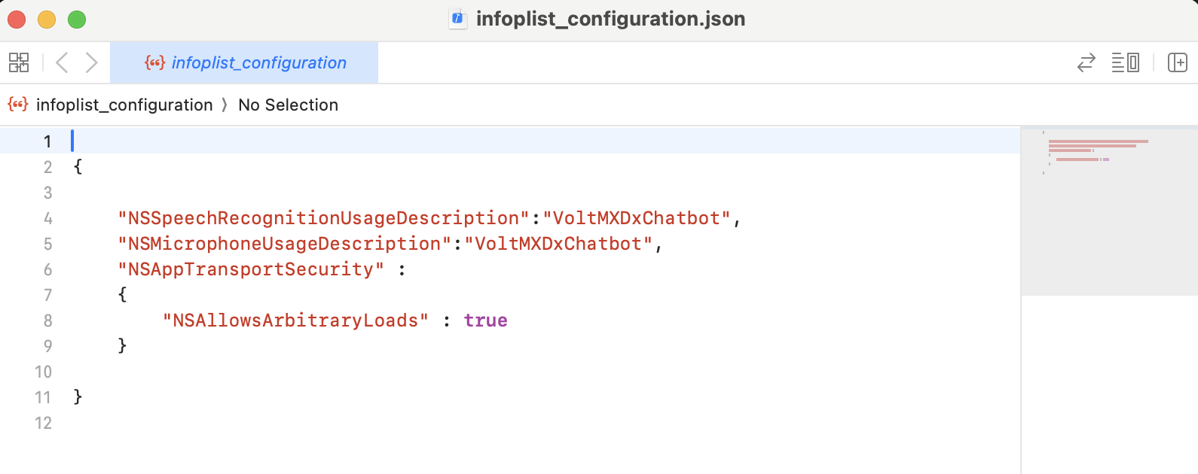
- Save the file.
After you configure the native settings, you can Build and Run your app to see the component work in real time.

SET UP THE CHATBOT - DIALOG FLOW V2

Basic Setup
Set up the Natural Language Processing (NLP) bot in the Dialogflow console to run your chatbot. To set up the NLP bot, follow these steps:
- Create New Agent
- Import the Dialogflow Agent

Create New Agent
To create a new agent in your Dialogflow console, follow these steps:
1. Open and sign in to your account in your Dialogflow console.
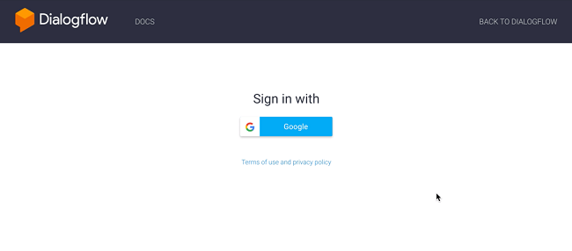
2. In the console, from the left menu pane, click Create new agent.
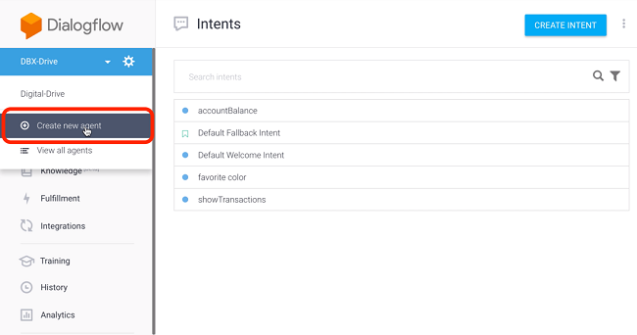
3. Provide a name for your agent, then click Create.
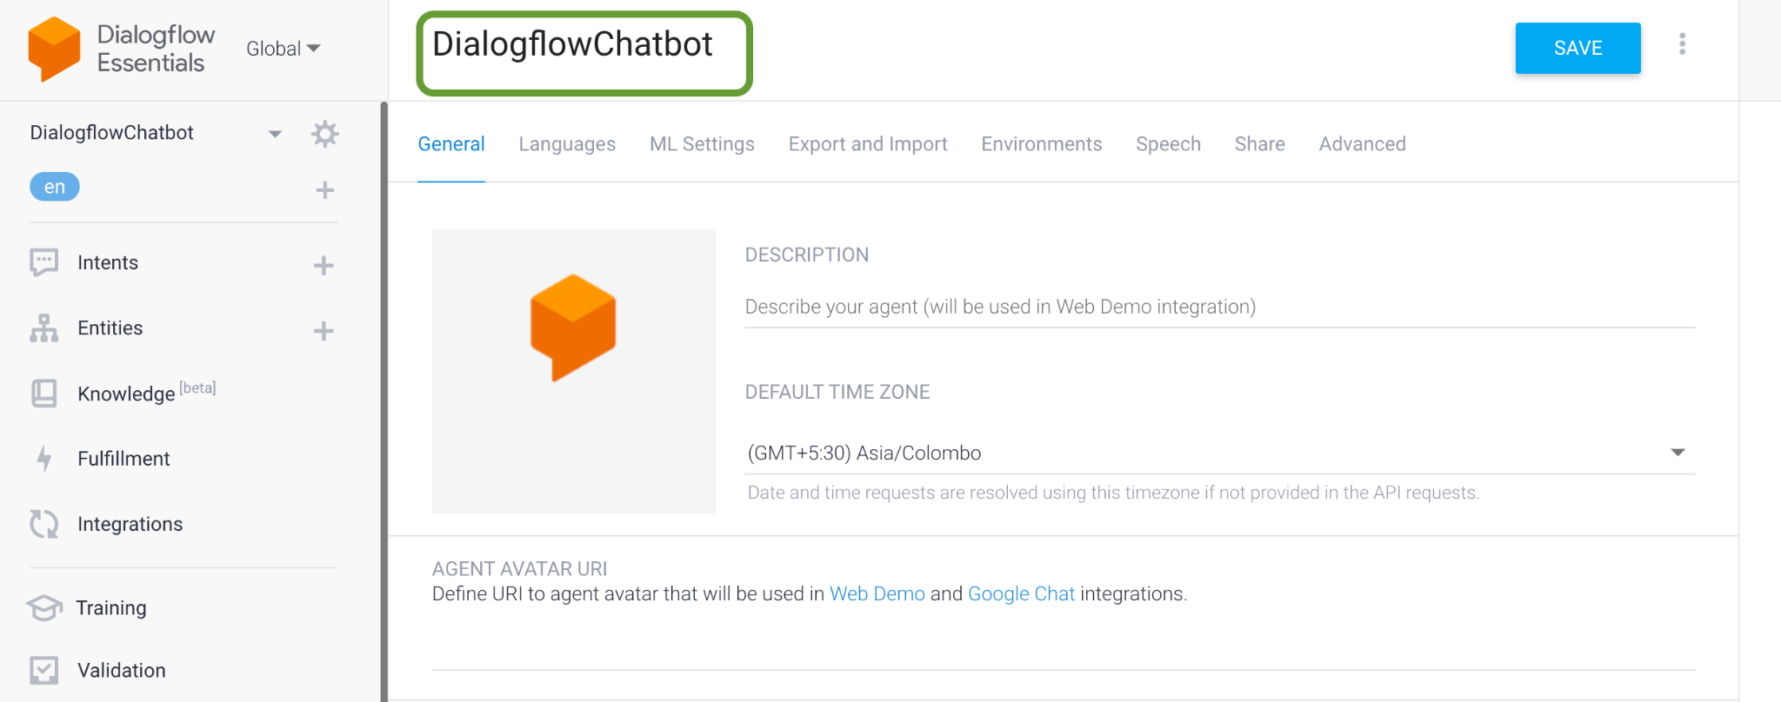

Import the Dialogflow Agent (Bot)
Once you create a new agent (bot), you have to import the bot. To import the bot, follow these steps:
- Open the agent that you created, click Export and Import.
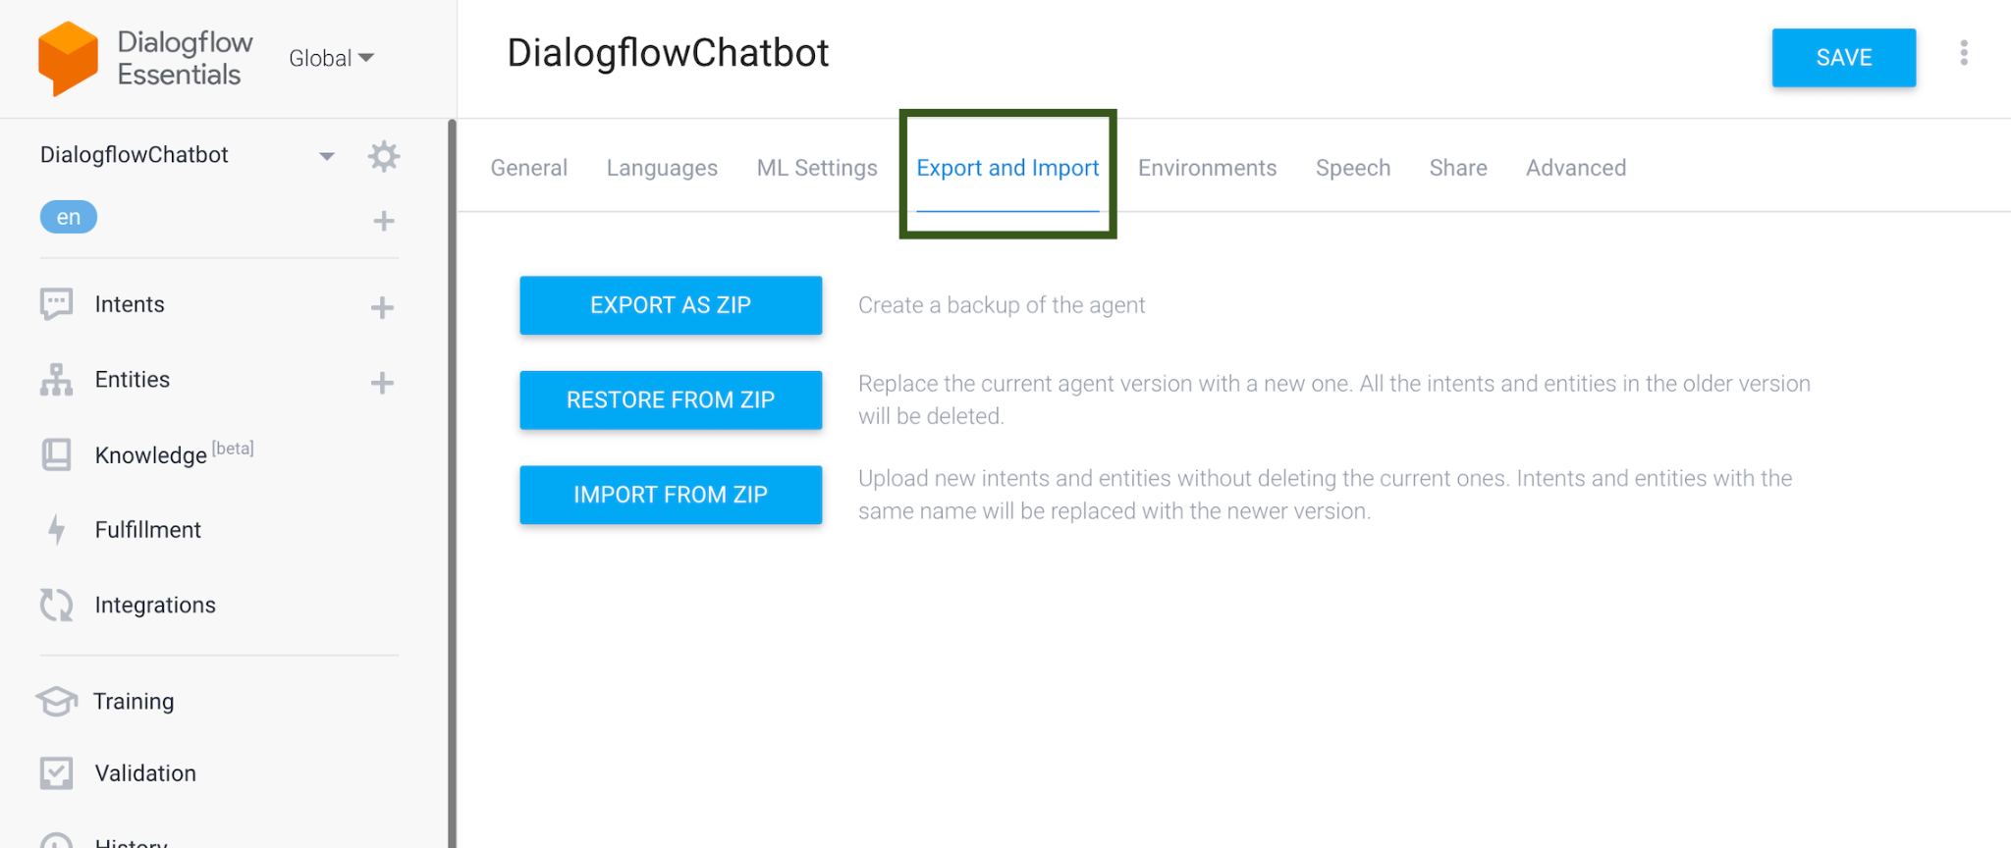
- Click Import from Zip to import your bot to the Dialogflow console.
Note: Before you import the bot to the Dialogflow console, you have to download the exported NLP_VoltmxDxBankingBot_Dialogflow zip file. To download the zip file, click here.
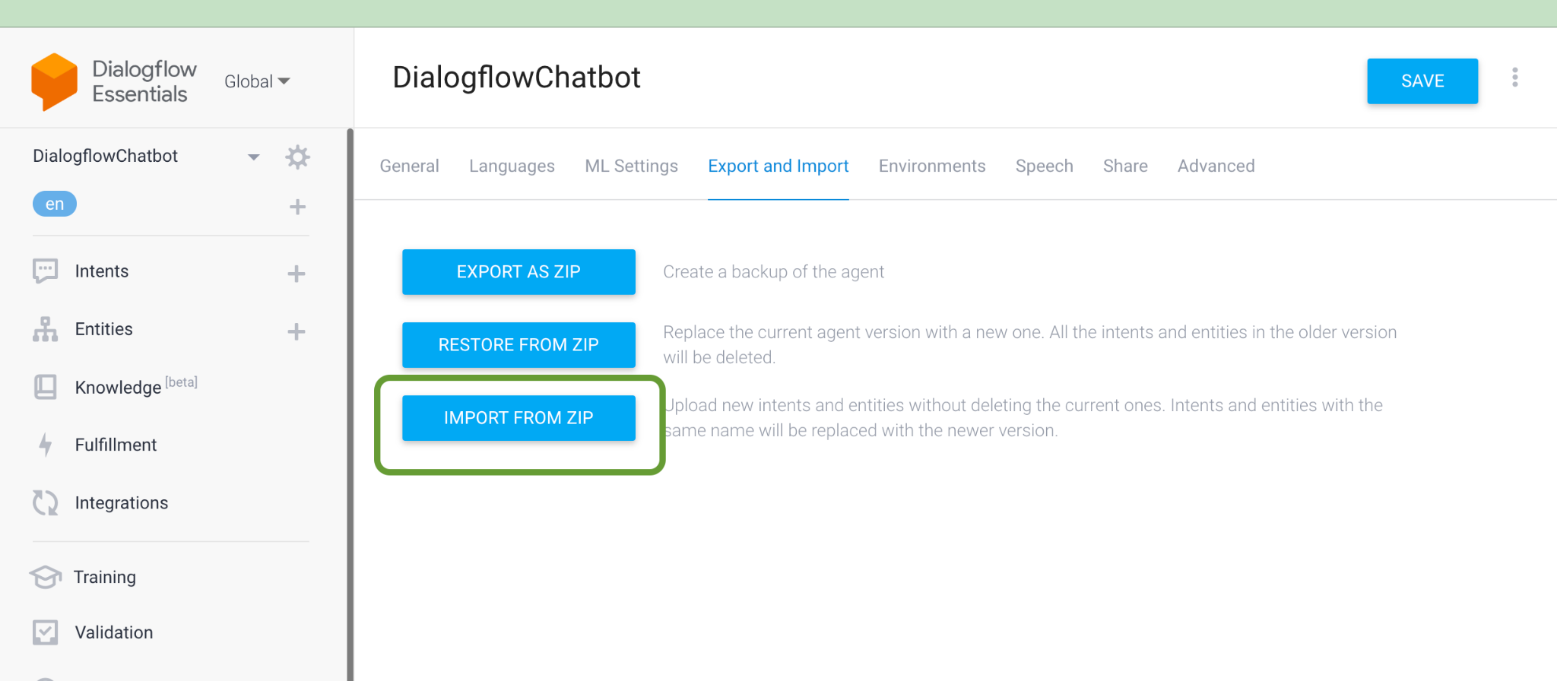
- Click the downloaded NLP bot. The Upload agent dialog box opens.
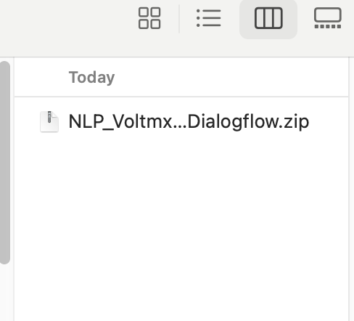

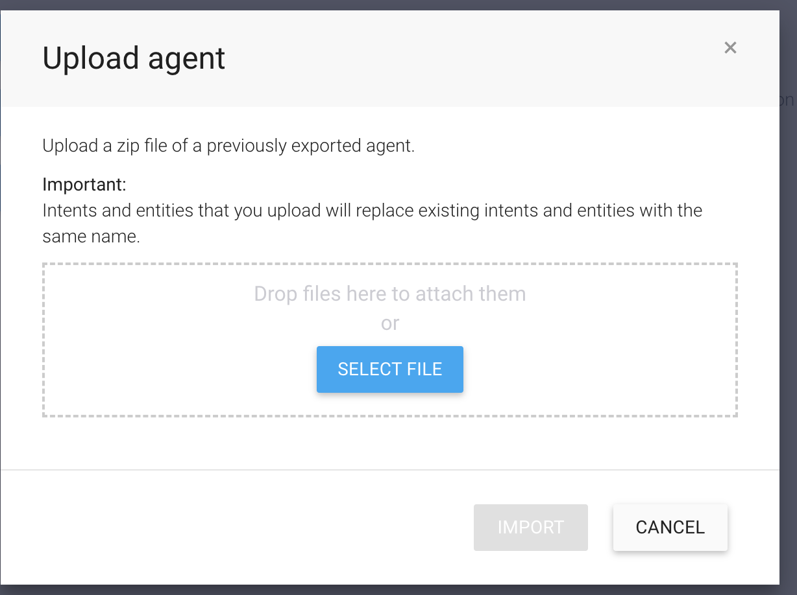
- Type Import in the specified field as shown here, and then click Import.
- Click Done to complete the importing process.
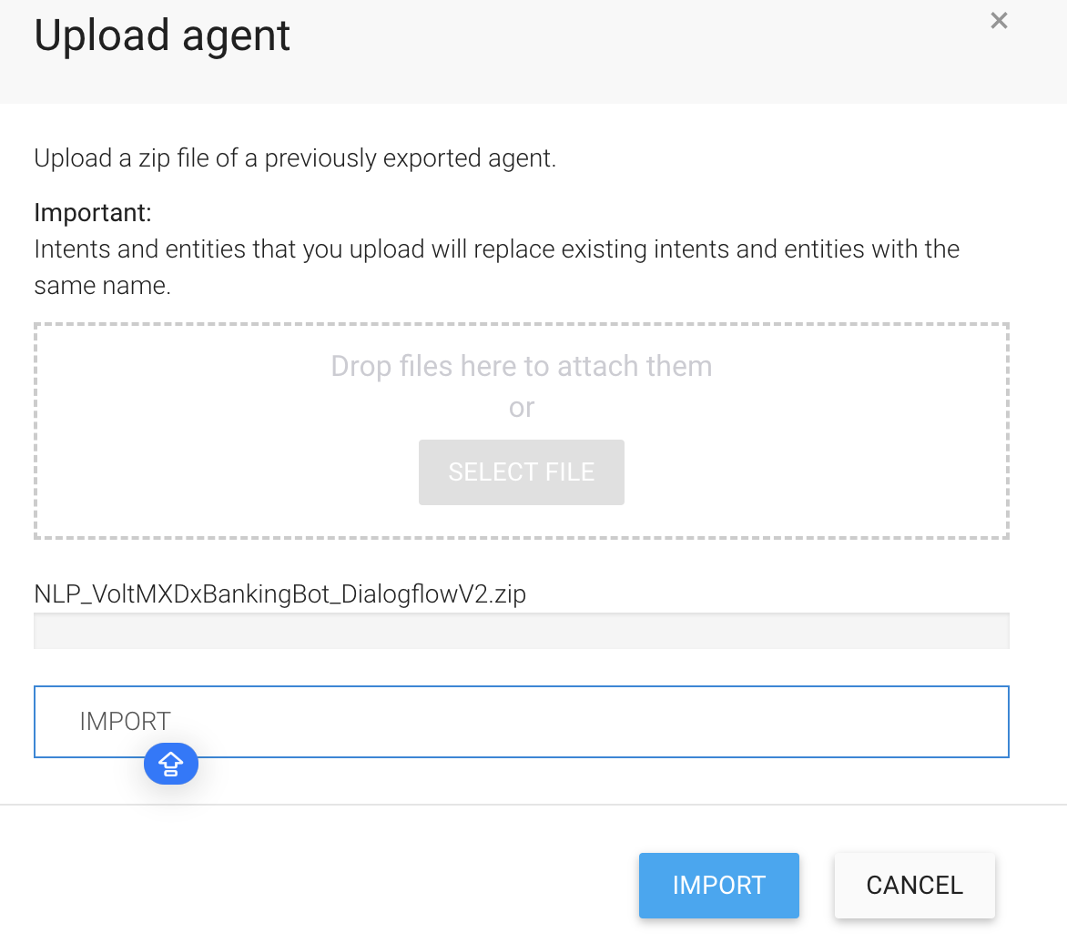
- To Create a Google Service Account and Private Key follow these steps

VoltMX IRIS Setup
To run the chatbot, you have to configure the Iris project as follows:

Set Operation Security Level
When you import the chatbot to your Iris project, the Foundry services of the chatbot are added to the Foundry app, which is associated with the Iris project. While importing the chatbot to your Iris project, if there is no Foundry app associated with the existing Iris project, a new Foundry app is automatically added to your Foundry environment and is associated with your Iris.
To set the Operation Security Level, follow these steps:
- Click the Foundry app associated with your Iris project. The app opens in the Foundry console.
- Under the Configure Services tab, click Integration and then click the voltmxmpBotFramework Integration service.
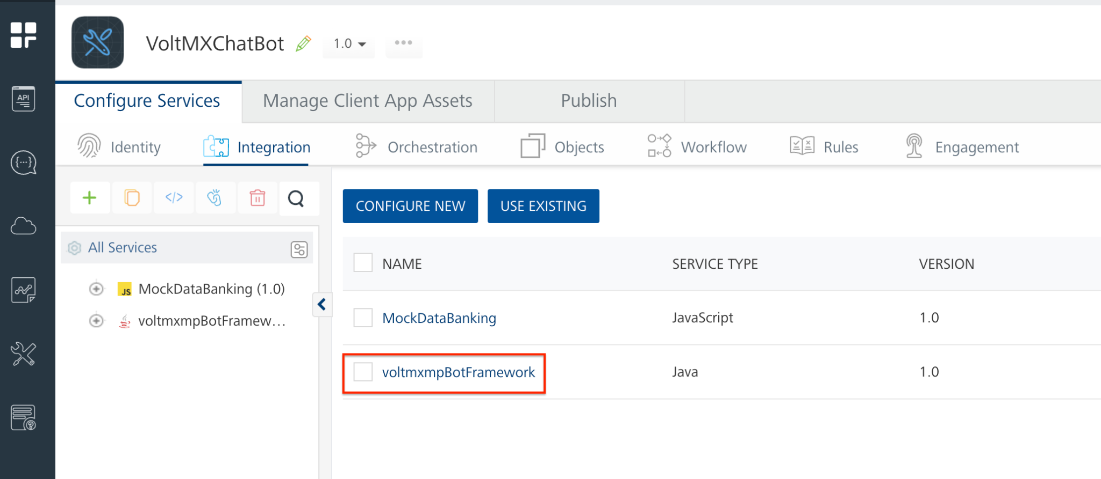
3. On the right pane, expand the voltmxmpBotFramework service and then select the operation
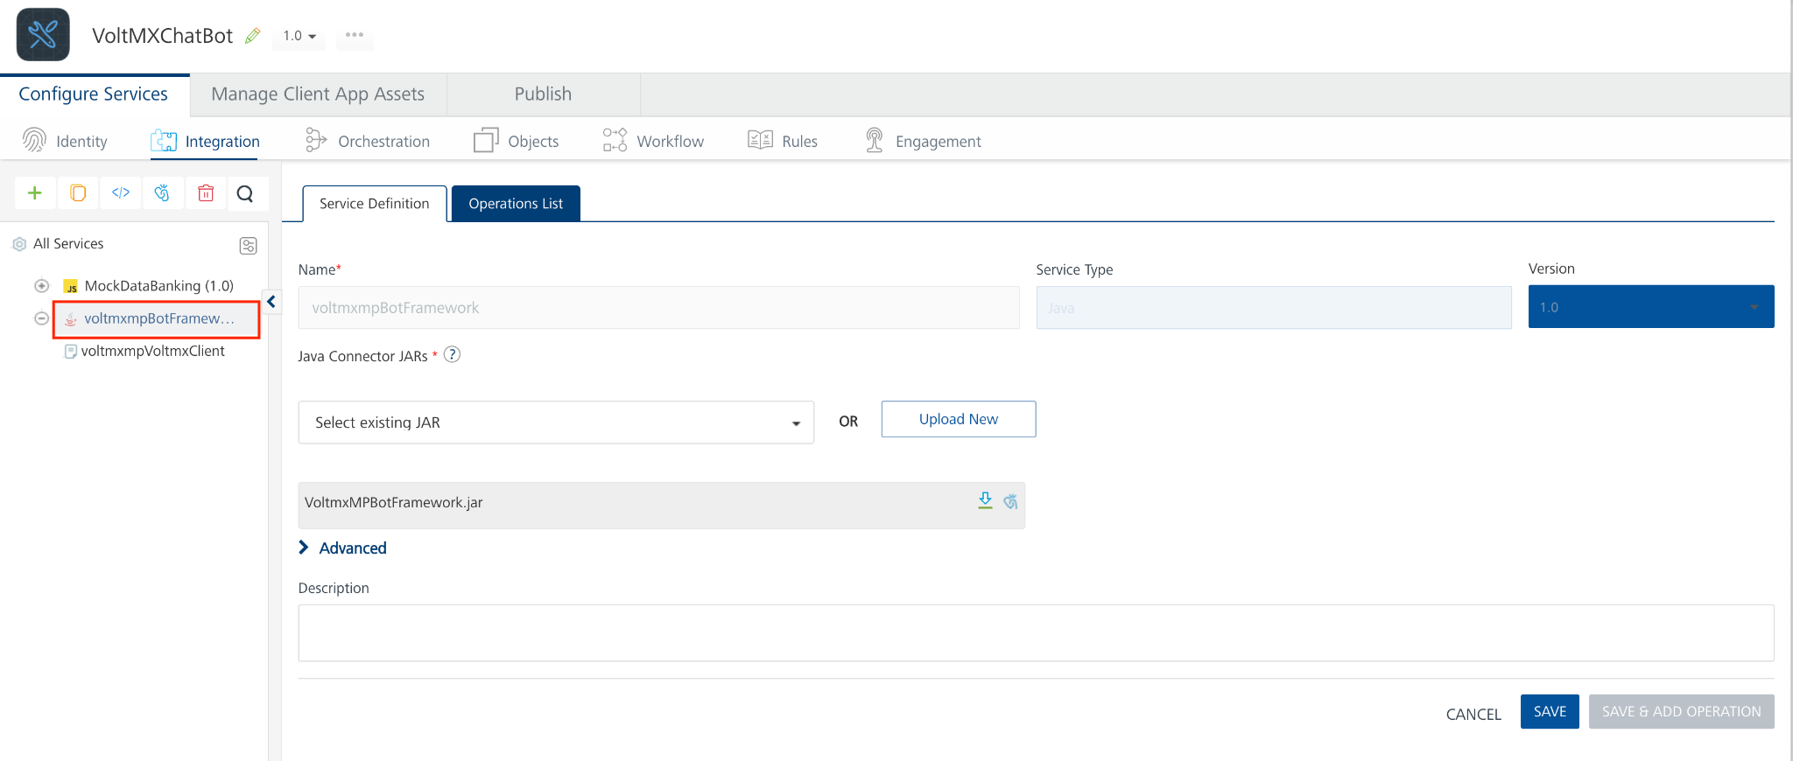
4. For the voltmxmpVoltmxClient operation, you can set the Operation Security Level based on your requirement. By default, the Operation Security Level is set as Authenticated App User, which does not allow you to access the chatbot if your authentication fails. Only if the authentication is successful, you will be able to access the chatbot.
5. You can set the Operation Security Level as Public, if you do not require any authentication for your app. Any individual can then access the app.
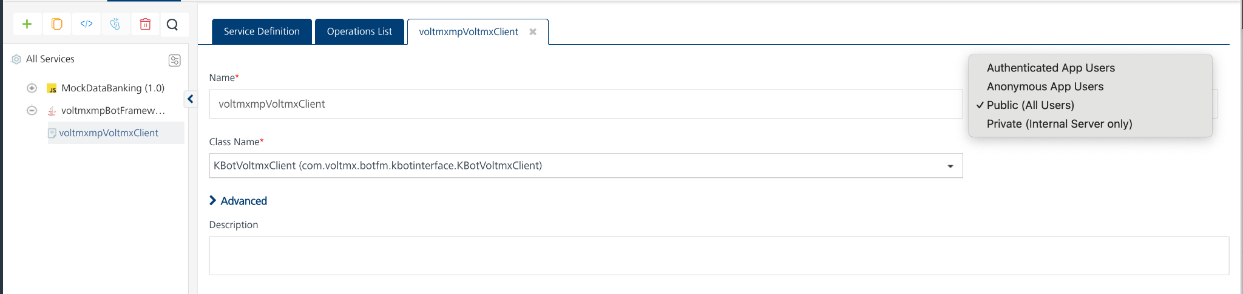
6. Save the operation
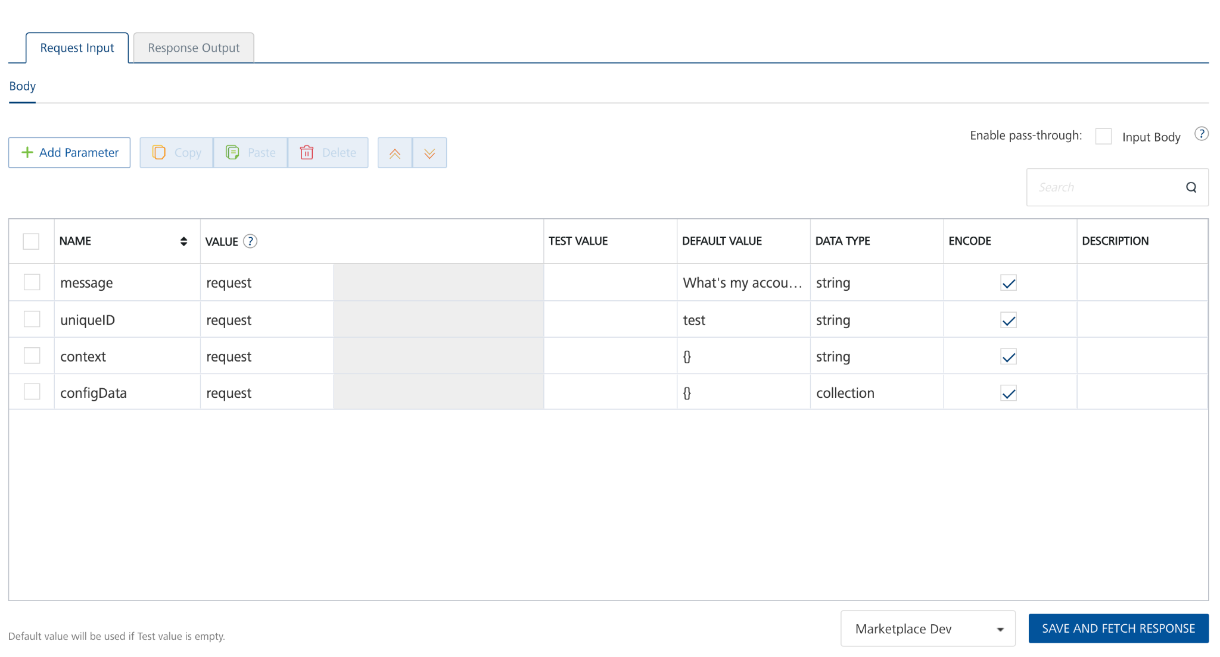

Publish the Foundry App
After you set the Operation Security Level, you must publish the Foundry app. To publish the Foundry app, follow these steps:
- In Foundry, and then click Publish to Foundry to open the Publish page of your Foundry app.
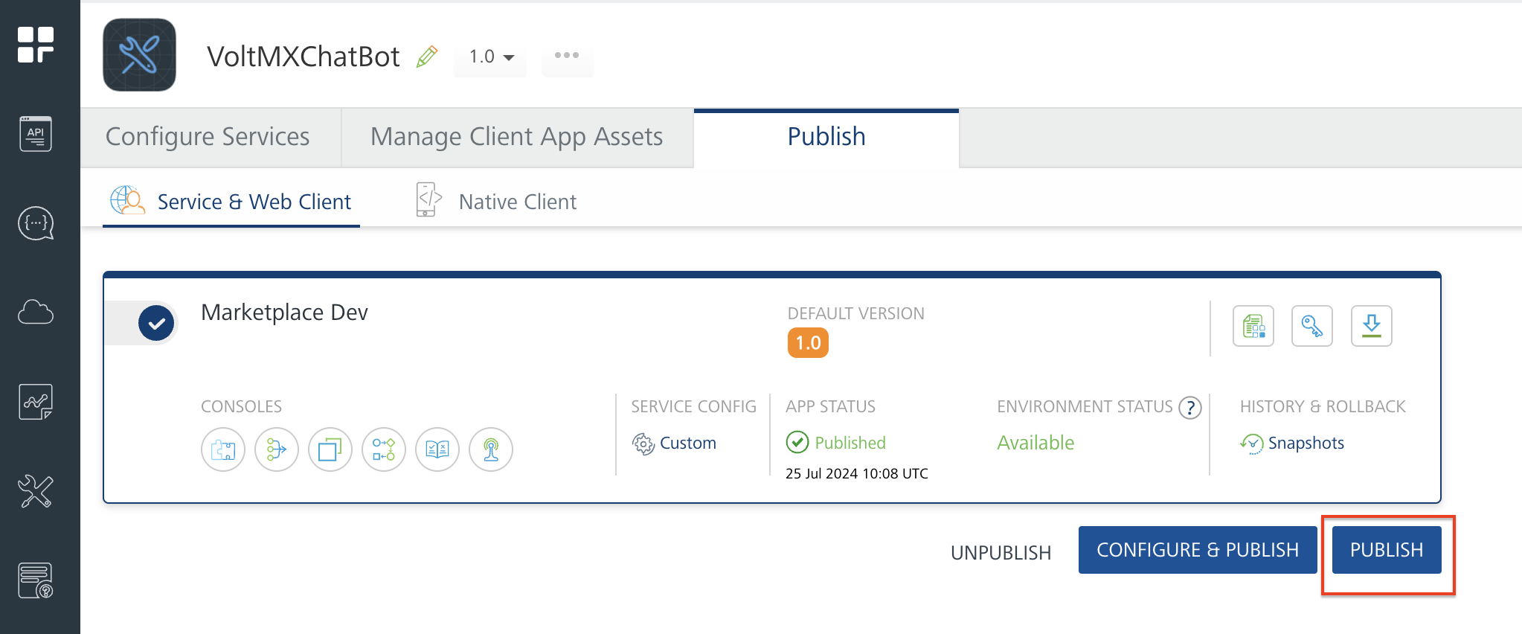
- Select the environment to which you want to publish your app, and then click Publish.

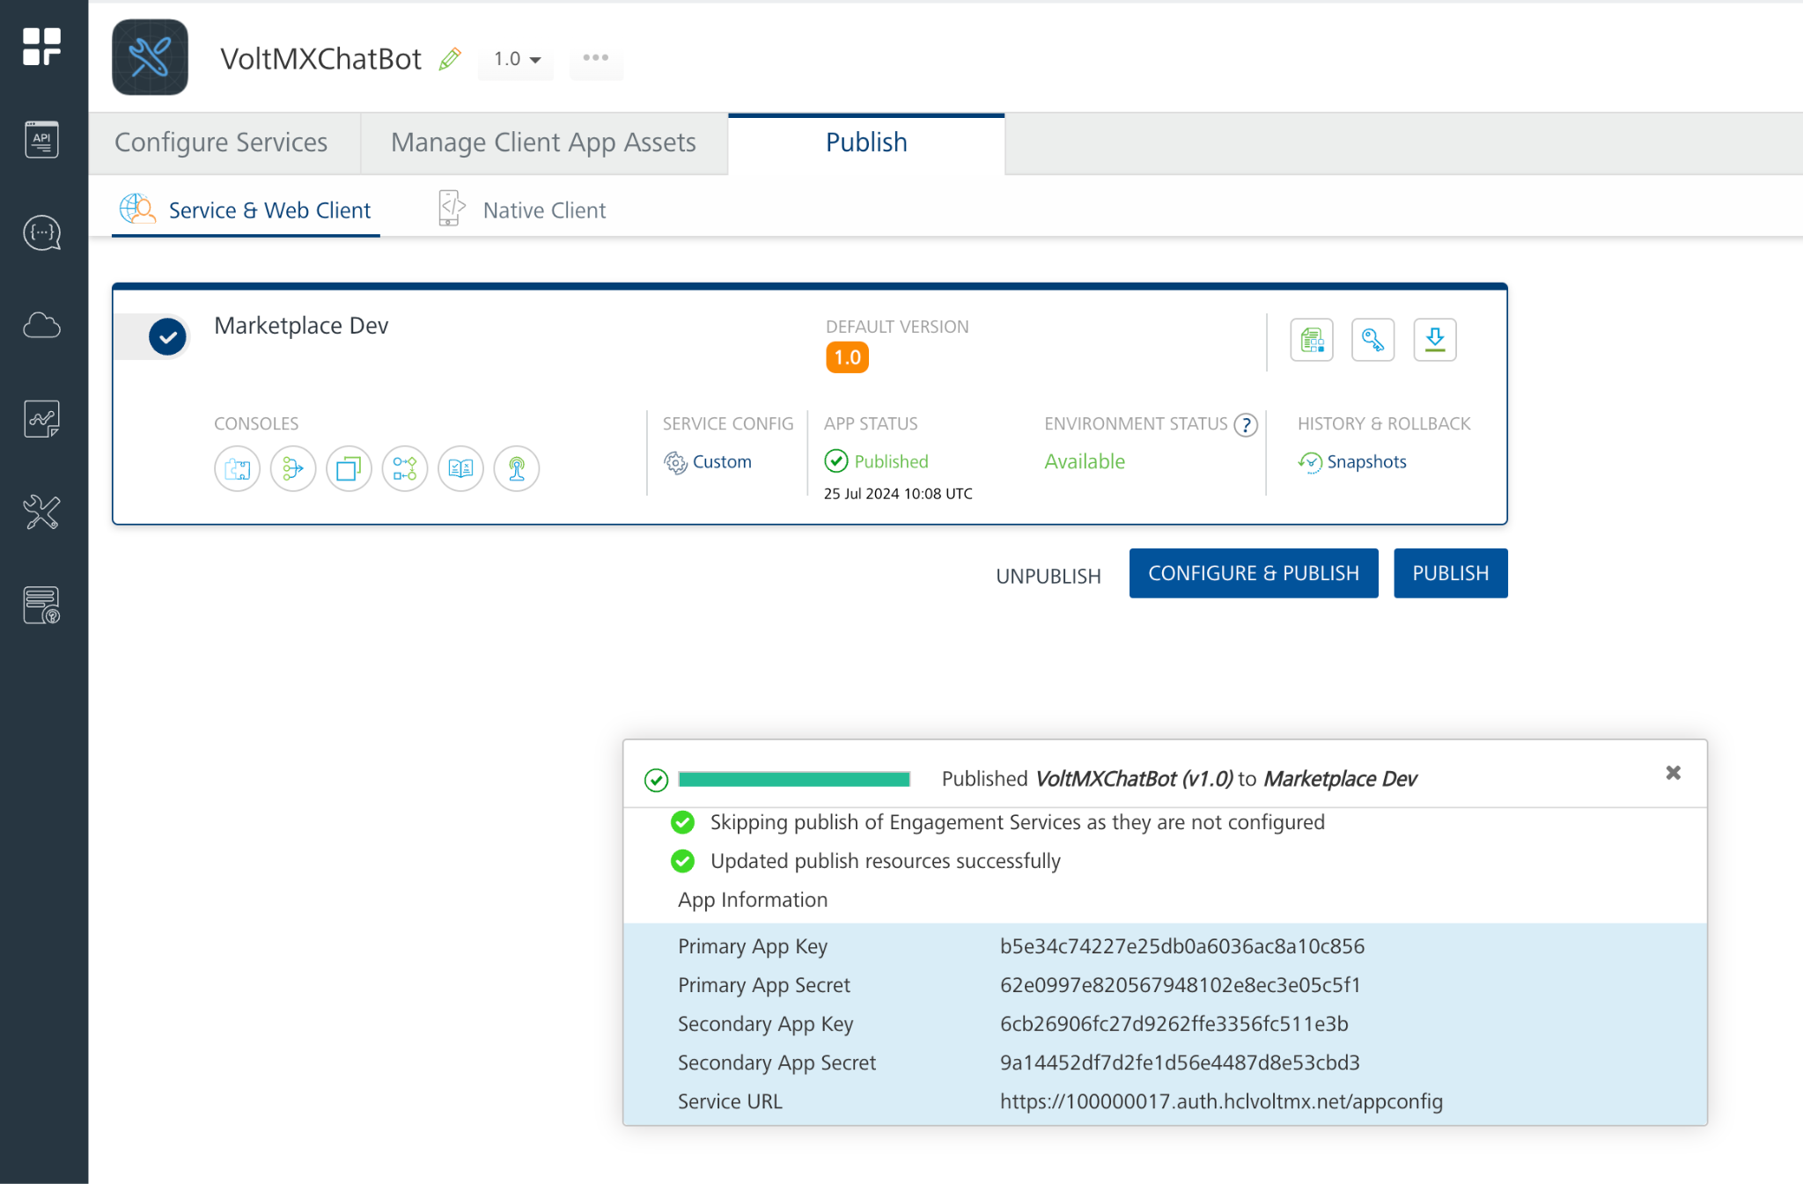

Add NLP Configurations
After publishing your app in the foundry, you must configure the NLP settings. To configure your NLP settings, follow these steps:
- In Iris, On the Project Explorer -> Go to the form that contains the chatbot and then select the chatBot.
- On the Properties panel, click the Action tab, and then go to the Chatbot → nlpConfiguration event. Click Edit.
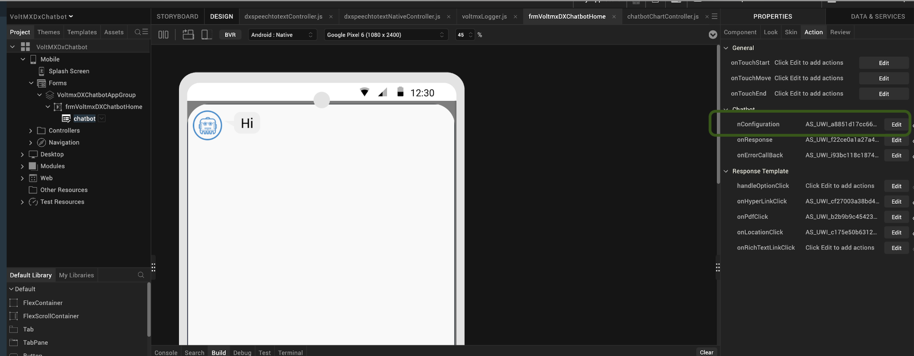
3. Open the Code Snippet attached to the nlpConfiguration event.
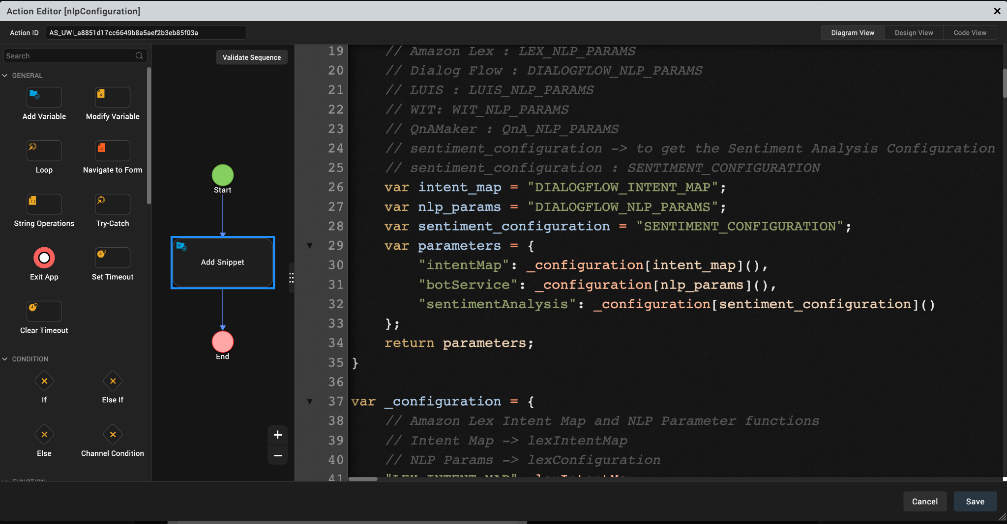

4. In the code snippet, change the values of the intent_map and nlp_params as shown in the given screenshot.
Note: The intent_map and nlp_params should be the same as Foundry NLP Configurations.

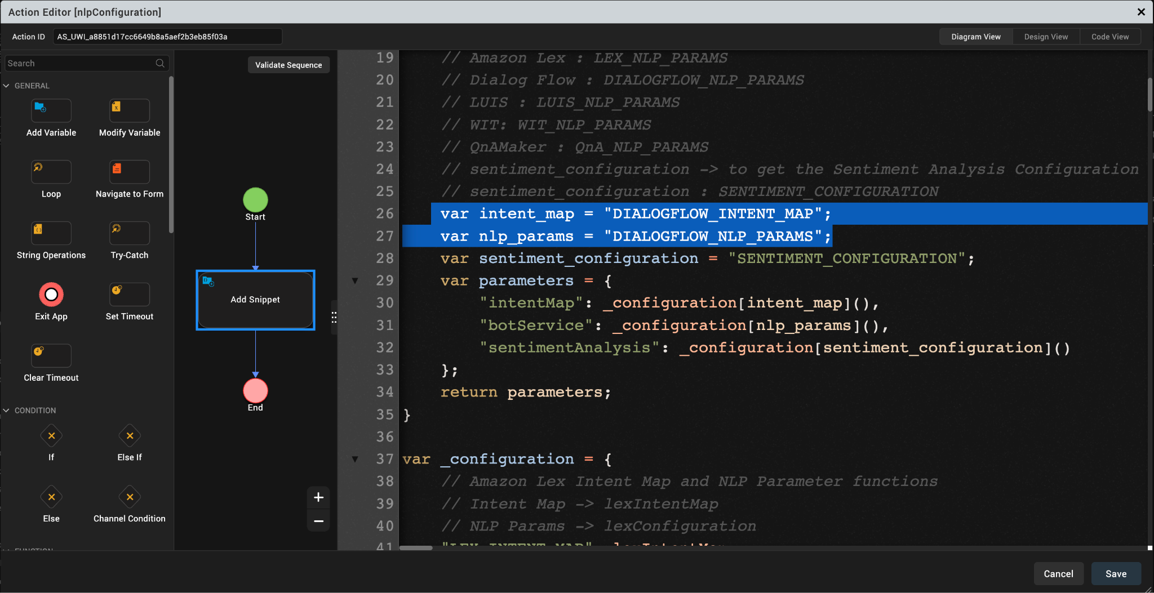

Provide Permissions
Before you build the project, you must provide the necessary permissions for the chatbot to run. The permissions vary based on the platform (Android and iOS). For more information about how to provide the necessary information, refer to the Prerequisites section for Android and iOS on the Reference page.

Refresh the Project

You must refresh the Volt MX Iris project to update the infoplist_configuration.json file. To refresh the project, open Project from the main menu, and then click Refresh.

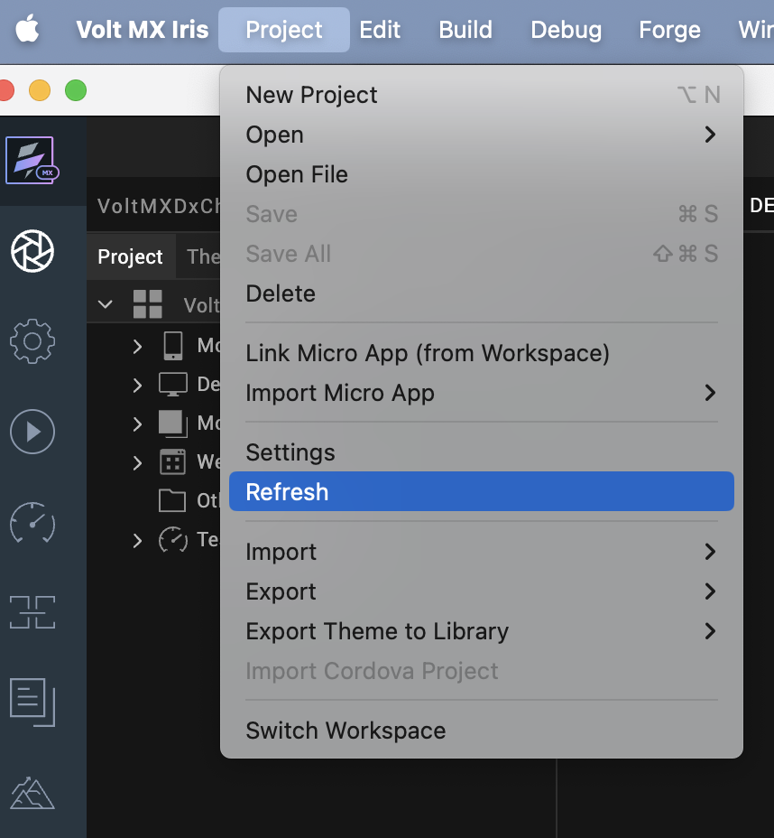

Build the Project
The final step before you run the chatbot, is to build the Iris project. To build your project, follow these steps:
- From the main menu, open Build.
The Build Generation window appears.
- Under Native, select the iOS and Android Mobile platforms, and then click Build.

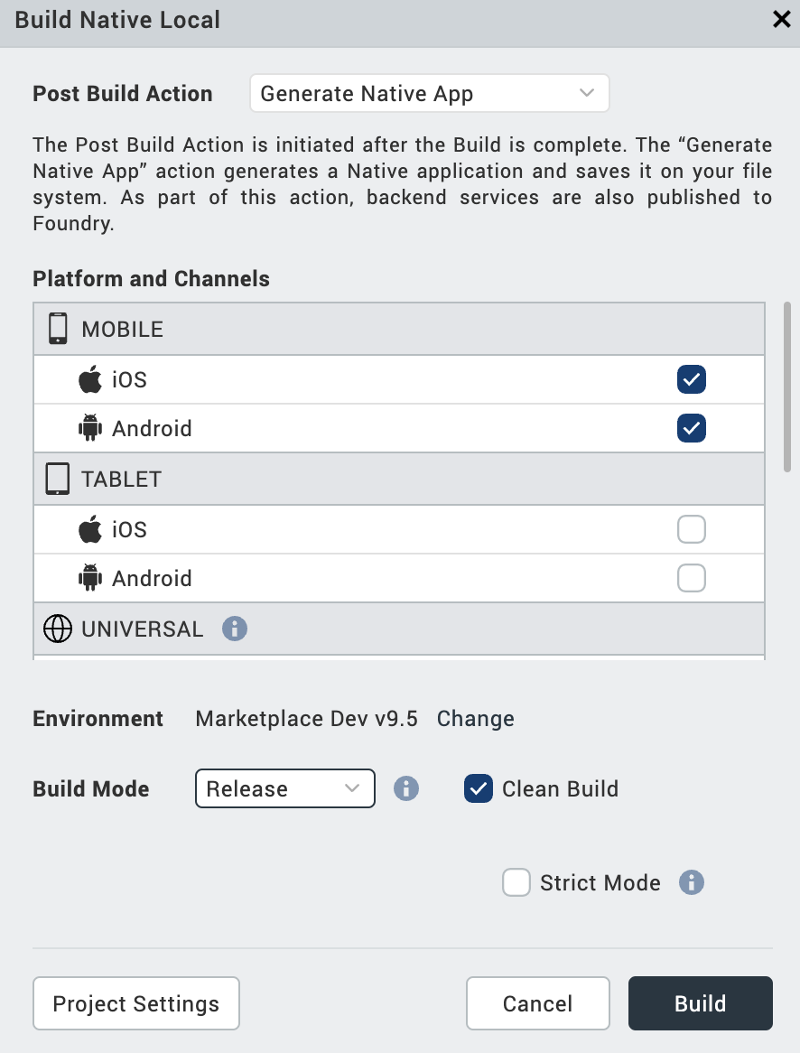
On a successful build, a build confirmation window appears as shown in the following image.
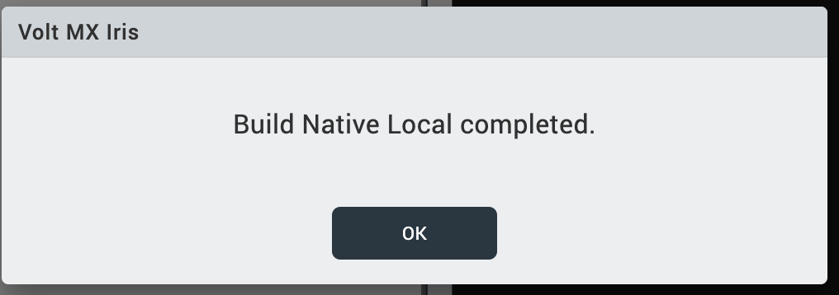

Advanced Setup for Dialogflow

Dialogflow Setup
For information about how to set up Dialogflow, refer Dialogflow Setup.

VoltMX Iris Project Setup
To run the chatbot, you must configure the Volt MX Iris project as follows:
- Configure HCL Foundry
- Publish the HCL Foundry App
- Provide Permissions
- Build the Project
Note: Before you configure your Volt MX Iris project, you must import the chatbot to your Volt MX Iris project. For more information about how to import the chatbot to your Volt MX Iris project, refer to the Import the Project section on the References page.

Configure HCL Foundry
When you import the chatbot to your Volt MX Iris project, the HCL Foundry services of the chatbot are added to the HCL Foundry app, which is associated with the Volt MX Iris project. While importing the chatbot to your Volt MX Iris project, if there is no HCL Foundry app associated with the existing Iris project, a new HCL Foundry app is automatically added to your HCL Foundry environment and is associated with your Volt MX Iris.
- To configure the HCL Foundry app for the chatbot that you imported to your DialogFlow console, follow these steps:
From the Project Explorer on Volt MX Iris, click DATA & SERVICES.
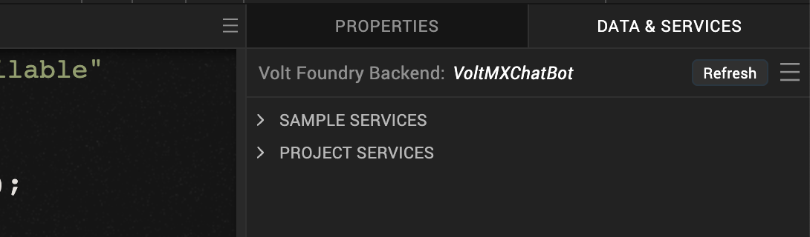
- In the HCL Foundry window, under the Integration tab, expand the service and then select the voltmxmpVoltmxClient operation.
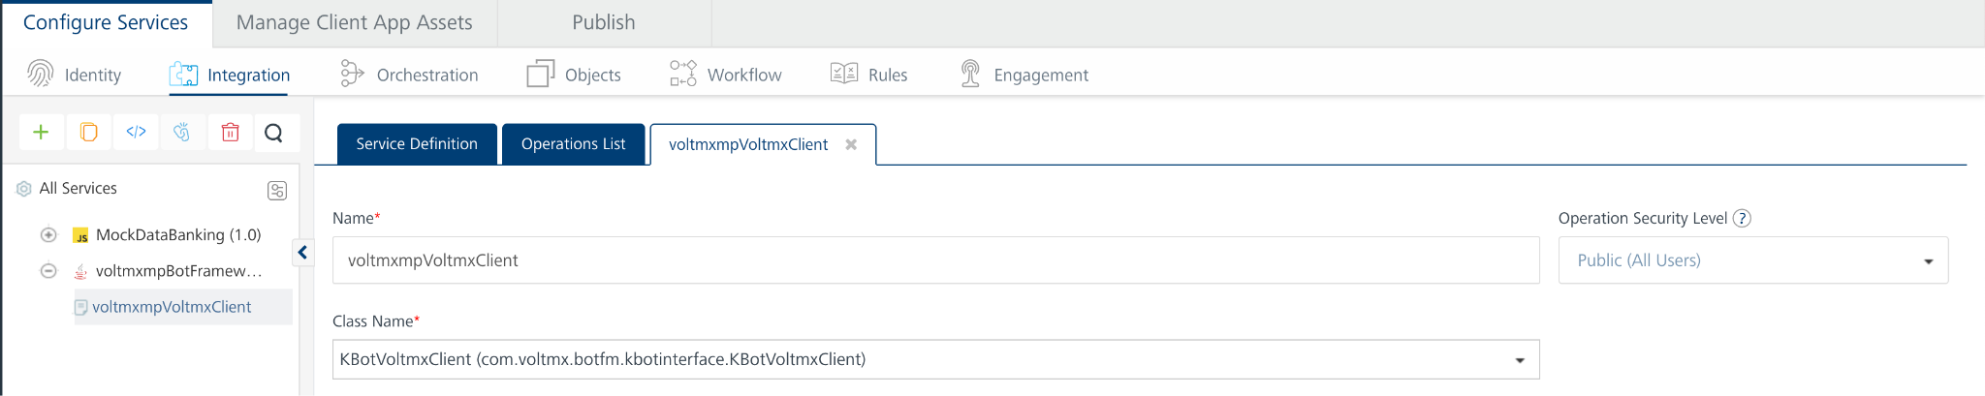
- In the operation configuration, expand the Advanced section.
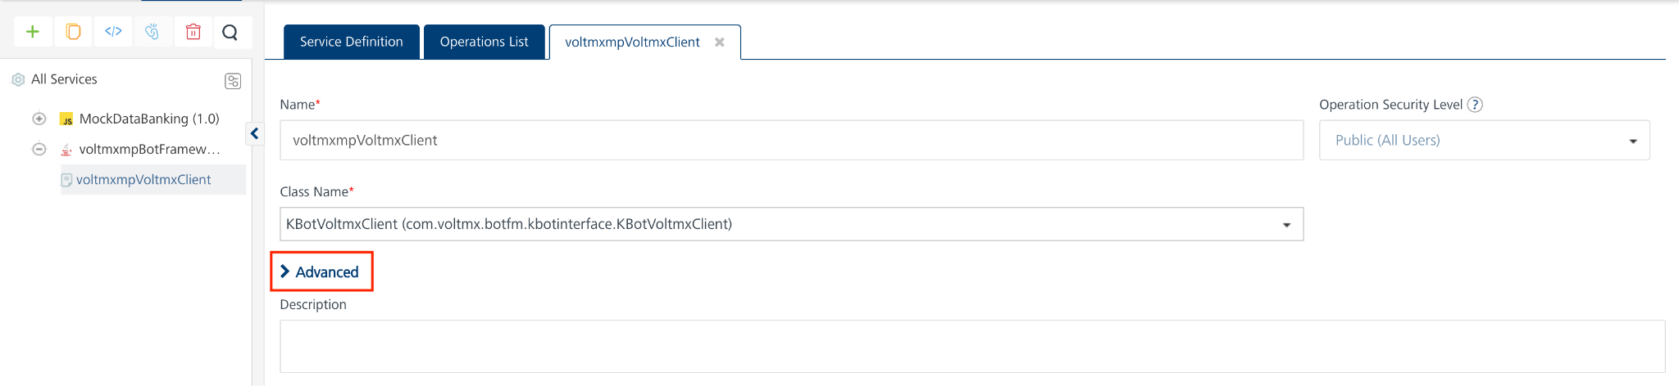
- Under Custom Code Invocation, for Preprocessor, click Expand.
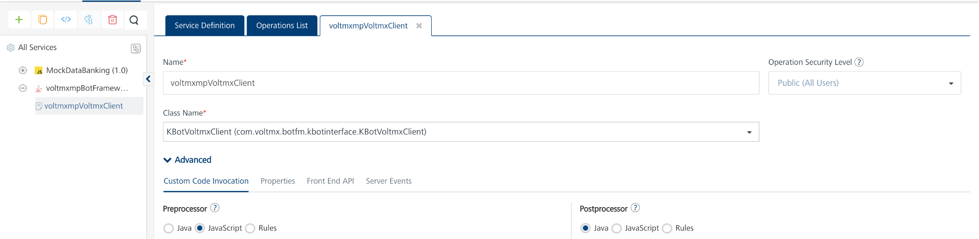
- In the code snippet, change the values of the intent_map and nlp_params as shown in the given screenshot.
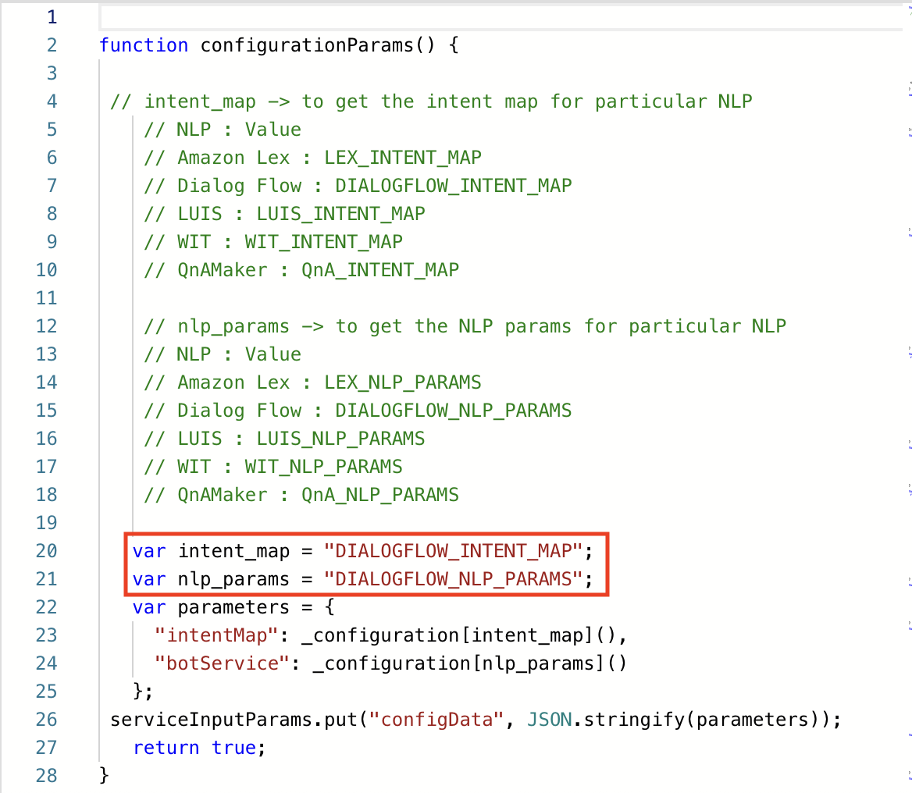

- Remove the multi-line comments from the code and search for the dialogFlowConfiguration method in the code.
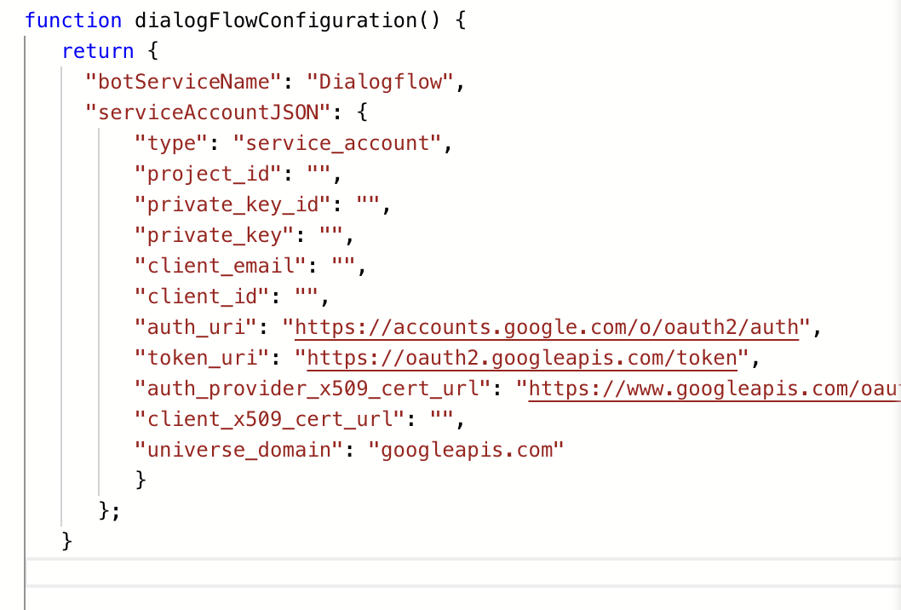

- In the DialogFlowConfiguration method, add the .json file content that we will get from

Create a Google Service Account and Private Key
- GoTo Dialogflow console and go to settings of the project.
- click on GoogleProject.

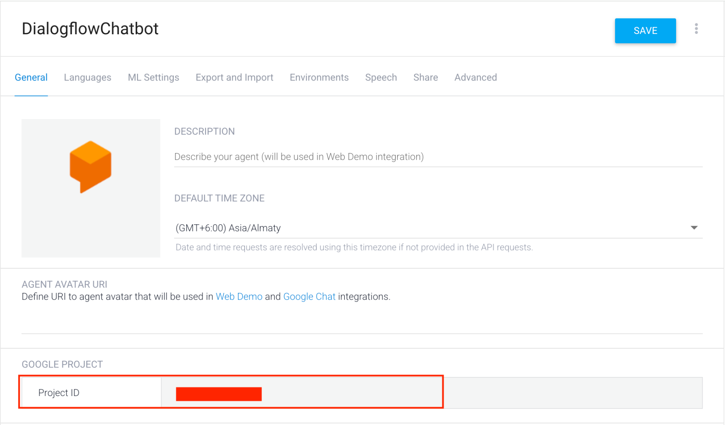
- Click on GoogleProject and goto ServiceAccounts
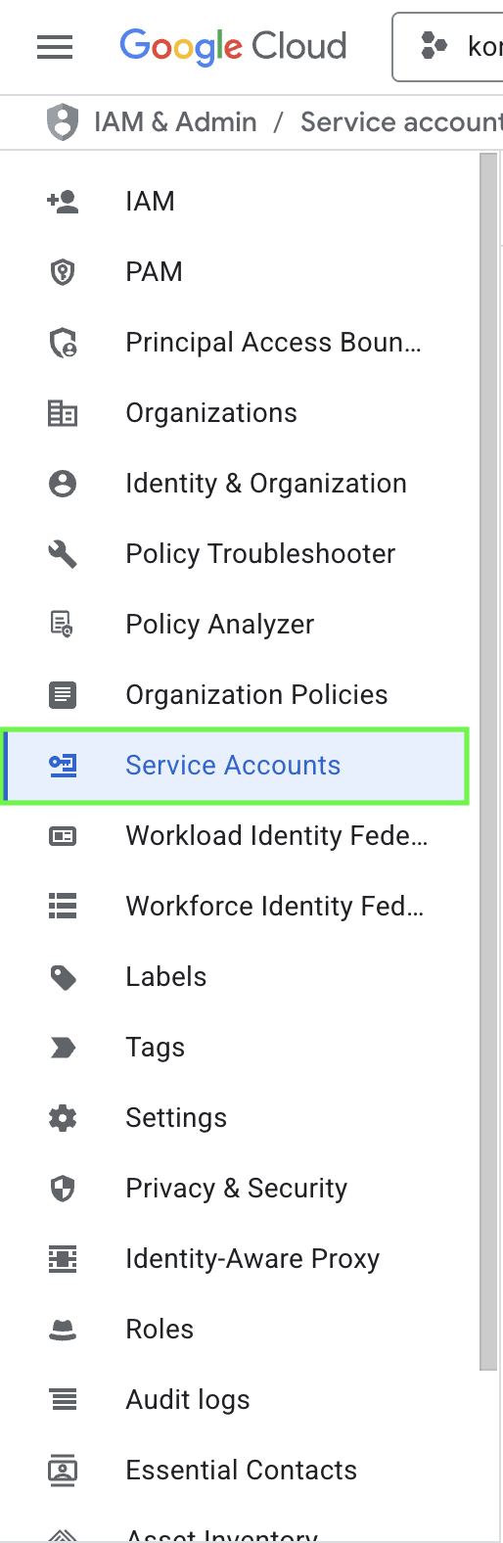
- Click on three dots at the end.

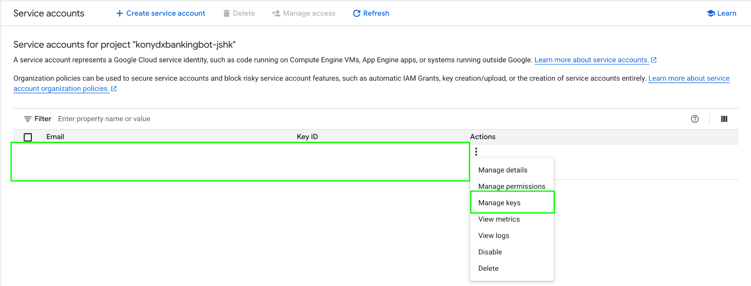
- Click on Manage Keys and ADD KEY
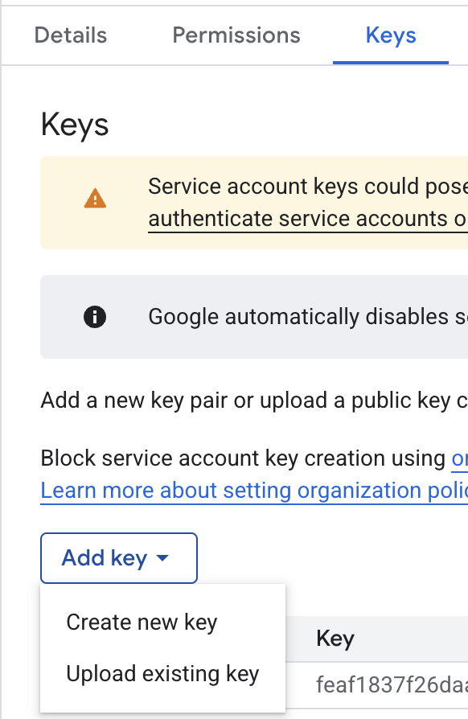
- Now, Click on Create new key and select type as .JSON file

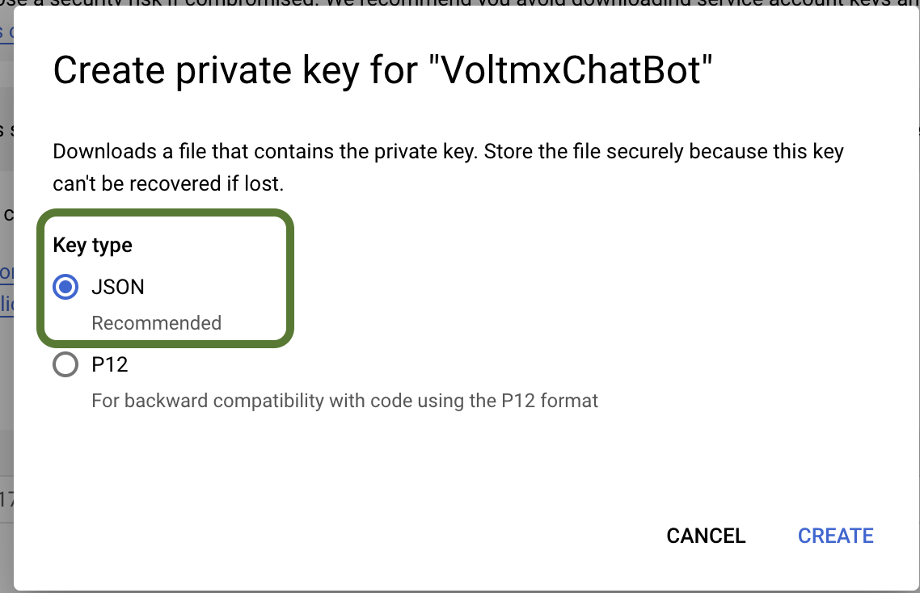
- when you click on the create button it will download the json file.
- Copy the contents of the .json file and add under the steps mentioned in point6.

8. Save the operation.

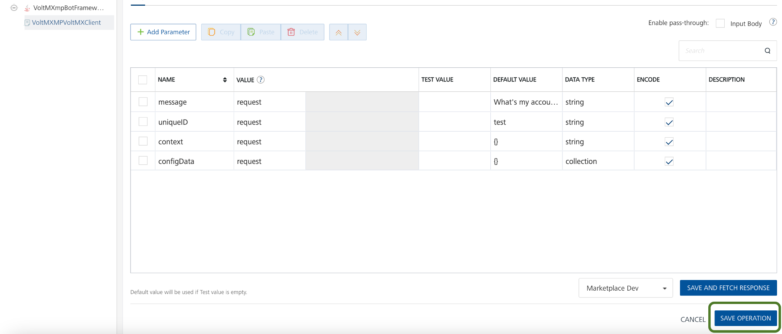

Publish the HCL Foundry App
For information about how to publish the HCL Foundry app, refer to the Publishing the HCL Foundry App section.

Provide Permissions
Before you build the project, you must provide the necessary permissions for the chatbot to run. The permissions vary based on the platform (Android and iOS). For more information about how to provide the necessary information, refer to the Prerequisites section for Android and iOS on the Reference page.

Build the Project
For information about how to build the app, refer to the Build the Project section.

SET UP THE CHATBOT - WIT.AI

Basic Setup

Wit.ai Bot Setup
Set up the Natural Language Processing (NLP) bot in the Wit.ai Console to run your chatbot. To set up the NLP bot, follow these steps:
Note: To download the exported NLP_VoltmxDxBankingBot_Wit zip file, click here.
- Import the Chatbot
- Configure the Chatbot App

Import the Chatbot App
To import the chatbot to your Wit.ai console, follow these steps:
- Sign in to Wit.ai Console, and then open your account. Create an account if you do not already have one.
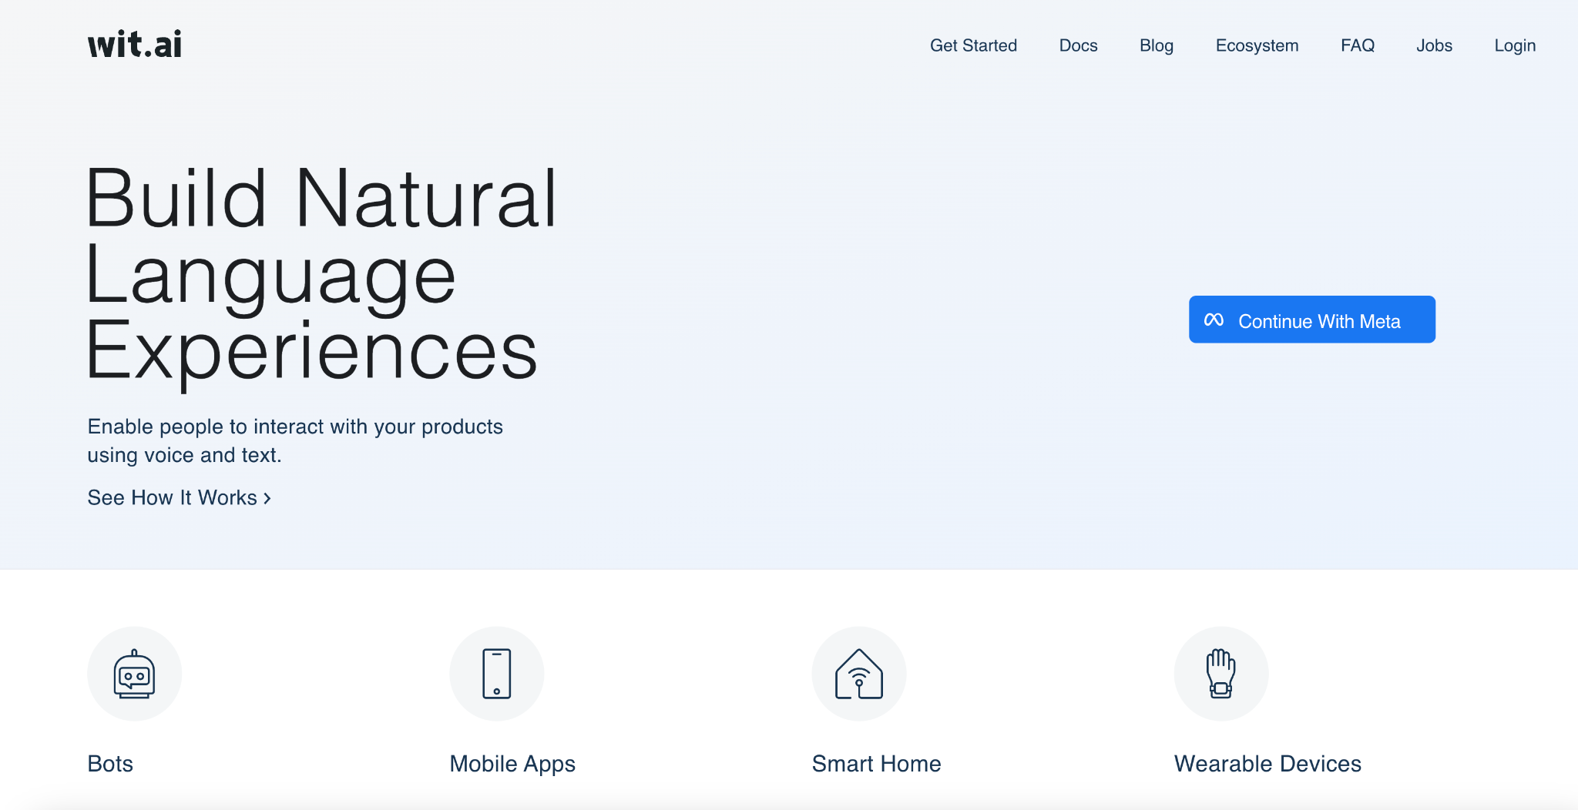
- Click the + New App icon to create a new app.
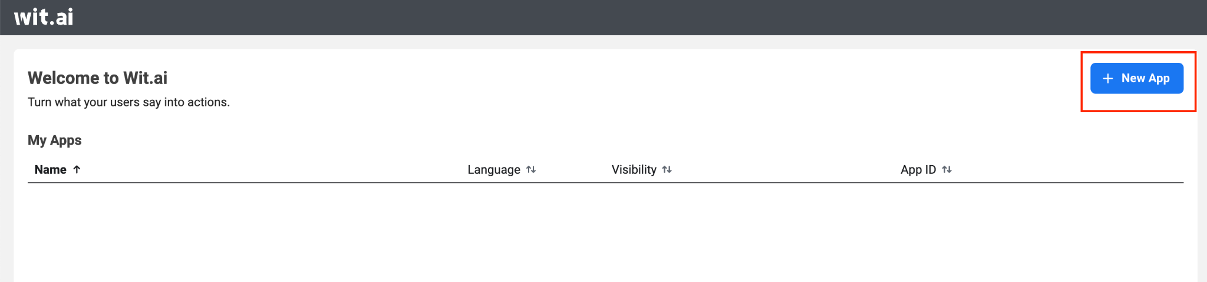
- Type the name and select the language of the app, and then click Browse.
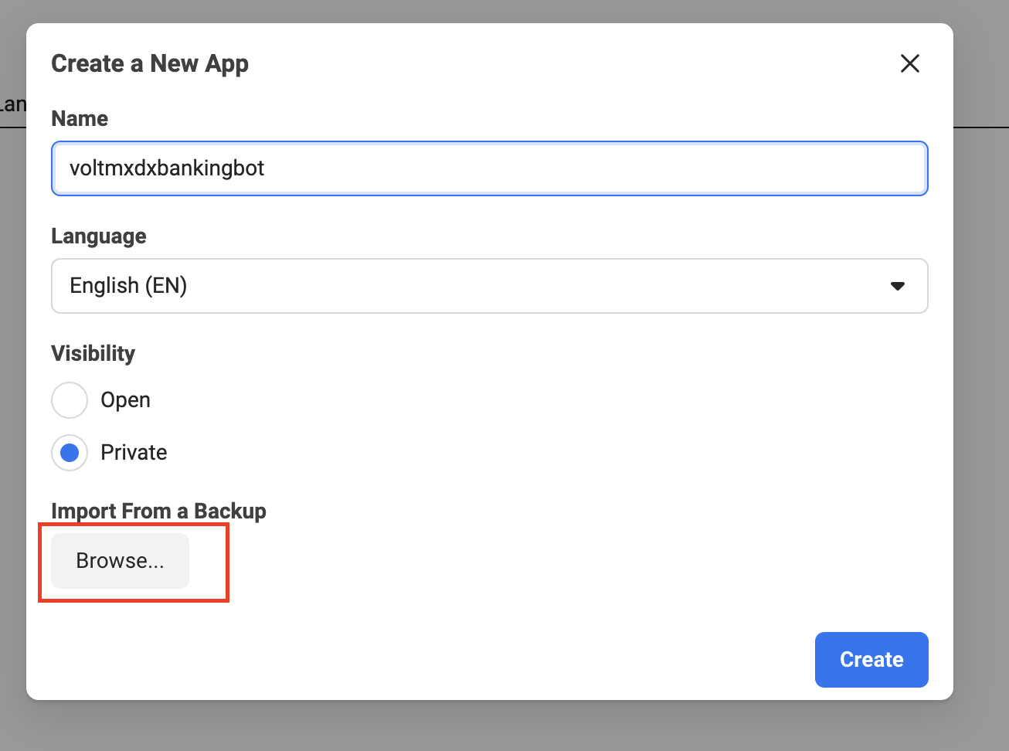
- Select the zip file that you have downloaded, and then click Choose.
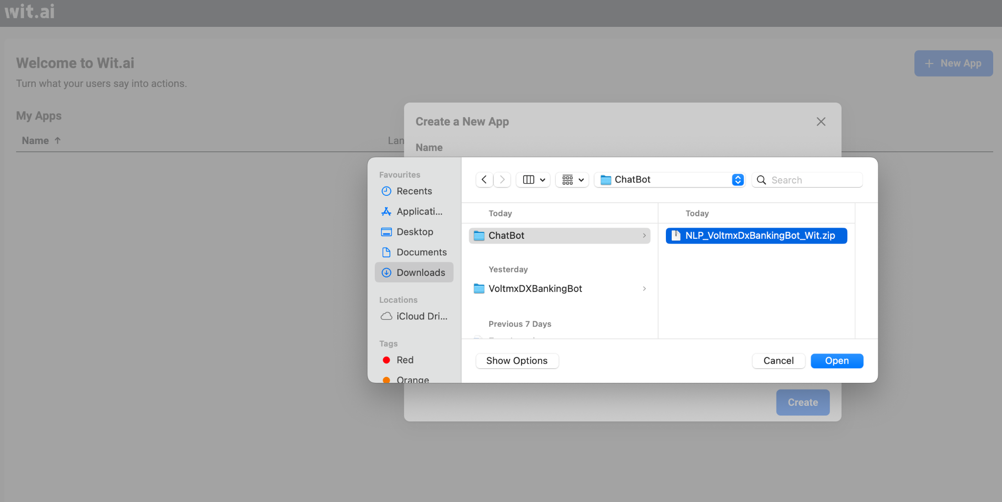
- Click Create app to create the chatbot app.
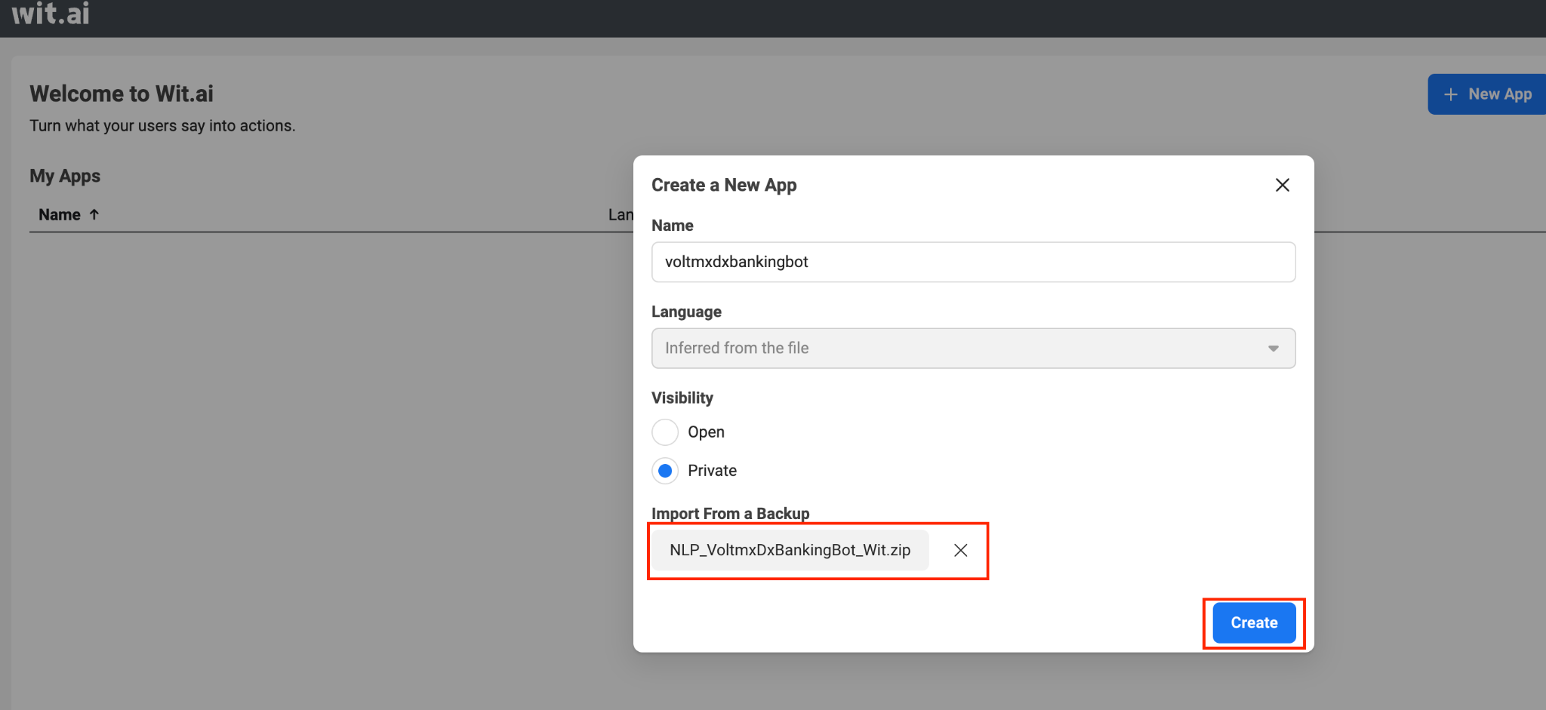

Configure the Chatbot App
After you have created the chatbot app, perform the following configurations:
- Click Settings.
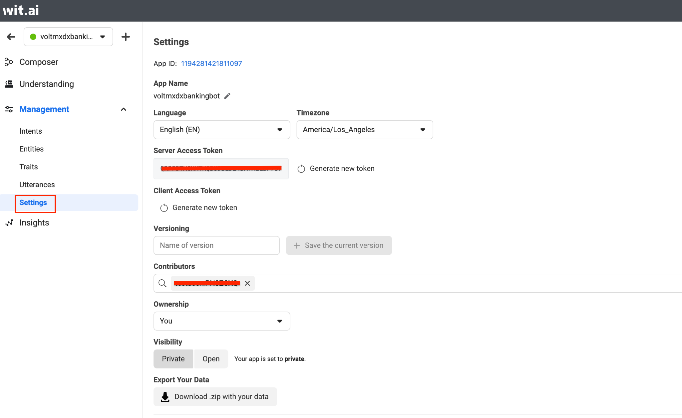

Copy the Server Access Token to your clipboard.
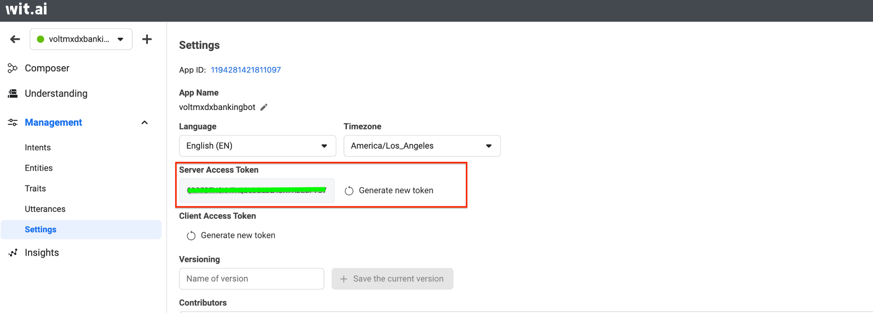
- Click the Understanding tab, and then reload the page. The status of the app changes to Done.
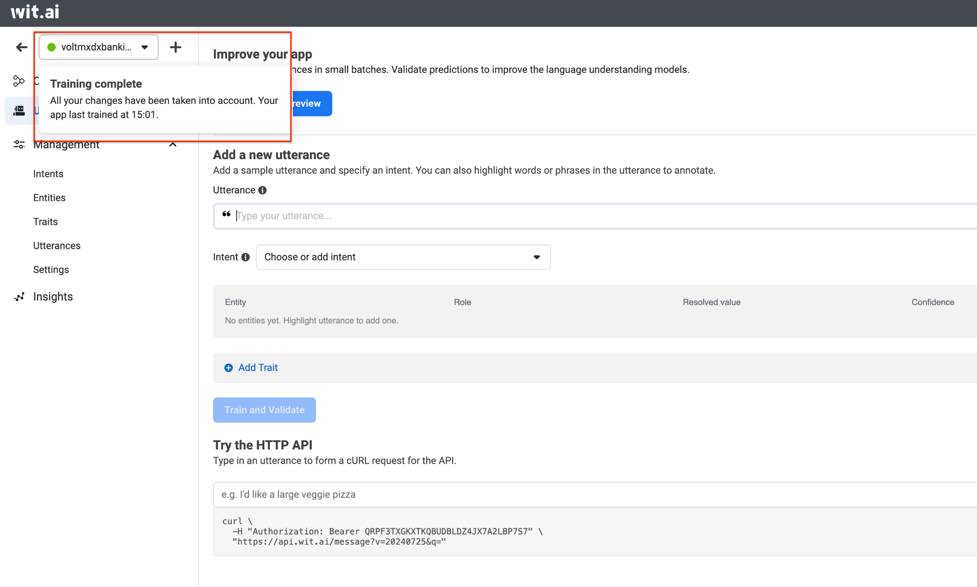
You can now test your bot by typing a sentence under Add a new utterance.
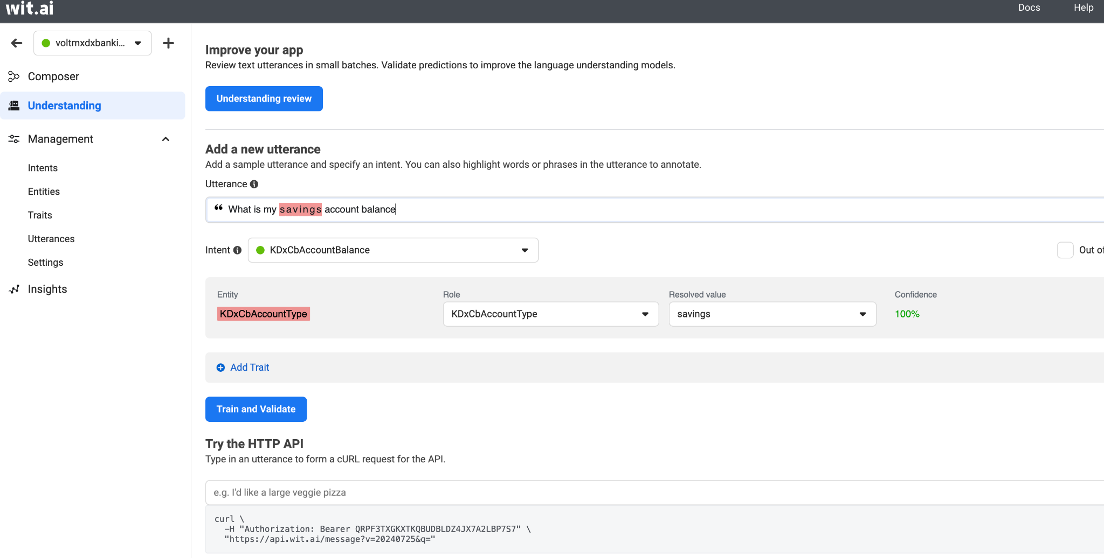

Volt MX Iris Project Setup
To run the chatbot, you have to configure the Volt MX Iris project as follows:
- Set Operation Security Level
- Publish the HCL Volt MX Foundry App
- Add NLP Configurations
- Provide Permissions
- Refresh the Project
Note: Before you configure your Volt MX Iris project, ensure that you have imported the chatbot to your Volt MX Iris Project. For more information about how to import the chatbot to your Volt MX Iris project, refer to the Import the Project section on the References page.

Set Operation Security Level
When you import the chatbot to your Volt MX Iris project, the HCL Volt MX Foundry services of the chatbot are added to the HCL Volt MX Foundry app, which is associated with the Volt MX Iris project. While importing the chatbot to your Volt MX Iris project, if there is no HCL Volt MX Foundry app associated with the existing Volt MX Iris project, a new HCL Volt MX Foundry app is automatically added to your HCL Volt MX Foundry environment and is associated with your Volt MX Iris.
To set the Operation Security Level, follow these steps:
- Click the HCL Volt MX Foundry app associated with your Volt MX Iris project from the Project Explorer. Click DATA & SERVICES
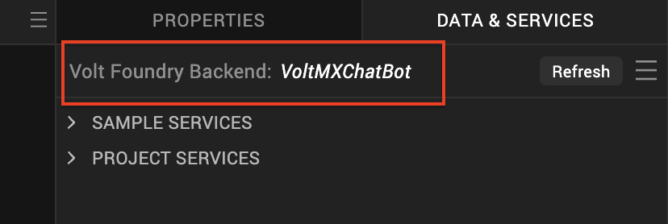
- Under the Configure Services tab, click Integration and then click the voltmxmpBotFramework Integration service.

- On the right pane, expand the voltmxmpBotFramework service and then select the voltmxmpVoltmxClient operation.
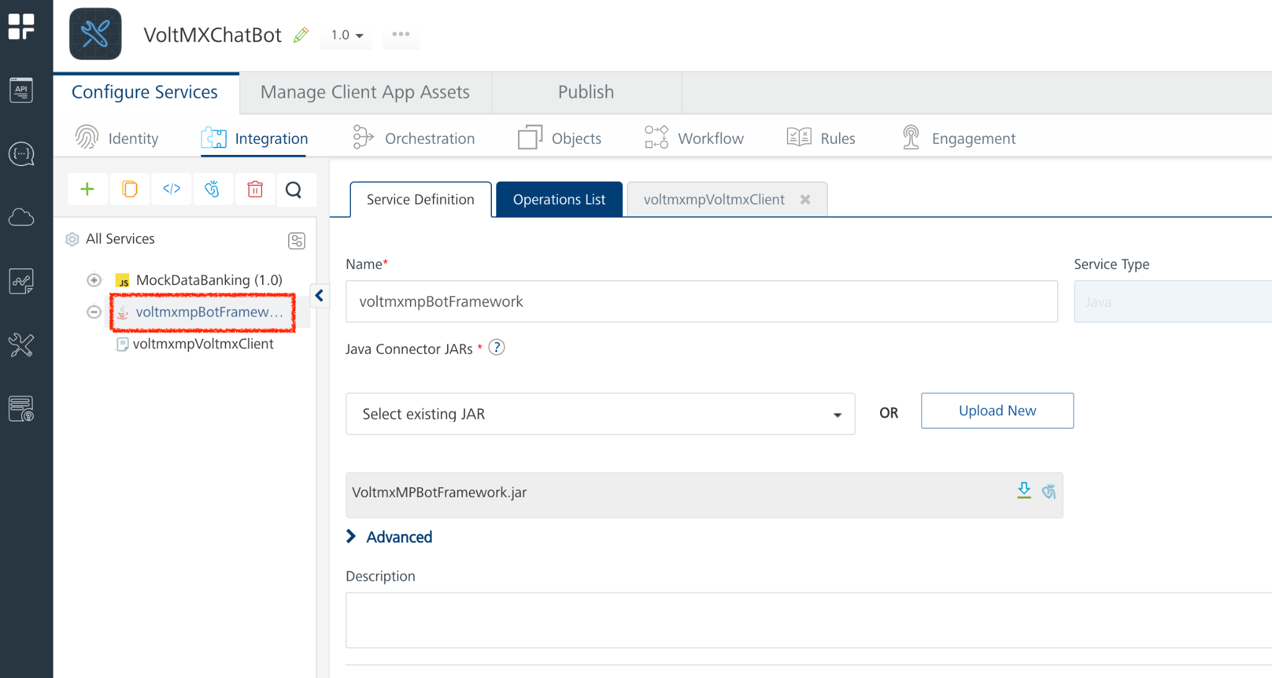

- For the voltmxmpVoltmxClient operation, you can set the Operation Security Level based on your requirement. By default, the Operation Security Level is set as Authenticated App Users, which does not allow you to access the chatbot if your authentication fails. Only if the authentication is successful, you will be able to access the chatbot.
- You can set the Operation Security Level as Public, if you do not require any authentication for your app. Any individual can then access the app.
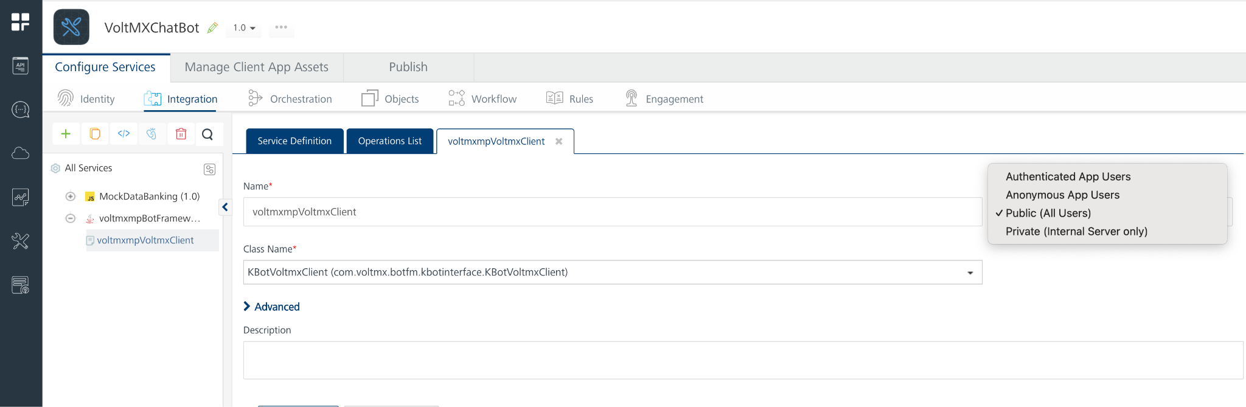
Note: For your convenience, set the Operation Security Level as Public. If you set the Operation Security Level as Authenticated App User, ensure that you configure the credentials in the Identity service of your app.
- Save the operation, and then click the icon to go back to Volt MX Iris.
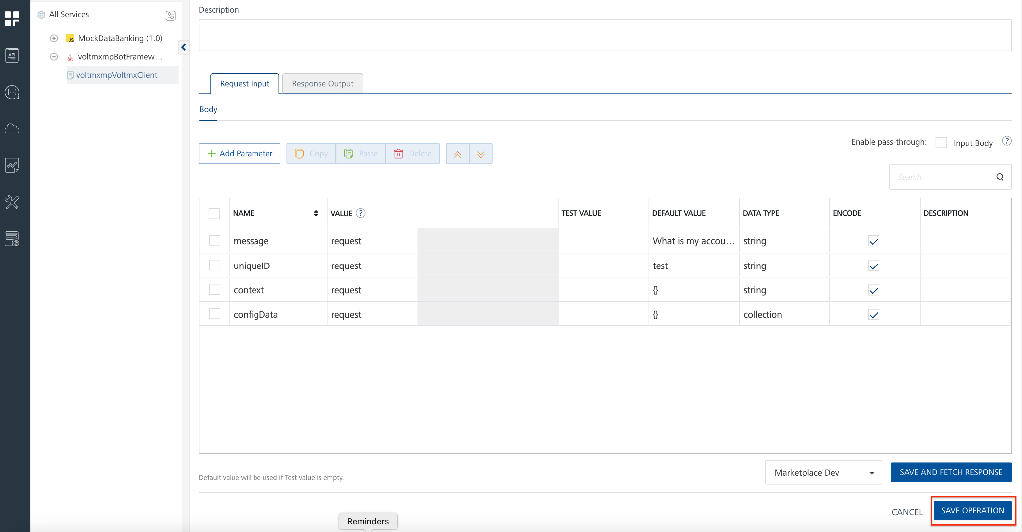

Publish the HCL Volt MX Foundry App
After you set the Operation Security Level, you must publish the HCL Volt MX Foundry app. To publish the HCL Volt MX Foundry, follow these steps:
- In Volt MX Iris, click DATA & SERVICES, and then click Publish Project Services to Publish to your foundry app.
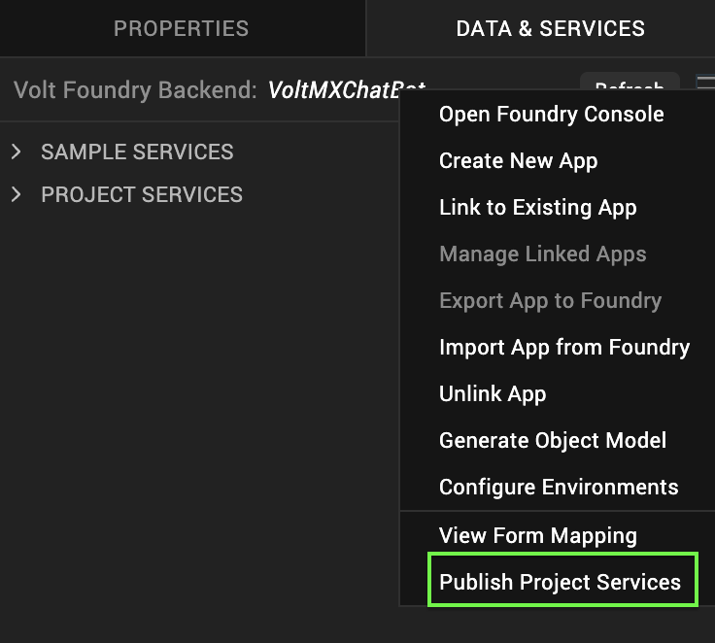

- Select the environment to which you want to publish your app, and then click Publish.
- After the app is published to your environment, the following window appears confirming the publish.

Add NLP Configurations
After publishing your app, you must configure the NLP settings. To configure your NLP settings, follow these steps:
- On the left navigation pane, click the icon to go back to Volt MX Iris from the Publish page.
- On the Project Explorer, go to the form that contains the chatbot and then select the chatBot.
- On the Properties panel, click the Action tab, and then go to the Chatbot → nConfiguration event. Click Edit.
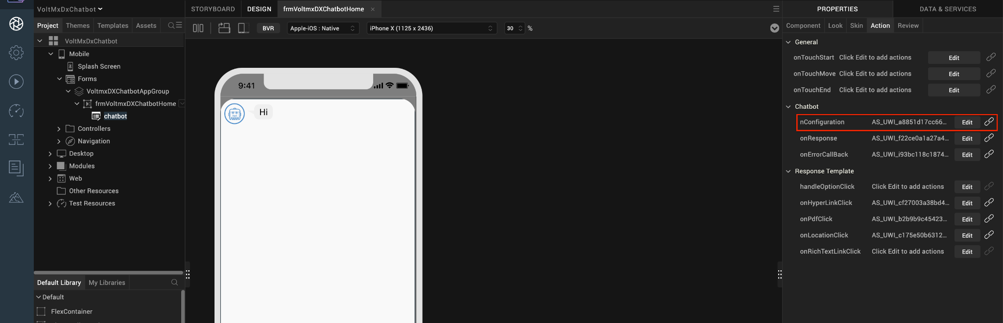
- Open the Code Snippet attached to the nConfiguration event.
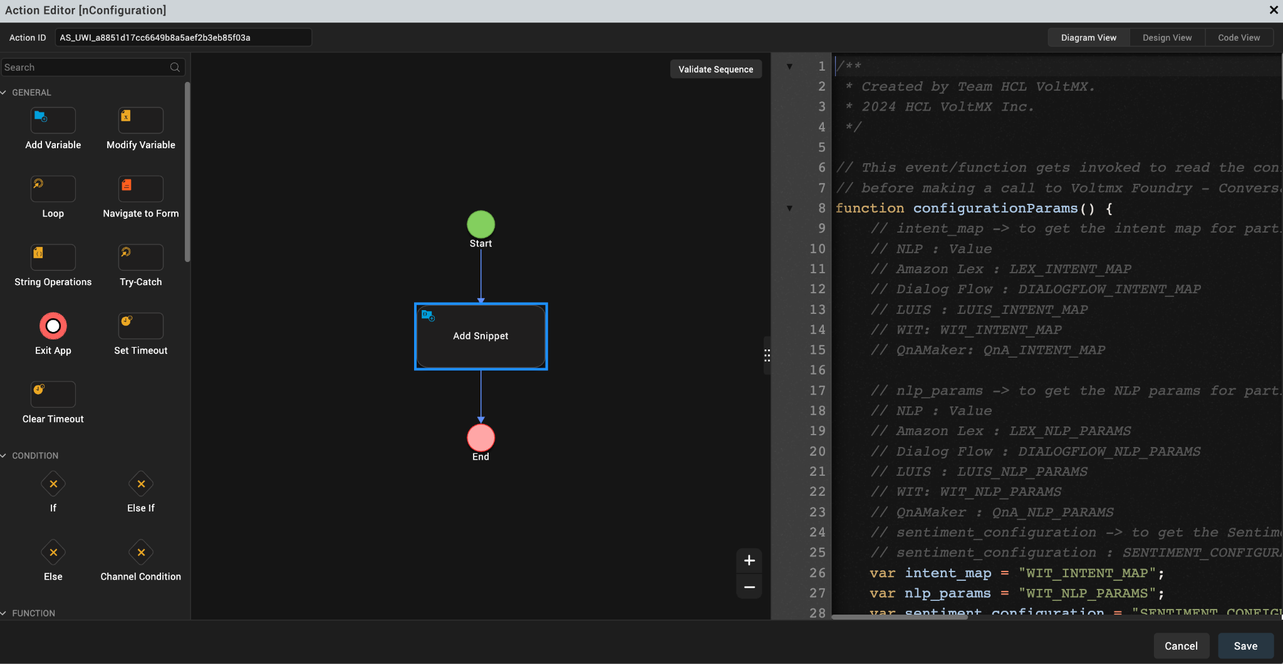

- In the code snippet, change the values of the intent_map and nlp_params as shown in the given screenshot.
Note: The intent_map and nlp_params should be the same as Foundry NLP Configurations.
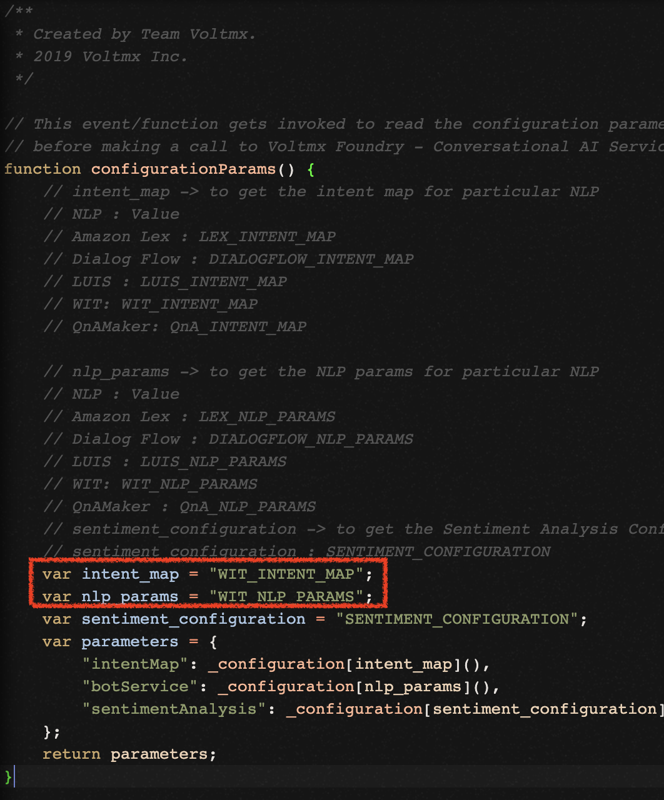

Provide Permissions
Before you build the project, you must provide the necessary permissions for the chatbot to run. The permissions vary based on the platform (Android and iOS). For more information about how to provide the necessary information, refer to the Prerequisites section for Android and iOS on the Reference page.

Refresh the Project

You must refresh the Volt MX Iris project to update the infoplist_configuration.json file. To refresh
the project, open Project from the main menu, and then click Refresh.

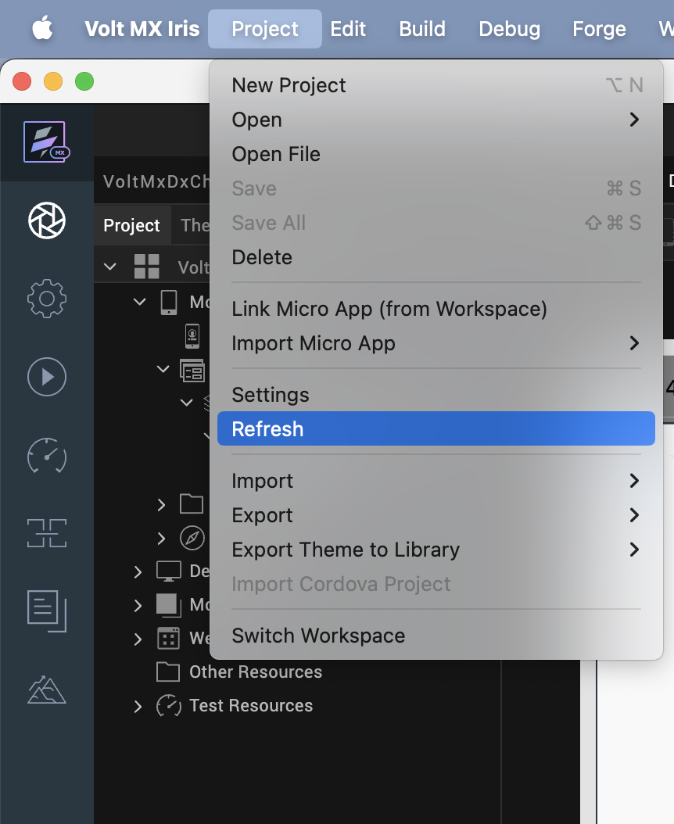

Build the Project
The final step before you run the chatbot, is to build the Volt MX Iris project. To build your project, follow these steps:
- From the main menu, open Build, and then click Build Native Local..
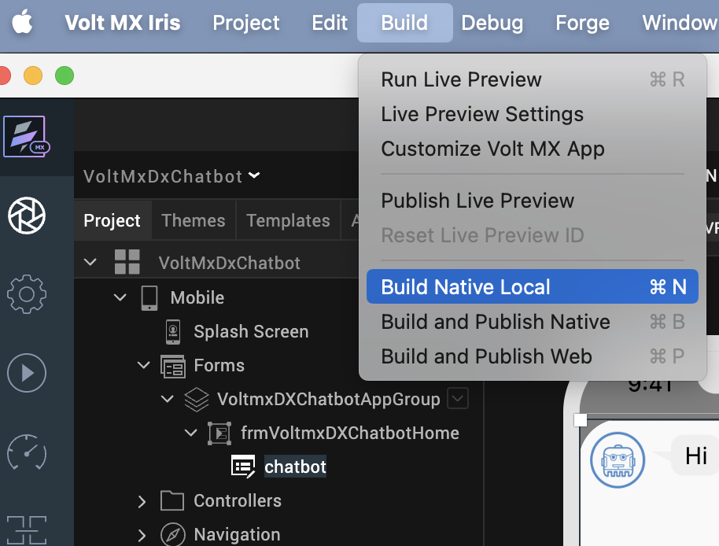
The Build Generation window appears.

- Under Platform and Channels, select the iOS and Android Mobile platforms, and then click Build.
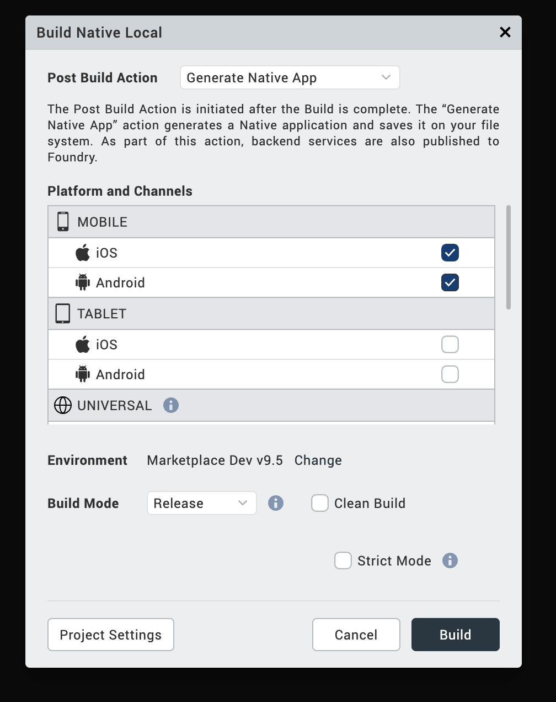

- On a successful build, a build confirmation window appears as shown in the following image.
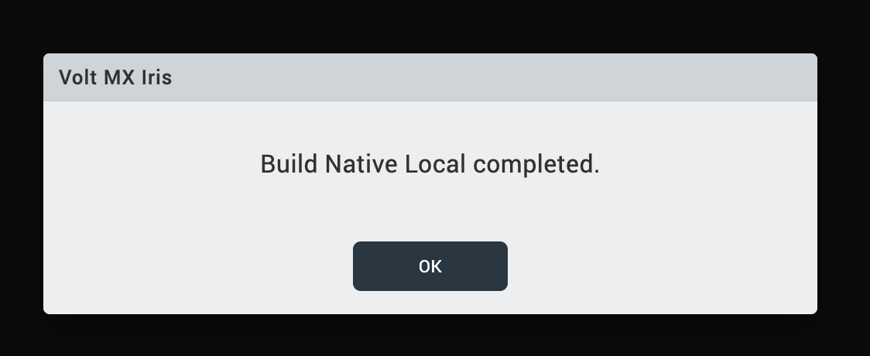

Advanced Setup

Wit.ai Bot Setup
For information about how to set up Wit.ai, refer Wit.ai Bot Setup.

Volt MX Iris Project Setup
To run the chatbot, you must configure the Volt MX Iris project as follows:
- Configure HCL Foundry
- Publish the HCL Foundry App
- Provide Permissions
- Build the Project
Note: Before you configure your Volt MX Iris project, you must import the chatbot to your Volt MX Iris project. For more information about how to import the chatbot to your Volt MX Iris project, refer to the Import the Project section on the References page.

Configure HCL Foundry
When you import the chatbot to your Volt MX Iris project, the HCL Foundry services of the chatbot are added to the HCL Foundry app, which is associated with the Volt MX Iris project. While importing the chatbot to your Volt MX Iris project, if there is no HCL Foundry app associated with the existing Iris project, a new HCL Foundry app is automatically added to your HCL Foundry environment and is associated with your Volt MX Iris.
To configure the HCL Foundry app for the chatbot that you imported to your Wit.ai console, follow these steps:
- From the Project Explorer on Volt MX Iris, click DATA & SERVICES.
- In the HCL Foundry window, under the Integration tab, expand the service and then select the voltmxmpVoltmxClient operation.
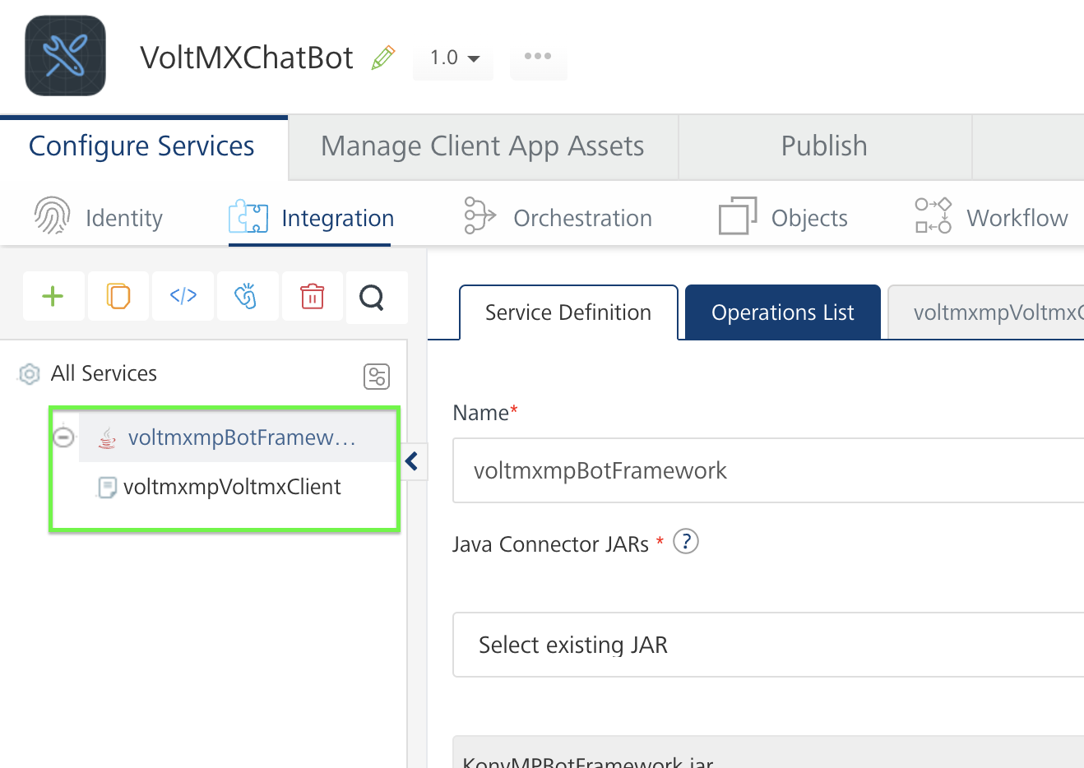
- In the operation configuration, expand the Advanced section.
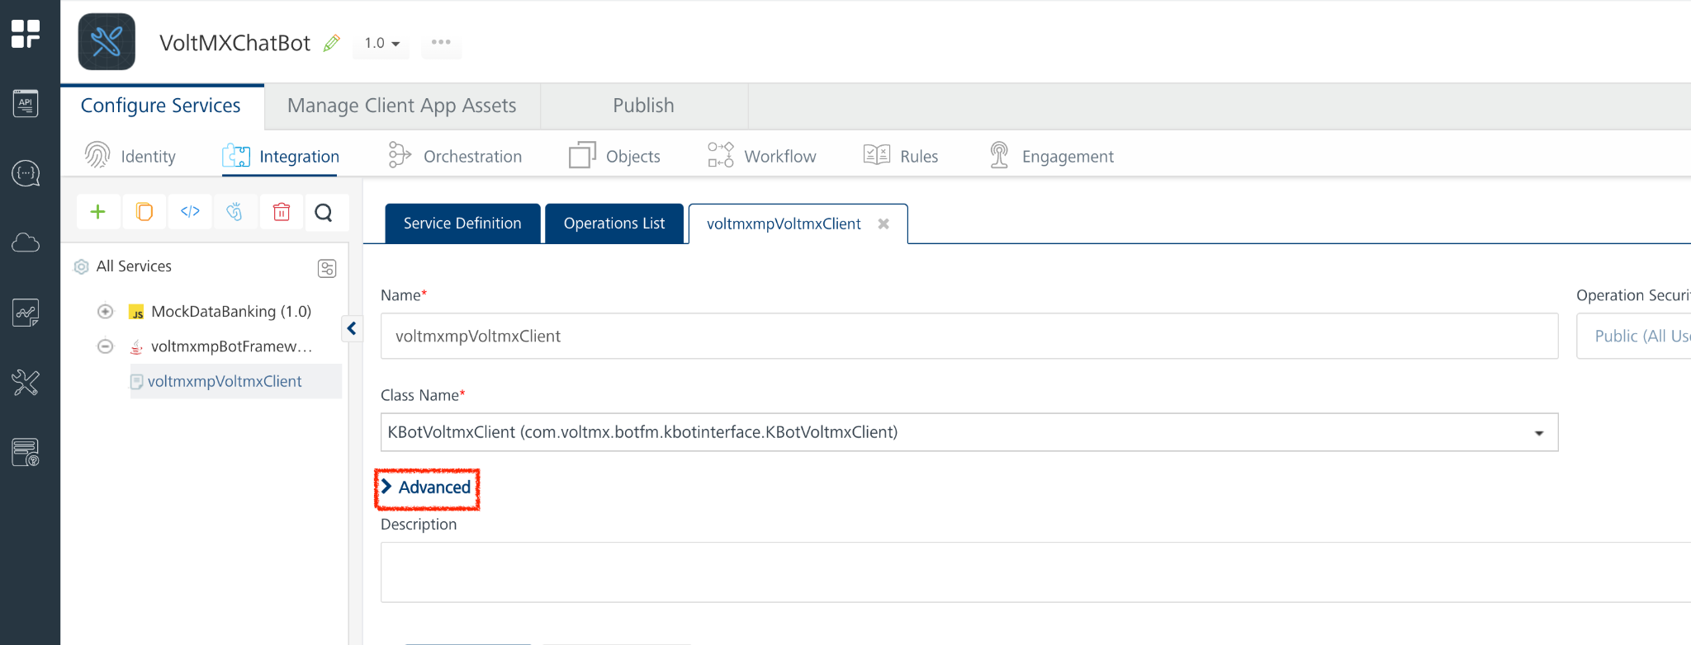
- Under Custom Code Invocation, for Preprocessor, click Expand.
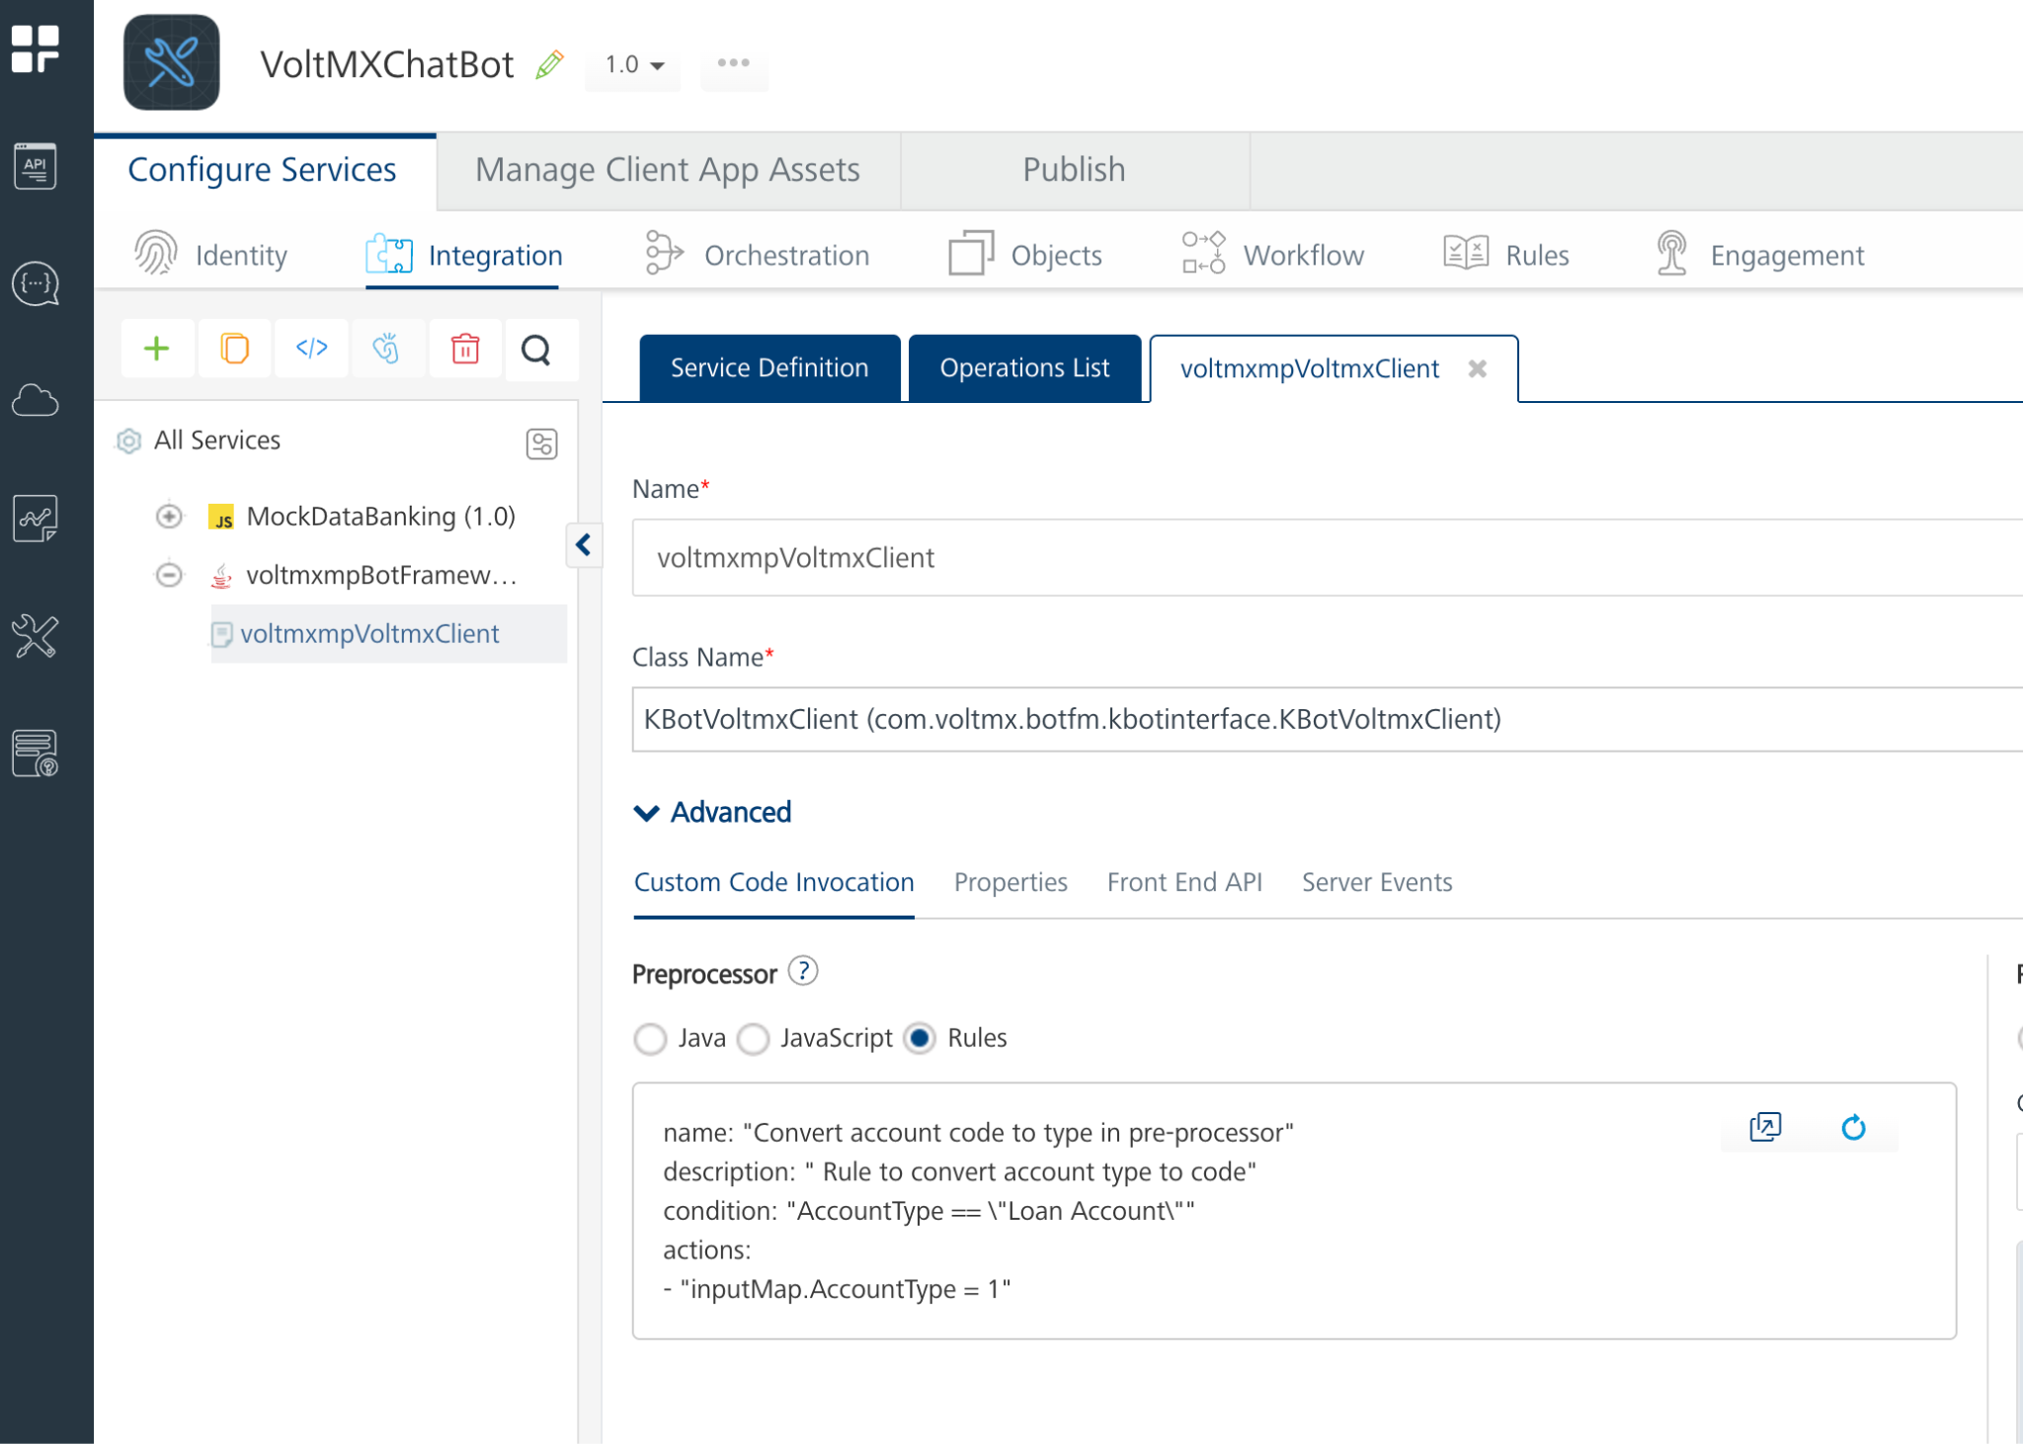
- In the code snippet, change the intent_map and nlp_params parameter values in the configurationParams function with wit.ai values WIT_INTENT_MAP and WIT_NLP_PARAMS respectively
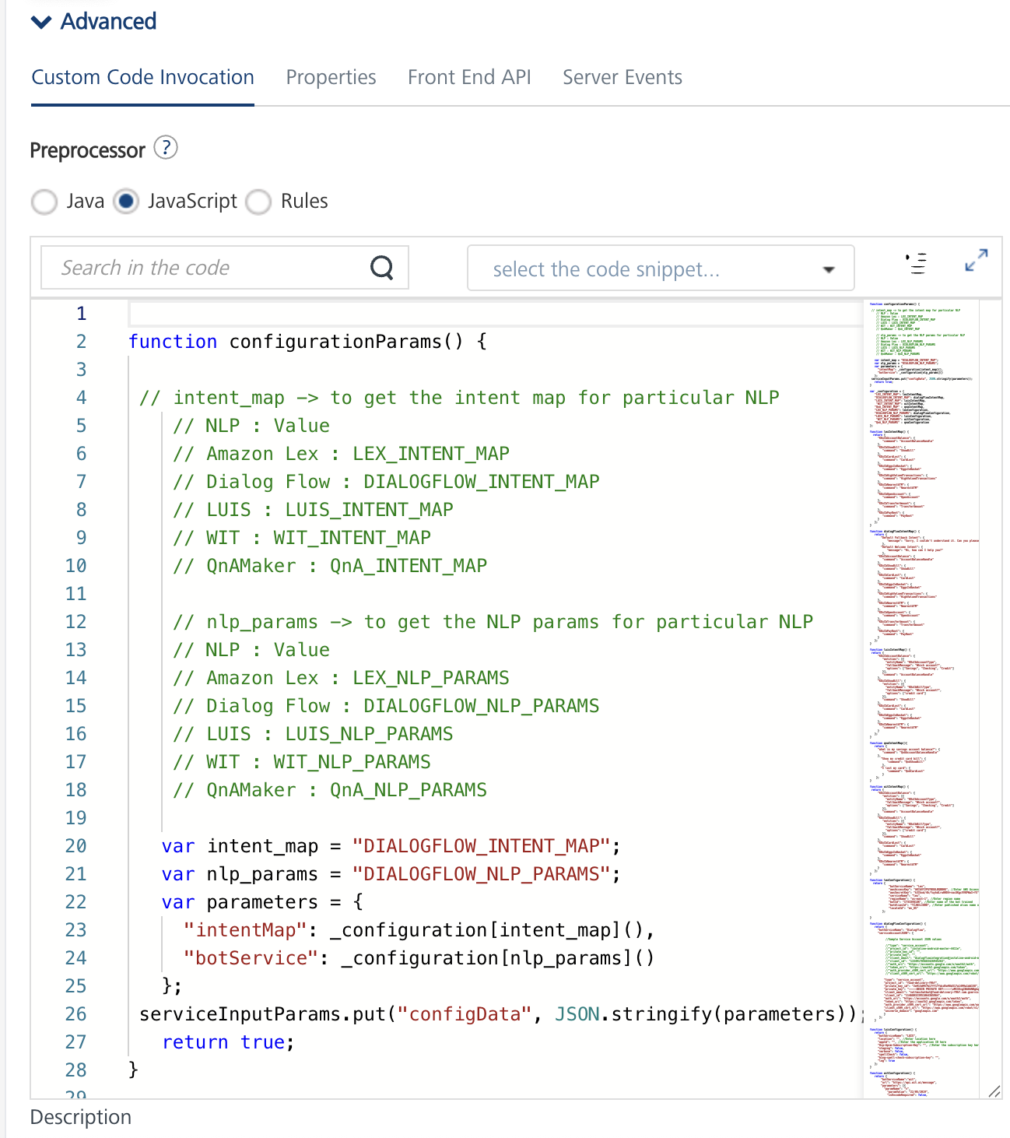
- In the witConfiguration function, add the Service Access Token copied from the Wit.ai console. Add the token to the paramValue parameter present under headerParameters.
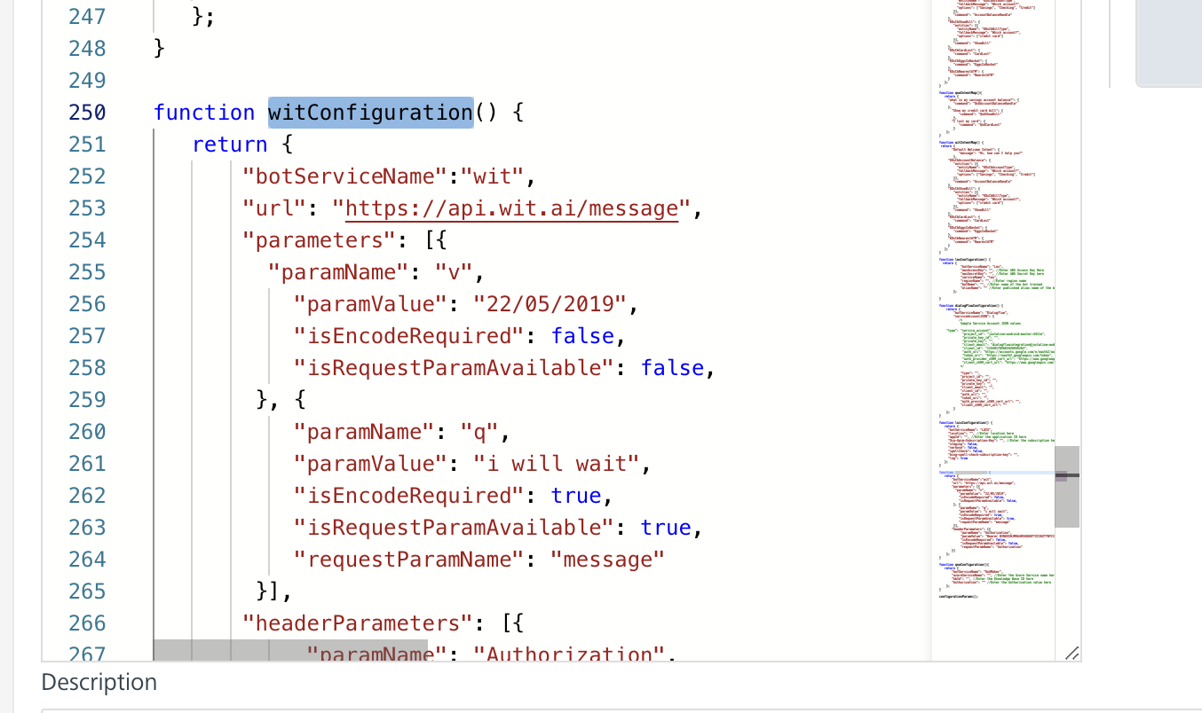
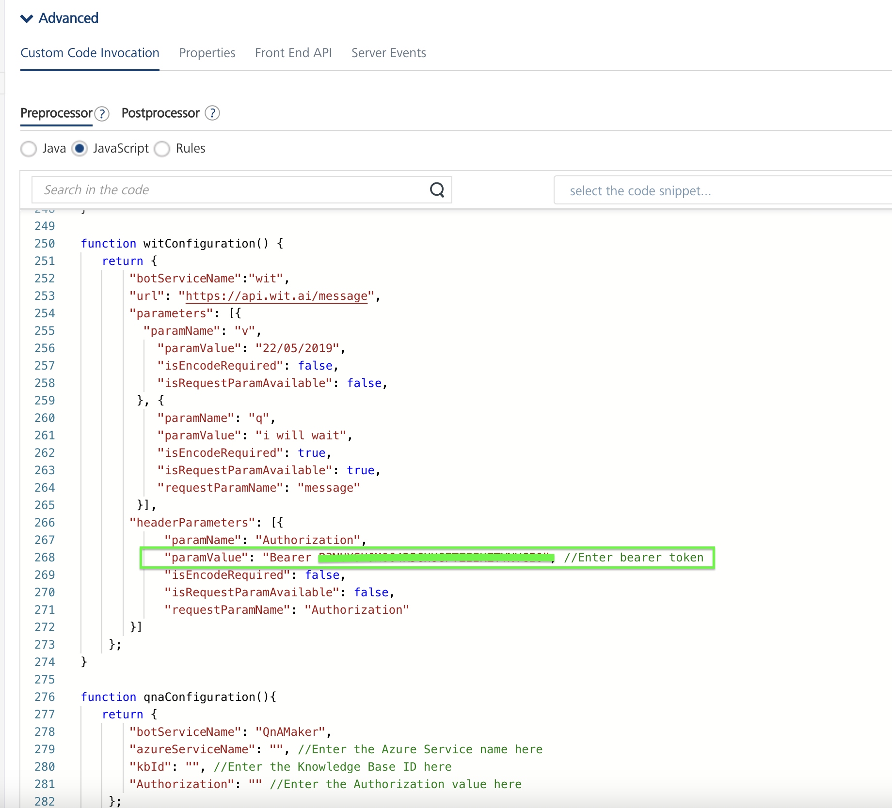
- Click Save Operation.
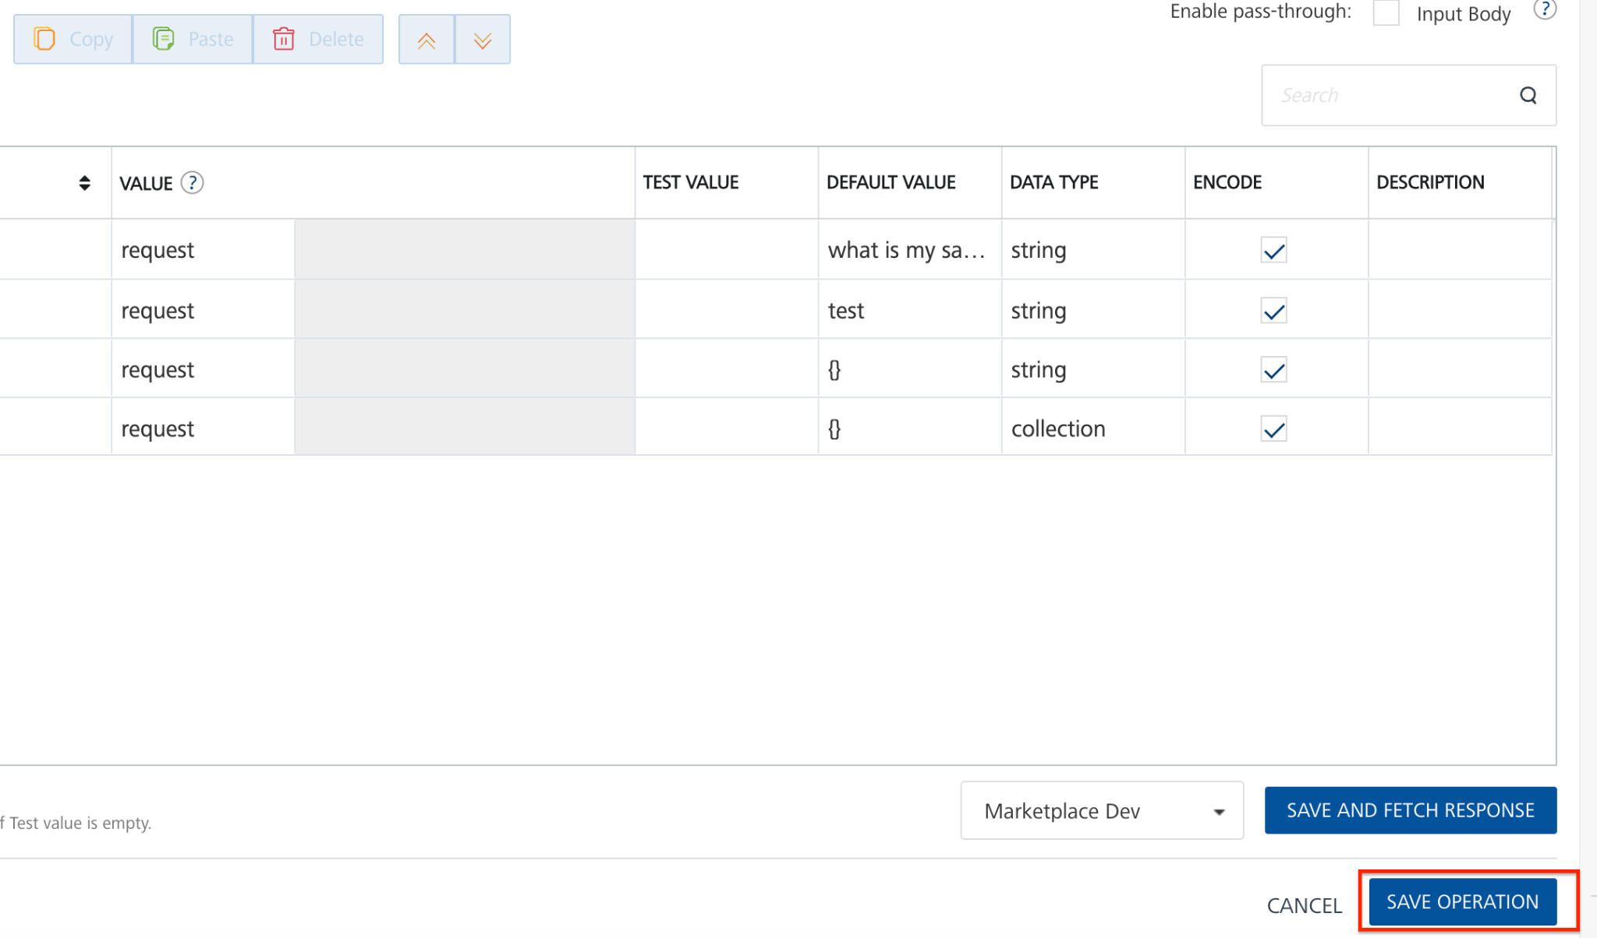
- Click the icon to go back to Volt MX Iris.
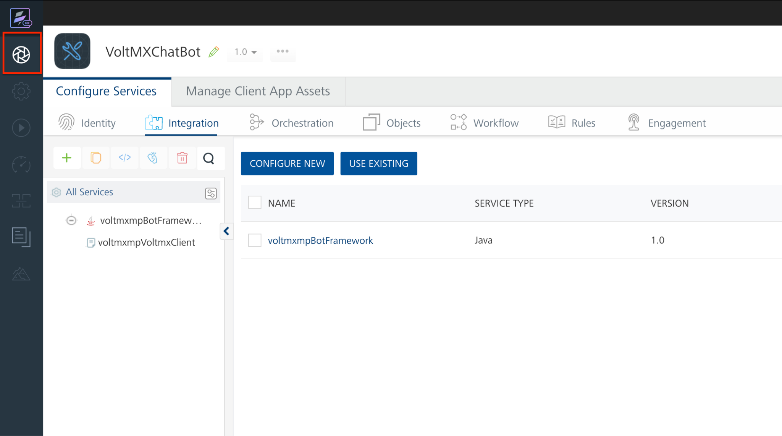

Publish the HCL Foundry App
For information about how to publish the HCL Foundry app, refer to the Publishing the HCL Foundry App section.

Provide Permissions
Before you build the project, you must provide the necessary permissions for the chatbot to run. The permissions vary based on the platform (Android and iOS). For more information about how to provide the necessary information, refer to the Prerequisites section for Android and iOS on the Reference page.

Build the Project
For information about how to build the app, refer to the Build the Project section.

Set Up THE CHATBOT - AMAZON LEX

Basic Setup

Amazon Lex Setup
Set up the Natural Language Processing (NLP) bot in the Amazon Lex console to run your chatbot. To setup the NLP bot, follow these steps:
- Import the NLP Bot
- Build and Publish the NLP Bot
- Create an IAM User

Import the NLP Bot:
To import the Sample NLP bot to your Amazon Lex console, follow these steps:
- Open and login to your account in AWS Management Console.
- In the Services section, search for Amazon Lex and open the Amazon Lex console.
- Click Bots to open the Amazon Lex Bots console.
- In the Amazon Lex Bots console, click Action and select Import to import the VoltmxDXBankingBot.zip file.
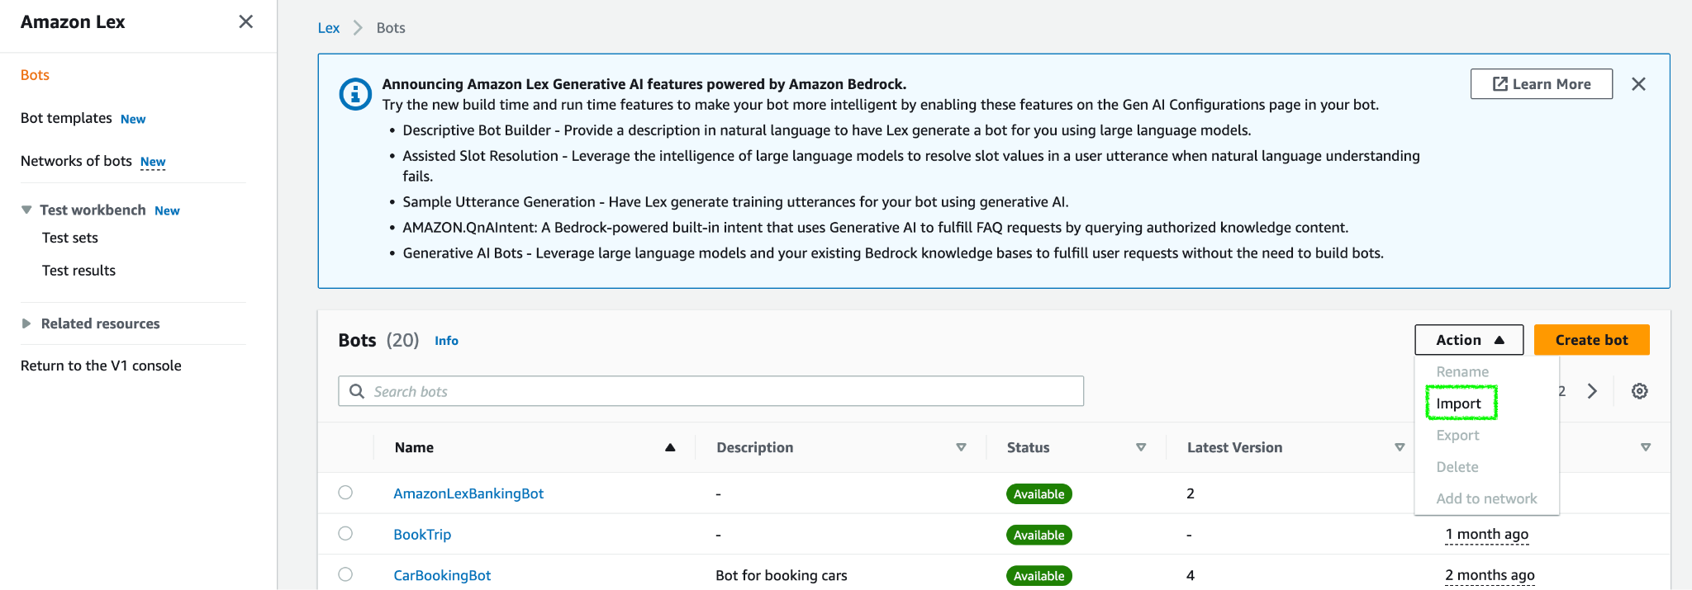

Note: Before you import the bot to the Amazon Lex console, you have to download the exported VoltmxDXBankingBot.zip file. To download the zip file, click here.

- Click Browse and select the VoltmxDXBankingBot.zip file.
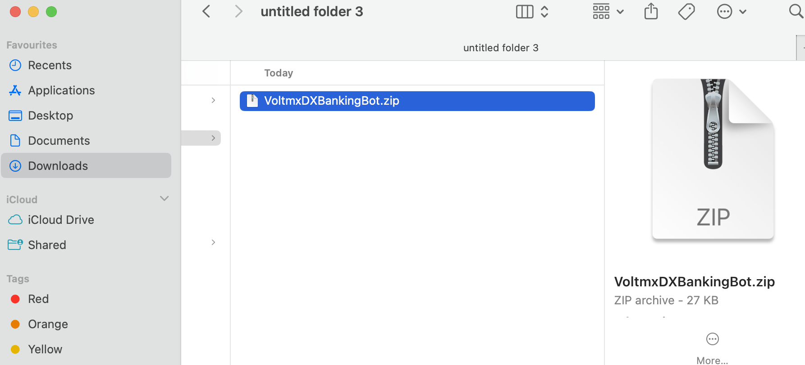
- Click Import to import the bot to AWS Amazon Lex console. This imports the bot to AWS Amazon Lex console.
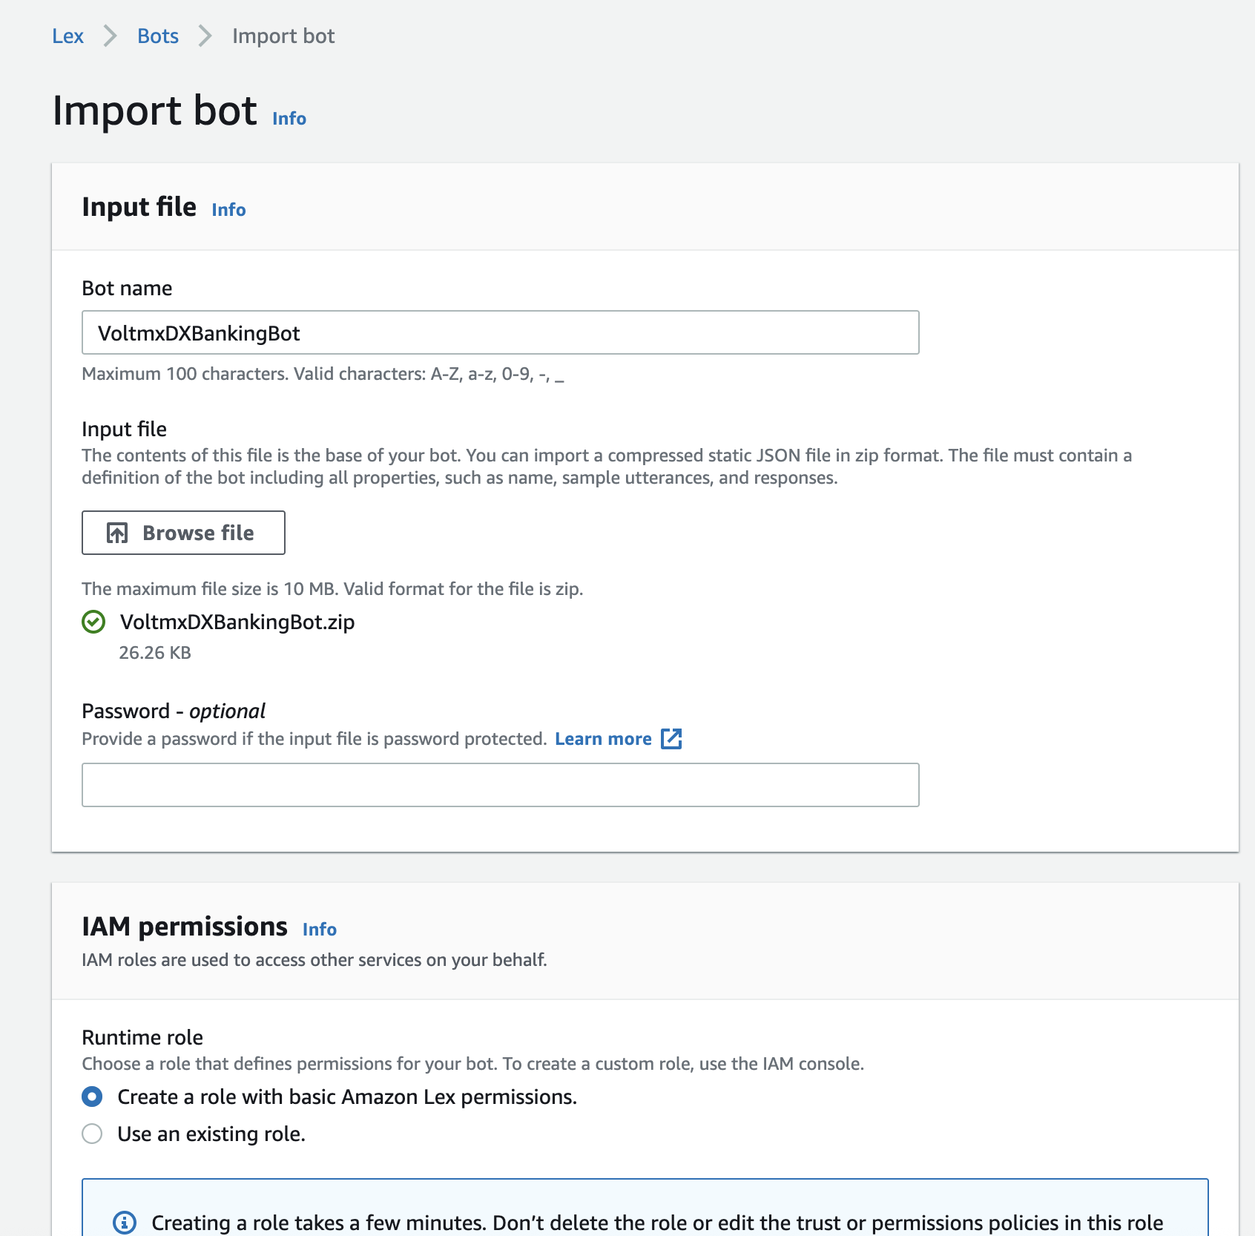
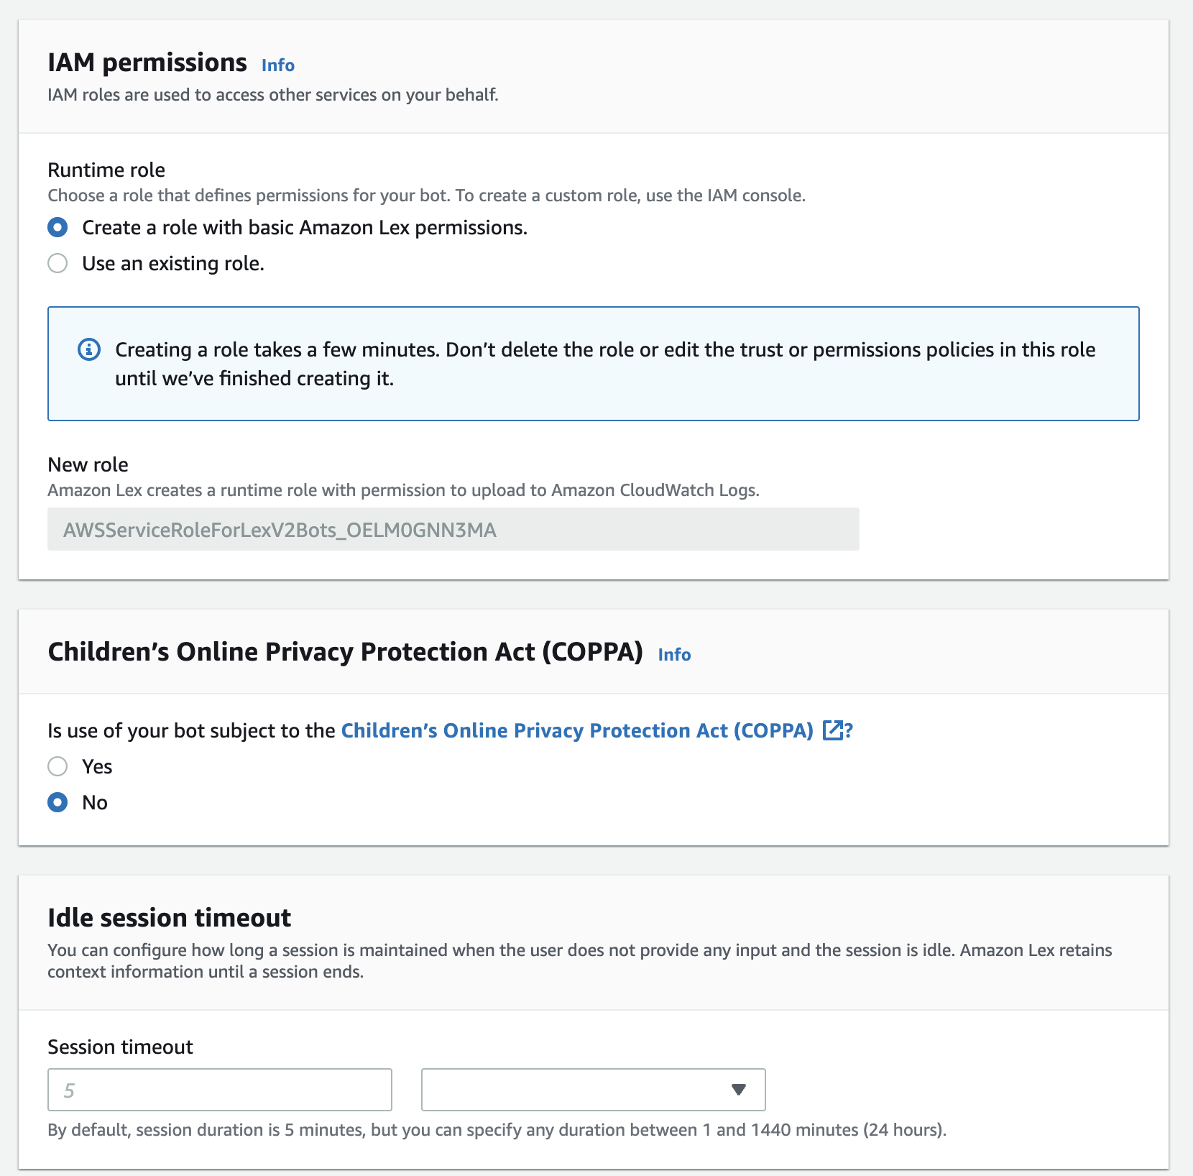
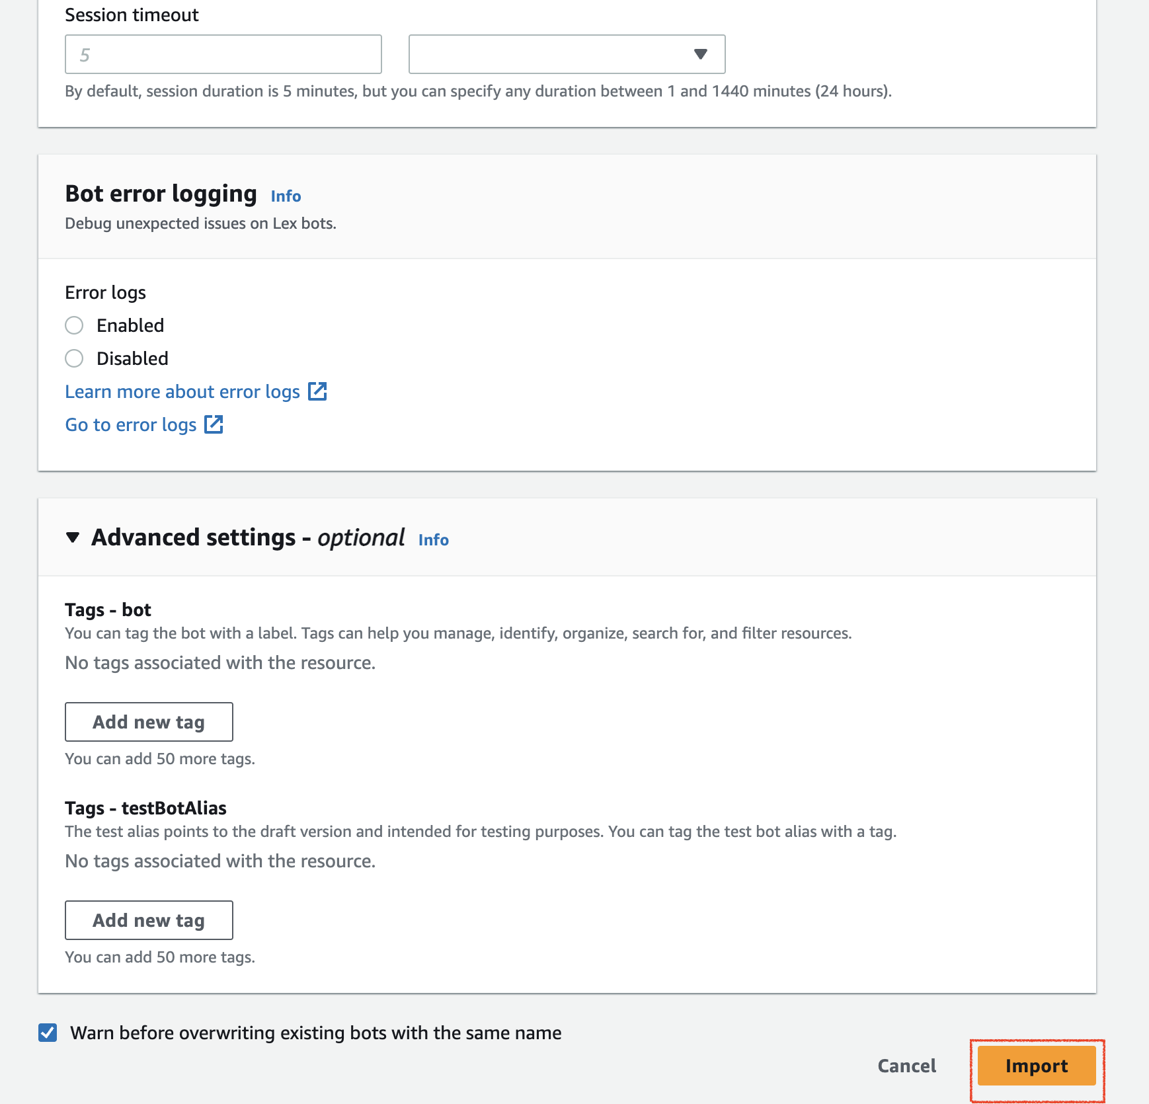
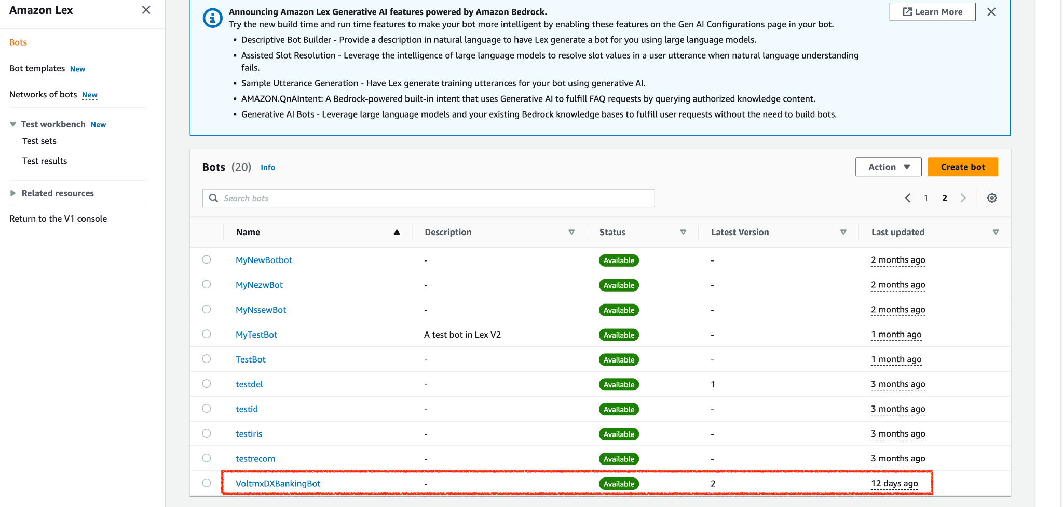

Build and Publish the NLP Bot:
Once you import the bot you have to build and publish the imported bot. To build and publish the bot follow these steps:

- Select the imported bot and On the left panel, click "Bot versions". You can see the draft version.
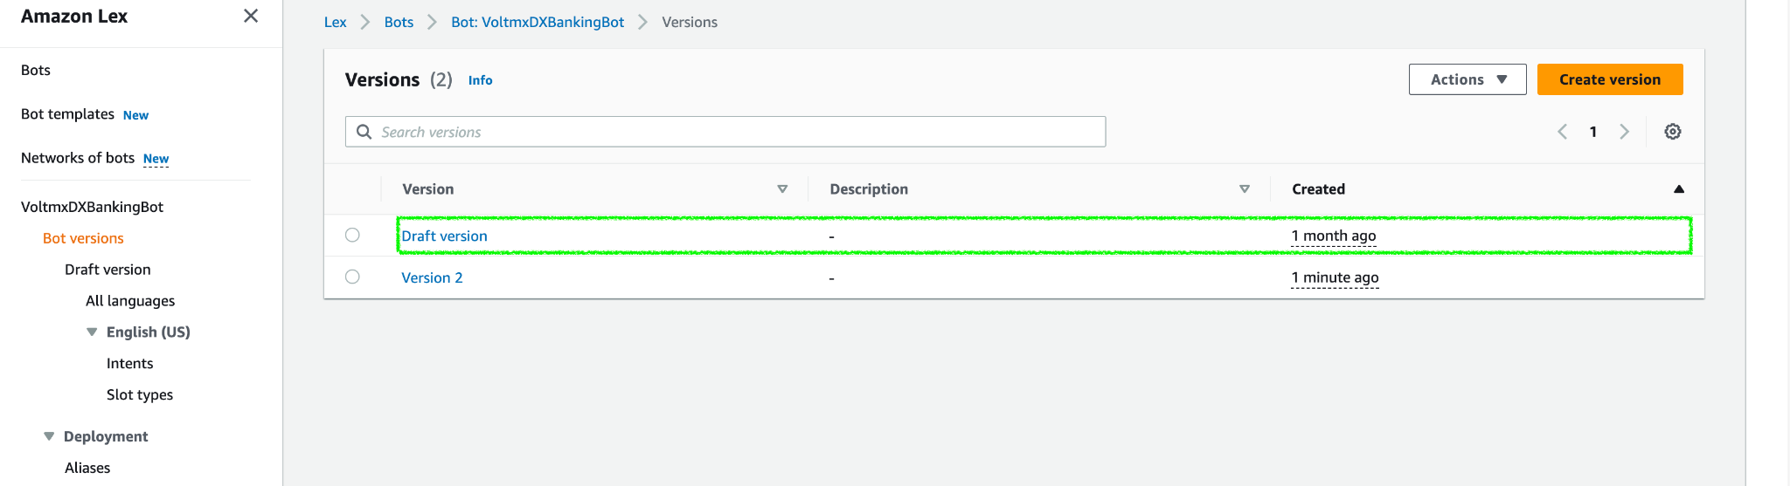

- On the left panel, select Draft version and Click Intents to build the bot.
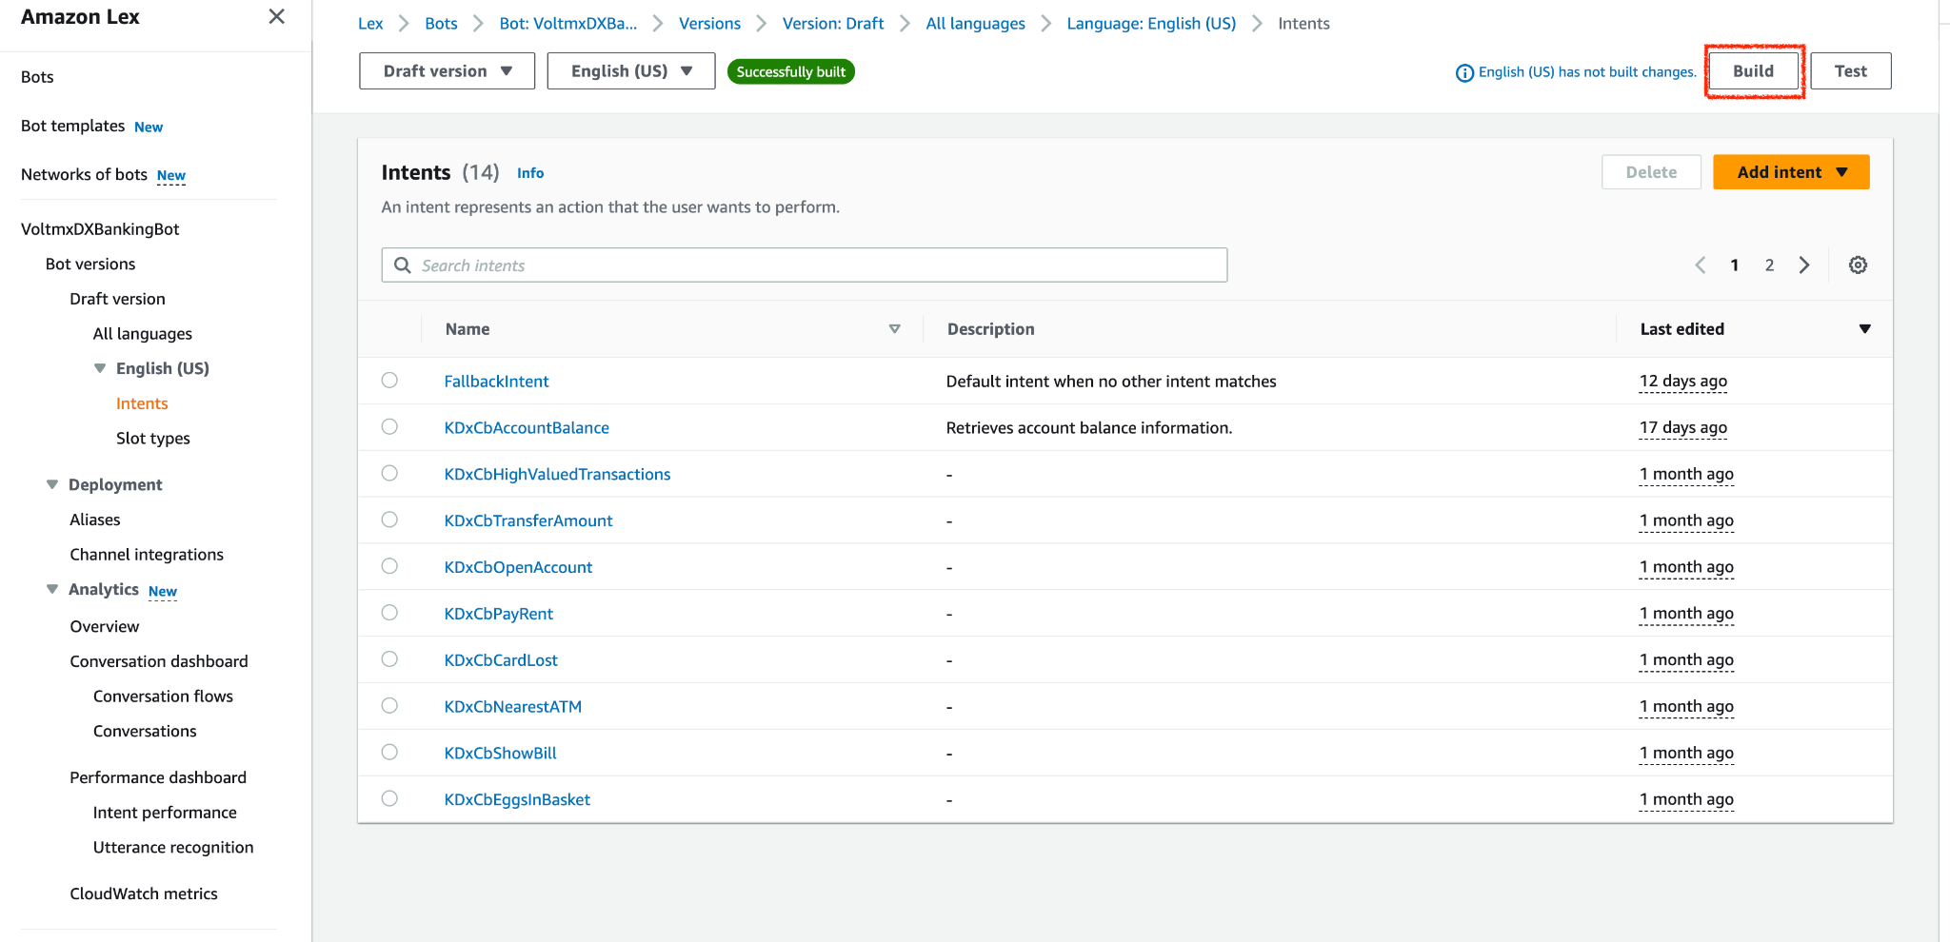
- Once the build is complete, a dialog box appears confirming that the build is successful.

- Create a version for the bot by clicking Create Version.
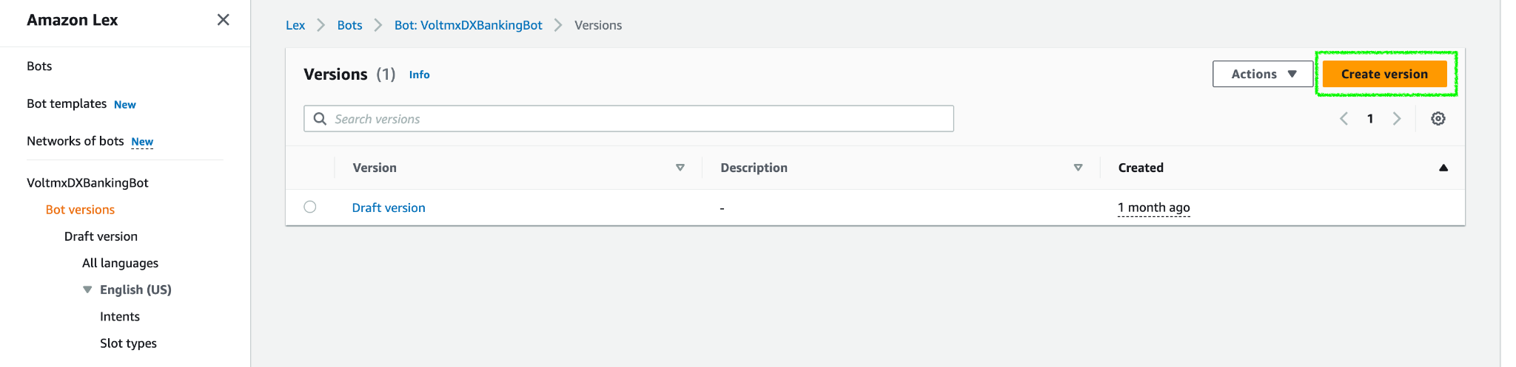
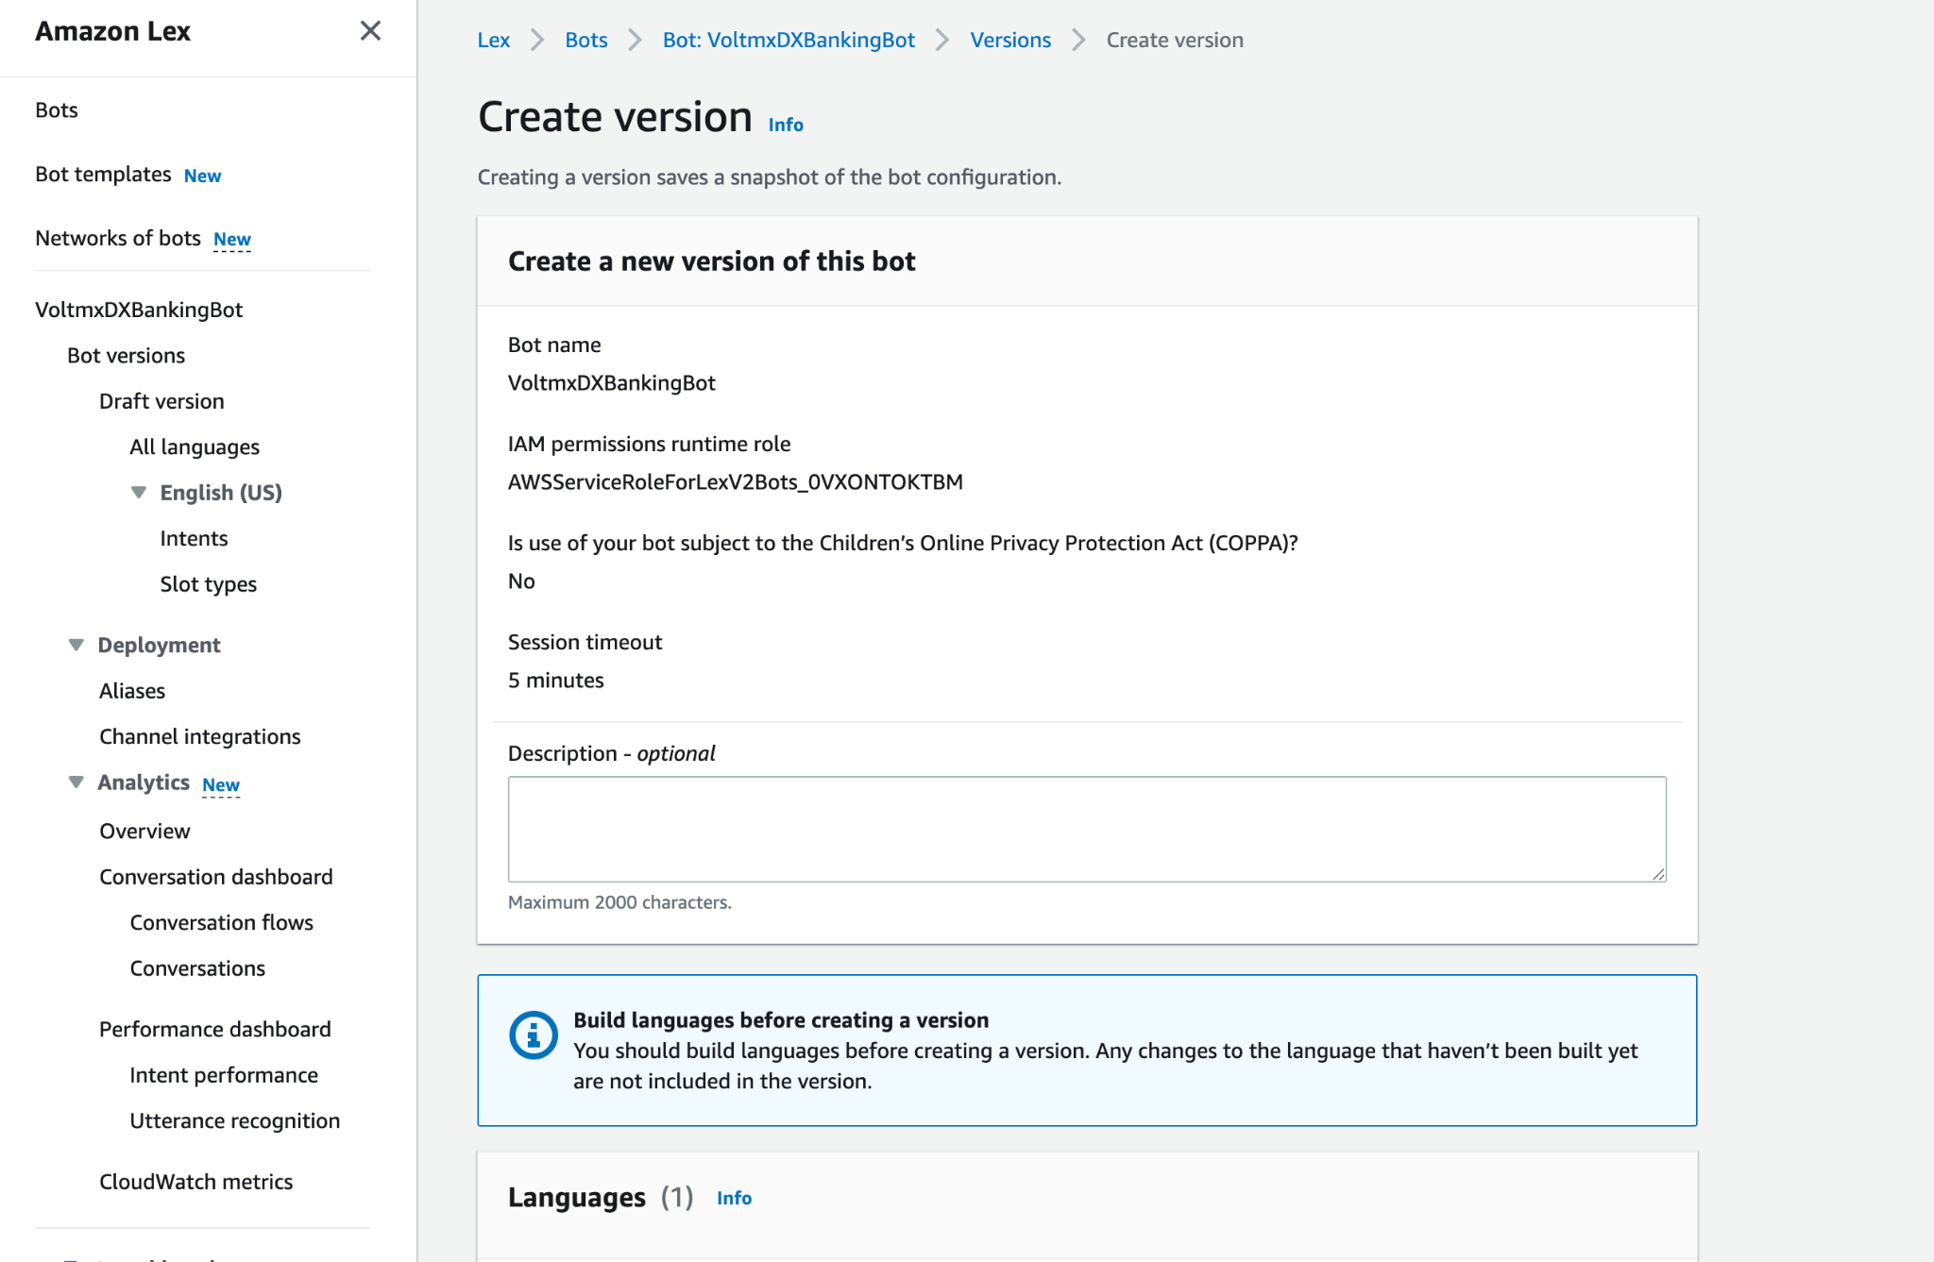
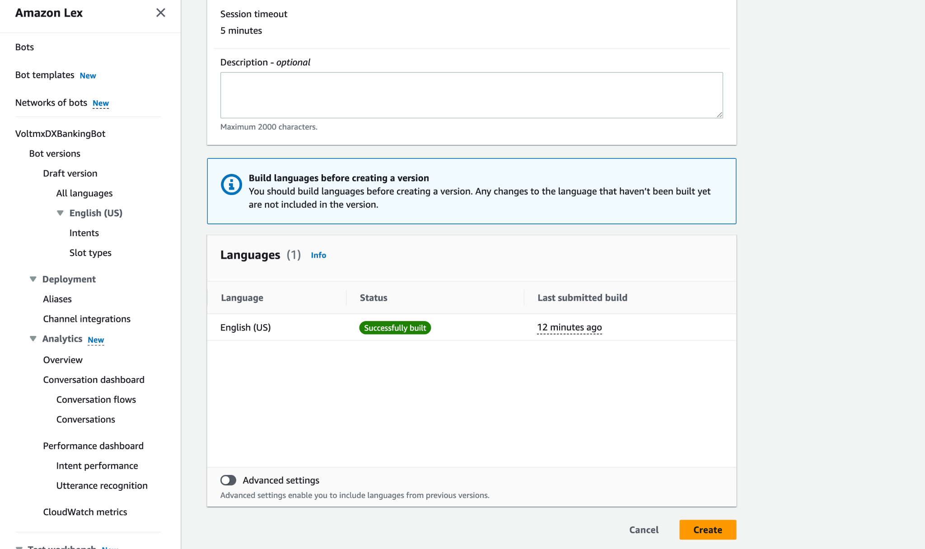
- After successfully version creation for the bot. In the Bot versions you can see the newly created version.
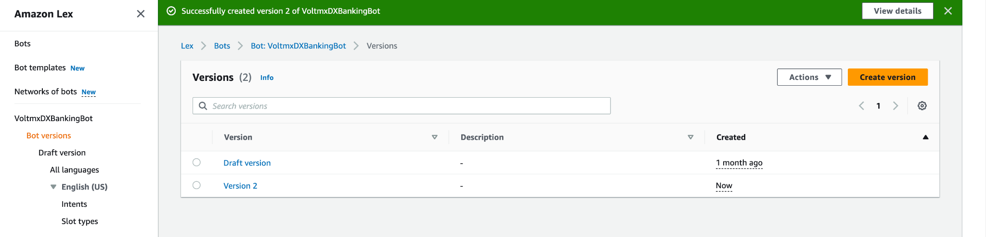
- Create a Bot Alias: You must associate a bot alias with a bot version to use the version in an app.
In the left panel under Deployment -> Aliases -> Click Create Alias
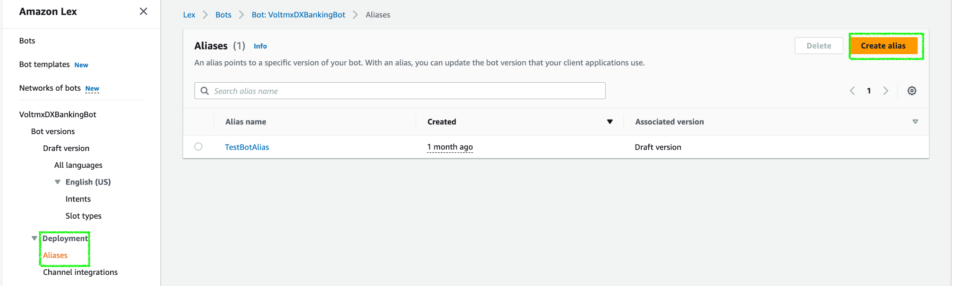
- Provide Alias name and Bot version to associate with this alias
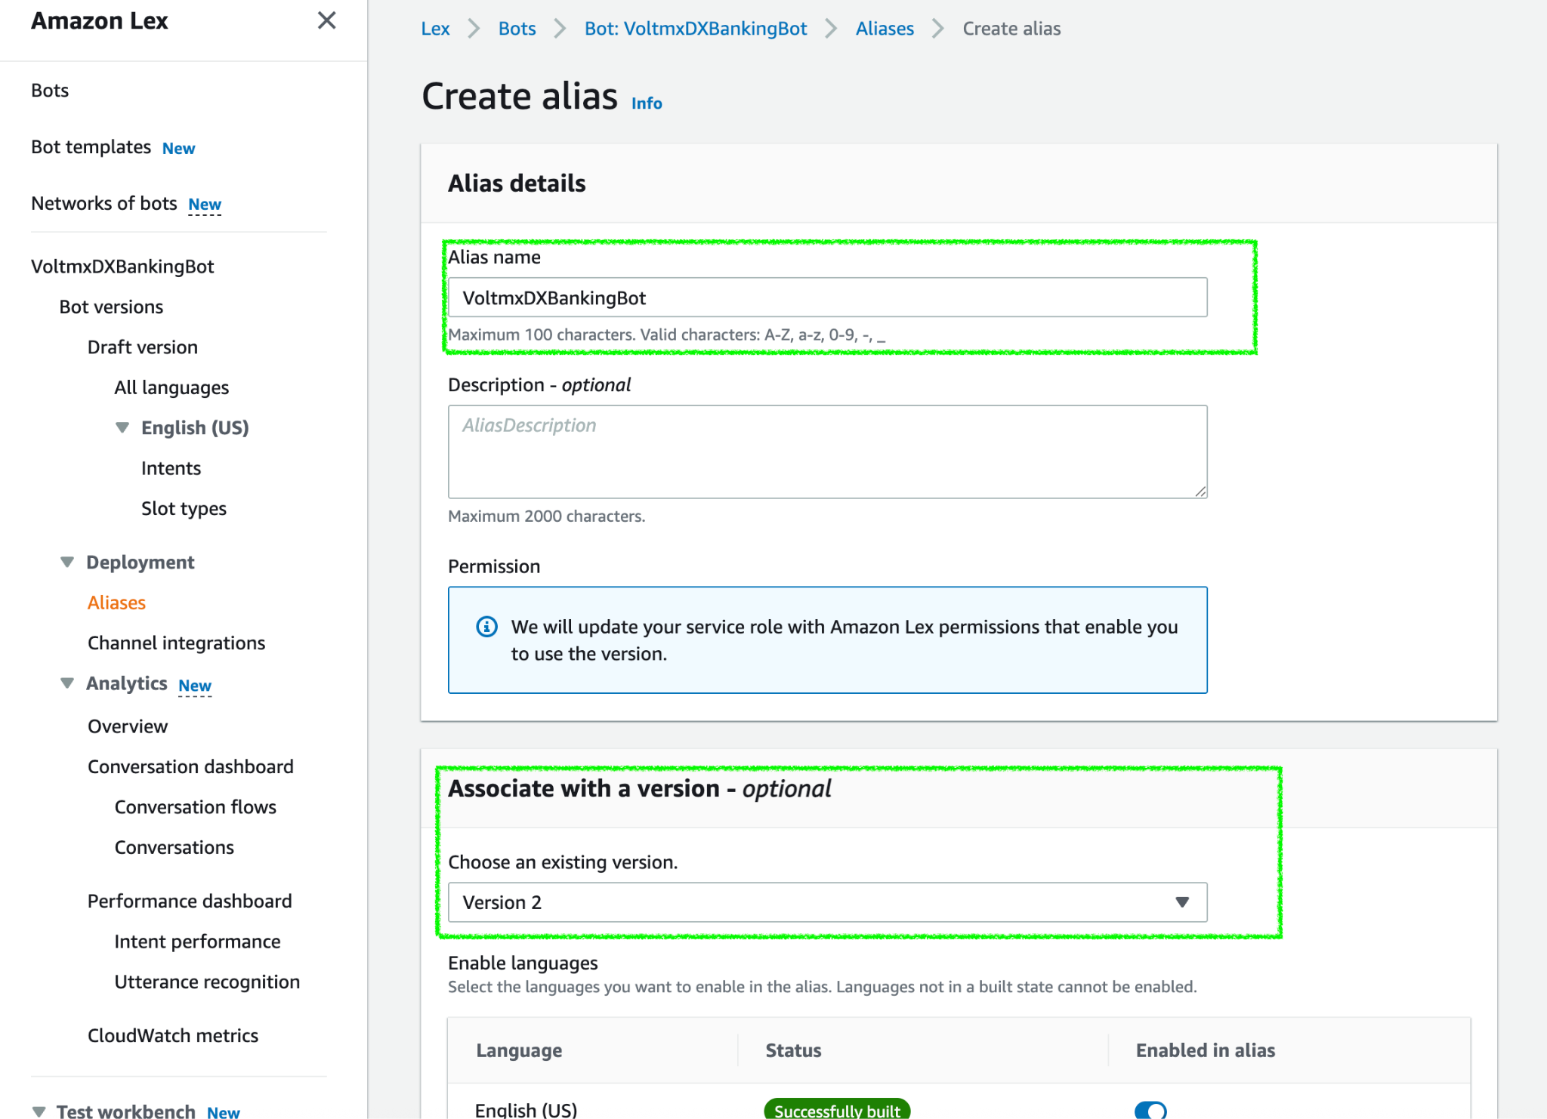
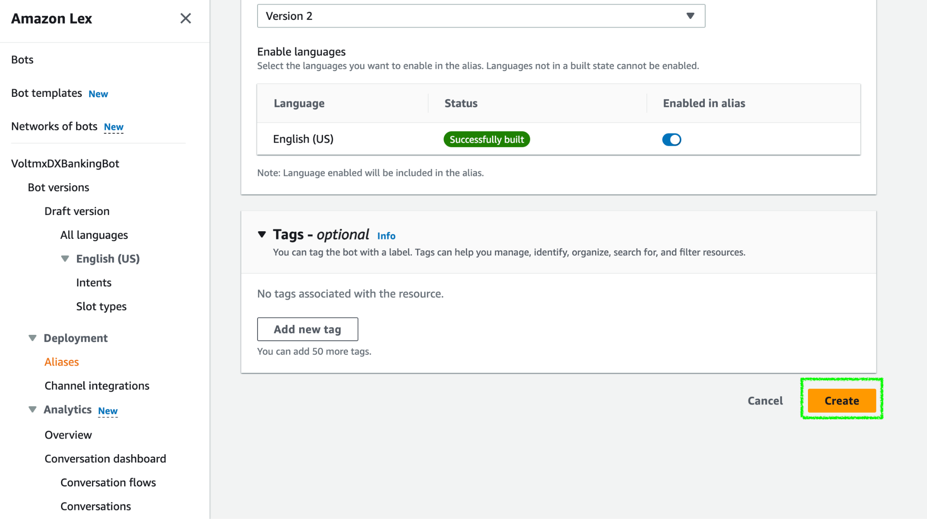

- Click "Create".
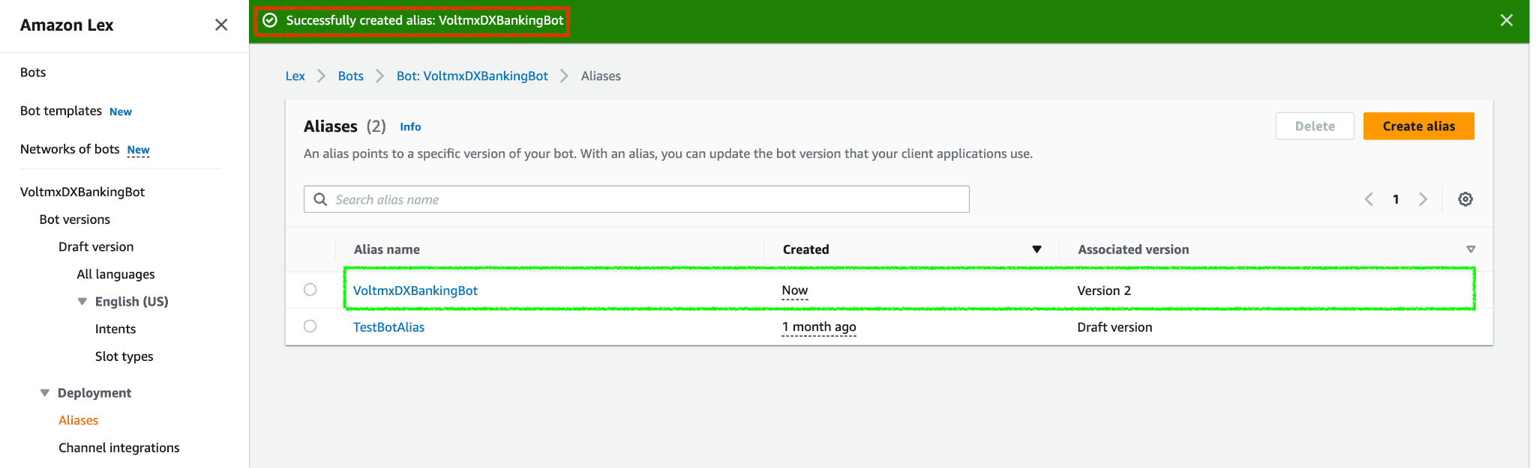

- Now we need to associate the alias for the created bot version. Go to Bot Versions and click on the version you have created.
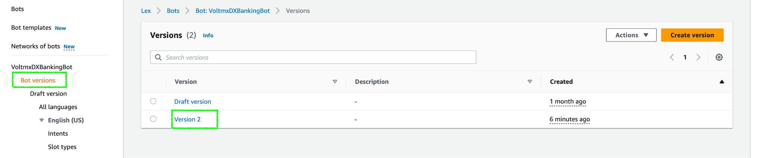
- After clicking on the version, go to the associated alias and click on Associate alias with version.
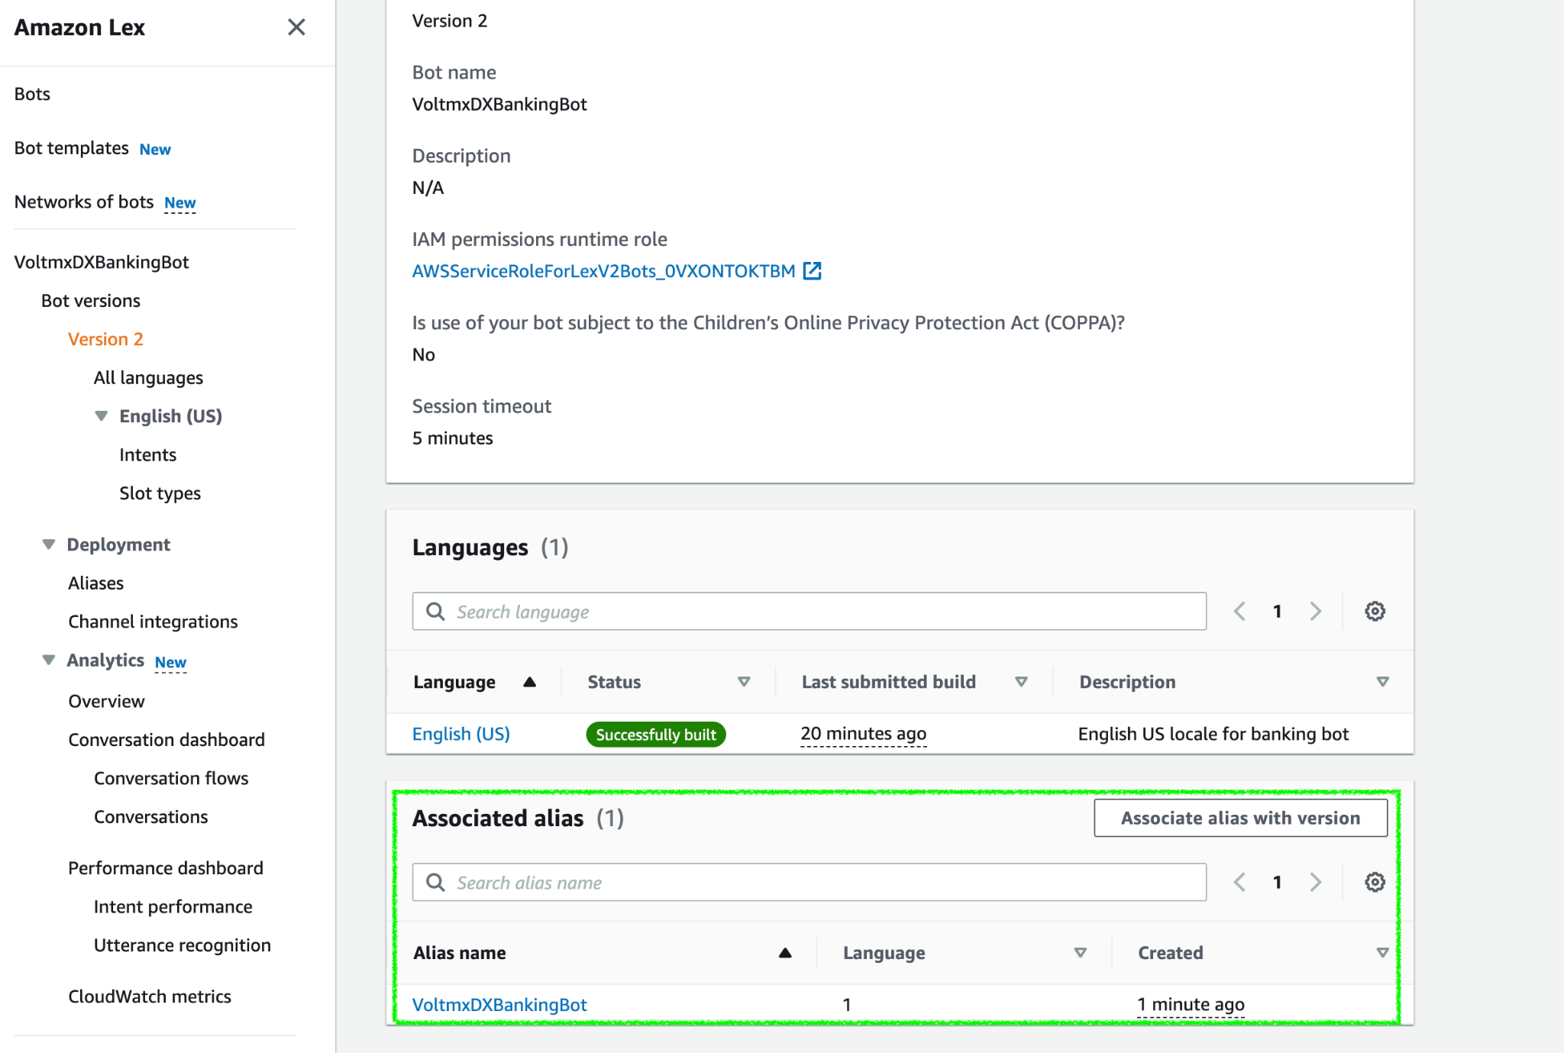
- In the alias you can select your associated alias
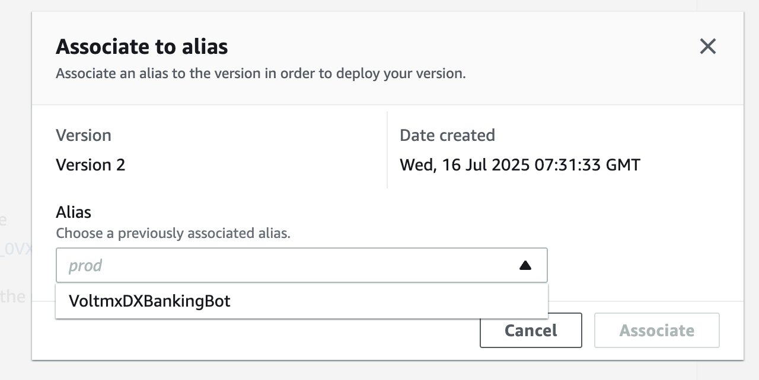

- Check if an Alias is Associated:
a. Click on the bot, scroll to the same “Create versions and aliases for deployment” section.
b.Click “View aliases” to check whether any aliases are already associated with the version.
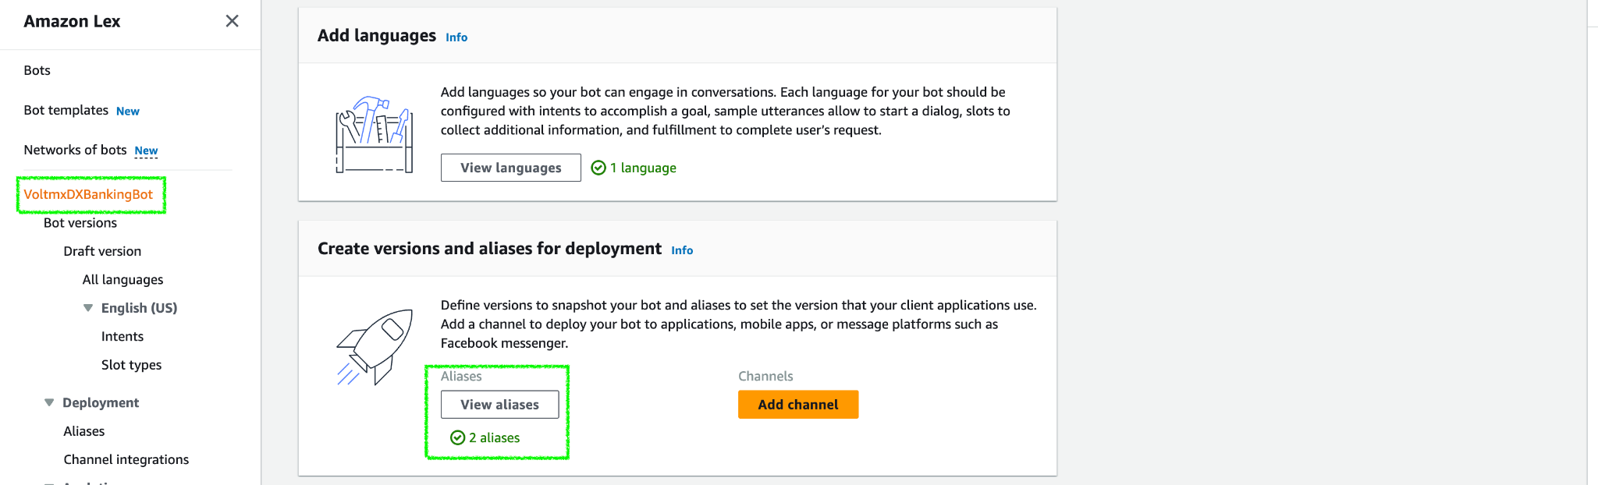

Create an IAM User:
AWS Identity and Access Management (IAM) allows you to securely control access to AWS services and resources for your users. For more information on IAM, click here.
To create an IAM user for Chatbot Framework, follow these steps:
- Navigate back to AWS console from the AWS bot console and search for IAM.
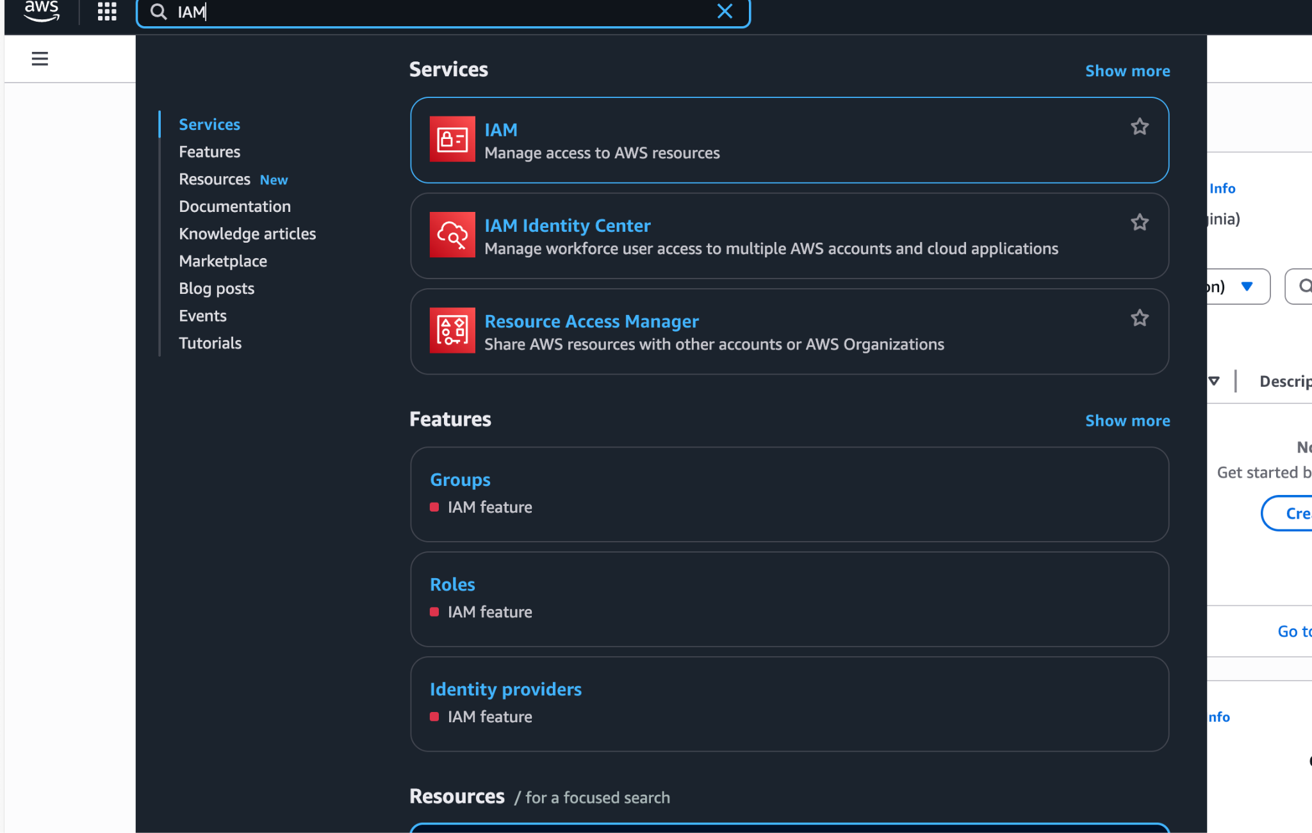
Open IAM console.
- Click Users from the left panel to access the list of IAM users for your AWS account.
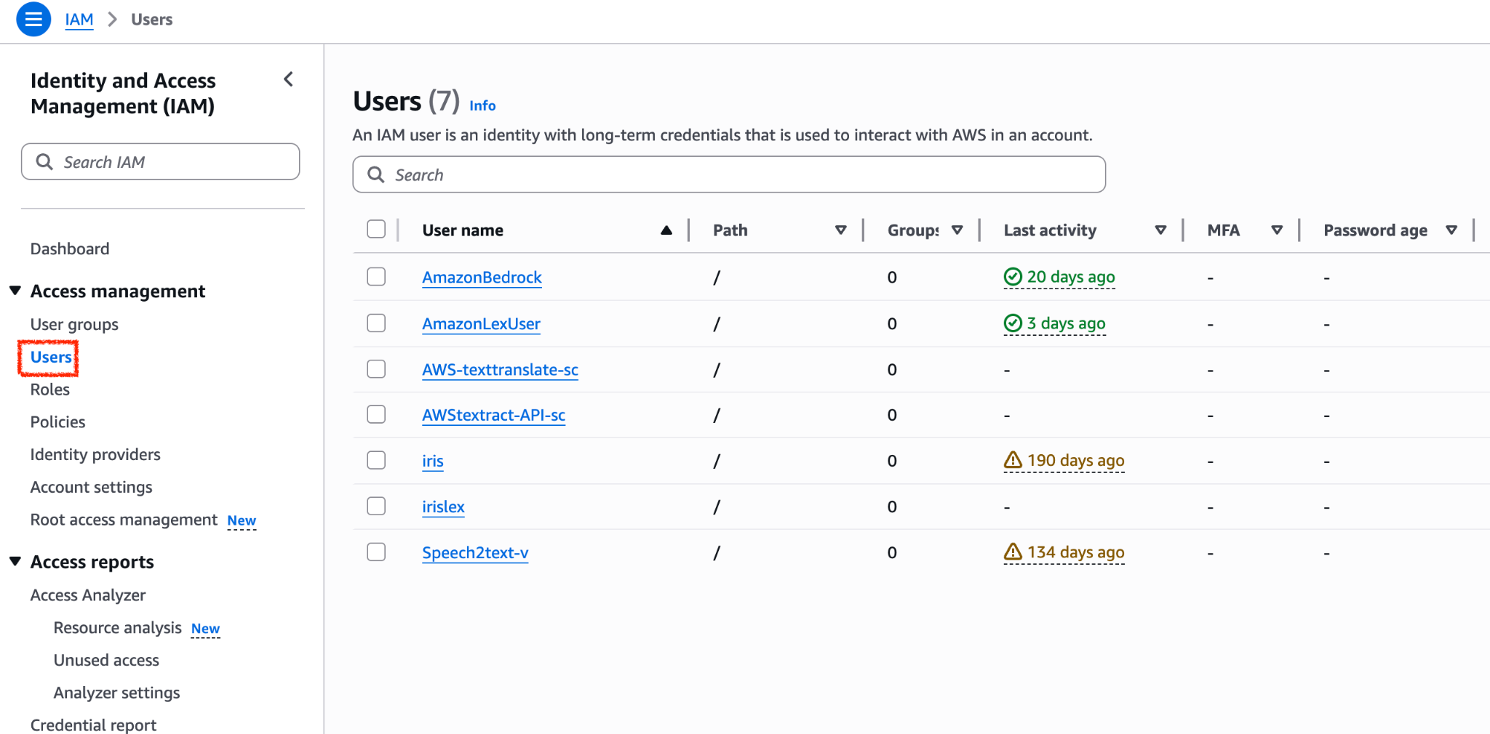

- Click Create User to open Set User Details to add an IAM user.
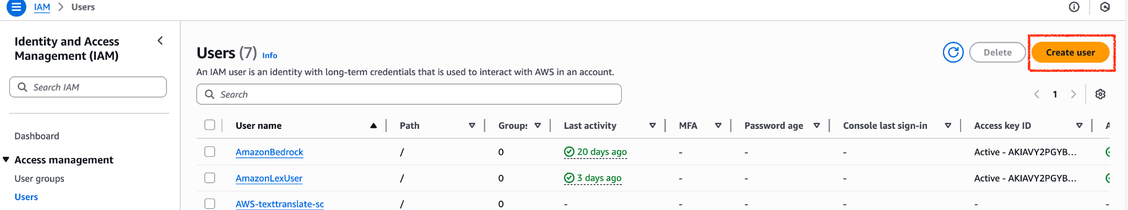

- Under Specify user details, provide a username for the user and click next.
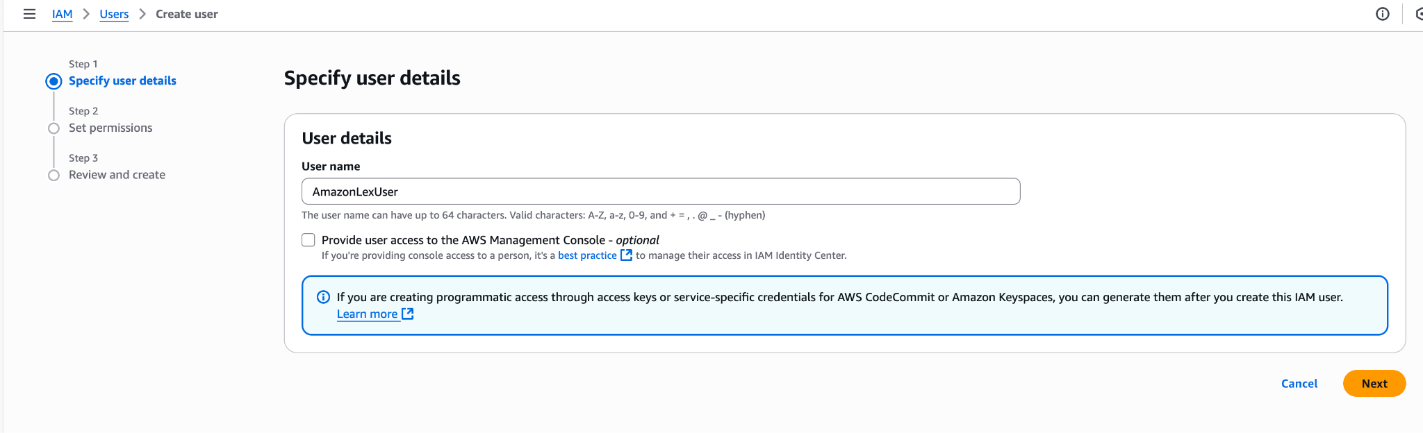
- Under Set permissions, select Attach existing policies directly to add policies to IAM users for accessing the Amazon Lex bot.
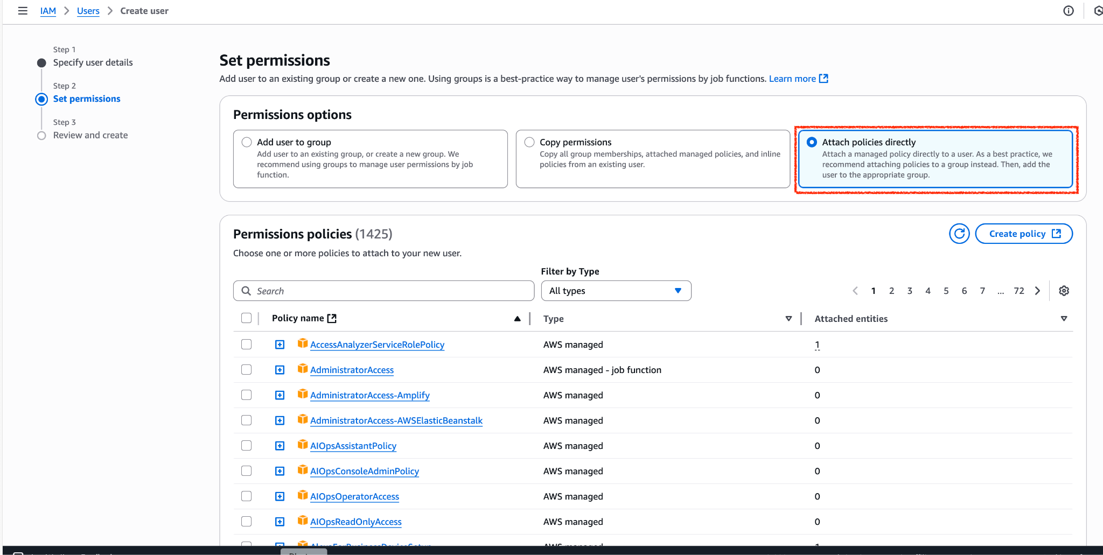
- Search Amazonlex in the search bar to search for the respective policies. Add all the three policies as shown in the image and click Next.
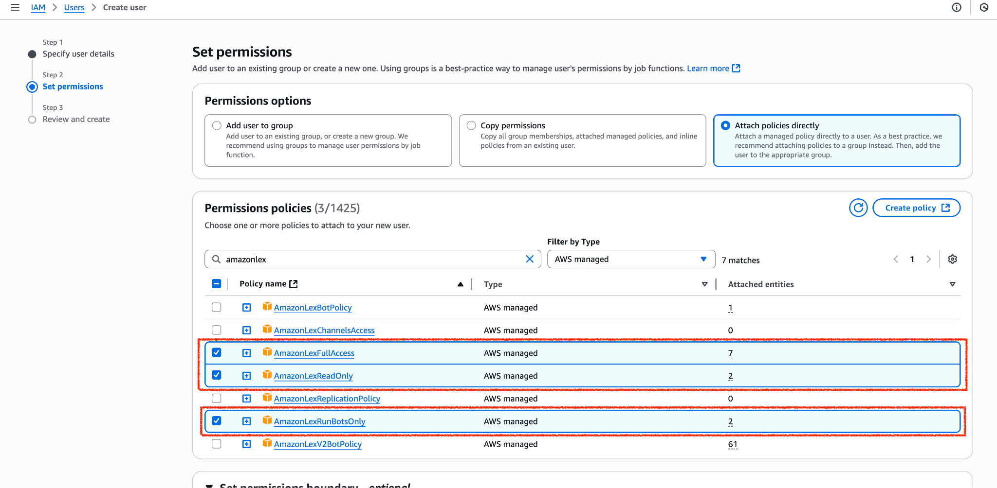

- Add Tags based on your requirement and click Next: Create User.
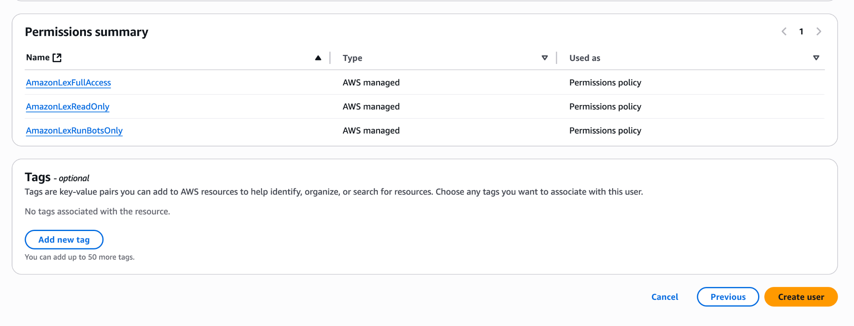
Note: Adding Tags is not mandatory.
- Under Permission summary check whether all the three policies that are required to access the Amazon Lex bot are added and click Create User.
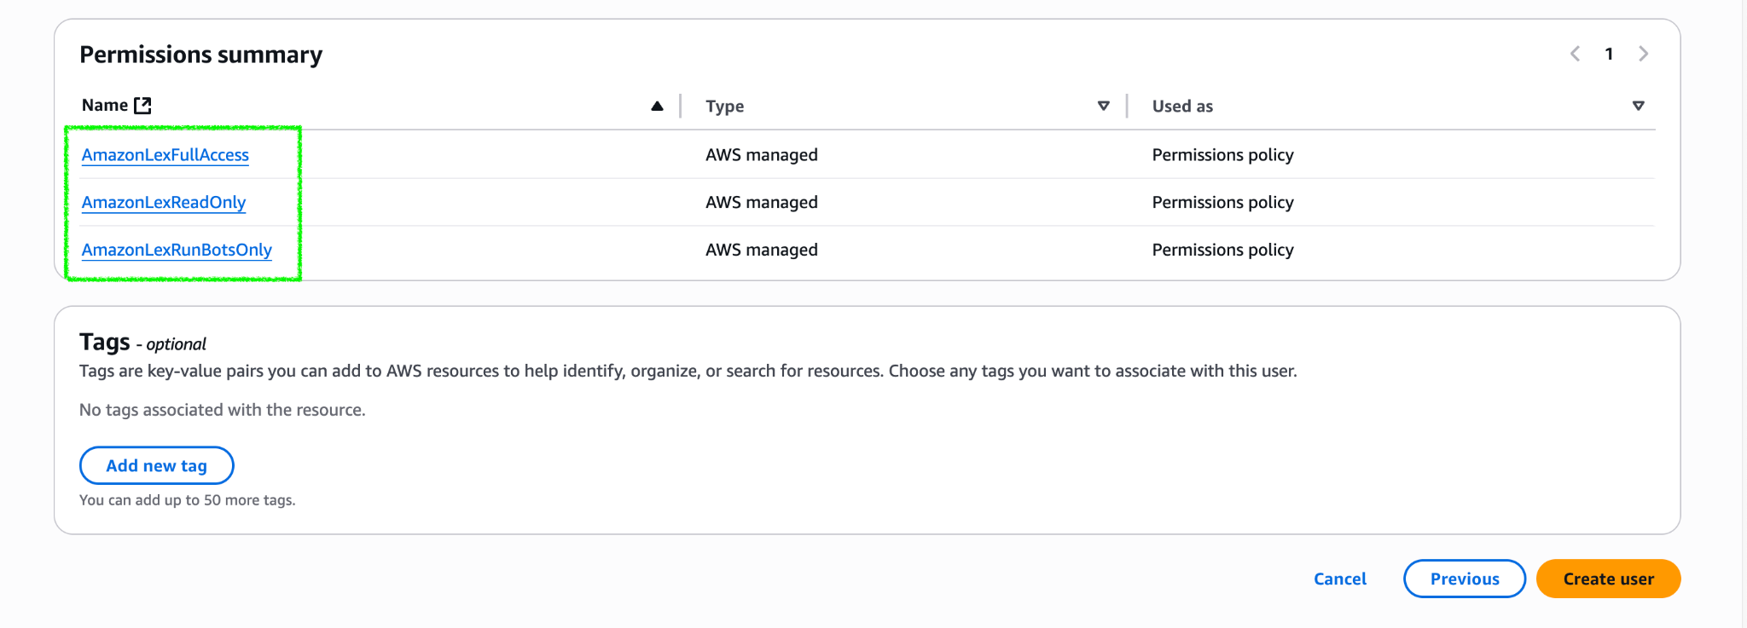
- A success message appears on a user creation as shown in the following image.
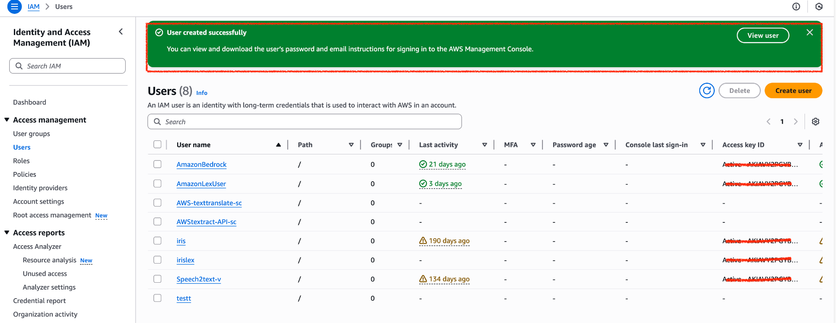
- Click on view user and create access key
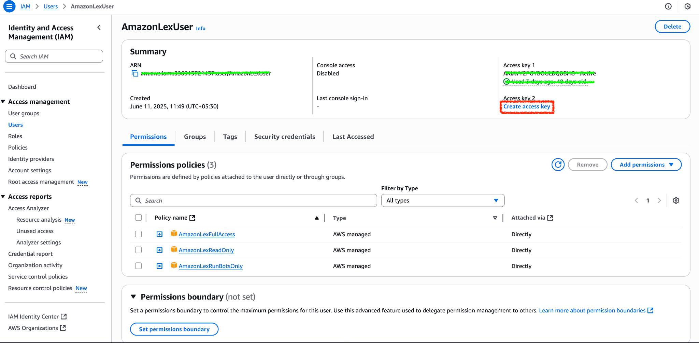
- Under Access key best practices & alternatives select other and click next to create access key.
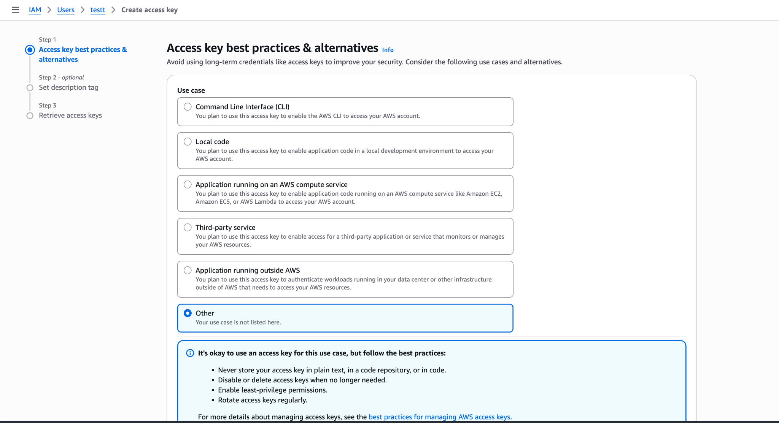
- Click Download .csv to download the .CSV file that contains AWS Access Key, AWS Secret Key and other information, which is required to access Amazon Lex bots.
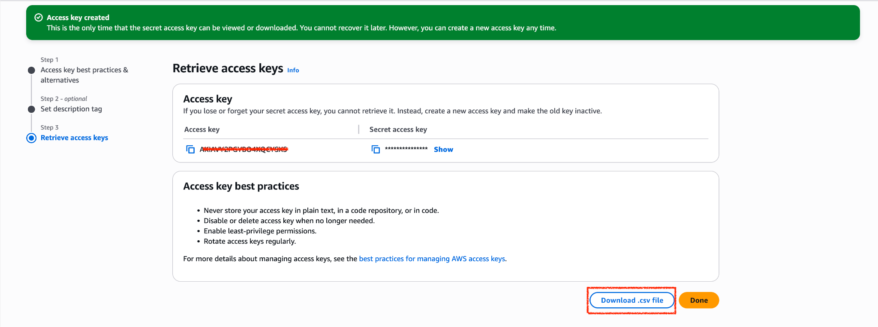
Note: Make sure that you download the credentials or copy the Access Key ID and Secret Access Key to a file.

Volt MX Iris Project Setup
To run the chatbot, you have to configure the Volt MX Iris project as follows:
- Set Operation Security Level
- Publish the HCL Volt MX Foundry App
- Add NLP Configurations
- Provide Permissions
- Refresh the Project
Note: Before you configure your Volt MX Iris project, ensure that you have imported the chatbot to your Volt MX Iris Project. For more information about how to import the chatbot to your Volt MX Iris project, refer to the Import the Project section on the References page.

Set Operation Security Level
When you import the chatbot to your Volt MX Iris project, the HCL Volt MX Foundry services of the chatbot are added to the HCL Volt MX Foundry app, which is associated with the Volt MX Iris project. While importing the chatbot to your Volt MX Iris project, if there is no HCL Volt MX Foundry app associated with the existing Volt MX Iris project, a new HCL Volt MX Foundry app is automatically added to your HCL Volt MX Foundry environment and is associated with your Volt MX Iris.
To set the Operation Security Level, follow these steps:
- Click the HCL Volt MX Foundry app associated with your Volt MX Iris project from the Project Explorer. Click DATA & SERVICES
- Under the Configure Services tab, click Integration and then click the voltmxmpBotFramework Integration service.

- On the right pane, expand the voltmxmpBotFramework service and then select the voltmxmpVoltmxClient operation.

- For the voltmxmpVoltmxClient operation, you can set the Operation Security Level based on your requirement. By default, the Operation Security Level is set as Authenticated App Users, which does not allow you to access the chatbot if your authentication fails. Only if the authentication is successful, you will be able to access the chatbot.
- You can set the Operation Security Level as Public, if you do not require any authentication for your app. Any individual can then access the app.
Note: For your convenience, set the Operation Security Level as Public. If you set the Operation Security Level as Authenticated App User, ensure that you configure the credentials in the Identity service of your app.
- Save the operation, and then click the icon to go back to Volt MX Iris.

Publish the HCL Volt MX Foundry App
After you set the Operation Security Level, you must publish the HCL Volt MX Foundry app. To publish the HCL Volt MX Foundry, follow these steps:
- In Volt MX Iris, click DATA & SERVICES, and then click Publish Project Services to Publish to your foundry app.

- Select the environment to which you want to publish your app, and then click Publish.
- After the app is published to your environment, the following window appears confirming the publish.

Add NLP Configurations
After publishing your app, you must configure the NLP settings. To configure your NLP settings, follow these steps:
- On the left navigation pane, click the icon to go back to Volt MX Iris from the Publish page.
- On the Project Explorer, go to the form that contains the chatbot and then select the chatBot.
- On the Properties panel, click the Action tab, and then go to the Chatbot → nConfiguration event. Click Edit.
- Open the Code Snippet attached to the nConfiguration event.
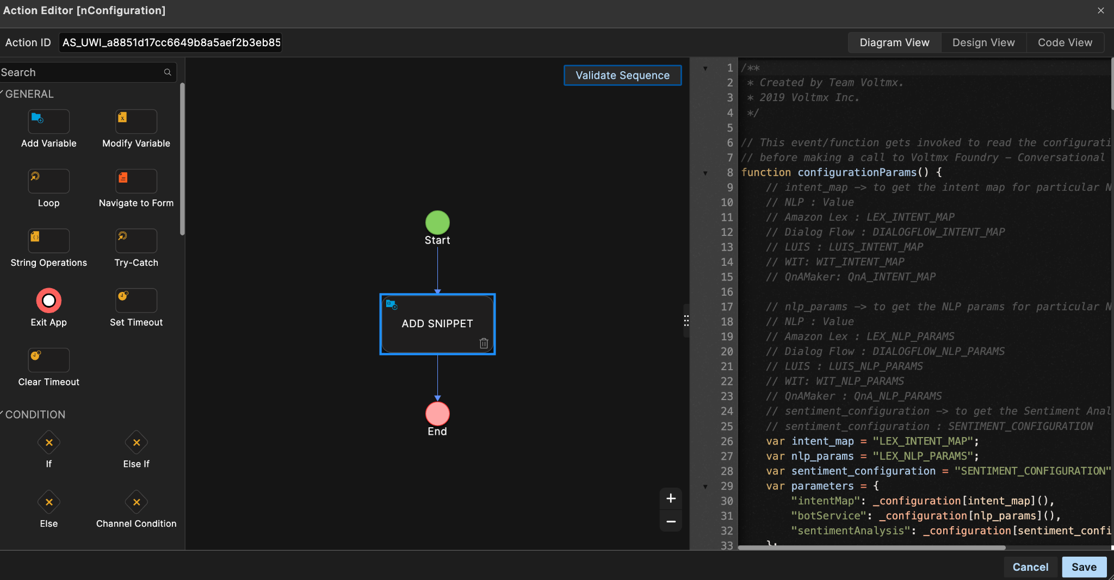
- In the code snippet, change the values of the intent_map and nlp_params as shown in the given screenshot.
Note: The intent_map and nlp_params should be the same as Foundry NLP Configurations.
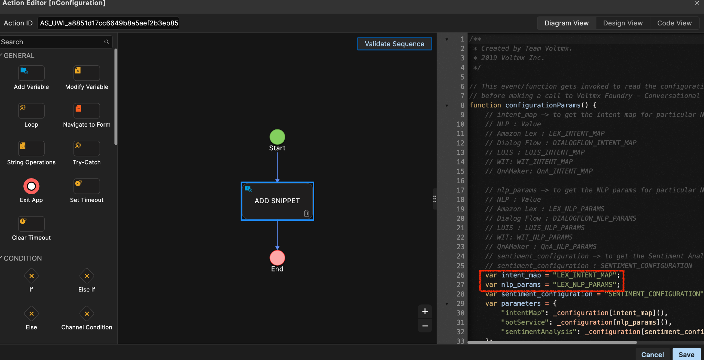

Provide Permissions
Before you build the project, you must provide the necessary permissions for the chatbot to run. The permissions vary based on the platform (Android and iOS). For more information about how to provide the necessary information, refer to the Prerequisites section for Android and iOS on the Reference page.

Refresh the Project

You must refresh the Volt MX Iris project to update the infoplist_configuration.json file. To refresh
the project, open Project from the main menu, and then click Refresh.

Build the Project
The final step before you run the chatbot, is to build the Volt MX Iris project. To build your project, follow these steps:
- From the main menu, open Build, and then click Build Native Local..
The Build Generation window appears.

- Under Platform and Channels, select the iOS and Android Mobile platforms, and then click Build.

- On a successful build, a build confirmation window appears as shown in the following image.

Advanced Setup

Amazon Lex Bot Setup
For information about how to set up Amazon Lex, refer Amazon Lex Setup.

Volt MX Iris Project Setup
To run the chatbot, you must configure the Volt MX Iris project as follows:
- Configure HCL Foundry
- Publish the HCL Foundry App
- Provide Permissions
- Build the Project
Note: Before you configure your Volt MX Iris project, you must import the chatbot to your Volt MX Iris project. For more information about how to import the chatbot to your Volt MX Iris project, refer to the Import the Project section on the References page.

Configure HCL Foundry
When you import the chatbot to your Volt MX Iris project, the HCL Foundry services of the chatbot are added to the HCL Foundry app, which is associated with the Volt MX Iris project. While importing the chatbot to your Volt MX Iris project, if there is no HCL Foundry app associated with the existing Iris project, a new HCL Foundry app is automatically added to your HCL Foundry environment and is associated with your Volt MX Iris.
To configure the HCL Foundry app for the chatbot that you imported to your Amazon Lex console, follow these steps:
- From the Project Explorer on Volt MX Iris, click DATA & SERVICES.
- In the HCL Foundry window, under the Integration tab, expand the service and then select the voltmxmpVoltmxClient operation.
- In the operation configuration, expand the Advanced section.
- Under Custom Code Invocation, for Preprocessor, click Expand.
- In the code snippet, change the intent_map and nlp_params parameter values in the configurationParams function with Amazon Lex values LEX_INTENT_MAP and LEX_NLP_PARAMS respectively
- In the lexConfiguration function, add the bot details such as.AWS Secret Key, AWS Access key that you downloaded earlier to the missing details. Add the Locale Id, Bot Id, and BotAlias Id from bot and Region Name to the regionName key. You can find a suitable region from the AWS Regions and Endpoints.
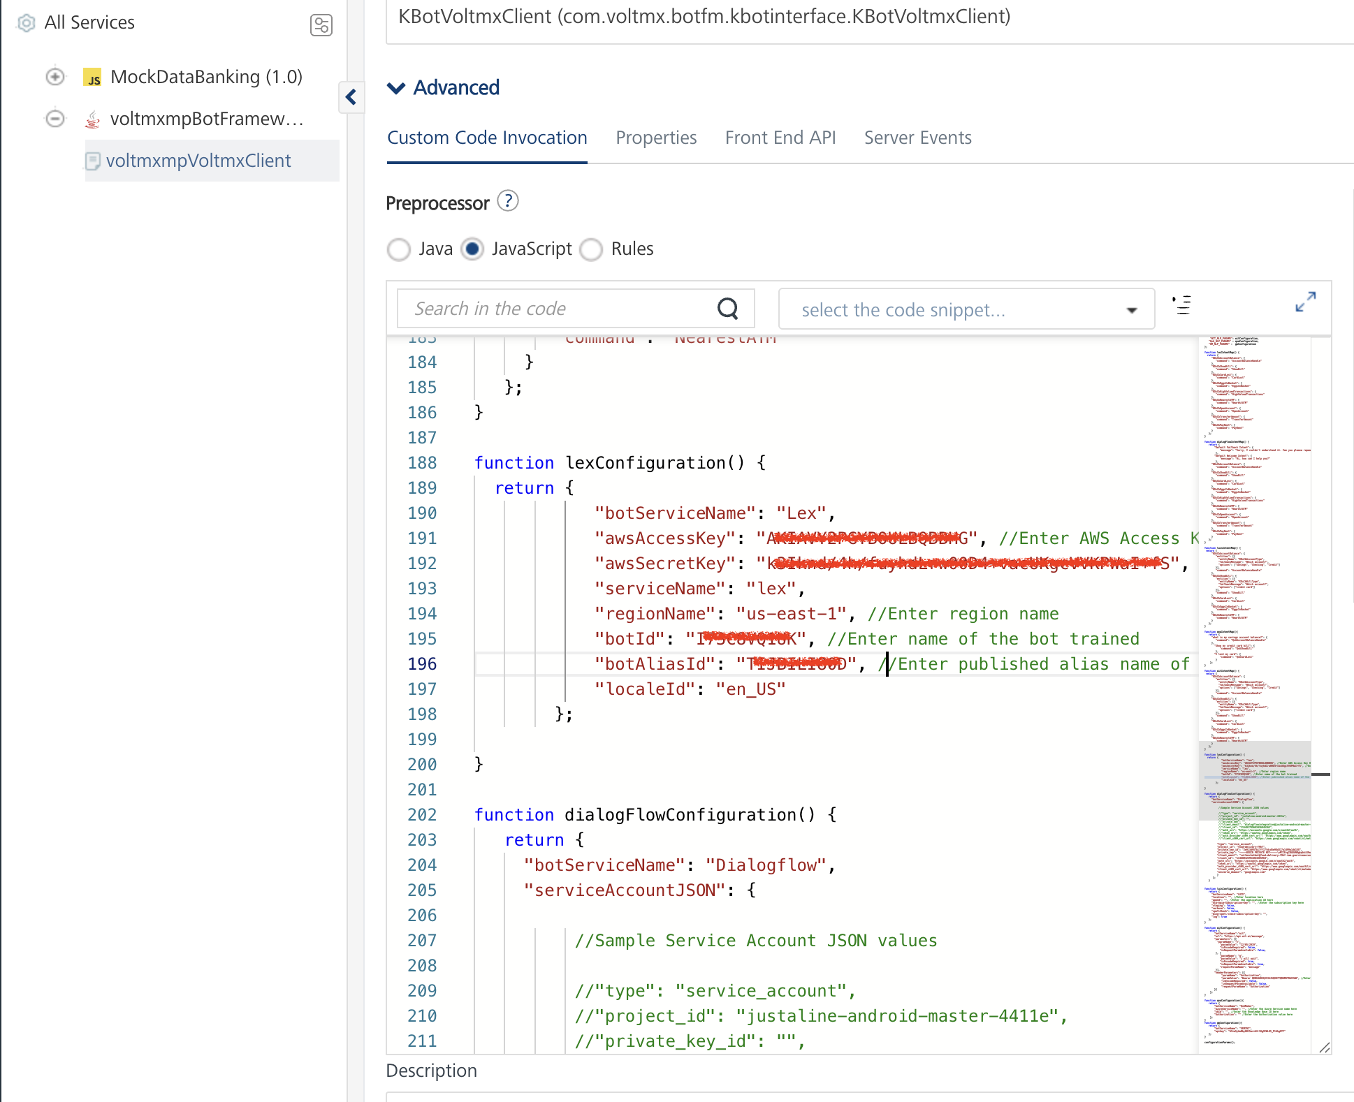
- Click Save Operation.
- Click the icon to go back to Volt MX Iris.

Publish the HCL Foundry App
For information about how to publish the HCL Foundry app, refer to the Publishing the HCL Foundry App section.

Provide Permissions
Before you build the project, you must provide the necessary permissions for the chatbot to run. The permissions vary based on the platform (Android and iOS). For more information about how to provide the necessary information, refer to the Prerequisites section for Android and iOS on the Reference page.

Build the Project
For information about how to build the app, refer to the Build the Project section.

Set Up the Chatbot - Command Handling at HCL Volt MX Foundry
Command Handling in Chatbot is the step required to execute the core business logic after the NLP returns the Intent based on the user's query. Command Handling can be done either at HCL Volt MX Foundry or at Volt MX Iris.
For every response returned by the NLP, the Chatbot flow reaches the command handling method. A Chatbot consumer can decide whether to handle the commands for every query or for only some queries corresponding to specific Dialog States/Intents.
Command Handling at HCL Volt MX Foundry can be done using a hook provided to the Chatbot consumer at HCL Volt MX Foundry.
Note: Download a sample Command Handling project from here.

Create a Command Handling Package
Create a Java package with name com.voltmx.botfm.onresponse, as shown in the given images.

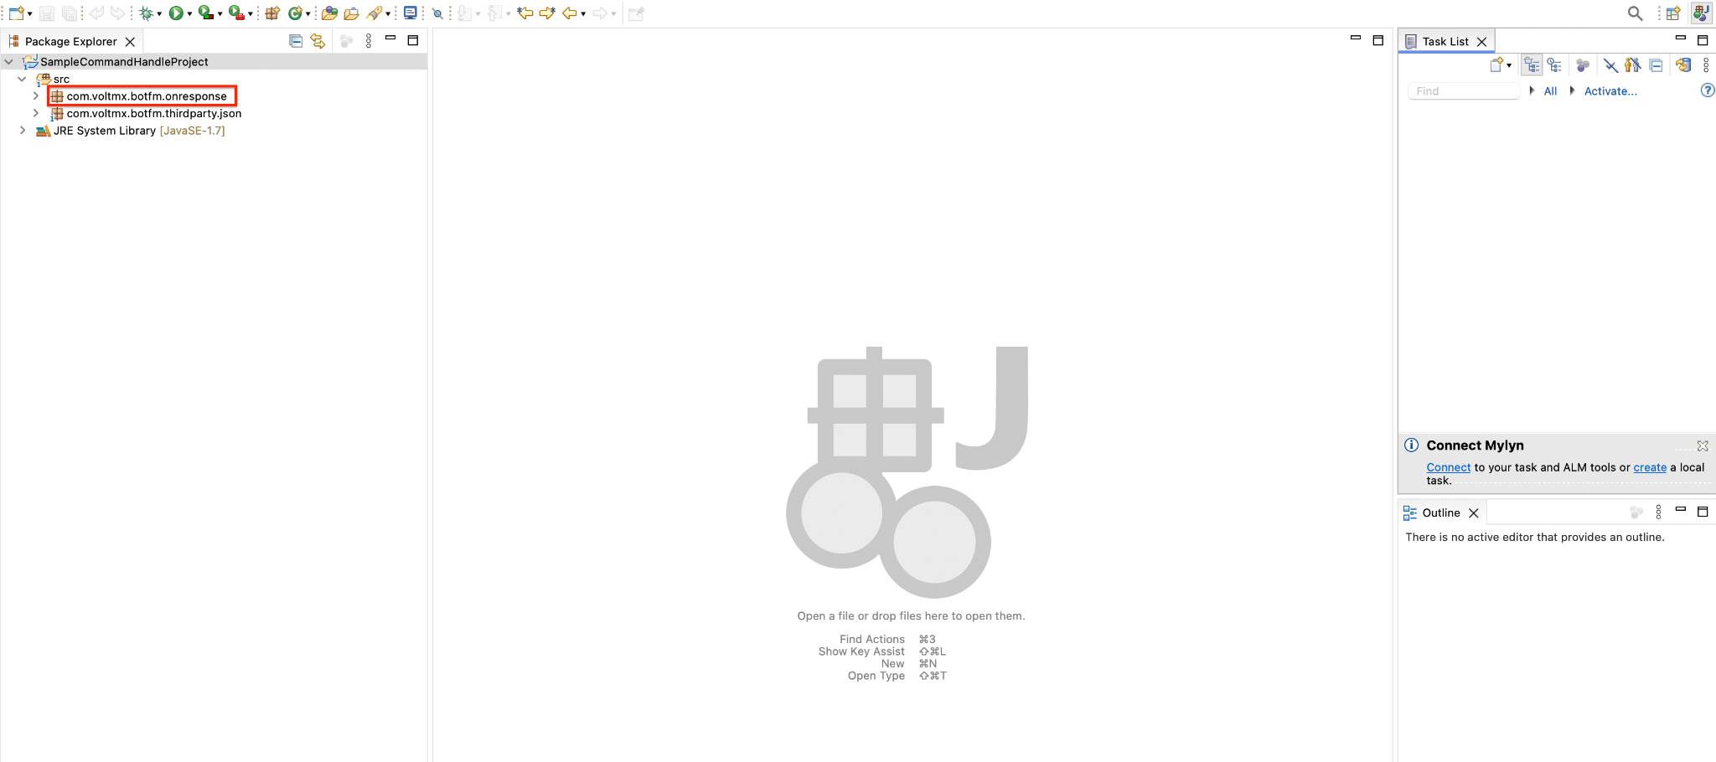

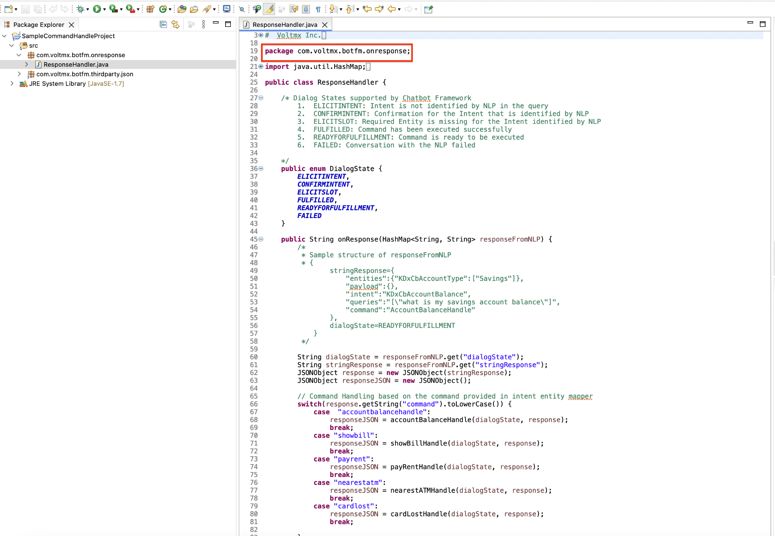

Create a Command Handling Class
Create a Java class named ResponseHandler under the package com.voltmx.botfm.onresponse.

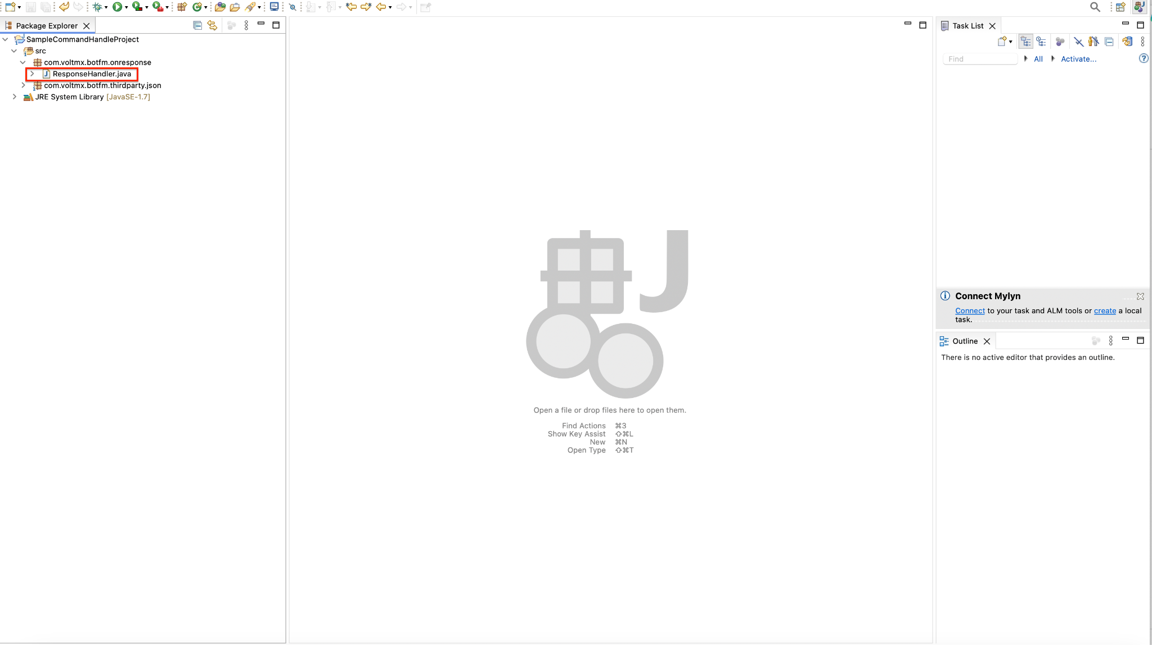

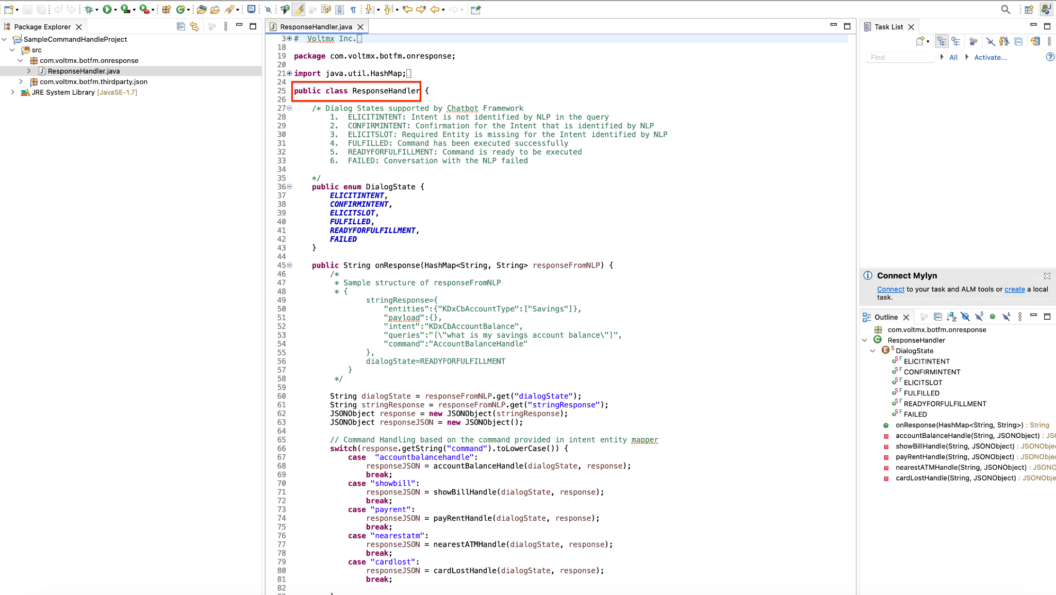

Create Command Handling Method
Create a Java method named onResponse in the ResponseHandler class having the signature:
public String onResponse(HashMap<String, String> responseFromNLP)

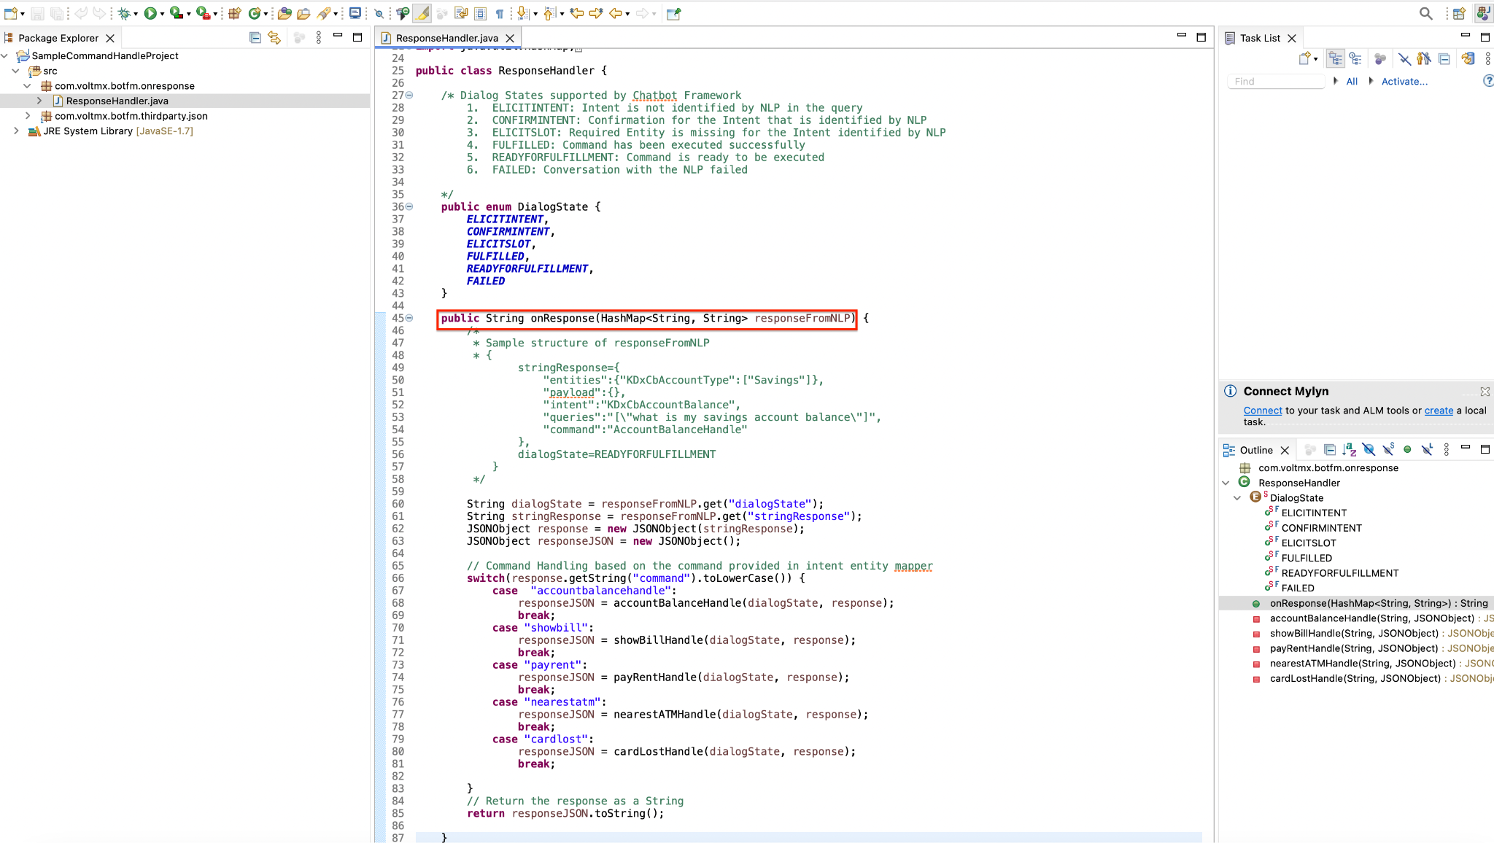

Structure of the responseFromNLP parameter
The parameter to onResponse method is a Java HashMap data structure with both the arguments of type String.
Example data received as a HashMap parameter to onResponse method:
responseFromNLP: {
stringResponse = {
"entities": {
"KDxCbAccountType": ["Savings"]
},
"intent": "KDxCbAccountBalance",
"queries": "[\"what is my savings account balance\"]",
"command": "AccountBalanceHandle",
"uniqueID": "123abc"
},
dialogState = READYFORFULFILLMENT
}

// Accessing
String dialogState = responseFromNLP.get("dialogState");
String stringResponse = responseFromNLP.get("stringResponse");
JSONObject response = new JSONObject(stringResponse);
String uniqueID = response.get("uniqueID");

The parameter to onResponse method contains two key-value pairs:
I. dialogState
The dialogState represents the current state of conversation. It is of the type String and contains a value from the following Dialog states:
- ELICITINTENT: Intent is not identified by NLP in the query
- CONFIRMINTENT: Confirmation for the Intent that is identified by NLP
- ELICITSLOT: Required Entity is missing for the Intent identified by NLP
- FULFILLED: Command has been executed successfully
- READYFORFULFILLMENT: Command is ready to be executed
- FAILED: Conversation with the NLP failed

II. stringResponse
The stringResponse parameter is of the type String and it is the string format of JSON containing the values required to handle the command. The stringResponse contains following key-value pairs:
- entities: Name of the entities and value assigned to each of the entities
- intent: Intent that is identified by the NLP and needs to be handled
- queries: List of queries received by NLP for this intent in order to fulfill
- command: Command provided in the intent entity mapper corresponding to the intent
- uniqueID: The uniqueID parameter is of type String and is a unique value associated to each end user. It is required to differentiate multiple end users while handling the command.
Sample stringResponse format:
stringResponse = {
"entities": {
"KDxCbAccountType": ["Savings"]
},
"intent": "KDxCbAccountBalance",
"queries": "[\"what is my savings account balance\"]",

"command": "AccountBalanceHandle",

"uniqueID": "123abc"
}

Export the Project as JAR after adding the response
- Click on Export after adding the code to fetch response from LOB
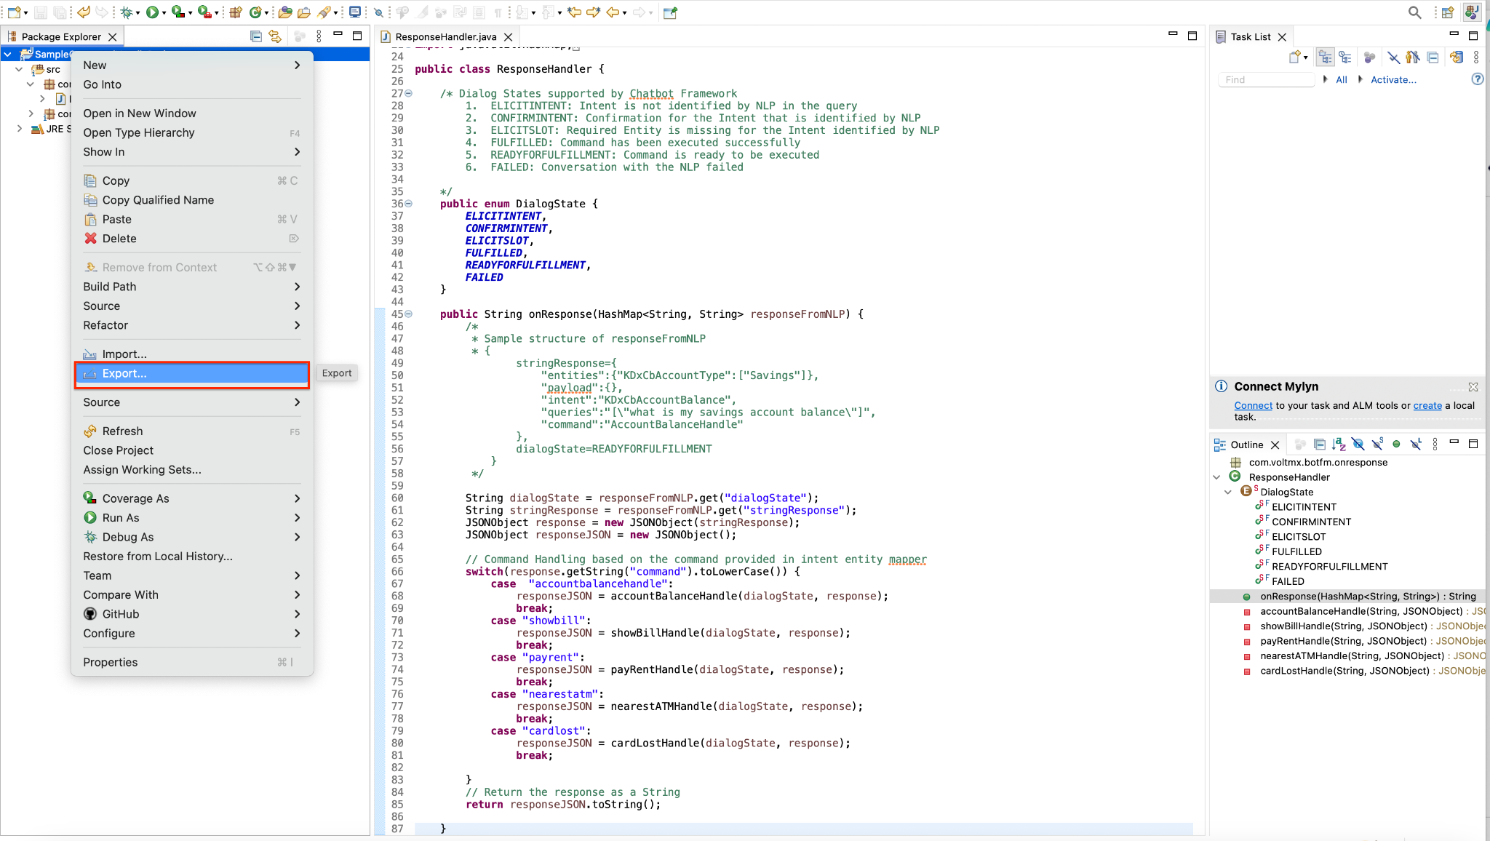

- Select JAR under Java to export the Project as a JAR file
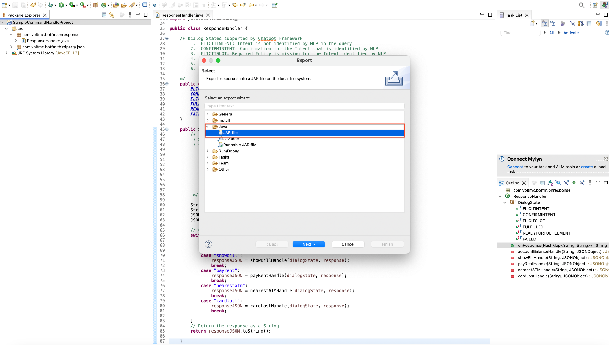

- Select the Export Java source files and resources to pack the source files along with the JAR, which could be used for debugging. Also Select the export destination path to place the exported JAR.
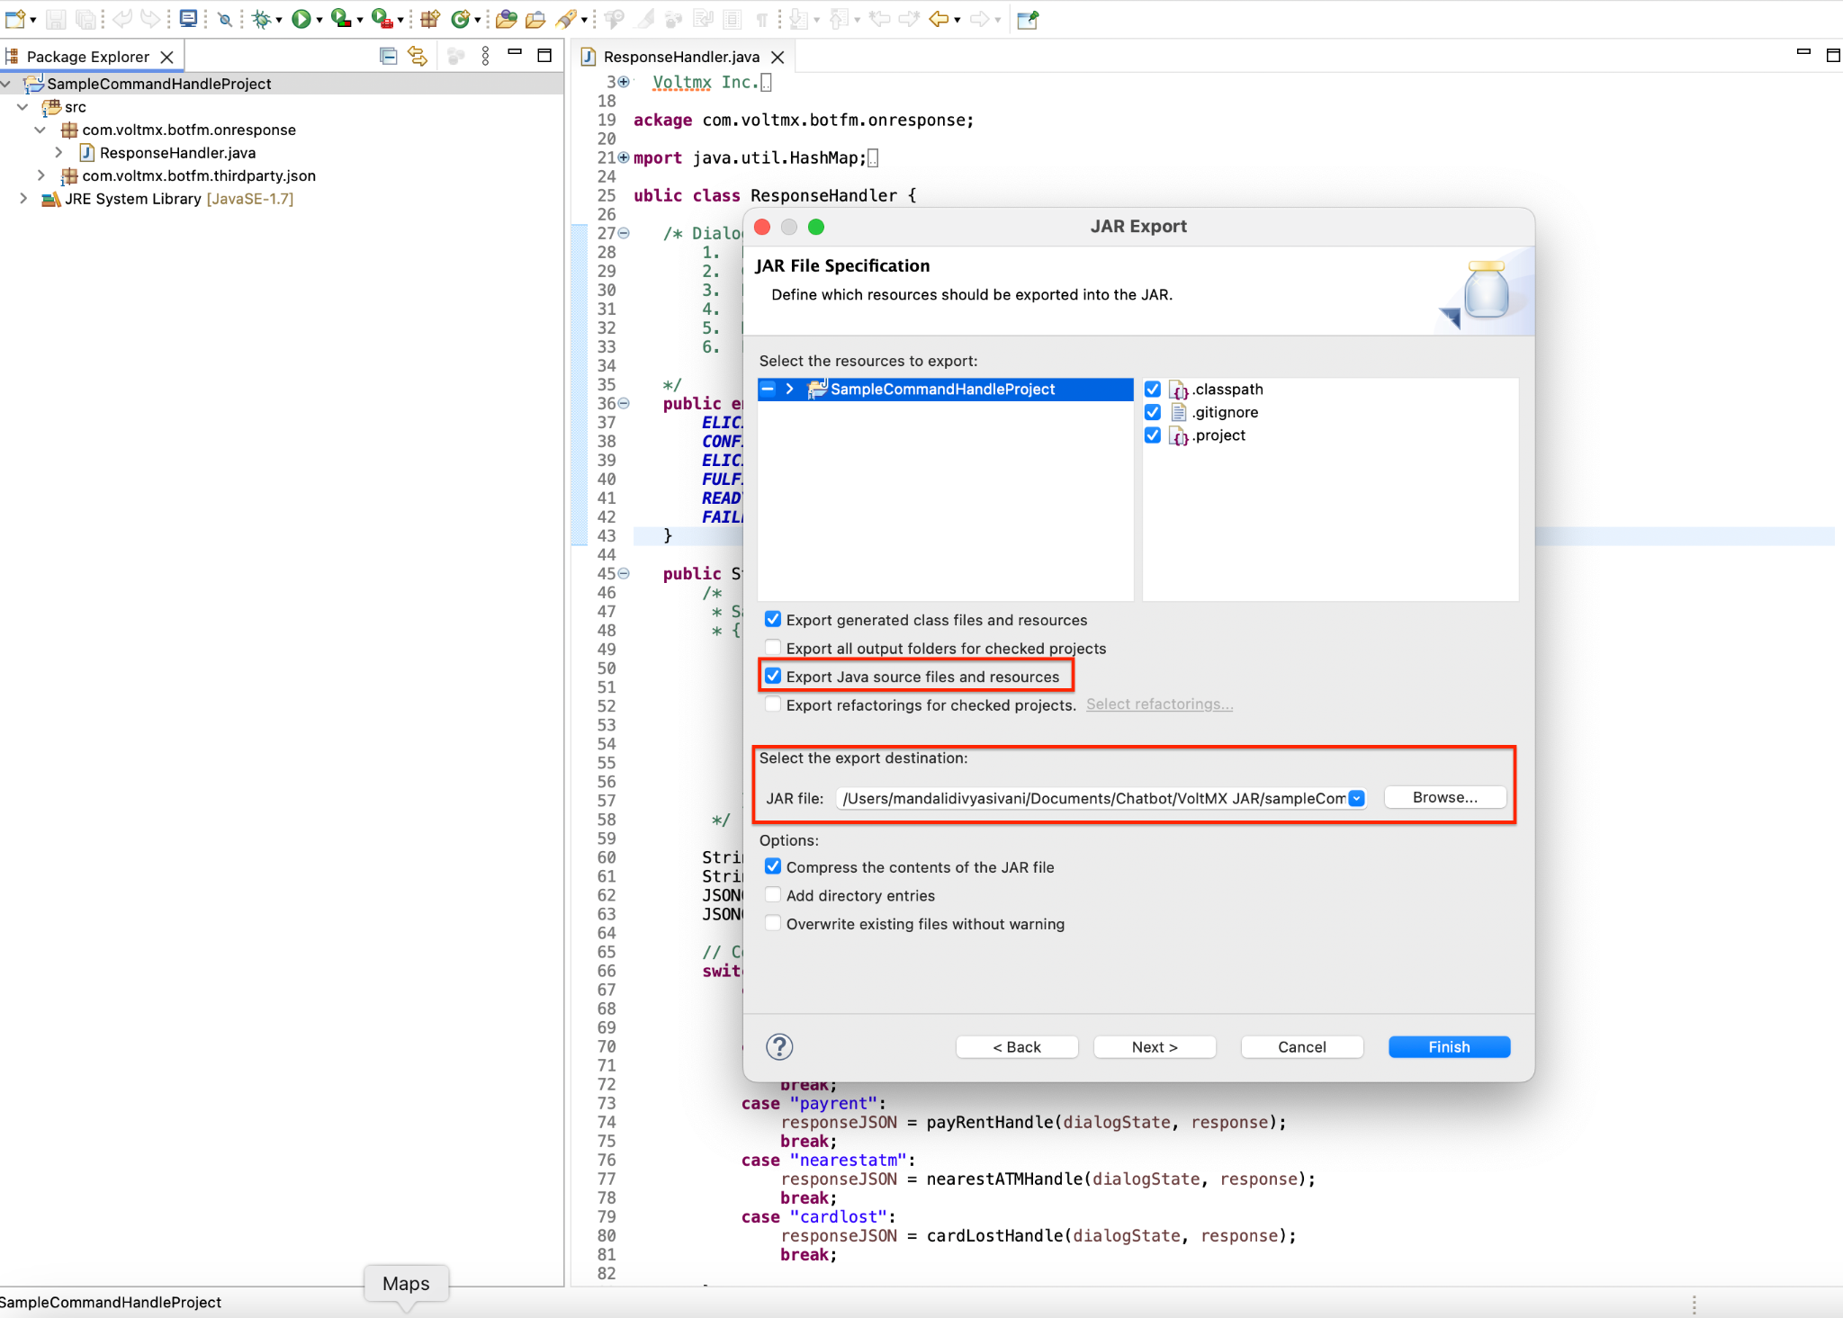

Deploy the exported Command Handle JAR in HCL Volt MX Foundry

- Login to HCL Volt MX Foundry and open the Foundry app containing the Chatbot Foundry services
- Select Integration tab under Configure Services to open the Integration services in Chatbot
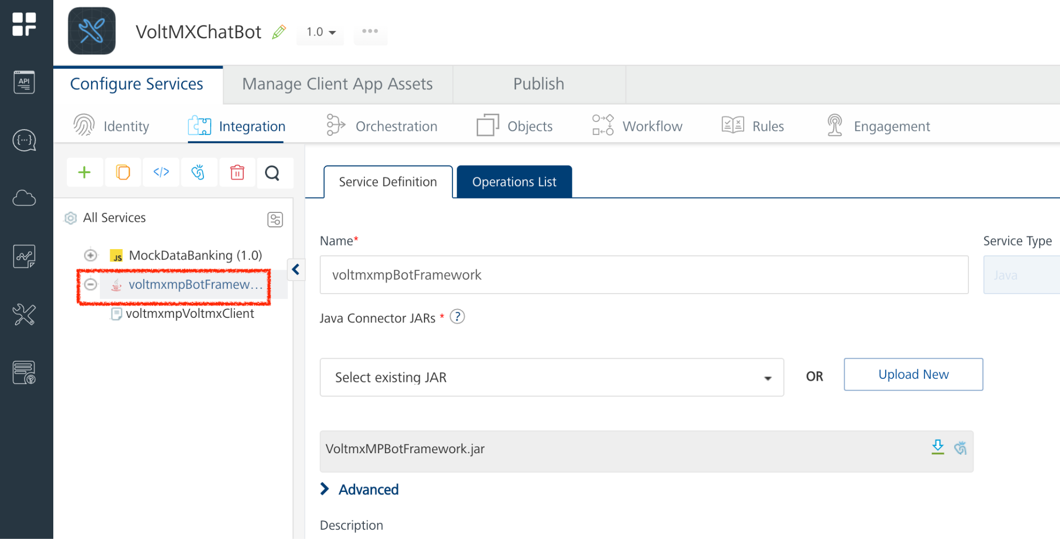
- Click on the Chatbot Integration service to open the service
- Expand the Advanced option to open the advanced options under the Integration service.
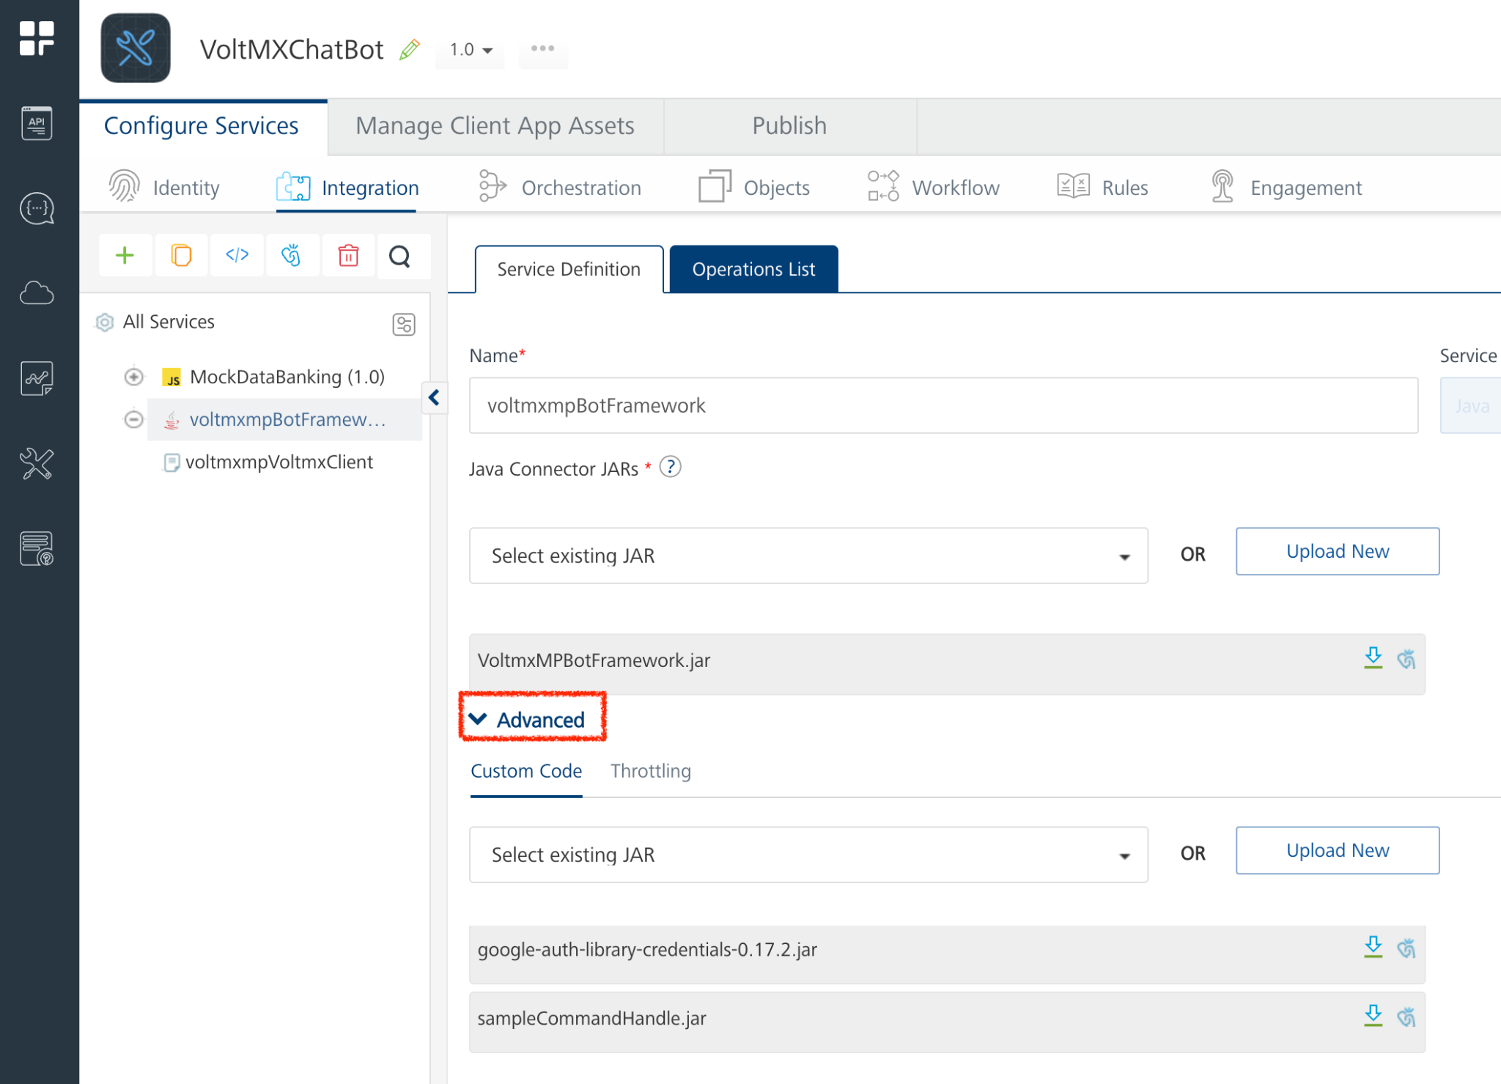
- Unlink the command handle JAR if it already exists.
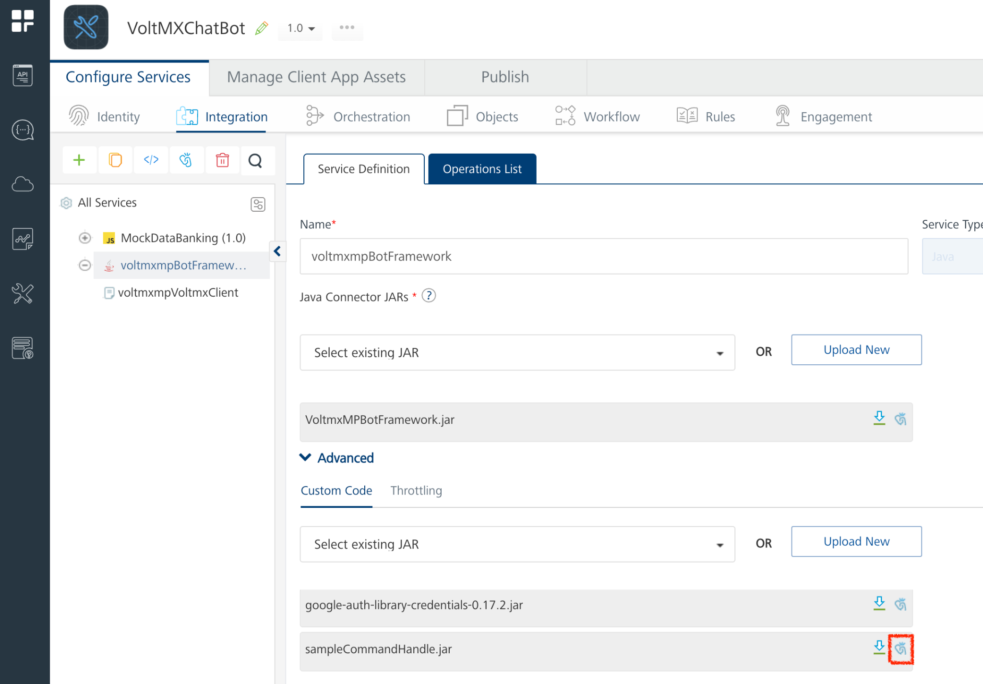

- Select Confirm to Unlink the resource
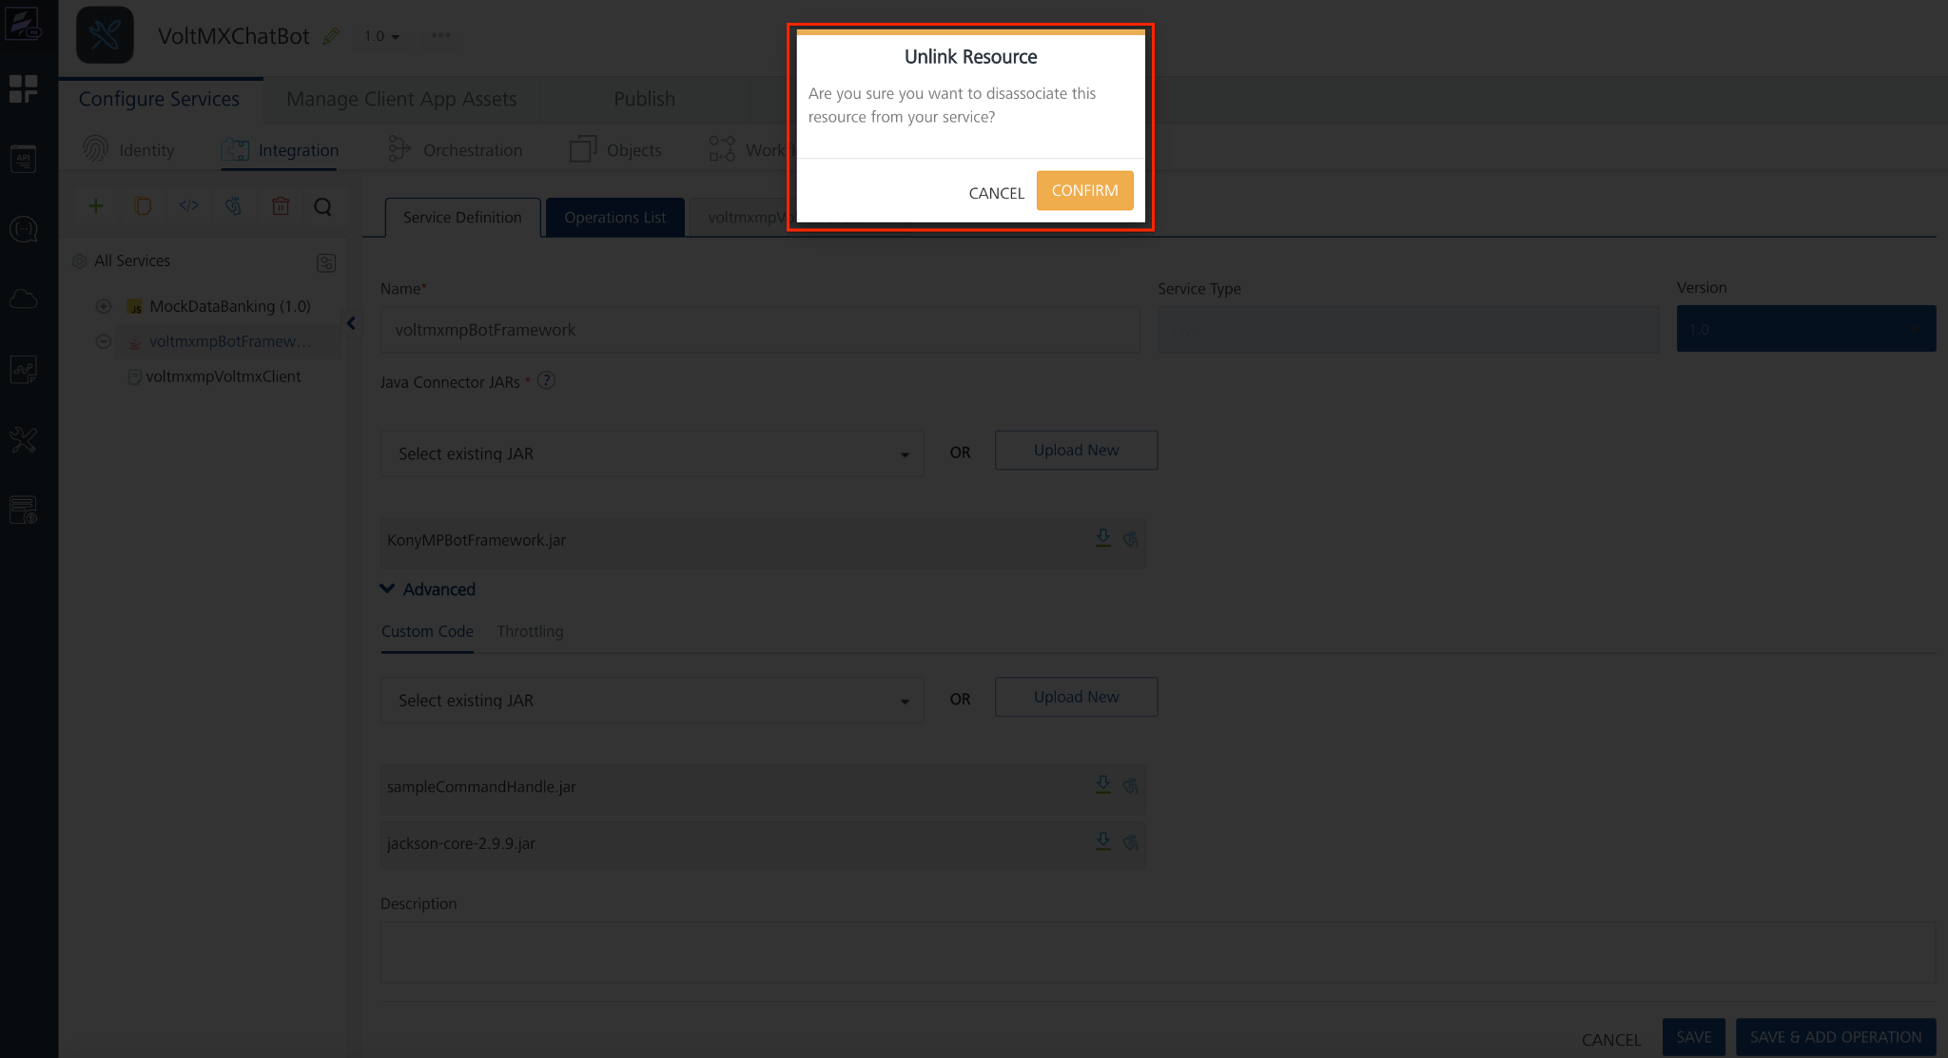

- Click on Upload New to upload the latest Command Handle JAR
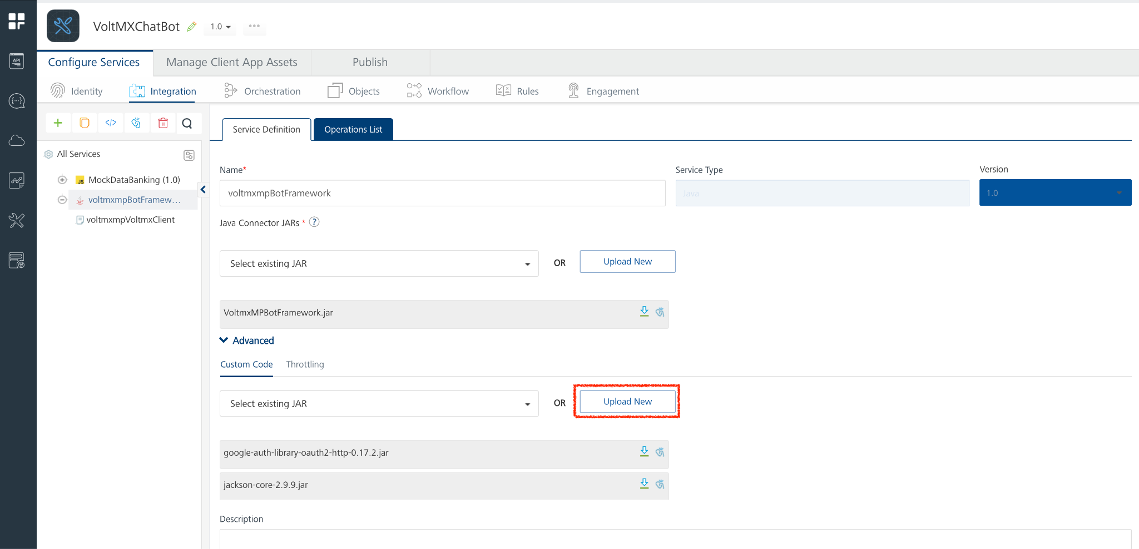
- Select the exported JAR from file browser and click on Choose
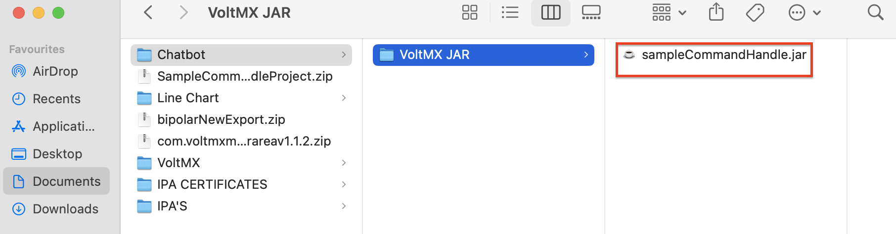
- Click on Save to successfully save the updated resource of the Integration service

Publish the HCL Volt MX Foundry app

- Select Publish tab to open the Volt MX Foundry app Publish console
- Select the environment to which the Volt MX Foundry app is to be published and then click on Publish.
Make sure that the Volt MX Foundry app is published successfully.

Test the deployed Command Handle JAR

- After publishing the app, click on Integration to open the App Services console
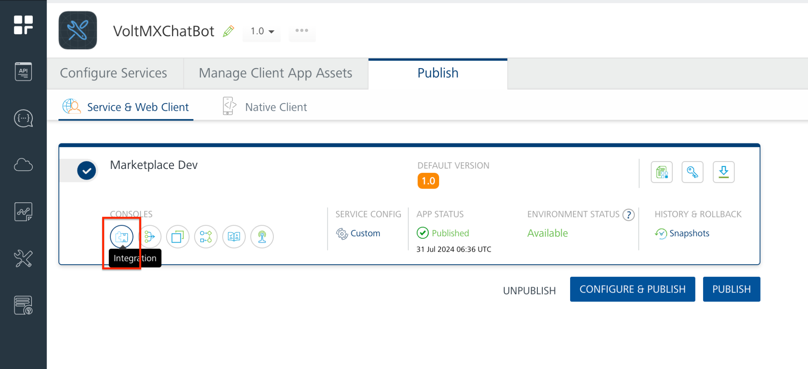
- Select the Operation connected to Chatbot services
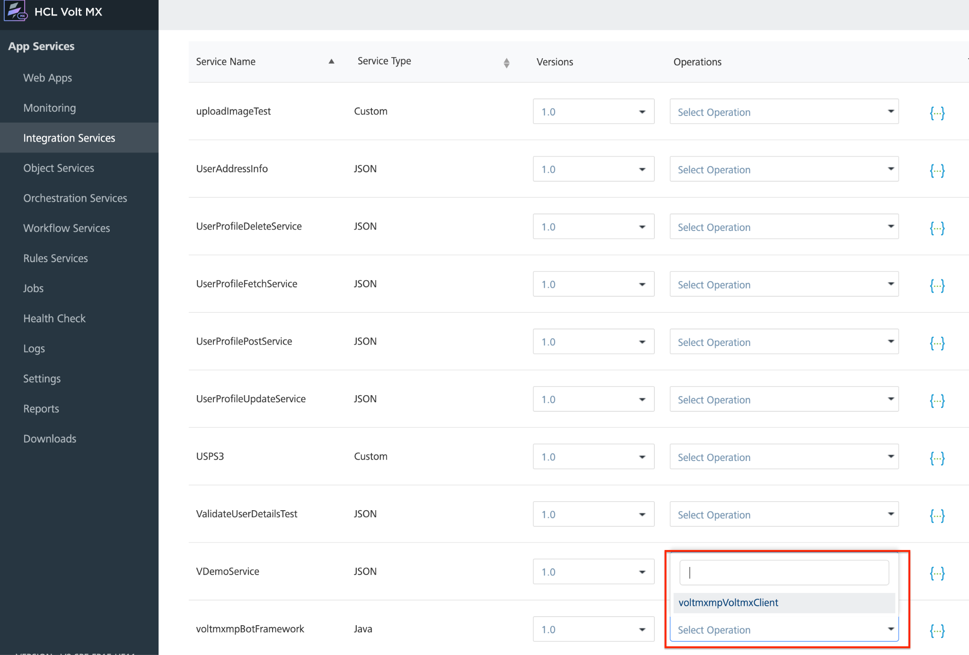
- Change the message and other input parameters to test the functionality of handled commands.
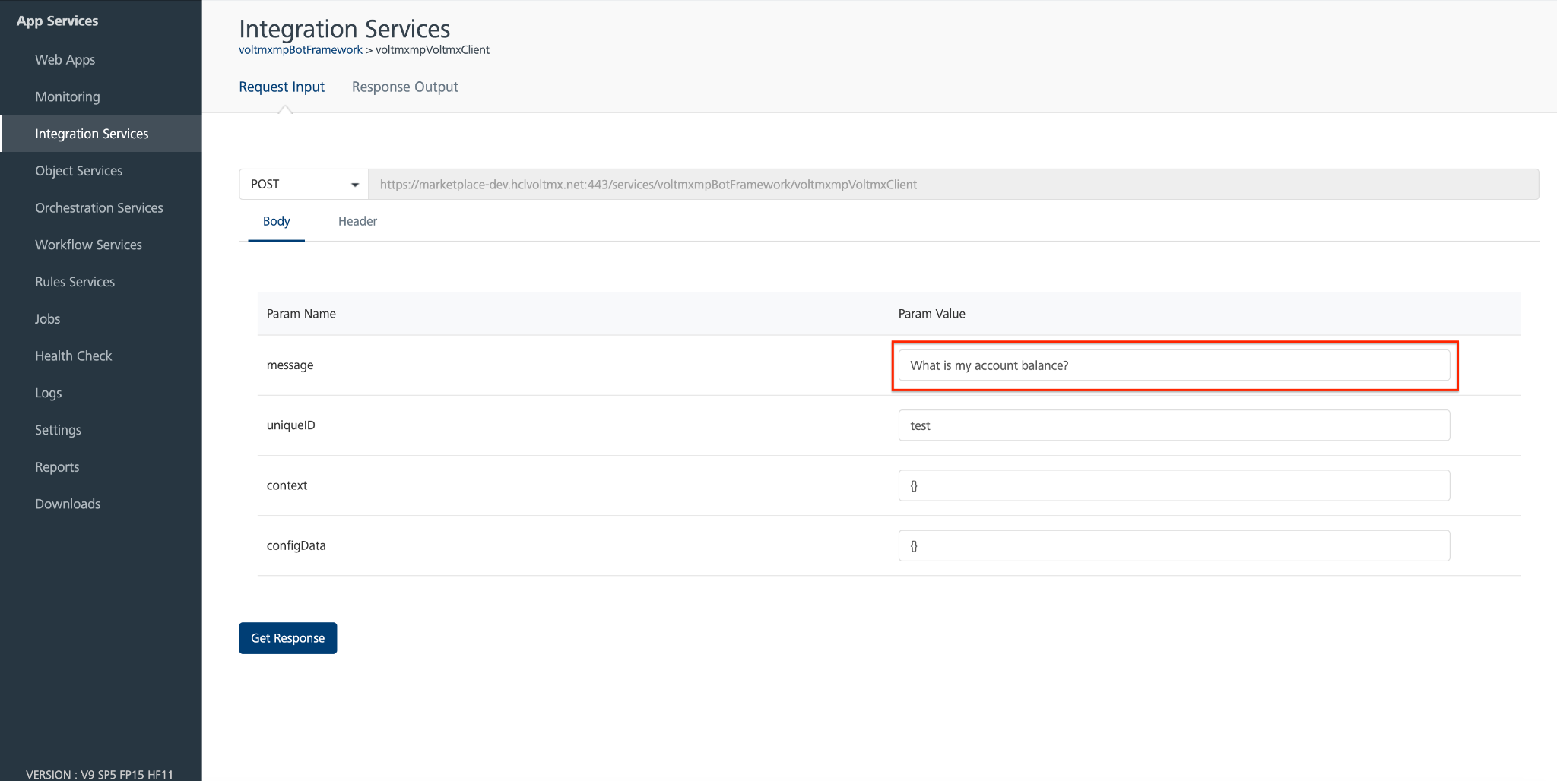

- Click on Get Response to fetch response from NLP and handle command in deployed JAR
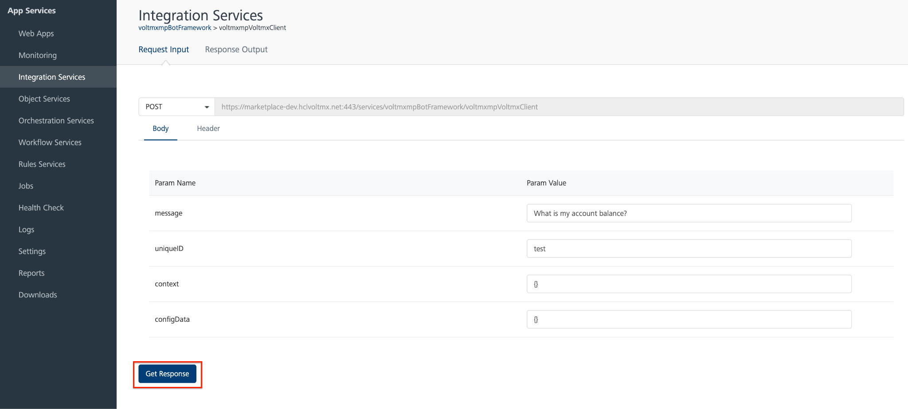

- Check whether the response message is same as the message set during command handling

VoltMX Conversational AI Chatbot Framework References
This is a reference document for the Voltmx's Conversational AI Dev Toolkit. It contains information about the framework's Properties, Skins, Events, and APIs. This document also includes details on the chatbot functionality and provides certain code examples.
You can set up the chatbot by using Dialogflow V2, Wit.ai, Amazon lex and Command Handling.

VoltMX Conversational AI Chatbot Functionality
The chatbot functionality is divided into three broad categories:
- User Interface
- Middle Ware
- Bot Service
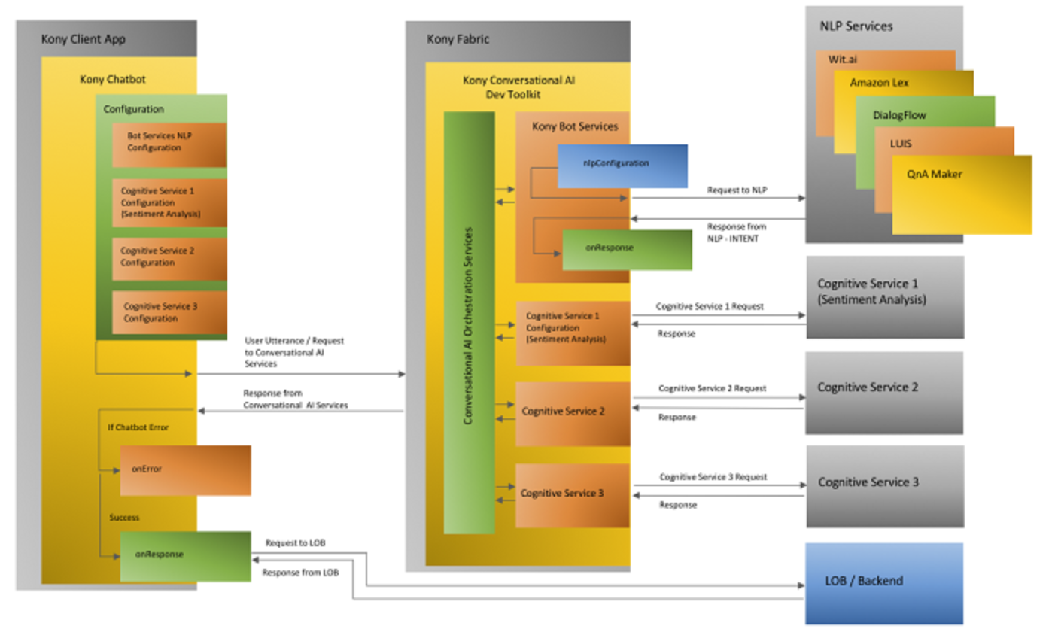

User Interface
The User Interface handles the client-side application. The client-side application consists of multiple templates and a speech to text component. The templates are as follows:
- Option and Quick Replies Templates
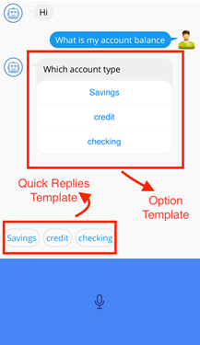
- PDF Template

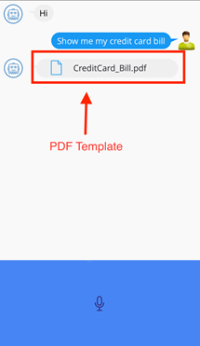

- Location Template
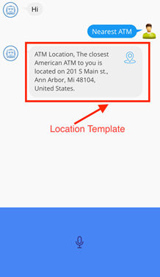
- Hyperlink Template
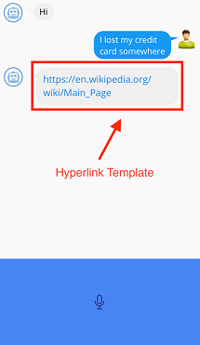
- Rich Text Template
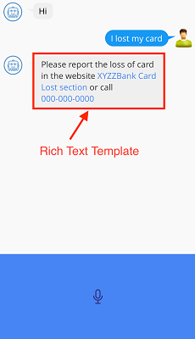
- The User Interface also contains a Speech to Text component.
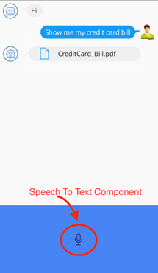

Prerequisites
- HCL Foundry
- Volt MX Iris

Android
- Add Permissions
- Open Iris
- Click the Settings icon from the left navigation bar to open the Project Settings window.
- Navigate to Native → Android → Mobile/ Tablet. Scroll down and under Manifest Properties & Gradle Build Entries navigate to Permissions.
- Select RECORD_AUDIO and INTERNET permissions and click Add.
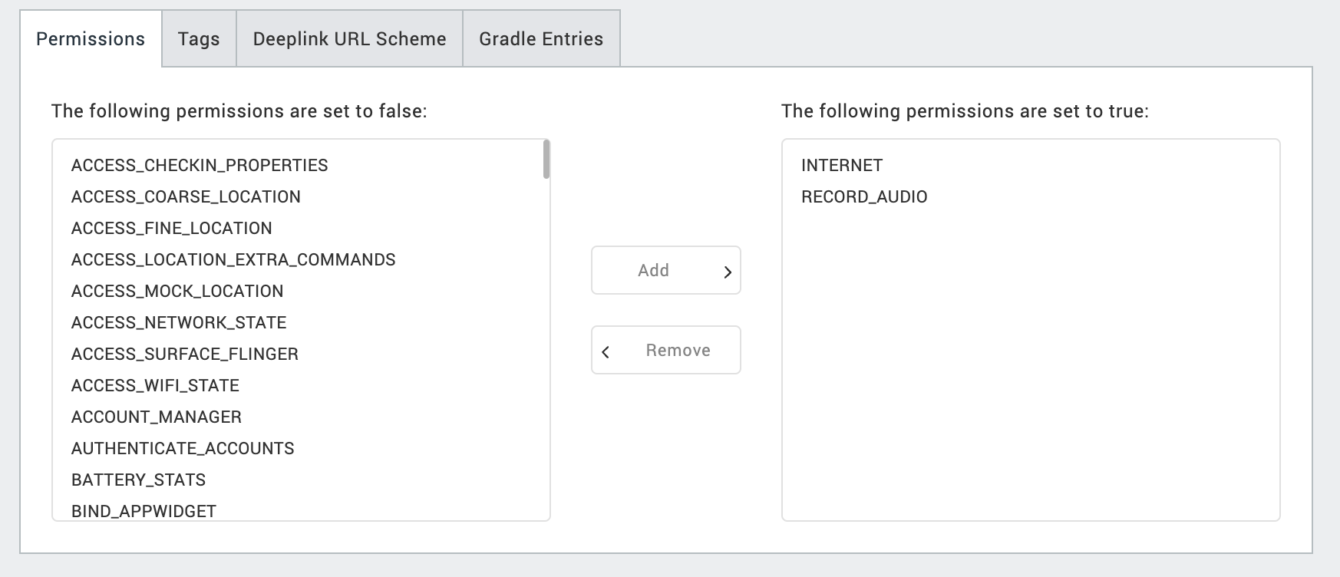
- Under Manifest tag add this
<queries>
<intent>
<action
android:name="android.speech.RecognitionService"/>
</intent>
</queries>

IOS
- Add Permissions
- Open Iris.
- In the Assets Explorer, right click Media and select Resource Location.
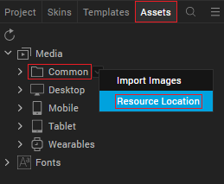
- Navigate to VoltMXDXChatbot→ resources→ common→ infoplist_configuration.json file. This file contains the Microphone usage and Speech Recognition descriptions.
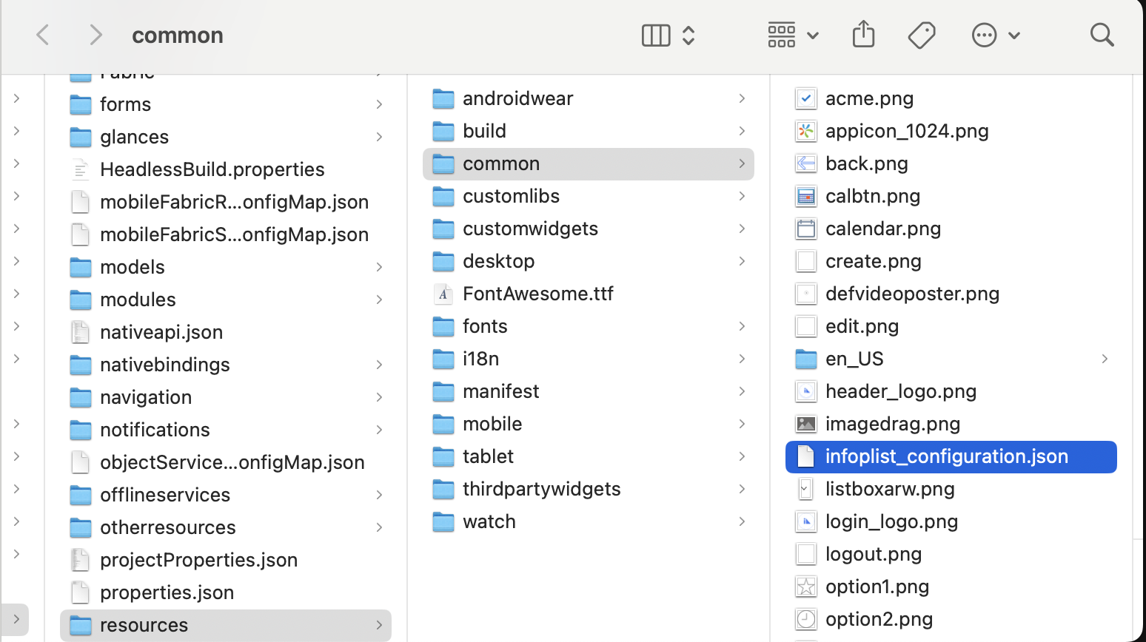
- Copy the below permission list and paste it in the infoplist_configuration.json
{
"NSSpeechRecognitionUsageDescription":"Chatbot",
"NSMicrophoneUsageDescription":"Chatbot",
"NSAppTransportSecurity" :
{
"NSAllowsArbitraryLoads" : true
}
}

Voltmx Client Operation Security Level

- Set Operation Security Level
To set the Operation Security level, follow these steps:
- Select the HCL Volt MX Foundry app associated with your Volt MX Iris project, to open the app in the HCL Volt MX Foundry console.
- In Configure Services, select Integration and click the voltmxMPBotFramework Integration Service.
- Expand the voltmxMPBotFramework service in the right pane, and then select the voltmxmpVoltmxClient operation.
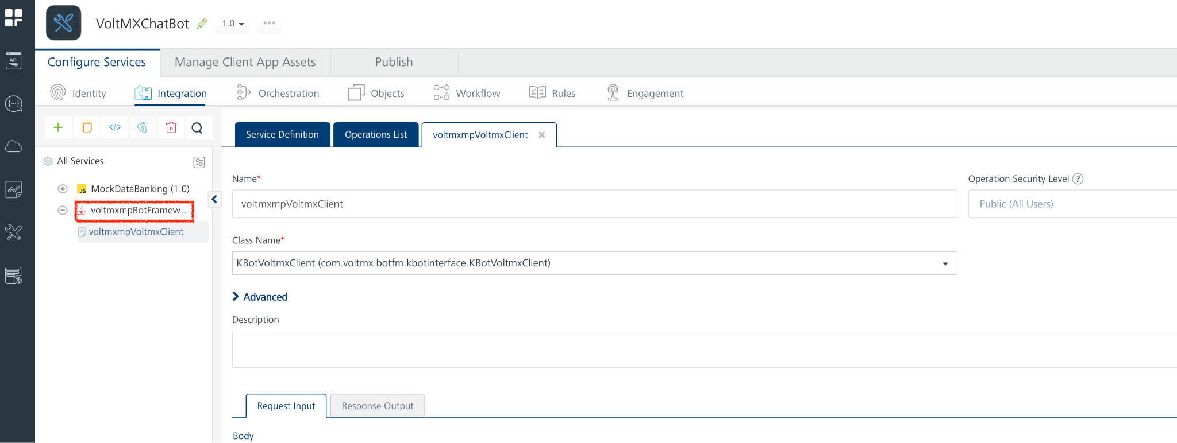
- For the voltmxmpVoltmxClient operation, you can set the Operation Security Level based on your requirements. By default, the Operation Security Level is set as Authenticated App User, which does not allow you to access the chatbot if your authentication fails. On successful authentication, you will be able to access the chatbot.
- You can set the Operation Security Level as Public, if you do not require any sort of authentication for your app. Any individual can access the app.
Note: For your convenience, set the Operation Security Level to Public. If you set the Operation Security Level as Authenticated App User, ensure that you configure your credentials in the Identity Service of your app.
- Save the operation, and then Click the icon to go back to Volt MX Iris.

Properties
You can use chatbot's Properties to customize and configure the elements. These elements can be UI elements, service parameters, and more. You can set the properties from the VoltMX IrisProperties panel.
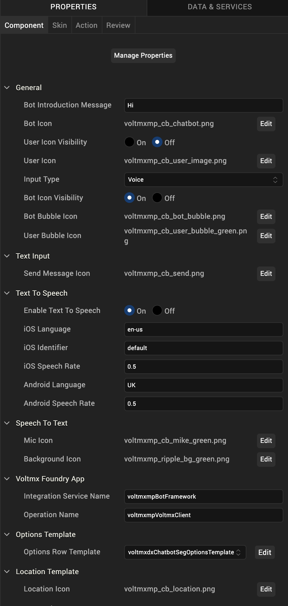
You can also configure these properties by using a JavaScript code.

General Properties
General Properties for the Chabot are as follows:
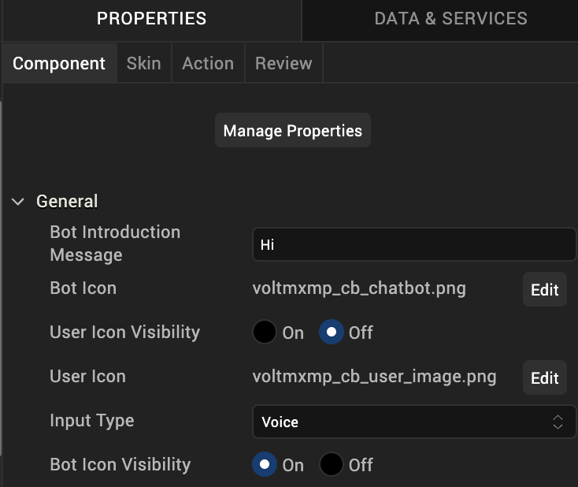
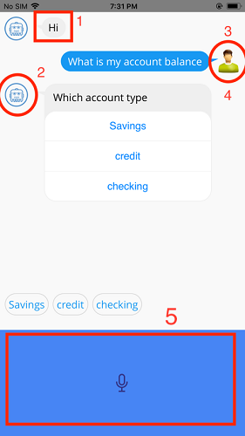

1. Bot Introduction Message
Description: | Displays the chatbot introduction message as specified by the user.
Syntax: | botIntroMsg
Type: | String
Read/Write: | Read + Write
Default Value: | "Hi"
Example: | this.view.chatbot.botIntroMsg = 'hello';
2. Bot Icon
Description: | Enables the user to change the bot image icon on the chat screen.
Syntax: | imgBotSrc
Type: | String
Read/Write: | Read + Write
Example: | this.view.chatbot.imgBotSrc = 'imageName';
3. User Icon Visibility
Description: | Enables the user to toggle between the visibility of the user image icon.
Syntax: | userImageVisibility
Type: | Boolean
Read/Write: | Read + Write
Default Value: | false
Example: | this.view.chatbot.userImageVisibility = true;
4. User Icon
Description: | Enables the user to change the user image icon on the chat screen.
Syntax: | userImage
Type: | String
Read/Write: | Read + Write
Default Value: | false
Example: | this.view.chatbot.userImage='imagedrag.png';
5. Input Type
Description: | Enables the input type for the Chatbot.
Syntax: | inputType
Type: | String
Read/Write: | Read + Write
Valid Inputs: | - "Voice"  - "Text"  - "Voice and Text"
Default Value: | "Voice"
Example: | this.view.chatbot.inputType = "Voice";

Text Input Properties
Text Input Properties for the Chabot are as follows:
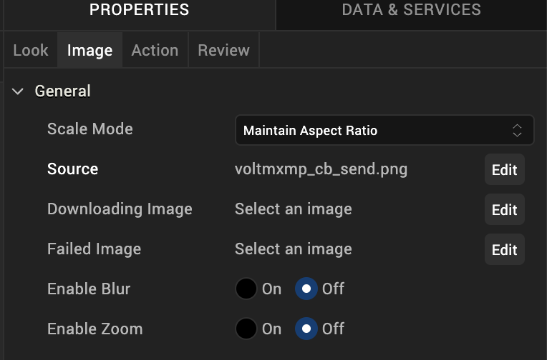
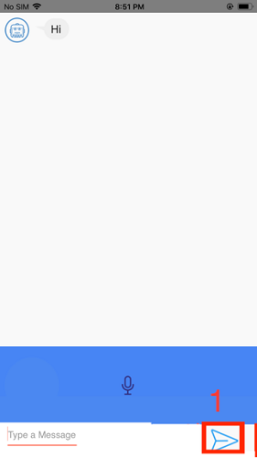

Text to Speech Properties
Text to Speech Properties for the Chabot are as follows:
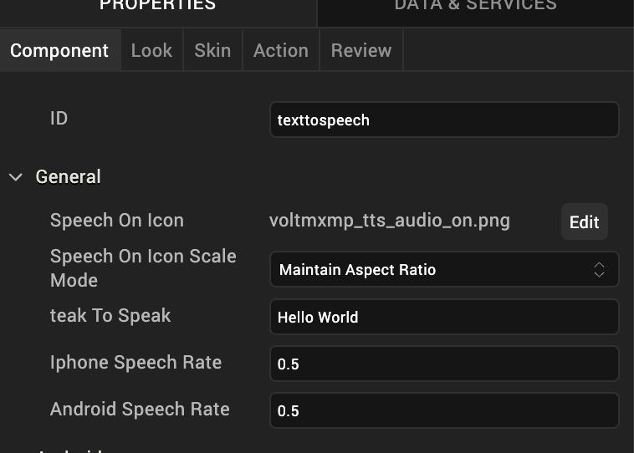
- Enable Text To Speech
Description: | Enables or disables the Text to Speech engine.
Syntax: | readText
Type: | Boolean
Read/Write: | Write
Default Value: | true
Example: | this.view.chatbot.readText = true;
- Android Speech Rate
Description: | Sets the speech rate in Android.
Syntax: | setAndroidSpeechRate
Type: | String
Read/Write: | Write
Default Value: | 1.0
Example: | this.view.chatbot.setAndroidSpeechRate = '0.5';
- iOS Speech Rate
Description: | Sets the speech rate in iOS.
Syntax: | setiOSSpeechRate
Type: | String
Read/Write: | Write
Default Value: | 1.0
Example: | this.view.chatbot.setiOSSpeechRate= '0.5';

Speech To Text properties
Speech to Text Properties for the Chabtot are as follows:
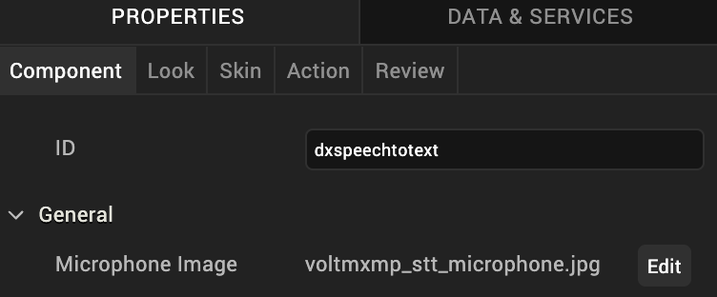
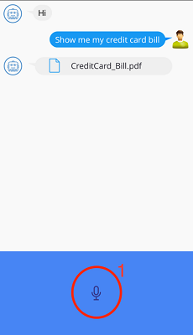
- Enable Speech To Text
Description: | Enables or disables the Speech to Text engine.
Syntax: | voiceInput
Type: | Boolean
Read/Write: | Write
Default Value: | true
Example: | this.view.chatbot.voiceInput = false;
- Mic Icon
Description: | Enables the user to change the Mic icon.
Syntax: | micImage
Type: | String
Read/Write: | Read + Write
Example: | this.view.chatbot.micImage = 'image.png';

Foundry App Properties
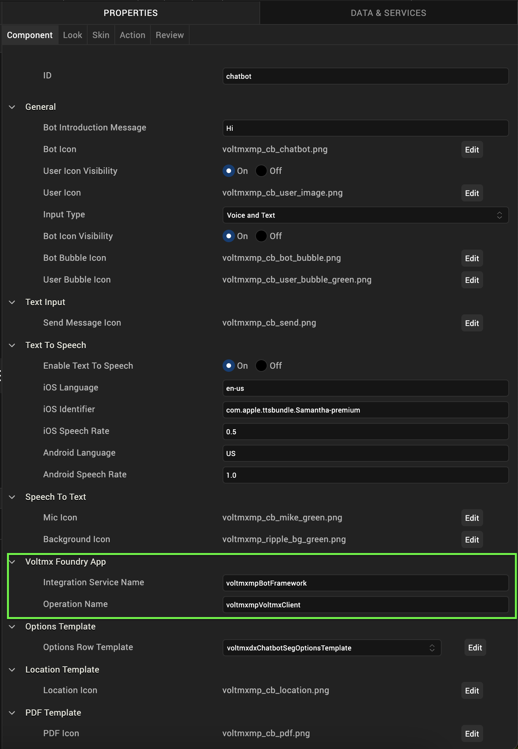
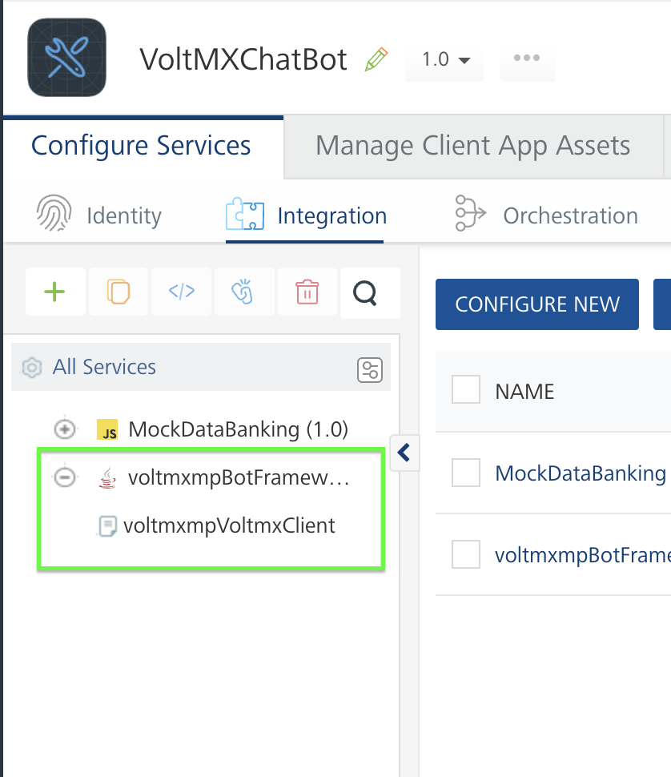
1. Integration Service Name
Description: | Specifies the name of the integration service that is used in the Foundry app linked to the chatbot Volt MX Iris project.
Syntax: | integrationServiceName
Type: | String
Read/Write: | Write
Default Value: | "voltmxmpBotFramework"
Example: | this.view.chatbot.integrationServiceName = 'service Name';
2. Operation Name
Description: | Specifies the name of the operation that is used in the mentioned Integration Service of the Foundry app linked to the Volt MX Iris project.
Syntax: | operationName
Type: | String
Read/Write: | Write
Default Value: | "voltmxmpVoltmxClient"
Example: | this.view.chatbot.operationName = 'operation Name';

Options Template Property
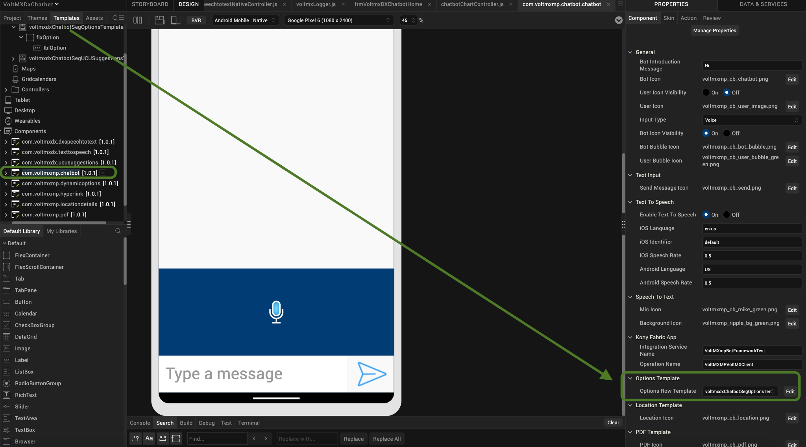
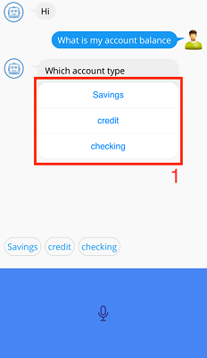
- Options Row Template
Description: | Specifies the option for the user to change the row template for the Options Segment for the dynamic options sub-component.
Syntax: | optionsRowTemplate
Type: | rowTemplate
Read/Write: | Write
Example: | this.view.chatbot.optionsRowTemplate = 'templateName';

Location Template Property
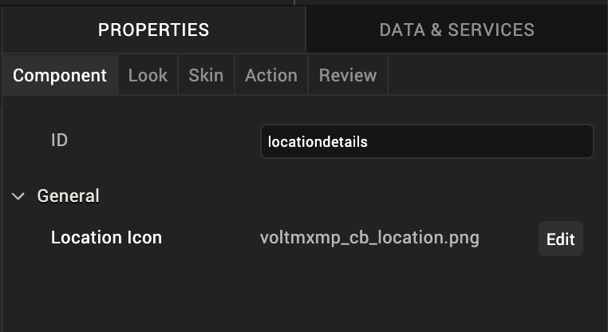
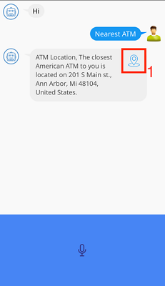
1. Location Icon
Description: | Enables the user to change the location icon for the location details sub-component.
Syntax: | locationIcon
Type: | String
Read/Write: | Read + Write
Default Value: | "voltmxmp_cb_location3.png"
Example: | this.view.chatbot.locationIcon = 'image_name.png';

PDF Template Property
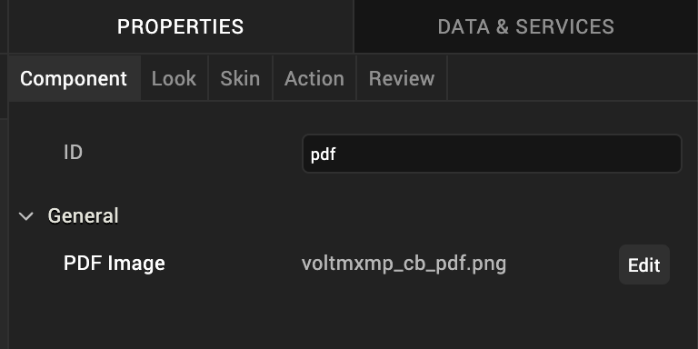
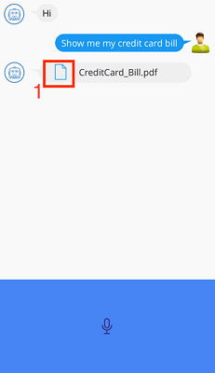
1. PDF Icon
Description: | Enables the user to change the PDF icon for the location details sub-component.
Syntax: | pdfImg
Type: | String
Read/Write: | Read + Write
Default Value: | "voltmxmp_cb_pdf1.png"
Example: | this.view.chatbot.pdfImg = 'image_name.png';
Note: All the images must be uploaded to the Resources folder of your Volt MX Iris project.

Skins
Skins define the appearance of a widget. You can apply and manipulate skins based on your preference. For more information, refer to the Understanding Skins and Themes section of the Voltmx Iris User Guide.

General Skin

- Bot Message Skin
Description: | Enables the user to change the skin of the messaged display from the bot's end.
Syntax: | botMsgSkin
Type: | String (skin)
Default: | "voltmxmpcbsknLblBmefefef"
Read/ Write: | Read + Write
Example: | this.view.chatbot.botMsgSkin = 'skinName';
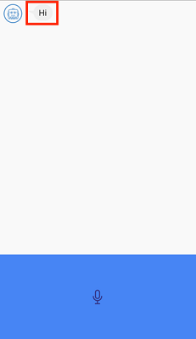

- User Message Skin
Description: | Enables the user to change the skin of the message displayed from the user's end.
Syntax: | userMsgSkin
Type: | String (skin)
Default: | "voltmxmpcbsknLbl1798f2"
Read/ Write: | Read + Write
Example: | this.view.chatbot.userMsgSkin = 'skinName';
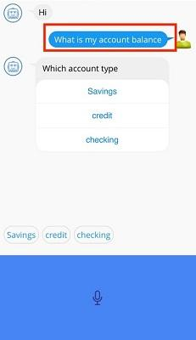

- Chat Background Skin
Description: | Enables the user to change the chat background skin (FlexScrollContainer skin)
Syntax: | chatBackgroundSkin
Type: | String (skin)
Default: | "voltmxmpcbsknFlxf9f9f9"
Read/ Write: | Read + Write
Example: | this.view.chatbot.chatBackgroundSkin = 'skinName';
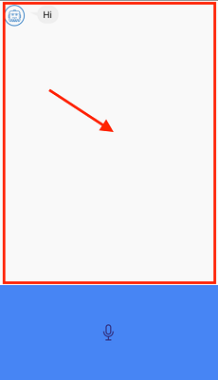

- Footer Skin
Description: | Enables the user to change the footer (contains TextArea and mic image) skin for chatbot - (FlexContainer skin)
Syntax: | footerSkin
Type: | String (skin)
Default: | "slFbox"
Read/ Write: | Read + Write
Example: | this.view.chatbot.footerSkin = 'skinName';
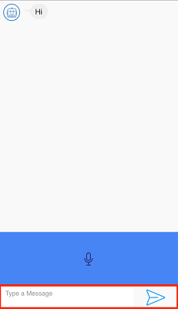

- Input Text Area Skin
Description: | Enables the user to change the skin of the TextArea where the user can type the message (TextArea skin)
Syntax: | inputTextAreaSkin
Type: | String (skin)
Default: | "voltmxmpcbsknTxtArea"
Read/ Write: | Read + Write
Example: | this.view.chatbot.inputTextAreaSkin = 'skinName';
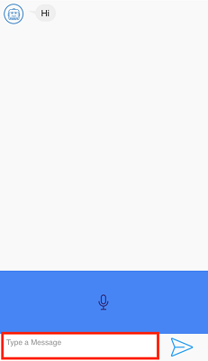

Option Template Skin
1. Options Background Skin
Description: | Enables the user to change the background skin of options (FlexContainer skin)
Syntax: | optionsBgSkin
Type: | String (skin)
Default: | "voltmxmpcbsknFlxEFEFEF"
Read/ Write: | Read + Write
Example: | this.view.chatbot.optionsBgSkin= 'skinName';
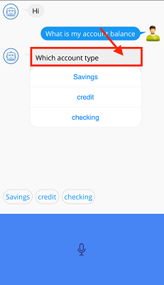

2. Options Query Skin
Description | Enables the user to change the query label skin in dynamic options (label skin).
Syntax: | optionsQuerySkin
Type: | String (skin)
Default: | "voltmxmpcbsknFlxEFEFEF"
Read/ Write: | Read + Write
Example: | this.view.chatbot.optionsBgSkin= 'skinName';
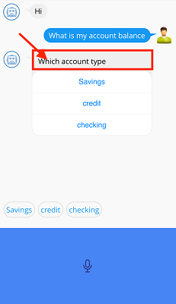

Location Template Skin
- Location Details Background Skin
Description: | Enables the user to edit the location details of the sub-component's background skin.
Syntax: | locationBgSkin
Type: | String (skin)
Default: | "voltmxmpcbsknFlxEFEFEF"
Read/ Write: | Read + Write
Example: | this.view.chatbot.locationBgSkin= 'skinName';
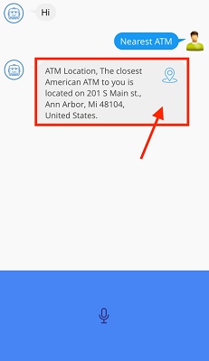
- Location Details Text Skin
Description: | Enables the user to edit the location details of the sub-component's text skin.
Syntax: | locDetailsTextSkin
Type: | String (skin)
Default: | "voltmxmpcbsknFlxEFEFEF"
Read/ Write: | Read + Write
Example: | this.view.chatbot.locDetailsTextSkin= 'skinName';
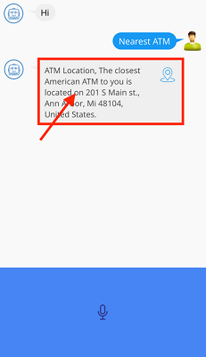

PDF Template Skin
- PDF Details Background Skin
Description: | Enables the user to edit the PDF sub-component’s background skin.
Syntax: | pdfDetailsBgSkin
Type: | String (skin)
Default: | "voltmxmpcbsknFlxEFEFEF"
Read/ Write: | Read + Write
Example: | this.view.chatbot.pdfDetailsBgSkin= 'skinName';
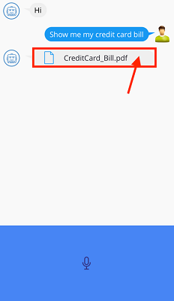

- PDF Title Skin
Description: | Enables the user to edit the PDF sub-component’s title skin.
Syntax: | pdfTitleSkin
Type: | String (skin)
Default: | "voltmxmpcbsknLbl22212aff"
Read/ Write: | Read + Write
Example: | this.view.chatbot.pdfTitleSkin= 'skinName';
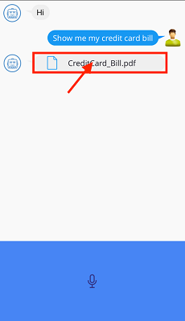

Quick Reply Template Skin
1. Quick Reply Background Skin

Description: | Enables the user to edit the quick reply template background skin.
Syntax: | quickReplyBgSkin
Type: | String (skin)
Default: | "voltmxmpcbsknFlxWhiteF9F9F9"
Read/ Write: | Read + Write
Example: | this.view.chatbot.quickReplyBgSkin= 'skinName';
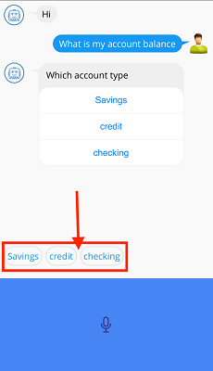

2. Quick Reply Button Skin
Description: | Enables the user to edit the quick reply template button skin.
Syntax: | quickReplyBgSkin
Type: | String (skin)
Default: | "voltmxmpcbsknBtnD3D3D3"
Read/ Write: | Read + Write
Example: | this.view.chatbot.quickReplyBtnSkin= 'skinName';
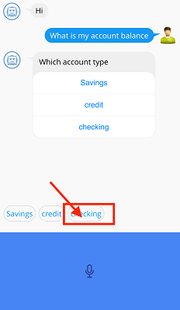

Hyperlink Template Skin
- Hyperlink Background Skin
Description: | Enables the user to edit the Hyperlink sub-component’s background skin.
Syntax: | hyperlinkBgSkin
Type: | String (skin)
Default: | "voltmxmpcbsknFlxEFEFEF"
Read/ Write: | Read + Write
Example: | this.view.chatbot.hyperlinkBgSkin= 'skinName';
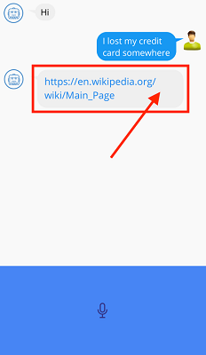

- Hyperlink Skin
Description: | Enables the user to edit the Hyperlink sub-component’s text (hyperlink) skin.
Syntax: | hyperlinkSkin
Type: | String (skin)
Default: | "voltmxmpsknLblHpl1983ee"
Read/ Write: | Read + Write
Example: | this.view.chatbot.hyperlinkSkin= 'skinName';
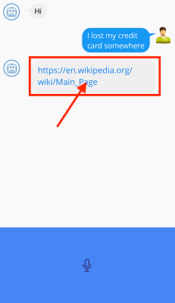

Rich Text Template Skin
- Rich Text Skin
Description: | Enables the user to edit the skin of a rich text widget.
Syntax: | richTextSkin
Type: | String (skin)
Default: | "voltmxmpsknRichTextEFEFEFBG"
Read/ Write: | Read + Write
Example: | this.view.chatbot.richTextSkin = 'skinName';
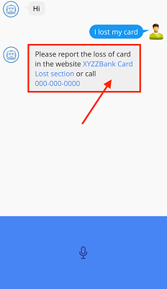

- Rich Text Link Skin
Description: | Enables the user to edit the link skin of rich text widget.
Syntax: | richTextLinkSkin
Type: | String (skin)
Default: | "voltmxmpcbsknRichTextLink"
Read/ Write: | Read + Write
Example: | this.view.chatbot.richTextLinkSkin = 'skinName';
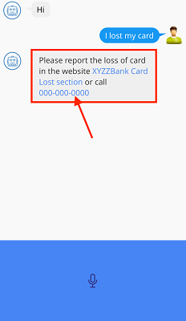

Custom Template Skin
- Custom Template Background Skin
Description: | Enables the user to edit the custom template background skin.
Syntax: | customTemplateBGSkin
Type: | String (skin)
Default: | "voltmxmpcbsknFlxWhiteF9F9F9"
Read/ Write: | Read + Write
Example: | this.view.chatbot.customTemplateBGSkin= 'skinName';

Events
The framework invokes events when its corresponding action is performed. You can configure any logic you want the component to perform whenever an event occurs. You can configure the events directly on the Actions tab or by writing a JavaScript. For more information, refer to Add Actions in the Volt MX Iris User Guide.

Chatbot
1. nlpConfiguration
Description: | The event is invoked when the user returns a JSON with intent - entity mapper and bot service configuration.
Syntax: | nlpConfiguration
Return Type | JSON
Example: | You can find the code in the Examples section.
2. onResponse
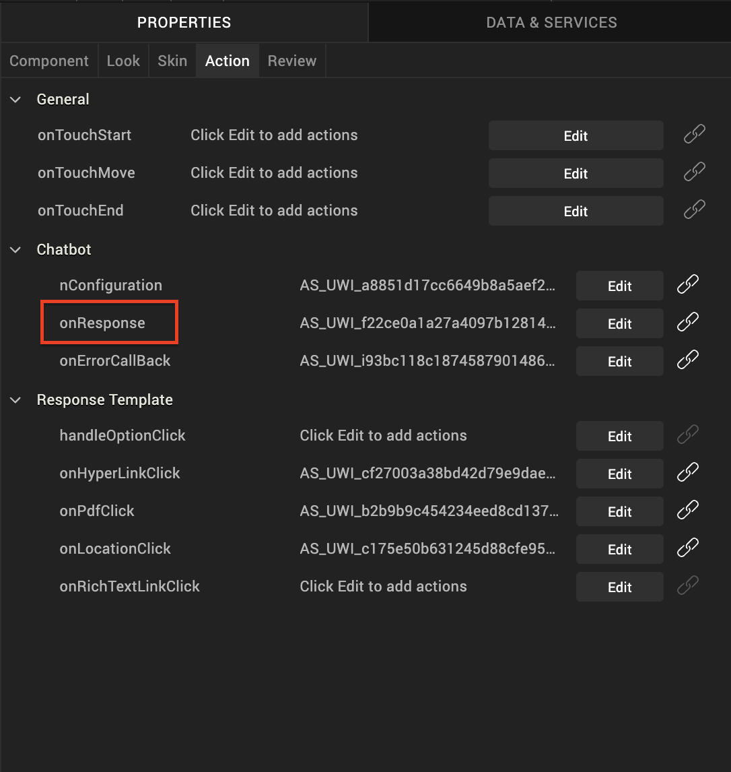

Description: | This event is invoked when a command is sent from the bot service. The bot Service sends a command configured in the intent map of config data. The command is sent after all the required entities are given by the user.
Syntax: | onResponse
Parameters: | dialogState  Specifies the dialog state of the intent.  response:  It is a JSON parameter. Specifies the last bot response. This JSON has intent and entities, along with the command which mentions the user for what details the LOB (Line Of Business) back end should be contacted.  The parameter to onResponse method contains two key-value pairs:  - dialogState  The dialogState represents the current state of conversation. It is of type String and contains the value from below mentioned Dialog states:  - ELICITINTENT: Intent is not identified by NLP in the query  - CONFIRMINTENT: Confirmation for the Intent that is identified by NLP  - ELICITSLOT: Required Entity is missing for the Intent identified by NLP  - FULFILLED: Command has been executed successfully  - READYFORFULFILLMENT: Command is ready to be executed  - FAILED: Conversation with the NLP failed  - response  The response parameter is of type JSON containing the values required to handle the command. The response contains following key-value pairs:  - entities: Name of the entities and value assigned to each of the entities  - intent: Intent that is identified by the NLP and needs to be handled  - queries: List of queries received by NLP for this intent in order to fulfill  - command: Command provided in the intent entity mapper corresponding to the intent.  - payload : if command handling is not done at HCL Foundry, payload will be empty.  - uniqueID: The uniqueID parameter is of type String and is a unique value associated to each end user. It is required to differentiate multiple end users while handling the command.  * /  Sample parameter structures  dialog State {  String  } - & gt;  "ELICITSLOT",  resp {  JSON  } - & gt; {  "intent": "KDxCbAccountBalance",  "command": "AccountBalanceHandle",  "uniqueID": "123abc",  "payload": {  "type": "options",  "message": "Which account type",  "options": ["credit", "checking", "Savings"]  }  }  */  * /  Dialog States  1. ELICITINTENT: Intent is not identified by NLP in the query  2. CONFIRMINTENT: Confirmation for the Intent that is identified by NLP  3. ELICITSLOT: Required Entity is missing for the Intent identified by NLP  4. FULFILLED: Command has been executed successfully  5. READYFORFULFILLMENT: Command is ready to be executed  6. FAILED: Conversation with the NLP failed  */
Dialog States values: | "ELICITINTENT","CONFIRMINTENT","ELICITSLOT","READYFORFULFILLMENT","FAILED", "FULFILLED"
Example: | You can find the code in the Examples section.
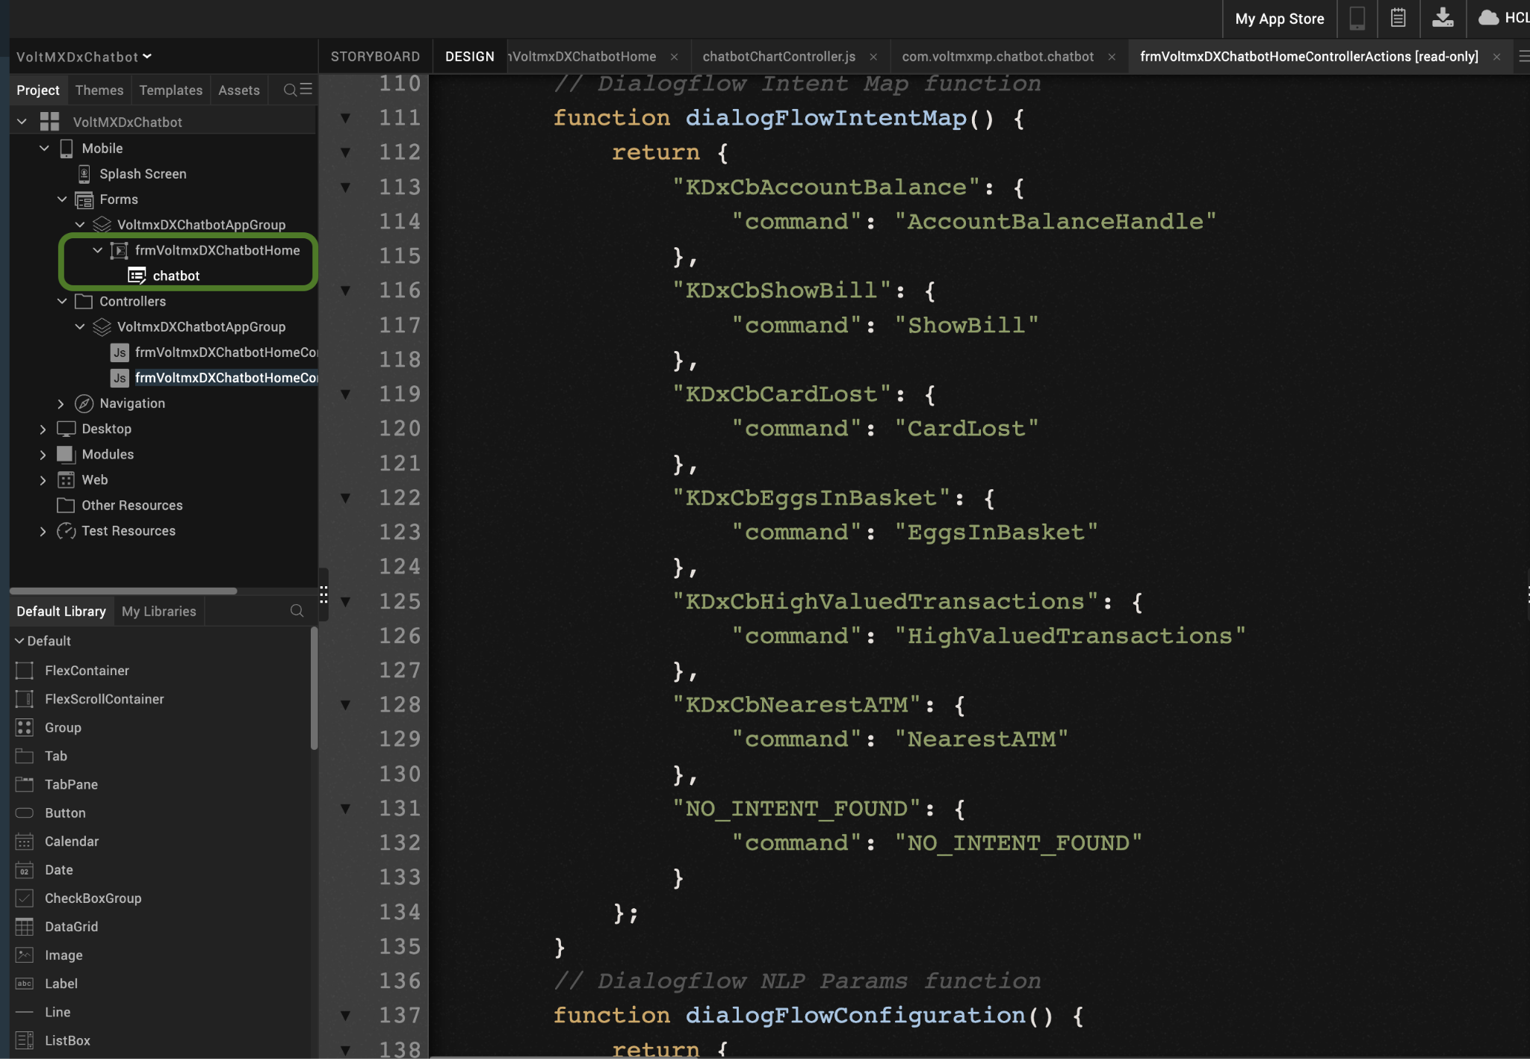
Note: If command handling is not done at VoltMX Foundry the payload will be empty then make sure to configure the onResponse Event.
The control flow is highlighted in the image below:
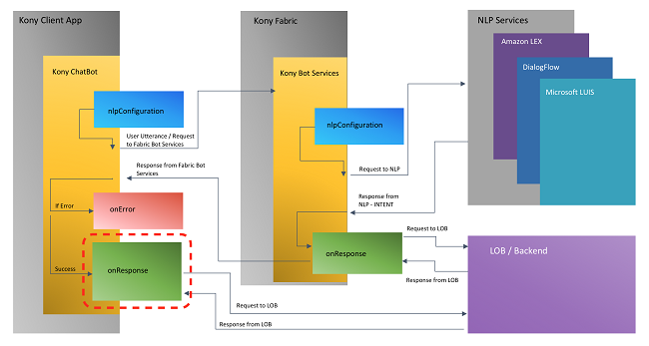
3. onErrorCallback
Description: | This event is invoked when some exception occurs in the chatbot.
Syntax: | onErrorCallback
Parameters: | error:  It is a JSON parameter. Specifies the exception information.  /*  Parameters: error  Sample error Structure {  error: "responseError",  message: {\  "Error\":\"com.kony.botfm.kbotcustomexception.K…llback Intent\",\"opStatus\":\"INTERNAL_ERROR\"}"  }  */

Response Template
1. onHyperLinkClick
Description: | This event is invoked when the user clicks on the Hyperlink, which is a response from the bot.
Syntax: | onHyperLinkClick
Parameters: | response  Specifies all the essential information that is received from Foundry.  /*  Parameters : response  Sample response structure :  {  payload: {  type: "hyperlink",  url: "https://en.wikipedia.org/wiki/Main_Page"  }  }  */
Example: | this.view.chatbot.onHyperLinkClick = function() {  alert("Hyperlink Clicked");  }
2. onPdfClick
Description: | This event is invoked when the user clicks on the PDF link, which is a response from the bot.
Syntax: | onPdfClick
Parameters: | response  Specifies all the essential information that is received from Foundry.  /*  Parameters: response  Sample response Structure:  {  payload: {  title: "CreditCard_Bill.pdf",  type: "pdf",  url: "https://www.greatlakeslink.com/mglstatic/borrower/fiq/pdf/sample_credit_card_statement_fiq.pdf"  }  }  */
Example: | this.view.chatbot.onPdfClick = function() {  alert("PDF Clicked");  }
3. onLocationClick
Description: | This event is invoked when the user clicks on the location, that is a response from the bot.
Syntax: | onLocationClick
Parameters: | response  Specifies all the essential information that is received from Foundry.  /*  Parameters : response  Sample response Structure  {  payload:{  details: "The closest American ATM to you is located on 201 S Main st.,  Ann Arbor, Mi 48104, United States.",  latitude: "42.2803616",  longitude: "-83.7482194",  title: "ATM Location",  type: "location"  }  }  */
Example: | this.view.chatbot.onLocationClick= function() {  alert("Location found");  }
4. handleOptionClick
Description: | This event is invoked when the user clicks on any option. The main use of this event is that users can display one type of message and pass different types of messages to Foundry
Syntax: | handleOptionClick
Parameters: | eventObject  eventObject contains the following keys:  displayMessage  The value assigned to this key will be displayed in the UI.  requestMessage  The value assigned to this key will be passed to Foundry.
Example: | this.view.chatbot.handleOptionClick= function() {  alert("Option Clicked");  }

APIs
The following APIs pertain to the Volt MX's Conversational AI Dev Toolkit:
- setUUID
Description: | This API must be set by the developer to maintain different sessions for individual users. The value must be unique. The back-end NLP services expect unique id. For example, Amazon Lex and Dialog Flow.
Syntax: | setUUID(uuid)
Parameters: | uuid  This parameter is of type String and should be unique to differentiate end users. The uuid value set using this API can be accessed in onResponse event as uniqueID inside response object.
Example: | this.view.chatbot.setUUID("123abc");
Note: The uuid string should not contain any spaces. The string should not contain any personal information also.
- getUUID
Description: | This API returns the uuid string set by the developer to maintain different sessions for individual users.
Syntax: | getUUID()
Example: | this.view.chatbot.getUUID();
- handleTemplateCallback
Description: | This API is used when different Template callback events are invoked to carry out a task and when users want the component to handle default actions.
Syntax: | handleTemplateCallback(response)
Parameters: | response  Sends back the response received from the template call back event without altering it.
Example: | this.view.chatbot.handleTemplateCallback(response);
- contactBot
Description: | The API performs this function.
Syntax: | contactBot(data)
Parameters: | data  The data parameter is a JSON structure. The response structures depend on the type of JSON response. There are multiple predefined templates/ data formats supported by Chatbot such asMessage, Message with Options, Hyperlink, PDF, and Location Details.
Example: | this.view.chatbot.contactBot(response);
Chatbot extends its support to add user-defined UI. This is done by using Custom Templates. Following are the sample formats to set data to the chatbot templates:
- Format for only Message
var response = {
"payload": {
"type": "message ",
"message": "You have $4463 in your Savings account."
}
};
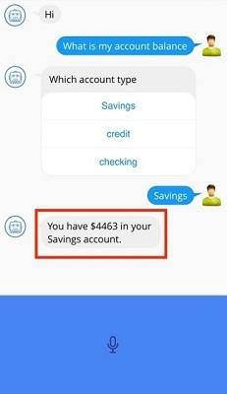
- Format for Message with Options
var response = {
"payload": {
"type": "options",
"message": "Which account type",
"options": ["Savings", "credit", "checking"]
}
};
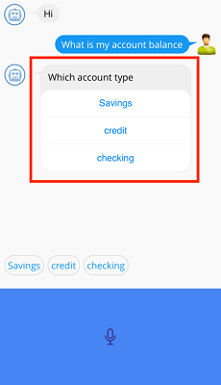
- Format for Hyperlink
var response = {
"payload": {
"type": "hyperlink",
"url": "https://en.wikipedia.org/wiki/Main_Page"
}
};
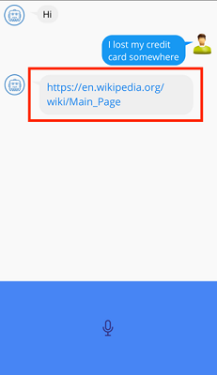
- Format for PDF
var response = {
"payload": {
"size": "",
"type": "pdf",
"title": "CreditCard_Bill.pdf",
"url": "https://files.consumerfinance.gov/f/documents/cfpb_building_block_activities_sample-credit-card-statement_handout.pdf"
}
};
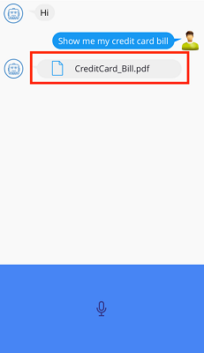
- Format for Location Details
var response = {
"payload": {
"latitude": "17.385044",
"details": "The closest American ATM to you is located on 201 S Main st., Ann Arbor, Mi 48104, United States.",
"type": "location",
"title": "ATM Location",
"longitude": "78.486671"
}
};
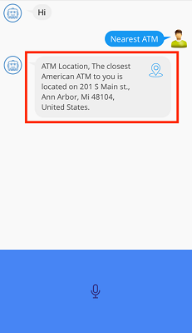
- Format for Rich Text
var response = {
"payload": {
"type": "richText",
"message": "Please report the loss of card in the website <a href = 'https://www.xyzzbank.com/lostCard'>XYZZBank Card Lost section</a> or call <tel number='000-000-0000'>000-000-0000</tel> ",
"speech": "Please report the loss of card in the website or call our customer care"
}
};
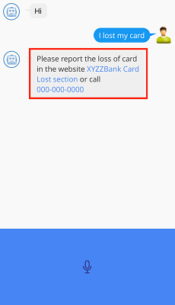
- Format for Custom Templates
Users must send the Volt MX FlexContainer widget that contains a custom UI to be added to the chatbot. Also, users can configure the speech to be uttered when the custom template is rendered on the Chatbot screen. The speech should be sent as a String.
var response = {
"payload": {
"type": "customWidgetTemplate",
"widget": < Flex container containing custom UI >,
"speech": < Speech to be uttered when custom template is rendered >
}
};

Note: While sending the data, ensure that you follow the required templates.

Create Custom Template
- Open your Iris project.
- In the Templates Explorer, right-click Components, and then select New → w/o Contract.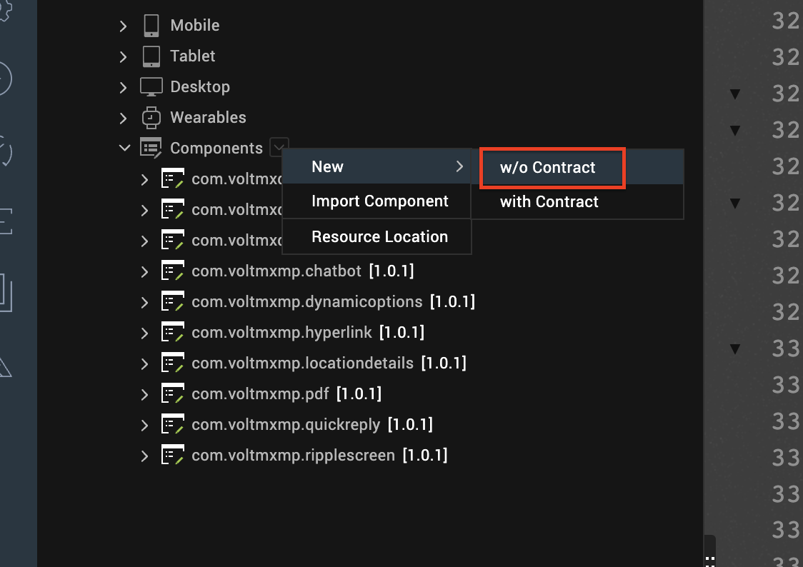

- Provide a Name and Namespace to your Component, and then click OK.
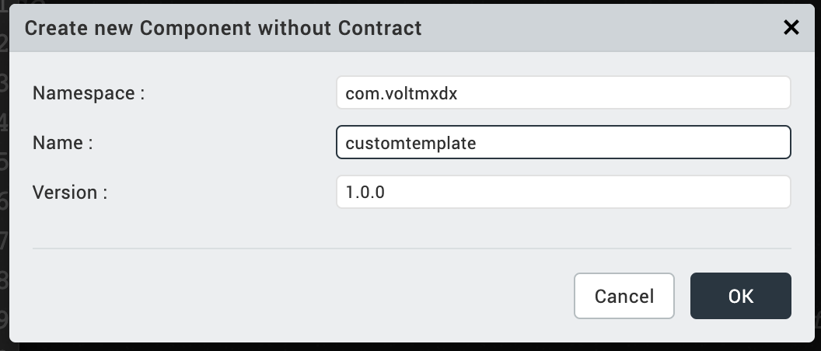
The component is added to the list of components.
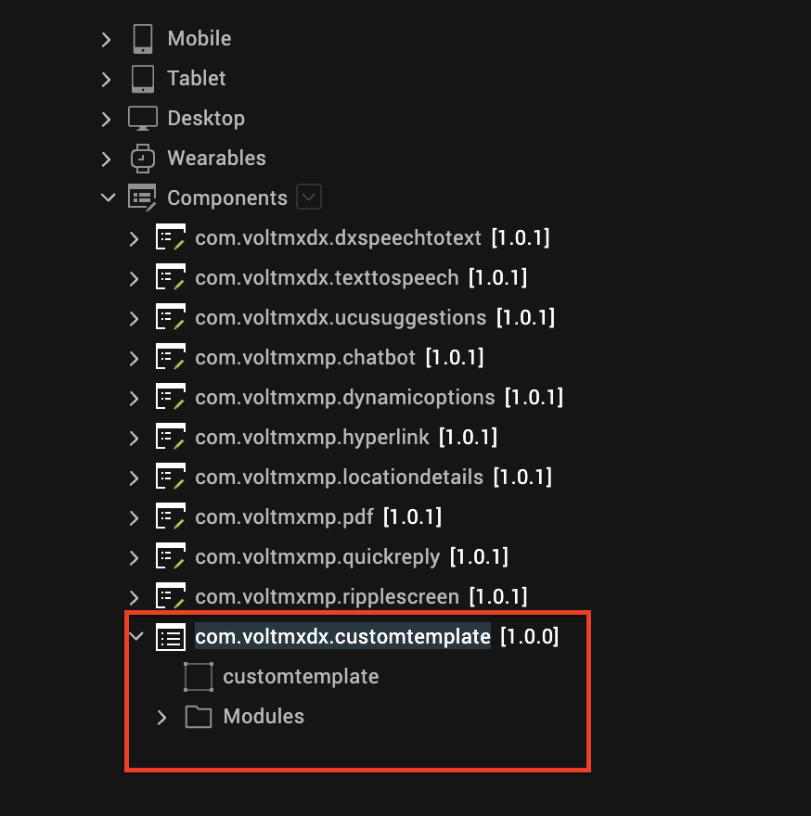
- Customize the component template based on your requirements.
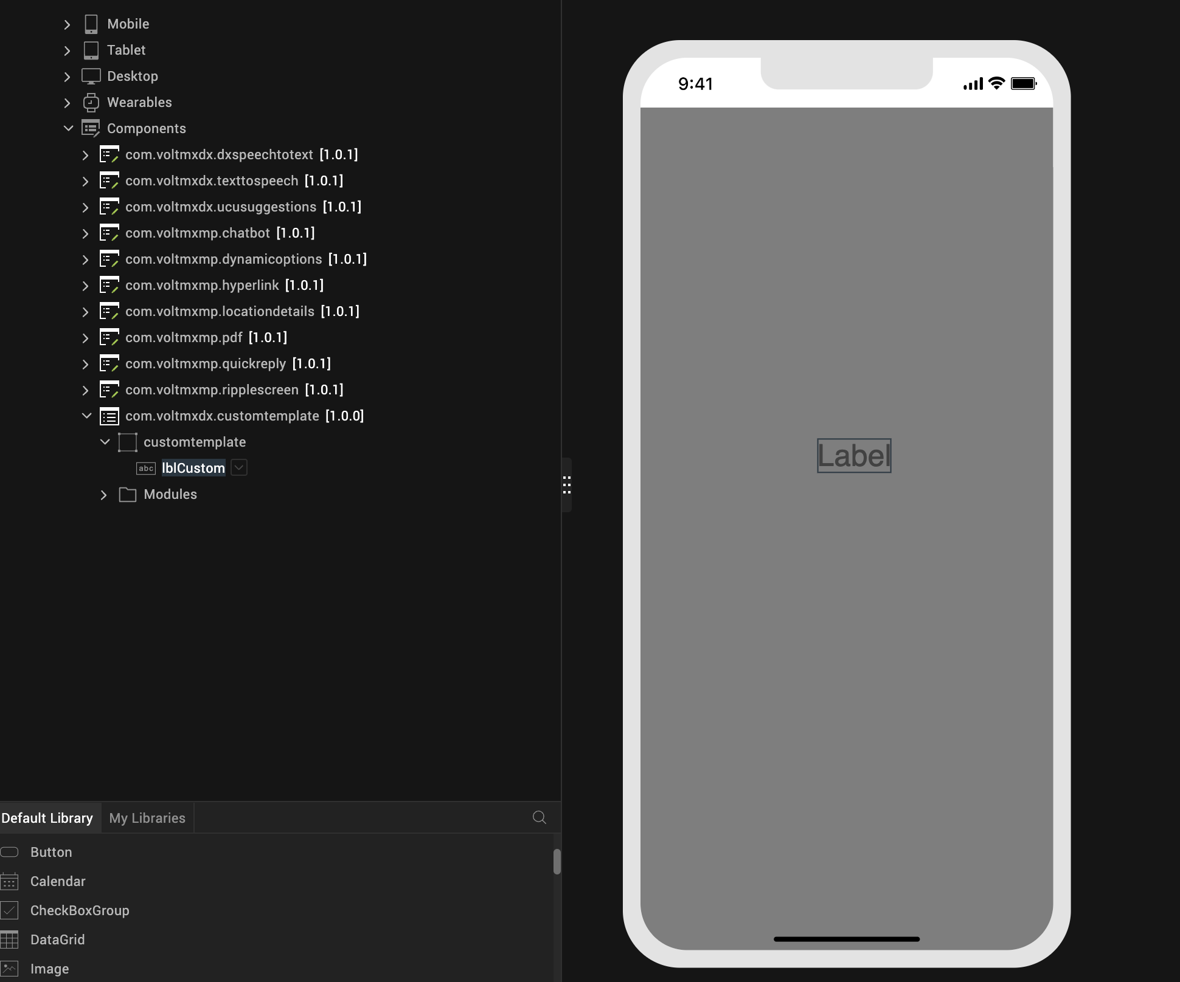
- To use the custom template in your chatbot, you have to call the controlBot API in the form controller that contains the chatbot.
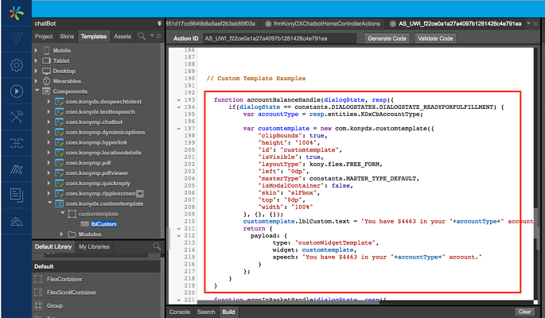

Known Exceptions

Client Side Exceptions
The error.message key in the error callback can contain the following messages:
- "Invalid value for Input Type Property"
- "Empty message given"
- "Invalid params to create a message in UI"
- "Invalid type in payload Object"
- "Server returned a null response"
- "No Internet Connection Available"
- "Please connect to VoltMX Foundry"
- "Invalid inputs to invoke a template"
- "Invalid inputs to invoke a custom template"
- "Response/eventObject is null. Please check."
- "latitude/longitude coordinates missing"
- "Response payload empty/undefined"
- "url missing in payload"
- "Response payload empty/undefined"
- "Invalid type value in response Object"
- "Record Audio Permission is not given"

Server Side Exceptions
The Chatbot framework can throw the following list of exceptions, classified based on NLP:
Generic
- Backend name returned is null -> Invalid bot service name provided in the configuration
- Backend Access Type is invalid -> Invalid access type provided
- Intent value found null in the context -> Intent value not received from NLP
- Fallback message is required for the entities in the intent entity map -> Intent entity mapper does not contain fallback message for required entity
- Intent entity mapper has invalid configuration -> Intent entity mapper does not contain matched Entity for the Intent
- Response Object is not present -> Response object is not set after contacting NLP
- Context object is not available in request params or Invalid configuration provided for context -> Missing/Invalid context provided as request parameter
- Command or message is not present in the configuration for the intent: <intentName> -> Command or message is not given in the intent entity mapper for specified intent <intentName>
- Unable to find the intent entity mapper in the configuration for intent :<intentName> -> Intent entity mapper is missing for the specified intent <intentName>
- Invalid Bot Service Name given in configuration parameters -> Invalid Bot Service Name given in configuration parameters
- Intent Entity Mapper is not supported as per configuration -> Intent Entity Mapper is not supported as per configuration
- Required Intent is not available in intent entity mapper -> Intent is not provided in the intent entity mapper
- Bot Service Name is not specified -> Bot Service Name is not provided in Chatbot configuration
- Configuration Parameters are not available -> Configuration Parameters are not provided in Chatbot configuration
- Bot Service Configuration Parameters are not available -> Bot Service parameters are not provided in Chatbot configuration

Wit
- Unable to handle the invalid entities length from backend -> Number of entities returned from Wit is invalid
- Required Parameters are missing in Wit configuration -> Required parameters are missing in Wit bot service configuration parameters
- URL must be present in Wit configuration -> URL is not provided in Wit bot service configuration parameters
- Parameters missing in Wit configuration -> Parameters are not provided in Wit bot service configuration parameters
- Header Parameters missing in Wit configuration ->Header Parameters are not provided in Wit bot service configuration parameters
- Authorization missing in Wit configuration -> Authorization parameter is not provided in Wit bot service configuration

Dialogflow
- Required Parameters are missing in DialogFlow configuration -> Required parameters are missing in DialogFlow bot service configuration parameters
- URL must be present in DialogFlow Configuration -> URL is not provided in DialogFlow bot service configuration parameters
- Parameters missing in DialogFlow Configuration -> Parameters are not provided in DialogFlow bot service configuration parameters
- Header Parameters missing in DialogFlow Configuration -> Header Parameters are not provided in DialogFlow bot service configuration parameters
- Authorization missing in DialogFlow configuration -> Authorization parameter is not provided in DialogFlow bot service configuration
Amazon Lex
- Required Parameters are missing in Amazon Lex configuration -> Required parameters are missing in Amazon Lex bot service configuration parameters
- Access Key must be present in Amazon Lex configuration -> AWS Access Key is not provided in Amazon Lex bot service configuration parameters
- Secret Key must be present in Amazon Lex configuration -> AWS Secret Key is not provided in Amazon Lex bot service configuration
- Service Name must be present in Amazon Lex configuration -> AWS Service Name is not provided in Amazon Lex bot service configuration
- Region Name must be present in Amazon Lex configuration -> AWS Region Name is not provided in Amazon Lex bot service configuration
- Bot Id must be present in Amazon Lex configuration -> Amazon Lex Bot Id is not provided in Amazon Lex bot service configuration
- Bot Alias Id must be present in Amazon Lex configuration -> Amazon Lex Alias Id is not provided in Amazon Lex bot service configuration

VoltMX Foundry Configuration

Preprocessor Configuration
To configure the HCL Volt MX Foundry app, follow these steps:
- Open manage.hclvoltmx.com.
- Expand the left pane of the HCL Volt MX Foundry console and select Apps. Search and select the app.
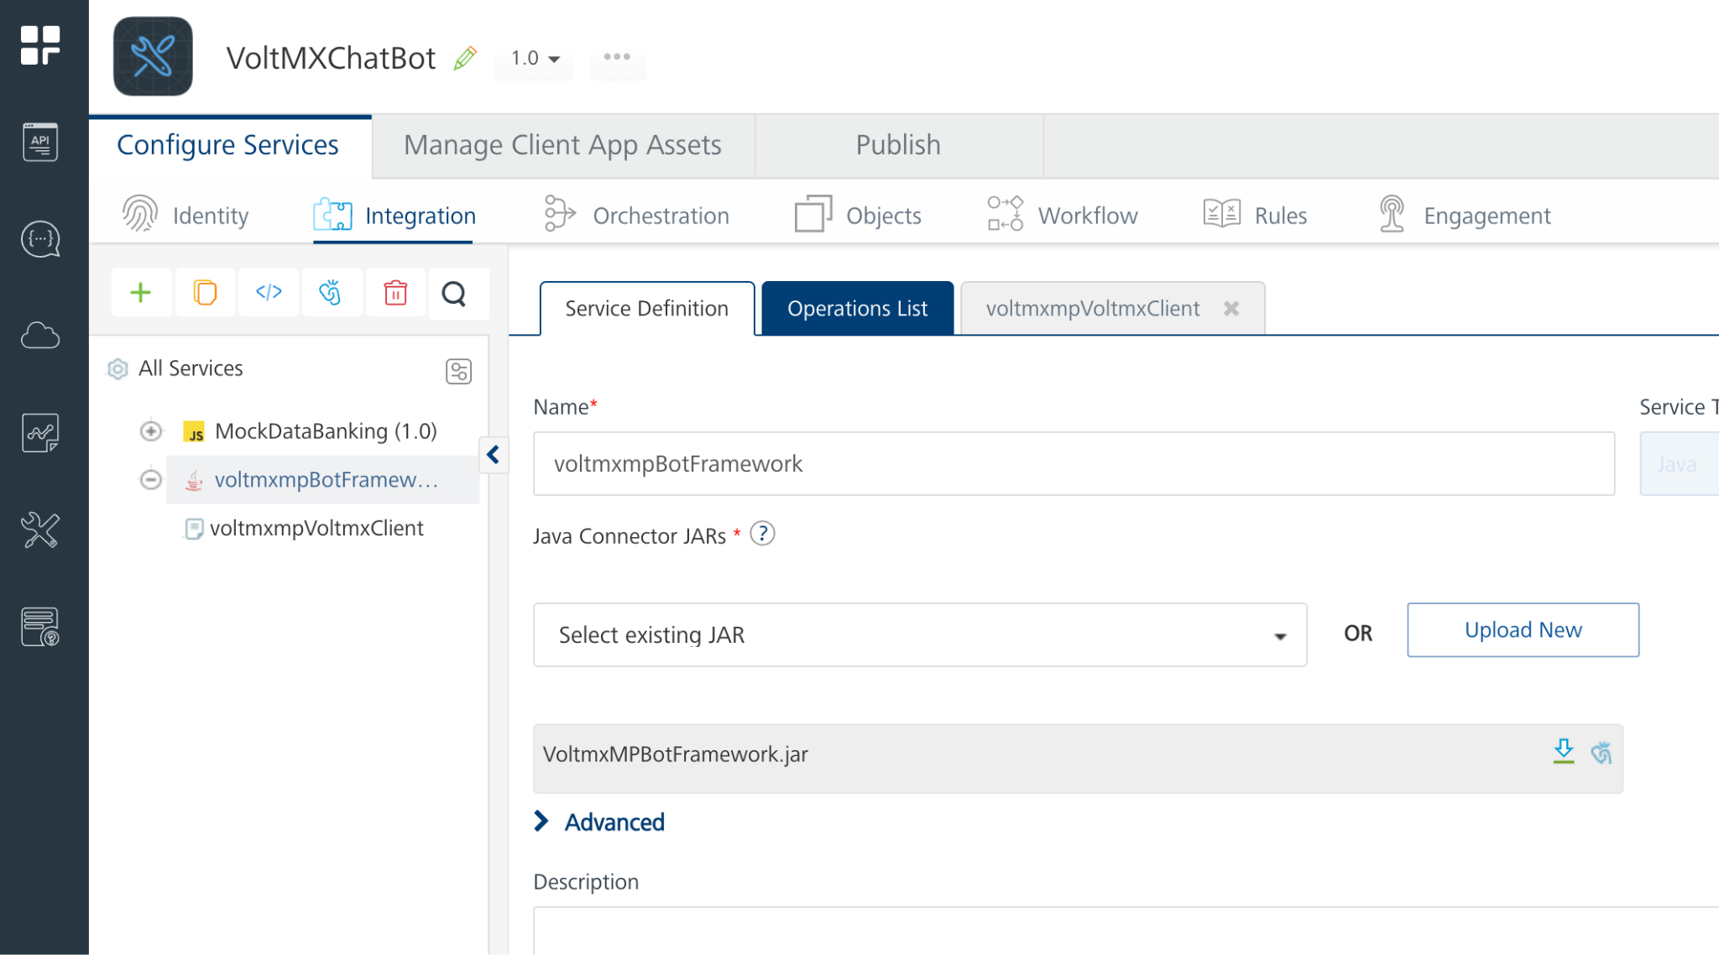
- Under the Integration tab, select the voltmxmpBotFramework Integration service.
- From the left-pane, expand thevoltmxmpBotFramework service, and then select the voltmxmpVoltmxClient operation.
Note: The voltmxmpBotFramework and voltmxmpVoltmxClient are the default service and operation names. If the user renames the existing service and operation in the Volt MX Foundry app. The same names must be specified in the Iris Properties pane.
- Expand the Advance tab, and under Custom Code Invocation, select Preprocessor with JavaScript.
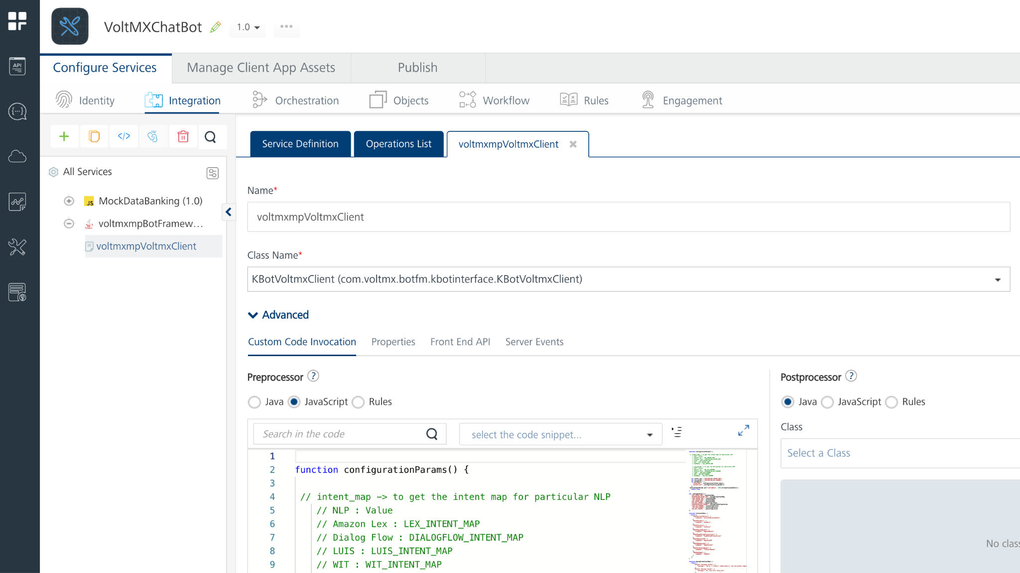
- Add your config data to the Preprocessor and feed it to the chatbot framework.

Defining Intent-Mapper in Preprocessor
If the bot is to respond to any intent with a text message, just a message is sufficient for the intent mapper to that intent. In such cases, the bot responds with a given message, whenever a particular intent matches.
Example 1
If component users want to send only one message for any intent, they can mention the intentMap in the following structure.
"thanks": {
"message": "It's my pleasure to help. Bon Voyage!"
},
In the following example, whenever the user's intent matches to 'thanks', the bot will respond with the given message (It's my pleasure to help. Bon Voyage!).
Example 2
If any intent has mandatory/required entities, all the entities along with respective fallback messages (message that should be displayed by the bot if that entity is not clear from the user’s message and needs further clarity) needs to be mentioned in the intentMap for that intent. The following is the sample intentMap for the accountBalance Intent.
"accountBalance": {
"entities": [{
"entityName": "accountType",
"fallbackMessage": "Which account?",
"options": ["Savings", "Checking", "Credit Card"]
}],
"command": "account_balance"
},
In this example, accountBalance is the intent, accountType is a mandatory entity, and options is an optional field, which contains options available for that entity values. In the above example, options are the various types of accounts that are allowed by the NLP.
Example 3
If bot users want to observe all their transactions, the intent mapper looks as follows.
"showTransactions": {
"command": " showTransactions "
},

Dialogflow V2
To configure the chatbot imported to Dialogflow, perform the following steps:
- Open the Dialogflow console and sign in by using your Google account.
- Click Create Agent and specify a name for your agent.
- Create all the necessary entities for the agent.
- Create intents for that agent and continue to add training phases.
- For each training phase that you add, click on a word and map the phase to an entity.
- Under Action and Parameters, select all the mandatory entities that the user must fulfill.
- Add the respective response when the criteria for the mandatory entities get fulfilled.
- Click Save and the agent trains itself by using advanced machine learning.
Note:
- If you want to make your agent smart, go to the Small Talk section and enable Small Talk. Once you enable small talk, you do not need to train the agent for basic conversation such as greetings.
- If you want to cancel the context, you must send a message saying "Cancel" to the bot Service. The bot will continue to remain in the same context unless you send a "Cancel" message.
Example:
If any user searches for his account balance and suddenly wants to quit during the process, he must send a "Cancel" message to the bot Service. If not, the bot service will keep on asking the user to provide his account details.
For more information on how to set up Chatbot by using Dialogflow, click here.
Sample NLP Configurations for Dialogflow V2
function metaData() {
var configData = {
"intentMap": {
"weather": {
"entities": [{
"entityName": "city",
"fallbackMessage": "which city?",
}],
"command": "FetchWeather"
},
"get_shirt": {
"command": "getShirt"
},
"accountBalance": {
"command": "AccountBalanceHandle"
},
"showBill": {
"command": "ShowBill"
},
"showTransactions": {
"command": "ShowTransactions"
},
},
"botService": {
"botServiceName": "Dialogflow",
"serviceAccountJSON": {
"type": "service_account",
"project_id": "",
"private_key_id": "",
"private_key": "",
"client_email": "",
"client_id": "",
"auth_uri": "",
"token_uri": "",
"auth_provider_x509_cert_url": "",
"client_x509_cert_url": ""
}
};
};
serviceInputParams.put('configData', JSON.stringify(configData));
return true;
}
metaData();

Sample JSON value structure for IntentMap
"intentName": {
"entities": [{
"entityName": "entityName",
"fallbackMessage": "Default Fallback Message",
}],
"command": "commandHandler"
},
With the above structure, you can add the intents and entities by using the command. Save and publish the VoltMX Foundry app to use Dialogflow as an NLP engine.

Wit.ai
Wit.ai makes it easy for developers to build applications and devices that you can talk or text to.
For more information on how to work with Wit.ai, click here. To get started with Wit.ai, follow these steps:
- Sign in to Wit.ai.
- Create an app and train it with suitable intents and entities.
For more information on chatbot setup by using Wit.ai, click here.
Sample NLP Configurations for Wit.ai
function metaData() {
var configData = {
"intentMap": {
"weather": {
"command": "FetchWeather"
}
},
"botService": {
"botServiceName":"wit",
"url": "https://api.wit.ai/message",
"parameters": [{
"paramName": "v",
"paramValue": "22/05/2019",
"isEncodeRequired": false,
"isRequestParamAvailable": false,
}, {
"paramName": "q",
"paramValue": "i will wait",
"isEncodeRequired": true,
"isRequestParamAvailable": true,
"requestParamName": "message"
}],
"headerParameters": [{
"paramName": "Authorization",
"paramValue": "", //Enter bearer token
"isEncodeRequired": false,
"isRequestParamAvailable": false,
"requestParamName": "Authorization"
}]
}
};
serviceInputParams.put('configData', JSON.stringify(configData));
return true;
}
metaData();

Amazon Lex
Amazon Lex is a Natural Language Understanding (NLU) that analyses users, from what they say and provides estimations. For more information on Amazon Lex, click here.
Follow these steps involving to configure your chatbot by using Amazon Lex:
- Open the AWS Management console and sign in to Amazon Lex.
- Create a bot.
- Train the bot by using some entities and intents.
For more information on chatbot setup by using Amazon Lex, click here.
Sample NLP Configurations for Amazon Lex

function metaData() {
var configData = {
"intentMap": {
"weather": {
"entities": [{
"entityName": "city",
"fallbackMessage": "which city?",
}],
"command": "FetchWeather"
},
"get_shirt": {
"command": "getShirt"
},
"accountBalance": {
"command": "AccountBalanceHandle"
},
"showBill": {
"command": "ShowBill"
},
"showTransactions": {
"command": "ShowTransactions"
},
},
"botService": {
{
"botServiceName": "Lex",
"awsAccessKey": < AWS Access Key > , //Enter AWS Access Key Here
"awsSecretKey": < AWS Secret Key > , //Enter AWS Secret Key here
"serviceName": "lex",
"regionName": < region name > , //Enter region name
"botId": "", //Enter id of the bot trained
"botAliasId": "", //Enter published alias id of the bot
"localeId": "en_US"
}
};
serviceInputParams.put('configData', JSON.stringify(configData));
return true;
}
metaData();

Note: The Chatbot framework makes use of AWS Signature version 4 for authenticating the requests sent to Amazon Lex. Visit AWS Signature version 4 documentation for more details. The framework uses the sample code provided for AWS signature calculations at Amazon S3 sample signature generation.

REVISION HISTORY
Asset version 1.0.1:

Limitations
- You cannot change some of the layout properties at run time.
- The present Chatbot Framework supports only a single value for an entity. Support for multiple values of an entity will be provided in the future version of the Chatbot Framework.

Known Issues
- Text to speech and Speech to text features do not work in Functional Preview.
- It is preferable to change the UI configurable properties in the VoltMX Iris canvas, than to change them through the code. Changes made to the UI related properties in code dynamically may not get reflected.

Code Examples

nlpConfiguration Example
function configurationParams() {
// intent_map -> to get the intent map for particular NLP
// NLP : Value
// Amazon Lex : LEX_INTENT_MAP
// Dialog Flow : DIALOGFLOW_INTENT_MAP
// LUIS : LUIS_INTENT_MAP
// WIT: WIT_INTENT_MAP
// QnAMaker: QnA_INTENT_MAP

// nlp_params -> to get the NLP params for particular NLP
// NLP : Value
// Amazon Lex : LEX_NLP_PARAMS
// Dialog Flow : DIALOGFLOW_NLP_PARAMS
// LUIS : LUIS_NLP_PARAMS
// WIT: WIT_NLP_PARAMS
// QnAMaker : QnA_NLP_PARAMS
// sentiment_configuration -> to get the Sentiment Analysis Configuration
// sentiment_configuration : SENTIMENT_CONFIGURATION
var intent_map = "DIALOGFLOW_INTENT_MAP";
var nlp_params = "DIALOGFLOW_NLP_PARAMS";
var sentiment_configuration = "SENTIMENT_CONFIGURATION";
var parameters = {
"intentMap": _configuration[intent_map](),
"botService": _configuration[nlp_params](),
"sentimentAnalysis": _configuration[sentiment_configuration]()
};
return parameters;
}

var _configuration = {
// Amazon Lex Intent Map and NLP Parameter functions
// Intent Map -> lexIntentMap
// NLP Params -> lexConfiguration
"LEX_INTENT_MAP": lexIntentMap,
"LEX_NLP_PARAMS": lexConfiguration,

// Dialogflow Intent Map and NLP Parameter functions
// Intent Map -> dialogFlowIntentMap
// NLP Params -> dialogFlowConfiguration
"DIALOGFLOW_INTENT_MAP": dialogFlowIntentMap,
"DIALOGFLOW_NLP_PARAMS": dialogFlowConfiguration,

// LUIS Intent Map and NLP Parameter functions
// Intent Map -> luisIntentMap
// NLP Params -> luisConfiguration
"LUIS_INTENT_MAP": luisIntentMap,
"LUIS_NLP_PARAMS": luisConfiguration,

// Wit.ai Intent Map and NLP Parameter functions
// Intent Map -> witIntentMap
// NLP Params -> witConfiguration
"WIT_INTENT_MAP": witIntentMap,
"WIT_NLP_PARAMS": witConfiguration,

// QnA Maker Intent Map and NLP Parameter functions
// Intent Map -> qnaIntentMap
// NLP Params -> qnaConfiguration
"QnA_INTENT_MAP": qnaIntentMap,
"QnA_NLP_PARAMS": qnaConfiguration,

// Sentiment Analysis Configurations function
// Sentiment Configuration -> sentimentConfiguration
"SENTIMENT_CONFIGURATION": sentimentConfiguration
};

// Amazon Lex Intent Map function
function lexIntentMap() {
return {
"KDxCbAccountBalance": {
"command": "AccountBalanceHandle"
},
"KDxCbShowBill": {
"command": "ShowBill"
},
"KDxCbCardLost": {
"command": "CardLost"
},
"KDxCbEggsInBasket": {
"command": "EggsInBasket"
},
"KDxCbHighValuedTransactions": {
"command": "HighValuedTransactions"
},
"KDxCbNearestATM": {
"command": "NearestATM"
},
};
}

// Amazon Lex NLP Params function
function lexConfiguration() {
return {
"botServiceName": "Lex",
"awsAccessKey": "", //Enter AWS Access Key Here
"awsSecretKey": "", //Enter AWS Secret Key here
"serviceName": "lex",
"regionName": "", //Enter region name
"localeId": "en_US",
"botId": "", //Enter id of the bot trained
"botAliasId": "" //Enter published alias id of the bot
};
}

// Dialogflow Intent Map function
function dialogFlowIntentMap() {
return {
"Default Fallback Intent": {
"command": "DefaultFallbackHandle"
},
"Default Welcome Intent": {
"command": "DefaultWelcomeHandle"
},
"KDxCbAccountBalance": {
"command": "AccountBalanceHandle"
},
"KDxCbShowBill": {
"command": "ShowBill"
},
"KDxCbCardLost": {
"command": "CardLost"
},
"KDxCbEggsInBasket": {
"command": "EggsInBasket"
},
"KDxCbHighValuedTransactions": {
"command": "HighValuedTransactions"
},
"KDxCbNearestATM": {
"command": "NearestATM"
},
"NO_INTENT_FOUND": {
"command": "NO_INTENT_FOUND"
}
};
}

// Dialogflow NLP Params function
function dialogFlowConfiguration() {
return {
"botServiceName": "Dialogflow",
"serviceAccountJSON": {
"type": "service_account",
"project_id": "",
"private_key_id": "",
"private_key": "",
"client_email": "",
"client_id": "",
"auth_uri": "https://accounts.google.com/o/oauth2/auth",
"token_uri": "https://oauth2.googleapis.com/token",
"auth_provider_x509_cert_url": "https://www.googleapis.com/oauth2/v1/certs",
"client_x509_cert_url": "",
"universe_domain": "googleapis.com"
}
};
}

// LUIS Intent Map function
function luisIntentMap() {
return {
"KDxCbAccountBalance": {
"entities": [{
"entityName": "KDxCbAccountType",
"fallbackMessage": "Which account?",
"options": ["Savings", "Checking", "Credit"]
}],
"command": "AccountBalanceHandle"
},
"KDxCbShowBill": {
"entities": [{
"entityName": "KDxCbBillType",
"fallbackMessage": "Which account?",
"options": ["Credit Card"]
}],
"command": "ShowBill"
},
"KDxCbCardLost": {
"command": "CardLost"
},
"KDxCbEggsInBasket": {
"command": "EggsInBasket"
},
"KDxCbNearestATM": {
"command": "NearestATM"
}
};
}

// LUIS NLP Params function
function luisConfiguration() {
return {
"botServiceName": "LUIS",
"location": "", //Enter the location here
"appId": "", //Enter the application ID here
"Ocp-Apim-Subscription-Key": "", //Enter the subscription key here
"staging": false,
"verbose": false,
"spellCheck": false,
"bing-spell-check-subscription-key": "",
"log": true
};
}

// Wit.ai Intent Map function
function witIntentMap() {
return {
"KDxCbAccountBalance": {
"entities": [{
"entityName": "KDxCbAccountType",
"fallbackMessage": "Which account?",
"options": ["Savings", "Checking", "Credit"]
}],
"command": "AccountBalanceHandle"
},
"KDxCbShowBill": {
"entities": [{
"entityName": "KDxCbBillType",
"fallbackMessage": "Which account?",
"options": ["credit card"]
}],
"command": "ShowBill"
},
"KDxCbCardLost": {
"command": "CardLost"
},
"KDxCbEggsInBasket": {
"command": "EggsInBasket"
},
"KDxCbNearestATM": {
"command": "NearestATM"
}
};
}

// Wit.ai NLP Params function
function witConfiguration() {
return {
"botServiceName": "wit",
"url": "https://api.wit.ai/message",
"parameters": [{
"paramName": "v",
"paramValue": "22/05/2019",
"isEncodeRequired": false,
"isRequestParamAvailable": false,
}, {
"paramName": "q",
"paramValue": "i will wait",
"isEncodeRequired": true,
"isRequestParamAvailable": true,
"requestParamName": "message"
}],
"headerParameters": [{
"paramName": "Authorization",
"paramValue": "", //Enter bearer token
"isEncodeRequired": false,
"isRequestParamAvailable": false,
"requestParamName": "Authorization"
}]
};
}

// QnA Maker Intent Map function
function qnaIntentMap() {
return {
"what is my savings account balance?": {
"command": "QnAAccountBalanceHandle"
},
"Show my credit card bill": {
"command": "QnAShowBill"
},
"I lost my card": {
"command": "QnACardLost"
},
"What is my password": {
"command": "QnAPassword"
}
};
}

// QnA Maker NLP Params function
function qnaConfiguration() {
return {
"botServiceName": "QnAMaker",
"azureServiceName": "", //Enter the Azure Service name here
"kbId": "", //Enter the Knowledge Base ID here
"Authorization": "" //Enter the Authorization value here
};
}

// Sentiment Analysis configuration function
function sentimentConfiguration() {
return {
"endpointURL": "", //Enter the Endpoint URL here
"Ocp-Apim-Subscription-Key": "" //Enter the Ocp-Apim-Subscription-Key here
};
}

return configurationParams();

onResponse Example
var self = this;
self.getTransactions = ["579 dollars were debited towards your purchase on Amazon.", "968 dollars were transferred to Bob.", "1246 dollars were transferred to savings account.", "1384 dollars were debited towards payment of credit card bill.", "1492 dollars were debited towards home loan EMI."];
self.transferAmountFull = "The amount has been transfered.";
self.openAccountFull = "The request to open your account has been raised.";
self.nearestATMFull = "The closest American ATM to you is located on 201 S Main st., Ann Arbor, Mi 48104, United States.";
self.raiseExpensesFull = "You spent about $4412 on Amazon over the last four years.";
self.autoPayMessage = "Autopay of $800 for monthly car loan is already paid on 27th of August. Autopay of $250 to Kids music classes is scheduled for 8th of September and You have sufficient funds.";
self.payRentConfirmation = "Let me confirm. I have the source account to be your Savings account, the target account to be 'Madrone Apartments' account and the amount to be $2000. Is this correct?";
self.integrationServiceName = "MockDataBanking";
self.negativeSentimentText = {
"KDxCbAccountBalance" : "We understand your concern. "
};

commandFunction(dialogState, resp);

// Command handling function
// Executes the commands and displays appropriate response
function commandFunction(dialogState, responseObject) {

/*
Sample parameter structures
dialog State {String} -> "ELICITSLOT",
responseObject {JSON} -> {
"intent": "KDxCbAccountBalance",
"command": "AccountBalanceHandle",
"payload": {
"type": "options",
"message": "Which account type",
"options": ["credit", "checking", "Savings"]
},
"uniqueID": "abcd",
nlpResponse: {
"answers":
[
{
"score":100,
"metadata":[],
"answer":"You have $500 in your Savings account.",
"questions":["what is my savings account balance?"],
"context":
{
"isContextOnly":false,
"prompts":[
{
"displayText":"Show my credit card bill",
"qnaId":5,"qna":null,
"displayOrder":0
}
]
},
"id":4,
"source":"Editorial"
}
],
"debugInfo":null
}
}
*/

/*
Dialog States

1. ELICITINTENT: Intent is not identified by NLP in the query
2. CONFIRMINTENT: Confirmation for the Intent that is identified by NLP
3. ELICITSLOT: Required Entity is missing for the Intent identified by NLP
4. FULFILLED: Command has been executed successfully
5. READYFORFULFILLMENT: Command is ready to be executed
6. FAILED: Conversation with the NLP failed

*/
try {
var response = {};
var chatbotResponse = responseObject.response;
if(chatbotResponse.command !== null && chatbotResponse.command !== undefined) {
switch (chatbotResponse.command.toLowerCase()) {
case "qnaaccountbalancehandle": {
response = qnaAccountBalanceHandle(dialogState, responseObject);
break;
}
case "qnacardlost":
{
response = qnaCardLostHandle(dialogState, responseObject);
break;
}
case "qnashowbill":
{
response = qnaShowBillHandle(dialogState, responseObject);
break;
}
case "qnapassword":
{
response = qnaPasswordHandle(dialogState, responseObject);
break;
}
case "cardlost":
{
response = cardLostHandle(dialogState, responseObject);
break;
}
case "showbill":
{
response = showBillHandle(dialogState, responseObject);
break;
}
case "accountbalancehandle":
{
response = accountBalanceHandle(dialogState, responseObject);
break;
}
case "highvaluedtransactions":
{
response = highValuedTransactionsHandle(dialogState, responseObject);
break;
}
case "eggsinbasket":
{
response = eggsInBasketHandle(dialogState, responseObject);
break;
}
case "nearestatm":
{
response = nearestATMHandle(dialogState, responseObject);
break;
}
case "openaccount":
{
response = openAccountFullHandle(dialogState, responseObject);
break;
}
case "transferamount":
{
response = transferAmountFullHandle(dialogState, responseObject);
break;
}
case "payrent":
{
response = payRentHandle(dialogState, responseObject);
break;
}
case "defaultfallbackhandle":
{
response = defaultFallbackHandle(dialogState, responseObject);
break;
}
case "defaultwelcomehandle":
{
response = defaultWelcomeHandle(dialogState, responseObject);
break;
}
case "no_intent_found":
{
response = noIntentFoundHandle(responseObject);
break;
}
case "showlasttransactions":
{
response = showLastTransactionsHandle(responseObject);
break;
}
}
}
else {
self.view.chatbot.contactBot(chatbotResponse);
}

} catch (exception) {
alert(JSON.stringify(exception.message));
}
}

function noIntentFoundHandle(responseObject) {
var resp = responseObject.response;
var missedUtterance = {
"KDxCbCardLost": {
"intent": "KDxCbCardLost",
"showUtterance": "Card missing",
"hitWithUtterance": "Card missing"
},
"KDxCbAccountBalance": {
"intent": "KDxCbAccountBalance",
"showUtterance": "Account balance",
"hitWithUtterance": "what is my account balance"
},
"KDxCbShowBill": {
"intent": "KDxCbShowBill",
"showUtterance": "Show Bill",
"hitWithUtterance": "show my bill"
},
"KDxCbShowLastTransactions": {
"intent": "KDxCbShowLastTransactions",
"showUtterance": "Show Transactions",
"hitWithUtterance": "my last transactions"
},
"KDxCbRaiseInExpenses": {
"intent": "KDxCbRaiseInExpenses",
"showUtterance": "Expense Raise",
"hitWithUtterance": "what is my raise in expenses"
},
"KDxCbNearestATM": {
"intent": "KDxCbNearestATM",
"showUtterance": "Nearest Atm",
"hitWithUtterance": "Atm near me"
},
"KDxCbAutoPay": {
"intent": "KDxCbAutoPay",
"showUtterance": "Auto Payment",
"hitWithUtterance": "show me my auto payments"
}
};
var msgToShow = "Did you mean this?";
// if(resp.sentimentAnalysis.score < 0.2){
msgToShow = "My sincere Apologies for the Inconvenience. I am learning from your queries and I appreciate your patience. Did you mean this?";
// }
resp.missedUserUtterance = missedUtterance;
resp.msgToShow = msgToShow;
// self.setUtter(resp);
// var intent = missedUtterance[resp.payload.suggestedIntent]
var finalResponse = {
"payload": {
"type": "ucuSuggestions",
"response": resp
}
};
self.view.chatbot.contactBot(finalResponse);
}

function showLastTransactionsHandle(responseObject) {
var chatbotResponse = responseObject.response;
self.nlpResponse = chatbotResponse;
if(chatbotResponse.payload.clientCommandHandlingReq === undefined || chatbotResponse.payload.clientCommandHandlingReq) {
if(dialogState == constants.DIALOGSTATES.DIALOGSTATE_READYFORFULFILLMENT) {
self.noOfTransactions = chatbotResponse.entities.number[0];
if (!voltmx.net.isNetworkAvailable(constants.NETWORK_TYPE_ANY)) {
throw {
"message": "No Internet Connection Available"
};
}
var sdkClient = voltmx.sdk.getCurrentInstance();
if (voltmx.sdk.isNullOrUndefined(sdkClient)) {
throw {
"message": "Please connect to Voltmx Foundry",
};
}
var intService = sdkClient.getIntegrationService(self.integrationServiceName);
if (voltmx.sdk.isNullOrUndefined(intService)) {
throw {
"message": "Please connect to Voltmx Foundry",
};
}
voltmx.application.showLoadingScreen(null, "", constants.LOADING_SCREEN_POSITION_ONLY_CENTER, true, false, {});
intService.invokeOperation("getTransactions", {}, {}, getTransactionsSuccess, getTransactionsError);
}
else {
self.view.chatbot.contactBot(self.nlpResponse);
}
}
else {
self.view.chatbot.contactBot(self.nlpResponse);
}
}

function getTransactionsSuccess(response){
var responseBody = JSON.parse(response.body);
var finalResponse = {};
var transactions = "";
if (responseBody.length !== 0) {
for (var j = 0; j < self.noOfTransactions; j++) {
var resp = responseBody[j];
var money = resp.statementAmount;
if(money < 0){
transactions += "Spent $" + -(money) + " on " + resp.narrative + ". <br>";
}
else{
transactions += "Received $" + money + " for " + resp.narrative + ". <br>";
}
}
finalResponse = {
payload: {
type: "richText",
message: transactions,
speech: transactions
}
};
if (finalResponse !== undefined && Object.keys(finalResponse).length !== 0) {
self.view.chatbot.contactBot(finalResponse);
} else {
self.view.chatbot.contactBot(self.nlpResponse);
}
} else {
finalResponse = {
payload: {
"type": "message",
"message": "No transactions found"
}
};
self.view.chatbot.contactBot(finalResponse);
}
}

function getTransactionsError(error){
alert(JSON.stringify(error));
}

// Return sentiment text based on Sentiment Analysis response
function getSentimentText(responseObject) {
var sentimentText = "";
var chatbotResponse = responseObject.response;
var intent = chatbotResponse.intent;
if (responseObject.sentimentAnalysisResp !== null && responseObject.sentimentAnalysisResp !== undefined) {
var sentimentAnalysisResp = JSON.parse(responseObject.sentimentAnalysisResp);
if (sentimentAnalysisResp.score !== null && sentimentAnalysisResp.score !== undefined) {
var sentimentScore = sentimentAnalysisResp.score;
if (sentimentScore < 0.5 && self.negativeSentimentText.hasOwnProperty(intent)) {
sentimentText = self.negativeSentimentText[intent];
}
}
}
return sentimentText;
}

// ============================= Templates ============================================

// Rich Text Template Example

function qnaPasswordHandle(dialogState, responseObject){
var chatbotResponse = responseObject.response;
self.nlpResponse = chatbotResponse;
if(chatbotResponse.payload.clientCommandHandlingReq === undefined || chatbotResponse.payload.clientCommandHandlingReq) {
if(dialogState == constants.DIALOGSTATES.DIALOGSTATE_READYFORFULFILLMENT) {
// The payload type received in 'chatbotResponse' object ==> 'message'

// Chatbot framework knows how to process payloads of type 'message' and 'options' for QnAMaker
// So, can safely return the response object to Chatbot for default processing

// To set/override the 'payload', follow the below example
var finalResponse = {
payload: {
type: "richText",
message: chatbotResponse.payload.message
}
};
self.view.chatbot.contactBot(finalResponse);
}
else{
self.view.chatbot.contactBot(self.nlpResponse);
}
}
else {
self.view.chatbot.contactBot(self.nlpResponse);
}
}

// Message Template Example

function cardLostHandle(dialogState, responseObject){
var chatbotResponse = responseObject.response;
self.nlpResponse = chatbotResponse;
if(chatbotResponse.payload.clientCommandHandlingReq === undefined || chatbotResponse.payload.clientCommandHandlingReq) {
if(dialogState == constants.DIALOGSTATES.DIALOGSTATE_READYFORFULFILLMENT) {
var finalResponse = {
payload: {
type: "message",
message: "Please contact the nearest branch to report the loss of your card"
}
};
self.view.chatbot.contactBot(finalResponse);
}
else {
self.view.chatbot.contactBot(self.nlpResponse);
}
}
else {
self.view.chatbot.contactBot(self.nlpResponse);
}
}

// PDF Template Example

function showBillHandle(dialogState, responseObject){
var chatbotResponse = responseObject.response;
self.nlpResponse = chatbotResponse;
if(chatbotResponse.payload.clientCommandHandlingReq === undefined || chatbotResponse.payload.clientCommandHandlingReq) {
if(dialogState == constants.DIALOGSTATES.DIALOGSTATE_READYFORFULFILLMENT) {
var finalResponse = {
payload: {
type: "pdf",
url: "https://files.consumerfinance.gov/f/documents/cfpb_building_block_activities_sample-credit-card-statement_handout.pdf",
title: "CreditCard_Bill.pdf"
}
};
self.view.chatbot.contactBot(finalResponse);
}
else{
self.view.chatbot.contactBot(self.nlpResponse);
}
}
else {
self.view.chatbot.contactBot(self.nlpResponse);
}
}

//Location Template Example

function nearestATMHandle(dialogState, responseObject){
var chatbotResponse = responseObject.response;
self.nlpResponse = chatbotResponse;
if(chatbotResponse.payload.clientCommandHandlingReq === undefined || chatbotResponse.payload.clientCommandHandlingReq) {
if(dialogState == constants.DIALOGSTATES.DIALOGSTATE_READYFORFULFILLMENT) {
var finalResponse = {
"payload": {
"latitude": "42.2803616",
"details": self.nearestATMFull,
"type": "location",
"title": "ATM Location",
"longitude": "-83.7482194"
}
};
self.view.chatbot.contactBot(finalResponse);
}
else{
self.view.chatbot.contactBot(self.nlpResponse);
}
}
else {
self.view.chatbot.contactBot(self.nlpResponse);
}
}

function highValuedTransactionsHandle(dialogState, responseObject) {
var chatbotResponse = responseObject.response;
self.nlpResponse = chatbotResponse;
if (chatbotResponse.payload.clientCommandHandlingReq === undefined || chatbotResponse.payload.clientCommandHandlingReq) {
if (dialogState == constants.DIALOGSTATES.DIALOGSTATE_READYFORFULFILLMENT) {
var i = 0;
var title = "";
var voiceMessage = "";

if (chatbotResponse.entities.KDxCbAmount === null || chatbotResponse.entities.KDxCbAmount === undefined) {
self.highValuedTransactions = "Here are your last " + chatbotResponse.entities.KDxCbLimit[0] + " high value transactions: ";
title = "Last " + chatbotResponse.entities.KDxCbLimit[0] + " high value transactions:";
voiceMessage = "Last " + chatbotResponse.entities.KDxCbLimit[0] + " high value transactions are";
} else {
self.highValuedTransactions = "Here are your last " + chatbotResponse.entities.KDxCbLimit[0] + " transactions over " + chatbotResponse.entities.KDxCbAmount[0] + " dollars: ";
title = "Last " + chatbotResponse.entities.KDxCbLimit[0] + " transactions over $" + chatbotResponse.entities.KDxCbAmount[0];
voiceMessage = "Last " + chatbotResponse.entities.KDxCbLimit[0] + " transactions over " + chatbotResponse.entities.KDxCbAmount[0] + " dollors.";
}

var money = [579, 968, 1246, 1384, 1492];
var dates = ["Jul 30", "Jun 29", "Jun 20", "May 11", "May 21"];
title += "<br>";
for (i = 4; i > (4 - parseInt(chatbotResponse.entities.KDxCbLimit[0])); i--) {
title += "Spent $" + money[i] + " on " + dates[i] + ". <br>";
voiceMessage += "Spent "+ money[i] + " dollors on " + dates[i] + "";
}

var finalResponse = {
payload: {
type: "richText",
message: title,
speech: voiceMessage
}
};
self.view.chatbot.contactBot(finalResponse);
} else {
self.view.chatbot.contactBot(self.nlpResponse);
}
} else {
self.view.chatbot.contactBot(self.nlpResponse);
}
}

function qnaCardLostHandle(dialogState, responseObject){
var chatbotResponse = responseObject.response;
self.nlpResponse = chatbotResponse;
if(chatbotResponse.payload.clientCommandHandlingReq === undefined || chatbotResponse.payload.clientCommandHandlingReq) {
if(dialogState == constants.DIALOGSTATES.DIALOGSTATE_READYFORFULFILLMENT) {
// The payload type received in 'chatbotResponse' object ==> 'message'

// Chatbot framework knows how to process payloads of type 'message' and 'options' for QnAMaker
// So, can safely return the response object to Chatbot for default processing

// To set/override the 'payload', follow the below example
var finalResponse = {
payload: {
type: "message",
message: getSentimentText(responseObject) + chatbotResponse.payload.message
}
};
self.view.chatbot.contactBot(finalResponse);
}
else{
self.view.chatbot.contactBot(self.nlpResponse);
}
}
else {
self.view.chatbot.contactBot(self.nlpResponse);
}
}

function qnaAccountBalanceHandle(dialogState, responseObject){
var chatbotResponse = responseObject.response;
self.nlpResponse = chatbotResponse;
if(chatbotResponse.payload.clientCommandHandlingReq === undefined || chatbotResponse.payload.clientCommandHandlingReq) {
if(dialogState == constants.DIALOGSTATES.DIALOGSTATE_READYFORFULFILLMENT) {
// The payload type received in 'chatbotResponse' object ==> 'options'

// Chatbot framework knows how to process payloads of type 'message' and 'options' for QnAMaker
// So, can safely return the response object to Chatbot for default processing
chatbotResponse.payload.message = getSentimentText(responseObject) + chatbotResponse.payload.message;
self.view.chatbot.contactBot(chatbotResponse);
}
else{
self.view.chatbot.contactBot(self.nlpResponse);
}
}
else {
self.view.chatbot.contactBot(self.nlpResponse);
}
}

function qnaShowBillHandle(dialogState, responseObject){
var chatbotResponse = responseObject.response;
self.nlpResponse = chatbotResponse;
if(chatbotResponse.payload.clientCommandHandlingReq === undefined || chatbotResponse.payload.clientCommandHandlingReq) {
if(dialogState == constants.DIALOGSTATES.DIALOGSTATE_READYFORFULFILLMENT) {
// The payload type received in 'chatbotResponse' object ==> 'message'

// Chatbot framework knows how to process payloads of type 'message' and 'options' for QnAMaker
// So, can safely return the response object to Chatbot for default processing
chatbotResponse.payload.message = getSentimentText(responseObject) + chatbotResponse.payload.message;
self.view.chatbot.contactBot(chatbotResponse);
}
else{
self.view.chatbot.contactBot(self.nlpResponse);
}
}
else {
self.view.chatbot.contactBot(self.nlpResponse);
}
}

function payRentHandle(dialogState, responseObject){
var chatbotResponse = responseObject.response;
self.nlpResponse = chatbotResponse;
if(chatbotResponse.payload.clientCommandHandlingReq === undefined || chatbotResponse.payload.clientCommandHandlingReq) {
if(dialogState == constants.DIALOGSTATES.DIALOGSTATE_READYFORFULFILLMENT) {
var finalResponse = {
payload: {
type: "message",
message: getSentimentText(responseObject) + self.transferAmountFull
}
};
self.view.chatbot.contactBot(finalResponse);
}
else if(dialogState == constants.DIALOGSTATES.DIALOGSTATE_CONFIRMINTENT) {
var finalResponse = {
payload: {
type: "message",
message: getSentimentText(responseObject) + self.payRentConfirmation
}
};
self.view.chatbot.contactBot(finalResponse);
}
else{
self.view.chatbot.contactBot(self.nlpResponse);
}
}
else {
self.view.chatbot.contactBot(self.nlpResponse);
}
}

function transferAmountFullHandle(dialogState, responseObject){
var chatbotResponse = responseObject.response;
self.nlpResponse = chatbotResponse;
if(chatbotResponse.payload.clientCommandHandlingReq === undefined || chatbotResponse.payload.clientCommandHandlingReq) {
if(dialogState == constants.DIALOGSTATES.DIALOGSTATE_READYFORFULFILLMENT) {
var finalResponse = {
payload: {
type: "message",
message: getSentimentText(responseObject) + self.transferAmountFull
}
};
self.view.chatbot.contactBot(finalResponse);
}
else{
self.view.chatbot.contactBot(self.nlpResponse);
}
}
else {
self.view.chatbot.contactBot(self.nlpResponse);
}
}

function openAccountFullHandle(dialogState, responseObject){
var chatbotResponse = responseObject.response;
self.nlpResponse = chatbotResponse;
if(chatbotResponse.payload.clientCommandHandlingReq === undefined || chatbotResponse.payload.clientCommandHandlingReq) {
if(dialogState == constants.DIALOGSTATES.DIALOGSTATE_READYFORFULFILLMENT) {
var finalResponse = {
payload: {
type: "message",
message: getSentimentText(responseObject) + self.openAccountFull
}
};
self.view.chatbot.contactBot(finalResponse);
}
else{
self.view.chatbot.contactBot(self.nlpResponse);
}
}
else {
self.view.chatbot.contactBot(self.nlpResponse);
}
}

function accountBalanceHandle(dialogState, responseObject){
var chatbotResponse = responseObject.response;
self.nlpResponse = chatbotResponse;
if(chatbotResponse.payload.clientCommandHandlingReq === undefined || chatbotResponse.payload.clientCommandHandlingReq) {
if(dialogState == constants.DIALOGSTATES.DIALOGSTATE_READYFORFULFILLMENT) {
self.accountType = chatbotResponse.entities.KDxCbAccountType;
if (!voltmx.net.isNetworkAvailable(constants.NETWORK_TYPE_ANY)) {
throw {
"message": "No Internet Connection Available"
};
}
var sdkClient = voltmx.sdk.getCurrentInstance();
if (voltmx.sdk.isNullOrUndefined(sdkClient)) {
throw {
"message": "Please connect to Voltmx Foundry",
};
}
var intService = sdkClient.getIntegrationService(self.integrationServiceName);
if (voltmx.sdk.isNullOrUndefined(intService)) {
throw {
"message": "Please connect to Voltmx Foundry",
};
}
voltmx.application.showLoadingScreen(null, "", constants.LOADING_SCREEN_POSITION_ONLY_CENTER, true, false, {});
intService.invokeOperation("getAccountBalance", {}, {}, getAccountBalanceSuccess, getAccountBalanceError);
}
else {
self.view.chatbot.contactBot(self.nlpResponse);
}
}
else {
self.view.chatbot.contactBot(self.nlpResponse);
}
}

function getAccountBalanceSuccess(response){
var responseBody = JSON.parse(response.body);
var finalResponse = {};
if (responseBody.length !== 0) {
var resp = responseBody[0];
for (var j = 0; j < responseBody.length; j++) {
if (responseBody[j].productId === self.accountType.toString()) {
resp = responseBody[j];
break;
}
}
var balance = resp.ledgerBalance;
var currency = resp.currencyId;
var productId = resp.productId;
finalResponse = {
payload: {
type: "message",
message: "You have " + currency + " " + balance + " in your " + productId + " account"
}
};
if (finalResponse !== undefined && Object.keys(finalResponse).length !== 0) {
self.view.chatbot.contactBot(finalResponse);
} else {
self.view.chatbot.contactBot(self.nlpResponse);
}
} else {
finalResponse = {
payload: {
"type": "message",
"message": "Invalid account type provided"
}
};
self.view.chatbot.contactBot(finalResponse);
}
}

function getAccountBalanceError(error){
alert(JSON.stringify(error));
}

function defaultFallbackHandle(dialogState, responseObject){
var chatbotResponse = responseObject.response;
self.nlpResponse = chatbotResponse;
if(chatbotResponse.payload.clientCommandHandlingReq === undefined || chatbotResponse.payload.clientCommandHandlingReq) {
var finalResponse = {
payload: {
type: "message",
message: getSentimentText(responseObject) + "Sorry, I couldn't understand it. Can you please repeat that"
}
};
self.view.chatbot.contactBot(finalResponse);
}
else {
self.view.chatbot.contactBot(self.nlpResponse);
}
}

function defaultWelcomeHandle(dialogState, responseObject){
var chatbotResponse = responseObject.response;
self.nlpResponse = chatbotResponse;
if(chatbotResponse.payload.clientCommandHandlingReq === undefined || chatbotResponse.payload.clientCommandHandlingReq) {
var finalResponse = {
payload: {
type: "message",
message: getSentimentText(responseObject) + "Hi, how can I help you?"
}
};
self.view.chatbot.contactBot(finalResponse);
}
else {
self.view.chatbot.contactBot(self.nlpResponse);
}
}

function eggsInBasketHandle(dialogState, responseObject){
var chatbotResponse = responseObject.response;
self.nlpResponse = chatbotResponse;
if(chatbotResponse.payload.clientCommandHandlingReq === undefined || chatbotResponse.payload.clientCommandHandlingReq) {
if(dialogState == constants.DIALOGSTATES.DIALOGSTATE_READYFORFULFILLMENT) {
if (!voltmx.net.isNetworkAvailable(constants.NETWORK_TYPE_ANY)) {
throw {
"message": "No Internet Connection Available"
};
}
var sdkClient = voltmx.sdk.getCurrentInstance();
if (voltmx.sdk.isNullOrUndefined(sdkClient)) {
throw {
"message": "Please connect to Voltmx Foundry",
};
}
var intService = sdkClient.getIntegrationService(self.integrationServiceName);
if (voltmx.sdk.isNullOrUndefined(intService)) {
throw {
"message": "Please connect to Voltmx Foundry",
};
}
voltmx.application.showLoadingScreen(null, "", constants.LOADING_SCREEN_POSITION_ONLY_CENTER, true, false, {});
intService.invokeOperation("getAccountBalance", {}, {}, getAccountBalancesSuccess, getAccountBalancesError);
}
}
else {
self.view.chatbot.contactBot(self.nlpResponse);
}
}

function getAccountBalancesSuccess(response){
var responseBody = JSON.parse(response.body);
var finalResponse = {};
var totalBalance = 0;
if (responseBody.length !== 0) {
for (var j = 0; j < responseBody.length; j++) {
var resp = responseBody[j];
totalBalance += parseFloat(resp.ledgerBalance.replace(",", ""));
}
var currency = resp.currencyId;
finalResponse = {
payload: {
type: "message",
message: "You have " + currency + " " + totalBalance + " in all your accounts"
}
};
if (finalResponse !== undefined && Object.keys(finalResponse).length !== 0) {
self.view.chatbot.contactBot(finalResponse);
} else {
self.view.chatbot.contactBot(self.nlpResponse);
}
} else {
finalResponse = {
payload: {
"type": "message",
"message": "Invalid accounts found"
}
};
self.view.chatbot.contactBot(finalResponse);
}
}

function getAccountBalancesError(error){
alert(JSON.stringify(error));
}

Response Format Example
{
"payload": {
"options": [
"Savings",
"Checking",
"Credit"
],
"message": "Which account type?",
"type": "options"
},
"intent": "accountBalance",
"command": "AccountBalanceHandle"
}

Licensing Information

Amazon Lex
The Chatbot framework makes use of AWS Signature version 4 for authenticating the requests sent to Amazon Lex. Visit AWS Signature version 4 documentation for more details. The framework uses the sample code provided for AWS signature calculations at Amazon S3 sample signature generation.

Dialogflow V2
The Chatbot framework makes use of 9 external libraries for Google OAuth2 authentication. Below is the required licensing information.

Google Auth Library For Java OAuth2 HTTP
File Name | google-auth-library-oauth2-http-0.17.2.jar
URL | https://mvnrepository.com/artifact/com.google.auth/google-auth-library-oauth2-http
License | BSD 3-clause
Version | 0.17.2
Google Auth Library For Java Credentials
File Name | google-auth-library-credentials-0.17.2.jar
URL | https://mvnrepository.com/artifact/com.google.auth/google-auth-library-credentials
License | BSD 3-clause
Version | 0.17.2
Google HTTP Client Library For Java
File Name | google-http-client-1.32.1.jar
URL | https://mvnrepository.com/artifact/com.google.http-client/google-http-client
License | Apache 2.0
Version | 1.32.1
Jackson 2 Extensions to The Google HTTP Client Library For Java
File Name | google-http-client-jackson2-1.32.1.jar
URL | https://mvnrepository.com/artifact/com.google.http-client/google-http-client-jackson2
License | Apache 2.0
Version | 1.32.1
GRPC Context
File Name | grpc-context-1.22.1.jar
URL | https://mvnrepository.com/artifact/io.grpc/grpc-context
License | Apache 2.0
Version | 1.22.1
Guava: Google Core Libraries For Java
File Name | guava-28.1-android.jar
URL | https://mvnrepository.com/artifact/com.google.guava/guava
License | Apache 2.0
Version | 28.1-android
Jackson Core
File Name | jackson-core-2.9.9.jar
URL | https://mvnrepository.com/artifact/com.fasterxml.jackson.core/jackson-core
License | Apache 2.0
Version | 2.2.9
OpenCensus-API
File Name | opencensus-api-0.24.0.jar
URL | https://mvnrepository.com/artifact/io.opencensus/opencensus-api/0.24.0
License | Apache 2.0
Version | 0.24.0
OpenCensus-Contrib
File Name | opencensus-contrib-http-util-0.24.0.jar
URL | https://mvnrepository.com/artifact/io.opencensus/opencensus-contrib-http-util
License | Apache 2.0
Version | 0.24.0

