Date: 07-Feb-2022

voice output interface
version: 2.0.1

1. OVERVIEW
The Voice Output Interface converts text input from a user to voice and reads the text aloud. Under the hood, the component uses the android.speech.tts and the Apple Speech Synthesis frameworks. The component supports both Mobile and Web platforms.
A. Use case:
  - You can customize the images on the component and use any language that is supported by the packages.
  - You can use the component in scenarios where you want to convert any text input to voice, for example, in voice assistants, or to read content aloud.

B. Features:
- Ready-to-use component.
- Useful component for project analysis.
- Easy to plug into your app.
- Facility to modify the UI.

C. Percentage of re-use:

80-90% (Data can be customizable)

2. GETTING STSRTED
This is a getting started section for the Voice Output Interface component. It contains information about setting up and running your component in an application.
For information about the Dynamic Usage, Properties, Events, and APIs of the component, visit the Reference section.

A. Prerequisites
Before you start using the Voice Output Interface component, make sure that you meet all the prerequisites.
- HCL Foundry
- Volt MX Iris
B. Platforms Supported

Mobile

iOS

Android

Tablets

PWA

C. Importing the Component to your project:
You can import the Forge components only into the apps that are of the Reference Architecture type.

To import the Voice Output component, do the following:

Open your app project in Volt MX Iris.

In the Project Explorer, click the Templates tab.

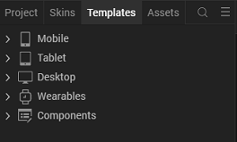

3. Right-click Components, and then select Import Component. The Import Component dialog box appears.
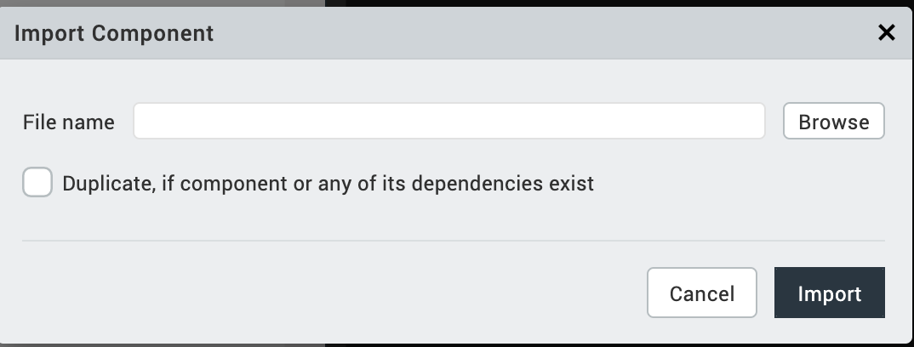
4. Click Browse to navigate to the location of the component, select the component, and then click Import. The component and its associated widgets and modules are added to your project.
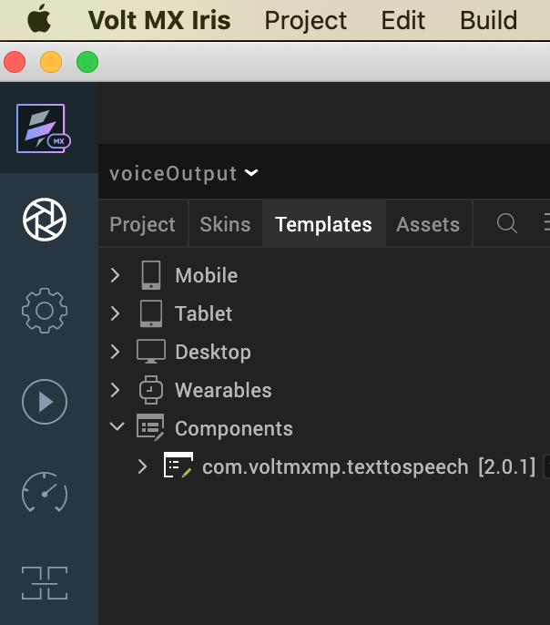
Once you have imported a component to your project, you can easily add the component to a form. For more information, refer Add a Component to a Form.

3. REFERENCES

A. Dynamic Usage
You can also add an VoiceOutput component dynamically. To do so:
- In the Project Explorer, on the Projects tab, click Controllers section to access the respective Form Controller. Create a method and implement the code snippet similar to the sample code mentioned below.
In the code snippet, you can edit the properties of the component as per your requirement. For more information, see Setting Properties.
/* Creating a component's Object */

createComponent: function()
{
/* Creating the component's object */
var textToSpeech = new com.voltmxmp.texttospeech(
{
"clipBounds": true,
"height": "10%",
"width": "12%",
"id": "textToSpeech",
"isVisible": true,
"left": "0dp",
"top": "0dp"
}, {}, {});

/* Setting the component's properties */
textToSpeech.speechOnIcon = "<Speech on icon name>";
textToSpeech.speechOnIconScaleMode = "<speech on Icon Scale Mode>";
textToSpeech.speechOffIcon = "<speech Off Icon name>";
textToSpeech.speechOffIconScaleMode = "<speech on Icon Scale Mode>";
textToSpeech.setRate = "0.3";
textToSpeech.setAndroidLanguage = "<language>";
textToSpeech.preUtteranceDelay = "<pre Utterance Delay>";
textToSpeech.postUtteranceDelay = "<post Utterance Delay >";
textToSpeech.pitchMultiplier = "<Multiplier>";
textToSpeech.setIphoneLanguage = "<language>";
textToSpeech.volume = "<volume>";
textToSpeech.stopSpeechApibehaviour = "<stop behaviour>";
textToSpeech.setWebLanguage = "<language>";
textToSpeech.setPitch = "<pitch>";
textToSpeech.setWebVolume = "<volume>";

/* Defining the component's events */
textToSpeech.speechOn = function()
{
alert("Starting Speech.");
};

textToSpeech.speechOff = function()
{
alert("Stopping Speech.");
};

/* Adding the component to the form */
this.view.add(textToSpeech);
}

- Save the file.

B. Properties
The properties provided on the Component tab allow you to customize the UI elements in the VoiceOutput component. You can set the properties directly on the Component tab or by writing a JavaScript.
1. Speech On Icon
Category: | Pass Through
Description: | Specifies the source of the image that you want to display as the Speech On icon.
Syntax: | speechOnIcon
Type: | String
Read/Write: | Write
Example: | this.view.componentID.speechOnIcon = "speech_on.png";

2. Speech On Icon Scale Mode

Category: | Pass Through
Description: | Specifies the scaling mode of the image that you want to display as the Speech On icon.
Syntax: | speechOnIconScaleMode
Type: | - List Selector  - String
Read/Write: | Write
Example: | this.view.componentID.speechOnIconScaleMode = "Maintain Aspect Ratio";
- Speech Off Icon
Category: | Pass Through
Description: | Specifies the source of the image that you want to display as the Speech Off icon.
Syntax: | speechOffIcon
Type: | String
Read/Write: | Write
Example: | this.view.componentID.speechOffIcon = "speech_off.png";

- Speech Off Icon Scale Mode
Category: | Pass Through
Description: | Specifies the scaling mode of the image that you want to display as the Speech Off icon.
Syntax: | speechOffIconScaleMode
Type: | - List Selector  - String
Read/Write: | Write
Example: | this.view.componentID.speechOffIconScaleMode = "Maintain Aspect Ratio";

- Speech Rate
Category: | Custom
Description: | Specifies the rate that you want to set for the speech. Low values correspond to slow speech, and high values correspond to fast speech.
Syntax: | setRate
Type: | String
Read/Write: | Write
Example: | this.view.componentID.setRate = "0.3";
Remarks: | - The values are in the range of MinimumSpeechRate and MaximumSpeechRate. These values depend on the platform.  - For more information on speech rates, you can refer to android.speech.tts and Apple AV Speech Utterance.

Android
1. Language
Category: | Custom
Description: | Specifies the language that you want to use for the text to speech feature on the Android platform.  The text to speech engine picks the language that matches the specified locale.
Syntax: | setAndroidLanguage
Type: | String
Read/Write: | Write
Example: | this.view.componentID.setAndroidLanguage = "UK";
iOS
1. Pre Utterance Delay

Category: | Custom
Description: | Specifies the delay that you want to set before the component speaks an utterance.
Syntax: | preUtteranceDelay
Type: | String
Read/Write: | Write
Example: | this.view.componentID.preUtteranceDelay = "0.0";
2. Post Utterance Delay
Category: | Custom
Description: | Specifies the delay that you want to set after the component speaks an utterance and before it speaks the next utterance.
Syntax: | postUtteranceDelay
Type: | String
Read/Write: | Write
Example: | this.view.componentID.postUtteranceDelay = "0.0";
3. Pitch Multiplier
Category: | Custom
Description: | Specifies the baseline pitch that the component uses for speech on the iOS platform.
Syntax: | pitchMultiplier
Type: | String
Read/Write: | Write
Example: | this.view.componentID.pitchMultiplier = "1.0";
4. Language
Category: | Custom
Description: | Specifies the language that you want to use for the text to speech feature on the iOS platform.
Syntax: | setIphoneLanguage
Type: | String
Read/Write: | Write
Example: | this.view.componentID.setIphoneLanguage = "en-us";
5. Volume
Category: | Custom
Description: | Specifies the volume of the speech on the iOS platform.
Syntax: | volume
Type: | String
Read/Write: | Write
Example: | this.view.componentID.volume = "0.5";
6. stopSpeech API Behavior
Category: | Custom
Description: | Specifies the action that you want the component to perform when the stopSpeech API is called.
Syntax: | stopSpeechApibehaviour
Type: | - List Selector  - String
Read/Write: | Write
Example: | this.view.componentID.stopSpeechApibehaviour = "stop immediately";

Desktop
1. Language
Category: | Custom
Description: | Specifies the language that you want to use for the speech to text feature on the Desktop Web platform.
Syntax: | setWebLanguage
Type: | String
Read/Write: | Write
Example: | this.view.componentID.setWebLanguage = "en-US";
2. Pitch
Category: | Custom
Description: | Specifies the baseline pitch that the component uses for speech on the Desktop Web platform.
Syntax: | setPitch
Type: | String
Read/Write: | Write
Example: | this.view.componentID.setPitch = "1.0";
3. Volume
Category: | Custom
Description: | Specifies the volume of the speech on the Desktop Web platform.
Syntax: | setWebVolume
Type: | String
Read/Write: | Write
Example: | this.view.componentID.setWebVolume = "0.5";

C. Events
1. speechOn
Category: | Custom
Description: | Invoked when the user clicks the component to start the speech.
Syntax: | speechOn
Example: | this.view.componentID.speechOn = function()  {  alert("Starting Speech.");  }.bind(this);
2. speechOff
Category: | Custom
Description: | Invoked when the user clicks the icon to stop the speech.
Syntax: | speechOff
Example: | this.view.componentID.speechOff = function()  {  alert("Stopping Speech.");  }.bind(this);

D. APIs
The following APIs pertain to the Voice Output Interface component:
1. speakOut

Description: Converts and speaks the given text.
Syntax: speakOut()
Parameters:
text [String]:
The text that you want to convert to speech.
Return Value:
None
Sample Input Format:
var text = "Convert this text to speech.";
this.view.componentID.speakOut(text);

2. stopSpeech
Description: Stops the current speech.
Syntax: stopSpeech()
Parameters: None
Return Value: None
Sample Input Format: this.view.componentID.stopSpeech();

E. Skins
1. Image Flex Skin

Category: | Pass Through
Description: | This skin links to the background of the component.
Syntax: | imageFlexSkin
Widget Type: | FlexContainer

4. REVISION HISTORY
App version 2.0.1
- Known issues:
No known issue.
- Limitations
Following are the limitations in the Voice Output Interface component:
- For Ios, the text we enter needs to follow the sentence format. The beginning letter should be capitalized. Otherwise, the speech engine will not be recognized as a sentence. There will be no delay between sentences.
- For example, “How are you? What are you from?”. This will be identified as two sentences. But for this, “how are you? what are you from?”. The speech engine will think this is a sentence.

