30 July 2025

360 Degree viewer

version:1.0.0

1. **OVERVIEW:**

A **360-degree viewer** is an interactive technology that allows users to explore images or videos in a fully immersive manner by rotating the view around a complete sphere. Unlike traditional media where viewers see a fixed frame, 360-degree content gives users the ability to look in any direction—up, down, left, right—simulating a real-world experience. This can be achieved through desktop interactions like click-and-drag, touchscreen gestures on mobile devices, or even by physically moving VR headsets or smartphones with device sensors.

The core of this technology lies in capturing visual data in all directions and stitching it together to create a seamless panoramic experience. This content is then rendered through specialized viewers that respond to user inputs or device motion to change the perspective dynamically. Whether it’s a still panoramic image or a fully spherical video, 360-degree viewers provide an unparalleled sense of presence and spatial awareness that traditional media cannot match.

In today’s digital landscape, the importance of 360-degree viewers is rapidly growing as they transform how audiences interact with content. Businesses and creators use this technology to engage users more deeply by offering a richer and more intuitive exploration experience. This interactive dimension is especially crucial in a world where digital attention spans are short and competition for engagement is fierce. By enabling viewers to “step inside” the scene rather than just look at it, 360-degree viewers create memorable, lasting impressions.

**Requirements:**

* Volt MX Iris
* [Volt MX Foundry](https://manage.hclvoltmx.com/)

1. **Devices:**

* Mobile
* Desktop/Laptop
* Tablet/Ipad

1. **Platforms:**

* Android
* IOS
* Windows (Web browsers)
* Mac (Web browsers)
* PWA (Can be used offline by referencing local script files instead of relying on CDNs.)

1. **GETTING STARTED**
2. **Prerequisites**

Before you start previewing the 360-degree image/video in your device, ensure that you have the following:

1. Voltmx Account

2. Voltmx Iris

1. **Create sample app and Import the Component**

To import the Viewer 360 into your workspace, follow these steps:

1. Open Voltmx Iris.
2. Click on project ->New Project
3. Select Web app and click on next.

1. Select Desktop and click on next.

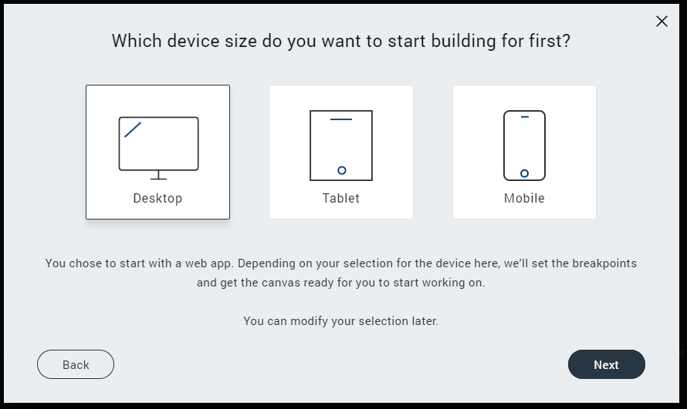

1. Provide the name of project and click on create.

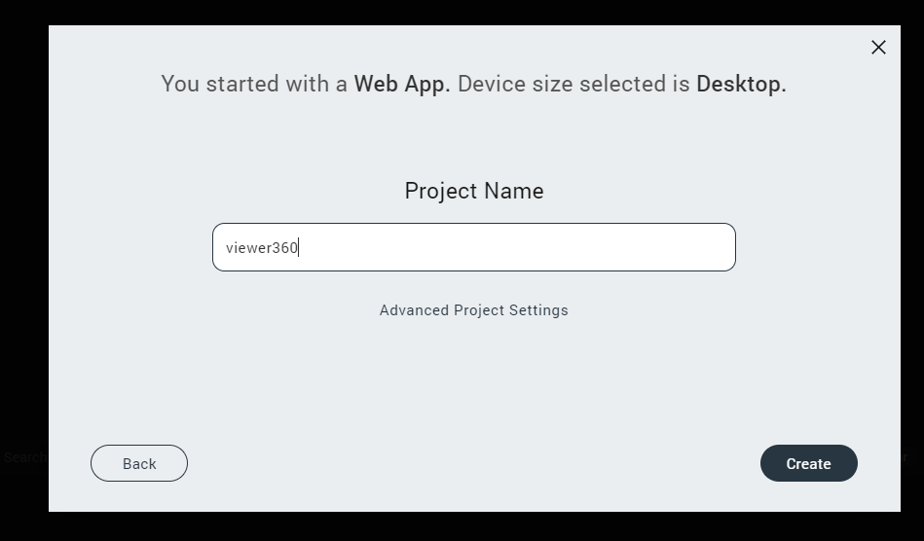

1. Go to project filter and enable mobile option and save.

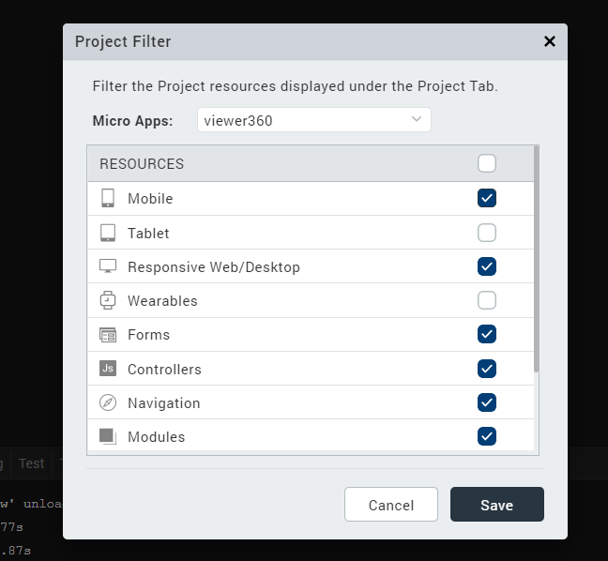

1. Create forms in Responsive web and Mobile as frmHome.

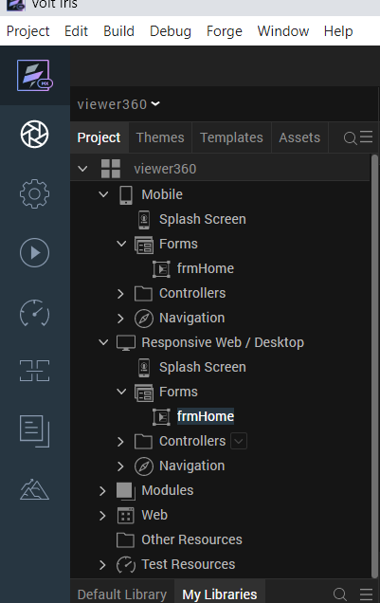

1. Go to templates, components, Import Component.

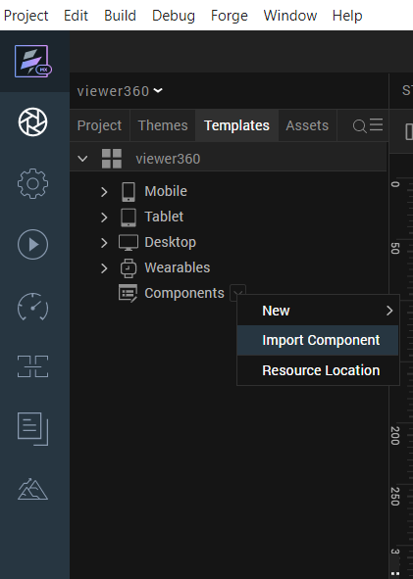

1. Browse, select the component and Import.

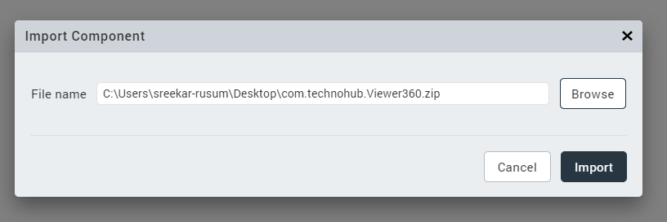

1. In the components section, Viewer360 will be available and ready to use.

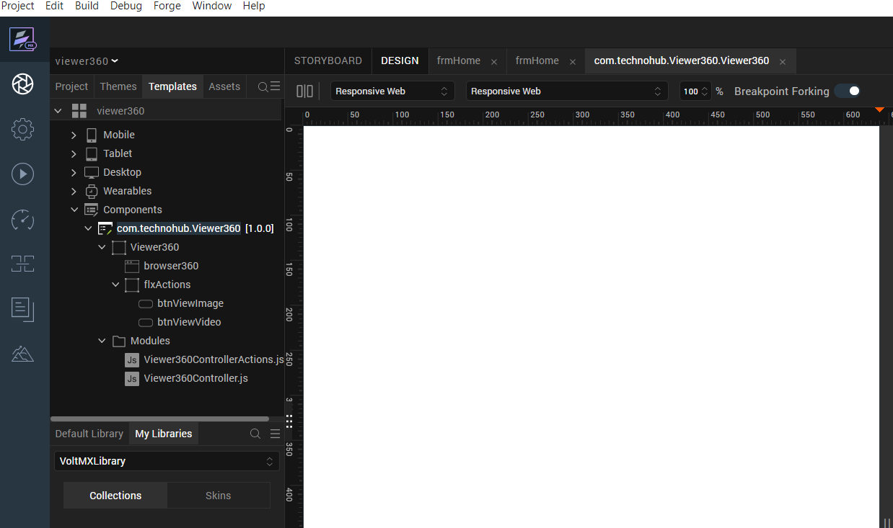

1. Insert the component in to Web, Mobile forms respectively and verify availability of below local files.

For more information, refer [Add a Component to a Form](https://opensource.hcltechsw.com/volt-mx-docs/docs/documentation/Iris/iris_user_guide/Content/C_UsingComponents.html" \l "add-a-component-to-a-form)

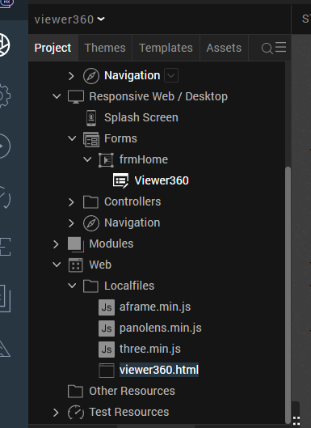

1. In controller files provide the base64, video URLs respectively as below.

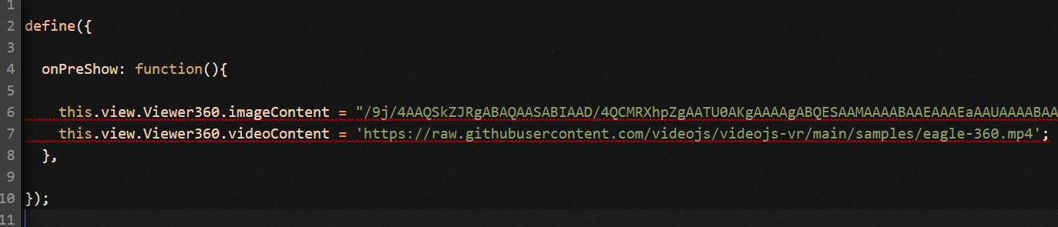

1. In Preshow, Invoke the function onPreshow.

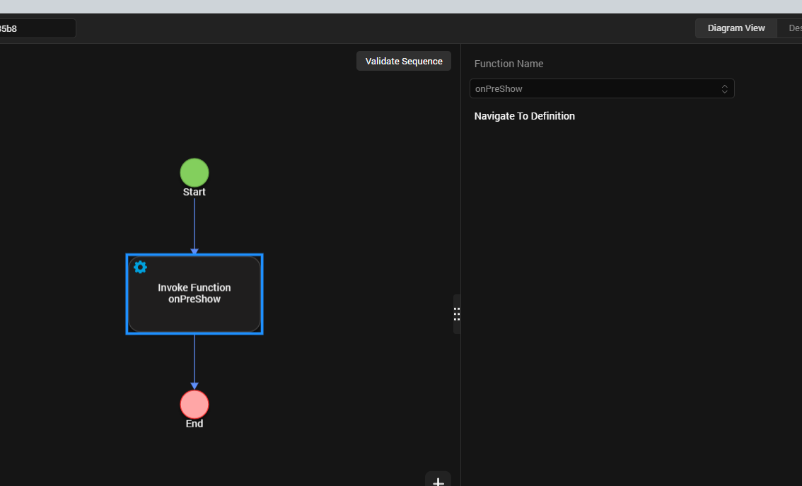

1. **Building and previewing the app.**

After performing all the above steps, you can build your app and run it on your device. For more information, you can refer to the [Building and Viewing an Application](https://opensource.hcltechsw.com/volt-mx-docs/docs/documentation/Iris/iris_user_guide/Content/Cloud_Build_in_VoltMX_Iris.html#cloud) section of the Volt MX User Guide.

1. **Application Flow.**
   1. **Responsive Web**

The landing page for web app is as follows.



Click on View Image button to view 360-degree Image and explore.

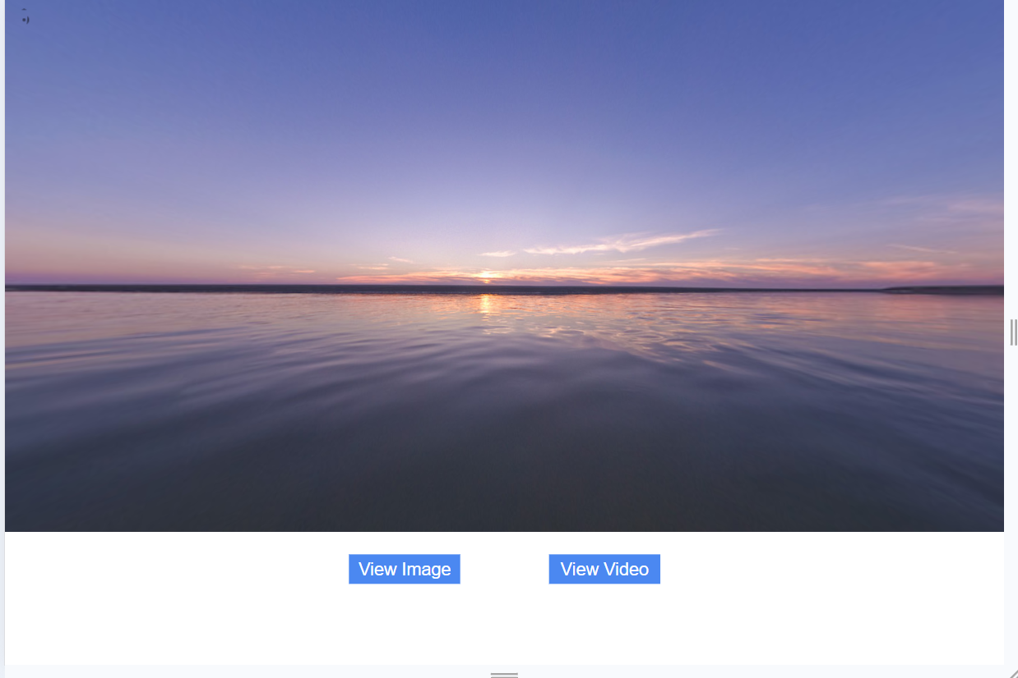

Click on View Video button to explore the video.

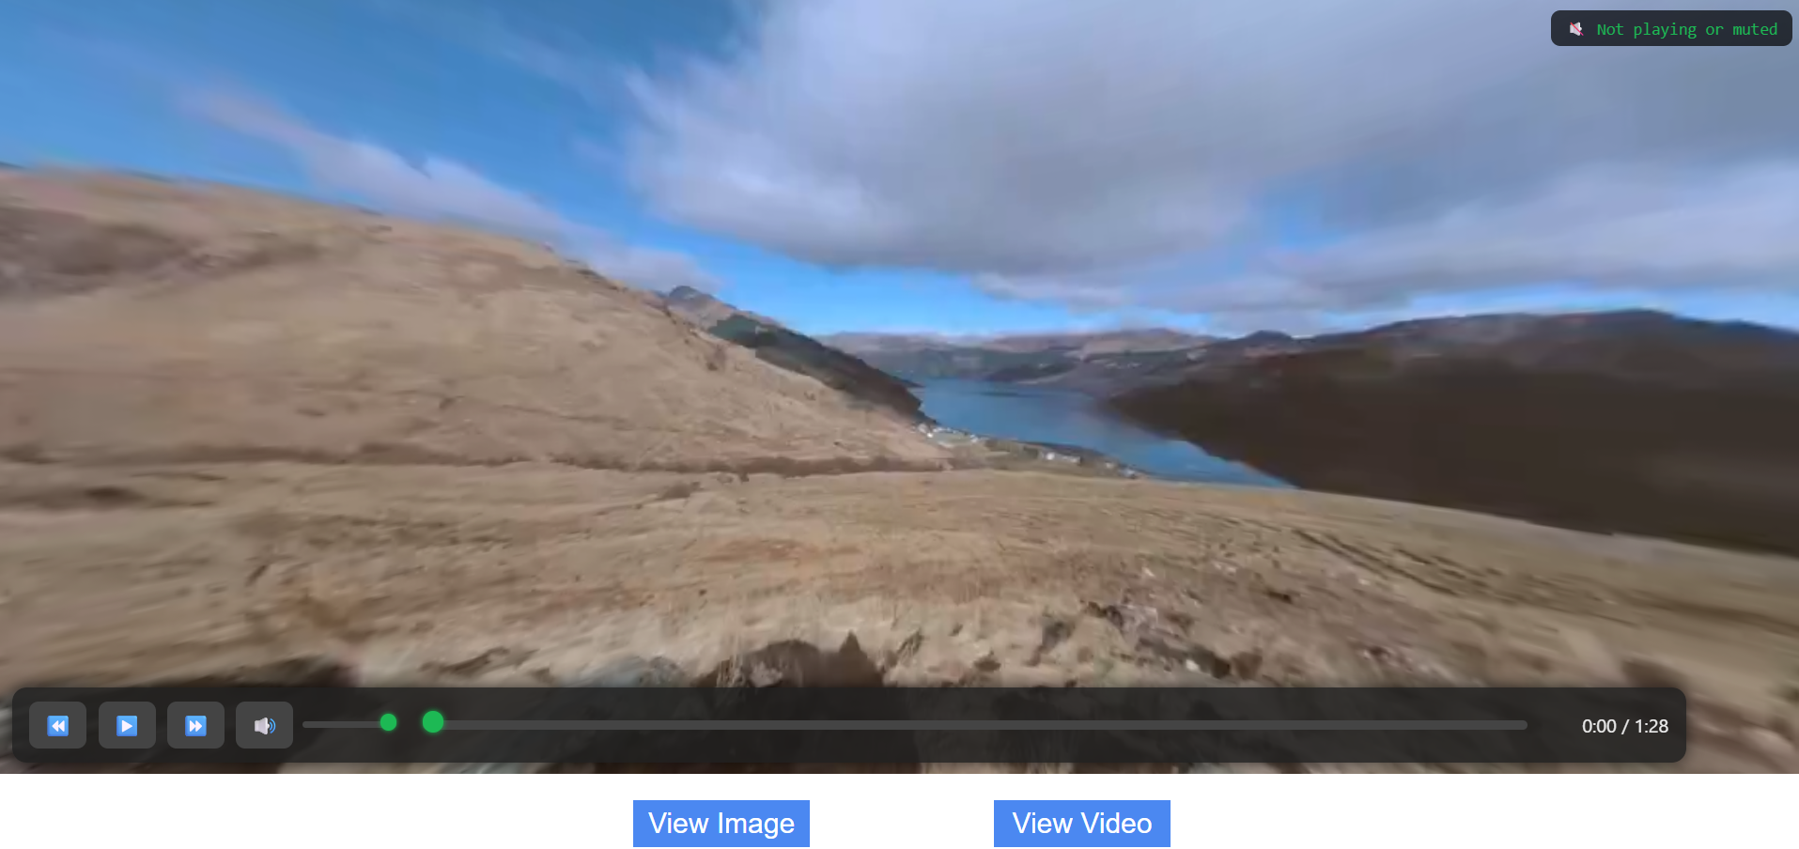

Buttons are provided to play/pause, forward, backword, mute/unmute.

Progress indicators are provided for sound, video length accordingly.

* 1. **Mobile Devices**

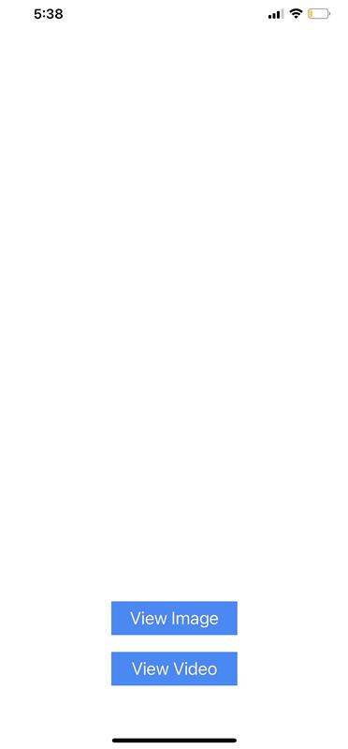

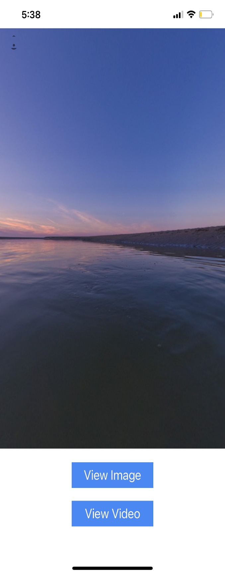Click on View Image button to view 360-degree Image and explore.

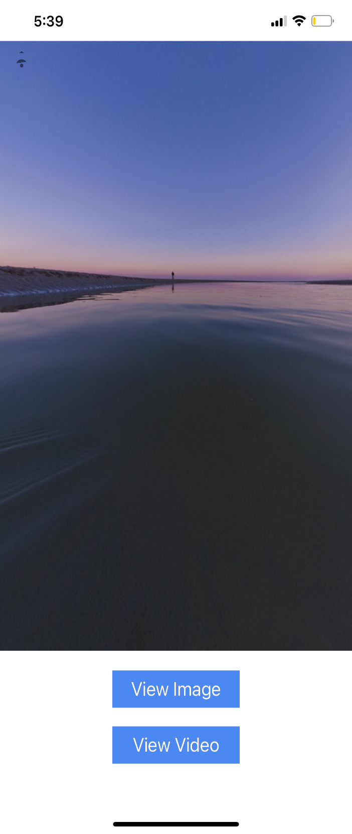

**Note:** On Android devices, **gyroscopic view** is available, allowing users to explore 360-degree images by physically moving their device. On iOS devices, users can navigate the 360-degree image using **touch gestures**.

Click on video button to explore the video.

**Click on allow to provide device motion access in IOS device.**

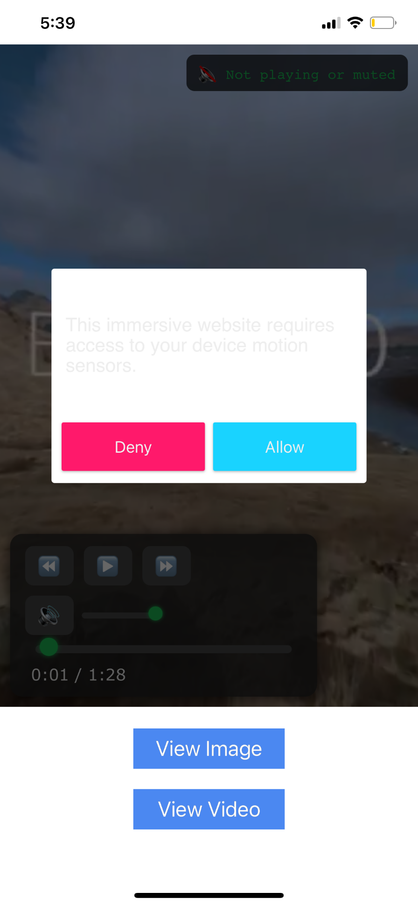

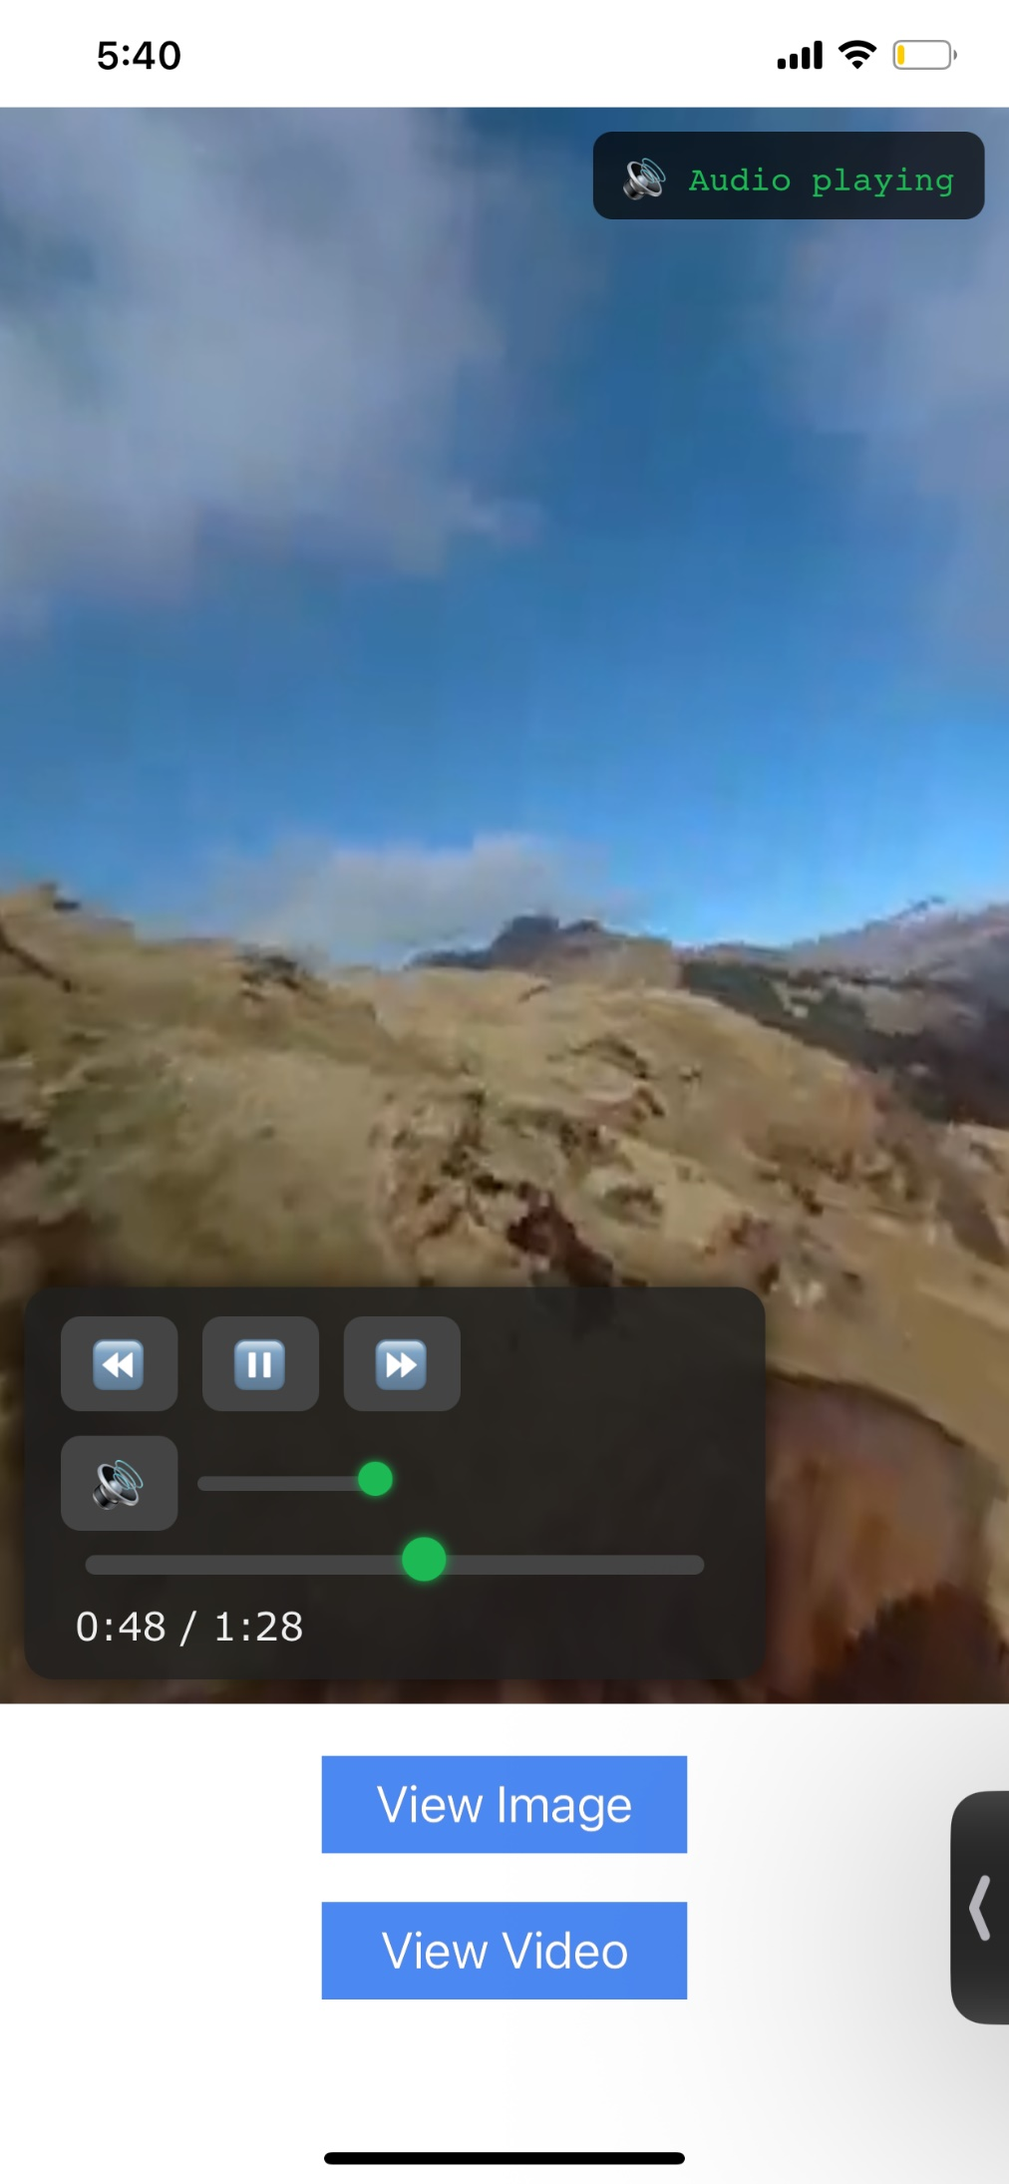

**3. REVISION HISTORY**

App version 1.0.

**A. Limitations:**

**1.** On iOS, the video automatically enters full screen mode. Please minimize it using Picture-in-Picture (PiP) mode to continue interacting with the app.

**2.** Browser widget behavior can sometimes be inconsistent. If you encounter any issues, feel free to recreate the browser widget with the same properties as the original one in component and rebuild the project.

**B. Known issues:**

No issues