05 June 2023

Vertical Slider(1.0.0)

# Overview

Use this component adds a ranged slider to the project. The starting and ending values of the range can be configured, as well as the starting selected value.

The user can click on the bar to set a value or click and drag on the range indicator icon to set a value.

## Use case

### To use a range bar to select or drag a value

## Percentage of re-use:

Approximately 99% reusable.

## Features.

Click and drag the indicator to select the value

# Getting Started

## Prerequisites

Before you start using the Vertical Slider component, ensure the following:

• [HCL Foundry](https://manage.hclvoltmx.com/)

• Volt MX Iris

## Platforms Supported

### PWA & Responsive Web

### Native

## Importing the app

You can import the Forge components only into the apps that are of the Reference Architecture type.

**To import the EncryptGlobal component, do the following:**

#### Open your app project in Volt MX Iris..

#### In the Project Explorer, click the **Templates** tab.

#### Right-click **Components**, and then select **Import Component**. The **Import Component** dialog box appears.

#### Click **Browse** to navigate to the location of the component, select the component, and then click **Import**. The component and its associated widgets and modules are added to your project.

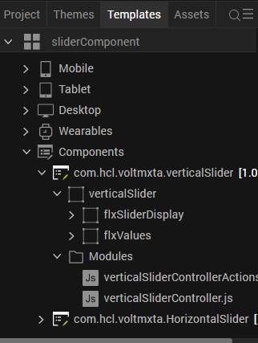

Once you have imported a component to your project, you can easily add the component to a form. For more information, refer [Add a Component to a Form](https://opensource.hcltechsw.com/volt-mx-docs/docs/documentation/Iris/iris_user_guide/Content/C_UsingComponents.html" \l "add-a-component-to-a-form)

## Building and previewing the app

Before you can use this component in a web context, we need to set some flags within the project settings. This will ensure that the drag function of the component will work on web pages.

Go to Project Settings -> Responsive Web and select the Enable JS Library mode (Legacy)

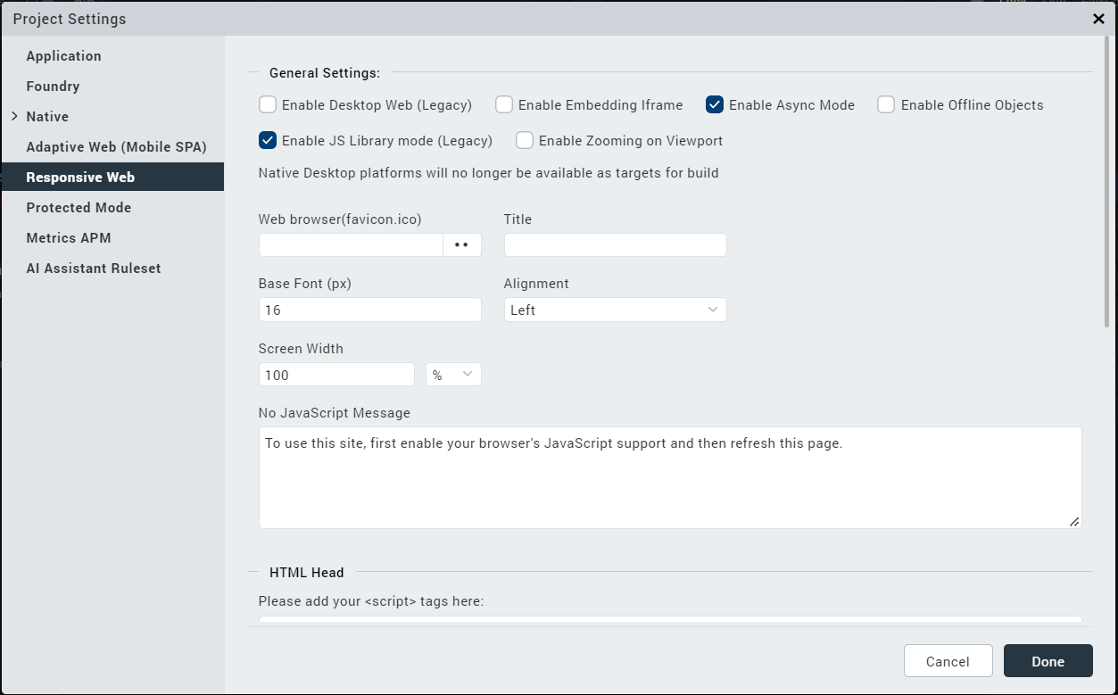

# Revision History

App version 1.0.0:

## Known Issues

NA

## Limitations

NA