Date: 10-Apr-2023

Vertical parallax

VERSION: 2.1.3

Overview
Parallax scrolling uses multiple objects at different speeds to give the impression of a 3d effect where nearby objects have a larger parallax than more distant objects when observed from different positions. If you're looking for a popular scrolling effect used by native mobile apps and amazing websites, download the vertical parallax.
The Vertical Parallax component is a single-page animated UI that contains a background and a foreground to create a parallax animation.

Use case:
An app where the user wants to display information about a location and an image of the location. Users can use the image as the background of the component and can include the information in the foreground of the component.

Percentage of re-use:
80-90%.

Features:
· Parallax scrolling effect in a vertical manner.
· Ability to animate background and foreground at different speeds
· Facility to customize the UI elements.

Getting Started

Prerequisites
Before you start using the Vertical Parallax component, ensure the following:
• HCL Foundry
• Volt MX Iris

Platforms Supported

Mobile

iOS

Android

PWA

Importing the app

You can import the Forge components only into the apps that are of the Reference Architecture type.

To import the Vertical Parallax component, do the following:

Open your app project in Volt MX Iris.

In the Project Explorer, click the Templates tab.

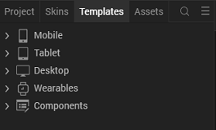

Right-click Components, and then select Import Component. The Import Component dialog box appears.

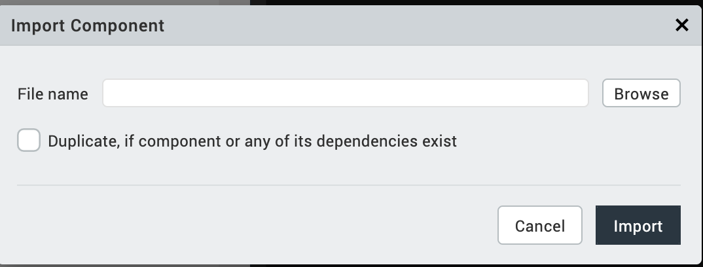

Click Browse to navigate to the location of the component, select the component, and then click Import. The component and its associated widgets and modules are added to your project.

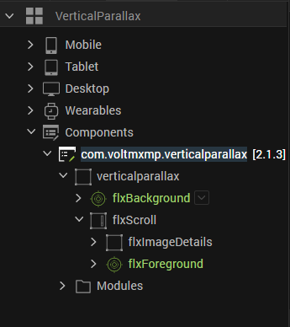
Once you have imported a component to your project, you can easily add the component to a form. For more information, refer Add a Component to a Form

Adding widgets to the component
The Vertical Parallax component uses Target Containers to hold the widgets that you add to the background or the foreground.
You can add widgets or other components to the Target Containers based on your preference. Let us add an Image Widget to the background and a TextArea (TextArea2) Widget to the foreground.

Adding an Image to the background

1. From the Project explorer, select the flxBackground target container.

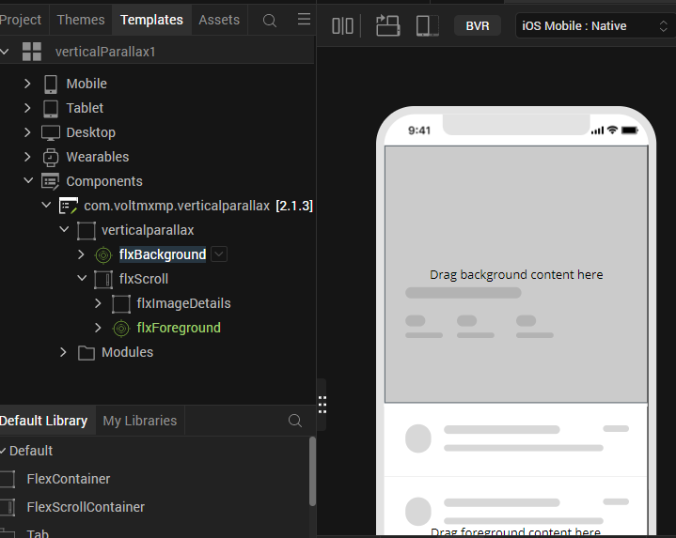

2. From the Default Library, drag and drop an Image widget onto the flxBackground target container
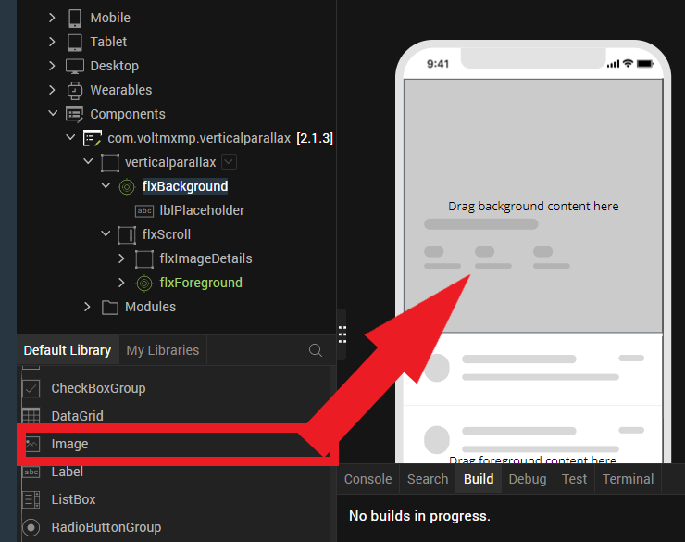

Note:
To fit the image to the background container, you can set the following values for the properties of the Image widget.
You can find these properties in the Look tab on the right side of Visualizer.
- Top: 0dp
- Left: 0dp
- Width: 100%
- Height: 100%

Adding a Text Area to the foreground
- From the Project explorer, select the flxForeground target container.

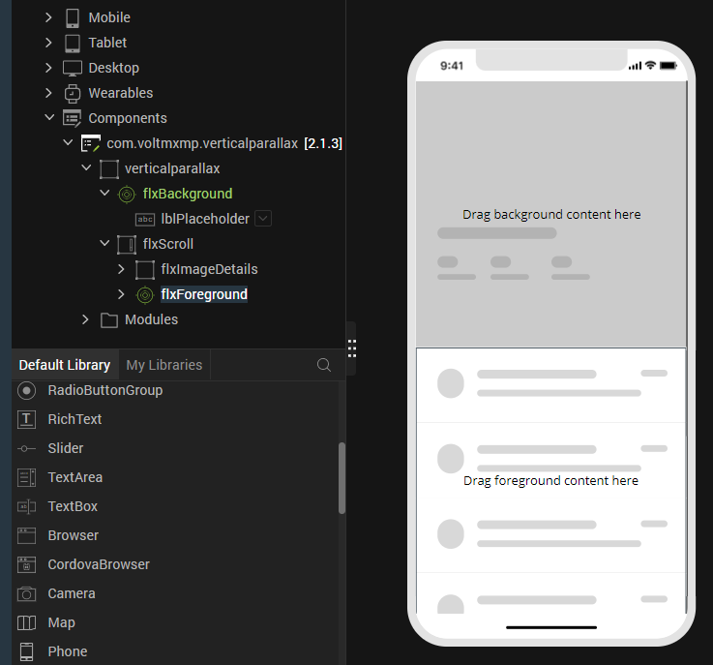

From the Default Library, drag and drop a TextArea widget onto the flxForeground target container.

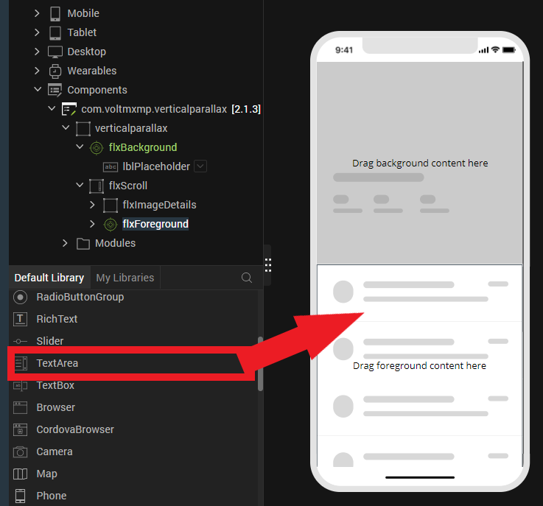

Building and previewing the app
After performing all the above steps, you can build your app and run it on your device. For more information, you can refer to the Building and Viewing an Application section of the Volt MX User Guide.
You can then run your app to see the Vertical Parallax work in real time.

References

Dynamic Usage
You can also add Vertical parallax component dynamically. To do so,
1. In Project Explorer, on the Projects tab, click Controllers section to access the respective Form Controller. Create a method and implement the code snippet like the sample code mentioned below.

createComponent: function()
{
/* Creating the component's object */

var VerticalParallax = new com.voltmxmp.verticalparallax(
{
"clipBounds": true,
"height": "100%",
"masterType": constants.MASTER_TYPE_USERWIDGET,
"layoutType": voltmx.flex.FREE_FORM,

"skin": "slForm",
"id": "VerticalParallax",
"isVisible": true,
"left": "0dp",
"top": "0dp",
"width": "100%",
"zIndex": 1
}, {}, {});

/* Setting the component's properties */
VerticalParallax.parallaxSpeed = 5;
VerticalParallax.backgroundHeight = "50%";
VerticalParallax.foregroundHeight = "100%";
VerticalParallax.foregroundTop = "50%";

/* Setting the Placeholder Properties */
VerticalParallax.isFgPlaceholderVisible = true;
VerticalParallax.isImgDetailsVisible = true;
VerticalParallax.isBgPlaceholderVisible = false;

/*Adding the component to a Form*/
this.view.add(VerticalParallax);
}

In the code snippet, you can edit the properties of the component as per your requirement. For more information, see Setting Properties.
2. Save the file

Properties
The properties provided on the Component tab allow you to customize the elements in the Vertical parallax component. These elements can be UI elements, service parameters, and so on. You can set the properties from the Volt MX Iris Properties panel on the right-hand side. You can also configure these properties using JavaScript code.

General Properties
1.Parallax Speed
Description: | Specifies the speed that you want to set for the parallax effect.
Syntax: | parallaxSpeed
Type: | Integer
Read/Write: | Write
Example: | this. view. componentID.parallaxSpeed= 5;

2. Background Height
Description: | Specifies the height of the background flex container.
Syntax: | backgroundHeight
Type: | String  Constant
Read/Write: | Read + Write
Default Value: | “50%”
Example: | this. view. componentID.backgroundHeight= “50%”;
Remarks: | - Make sure that the value of this property is equal to the Foreground Top to prevent UI distortions.  - For more information on the height of a FlexContainer widget, you can refer to the Height Property in the Quantum Visualizer Widget Programmers Guide.

3. Foreground Height
Description: | Specifies the height of the foreground flex container.
Syntax: | foregroundHeight
Type: | String  Constant
Read/Write: | Read + Write
Default Value: | “100%”
Example: | this. view. componentID.foregroundHeight= “100%”;
Remarks: | For more information on the height of a FlexContainer widget, you can refer to the Height Property in the Quantum Visualizer Widget Programmers Guide.

4. Foreground Top
Description: | Specifies the position of the top edge of the foreground flex container.
Syntax: | foregroundTop
Type: | String  Constant
Read/Write: | Read + Write
Default Value: | “50%”
Example: | this. view. componentID.foregroundTop= “50%”;
Remarks: | - Make sure that the value of this property is equal to the Background Height to prevent UI distortions.  - For more information on the top position of a FlexContainer widget, you can refer to the Top Property in the Quantum Visualizer Widget Programmers Guide.

2. Placeholder Properties
5. Foreground
Description: | Toggles the placeholder text on the foreground flex container.
Syntax: | isFgPlaceholderVisible
Type: | Boolean
Default Value: | true
Read/Write: | Read + Write
Example: | this. view. componentID.isFgplaceholderVisible= “true”;

6. image Details
Description: | Toggles the placeholder image on the background flex container.
Syntax: | isImgDetailsVisible
Type: | Boolean
Default Value: | true
Read/Write: | Read + Write
Example: | this. view. componentID.isImgDetailsVisible= “true”;

7. Background
Description: | Toggles the placeholder text on the background flex container.
Syntax: | isBgPlaceholderVisible
Type: | Boolean
Default Value: | true
Read/Write: | Read + Write
Example: | this. view. componentID.isBgplaceholderVisible= “false”;

Revision History
Asset Version | Modifications
Version 2.1.3 | - Bug fixes
Version 2.1.2 | - Added the following properties in General:  - Background Height  - Foreground Height  - Foreground Top
Version 2.1.1 | - Bug fixes and improvements.
Version 2.1.0 | - Bug fixes and improvements.
Version 2.0.0 | - Updated the UI of the component.  - Added the following properties in General:  - Parallax Speed  - Added the following properties in Placeholder Properties:  - Foreground  - Image Details  - Background  - Removed the following properties:  - Enable Background Image  - Title Visibility  - Enable Foreground Flex  Note:  For information on the properties that were removed, you can refer to the older documentation.
Version 1.0.0 | - Initial release of asset and documentation.

A. Limitations
- To avoid UI distortions, make sure that the values for the Background Height and the Foreground Top properties are equal.

Known Issues
- No support for Background Flex animation when a user scrolls down the Foreground. The Android and Windows platforms have the issue.

