Date: 05-Feb-24

vertical bar chart – distributed series

version: 1.1.2

Overview
Vertical Bar Chart – distributed series is a component that creates a chart or graph with vertical bars, based on the data that you provide.
In the Vertical Bar Chart – distributed series component, the intervals are defined on y-axis and the labels are defined on the x-axis.
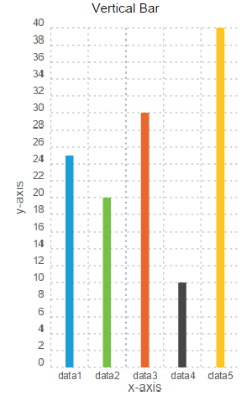

Use case:

You can use the component in your mobile app to represent the comparison between distinct items or data in the form of vertical bars. For examples, sales growth on monthly basis.

Features

Easily to update the chart with Iris properties or by API

Percentage of re-use:
80-90% (Data can be customizable and skins are not customized but can be changed manually)

Getting Started

Prerequisites
Before you start using the component, ensure you have the following:
- HCL Foundry
- Volt MX Iris

Platforms Supported

Mobile

iOS

Android

Tablets

iOS

Android

PWA

Importing the app

You can import the Forge components only into the apps that are of the Reference Architecture type.

To import the component, do the following:

Open your app project in Volt MX Iris.

In the Project Explorer, click the Templates tab.

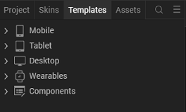

3.Right-click Components, and then select Import Component. The Import Component dialog box appears.
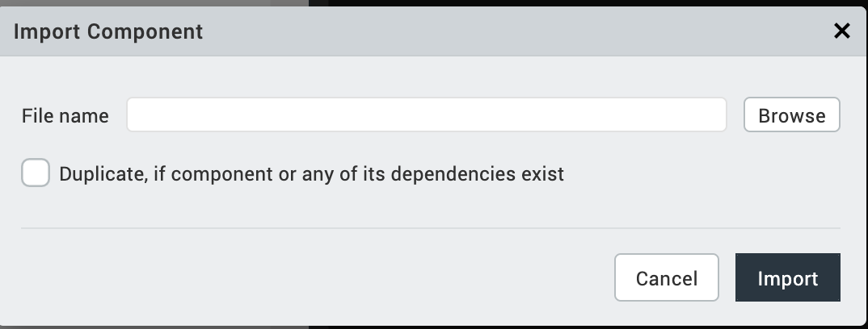
4.Click Browse to navigate to the location of the component, select the component, and then click Import. The component and its associated widgets and modules are added to your project.
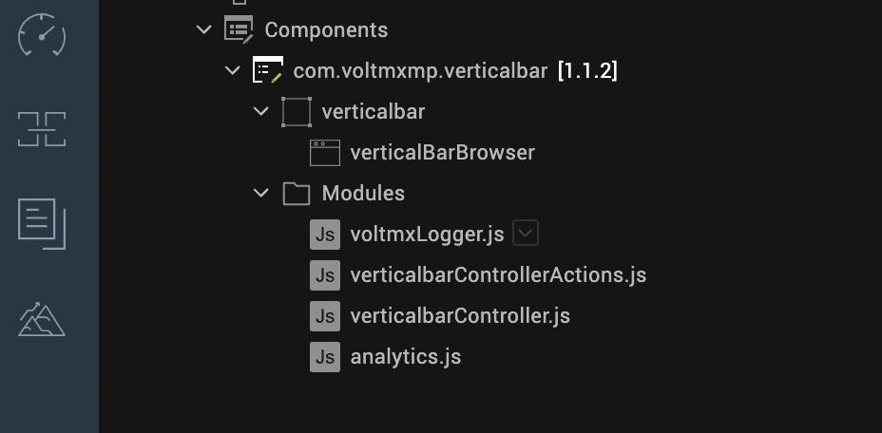

Once you have imported a component to your project, you can easily add the component to a form. For more information, refer Add a Component to a Form.

Building and previewing the app

Refer to below links:

Build & Generate Native Apps

Publish Apps to Enterprise App Store

References

Dynamic Usage
- You can add a Vertical Bar Chart – distributed series component dynamically. To do so,
In the Project Explorer, on the Projects tab, click Controllers section to access the respective formController. Create a method and implement the code snippet similar to the sample code mentioned below.
In the code snippet, you can edit the properties of the component as per your requirement. For more information, see Setting Properties.
var verticalbar = new com.voltmxmp.verticalbar(

{

"autogrowMode": voltmx.flex.AUTOGROW_NONE,

"clipBounds": true,

"id": "verticalbar",

"height": "90%",

"width": "100%",

"top": "10%",

"left": "0%",

"isVisible": true,

"skin": "slFbox",

"layoutType": voltmx.flex.FREE_FORM,

"masterType": constants.MASTER_TYPE_USERWIDGET,

"zIndex": 1

}, {}, {});

/* Setting the component s properties */

verticalbar.chartTitle = "Vertical Bar Chart";

verticalbar.bgColor = "#FFFFFF";

verticalbar.lowValue = "0";

verticalbar.highValue = "30";

verticalbar.chartData =

{

"data":

[

{"colorCode": "#1B9ED9", "label": "Data1", "value": "25"},

{"colorCode": "#76C044", "label": "Data2", "value": "20"},

{"colorCode": "#E8672B", "label": "Data3", "value": "10"},

{"colorCode": "#464648", "label": "Data4", "value": "30"},

{"colorCode": "#FFC522", "label": "Data5", "value": "40"}

]

};

verticalbar.enableStaticPreview = true;

verticalbar.titleFontColor = "#000000";

verticalbar.titleFontSize = "12";

verticalbar.xAxisTitle = "x-axis";

verticalbar.yAxisTitle = "y-axis";

verticalbar.enableGrid = true;

verticalbar.enableChartAnimation = true;

verticalbar.enableGridAnimation = true;

/* Adding the component to the form */

this.view.add(verticalbar);

- Save the file.

Properties

General
- Background Color
Description: | Specifies background color of the chart.
Syntax: | bgColor
Type: | String
Read/Write: | Write
Example: | this.view.<componentID>.bgColor= "#FFFFFF";

- Enable Chart Animation
Description: | Controls whether or not to enable the chart animation.
Syntax: | enableChartAnimation
Type: | Boolean
Read/Write: | Write
Remarks: | Disabling the chart animation will also disable the grid animation.
Example: | this.view.<componentID>.enableChartAnimation= true;

- Low Value
Description: | Specifies the starting value on the vertical (y) axis. The minimum value is the start index on y-axis.
Syntax: | lowValue
Type: | String
Read/Write: | Write
Remarks: | Providing a negative value converts the bar chart into a bipolar chart.  Low and High values must be passed according to the data passed to the chart.
Example: | this.view.<componentID>.lowValue= "0";

- High Value
Description: | Specifies the maximum value on vertical (y) axis. The maximum value is the end index on y-axis.
Syntax: | highValue
Type: | String
Read/Write: | Write
Remarks: | Low and High values must be passed according to the data passed to the chart.
Example: | this.view.<componentID>.highValue= "30";

- Enable Chart with Static Data
Description: | Specifies whether or not the chart should render in the data grids, with the given data.
Syntax: | enableStaticPreview
Type: | Boolean
Read/Write: | Write
Example: | this.view.<componentID>.enableStaticPreview = true;

- Chart Data
Description: | Enables a user to provide the data to generate the chart.
Syntax: | chartData
Type: | Data Grid
Read/Write: | Write
Remarks: | The property is static and cannot be assigned dynamically.

Axis Titles

- X-axis Title
Description: | Specifies the text to be displayed as the X-axis (horizontal axis) title.
Syntax: | xAxisTitle
Type: | String
Read/Write: | Write
Example: | this.view.<componentID>.xAxisTitle= "Day";

- Y-axis Title
Description: | Specifies the text to be displayed as the y-axis (vertical axis) title.
Syntax: | yAxisTitle
Type: | String
Read/Write: | Write
Example: | this.view.<componentID>.yAxisTitle= "Rate";

Grid

- Enable Grid
Description: | Controls whether or not to enable the chart grid.
Syntax: | enableGrid
Type: | Boolean
Read/Write: | Write
Example: | this.view.<componentID>.enableGrid= true;

- Enable Grid Animation
Description: | Controls whether or not to enable the grid animation.
Syntax: | enableGridAnimation
Type: | Boolean
Read/Write: | Write
Example: | this.view.<componentID>.enableGridAnimation= true;

Title

- Chart Title
Description: | Specifies the text to be displayed as the Chart title.
Syntax: | chartTitle
Type: | String
Read/Write: | Write
Example: | this.view.<componentID>.chartTitle = "Vertical Bar Chart";

- Title Font Size
Description: | Specifies the font size of the Chart title.
Syntax: | titleFontSize
Type: | String
Read/Write: | Write
Example: | this.view.<componentID>.titleFontSize= "12";

- Title Font Color
Description: | Specifies the font color of the Chart title.
Syntax: | titleFontColor
Type: | String
Read/Write: | Write
Example: | this.view.<componentID>.titleFontColor = "#000000";

Events
No Events

API’s

createChart
The API creates a vertical bar chart.
Syntax
createChart(data)
Parameters
data:
JSON array contains the data based on which the vertical bar chart is generated. The JSON array should contain data of column names and the corresponding values to generate bars for the columns, in the key-value pair format. Here is the JSON array format:
var data =
[
{"colorCode": "#1B9ED9", "label": "Data1", "value": "25"},
{"colorCode": "#76C044", "label": "Data2", "value": "20"}
];
In the above format, label, value, colorCode are keys and they are case sensitive.
- label: The key accepts string values, so define the value within the qoutation marks. You can specify upto 04 characters as a column name. For example, "Jan". Specifying more than 04 characters results distortion in the component UI.
- value: The key accepts integer values.
- colorCode: The key accepts color codes. The value of the key must be a 6-character Hex color code preceded by the number sign (#).
The component can conveniently handle a maximum of 07 key-value pairs in the JSON array. Defining more than 07 key-value pairs results distortion in the component UI.
Return Value
None
Example
var chartData =
[
{"colorCode": "#1B9ED9", "label": "Data1", "value": "25"},
{"colorCode": "#76C044", "label": "Data2", "value": "20"}
];
this.view.verticalbar.chartData={data: chartData};
this.view.verticalbar.createChart(chartData);

Note:
- The createChart API must be invoked to reflect the dynamic change of any property after adding the chart to a form either by drag and drop method or dynamic creation.
- The data must be passed in a proper format (without any missing values).
- If you populate the data dynamically through the createChart(data) API and also using the data grid, the chart generates based on the data passed dynamically through the createChart(data) API.

Revision History
App version 1.1.2:

Known Issues
Following are the known issues in the component:
- Cannot handle layout properties of the component as per the device orientation. You must handle the properties at the form level.
- You cannot invoke createChart() API on forms preShow and postShow.

Limitations
The following are the limitations with the component:
- The label names on the horizontal axis and vertical axis must not contain more than three characters. Providing more characters will cause an overlap.
- The maximum length of the data that can be passed to the chart is seven. Exceeding the limit leads to UI distortions.

