Date :  19-10-2023

Vehicle RC Verification India API(1.0.0)

# Overview

This API will provide vehicle verification by providing vehicle info if registration number is correct.

A government agency or an insurance company needs to verify the details of a vehicle based on its registration number. By using the Vehicle RC Verification India API, the agency can easily access relevant information such as the vehicle's make, model, fuel type, registration date, owner details, and other important data associated with the vehicle. This can help in ensuring the accuracy of vehicle information, verifying ownership, and preventing fraudulent activities related to vehicle registration and documentation. The API response can be integrated into the agency's existing system, allowing for efficient and reliable data verification processes.

# Getting Started

## Prerequisites

* Volt Foundry
* [**Rapid API Account**](https://rapidapi.com/rahilkhan224/api/vehicle-rc-verification-india)
* X-RapidAPI-Key, X-RapidAPI-Host, x-anas-secret

## Importing the adapter

**To import the Data Adapter to Volt Foundry, do the following:**

1. Sign in to the  [HCL Foundry](https://manage.hclvoltmx.com/).
2. From the left navigation menu, select **API Management**.
3. In **API Management**, select **Custom Data Adapters**.  
   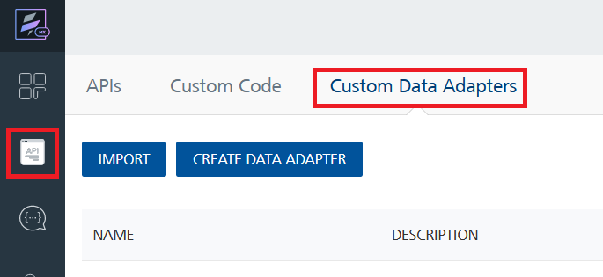
4. Click **IMPORT** to import a custom data adapter.  
   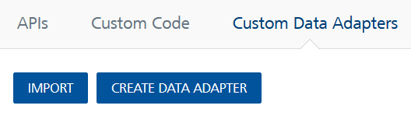
5. On the Import Data Adapter dialog box, click browser to import.  
   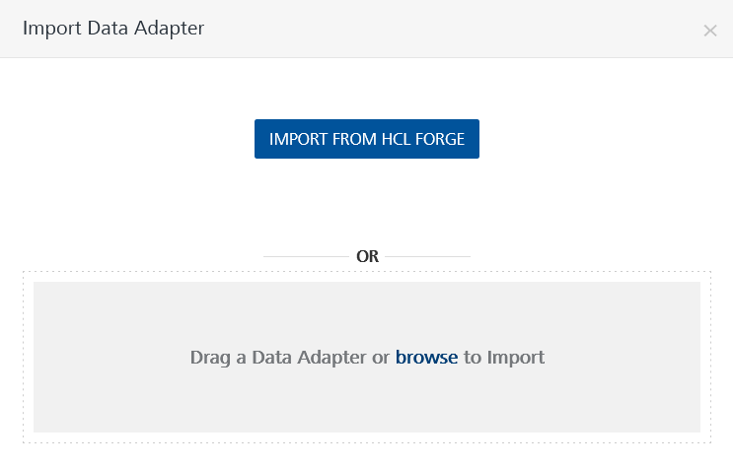
6. Select **Vehicle RC Verification India API zip** file and click **IMPORT**.

After you import the data adapter, Volt Foundry opens a window that shows the metadata of the data adapter.

After you import the data adapter, you can view it on the Custom Data Adapters page and use it to create services on Volt Foundry.

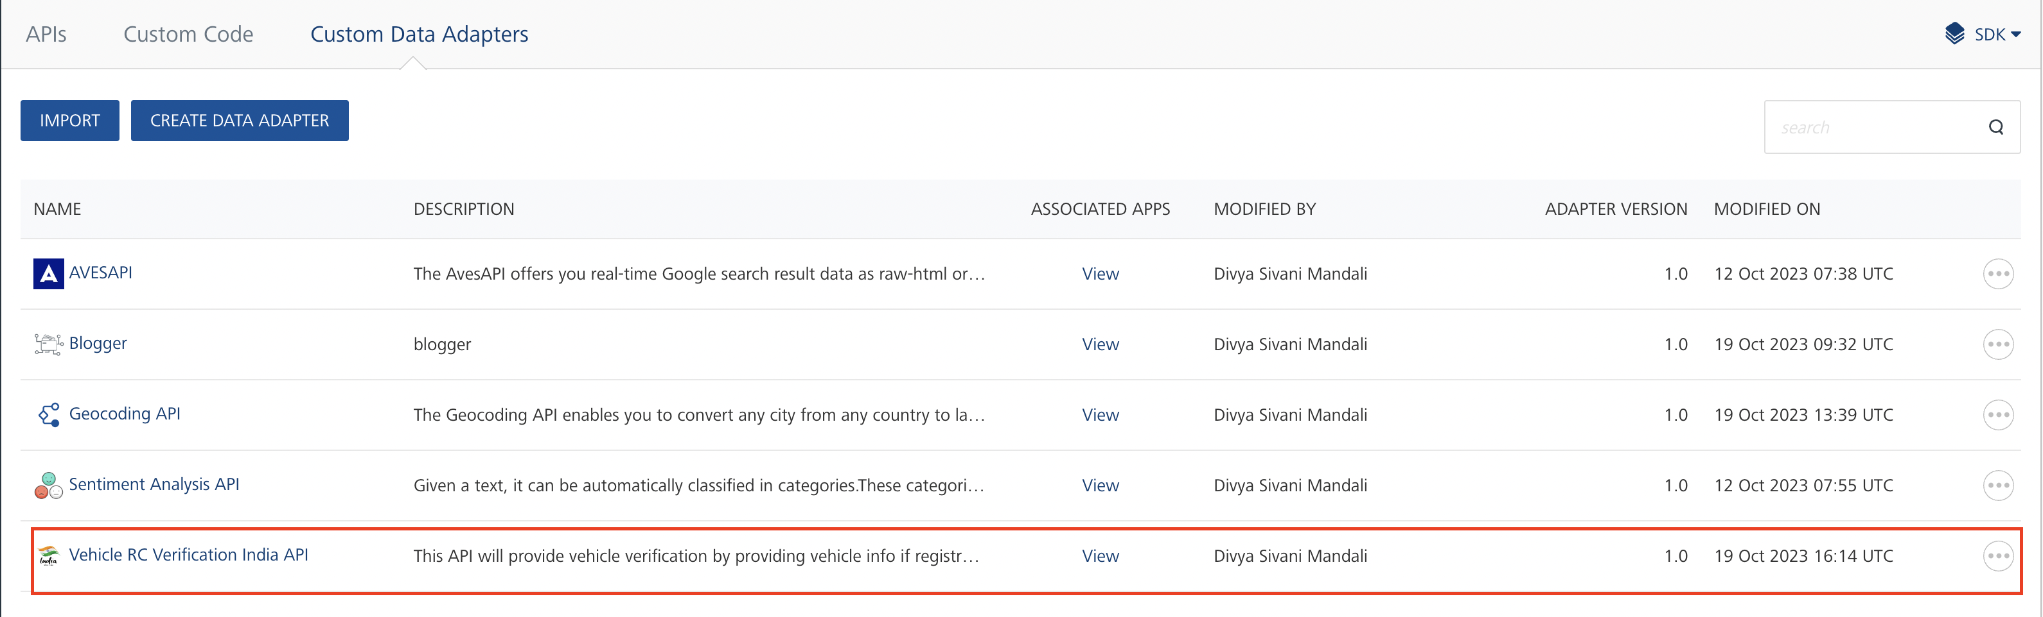

## [Creating an Integration service](javascript:void(0);)

After you import the data adapter into Volt Foundry, you can use it to create an Integration Service.

Follow the given steps to create an Integration service using the **Vehicle RC Verification India API** Adapter.

1. Sign in to the [HCL Foundry](https://manage.hclvoltmx.com/).
2. From the left navigation menu, select **API Management**.
3. In **API Management**, select **Integration**.  
   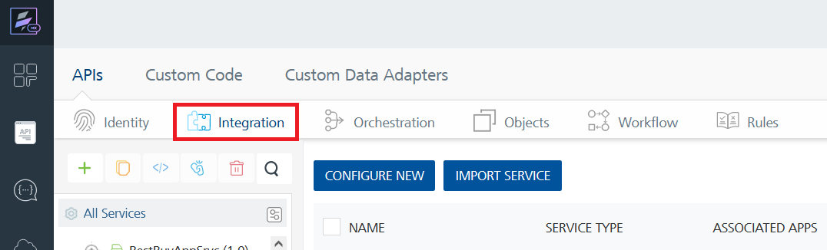
4. To create a new service, click the **+** button or the **CONFIGURE NEW** button.  
   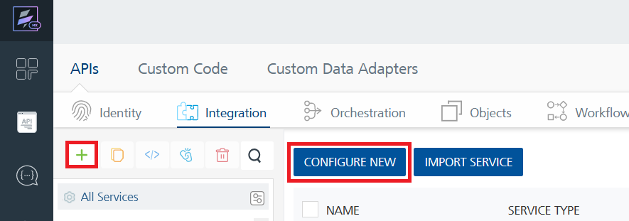
5. On the Service Definition tab, select the service type as**Vehicle RC Verification India API,** and click **SAVE**.

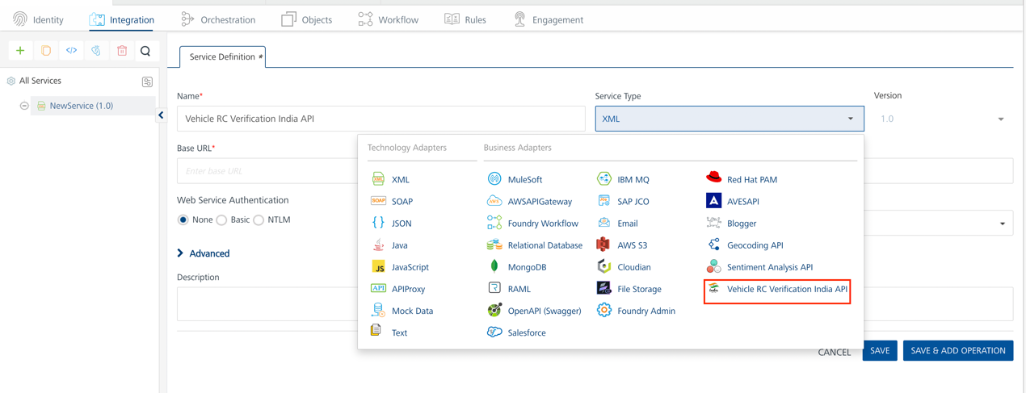

Alternatively, you can also create a Foundry app and create an Integration service inside it.

E. [Creating and Executing operations](javascript:void(0);)



After you create an integration service, you can create and execute operations using the service.

#### Creating an Operation

* In **API Management/Foundry app you created**, in the **Integration** section, select the service that you created.
* After you select the service, navigate to the **Operation List** tab.  
  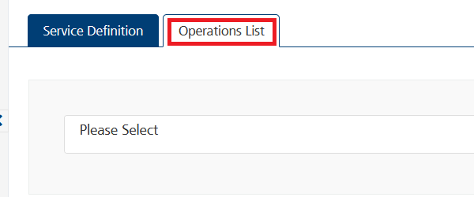
* From the drop down list, select an operation that you want to execute, and click **ADD OPERATION**.

#### Executing an Operation

* From the **Operations List** tab, in the **Configured Operations** section, select the operation you want to execute.

* On the Operation Page, in the **Request Input** tab, in the **Body** section, for the following parameters, specify the values in the respective boxes under the **Test Value** column.

**Mandatory Parameters**

* + **X-RapidAPI-Key, x-anas-secret, X-RapidAPI-Host [in header]:**  API Key associated with your RapidAPI account, required for authentication.

To get keys – Login in to [**Rapid API Account**](https://rapidapi.com/rahilkhan224/api/vehicle-rc-verification-india)-> You can view your keys.

* + **vehicleNumber:** The specific vehicle number that you want to retrieve information for.
  + **username:** Username or identifier associated with the user account for further validation and access permission.

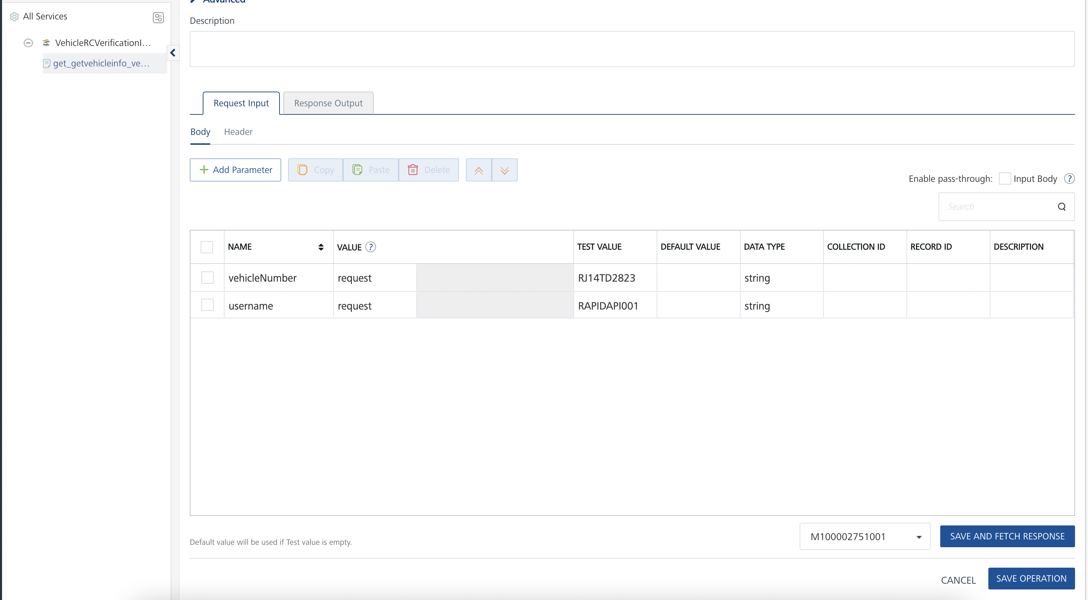

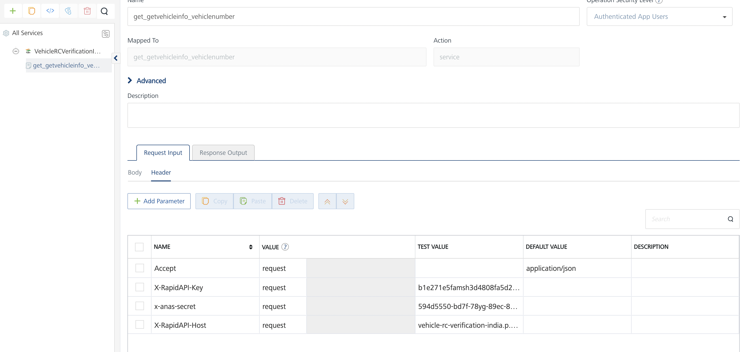

* Select a run-time environment and click **Save and Fetch Response** to get a response based on your inputs.

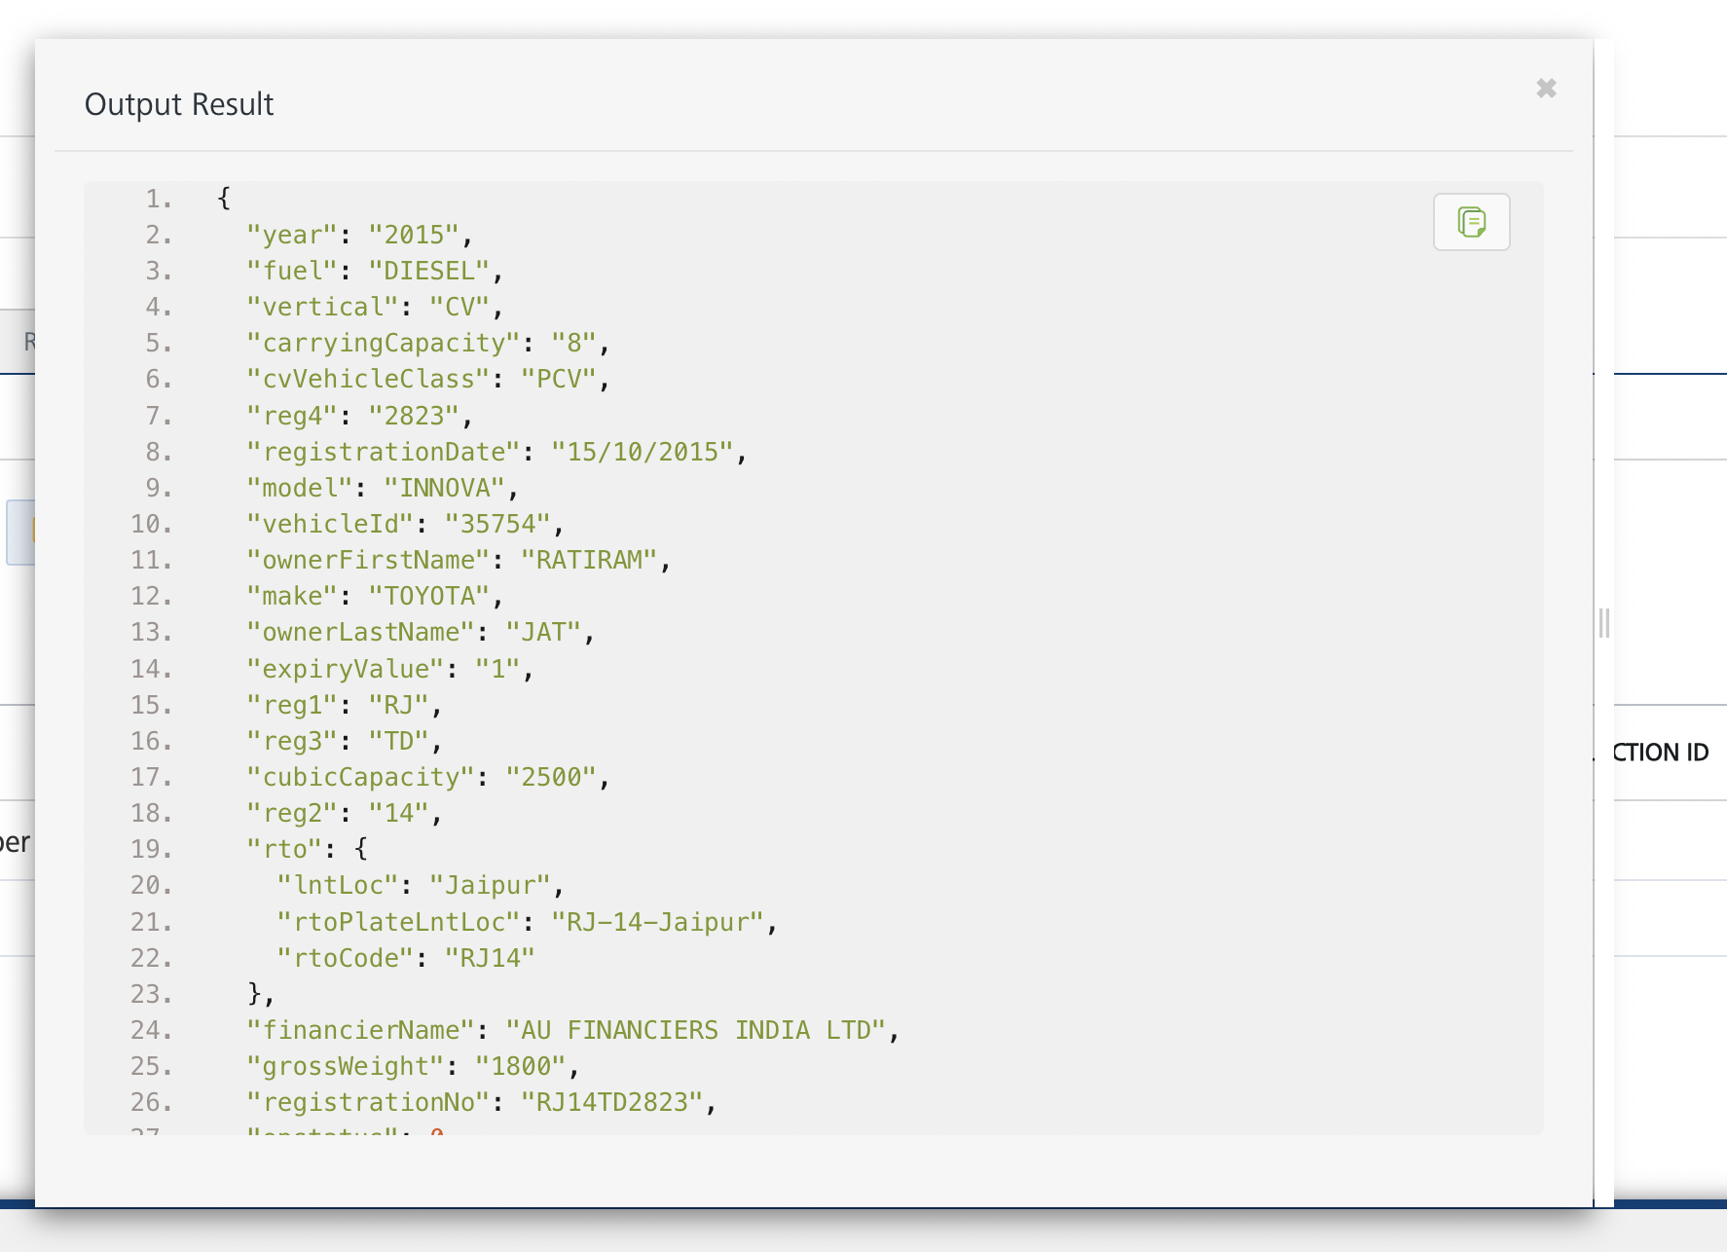

## [Publishing your application](javascript:void(0);)

If you want to use the services in client applications, you need to publish an app to a run-time environment. You can create the service (as described above) in an application or import the service into an application and publish the application.

# References

## Endpoint Documentation

### **Requests Input Parameters**

|  |  |
| --- | --- |
| **Parameter** | **Description** |
| X-RapidAPI-Key(string) | **[Required]** **[Header]**API Key associated with your account. |
| x-anas-secret (string) | [**Required]** **[Header]**A unique secret key provided to the user for authentication purposes. This key helps to ensure secure access to the API and its functionalities. It must be included in the request header for successful authentication. |
| X-RapidAPI-Host (string) | **[Required]** **[Header]**The host parameter specifies the domain name or IP address of the RapidAPI endpoint. In the context of the Vehicle RC Verification India API, the default host is set to 'vehicle-rc-verification-india.p.rapidapi.com'. This parameter is necessary for routing the request to the appropriate API endpoint. |
| vehicleNumber (string) | **[Required]** The specific vehicle number that you want to retrieve information for. |
| Username (string) | **[Required]** Username or identifier associated with the user account for further validation and access permission. |

### **Response and Definitions**

Your API response strongly depends on your query and the parameters you choose to make use of. Find below a representative example API response, returned for the vehicle number. Each available response object will be explained further below in this section.

#### Response Object:

|  |  |
| --- | --- |
| Object | Description |
| registrationNo (string) | The registration number of the vehicle. |
| make (string) | The brand or manufacturer of the vehicle. |
| model (string) | The specific model of the vehicle. |
| fuel (string) | The type of fuel the vehicle uses. |
| vehicleId (string) | The unique identification number associated with the vehicle. |
| vertical (string) | Indicates the category or vertical the vehicle belongs to. |
| rto (object) | Regional Transport Office details. |
| rto- rtoCode (string) | The code assigned to the Regional Transport Office. |
| rto- lntLoc (string) | The location of the Regional Transport Office. |
| rto- rtoPlateLntLoc (string) | The license plate location of the Regional Transport Office. |
| status (string) | Indicates the status of the vehicle information retrieval. |
| registrationDate (string) | The date of vehicle registration. |
| cvVehicleClass (string) | The commercial vehicle class of the vehicle. |
| seatingCapacity (integer) | The maximum number of people the vehicle can seat. |
| ownerFirstName (string) | The first name of the vehicle owner. |
| ownerLastName (string) | The last name of the vehicle owner. |
| financierName (string) | The name of the vehicle's financier. |
| expiryValue (integer) | The expiration value associated with the vehicle. |
| year (string) | The manufacturing year of the vehicle. |
| expiryDt (string) | The expiry date of the vehicle details. |
| reg1, reg2, reg3, reg4 (string) | Breakdown of the registration number into different components. |
| cubicCapacity (integer) | The engine's cubic capacity. |
| carryingCapacity (integer) | The maximum weight the vehicle can carry. |
| grossWeight (integer) | The total weight of the vehicle with its load. |

**Reference Document:** [Vehicle RC Verification India API Documentation (rahilkhan224) | RapidAPI](https://rapidapi.com/rahilkhan224/api/vehicle-rc-verification-india)

# Revision History

Adapter version 1.0.0:

## Known Issues

* No Known Issues

## Limitations

* No limitations