Date :  08-Feb-22

USPS Data Adapter (2.0.1)

# Overview

The US Postal Service (USPS) is the most popular mailing service provider in the United States. The USPS Data Adapter provides APIs to validate addresses, check prices, and other capabilities that you can use in shipping and other mailing needs.

## Use case

### You can use the USPS Data Adapter to validate an address, look up a city and its state to get the zip code, and look up a zip code to get the city and its state.

## Percentage of re-use:

70% (Data can be customizable and customer need to implement UI by themselves).

# Getting Started

## Prerequisites

Before you start using the USPS data adapter, ensure you have the following:

* [HCL Foundry](https://manage.hclvoltmx.com/)
* Volt MX Iris
* A USPS Web Tools User ID

## Platforms Supported

### Mobile

#### iOS

#### Android

### Tablets

### PWA

## Importing the adapter

**To import the Data Adapter to Volt Foundry, do the following:**

1. Sign in to the  [HCL Foundry](https://manage.hclvoltmx.com/).
2. From the left navigation menu, select **API Management**.
3. In **API Management**, select **Custom Data Adapters**.  
   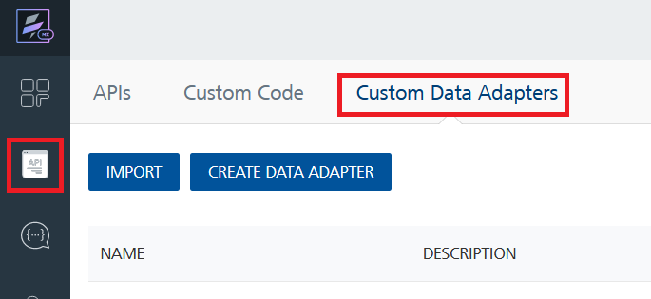
4. Click **IMPORT** to import a custom data adapter.  
   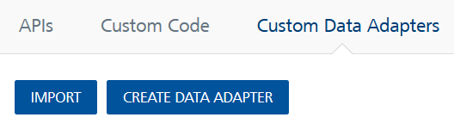
5. On the Import Data Adapter dialog box, click browser to import.  
   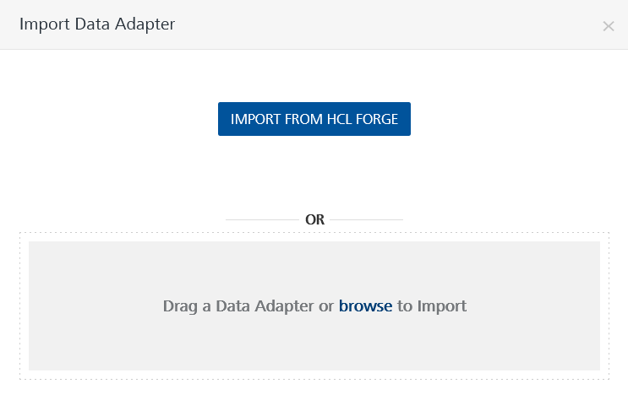
6. Selected USPS data adapter zip file and click **IMPORT**.

After you import the data adapter, Volt Foundry opens a window that shows the metadata of the data adapter.

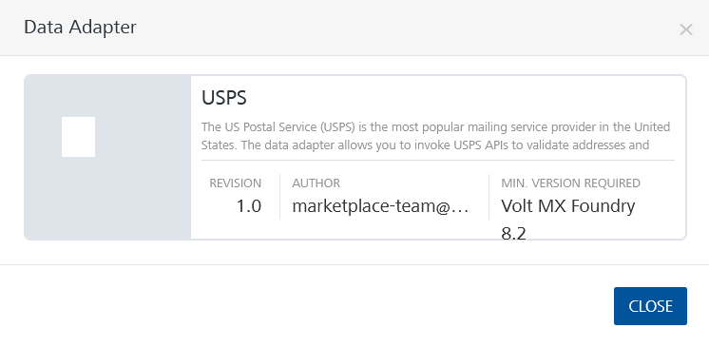

After you import the data adapter, you can view it on the Custom Data Adapters page and use it to create services on Volt Foundry.

After you add the data adapter to your Volt Foundry app, you need to get your **USPS User ID**. You can refer to below section for more information.

[Open](javascript:void(0);)[Getting a USPS User ID](javascript:void(0);)

To access the USPS APIs, you need to get a **USPS User ID** and add it to the Volt Foundry app.

Follow the given steps to get the USPS User ID:

1. Go to the [USPS Developer Portal](https://www.usps.com/business/web-tools-apis/welcome.htm) and click on **Register Now**.  
   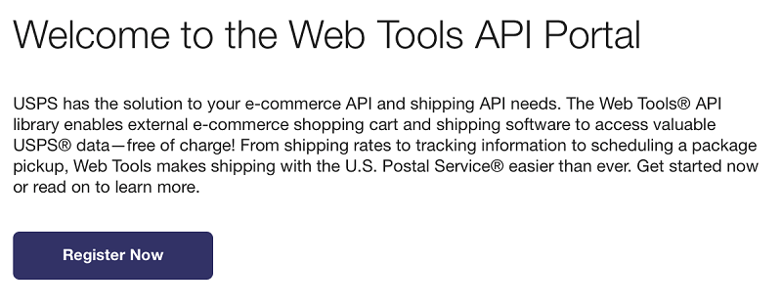
2. Fill the required information in the registration form, and click **Submit**.  
   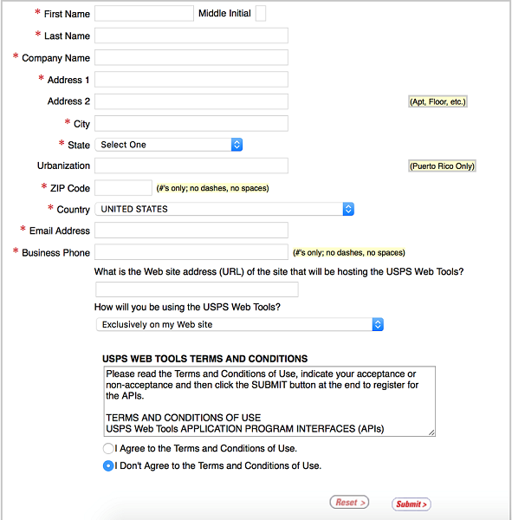
3. USPS will send you an Email with your User ID and other credentials.
4. You need to provide this UserID when you want to execute an operation.

[Open](javascript:void(0);)[Creating an Integration service](javascript:void(0);)

After you import the data adapter into Volt Foundry, you can use it to create an Integration Service.

Follow the given steps to create an Integration service using the USPS Data Adapter.

1. Sign in to the [HCL Foundry](https://manage.hclvoltmx.com/).
2. From the left navigation menu, select **API Management**.
3. In **API Management**, select **Integration**.  
   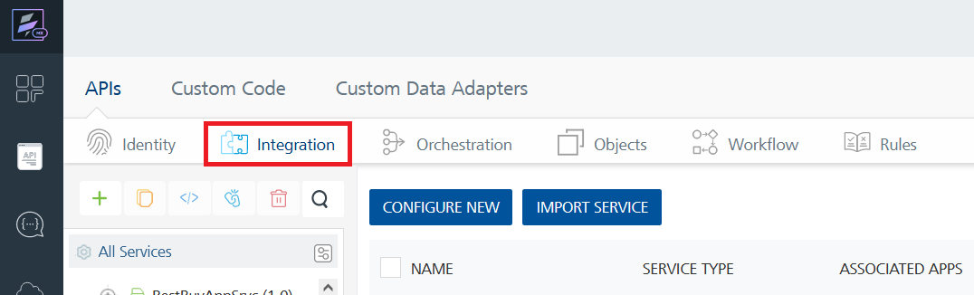
4. To create a new service, click the **+** button or the **CONFIGURE NEW** button.  
   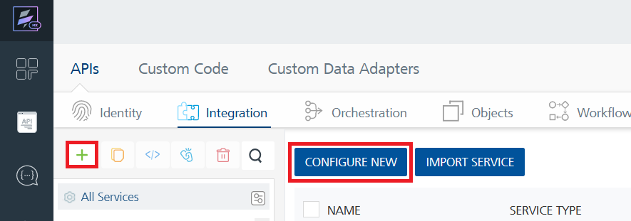
5. On the Service Definition tab, select the service type as USPS, and click **SAVE**.  
   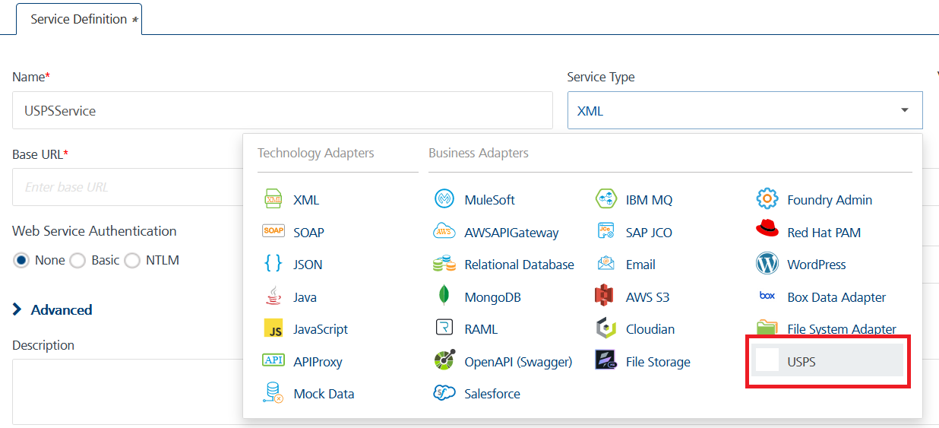

[Open](javascript:void(0);)[Creating and Executing operations](javascript:void(0);)

After you create an integration service, you can create and execute operations using the service.

#### Creating an Operation

1. In **API Management**, in the **Integration** section, select the service that you created.
2. After you select the service, navigate to the **Operation List** tab.  
   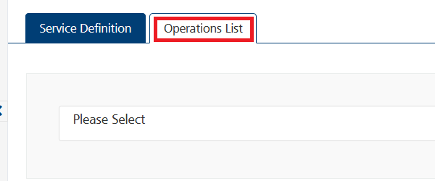
3. From the drop down list, select an operation that you want to execute, and click **ADD OPERATION**.  
   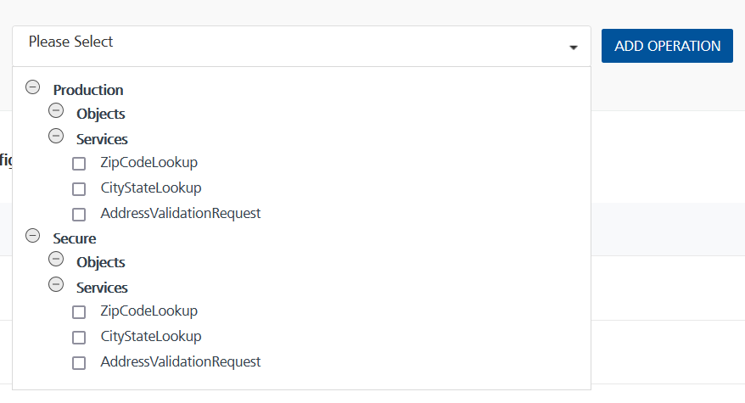

**Note:**

* USPS offers secure communication for **personally identifiable information (PII)**. Make sure that you use secure communication APIs when **PII data** is part of the network communication.
* For more information on the operations of the data adapter, you can refer to the References section of this document.

#### Executing an Operation

1. From the **Operations List** tab, in the **Configured Operations** section, select the operation you want to execute.

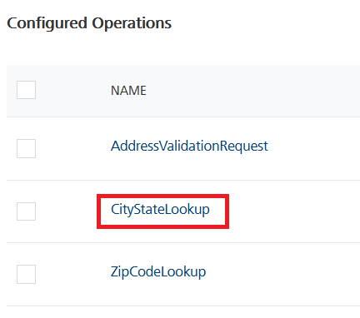

1. On the Operation Page, in the Request Input tab, enter a TEST VALUE for all the fields.  
   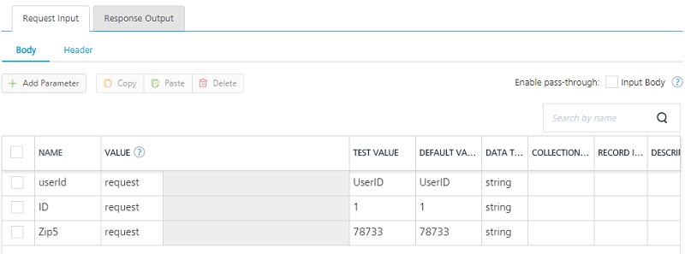
   * **userId**: The UserID you get from the USPS developer portal.
   * **ID**: An identifier for the ZIP code.
   * **Zip5**: The five-digit ZIP code that you want to look up.

**Note:** Make sure that you do not save the UserID on any client device. Configure the UserID only on Volt Foundry.

1. Select a run-time environment and click **Save and Fetch Response** to get a response from USPS based on your inputs.  
   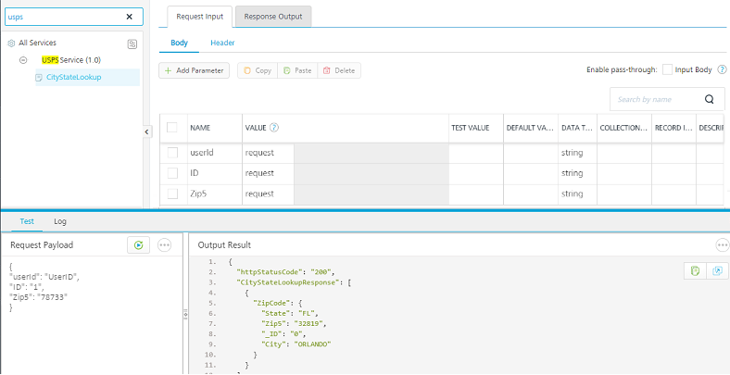

[Open](javascript:void(0);)[Publishing your application](javascript:void(0);)

If you want to use the services in client applications, you need to publish the app to a run-time environment.

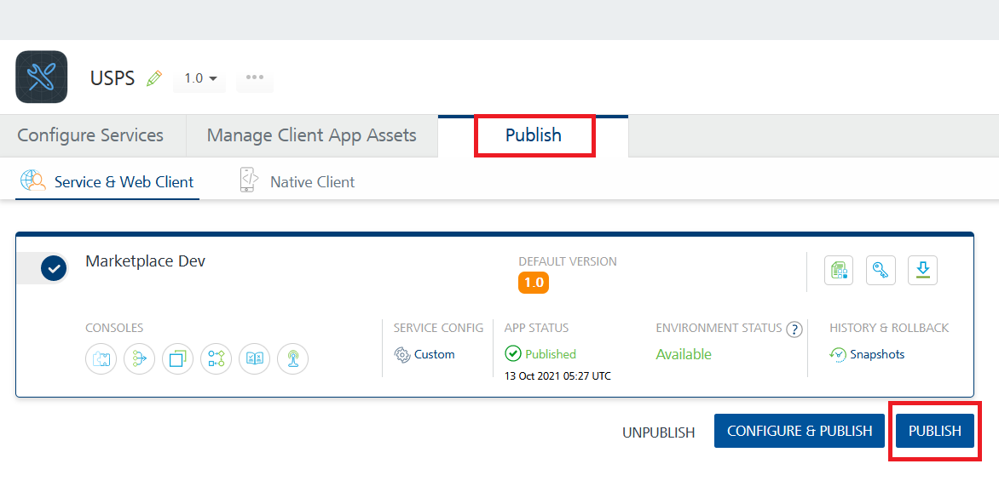

You can also link the Volt Foundry app to a client application.

# References

## Dynamic Usage

## Volt Foundry Operations

**Note:**

* USPS offers secure communication for **personally identifiable information (PII)**. Make sure that you use secure communication APIs when **PII data** is part of the network communication.
* Make sure that you do not save the **UserID** on any client device. Configure the **UserID** only on Volt Foundry.

You need to configure the Request Input variables on Volt Foundry based on the operation you want to perform. You can refer to the following drop down sections for sample requests and responses for the operations.

[Open](javascript:void(0);)[AddressValidationRequest](javascript:void(0);)

#### Description

You can use this operation to validate a destination address.

#### Request Input Variables

**Note:** You need to enter data for at least all of the following variables.

* City
* State
* Street Address

|  |  |  |
| --- | --- | --- |
| **Variable Name** | **Required/Optional** | **Description & Allowed Values** |
| userId | Required | The UserID that you get from the USPS developer portal. |
| ID | Required | An identifier for the address. You can include up to five addresses in every transaction. |
| FirmName | Optional | Maximum characters allowed are 38 |
| Address1 | Optional | The apartment number or suite number, if applicable. Maximum characters allowed are 38. |
| Address2 | Required | The Street Address. Maximum characters allowed are 38. |
| City | Required | Maximum characters allowed are 15. |
| State | Required | Maximum characters allowed are 2. |
| Zip5 | Optional | Input tab is exactly as presented, not all caps. Maximum characters allowed are 5. |
| Zip4 | Optional | Input tab is exactly as presented, not all caps. Maximum characters allowed are 4. |

#### Sample Request

{

"userId": "UserID from USPS",

"ID": "1",

"FirmName": "",

"Address1": "",

"Address2": "9225 Bee Cave Road",

"City": "Austin",

"State": "TX",

"Zip5": "78733",

"Zip4": ""

}

#### Sample Response

{

"httpStatusCode": "200",

"opstatus": 0,

"AddressValidateResponse":

[{

"Address":

{

"Zip4": "6203",

"State": "TX",

"Address2": "9225 BEE CAVE RD",

"Zip5": "78733",

"_ID": "1",

"City": "AUSTIN"

}

}]

}

[Open](javascript:void(0);)[CityStateLookup](javascript:void(0);)

#### Description

You can use this operation to look up a ZIP code to get the associated city and state.

#### Request Input Variables

|  |  |  |
| --- | --- | --- |
| **Variable Name** | **Required/Optional** | **Description & Allowed Values** |
| userId | Required | The UserID that you get from the USPS developer portal. |
| ID | Required | An identifier for the ZIP code. You can include up to five ZIP codes in every transaction. |
| Zip5 | Required | Input tab is exactly as presented, not all caps.  Maximum characters allowed are 5. |

#### Sample Request

{

"userId": "UserID from USPS",

"ID": "1",

"Zip5": "78733"

}

#### Sample Response

{

"httpStatusCode": "200",

"opstatus": 0,

"CityStateLookupResponse":

[{

"ZipCode":

{

"State": "TX",

"Zip5": "78733",

"_ID": "1",

"City": "AUSTIN"

}

}]

}

[Open](javascript:void(0);)[ZipCodeLookup](javascript:void(0);)

#### Description

You can use this operation to look up a city and its state to get the associated ZIP code.

#### Request Input Variables

|  |  |  |
| --- | --- | --- |
| **Variable Name** | **Required/Optional** | **Description & Allowed Values** |
| userId | Required | The UserID that you get from the USPS developer portal. |
| ID | Required | An identifier for the address. You can include up to five addresses in every transaction. |
| FirmName | Optional | Maximum characters allowed are 38 |
| Address1 | Optional | The apartment number or suite number, if applicable. Maximum characters allowed are 38. |
| Address2 | Required | The Street Address. Maximum characters allowed are 38. |
| City | Required | Maximum characters allowed are 15. |
| State | Required | Maximum characters allowed are 2. |

#### Sample Request

{

"userId": "UserID from USPS",

"ID": "1",

"FirmName": "",

"Address1": "",

"Address2": "9225 Bee Cave Road",

"City": "Austin",

"State": "TX",

}

#### Sample Response

{

"httpStatusCode": "200",

"opstatus": 0,

"ZipCodeLookupResponse":

[{

"Address":

{

"Zip4": "6203",

"State": "TX",

"Address2": "9225 BEE CAVE RD",

"Zip5": "78733",

"_ID": "1",

"City": "AUSTIN"

}

}]

}

[Open](javascript:void(0);)[ErrorResponse](javascript:void(0);)

#### Description

You will get an this response whenever an error occurs in the Web Tools Server.

#### Sample Response

{

"httpStatusCode": "200",

"opstatus": 0,

"Error":

{

"Source": "USPSCOM::DoAuth",

"Description": "XML Syntax Error: Please check the XML

request to see if it can be parsed.(B)",

"Number": "80040B19"

}

}

**Note:** For more information on the input requests, you can refer to the [USPS Documentation](https://www.usps.com/business/web-tools-apis/address-information-api.htm).

## Properties

-- None of the properties are exposed.

## Events

-- None of the events are exposed.

## API’s

-- None of the APIs are exposed.

# Revision History

App version 2.0.1:

## Known Issues

None

## Limitations

The input data should match the format of USPS API requirements to get the expected result.

The USPS service call only return one search result in response even though there are multiple hits in USPS site search comparingly. You can input search keys more specifically to get the exact result you want.