Date : 08-May-26

UCLASSIFY ADAPTER

VERSION: 1.0.0

OVERVIEW
uClassify is a cloud-based machine learning and text classification platform that enables developers to build, train, and integrate AI-powered text analysis models using simple REST APIs. It acts as an intelligent text processing service, allowing applications to perform natural language understanding tasks without requiring deep machine learning expertise or infrastructure management.
The platform provides pre-trained and custom AI classifiers that can analyze, categorize, and extract insights from textual data in real time. By exposing AI capabilities through lightweight API endpoints, uClassify enables seamless integration of text intelligence features into web, mobile, and enterprise applications.
The uClassify platform supports capabilities such as:
- Text Classification
- Sentiment Analysis
- Language Detection
- Topic Categorization
- Custom Classifier Training
- Text Moderation and Filtering
- Real-Time API-Based Predictions
- Machine Learning Model Management
The platform is powered by scalable machine learning models designed for fast and efficient text processing. Developers can either use publicly available classifiers or create and train custom classifiers tailored to specific business use cases.
This enables organizations and developers to build AI-powered applications such as content moderation systems, sentiment analysis tools, customer feedback analyzers, intelligent search systems, and automated text categorization solutions with minimal backend complexity and no requirement for dedicated AI infrastructure management.
- Use case:
- Sentiment Analysis Applications: Detect positive, negative, or neutral sentiment from user input.
- Language Detection Systems: Identify the language of textual content in real time.
- Content Moderation & Filtering: Detect abusive, harmful, or inappropriate text automatically.
- Customer Feedback Analysis: Analyze reviews, support tickets, and survey responses for insights.
- Email & Ticket Classification: Automate routing and prioritization of emails or support requests.
- Enterprise Workflow Automation: Integrate intelligent text analysis into business applications through APIs.
- Real-Time Text Intelligence: Process and classify live textual data with scalable cloud APIs.
- AI-Powered Text Classification: Categorize text into predefined topics or labels automatically.

- Features:

- Advanced Text Classification: Classifies text into custom or pre-trained categories with high accuracy.
- Sentiment Analysis Engine: Detects emotions, opinions, and sentiment from textual content.
- Custom Classifier Training: Allows developers to train machine learning models using custom datasets.
- Language Detection Support: Automatically identifies multiple languages from text input.
- Real-Time REST API Processing: Provides fast and scalable API-based text analysis integration.
- Scalable Cloud-Based AI Platform: Eliminates the need for infrastructure or machine learning expertise.
- Flexible Machine Learning Models: Supports reusable public classifiers and custom AI models.
- Content Moderation Capabilities: Filters toxic, offensive, or unsafe text content automatically.
- Percentage of Reuse:
- Approximately 80–90% reuse.

GETTING STARTED

Prerequisites
Before using the uclassify Data Adapter, ensure you have the following:
- HCL Foundry
- Account at uClassify .

Importing the data adapter

You can import uClassify Data Adapter into HCL Foundry directly from the Volt MX Forge website or by importing the data adapter zip file.

To import Data Adapter to Volt Foundry, do the following:
- Sign in to the HCL Foundry.
- From the left navigation menu, select API Management.
- In API Management, select Custom Data Adapters.

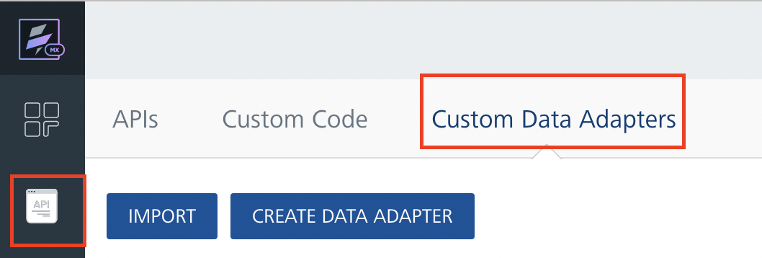
4. Click IMPORT to import a custom data adapter.
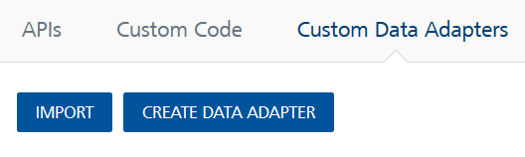
5. On the Import Data Adapter dialog box, click browser to import.

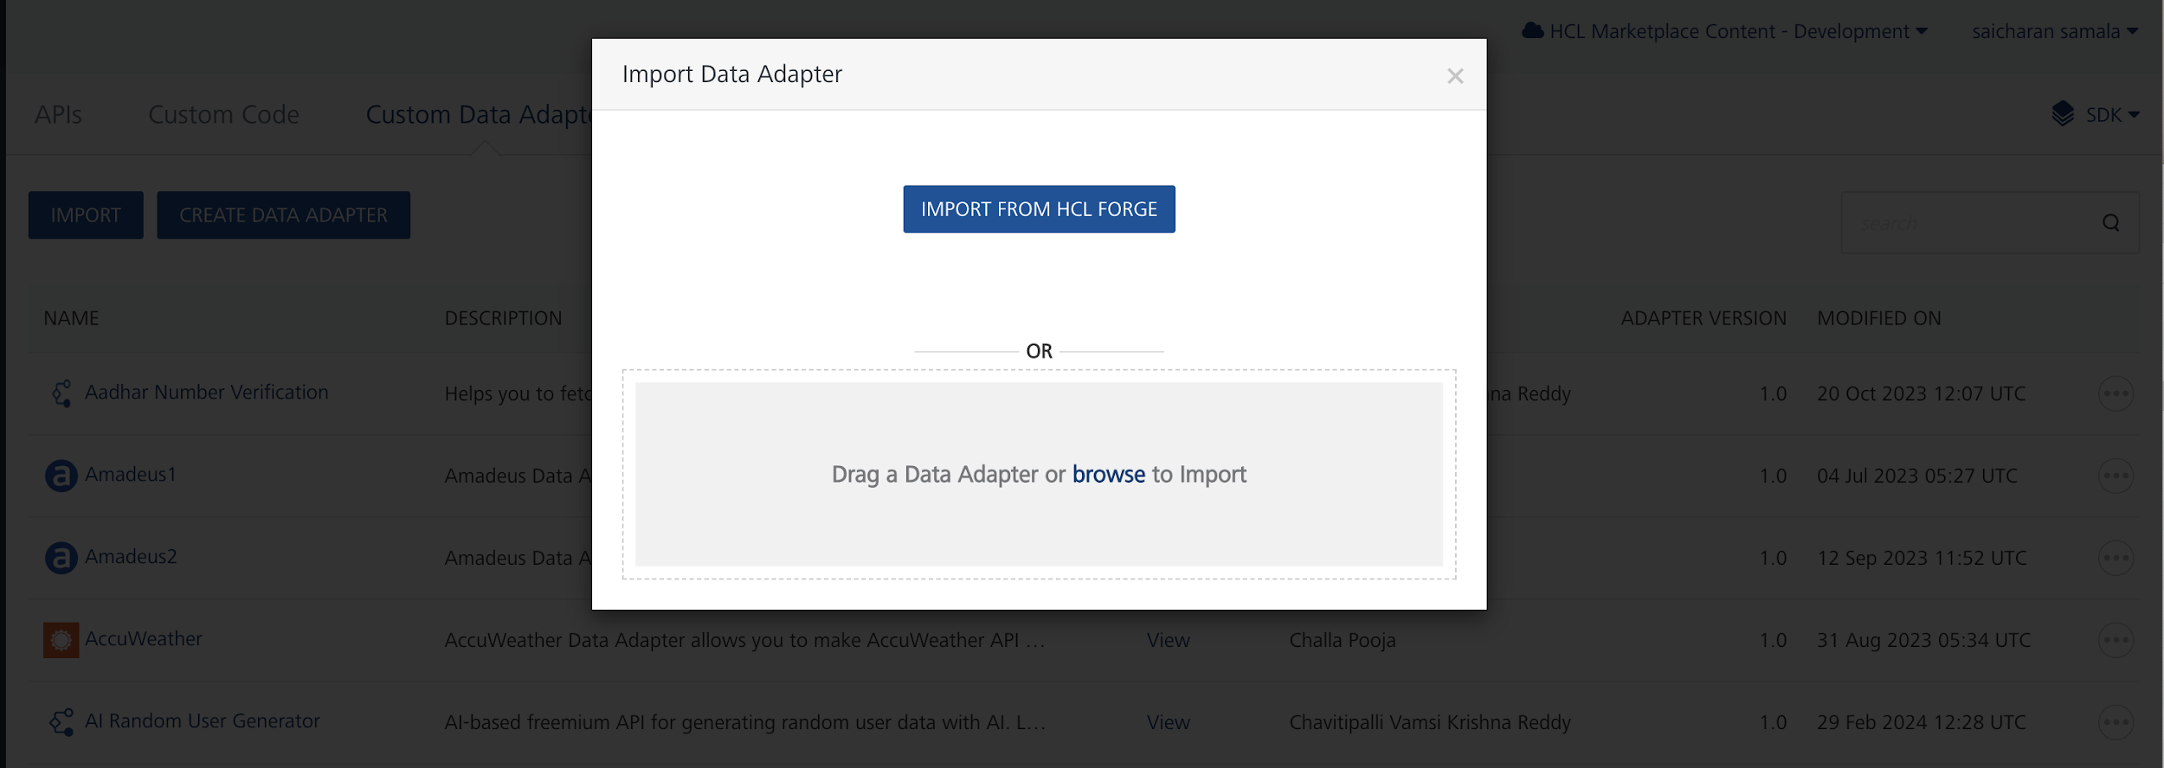

6. Click IMPORT FROM HCL FORGE. The Import Data Adapter from HCL Forge dialog appears with a list of available data adapters.

Click Import uClassify data adapter is listed on the Custom Data Adapters page.

To import the data adapter zip file, do the following:
- Perform steps 1 to 4 in the above procedure
- Drag the data adapter zip file into the Drag a Data Adapter box.
Or
Click browse. The Open dialog appears.
Navigate to the location where you downloaded the data adapter (zip file) on your computer, select the data adapter, and click Open. The Import Data Adapter dialog shows the selected data adapter.
Note: Click Remove if the selected data adapter is not the one that you want to import.

UClassify – Step-by-Step Setup and Classifier Creation Guide

1. Register a New User Account
- Open the UClassify login page:
UClassify Login Page
- Click on Register or Create a New Account.
- Enter the required details such as:
  - Username
  - Email ID
  - Password
- Complete the registration process.
- After successful registration, log in using your credentials.

2. Navigate to Manage Section
- After login, open the Manage page:
UClassify Manage Page
- In the Manage section, you can access:
  - API Keys
  - Classifiers
  - Training Options

3. Get API Keys
- In the Manage page, click on the API Key section.
- You will see:
  - Read API Key
  - Write API Key
- Copy both keys.
- Store the keys securely for future reference and API integration.

4. Create a New Classifier
- In the Manage page, go to the Classifiers section.
- Click on Create.
- Enter the classifier name.
- Click Create Classifier.
- After creation, the classifier will appear in the classifier list.

5. Edit the Classifier
- Locate the created classifier.
- Click on the Edit icon.
- Inside the classifier, you can configure and train the classifier.

6. Add Classes to the Classifier
- Inside the classifier page, locate the Add Class section.
- Enter the class name.
Example:
  - Positive
  - Negative
  - Neutral
- Click on Add Class.
- The class will now be added to the classifier.

7. Train the Classifier Using Text
- Click the Edit icon for the required class.
- Add sample text data for training.
Example:
  - “This product is very good.”
  - “Service was excellent.”
- Click on the Train option to train the classifier with the entered text.

8. Train the Classifier Using Files
- Inside the class training section, select the option to upload files.
- Upload the required training file containing sample text data.
- Click on Train.
- The uploaded content will be used to train the classifier.

9. Untrain the Classifier
- Open the class training section.
- Select the trained text or file data.
- Click on Untrain.
- The selected training data will be removed from the classifier training set.

Creating an Integration Service with UClassify Adapter:
After you import UClassify Adapter Data Adapter into Foundry, you must create an integration service with service type as UClassify Adapter.
To create an integration service with UClassify Adapter, do the following:
- Log on to your HCL Foundry. The Dashboard page appears by default.
- In the left pane, click the API Management menu. The APIs tab opens by default.
- Click the Integration tab. The Integration tab opens with a list of existing integration services.
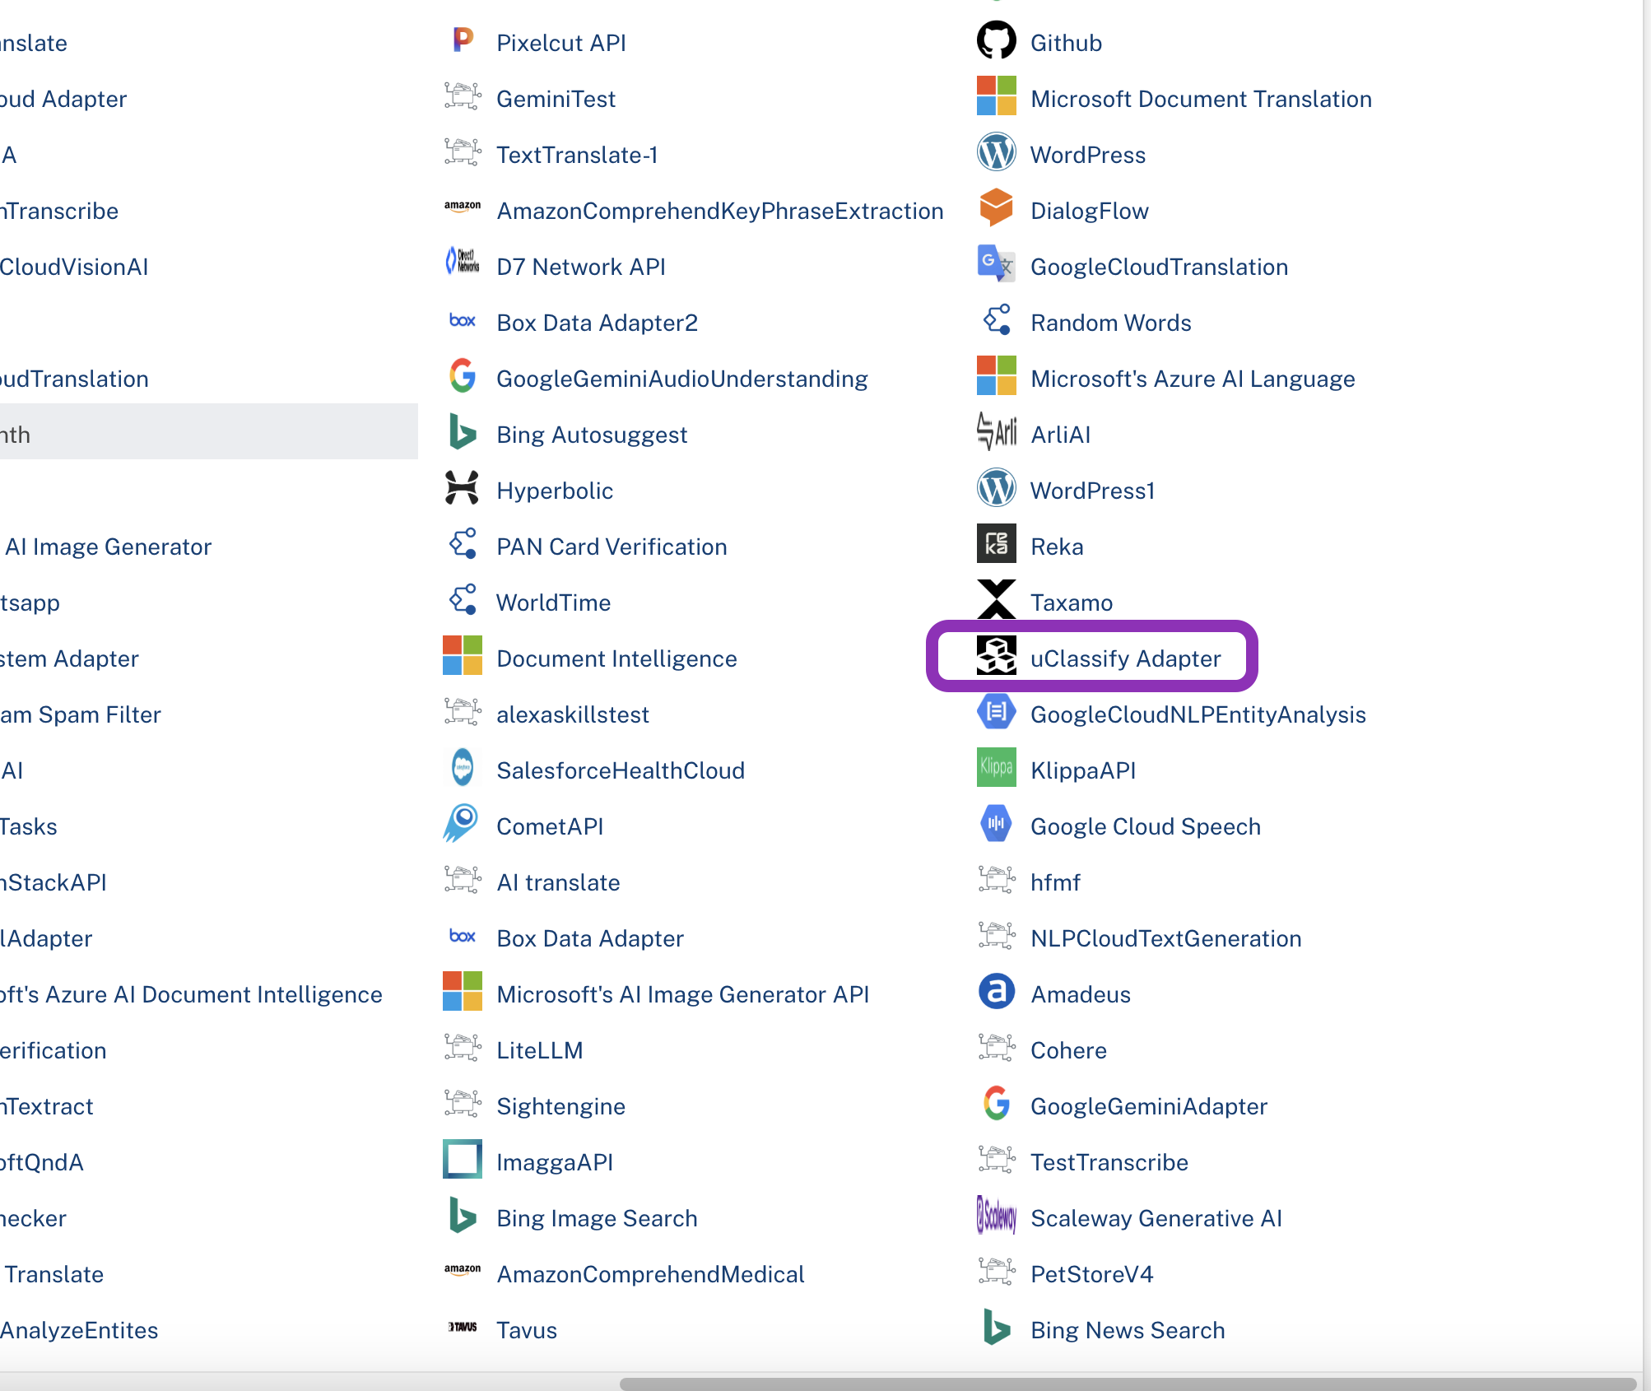
- Click CONFIGURE NEW. The Service Definition tab opens.
- In the Name box, type a unique name for your service.
- From the Service Type list, select UClassify Adapter & click save.

Creating an Operation
To make any API call in the HCL Foundry console, you must create an operation for the respective API and then execute the operation. Executing an operation involves making the API call and displaying the response.
This section provides steps to create an operation for the UClassify Adapter.
Steps to create an operation for the UClassify Adapter:
- Log on to your HCL Foundry. The Dashboard page appears by default.
- In the left pane, click the API Management menu. The APIs tab opens by default.
- Click the Integration tab. The Integration page appears with a list of existing integration services.
- From the list of integration services, select the integration service that you have created with the service type as UClassify Adapter. The Service Definition tab of the selected integration service opens by default.
- Click the Operations List tab. The Operations List tab opens.
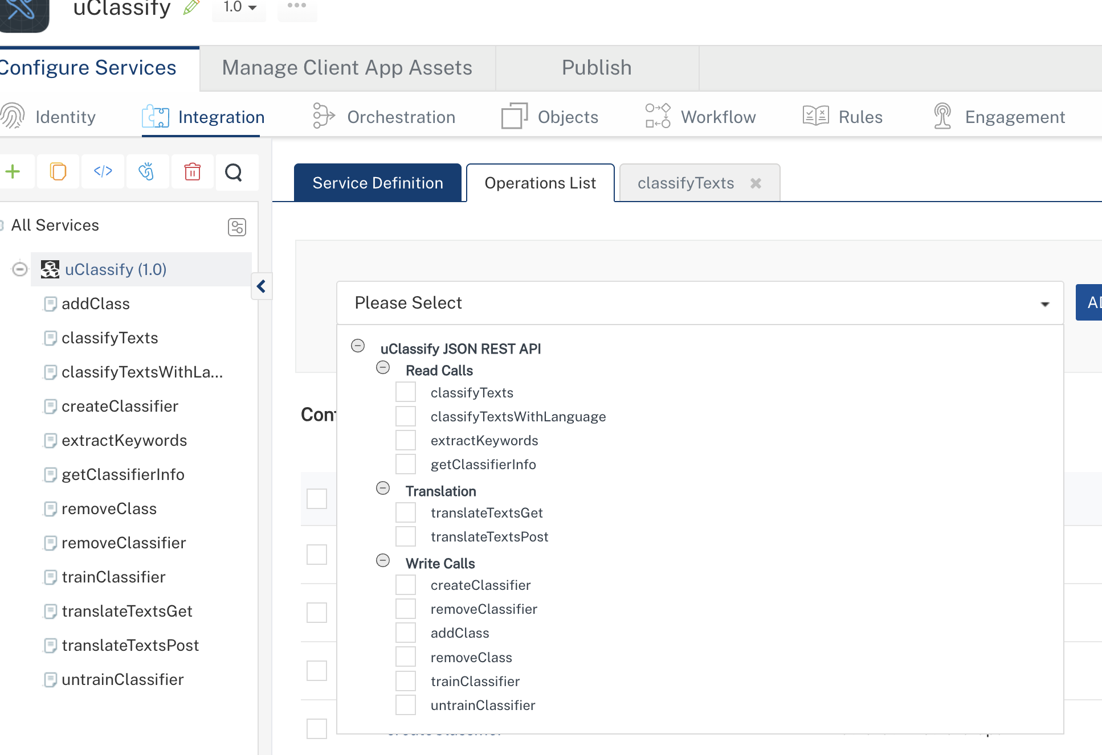
- Select classifyTexts and Click Add Operation.
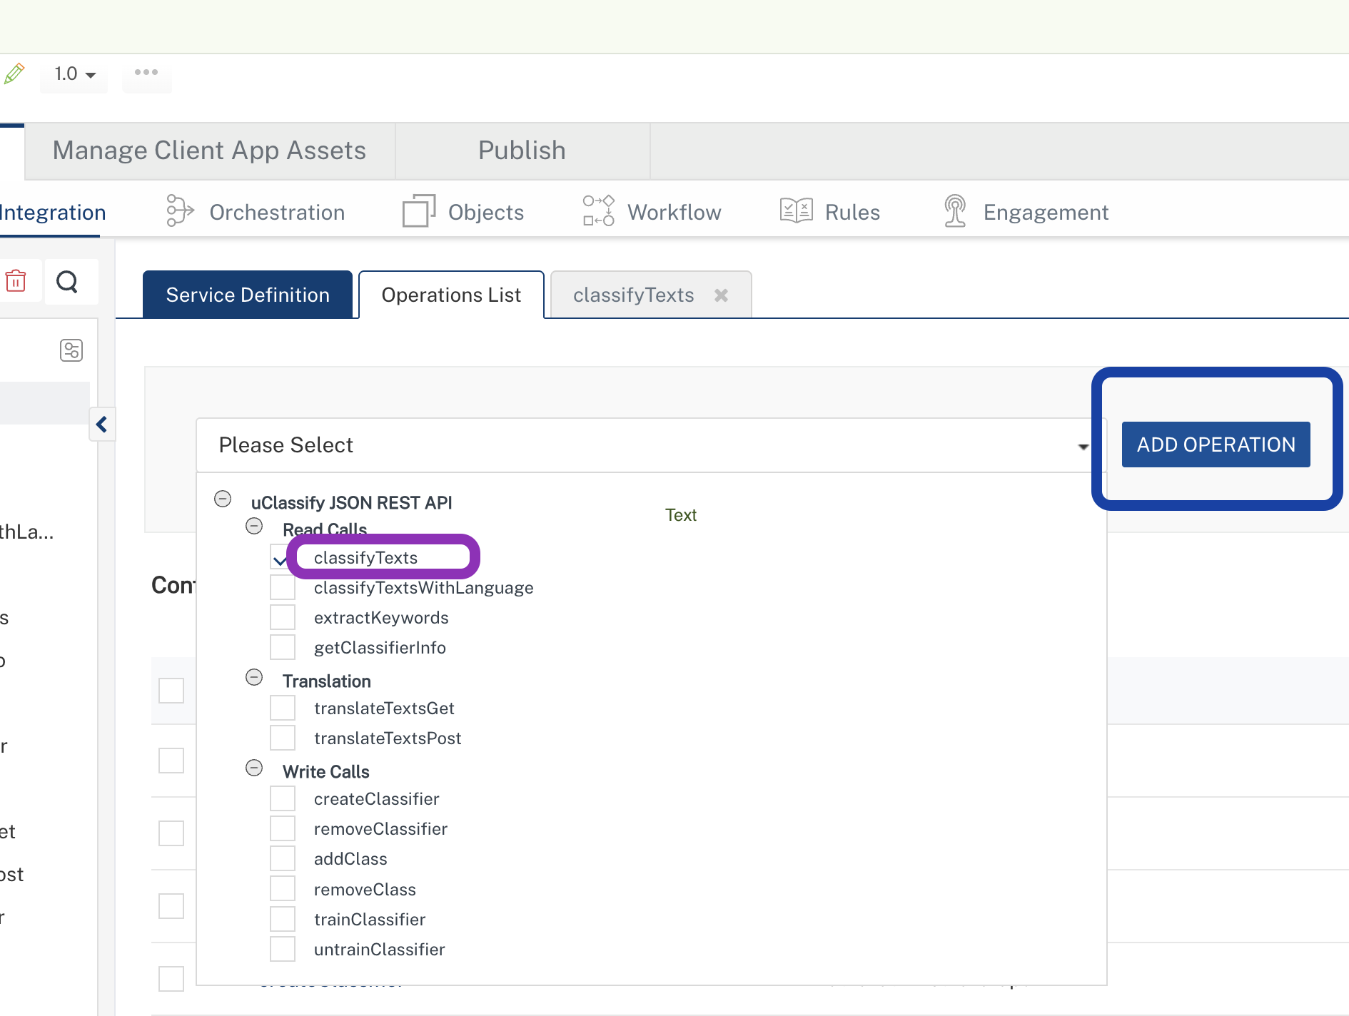

Executing Operation
Executing an operation involves making the API call by setting the necessary parameters and displaying the response. The procedure to execute any operation is the same, but the request parameters of the APIs vary. This section provides steps to execute the (explained in Creating an Operation).
Steps to execute the classifyTexts operation:
- Log on to your Hcl Foundry. The Dashboard page appears by default.
- In the left pane, click the API Management menu. The APIs tab opens by default.
- Click the Integration tab. The Integration tab opens with a list of existing integration services.
- From the list of integration services, select the integration service that you have created with service type as uClassify. The Service Definition tab of the selected integration service opens by default.
- Click the Operations List tab.
- In the Name box, the name of the operation is displayed by default. If you want, you can change the name.
- On the Request Input tab, in the Body section, for the following parameters, specify the values in the respective boxes under the Test Value column.
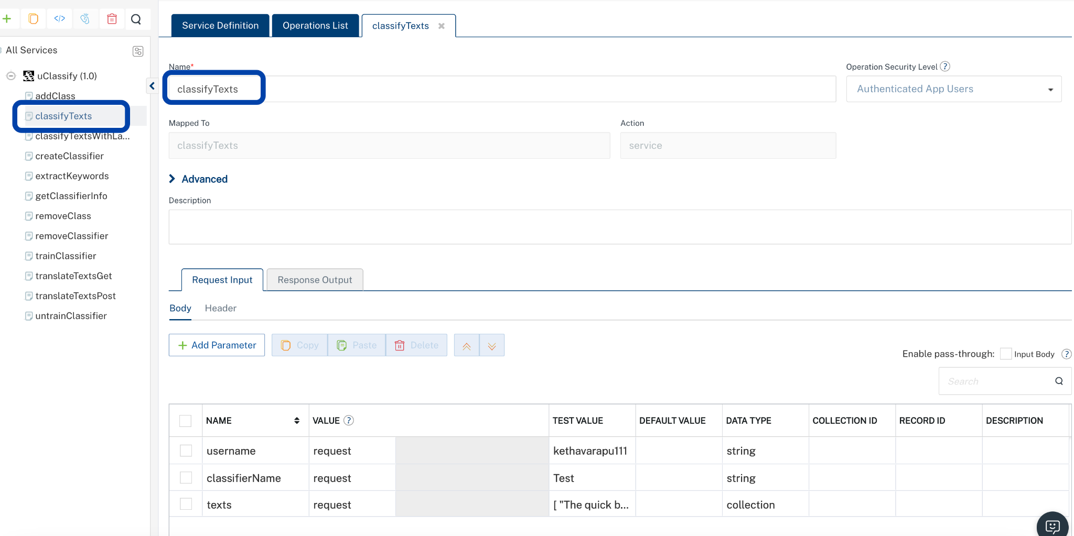
Parameter | Description | Syntax Example
username | Username should be provided whenever you created the account | YOUR_USERNAME
classifierName | Your classifier name | YOUR_CLASSIFIERNAME
texts | Whatever text you want to classify you need to enter in collection | [ "The quick brown fox jumps over the lazy dog.", "Artificial intelligence is transforming modern applications.", "Cloudflare Workers AI enables low-latency inference at the edge." ]
- . Click Header sub-tab. The Header section opens.
- For Authorization, In the box under the TEST VALUE and DEFAULT VALUE columns, type the API Key generated from uClassify | Key.
  - Authorization:<Token YOUR_READ_APIKEY_HERE>

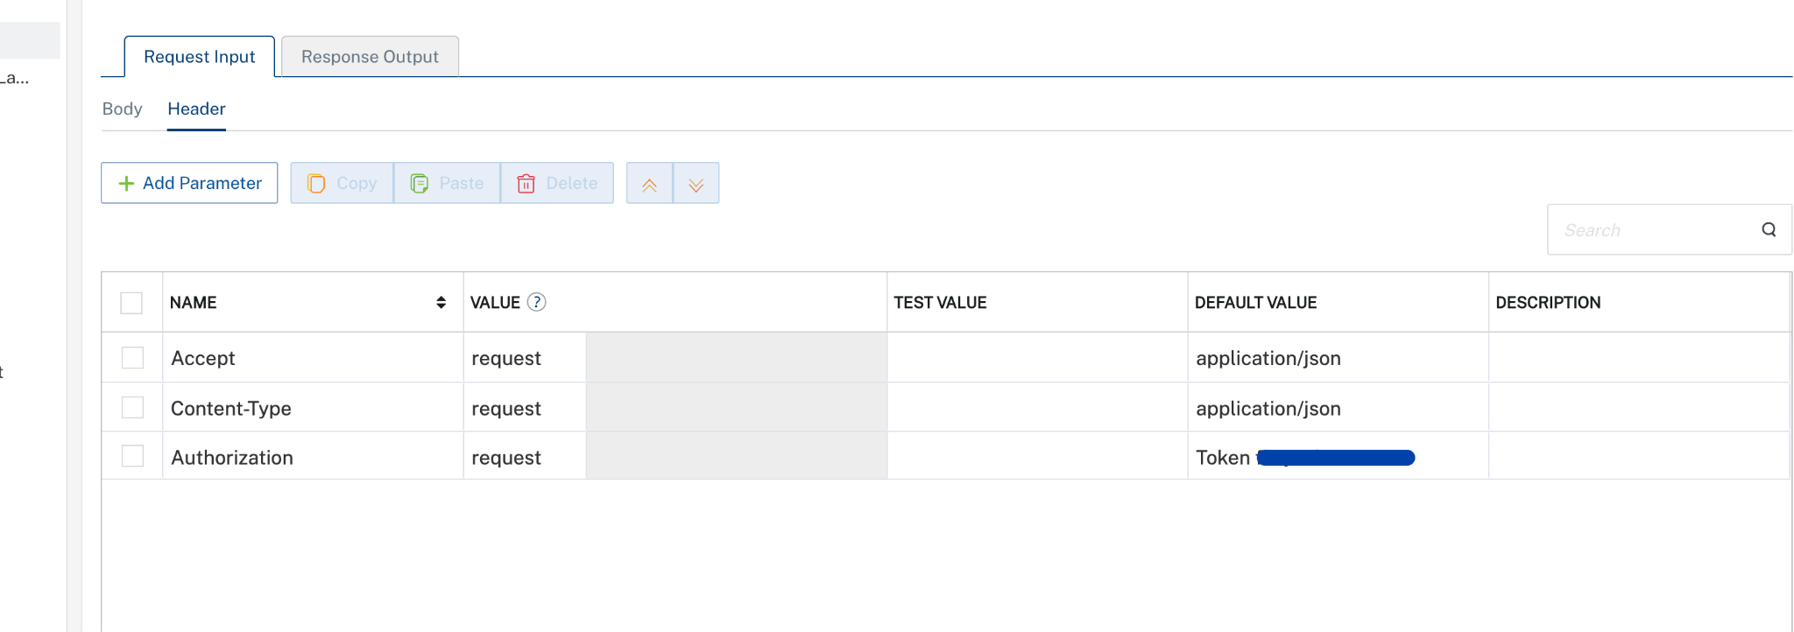
- Click SAVE AND FETCH RESPONSE. The Output Result dialog appears with the response. Otherwise, the Output Result shows an error.
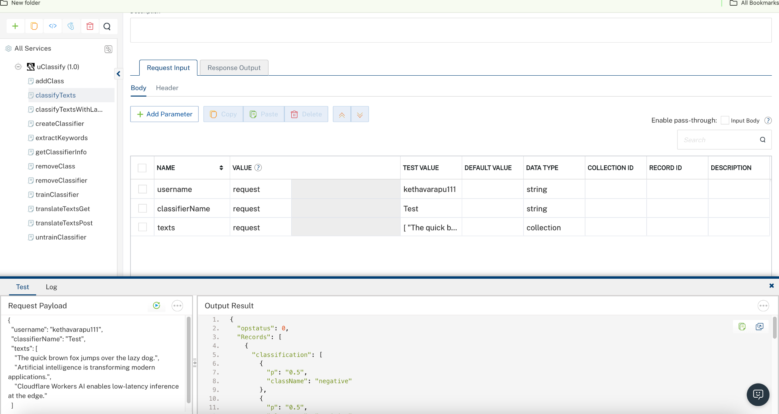
Note : For the uClassify TranslateTextGET and TranslateTextPOST endpoints, use uClassify Translation API as the endpoint URL while performing the Test Operation. This ensures that the translation requests are executed against the correct API endpoint.
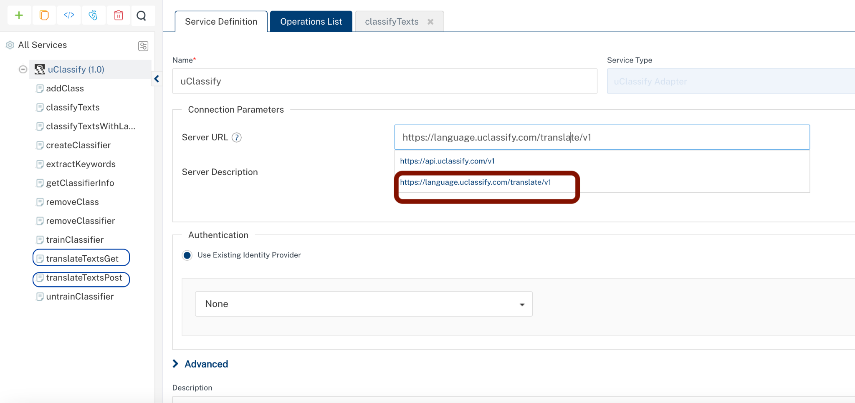

PUBLISHING THE APP IN VOLTMX FOUNDRY:
After adding the UClassify Adapter Data Adapter to your app and configuring the necessary configurations, you must publish the app to HCL Foundry. For more information, refer to Publish a foundry app.
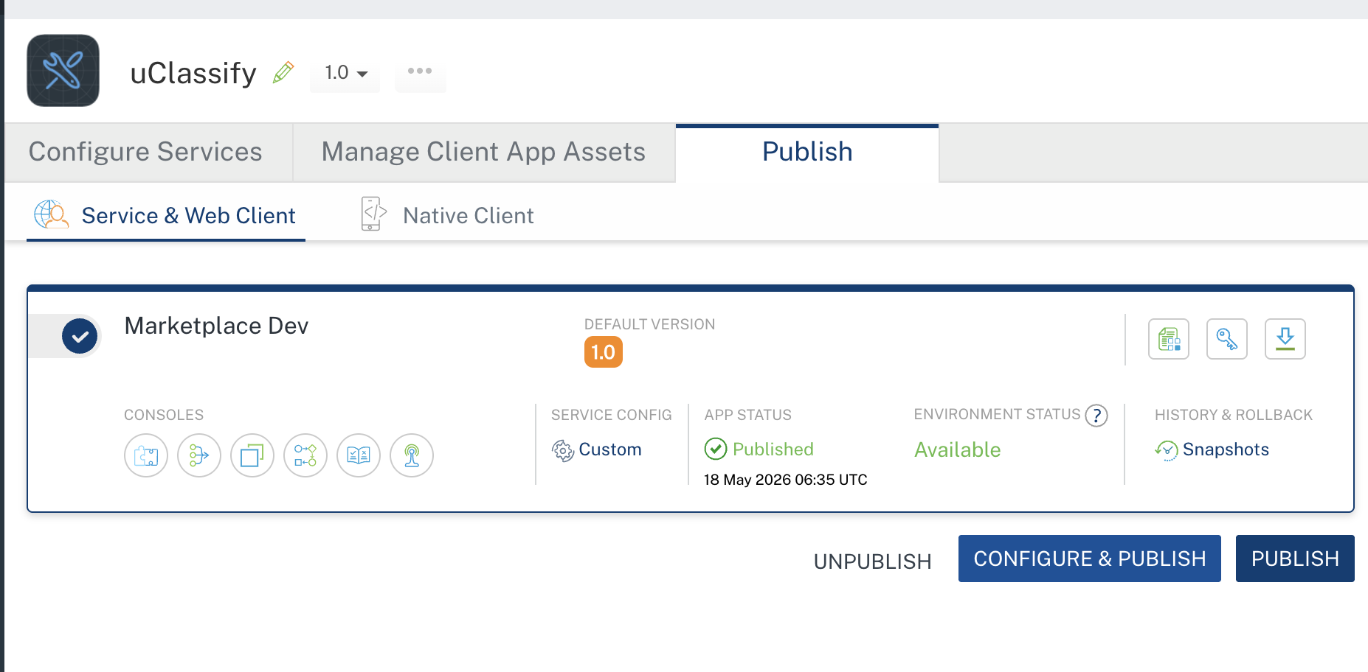

Reference documentation link: UClassify_documentation

REVISION HISTORY
Adapter version 1.0.0:

Known Issues
None

Limitations
  - We must properly train and configure the classifier to achieve accurate and reliable response results. Insufficient or incorrect training data may affect the quality and accuracy of predictions.

