Date :  23-02-2024

Tweet Feed

version: 1.0.0

# **Overview:**

Free feed with IOCs - malicious URLs, domains, IPs, and hashes. [Website: [https://tweetfeed.live](https://tweetfeed.live/)]

TweetFeed collects Indicators of Compromise (IOCs) shared by the infosec community at Twitter.

Here you will find a Feed with malicious URLs, domains, IPs, and SHA256/MD5 hashes.

#cybersecurity #infosec #phishing #malware.

# **Getting Started:**

**A. Prerequisites:**

* Volt Foundry

**B. Importing the adapter:**

**To import the Data Adapter to Volt Foundry, do the following:**

1. Sign in to the  [HCL Foundry](https://manage.hclvoltmx.com/).
2. From the left navigation menu, select **API Management**.
3. In **API Management**, select **Custom Data Adapters**.

1. Click **IMPORT** to import a custom data adapter.  
     
   A blue and white box with text

   Description automatically generated
2. On the Import Data Adapter dialog box, click browser to import.  
     
   A screen shot of a computer

   Description automatically generated
3. Select TweetFeed zip file and click **IMPORT**.

After you import the data adapter, Volt Foundry opens a window that shows the metadata of the data adapter.

After you import the data adapter, you can view it on the Custom Data Adapters page and use it to create services on Volt Foundry.

### **[Creating an Integration service](javascript:void(0);)**

After you import the data adapter into Volt Foundry, you can use it to create an Integration Service.

Follow the given steps to create an Integration service using the Tweet Feed Adapter:

1. Sign in to the [HCL Foundry](https://manage.hclvoltmx.com/).
2. From the left navigation menu, select **API Management**.
3. In **API Management**, select **Integration**.

1. To create a new service, click the **+** button or the **CONFIGURE NEW** button.

1. On the Service Definition tab, select the service type as Tweet Feed and click **SAVE**.

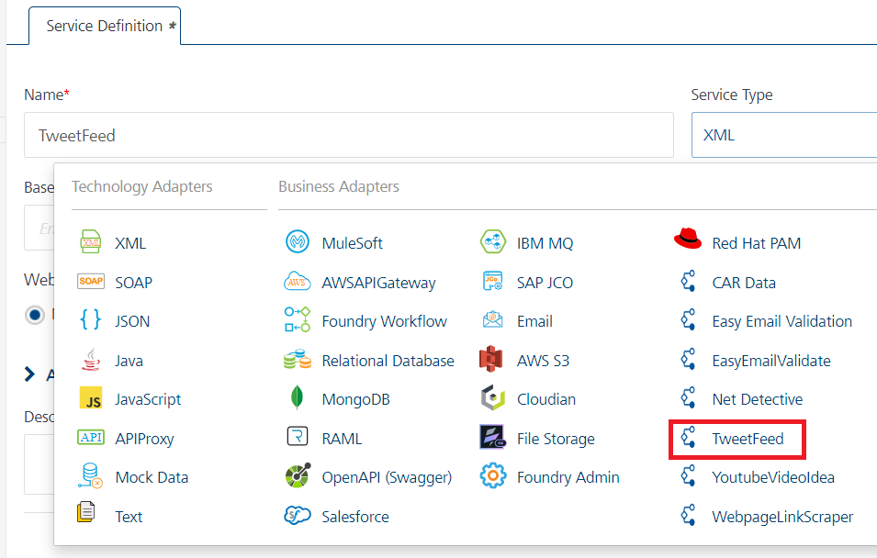

Alternatively, you can also create a Foundry app and create an Integration service inside it.

[Open](javascript:void(0);)**D.** [**Creating and Executing operations**](javascript:void(0);)

After you create an integration service, you can create and execute operations using the service.

#### Creating an Operation

* In **API Management/Foundry app you created**, in the **Integration** section, select the service that you created.
* After you select the service, navigate to the **Operation List** tab.

* From the drop-down list, select an operation that you want to execute, and click **ADD OPERATION**.

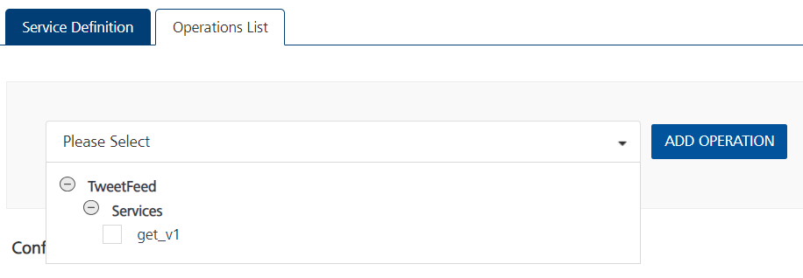

#### Executing an Operation

* From the **Operations List** tab, in the **Configured Operations** section, select the operation you want to execute.

* On the Operation Page, in the Request Input tab, enter a TEST VALUE for all the fields in body and header.

* Select a run-time environment and click **Save and Fetch Response** to get a response based on your inputs.  
    
  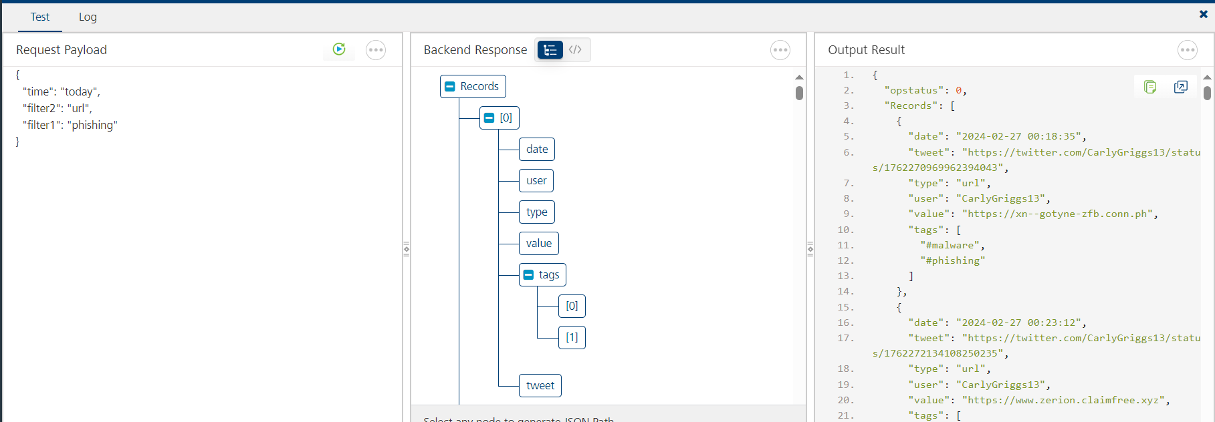

## **E**. [**Publishing your application**](javascript:void(0);)

If you want to use the services in client applications, you need to publish an app to a run-time environment. You can create the service (as described above) in an application or import the service into an application and publish the application.

# **References**

## Endpoint Documentation

## **Reference Link:** [TweetFeed API Documentation (danlopgom) | RapidAPI](https://rapidapi.com/danlopgom/api/tweetfeed/)

# **GET V1**

## This endpoint version1 Endpoint.

## The endpoint is available through this URL:

GET https://tweetfeed.p.rapidapi.com/v1/today/phishing/url

## **Parameters**

When calling this endpoint, please refer to the following parameters.

|  |  |  |  |
| --- | --- | --- | --- |
| **Parameter** | **Description** | **Types** | **Required** |
| X-RapidAPI-Key | Give details of the rapid Api key | String | Yes |
| X-RapidAPI-Host | Give details of the rapid Api host | String | Yes |
| time | Select 1 of these timeframes:  **today** - Today starting 00:00 UTC) **week** - Last 7 days **month** - Last 30 days **year** - Last 365 days | String | Yes |
| filter1 | Can be an specific user, type or tag:  Type→ **url**/**domain**/**ip** /**sha256**/**md5**  Tag→ **phishing**/**ransomware**/  **CobaltStrike** …  User→ **@malwrhunterteam** / **@1ZRR4H** / **@MBThreatIntel** / … (don't forget the @) | String | Optional |
| filter2 | Can be an specific user, type or tag:  Type→ **url**/**domain**/**ip** /**sha256**/**md5**  Tag→ **phishing**/**ransomware**/  **CobaltStrike** …  User→ **@malwrhunterteam** / **@1ZRR4H** / **@MBThreatIntel** / … (don't forget the @) | String | Optional |

# **Revision History**

Adapter version 1.0.0:

## **Known Issues**

**-**

**B. Limitations**

**-**