Date :  October 13th, 2023

traveladvisory ADAPTER (1.0.0)

# Overview

The **TravelAdvisory adapter** for HCL Volt Foundry’s Integration service allows callers to obtain basic travel advisory based on an input 2-character country code. The adapter also allows the callers to obtain travel advisory for all tracked countries.

The adapter will return a country’s safety score, from zero (safest) to five (extreme warning/avoid), a safety message, and a URL to obtain additional information.

This adapter uses the basic API from the web site Travel-Advisory.info (<https://www.travel-advisory.info/data-api>) as the third-party backend. Moreover, the adapter is built on a HCL Foundry Developer Portal to provide the RESTful interface.

An example use case for developing Foundry app that uses this adapter is to aid international business travelers. A company webapp or email attendant can display the destination country travel-advisory score, safety message, and link.

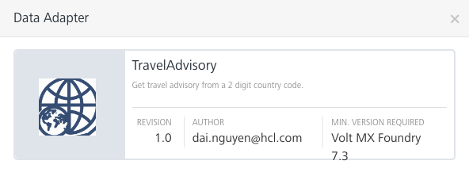

The **TravelAdvisory adapter** supports the following two **publicly accessible** operations:

1. **Get Advisory operation** – to obtain a country travel-advisory score, safety message, and a link for more information, based on an input 2-digit country code.
2. **Get All Advisory operation** - to obtain a JSON list of all tracked countries’ travel-advisory score, safety message, and link.

# Getting Started

## Prerequisites

* Volt Foundry

## Third Party Dependency

## At the time of this **TravelAdvisory adapter** creation (10/13/2023), Travel-Advisory.info provides a very basic REST API with no swagger support. The information provided herein is dependent on Travel-Advisory.info permission for its API usage and thusly is subject to change by Travel-Advisory.info.

## Importing the adapter

**To import the Data Adapter to Volt Foundry, do the following:**

1. Sign in to the  [HCL Foundry](https://manage.hclvoltmx.com/).
2. From the left navigation menu, select **API Management**.
3. In **API Management**, select **Custom Data Adapters**.  
   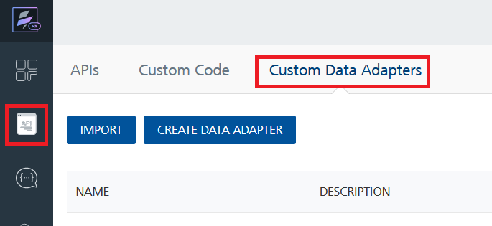
4. Click **IMPORT** to import a custom data adapter.  
   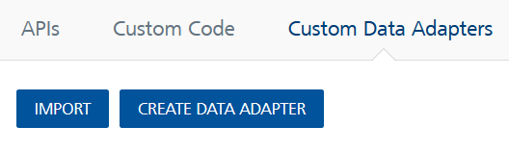
5. On the Import Data Adapter dialog box, click browser to import.  
   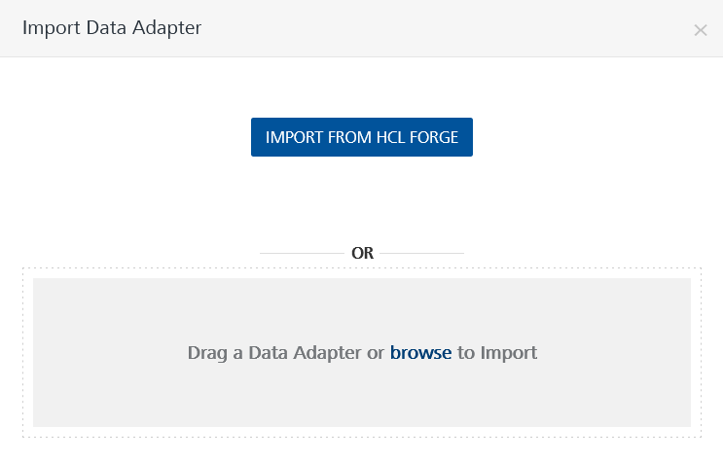
6. Select TravelAdvisory.zip zip file and click **IMPORT**.

After you import the data adapter, Volt Foundry opens a window that shows the metadata of the data adapter.

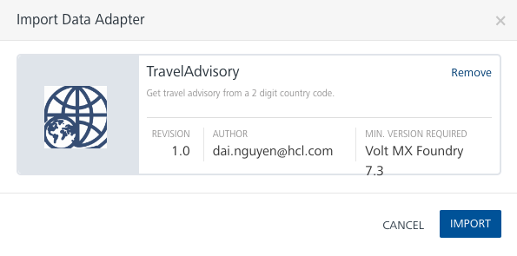

After you import the data adapter, you can view it on the Custom Data Adapters page and use it to create services on Volt Foundry.

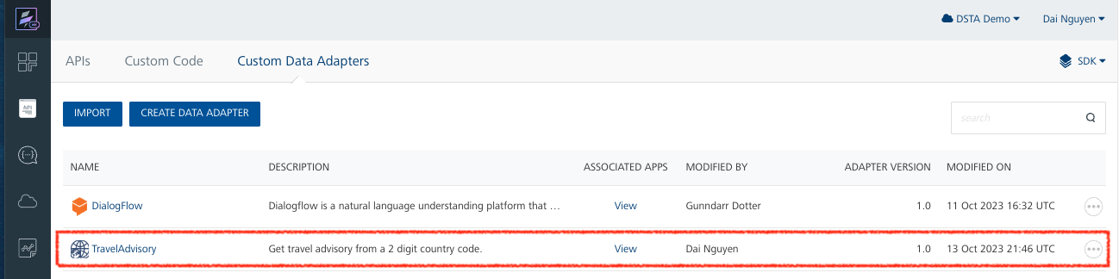

## Creating an Integration service

After you import the data adapter into Volt Foundry, you can use it to create an Integration Service.

Follow the given steps to create an Integration service using the **TravelAdvisory** Adapter.

1. Sign in to the [HCL Foundry](https://manage.hclvoltmx.com/).
2. From the left navigation menu, select **API Management**.
3. In **API Management**, select **Integration**.

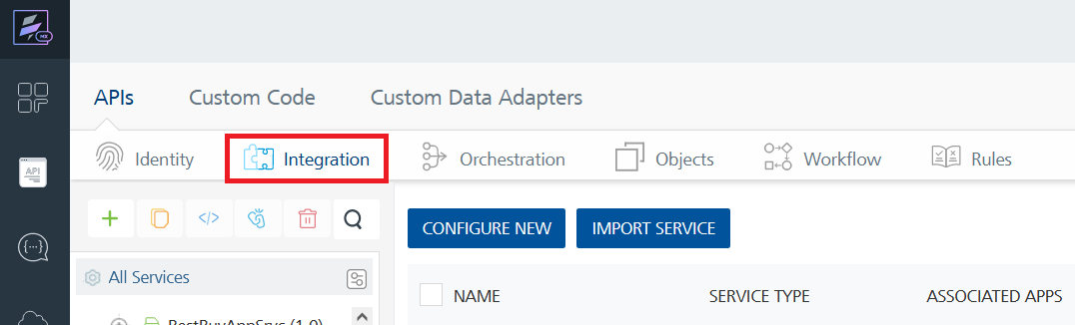

1. To create a new service, click the **+** button or the **CONFIGURE NEW** button.  
   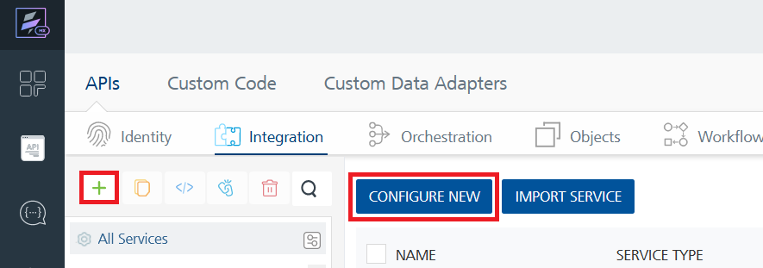
2. On the Service Definition tab, select the service type as TravelAdvisory, and click **SAVE**.

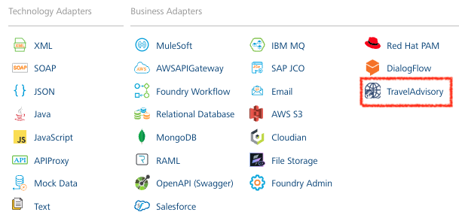

Alternatively, you can also create a Foundry app and create an Integration service inside it.

E. Creating and Executing operations



After you create an integration service, you can create and execute operations using the service.

#### Creating an Operation

* In **API Management/Foundry app you created**, in the **Integration** section, select the service that you created.
* After you select the service, navigate to the **Operation List** tab.  
  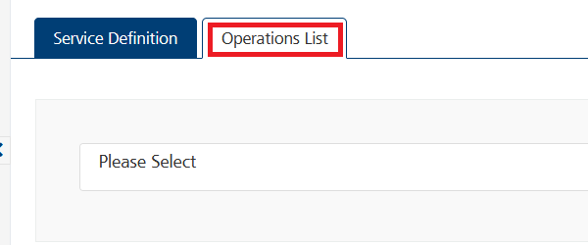
* From the drop down list, select an operation that you want to execute, and click **ADD OPERATION**.

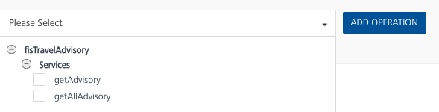

#### Executing the getAdvisory Operation

* From the **Operations List** tab, in the **Configured Operations** section, click on the **getAdvisory** operation.

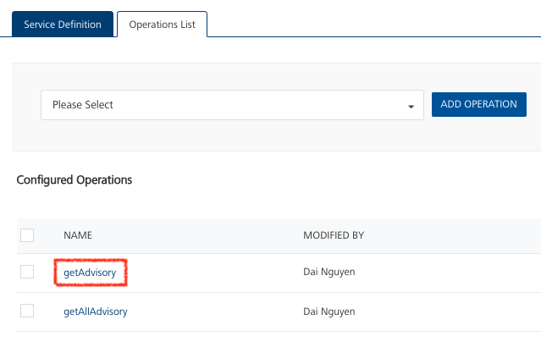

* In the display of the selected operation in the Operation Page, the Request Input tab will list all the input parameters available to an operation. You will provide a Test Value for **countrycode** input parameter, such as AW (Aruba). Select a run-time environment and click **Save and Fetch Response** to get a response based on your inputs.

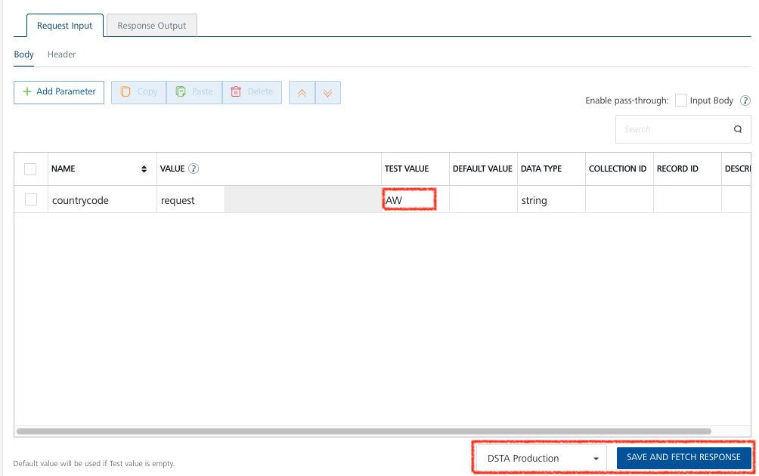

Note: This web site lists all the 2-character country codes: <https://en.wikipedia.org/wiki/ISO_3166-1_alpha-2#Officially_assigned_code_elements>

### Execution and Output Result:

### 

#### Executing the getAllAdvisory Operation

* From the **Operations List** tab, in the **Configured Operations** section, click on the **getAllAdvisory** operation.

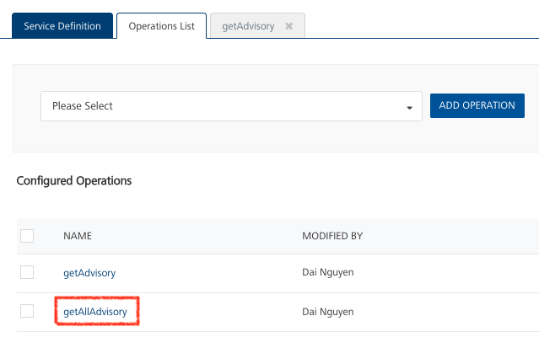

* In the display of the selected operation in the Operation Page, the Request Input tab is blank because this operation requires no input. Select a run-time environment and click **Save and Fetch Response** to get a response based on your inputs.

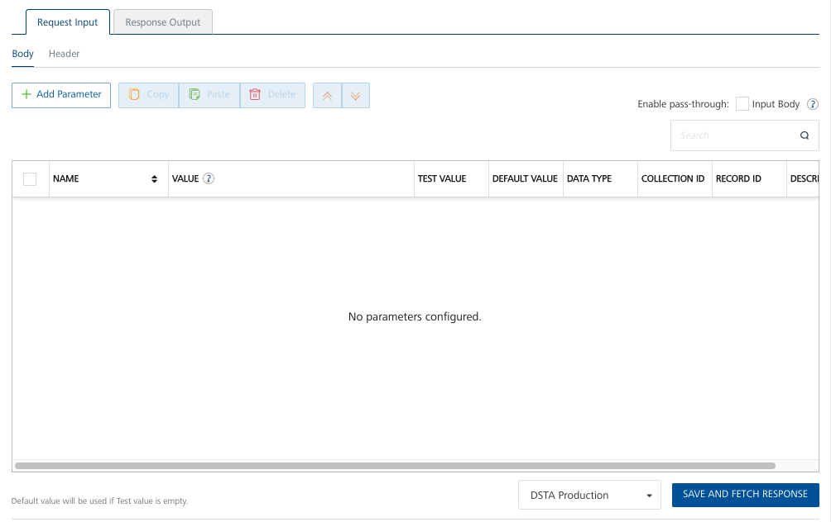

### Execution and Output Result:

### 

## Publishing your application

If you want to use the services in client applications, you need to publish an app to a run-time environment. You can create the service (as described above) in an application or import the service into an application and publish the application.

# References

## List of API Endpoints

1. **Get Advisory operation** – <https://dsta-demos.hclvoltmx.net/services/fisTravelAdvisory/getAdvisory>
2. **Get All Advisory operation** - https://dsta-demos.hclvoltmx.net/services/fisTravelAdvisory/getAllAdvisory

# Revision History

Adapter version 1.0.0:

## Known Issues

-List known issues

## Limitations

-List limitations