Date : 20-Sep-21
TIMELINE
Version: 1.0.2

- OVERVIEW
Timeline is a Volt MX Iris component for showing the events of a single day/multiple days in a single view of the application.

A. Use case:

Event Schedule

Travel Itinerary Plan

Workout or Daily Planner App

B. Features

Ready to use UI.

JSON input format

Auto resizing height as per content size

C. Percentage of re-use:
80-90% (Data can be customizable and skins are not customized but can be changed manually)

2. Getting Started

Prerequisites
Before you start using the Timeline component, ensure you have the following:
- HCL Foundry
- Volt MX Iris

Platforms Supported

Mobile

iOS

Android

Tablets

PWA

Importing the Component

You can import the Forge components only into the apps that are of the Reference Architecture type.

To import the TimeLine component, do the following:

Open your app project in Volt MX Iris.

In the Project Explorer, click the Templates tab.

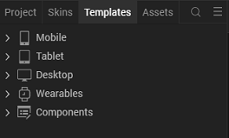
- Right-click Components, and then select Import Component. The Import Component dialog box appears.
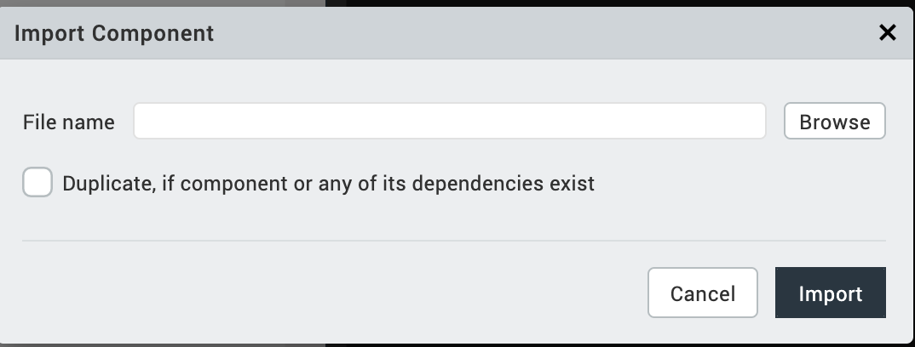

- Click Browse to navigate to the location of the component, select the component, and then click Import. The component and its associated widgets and modules are added to your project.

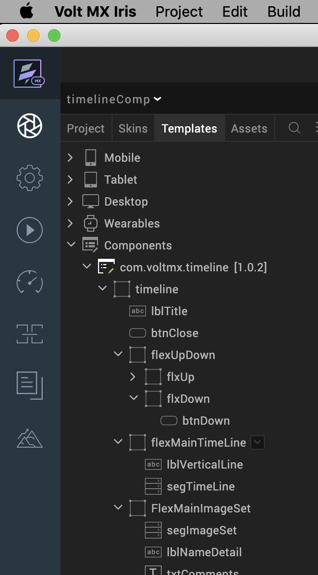

Once you have imported a component to your project, you can easily add the component to a form. For more information, refer Add a Component to a Form.

Building and previewing the app
After performing all the above steps, you can build your app and run it on your device. For more information, you can refer to the Building and Viewing an Application section of the Volt Mx Iris User Guide.
You can then run your app to see the Timeline work in real time.

3. References

A. Dynamic Usage
You can also add a Timeline component dynamically. To do so:
- In the Project Explorer, on the Projects tab, click Controllers section to access the respective Form Controller. Create a method and implement the code snippet like the sample code mentioned below.
In the code snippet, you can edit the properties of the component as per your requirement. For more information, see Setting Properties.

/* Creating a component's Object */
var TimeLine = new com.voltmx.timeline(
{
"clipBounds": true,
"height": "100%",
"id": "TimeLine ",
"isVisible": true,
"left": "0dp",
"top": "0dp",
"width": "100%",
"zIndex": 1

}, {}, {});

TimeLine.eventTitle = "<Title of the Event>";
TimeLine.masterdata =
{
"data":
[
{
"date": "2017-02-01T11:30AM ",
"desc": "<desc>",
"name": "<name>",
"sub1": "<sub1>",
"sub1icon": "<sublicon>",
"sub2": "<motive>",
"sub2icon": "<sub2icon>"
}
]
};
TimeLine.verticalLineText = "|\n|\n|\n|\n|\n|\n|\n|\n|\n|\n|\n|\n|\n|\n|\n|\n|\n|\n|\n|\n|\n|\n|\n|\n|\n|\n|\n|\n|\n|\n ";
TimeLine.verticalLineheight = "100%";
TimeLine.verticalLineWidth = "7px";
/*Adding the TimeLine component to a Form*/
this.view.add(TimeLine);
- Save the file.

B. Properties
The properties provided on the Component tab allow you to customize the UI elements in the Timeline component. You can set the properties directly on the Component tab or by writing a JavaScript.

1. Master Data(masterdata)
Category: | Custom
Description: | Specifies the list of data sources to the TimeLine.
Syntax: | masterdata
Type: | Data Grid
Read/Write: | Write
Example: | this.view.componentID.masterdata =  {  data:  [  {  "date": "2017-02-01T11:30AM ",  "desc": "",  "name": "session1",  "sub1": "",  "sub1icon": "",  "sub2": "",  "sub2icon": ""  }, {}  ]  }

2. Event Title(eventTitle)
Category: | Pass Through
Description: | Specifies the title of the TimeLine.
Syntax: | eventTitle
Type: | String
Read/Write: | Read + Write
Example: | this.view.componentID.eventTitle = "Title of the Event";

- Vertical Line Text (verticalLineText)
Specifies the text of the Line
- Vertical Line Height(verticalLineheight)
Specifies the Height of the Line
- Vertical Line Width(verticalLineWidth)
Specifies the Width of the Line
- Segment Master Data(segData)
Specifies the Master Data of the segment (so that we can add data statically)
Example: this.view.componentID.segData =[
{
lblDate: "07 JUN",
lblNum: "03:00 PM",
lblName: "Welcome Note ",
lblSub1: "Alex Sion, Ben Cortez",
imgthumb1: "thumb1.png",
lblSub2: "Brief discussion on Quarterly product performance",
imgthumb2: "thumb1.png"
},{ }
];

C. Events
-- None of the events are exposed.

D. APIs
This API sets the data to the TimeLine. You need to give the input data as a parameter.

Syntax
setData(data)
Parameters
data [JSON]
The data that you want to insert into the TimeLine.
Return Value
None
Sample Input Format
{

title : <TITLE>,

timeLineList:

[

{

"name" : <NAME> , (Mandatory)

"sub1" : <SUB HEADING 1>,

"sub1 icon" : <IMAGE NAME>

"date" : <DATE>, (Mandatory)

"sub2" : <SUB HEADING 2>,

"sub2 icon" : < IMAGE NAME >

"desc" : <DESCRIPTION>,

"thums": <ARRAY OF THUMBNAIL IMAGES>(optional)

"largeImage" : <ARRAY OF LARGE IMAGES>(optional)

}

]

}
In the given JSON format:
- title is a String that specifies the Title of the Event.
- timeLineList is a JSON Array that represents the number of sessions in an event.

The thumbnail image and large image can be of the src, rawbytes, or base64 formats.
For example
thums:

[

{"src":<image source>},

{"base64":<base64 String>},

{"rawbytes":<image rawbytes>}

]
The date should be in the yyyy-mm-ddThh:mm<AM/PM> format. Here, the T represents the separator between the Date and the Time.
For example:
24th Feb 2018, 11:30 AM should be written as 2018-02-24T11:30AM.
Note: The Timeline list should be sorted in the ascending order by date.

4. Revision History
App version 1.0.2

A. Limitations
- The initial version of the component does not support landscape mode.
- If the browser Height is minimized, then UI gets distorted.

