28 Mar 2024

**THE NEW YORK TIMES BEST SELLERS**

**VERSION: 1.0.1**

# **Overview**

**The New York Times Best Sellers** Data Adapter allows you to get information about **The New York Times Best Sellers** Lists and Book Reviews. The Best Sellers services return information about NYT Best Sellers lists going back to June 2008.

**The New York Times Best Sellers** Data Adapter allows you to make API calls directly from Voltmx Foundry. You can import the data adapter into Voltmx Foundry. After you import the data adapter, you can use the Quantum Fabric console to make New York Times Best Sellers API calls and view the responses by creating and executing required operations. Here is a use case that describes the use of **The New York Times Best Sellers** Data Adapter.

## **Use case:**

## Consider a case of a customer who wants to develop an app with the following services using **The New York Times Best Sellers** Data Adapter APIs:

* Get best sellers list.
* Get best sellers history.
* Get best sellers list by date.

In the above use case, you can develop the user interface and functionality of the mobile app using voltmx iris. To fetch the search results from The New York Times, you can use Voltmx Foundry with **The New York Times Best Sellers** Data Adapter. In the voltmx foundry console, you can create an integration service with **The New York Times Best Sellers** Data Adapter and create operations with the following New York Times Books APIs:

1. **GET_lists-format:** Returns the best sellers list.
2. **GET_lists-best-sellers-history-json:** Returns the best sellers history.
3. **GET_lists-date-list-json:** Returns the best sellers list by date.

After you create the necessary operations, you can integrate your mobile app with the integration service that you created with New York Times Best Sellers Data Adapter.

# **Getting Started**

## **Prerequisites**

Before you start using the **The New York Times Best Sellers** Data Adapter, ensure you have the following:

* An account with [New York Times](https://developer.nytimes.com/docs/books-product/1/overview).
* API Key issued by New York Times.
* Volt MX Iris
* [HCL Foundry](https://manage.hclvoltmx.com/)

## **Platforms Supported**

### Mobile

#### iOS

#### Android

### Tablet

#### iOS

#### Android

## **Importing the app**

## You can import **The New York Times Best Sellers** Data Adapter into HCL Foundry directly from the voltmx Forge website or by importing the data adapter zip file.

## **To  import the data adapter zip file, do the following:**

1. Log on to your HCL Foundry. The **Dashboard** page appears by default.
2. In the left pane, click the **API Management** menu. The **APIs** tab opens by default.

## Click the **Custom Data Adapters** tab. The **Custom Data Adapter** page appears.

## 

## Click **Import**. The **Import Data Adapter** dialog appears.

1. Click **IMPORT FROM HCL FORGE**. The **Import Data Adapter** from **HCL Forge** dialog appears with a list of available data adapters.
2. Click **Import**. **The New York Times Best Sellers**data adapter is listed on the **Custom Data Adapters** page.

**To import the data adapter zip file, do the following:**

1. Perform steps 1 to 4 in the above procedure
2. Drag the data adapter zip file into the **Drag a Data Adapter** box.

Or

Click **browse**. The **Open** dialog appears.

Navigate to the location where you downloaded the data adapter (zip file) on your computer, select the data adapter, and click **Open**. The **Import Data Adapter** dialog shows the selected data adapter.

## **Creating an Integration Service with The New York Times Best Sellers:**

After you import The New York Times Best Sellers Data Adapter into Foundry, you must create an integration service with service type as **The New York Times Best Sellers** to connect with your New York Times Best Sellers developer site.

**To create an integration service with New York Times Best Sellers, do the following:**

1. Log on to your HCL Foundry. The **Dashboard** page appears by default.
2. In the left pane, click the **API Management** menu. The **APIs** tab opens by default.
3. Click the **Integration** tab. The **Integration** tab opens with a list of existing integration services.
4. Click **CONFIGURE NEW**. The **Service Definition** tab opens.
5. In the **Name** box, type a unique name for your service.
6. From the **Service Type** list, select **The New York Times Best Sellers**
7. In the **ApiKey** box, type the API key provided by the New York Times shared through your registered mail ID.

1. Click **Save**.

If the details provided are valid, the HCL Foundry service connects to your New York Times developer site and allows you to make the API calls.

## **Creating an Operation**

To make any API call in the HCL Foundry console, you must create an operation for the respective API and then execute the operation. Executing an operation involves making the API call and displaying the response.

This section provides steps to create an operation for the **GET_lists-format** API.

Steps to create an operation for the GET_lists-format API:

1. Log on to your HCL Foundry. The **Dashboard** page appears by default.
2. In the left pane, click the **API Management** menu. The **APIs** tab opens by default.
3. Click the **Integration** tab. The **Integration** page appears with a list of existing integration services.
4. From the list of integration services, select the integration service that you have created with service type as **The New York Times Best Sellers**. The **Service Definition** tab of the selected integration service opens by default.
5. Click the **Operations List** tab. The **Operations List** tab opens.
6. Click the context menu arrow to expand the **Please Select** list. The **Books** services is displayed.
7. Click the plus icon to expand the **Books** list.
8. Click the plus icon to expand the **Services** list, and select **GET_lists-format**.

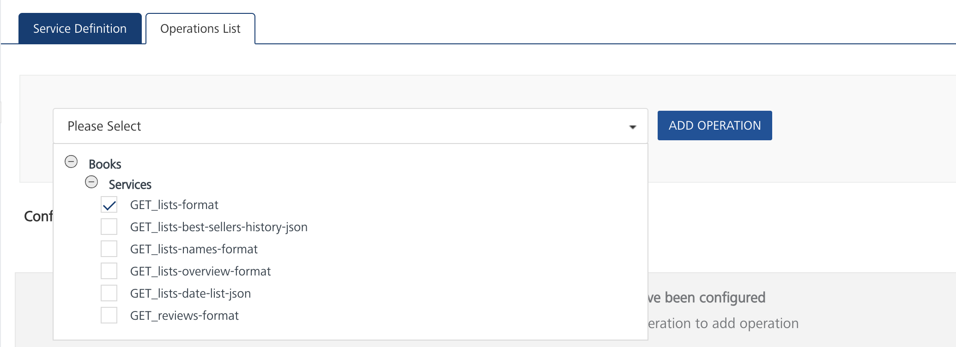

1. Click **ADD OPERATION**. The **GET_lists-format** operation is listed in the **Configured Operations** section.

## **Executing an Operation**

Executing an operation involves making the API call by setting the necessary parameters and displaying the response. The procedure to execute any operation is same, but the request parameters of the APIs vary. For more information on request parameters of each API, refer [Books API Catalog](https://developer.nytimes.com/docs/books-product/1/routes/lists.json/get).

This section provides steps to execute the **GET_lists-format** operation (explained in Creating an Operation).

**Steps to execute the GET_lists-format operation:**

1. Log on to your Hcl Foundry. The **Dashboard** page appears by default.
2. In the left pane, click the **API Management** menu. The **APIs** tab opens by default.
3. Click the **Integration** tab. The **Integration** tab opens with a list of existing integration services.
4. From the list of integration services, select the integration service that you have created with service type as **The New York Times Best Sellers**. The **Service Definition** tab of the selected integration service opens by default.
5. Click the **Operations List** tab.
6. Under the **Configured Operations** section, click the **GET_lists-format** operation. The **GET_lists-format** tab opens with the **Request Input** sub-tab opened by default.

1. In the **Name** box, the name of the operation is displayed by default. If you want, you can change the name.
2. On the **Request Input** tab, in the **Body** section, for the following parameters, specify the values in the respective boxes under the **Test Value** column.

**Mandatory Parameters**

* + **format:** The allowed values are json and jsonp.
  + **list:** The name of the Times best-seller list. To get valid values, use a **GET_lists-names-format** request.
  + **api-key:** The values allowed are json and jsonp. It takes string values.

**Optional Parameters**

* + **weeks-on-list:** The number of weeks that the best seller has been on list-name, as of bestsellers-date.
  + **bestsellers-date:** The week-ending date for the sales reflected on list-name.
  + **date:** In the format YYYY-MM-DD, the date on which the best-seller list was published on NYTimes.com (compare bestsellers-date).
  + **isbn:** International Standard Book Number, 10 or 13 digits.
  + **published-date:** The date the best-seller list was published on NYTimes.com (compare bestsellers-date).
  + **rank:** The rank of the best seller on list-name as of bestsellers-date.
  + **rank-last-week:** The rank of the best seller on list-name one week prior to bestsellers-date.
  + **offset:** Sets the starting point of the result set.
  + **sort-order:** Sets the result set either in ascending (ASC) or descending (DESC) order

1. Click **SAVE AND FETCH RESPONSE**. The **Output Result** dialog appears with the response. Otherwise, the **Output Result** shows an error.

## **3. Publishing the App in HCL FOUNDRY:**

After adding the **The New York Times Best Sellers** Data Adapter to your app and configuring the necessary configurations, you must publish the app to HCL Foundry. For more information, refer to [Publish a foundry app.](https://opensource.hcltechsw.com/volt-mx-docs/docs/documentation/Foundry/voltmx_appfactory_user_guide/Content/FoundryPublish.html)