Date : 23-Feb-25

TEXTCORTEX APPLICATION

VERSION: 1.0.0

OVERVIEW
The TextCortex AI API is a cloud-based REST service that provides advanced AI-powered text generation and content creation capabilities. The API leverages state-of-the-art language models to help users generate, rewrite, summarize, and enhance text across multiple languages and use cases. It offers flexible content generation with customizable parameters including tone, creativity level, and output length.
The service enables developers to integrate intelligent text generation capabilities directly into their applications, allowing users to create high-quality content, automate writing tasks, and enhance productivity. Typical use cases include content marketing, copywriting, email composition, social media posts, blog article generation, product descriptions, and automated content workflows.
Key features of the application:
TextCortex AI can be usefully applied in real-world scenarios. Here are a couple of examples:
- Content Marketing Automation: Generate blog posts, social media content, and marketing copy at scale, reducing content creation time and costs.
- E-commerce Product Descriptions: Automatically create compelling, SEO-optimized product descriptions for large catalogs, ensuring consistency and quality across thousands of items.
- Email and Communication: Draft professional emails, responses, and internal communications with appropriate tone and style tailored to the recipient and context.
- Multilingual Content Creation: Generate content in multiple languages for global audiences, enabling businesses to scale their content operations internationally.

GETTING STARTED
Prerequisites:

- HCL Foundry
- Volt MX Iris
- TextCortex API key and account access (from TextCortex platform)
Reference document:https://docs.textcortex.com/api/

Devices:
- Mobile

Platforms:
- Android
- IOS

Features
- Context-Aware Text Generation: Generates content based on full prompt context and instructions.
- Content Transformation: Rewrite, summarize, expand, or shorten text.
- Multilingual Output: Supports content generation in multiple languages.

App Functionality

When you build and run the app, users can enter text, select a processing tool, choose a tone, and generate AI-powered responses directly within the application.
Home Screen
Text Input
- The user enters the required text content in the input text area (e.g., a paragraph to rewrite or summarize).
Tool Selection
The user selects one of the available tools:
- Rewrite
- Expand
- Summarize
- Autocomplete
Tone Selection
The user chooses the preferred tone from the dropdown:
- Formal
- More Formal
- Less Formal

Text Processing
- After selecting the tool and tone, the user clicks the Generate button.
- The app sends the entered text, selected tool, and chosen tone to the AI service for processing.

Response Handling
- The AI-generated response is displayed in the AI Output section.
- Users can review the result and use the Regenerate option if they want a refreshed response.

Importing the app
To import the TextCortex Application into your workspace, follow these steps:
- Open Volt MX Iris
- On the main menu select Forge → Browse.
- Search for the TextCortex Application, and then click Import to Workspace. The app is imported to your workspace. A dialog box appears, confirming that the app has been imported. Click OK.
- Switch to your project containing the TextCortex Application. To switch to your project, click File → Open → Reference Architecture → <project name>

Building the app
After performing all the above steps, you can build your app and run it on your device. For more information, you can refer to the Building and Viewing an Application section of the Volt MX User Guide.
You can then run your app to see the TextCortex Application work in real time.

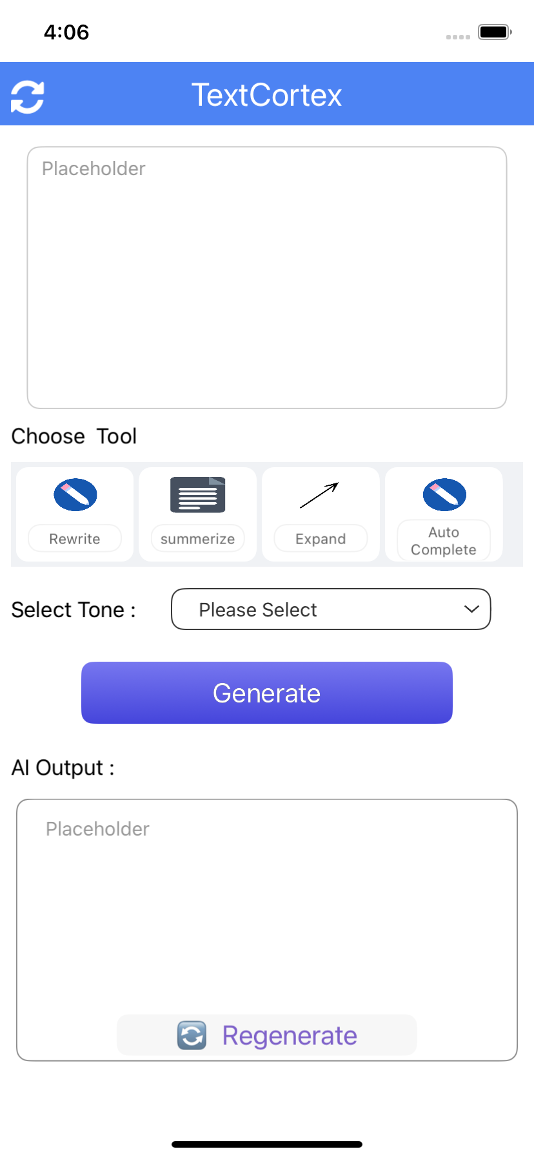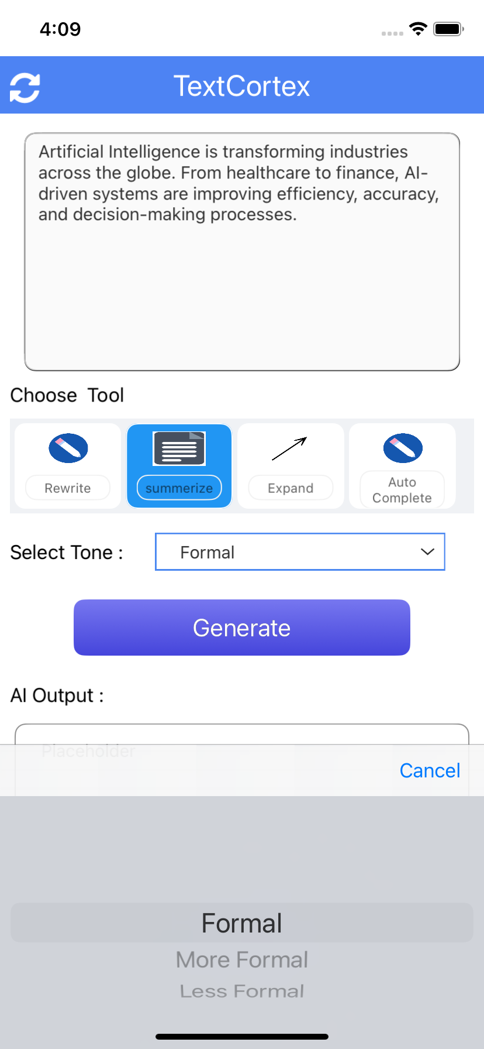

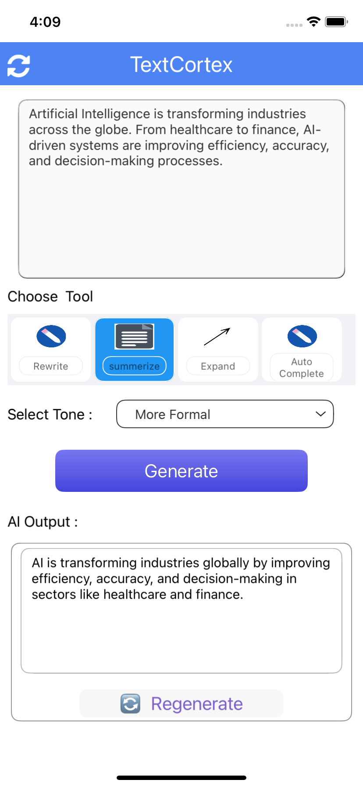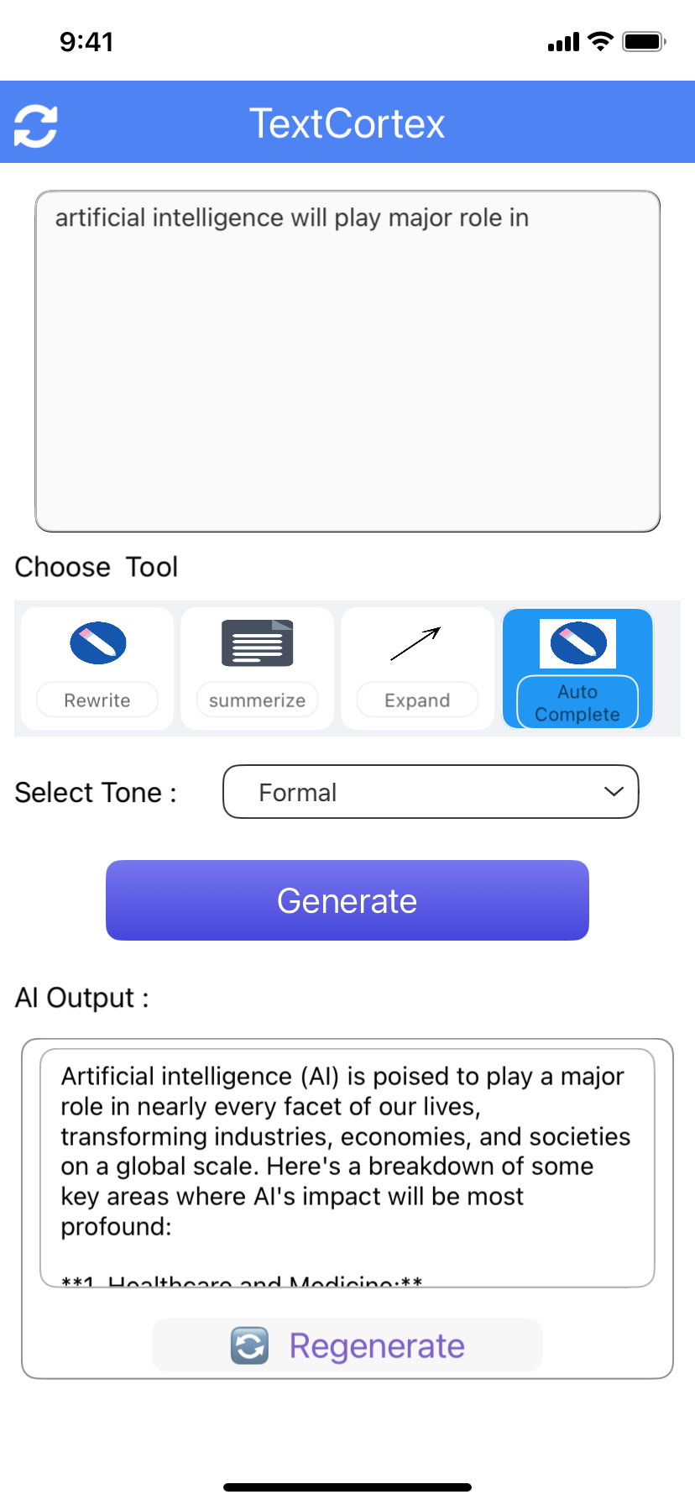

- Foundry APP Setup
To set the Foundry app, follow these steps:
- Click the HCL Volt MX Foundry app associated with your Volt MX Iris project from the Project Explorer. Click DATA & SERVICES.
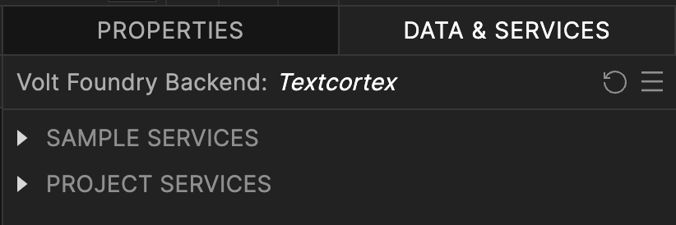
- Under the Configure Services tab, click Integration and can see the Textcortex Integration service. Click on that Integration service to add the keys.
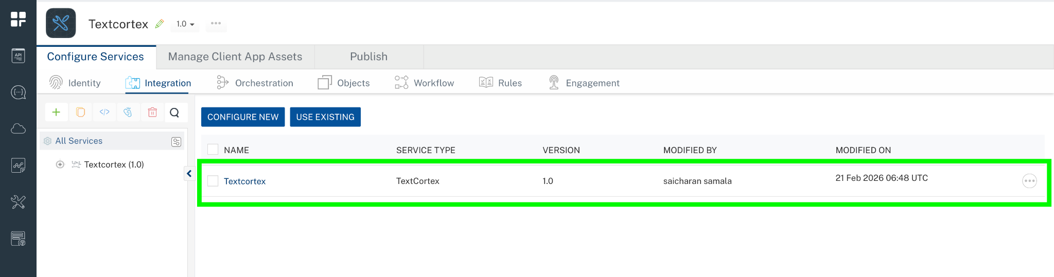
- Click the Operations List tab. The Operations List tab opens with the list of operations available.
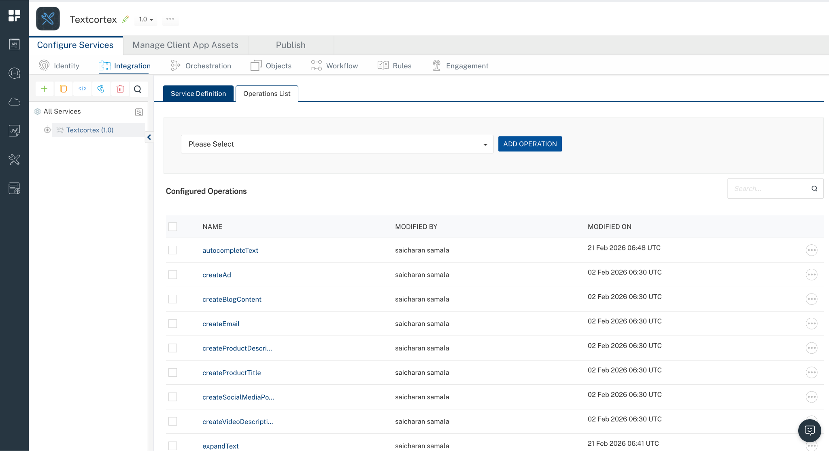
- Executing an Operation
Executing an operation involves making the API call by setting the necessary parameters and displaying the response. The procedure to execute any operation is the same, but the request parameters of the APIs vary. For more information on request parameters of API, refer https://docs.textcortex.com/api/
This section provides steps to execute the summarizeText operation.
A) Under the Configured Operations section, click the summarizeText operation. The summarizeText tab opens with the Request Input sub-tab opened by default. On the Request Input tab, in the Body section, for the following parameters, specify the values in the respective boxes under the Test Value or Default Value column.
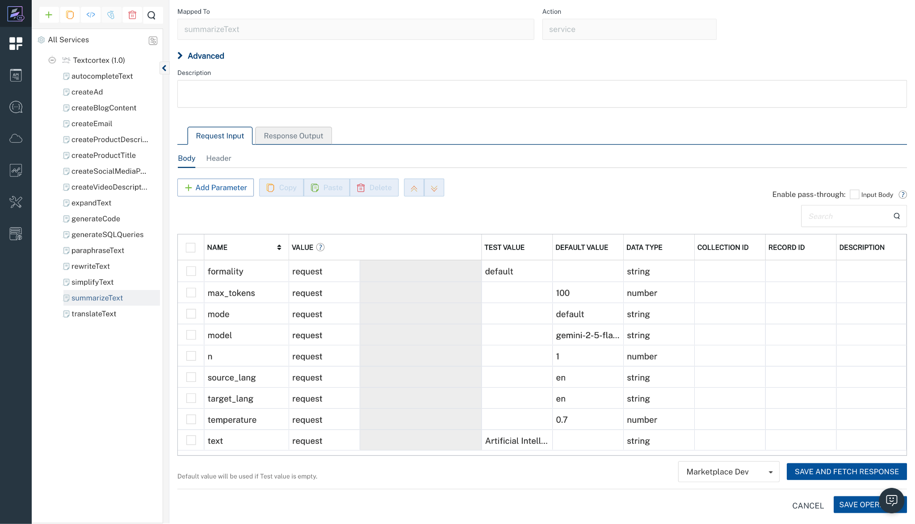
B) Click Header sub-tab. The Header section opens.
- For Authorization, In the box under the DEFAULT VALUE column, type the API Key
Syntax: Bearer Your_API_KEY

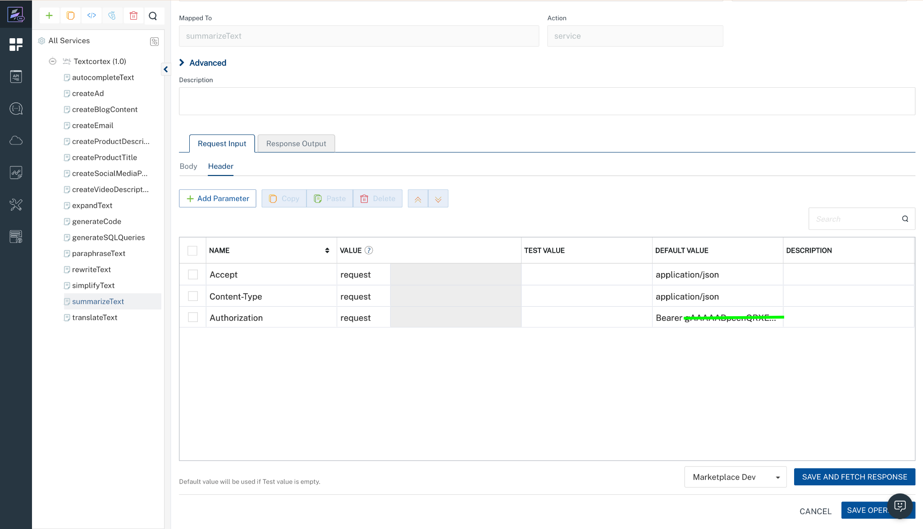
C) Click SAVE OPERATION.
D) Click SAVE AND FETCH RESPONSE. The Output Result dialog appears with the response. Otherwise, the Output Result shows an error.
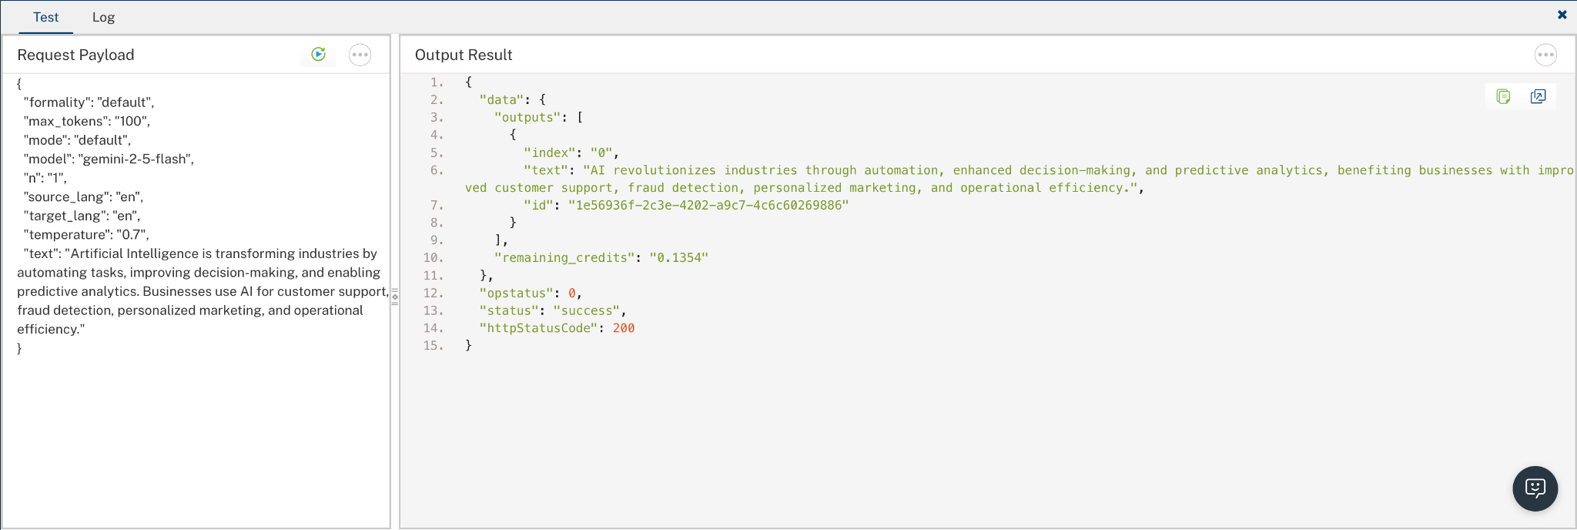

Publish the HCL Volt MX Foundry App
After you set the Operation Security Level, you must publish the HCL Volt MX Foundry app. To publish the HCL Volt MX Foundry, follow these steps:
In Volt MX Iris, click DATA & SERVICES, and then click Publish Project Services to Publish to your foundry app.
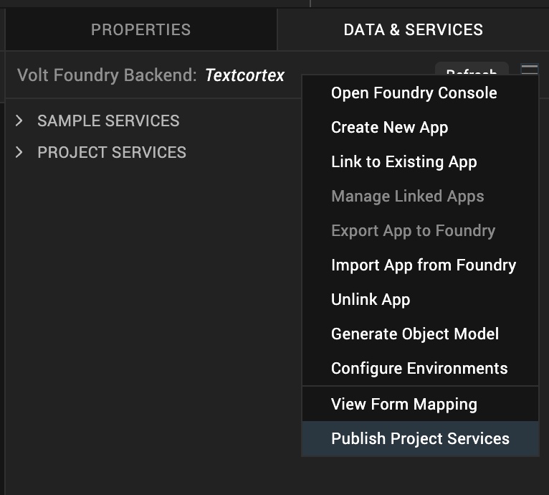
Select the environment to which you want to publish your app, and then click Publish.
After the app is published to your environment, the following window appears confirming the publish.
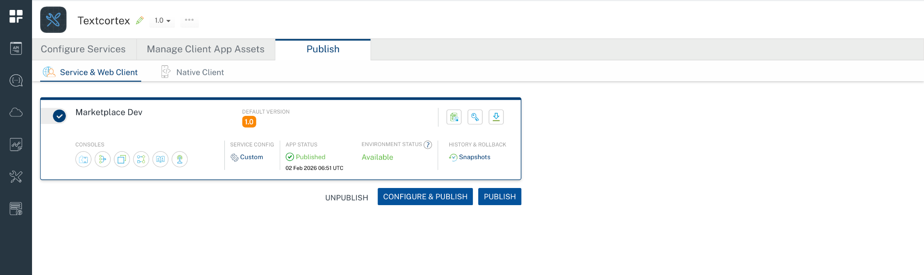

Building and previewing the app
After performing all the above steps, you can build your app and run it on your device. For more information, you can refer to the Building and Viewing an Application section of the Volt MX User Guide.
You can then run your app to see the TextCortex work in real time.

Reference Document: https://docs.textcortex.com/api/

REVISION HISTORY
App version 1.0.0:

Known Issues
None

Limitations
None

