Date : 02-Feb-25

TEXTCORTEX

VERSION: 1.0.0

OVERVIEW
The TextCortex AI API is a cloud-based REST service that provides advanced AI-powered text generation and content creation capabilities. The API leverages state-of-the-art language models to help users generate, rewrite, summarize, and enhance text across multiple languages and use cases. It offers flexible content generation with customizable parameters including tone, creativity level, and output length.
The service enables developers to integrate intelligent text generation capabilities directly into their applications, allowing users to create high-quality content, automate writing tasks, and enhance productivity. Typical use cases include content marketing, copywriting, email composition, social media posts, blog article generation, product descriptions, and automated content workflows.
- Use case:
TextCortex AI can be usefully applied in real-world scenarios. Here are a couple of examples:
- Content Marketing Automation: Generate blog posts, social media content, and marketing copy at scale, reducing content creation time and costs.
- E-commerce Product Descriptions: Automatically create compelling, SEO-optimized product descriptions for large catalogs, ensuring consistency and quality across thousands of items.
- Email and Communication: Draft professional emails, responses, and internal communications with appropriate tone and style tailored to the recipient and context.
- Multilingual Content Creation: Generate content in multiple languages for global audiences, enabling businesses to scale their content operations internationally.

- Features:
- Multiple Generation Modes: Supports various content creation modes including text generation, rewriting, summarization, expansion, and paraphrasing.
- Customizable Output: Control tone, creativity, formality, and length parameters to generate content that matches your specific requirements.
- Multilingual Support: Generate and process content in 70+ languages, enabling global content operations.
- Production-Ready API: Scalable cloud REST API with secure processing, consistent performance, and straightforward integration into applications, websites, or content management systems.
- Personas and Context: Utilize custom personas and contextual information to generate highly relevant, on-brand content.
- Percentage of Reuse:
- Approximately 80–90% reuse.

GETTING STARTED

Prerequisites
Before using the TextCortex Data Adapter, ensure you have the following:
- HCL Foundry
- Volt MX Iris
- Textcortex API Key

Creating an Textcortex Account and API Key:

- Go to https://textcortex.com/ and create a free account.
- Go to TextCortex Dashboard
- Navigate to Settings → API Keys
- Generate a new API Key
- Use it in requests as a Bearer token
Header format:
Authorization: Bearer YOUR_TEXTCORTEX_API_KEY

Importing the data adapter

You can import TextCortex Data Adapter into HCL Foundry directly from the Volt MX Forge website or by importing the data adapter zip file.

To import Data Adapter to Volt Foundry, do the following:
- Sign in to the HCL Foundry.
- From the left navigation menu, select API Management.
- In API Management, select Custom Data Adapters.

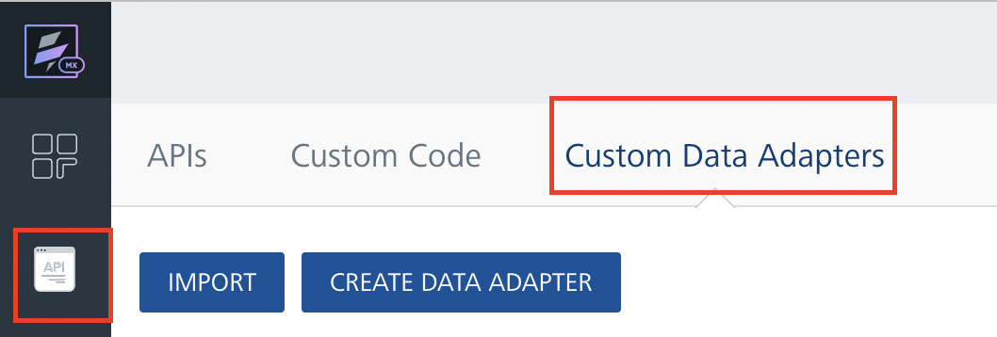
4. Click IMPORT to import a custom data adapter.
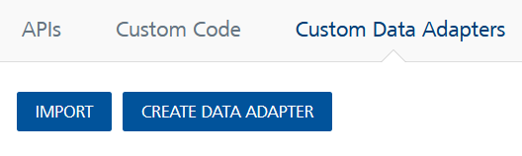

5. On the Import Data Adapter dialog box, click browser to import.

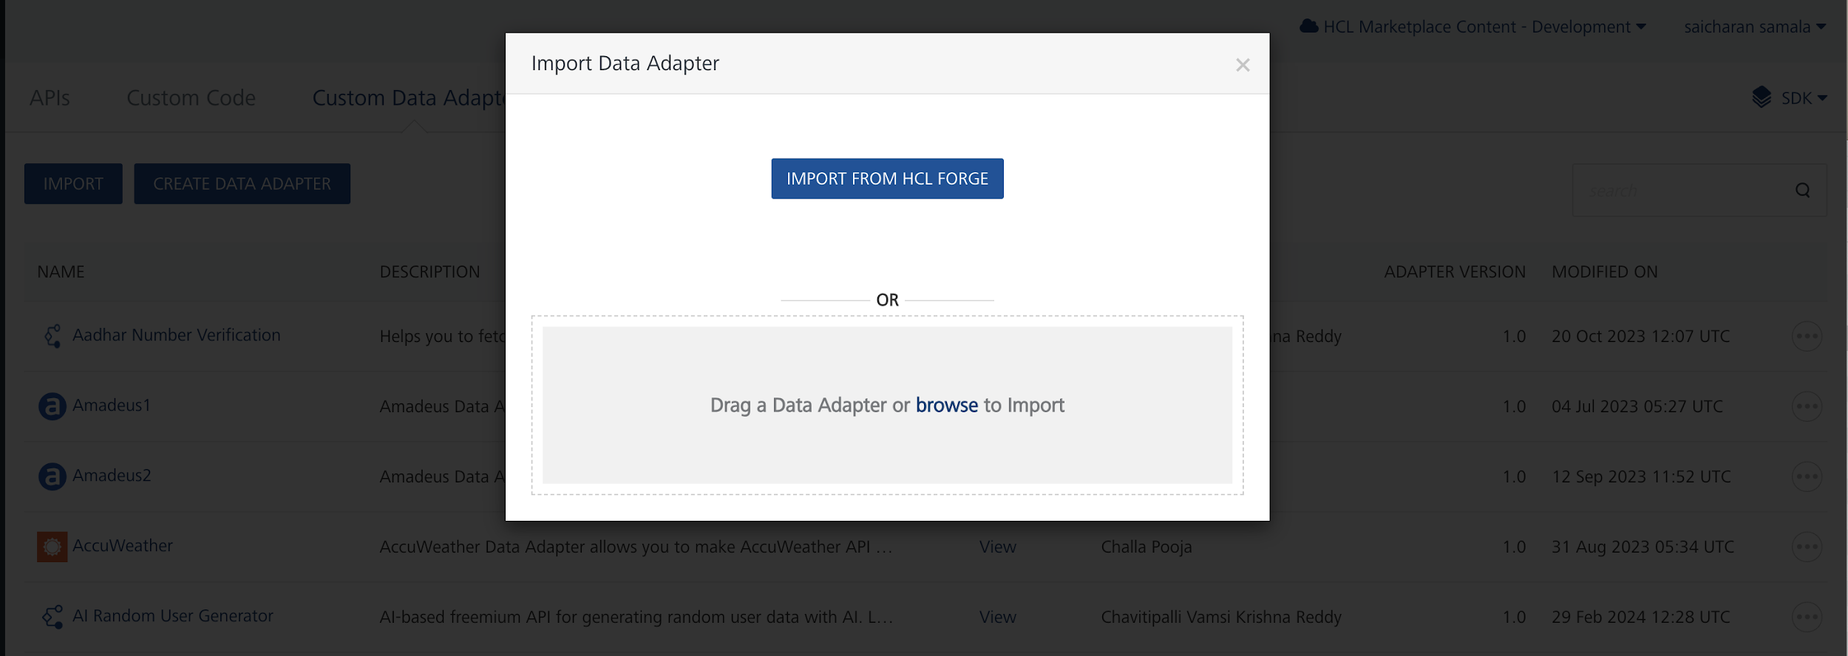

6. Click IMPORT FROM HCL FORGE. The Import Data Adapter from HCL Forge dialog appears with a list of available data adapters.
Click Import. TextCortex data adapter is listed on the Custom Data Adapters page.
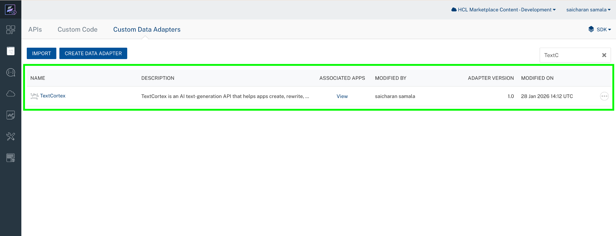
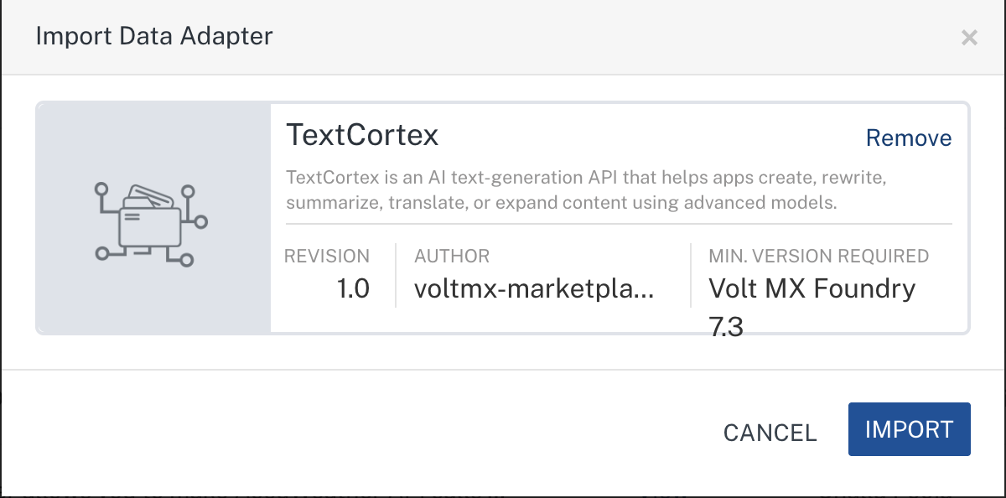
To import the data adapter zip file, do the following:
- Perform steps 1 to 4 in the above procedure
- Drag the data adapter zip file into the Drag a Data Adapter box.
Or
Click browse. The Open dialog appears.
Navigate to the location where you downloaded the data adapter (zip file) on your computer, select the data adapter, and click Open. The Import Data Adapter dialog shows the selected data adapter.
Note: Click Remove if the selected data adapter is not the one that you want to import.

Creating an Integration Service with TextCortex:
After you import TextCortex Data Adapter into Foundry, you must create an integration service with service type as TextCortex.
To create an integration service with TextCortex, do the following:
- Log on to your HCL Foundry. The Dashboard page appears by default.
- In the left pane, click the API Management menu. The APIs tab opens by default.
- Click the Integration tab. The Integration tab opens with a list of existing integration services.
- Click CONFIGURE NEW. The Service Definition tab opens.
- In the Name box, type a unique name for your service.
- From the Service Type list, select TextCortex.
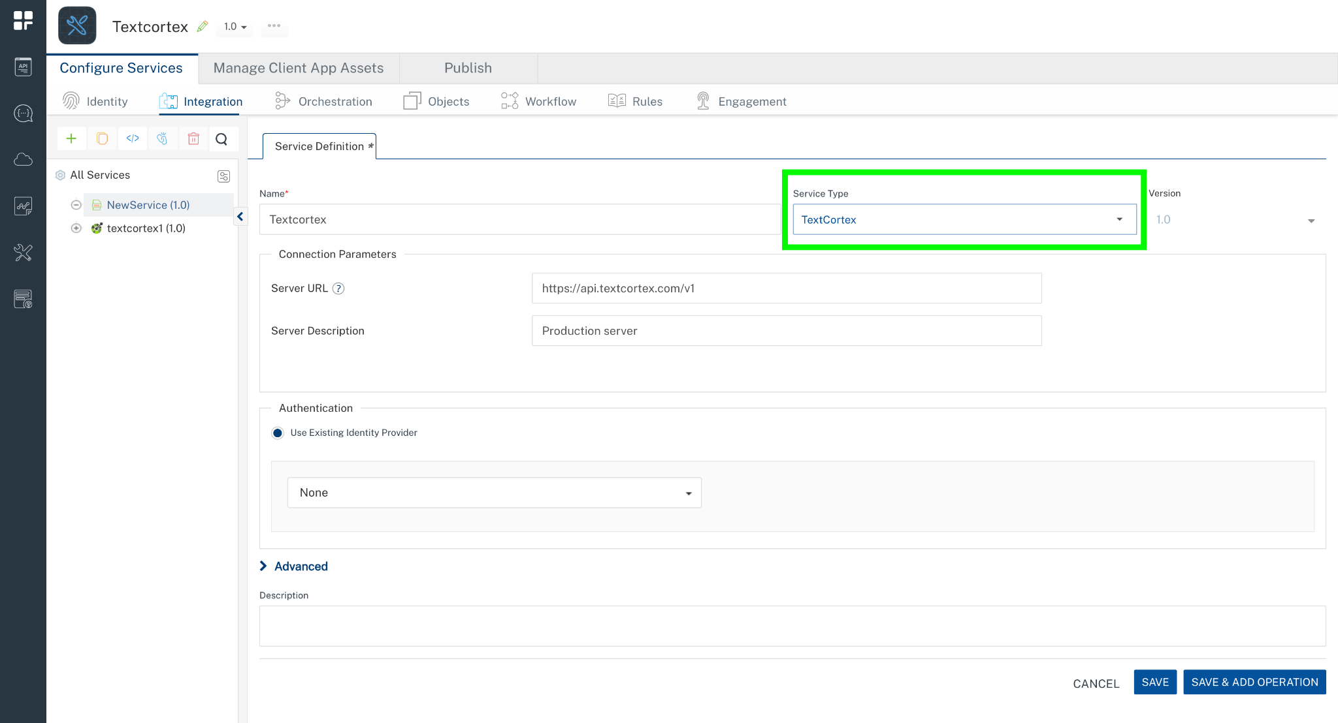
- Click Save

Creating an Operation
To make any API call in the HCL Foundry console, you must create an operation for the respective API and then execute the operation. Executing an operation involves making the API call and displaying the response.
This section provides steps to create an operation for the TextCortex.
Steps to create an operation for the TextCortex:
- Log on to your HCL Foundry. The Dashboard page appears by default.
- In the left pane, click the API Management menu. The APIs tab opens by default.
- Click the Integration tab. The Integration page appears with a list of existing integration services.
- From the list of integration services, select the integration service that you have created with the service type as TextCortex. The Service Definition tab of the selected integration service opens by default.
- Click the Operations List tab. The Operations List tab opens.
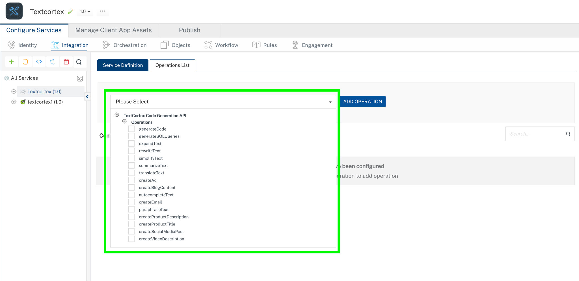
- Select Operations and Click Add Operation.
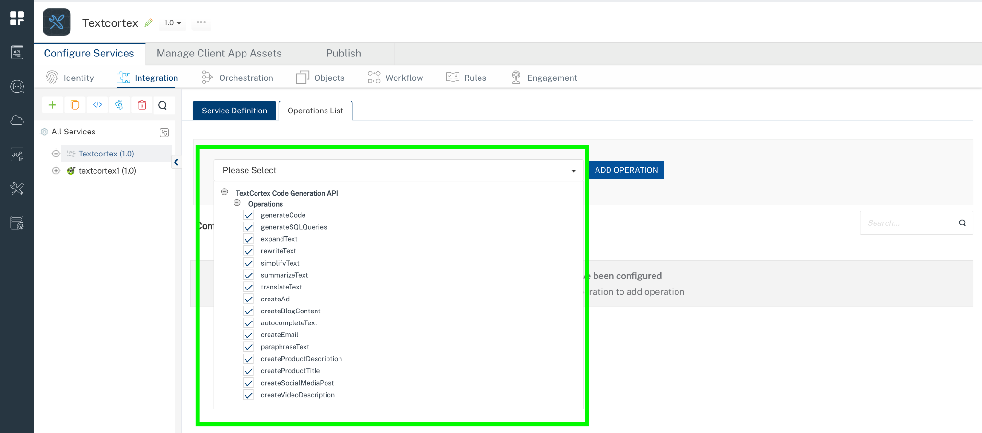

Executing Operation
Executing an operation involves making the API call by setting the necessary parameters and displaying the response. The procedure to execute any operation is the same, but the request parameters of the APIs vary.
Steps to execute the operation:
- Log on to your Hcl Foundry. The Dashboard page appears by default.
- In the left pane, click the API Management menu. The APIs tab opens by default.
- Click the Integration tab. The Integration tab opens with a list of existing integration services.
- From the list of integration services, select the integration service that you have created with service type as generatecode. The Service Definition tab of the selected integration service opens by default.
- Click the Operations List tab.
- In the Name box, the name of the operation is displayed by default. If you want, you can change the name.
- On the Request Input tab, in the Body section, for the following parameters, specify the values in the respective boxes under the Test Value column.
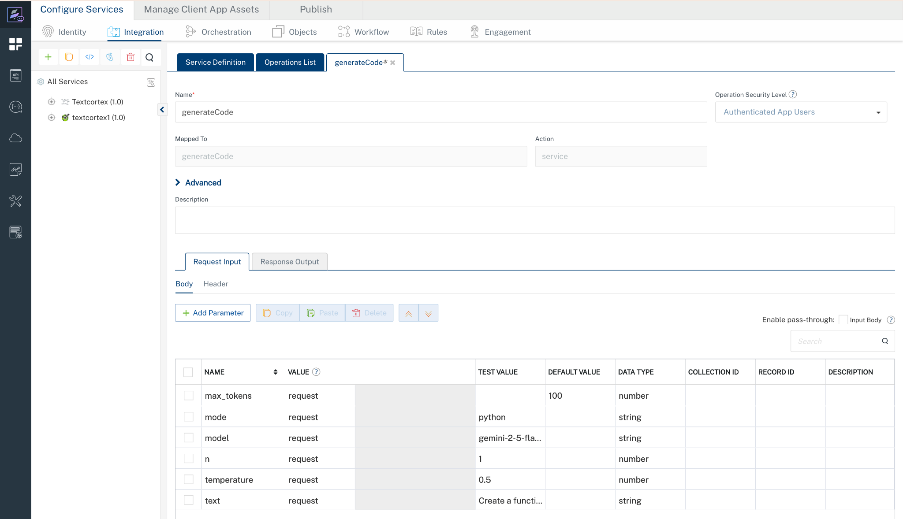

- Click Header sub-tab. The Header section opens.
- For Authorization, In the box under the DEFAULT VALUE column, type the API Key
Syntax: Bearer Your_API_KEY
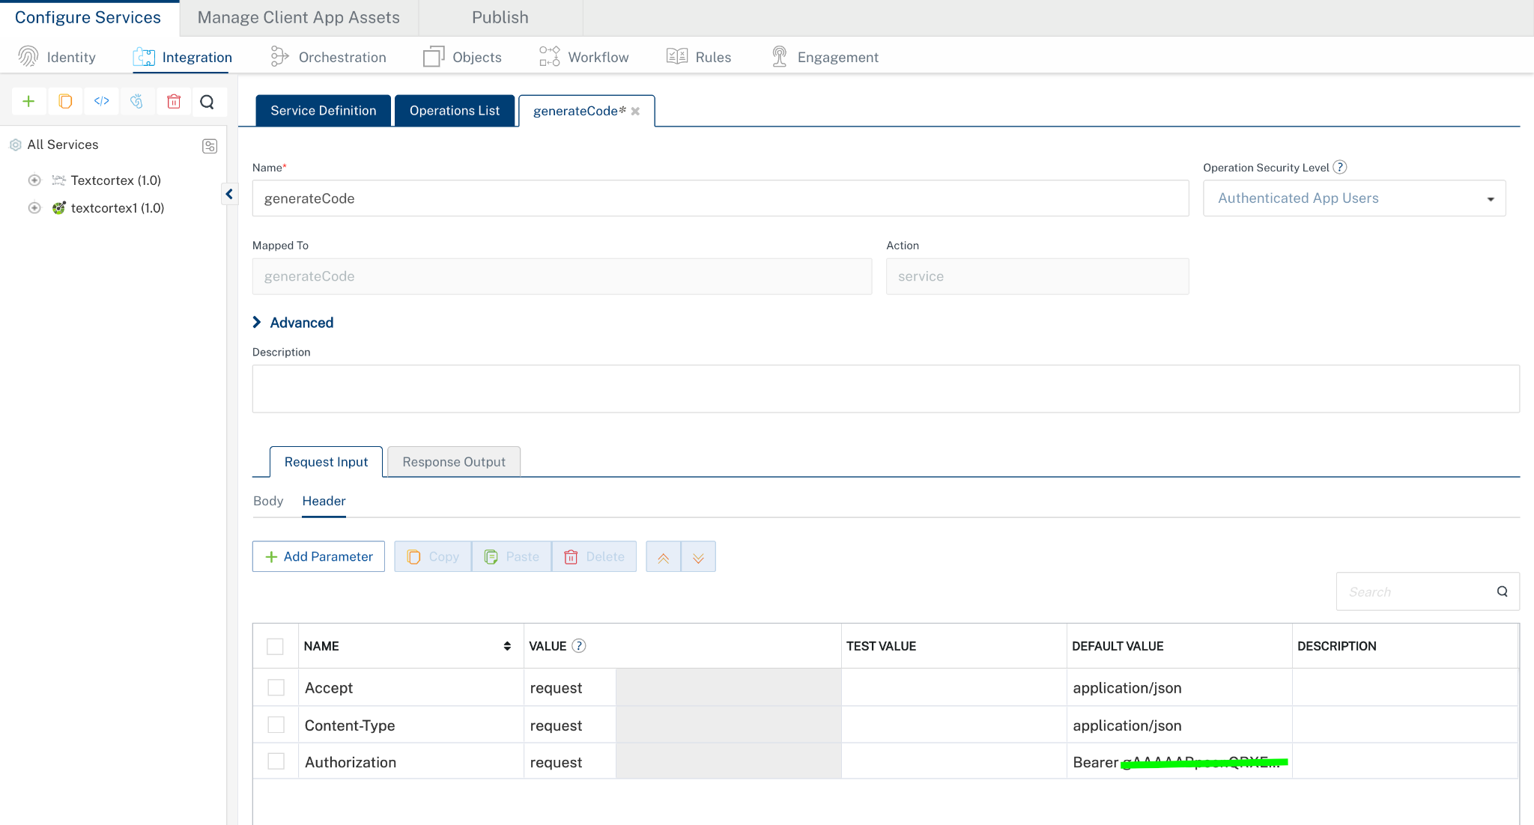
- Click SAVE AND FETCH RESPONSE. The Output Result dialog appears with the response. Otherwise, the Output Result shows an error.
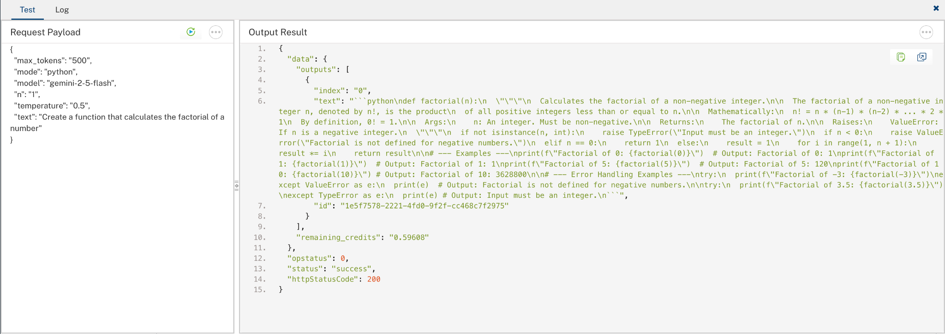

PUBLISHING THE APP IN VOLTMX FOUNDRY:
After adding the TextCortex Data Adapter to your app and configuring the necessary configurations, you must publish the app to HCL Foundry. For more information, refer to Publish a foundry app.
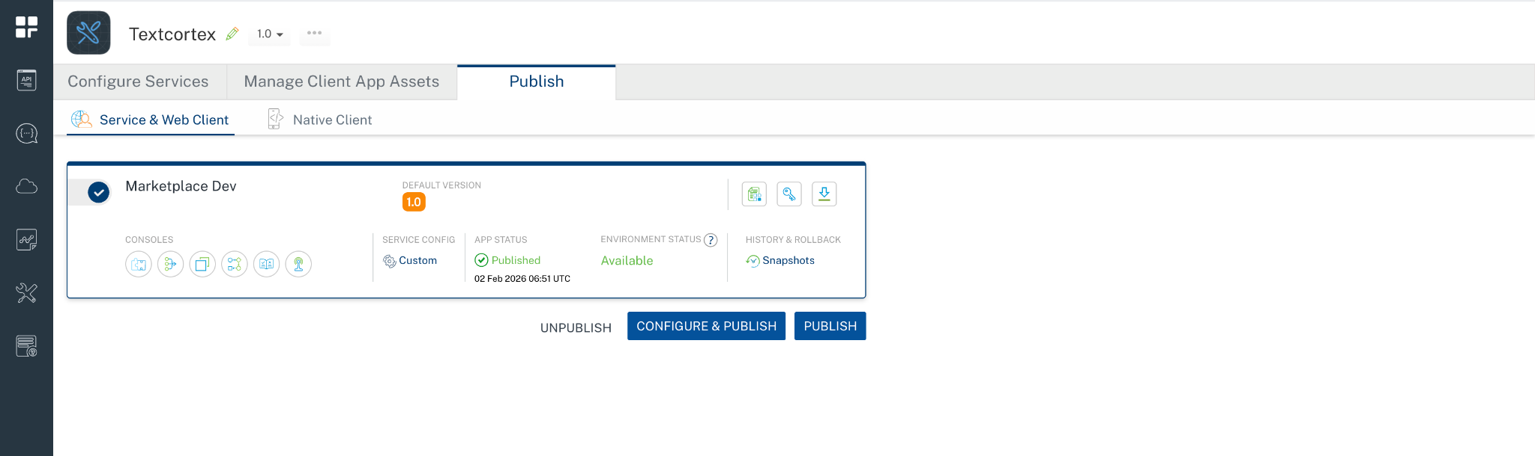

Reference documentation link: https://docs.textcortex.com/api/

REVISION HISTORY
Adapter version 1.0.0:

Known Issues
None

Limitations
None

