June-2023

Textbox input widget
Version: 1.0.0

Description
This simple TextBox component has configurable views, e.g., Required, Optional, Enabled, etc.
Once imported in Volt Iris, this component can be further customized to suit developer’s needs.
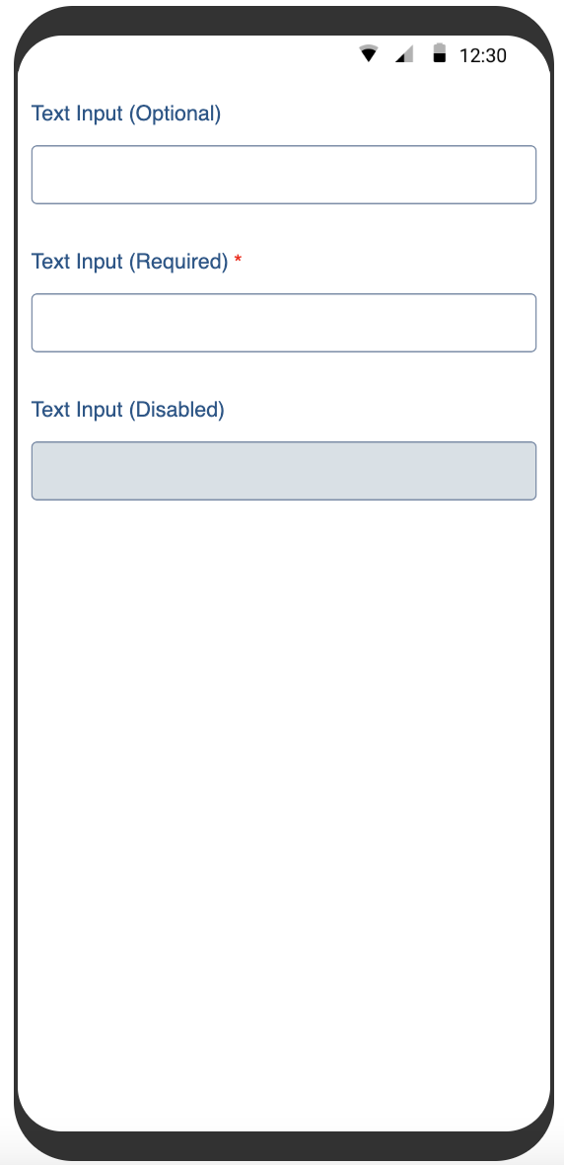

Properties / Events / Methods

Properties
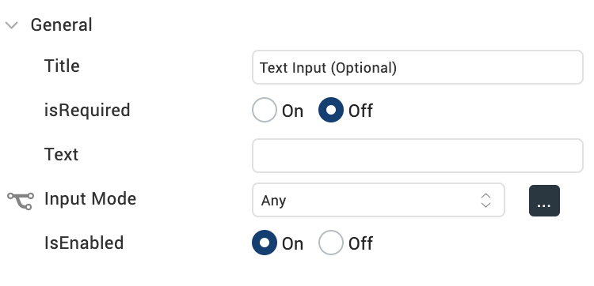

Events Exposed

onDone – All Platforms

onKeyUp – Desktop Web only

**Note: Developer can expose other TextBox events as required, after importing the component in Volt Iris.

