07 Feb 2024

Tabs (Icon with focus-circle)

version: 1.0.3

- OVERVIEW

Tabs are used to organize content at app level. Using these, users can quickly switch between different sections of the app.

Use case:
Consider a case that you want to develop an app for social networking that helps users to perform multiple transactions in separate sections. In this app, you want to develop a feature that helps users to make calls via internet, send messages, and view status. Using the Tabs component, you can achieve the feature in your app.

Features:
- Ready-to-use and easy to implement Tab patterns
- Useful component for Navigation between different sections (functional modules)
- Easy to plug into your app
- Facilitates easy customization of UI

Percentage of re-use:
Approximate 80% of reuse.

Getting Started

Prerequisites
Before you start using the Tabs (Icon with focus-Circle) component, ensure the following:
• HCL Foundry
• Volt MX Iris

Platforms Supported
- Mobile
- iOS
- Android

- Tablet & iPad

Importing the app

You can import the Forge components only into the apps that are of the Reference Architecture type.

To import the Tabs (Icon with focus-Circle) component, do the following:

Open your app project in Volt MX Iris.
2. In the Project Explorer, click the Templates tab.

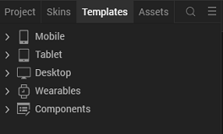
3.Right-click Components, and then select Import Component. The Import
Component dialog box appears.
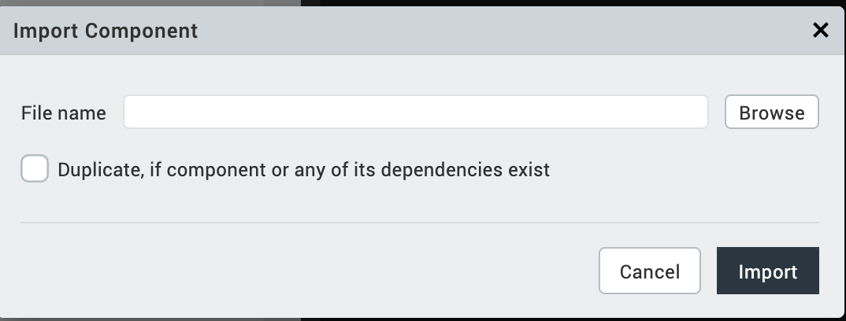
4.Click Browse to navigate to the location of the component, select the
component, and then click Import. The component and its associated widgets and
modules are added to your project.

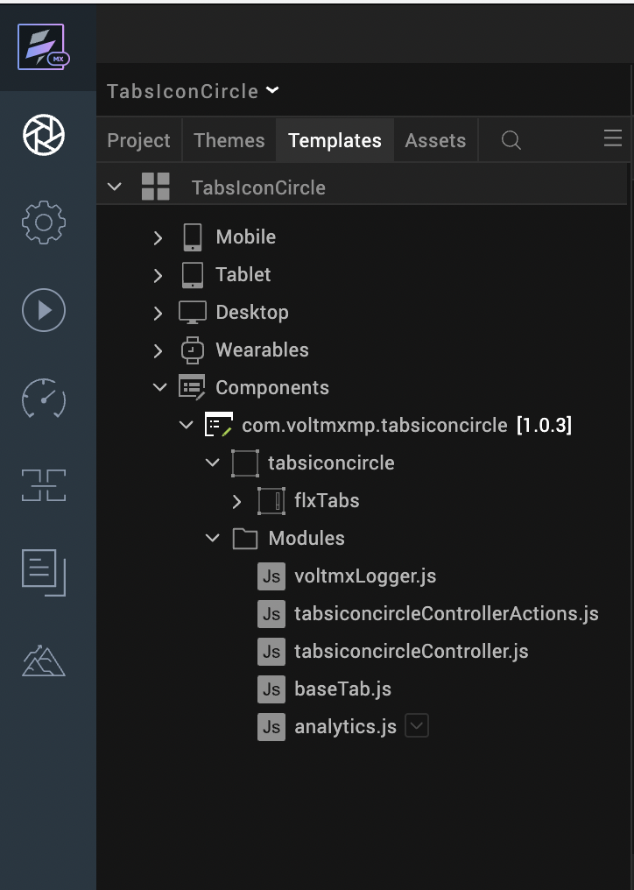
Once you have imported a component to your project, you can easily add the component to a form. For more information, refer Add a Component to a Form

Building and previewing the app
After performing all the above steps, you can build your app and run it on your device. For more information, you can refer to the Building and Viewing an Application section of the Volt MX User Guide.
You can then run your app to see the Tabs (Icon with focus-Circle) work in real time.

References

Dynamic Usage
You can also add Tabs (Icon with focus-Circle) component dynamically. To do so,
- In the Project Explorer, on the Projects tab, click Controllers section to access the respective Form Controller. Create a method and implement the code snippet similar to the sample code mentioned below.
/* Creating the component's Object */
var TabsIconCircle = new com.voltmxmp.tabsiconcircle(
{
"clipBounds":true,
"id": "TabsIconCircle",
"isVisible": true,
"left": "0%",
"width": "100%",
"top": "0%",
"zIndex": 1
}, {}, {});

/* Setting the component's properties */
TabsIconCircle.tabCount = 5;
TabsIconCircle.tabWidth = "20%";
TabsIconCircle.activeImage1 = "voltmxmp_tabsiconcircle_active_business.png";
TabsIconCircle.inactiveImage1 = "voltmxmp_tabsiconcircle_business.png";
TabsIconCircle.activeImage2 = "voltmxmp_tabsiconcircle_active_favourite.png";
TabsIconCircle.inactiveImage2 = "voltmxmp_tabsiconcircle_favourite.png";
TabsIconCircle.activeImage3 = "voltmxmp_tabsiconcircle_active_finance.png";
TabsIconCircle.inactiveImage3 = "voltmxmp_tabsiconcircle_finance.png";
TabsIconCircle.activeImage4 = "voltmxmp_tabsiconcircle_active_sports.png";
TabsIconCircle.inactiveImage4 = "voltmxmp_tabsiconcircle_sports.png";
TabsIconCircle.activeImage5 = "voltmxmp_tabsiconcircle_active_health.png";
TabsIconCircle.inactiveImage5 = "voltmxmp_tabsiconcircle_health.png";
TabsIconCircle.sknBackground = "voltmxmpSknTicBackground";
TabsIconCircle.sknHighlight = "voltmxmpspolight";
TabsIconCircle.sknUnderline = "voltmxmplblIndicatorSkin";

/* Adding the component to the Form */
this.view.add(TabsIconCircle);

In the code snippet, you can edit the properties of the component as per your requirement. For more information, see Setting Properties.
2. Save the file

Properties
The properties provided on the Component tab allows you to customize the elements in the Tabs (Icon with focus-Circle) component. These elements can be UI elements, service parameters, and so on. You can set the properties from the Volt MX Iris Properties panel on the right-hand side. You can also configure these properties using a JavaScript code.
Note: If you copy code from any example, make sure that you replace componentID with the name of your component.
General Properties

No of Tabs
Description: | Specifies the number of tabs that you want to create at the run time.
Syntax: | tabCount
Type: | Integer
Read/Write: | Write
Default Value: | 5
Range of Values: | - Minimum Value: 1  - Maximum Value: 6
Remarks: | - Make sure that you specify a value that is within the range of values and is valid. Otherwise, the component throws an INVALID_TABCOUNT exception.  - You need to provide active and inactive images for all the tabs. Otherwise, the component throws an INVALID_IMAGE_FILE exception.
Example: | this.view.componentID.tabCount = 5;

Width of Tab
Description: | Specifies the width of the tab in percentage.
Syntax: | tabWidth
Type: | String
Read/Write: | Write
Default Value: | 20%
Remarks: | Make sure that you append the value with %. Otherwise, the component throws an INVALID_TABWIDTH exception.
Example: | this.view.componentID.tabWidth = "20%";

Tab 1

Active Image:
Description: | Specifies the image that you want to use as the Active Image for the first tab.
Syntax: | activeImage1
Type: | String
Read/Write: | Read+Write
Example: | this.view.componentID.activeImage1 = "voltmxmp_tabsiconcircle_active_business.png";
Inactive Image:
Description: | Specifies the name of image that you want to use as the Inactive Image for the first tab.
Syntax: | inactiveImage1
Type: | String
Read/Write: | Write
Example: | this.view.componentID.inactiveImage1 = "voltmxmp_tabsiconcircle_business.png";

Tab 2

Active Image:
Description: | Specifies the image that you want to use as the Active Image for the second tab.
Syntax: | activeImage2
Type: | - Image  - String
Read/Write: | Read+Write
Example: | this.view.componentID.activeImage2 = "voltmxmp_tabsiconcircle_active_favourite.png";
Inactive Image:
Description: | Specifies the name of image that you want to use as the Inactive Image for the second tab.
Syntax: | inactiveImage2
Type: | String
Read/Write: | Write
Example: | this.view.componentID.inactiveImage2 = "voltmxmp_tabsiconcircle_favourite.png";

Tab 3

Active Image:
Description: | Specifies the image that you want to use as the Active Image for the third tab.
Syntax: | activeImage3
Type: | - Image  - String
Read/Write: | Read+Write
Example: | this.view.componentID.activeImage3 = "voltmxmp_tabsiconcircle_active_finance.png";
Inactive Image:
Description: | Specifies the name of image that you want to use as the Inactive Image for the third tab.
Syntax: | inactiveImage3
Type: | String
Read/Write: | Write
Example: | this.view.componentID.inactiveImage3 = "voltmxmp_tabsiconcircle_finance.png";

Tab 4

Active Image:
Description: | Specifies the image that you want to use as the Active Image for the fourth tab.
Syntax: | activeImage4
Type: | - Image  - String
Read/Write: | Read+Write
Example: | this.view.componentID.activeImage4 = "voltmxmp_tabsiconcircle_active_sports.png";
Inactive Image:
Description: | Specifies the name of image that you want to use as the Inactive Image for the fourth tab.
Syntax: | inactiveImage4
Type: | String
Read/Write: | Write
Example: | this.view.componentID.inactiveImage4 = "voltmxmp_tabsiconcircle_sports.png";

Tab 5

Active Image:
Description: | Specifies the image that you want to use as the Active Image for the fifth tab.
Syntax: | activeImage5
Type: | - Image  - String
Read/Write: | Read+Write
Example: | this.view.componentID.activeImage5 = "voltmxmp_tabsiconcircle_active_health.png";
Inactive Image:
Description: | Specifies the name of image that you want to use as the Inactive Image for the fifth tab.
Syntax: | inactiveImage5
Type: | String
Read/Write: | Write
Example: | this.view.componentID.inactiveImage5 = "voltmxmp_tabsiconcircle_health.png";

Tab 6

Active Image:
Description: | Specifies the image that you want to use as the Active Image for the sixth tab.
Syntax: | activeImage6
Type: | - Image  - String
Read/Write: | Read+Write
Example: | this.view.componentID.activeImage6 = "pinb.png";
Inactive Image:
Description: | Specifies the name of image that you want to use as the Inactive Image for the sixth tab.
Syntax: | inactiveImage6
Type: | String
Read/Write: | Write
Example: | this.view.componentID.inactiveImage6 = "pinb.png";

Skins:

Tab Background
Description: | This skin links to the background of the tabs.
Syntax: | sknBackground
Widget Type: | FlexContainer
Type: | String
Read/Write: | Read+Write
Example: | this.view.componentID.sknBackground = "voltmxmpSknTicBackground";

Tab Highlight
Description: | This skin links to the circle that highlights the active tab.
Syntax: | sknHighlight
Widget Type: | FlexContainer
Type: | String
Read/Write: | Read+Write
Example: | this.view.componentID.sknHighlight = "voltmxmpspolight";

Underline
Description: | This skin links to the underline of the selected tab.
Syntax: | sknUnderline
Widget Type: | Label
Type: | String
Read/Write: | Read+Write
Example: | this.view.componentID.sknUnderline = "voltmxmplblIndicatorSkin";

Events
The component invokes events when its corresponding action is performed. You can configure any logic you want the component to perform whenever an event occurs. You can configure the events directly on the Actions tab or by writing a JavaScript, For more information, refer to Add Actions in the Iris User Guide.

onTabChange
Description: | Invoked when the user clicks or taps a tab.
Syntax: | onTabChange
Type: | String
Read/Write: | Read+Write
Parameters: | eventObject [JSON]:  Information about the selected tab.  Contains the following keys:  - tabIndex [Integer]: The index of the selected tab  - activeImage [String]: The name of the active image of the selected tab  - inactiveImage [String]: The name of the inactive image of the selected tab
Example: | this.view.componentID.onTabChange = function(eventObject)  {  alert("Tab Selected: " + JSON.stringify(eventObject));  }
Sample JSON: | {  "activeImage" : "voltmxmp_tabsiconcircle_active_business.png",  "inactiveImage" : "voltmxmp_tabsiconcircle_business.png",  "tabIndex": 0  };

APIs
The following APIs pertain to the Tabs (Icon with focus-Circle) component.

goToTab
Description: | Switches to the specified tab.
Syntax: | goToTab(tabIndex)
Parameters: | tabIndex [Integer]:  The index of the tab that you want to switch to.
Return Value: | None
Example: | var tabIndex = 2;  this.view.componentID.goToTab(tabIndex);

getSelectedTabIndex
Description: | Fetches the index of the tab that is currently selected.
Syntax: | getSelectedTabIndex()
Parameters: | None
Return Value: | tabIndex [Number]:  The index of the tab that is currently selected.
Example: | var tabIndex = this.view.componentID.getSelectedTabIndex();  alert("Current tab: " + tabIndex);

3. moveLeft
Description: | Switches to the tab that is on the left of the tab that is currently selected.
Syntax: | moveLeft()
Parameters: | None
Return Value: | None
Example: | this.view.componentID.moveLeft();

4. moveRight
Description: | Switches to the tab that is on the right of the tab that is currently selected.
Syntax: | moveRight()
Parameters: | None
Return Value: | None
Example: | this.view.componentID.moveRight();

5. getSelectedTabDetails
Description: | Fetches the details of the tab that is currently selected.
Syntax: | getSelectedTabDetails()
Parameters: | None
Return Value: | tabObject [JSON]:  The details of the tab that is currently selected.  Contains the following keys:  - tabIndex [Integer]: The index of the selected tab  - activeImage [String]: The name of the active image of the selected tab  - inactiveImage [String]: The name of the inactive image of the selected tab
Example: | var tabObject = this.view.componentID.getSelectedTabDetails();  alert("Current tab details: " + JSON.stringify(tabObject));
Sample JSON: | {  "activeImage" : "voltmxmp_tabsiconcircle_active_business.png",  "inactiveImage" : "voltmxmp_tabsiconcircle_business.png",  "tabIndex": 0  };

6. createTabs
Description: | Creates tabs based on the specified data.
Syntax: | createTabs(tabData)
Parameters: | imageObject [Array of JSON]:  The data about the tabs that you want to create.  Contains the following keys:  - activeImage [String]: The name of the image that you want to use as the active image of the tab.  - inactiveImage [String]: The name of the image that you want to use as the inactive image of the tab.
Return Value: | None
Remarks: | - Make sure that you add the Tabs component to a form before you use the createTabs API.  - If the imageObject parameter is empty, the API creates tabs by using the values of the component properties.
Example: | var imageObject =  [  {  "activeImage" : "voltmxmp_tabsiconcircle_active_business.png",  "inactiveImage" : "voltmxmp_tabsiconcircle_business.png"  },  {  "activeImage" : "voltmxmp_tabsiconcircle_active_favourite.png",  "inactiveImage" : "voltmxmp_tabsiconcircle_favourite.png"  },  {  "activeImage" : "voltmxmp_tabsiconcircle_active_finance.png",  "inactiveImage" : "voltmxmp_tabsiconcircle_finance.png"  }  ];  this.view.componentID.createTabs(imageObject);

Revision History
App version 1.0.3:

Known Issues

No Known Issues.

Limitations
- The component only supports up to six tabs.

