01 Feb 2024

Tabs

version: 1.0.1

- OVERVIEW
Tabs are UI elements that are used to organize content of an app. A user can select a tab to switch to the relevant section of the app.

Use case:

The Tabs collection library contains different themes of tabs. You can customize the number of tabs and the width of every tab on the component. You can use these components in scenarios such as: A news app, in which you want to display different categories of news to a user.

The following Themes of tabs are bundled in the collection library -
- Tabs Icon Theme
- Tabs Icon with focus-Circle Theme
- Tabs Icon with Text Theme
- Tabs Text with focus-Arrow Theme
- Tabs Text with focus-Arrow and Underline Theme
- Tabs Text with focus-Line Theme
- Tabs Text with focus-Button Theme
- Tabs Text with focus-Button and Shell Theme

Features:
- Ready-to-use and easy to implement Tab patterns
- Useful component for Navigation between different sections (functional modules)
- Easy to plug into your app
- Facilitates easy customization of UI

Percentage of re-use:

Approximate 80% of reuse.

Getting Started

Prerequisites

This is a getting started section for the Tabs collection library. It contains information about setting up and running components from the library in an application.

Before you start using the Tabs collection library, make sure that you meet all the prerequisites.

- HCL Foundry
- Volt MX Iris

Platforms Supported

Mobile

IOS

Android

Tablet, iPad
After you make sure that you meet all the prerequisites, you can expand any of the following drop-down sections for details about every step of getting started with the collection library.

Importing the collection library to your project

You can import the Forge components only into the apps that are of the Reference Architecture type.

Make sure that you are signed into Volt MX Iris.

You can download the collection library onto your system as a zip file from Volt MX Forge.

You can then import the zip file by selecting the Import Library option from My Libraries as shown in below.

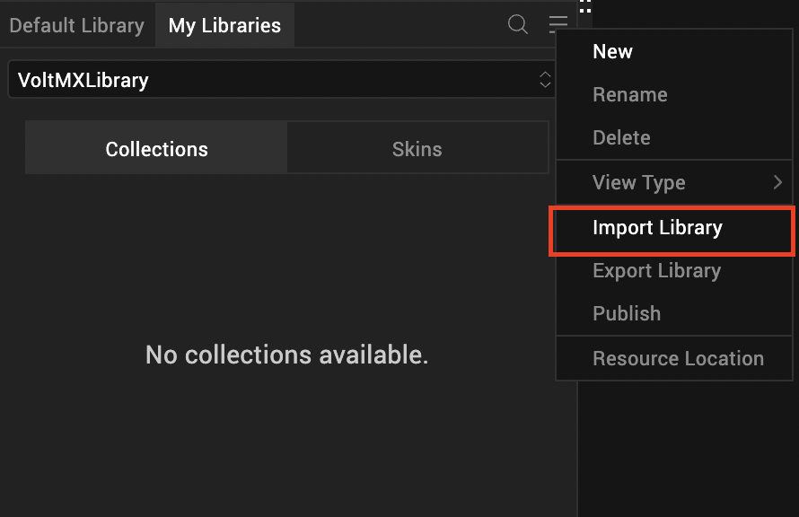

After Iris downloads the collection library, it adds the library to your workspace. You can access the library from the My Libraries tab on the lower-left panel on Iris.
After you import the collection library, you can add components from the library to your app.
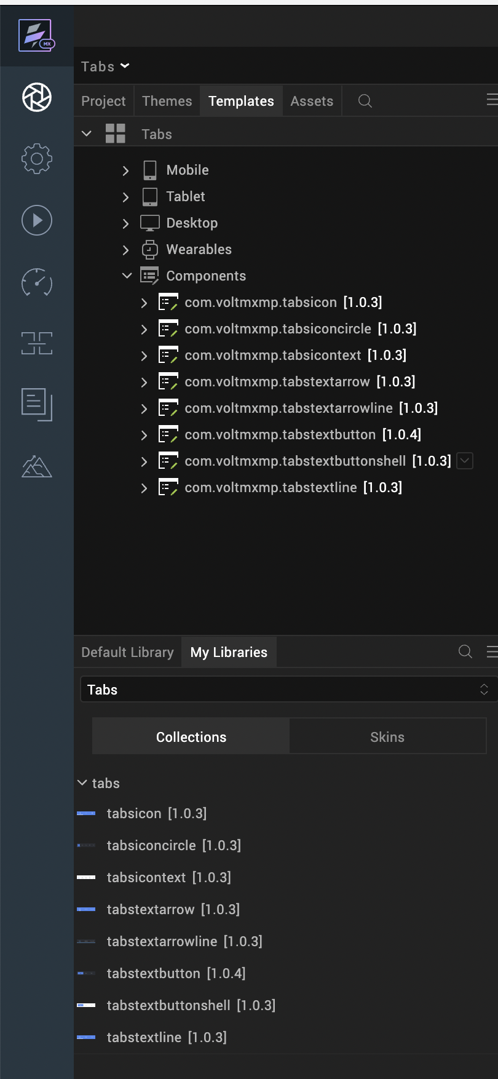

After you add the components to your form, you can Preview or Build your app.

Adding components to your app

From the lower-left panel of Iris, switch to the My Libraries tab

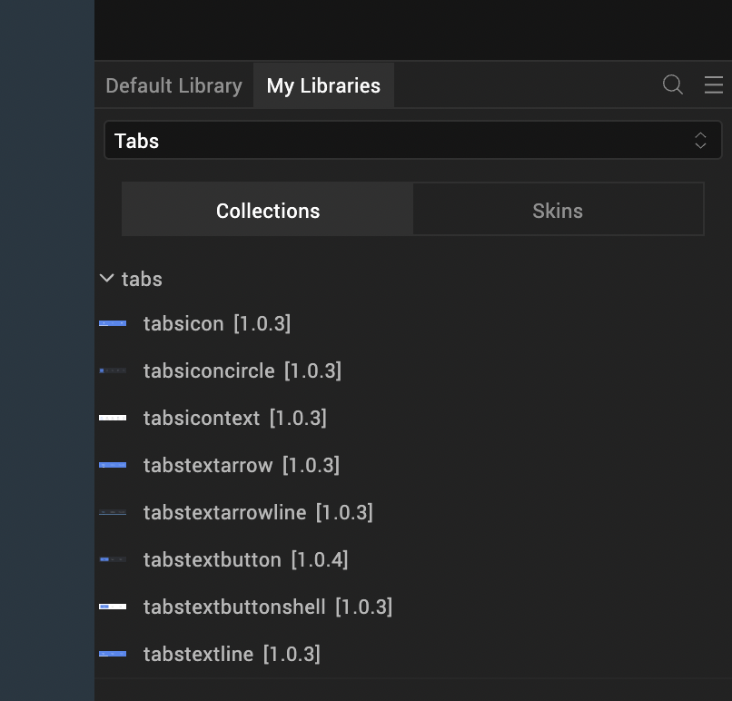

From the drop-down list, select the Tabs library that you imported from Forge.

From Collections, drag and drop a component onto your form.

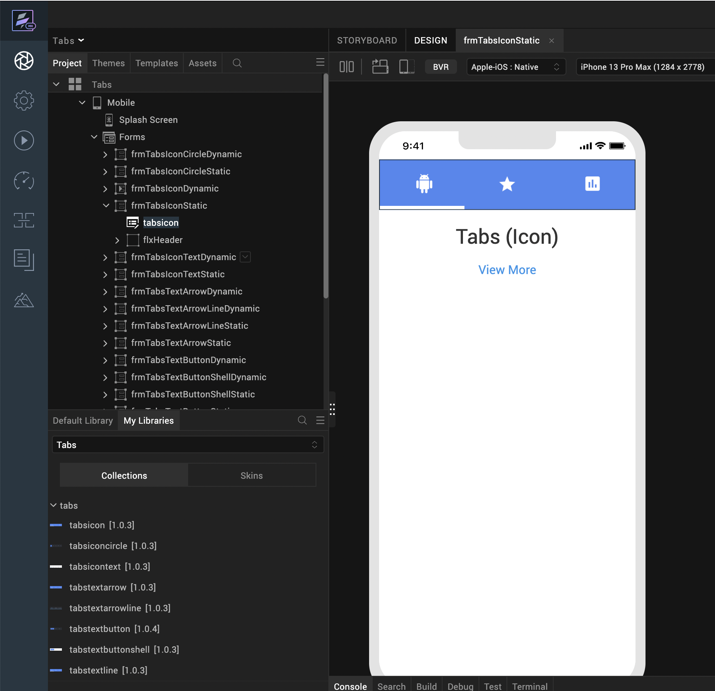

After you add a component to a form, you can Preview or Build Your app.

Building and previewing the app

After performing all the above steps, you can build your app and run it on your device. For more information, you can refer to the Building and Viewing an Application section of the Volt MX User Guide.

You can then run your app to see the Tabs work in real time.
For more information on the components in the library, you can refer to the following sections of the document.
- Tabs Icon Theme
- Tabs Icon with focus-Circle Theme
- Tabs Icon with Text Theme
- Tabs Text with focus-Arrow Theme
- Tabs Text with focus-Arrow and Underline Theme
- Tabs Text with focus-Button Theme
- Tabs Text with focus-Button and Shell Theme
- Tabs Text with focus-Line Theme

TABS: Icon Theme
The Tabs: Icon theme displays an icon on every tab and displays a line at the bottom edge of the tab that is currently selected (active). When a tab is selected, the component displays the active icon of the tab, when a tab is not selected, the component displays the inactive icon of the tab.

Note: If you copy the code from any example, make sure that you replace componentID with the name of your component.

Dynamic Usage:
If you want to use a component dynamically, you need to add the component to your project Templates. Follow the given steps to do so.
From the Project explorer, expand Mobile and Tablet.
Right-click forms and select New Form
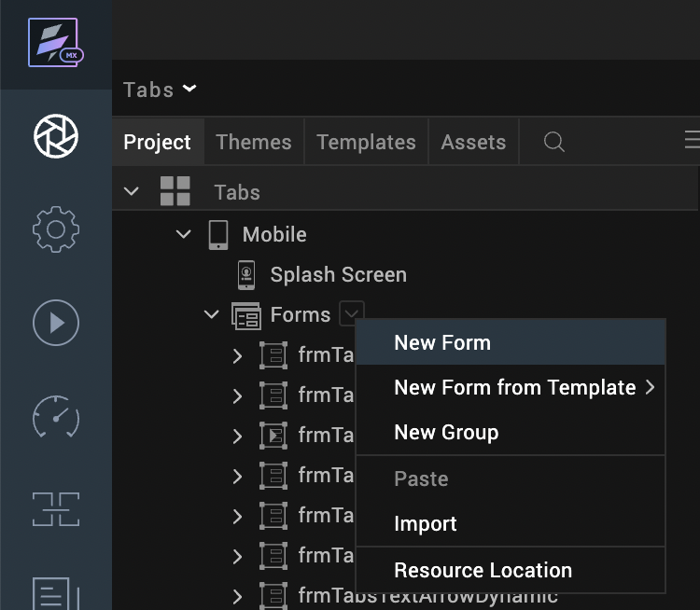
From the My Libraries tab, drag and drop the component onto the form.
From the Project explorer, go to the Templates tab.
The component that you want to add should be available in the Components section.
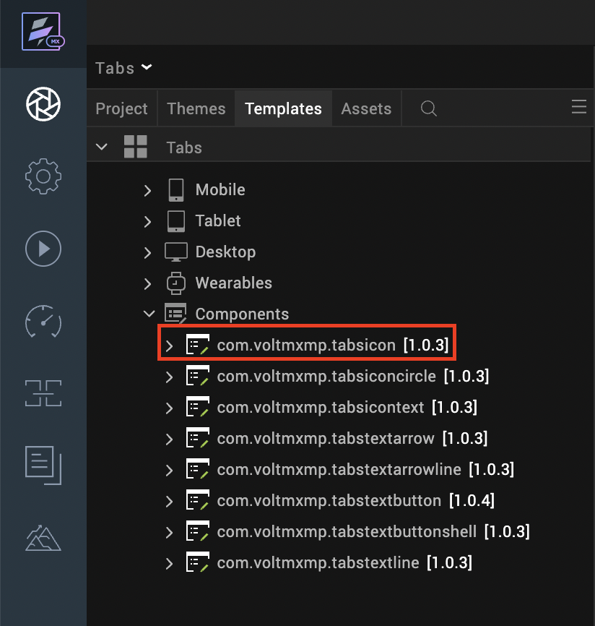

After you add the component into your project templates, follow the given steps to add the component to your app dynamically.
Access the FormController of the form you want to add the component into.
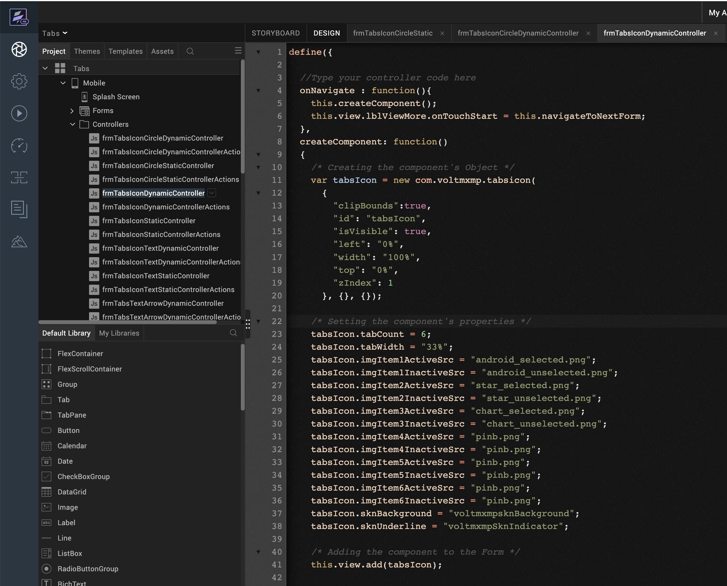
Create a function called createComponent(); and type a code inside the function to create and configure the component.
You can refer to the given sample code for more information.
/* Creating the component's Object */
var tabsIcon = new com.voltmxmp.tabsicon(
{
"clipBounds":true,
"id": "tabsIcon",
"isVisible": true,
"left": "0%",
"width": "100%",
"top": "0%",
"zIndex": 1
}, {}, {});

/* Setting the component's properties */
tabsIcon.tabCount = 6;
tabsIcon.tabWidth = "33%";
tabsIcon.imgItem1ActiveSrc = "android_selected.png";
tabsIcon.imgItem1InactiveSrc = "android_unselected.png";
tabsIcon.imgItem2ActiveSrc = "star_selected.png";
tabsIcon.imgItem2InactiveSrc = "star_unselected.png";
tabsIcon.imgItem3ActiveSrc = "chart_selected.png";
tabsIcon.imgItem3InactiveSrc = "chart_unselected.png";
tabsIcon.imgItem4ActiveSrc = "pinb.png";
tabsIcon.imgItem4InactiveSrc = "pinb.png";
tabsIcon.imgItem5ActiveSrc = "pinb.png";
tabsIcon.imgItem5InactiveSrc = "pinb.png";
tabsIcon.imgItem6ActiveSrc = "pinb.png";
tabsIcon.imgItem6InactiveSrc = "pinb.png";
tabsIcon.sknBackground = "voltmxmpsknBackground";
tabsIcon.sknUnderline = "voltmxmpSknIndicator";
/* Adding the component to the Form */
this.view.add(tabsIcon);

Properties
The properties provided on the Component tab allows you to customize the elements in the Tabs: Icon component. These elements can be UI elements, service parameters, and so on.
You can set the properties from the Volt MX Iris Properties panel on the right-hand side. You can also configure these properties using a JavaScript code.

General

No of Tabs
Description: | Specifies the number of tabs that you want to create at the run time.
Syntax: | tabCount
Type: | Integer
Read/Write: | Write
Default Value: | 3
Range of Values: | - Minimum Value: 1  - Maximum Value: 6
Remarks: | - Make sure that you specify a value that is within the range of values and is valid. Otherwise, the component throws an INVALID_TABCOUNT exception.  - You need to provide active and inactive images for all the tabs. Otherwise, the component throws an INVALID_IMAGE_FILE exception.
Example: | this.view.componentID.tabCount = 3;

Tab Width
Description: | Specifies the width of the tab in percentage.
Syntax: | tabWidth
Type: | String
Read/Write: | Write
Default Value: | 33%
Remarks: | Make sure that you append the value with %. Otherwise, the component throws an INVALID_TABWIDTH exception.
Example: | this.view.componentID.tabWidth = "33%";

Tab 1

Active Image:
Description: | Specifies the image that you want to use as the Active Image for the first tab.
Syntax: | imgItem1ActiveSrc
Type: | - Image  - String
Read/Write: | Read+Write
Example: | this.view.componentID.imgItem1ActiveSrc = "android_selected.png";
Inactive Image:
Description: | Specifies the name of image that you want to use as the Inactive Image for the first tab.
Syntax: | imgItem1InactiveSrc
Type: | String
Read/Write: | Write
Example: | this.view.componentID.imgItem1InactiveSrc = "android_unselected.png";

Tab 2

Active Image:
Description: | Specifies the image that you want to use as the Active Image for the second tab.
Syntax: | imgItem2ActiveSrc
Type: | - Image  - String
Read/Write: | Read+Write
Example: | this.view.componentID.imgItem2ActiveSrc = "star_selected.png";
Inactive Image:
Description: | Specifies the name of image that you want to use as the Inactive Image for the second tab.
Syntax: | imgItem2InactiveSrc
Type: | String
Read/Write: | Write
Example: | this.view.componentID.imgItem2InactiveSrc = "star_unselected.png";

Tab 3

Active Image:
Description: | Specifies the image that you want to use as the Active Image for the third tab.
Syntax: | imgItem3ActiveSrc
Type: | - Image  - String
Read/Write: | Read+Write
Example: | this.view.componentID.imgItem3ActiveSrc = "chart_selected.png";
Inactive Image:
Description: | Specifies the name of image that you want to use as the Inactive Image for the third tab.
Syntax: | imgItem3InactiveSrc
Type: | String
Read/Write: | Write
Example: | this.view.componentID.imgItem3InactiveSrc = "chart_unselected.png";

Tab 4

Active Image:
Description: | Specifies the image that you want to use as the Active Image for the fourth tab.
Syntax: | imgItem4ActiveSrc
Type: | - Image  - String
Read/Write: | Read+Write
Example: | this.view.componentID.imgItem4ActiveSrc = "pinb.png";
Inactive Image:
Description: | Specifies the name of image that you want to use as the Inactive Image for the fourth tab.
Syntax: | imgItem4InactiveSrc
Type: | String
Read/Write: | Write
Example: | this.view.componentID.imgItem4InactiveSrc = "pinb.png";

Tab 5

Active Image:
Description: | Specifies the image that you want to use as the Active Image for the fifth tab.
Syntax: | imgItem5ActiveSrc
Type: | - Image  - String
Read/Write: | Read+Write
Example: | this.view.componentID.imgItem5ActiveSrc = "pinb.png";
Inactive Image:
Description: | Specifies the name of image that you want to use as the Inactive Image for the fifth tab.
Syntax: | imgItem5InactiveSrc
Type: | String
Read/Write: | Write
Example: | this.view.componentID.imgItem5InactiveSrc = "pinb.png";

Tab 6

Active Image:
Description: | Specifies the image that you want to use as the Active Image for the sixth tab.
Syntax: | imgItem6ActiveSrc
Type: | - Image  - String
Read/Write: | Read+Write
Example: | this.view.componentID.imgItem6ActiveSrc = "pinb.png";
Inactive Image:
Description: | Specifies the name of image that you want to use as the Inactive Image for the sixth tab.
Syntax: | imgItem6InactiveSrc
Type: | String
Read/Write: | Write
Example: | this.view.componentID.imgItem6InactiveSrc = "pinb.png";

Skins:

Background
Description: | This skin links to the background of the tabs.
Syntax: | sknBackground
Widget Type: | FlexContainer
Example: | this.view.componentID.sknBackground = "voltmxmpsknBackground";

Underline
Description: | This skin links to the underline of the selected tab.
Syntax: | sknUnderline
Widget Type: | FlexContainer
Example: | this.view.componentID.sknUnderline = "voltmxmpSknIndicator";

Events
The component invokes events when its corresponding action is performed. You can configure any logic you want the component to perform whenever an event occurs. You can configure the events directly on the Actions tab or by writing a JavaScript, For more information, refer to Add Actions in the Iris User Guide.

onTabChange
Description: | Invoked when the user clicks or taps a tab.
Syntax: | onTabChange
Parameters: | dataObject [JSON] :  Information about the selected tab.  Contains the following keys:  - tabIndex [Integer] : The index of the selected tab  - activeImage [String] : The name of the active image of the selected tab  - inactiveImage [String] : The name of the inactive image of the selected tab
Example: | this.view.tabsIcon.onTabChange = function(dataObject)  {  alert("Tab Selected: " + JSON.stringify(dataObject));  };
Sample JSON: | {  "activeImage" : "chart_selected.png",  "inactiveImage" : "chart_unselected.png",  "tabIndex": 2  };

APIs
The following APIs pertain to the Tabs: Icon component.

goToTab
Description: | Switches to the specified tab.
Syntax: | goToTab(tabIndex)
Parameters: | tabIndex [Integer] :  The index of the tab that you want to switch to.
Return Value: | None
Example: | var tabIndex = 2;  this.view.componentID.goToTab(tabIndex);

getSelectedTabIndex
Description: | Fetches the index of the tab that is currently selected.
Syntax: | getSelectedTabIndex()
Parameters: | None
Return Value: | tabIndex [Number] :  The index of the tab that is currently selected.
Example: | var tabIndex = this.view.componentID.getSelectedTabIndex();  alert("Current tab: " + tabIndex);

3. moveLeft
Description: | Switches to the tab that is on the left of the tab that is currently selected.
Syntax: | moveLeft()
Parameters: | None
Return Value: | None
Example: | this.view.componentID.moveLeft();

4. moveRight
Description: | Switches to the tab that is on the right of the tab that is currently selected.
Syntax: | moveRight()
Parameters: | None
Return Value: | None
Example: | this.view.componentID.moveRight();

5. getSelectedTabDetails
Description: | Fetches the details of the tab that is currently selected.
Syntax: | getSelectedTabDetails()
Parameters: | None
Return Value: | Contains the following keys:  - tabIndex [Integer] : The index of the selected tab  - activeImage [String] : The name of the active image of the selected tab  - inactiveImage [String] : The name of the inactive image of the selected tab
Example: | var tabObject = this.view.componentID.getSelectedTabDetails();  alert("Current tab details: " + JSON.stringify(tabObject));
Sample JSON: | {  "activeImage" : "chart_selected.png",  "inactiveImage" : "chart_unselected.png",  "tabIndex": 2  };

6. createTabs
Description: | Creates tabs based on the specified data.
Syntax: | createTabs(tabData)
Parameters: | tabData [Array of JSON] :  The data about the tabs that you want to create.  Contains the following keys:  - activeImage [String] : The name of the image that you want to use as the active image of the tab.  - inactiveImage [String] : The name of the image that you want to use as the inactive image of the tab.
Return Value: | None
Remarks: | - Make sure that you add the Tabs component to a form before you use the createTabs API.  - If the tabData parameter is empty, the API creates tabs by using the values of the component properties.
Example: | var tabData =  [  {  "activeImage" : "chart_selected.png",  "inactiveImage" : "chart_unselected.png"  },  {  "activeImage" : "star_selected.png",  "inactiveImage" : "star_unselected.png"  },  {  "activeImage" : "android_selected.png",  "inactiveImage" : "android_unselected.png"  }  ];  this.view.componentID.createTabs(tabData);

Tabs: Icon with focus-circle THEME
The Tabs: Icon with focus-Circle theme displays an icon on every tab and displays a circle around the icon of the tab that is currently selected (active). The component also displays an underline on the selected tab. When a tab is selected, the component displays the active icon of the tab, and when a tab is not selected, the component displays the inactive icon of the tab.
Note:
- If you change any property at run time, or add the component dynamically, call the createTabs API using Actions to create and display the tabs.
- If you copy the code from any example, make sure that you replace componentID with the name of your component.

Dynamic Usage:
If you want to use a component dynamically, you need to add the component to your project Templates. Follow the given steps to do so.
From the Project explorer, expand Mobile and Tablet.
Right-click forms and select New Form
From the My Libraries tab, drag and drop the component onto the form.
From the Project explorer, go to the Templates tab.
The component that you want to add should be available in the Components section.
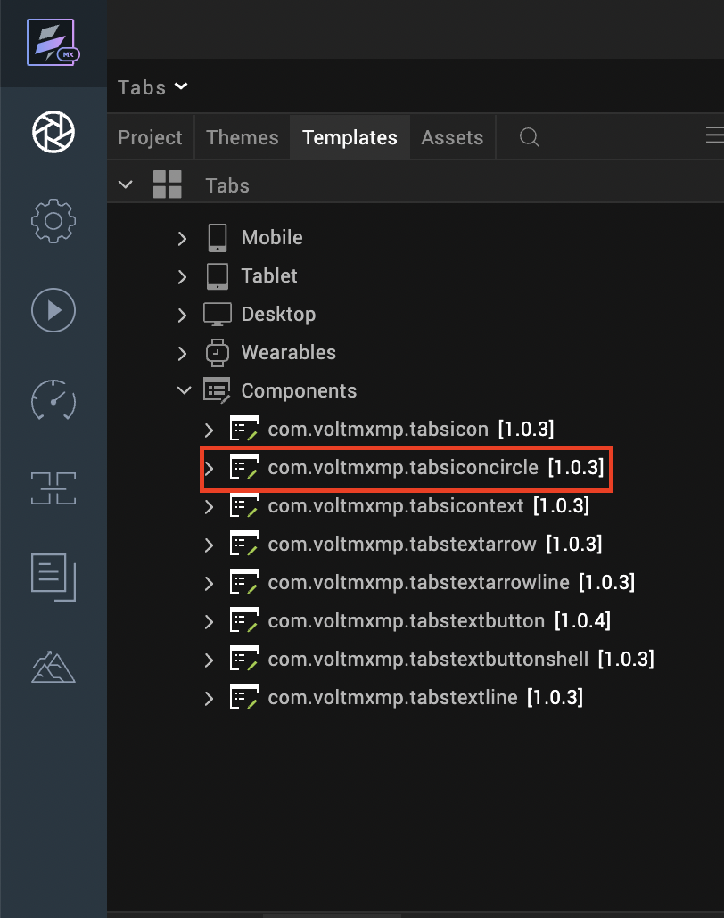

After you add the component into your project templates, follow the given steps to add the component to your app dynamically.
Access the FormController of the form you want to add the component into.
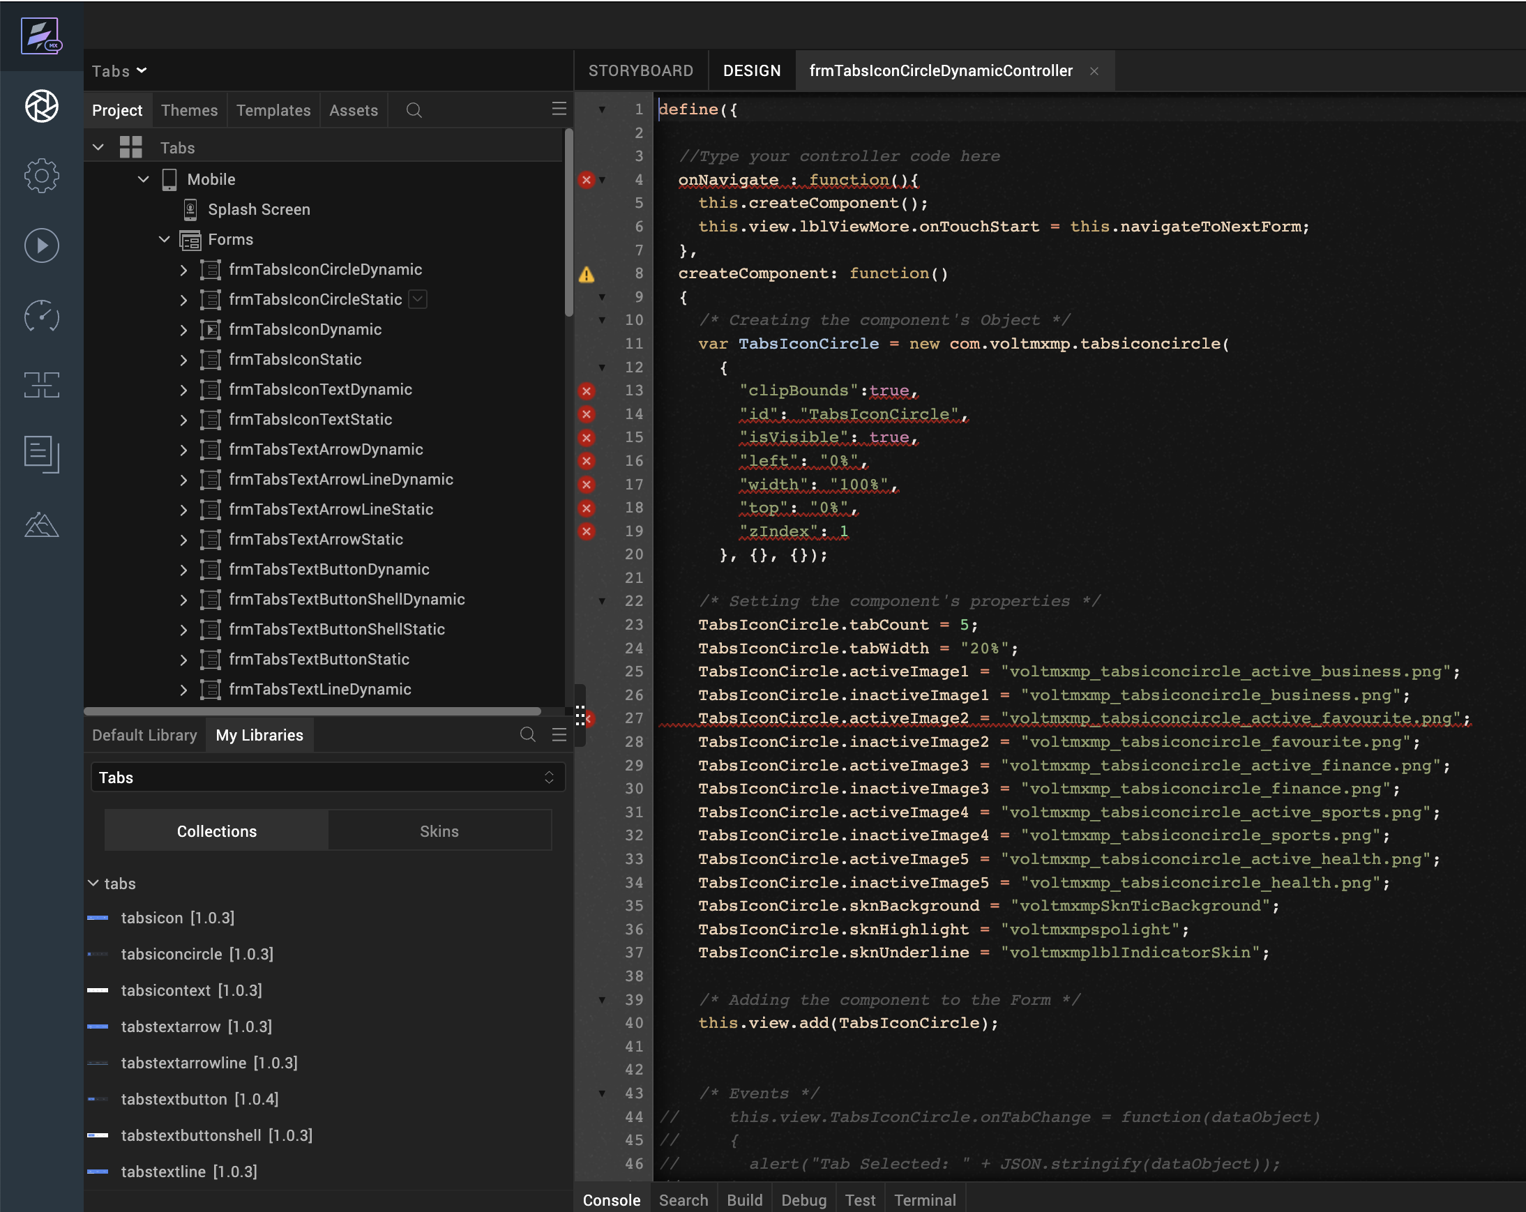
Create a function called createComponent(); and type a code inside the function to create and configure the component.
You can refer to the given sample code for more information.
/* Creating the component's Object */
var TabsIconCircle = new com.voltmxmp.tabsiconcircle(
{
"clipBounds":true,
"id": "TabsIconCircle",
"isVisible": true,
"left": "0%",
"width": "100%",
"top": "0%",
"zIndex": 1
}, {}, {});

/* Setting the component's properties */
TabsIconCircle.tabCount = 5;
TabsIconCircle.tabWidth = "20%";
TabsIconCircle.activeImage1 = "voltmxmp_tabsiconcircle_active_business.png";
TabsIconCircle.inactiveImage1 = "voltmxmp_tabsiconcircle_business.png";
TabsIconCircle.activeImage2 = "voltmxmp_tabsiconcircle_active_favourite.png";
TabsIconCircle.inactiveImage2 = "voltmxmp_tabsiconcircle_favourite.png";
TabsIconCircle.activeImage3 = "voltmxmp_tabsiconcircle_active_finance.png";
TabsIconCircle.inactiveImage3 = "voltmxmp_tabsiconcircle_finance.png";
TabsIconCircle.activeImage4 = "voltmxmp_tabsiconcircle_active_sports.png";
TabsIconCircle.inactiveImage4 = "voltmxmp_tabsiconcircle_sports.png";
TabsIconCircle.activeImage5 = "voltmxmp_tabsiconcircle_active_health.png";
TabsIconCircle.inactiveImage5 = "voltmxmp_tabsiconcircle_health.png";
TabsIconCircle.sknBackground = "voltmxmpSknTicBackground";
TabsIconCircle.sknHighlight = "voltmxmpspolight";
TabsIconCircle.sknUnderline = "voltmxmplblIndicatorSkin";

/* Adding the component to the Form */
this.view.add(TabsIconCircle);

Properties
The properties provided on the Component tab allows you to customize the elements in the Tabs: Icon with focus-Circle component. These elements can be UI elements, service parameters, and so on.
You can set the properties from the Volt MX Iris Properties panel on the right-hand side. You can also configure these properties using a JavaScript code.

General

No of Tabs
Description: | Specifies the number of tabs that you want to create at the run time.
Syntax: | tabCount
Type: | Integer
Read/Write: | Write
Default Value: | 5
Range of Values: | - Minimum Value: 1  - Maximum Value: 6
Remarks: | - Make sure that you specify a value that is within the range of values and is valid. Otherwise, the component throws an INVALID_TABCOUNT exception.  - You need to provide active and inactive images for all the tabs. Otherwise, the component throws an INVALID_IMAGE_FILE exception.
Example: | this.view.componentID.tabCount = 5;

Width of Tab
Description: | Specifies the width of the tab in percentage.
Syntax: | tabWidth
Type: | String
Read/Write: | Write
Default Value: | 20%
Remarks: | Make sure that you append the value with %. Otherwise, the component throws an INVALID_TABWIDTH exception.
Example: | this.view.componentID.tabWidth = "20%";

Tab 1

Active Image:
Description: | Specifies the image that you want to use as the Active Image for the first tab.
Syntax: | activeImage1
Type: | String
Read/Write: | Read+Write
Example: | this.view.componentID.activeImage1 = "voltmxmp_tabsiconcircle_active_business.png";
Inactive Image:
Description: | Specifies the name of image that you want to use as the Inactive Image for the first tab.
Syntax: | inactiveImage1
Type: | String
Read/Write: | Write
Example: | this.view.componentID.inactiveImage1 = "voltmxmp_tabsiconcircle_business.png";

Tab 2

Active Image:
Description: | Specifies the image that you want to use as the Active Image for the second tab.
Syntax: | activeImage2
Type: | - Image  - String
Read/Write: | Read+Write
Example: | this.view.componentID.activeImage2 = "voltmxmp_tabsiconcircle_active_favourite.png";
Inactive Image:
Description: | Specifies the name of image that you want to use as the Inactive Image for the second tab.
Syntax: | inactiveImage2
Type: | String
Read/Write: | Write
Example: | this.view.componentID.inactiveImage2 = "voltmxmp_tabsiconcircle_favourite.png";

Tab 3

Active Image:
Description: | Specifies the image that you want to use as the Active Image for the third tab.
Syntax: | activeImage3
Type: | - Image  - String
Read/Write: | Read+Write
Example: | this.view.componentID.activeImage3 = "voltmxmp_tabsiconcircle_active_finance.png";
Inactive Image:
Description: | Specifies the name of image that you want to use as the Inactive Image for the third tab.
Syntax: | inactiveImage3
Type: | String
Read/Write: | Write
Example: | this.view.componentID.inactiveImage3 = "voltmxmp_tabsiconcircle_finance.png";

Tab 4

Active Image:
Description: | Specifies the image that you want to use as the Active Image for the fourth tab.
Syntax: | activeImage4
Type: | - Image  - String
Read/Write: | Read+Write
Example: | this.view.componentID.activeImage4 = "voltmxmp_tabsiconcircle_active_sports.png";
Inactive Image:
Description: | Specifies the name of image that you want to use as the Inactive Image for the fourth tab.
Syntax: | inactiveImage4
Type: | String
Read/Write: | Write
Example: | this.view.componentID.inactiveImage4 = "voltmxmp_tabsiconcircle_sports.png";

Tab 5

Active Image:
Description: | Specifies the image that you want to use as the Active Image for the fifth tab.
Syntax: | activeImage5
Type: | - Image  - String
Read/Write: | Read+Write
Example: | this.view.componentID.activeImage5 = "voltmxmp_tabsiconcircle_active_health.png";
Inactive Image:
Description: | Specifies the name of image that you want to use as the Inactive Image for the fifth tab.
Syntax: | inactiveImage5
Type: | String
Read/Write: | Write
Example: | this.view.componentID.inactiveImage5 = "voltmxmp_tabsiconcircle_health.png";

Tab 6

Active Image:
Description: | Specifies the image that you want to use as the Active Image for the sixth tab.
Syntax: | activeImage6
Type: | - Image  - String
Read/Write: | Read+Write
Example: | this.view.componentID.activeImage6 = "pinb.png";
Inactive Image:
Description: | Specifies the name of image that you want to use as the Inactive Image for the sixth tab.
Syntax: | inactiveImage6
Type: | String
Read/Write: | Write
Example: | this.view.componentID.inactiveImage6 = "pinb.png";

Skins:

Tab Background
Description: | This skin links to the background of the tabs.
Syntax: | sknBackground
Widget Type: | FlexContainer
Example: | this.view.componentID.sknBackground = "voltmxmpSknTicBackground";

Tab Highlight
Description: | This skin links to the circle that highlights the active tab.
Syntax: | sknHighlight
Widget Type: | FlexContainer
Example: | this.view.componentID.sknHighlight = "voltmxmpspolight";

Underline
Description: | This skin links to the underline of the selected tab.
Syntax: | sknUnderline
Widget Type: | Label
Example: | this.view.componentID.sknUnderline = "voltmxmplblIndicatorSkin";

Events
The component invokes events when its corresponding action is performed. You can configure any logic you want the component to perform whenever an event occurs. You can configure the events directly on the Actions tab or by writing a JavaScript, For more information, refer to Add Actions in the Iris User Guide.

onTabChange
Description: | Invoked when the user clicks or taps a tab.
Syntax: | onTabChange
Parameters: | eventObject [JSON] :  Information about the selected tab.  Contains the following keys:  - tabIndex [Integer] : The index of the selected tab  - activeImage [String] : The name of the active image of the selected tab  - inactiveImage [String] : The name of the inactive image of the selected tab
Example: | this.view.componentID.onTabChange = function(eventObject)  {  alert("Tab Selected: " + JSON.stringify(eventObject));  }
Sample JSON: | {  "activeImage" : "voltmxmp_tabsiconcircle_active_business.png",  "inactiveImage" : "voltmxmp_tabsiconcircle_business.png",  "tabIndex": 0  };

APIs
The following APIs pertain to the Tabs: Icon with focus-Circle component.

goToTab
Description: | Switches to the specified tab.
Syntax: | goToTab(tabIndex)
Parameters: | tabIndex [Integer] :  The index of the tab that you want to switch to.
Return Value: | None
Example: | var tabIndex = 2;  this.view.componentID.goToTab(tabIndex);

getSelectedTabIndex
Description: | Fetches the index of the tab that is currently selected.
Syntax: | getSelectedTabIndex()
Parameters: | None
Return Value: | tabIndex [Number] :  The index of the tab that is currently selected.
Example: | var tabIndex = this.view.componentID.getSelectedTabIndex();  alert("Current tab: " + tabIndex);

3. moveLeft
Description: | Switches to the tab that is on the left of the tab that is currently selected.
Syntax: | moveLeft()
Parameters: | None
Return Value: | None
Example: | this.view.componentID.moveLeft();

4. moveRight
Description: | Switches to the tab that is on the right of the tab that is currently selected.
Syntax: | moveRight()
Parameters: | None
Return Value: | None
Example: | this.view.componentID.moveRight();

5. getSelectedTabDetails
Description: | Fetches the details of the tab that is currently selected.
Syntax: | getSelectedTabDetails()
Parameters: | None
Return Value: | tabObject [JSON] :  The details of the tab that is currently selected.  Contains the following keys:  - tabIndex [Integer] : The index of the selected tab  - activeImage [String] : The name of the active image of the selected tab  - inactiveImage [String] : The name of the inactive image of the selected tab
Example: | var tabObject = this.view.componentID.getSelectedTabDetails();  alert("Current tab details: " + JSON.stringify(tabObject));
Sample JSON: | {  "activeImage" : "voltmxmp_tabsiconcircle_active_business.png",  "inactiveImage" : "voltmxmp_tabsiconcircle_business.png",  "tabIndex": 0  };

6. createTabs
Description: | Creates tabs based on the specified data.
Syntax: | createTabs(tabData)
Parameters: | imageObject [Array of JSON] :  The data about the tabs that you want to create.  Contains the following keys:  - activeImage [String] : The name of the image that you want to use as the active image of the tab.  - inactiveImage [String] : The name of the image that you want to use as the inactive image of the tab.
Return Value: | None
Remarks: | - Make sure that you add the Tabs component to a form before you use the createTabs API.  - If the imageObject parameter is empty, the API creates tabs by using the values of the component properties.
Example: | var imageObject =  [  {  "activeImage" : "voltmxmp_tabsiconcircle_active_business.png",  "inactiveImage" : "voltmxmp_tabsiconcircle_business.png"  },  {  "activeImage" : "voltmxmp_tabsiconcircle_active_favourite.png",  "inactiveImage" : "voltmxmp_tabsiconcircle_favourite.png"  },  {  "activeImage" : "voltmxmp_tabsiconcircle_active_finance.png",  "inactiveImage" : "voltmxmp_tabsiconcircle_finance.png"  }  ];  this.view.componentID.createTabs(imageObject);

tabs: Icon With Text Theme
The Tabs: Icon with Text theme displays an icon and a title on every tab and highlights the title of the tab that is currently selected (active). When a tab is selected, the component displays the active icon of the tab, and when a tab is not selected, the component displays the inactive icon of the tab.
Note:
- If you change any property at run time, or add the component dynamically, call the createTabs API using Actions to create and display the tabs.
- If you copy the code from any example, make sure that you replace componentID with the name of your component.

Dynamic Usage:
If you want to use a component dynamically, you need to add the component to your project Templates. Follow the given steps to do so.
From the Project explorer, expand Mobile and Tablet.
Right-click forms and select New Form
From the My Libraries tab, drag and drop the component onto the form.
From the Project explorer, go to the Templates tab.
The component that you want to add should be available in the Components section.
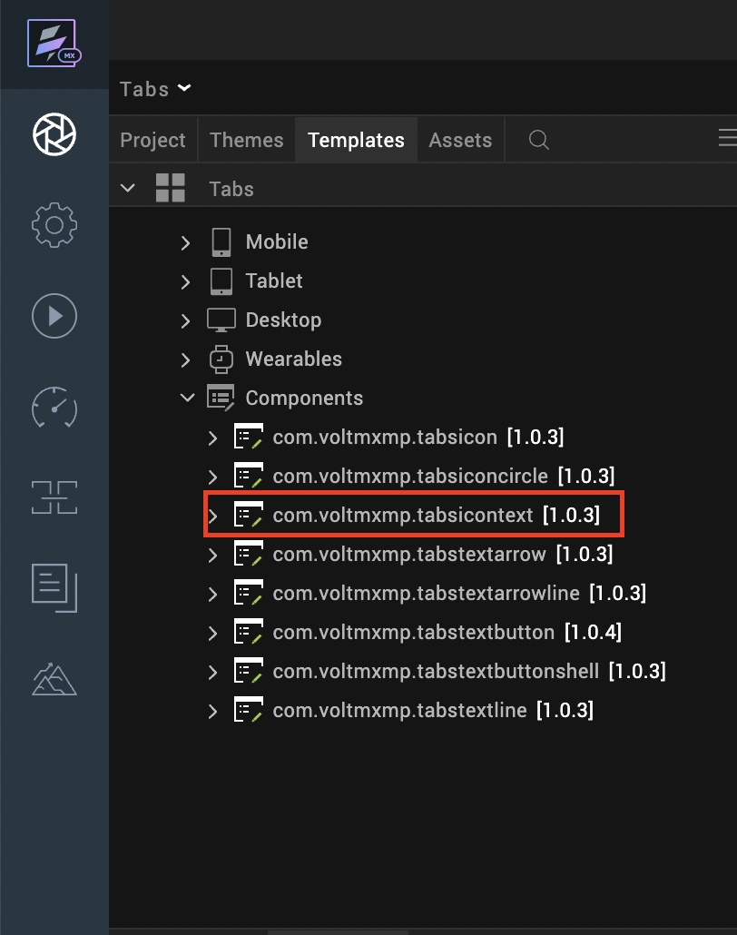

After you add the component into your project templates, follow the given steps to add the component to your app dynamically.
Access the FormController of the form you want to add the component into.
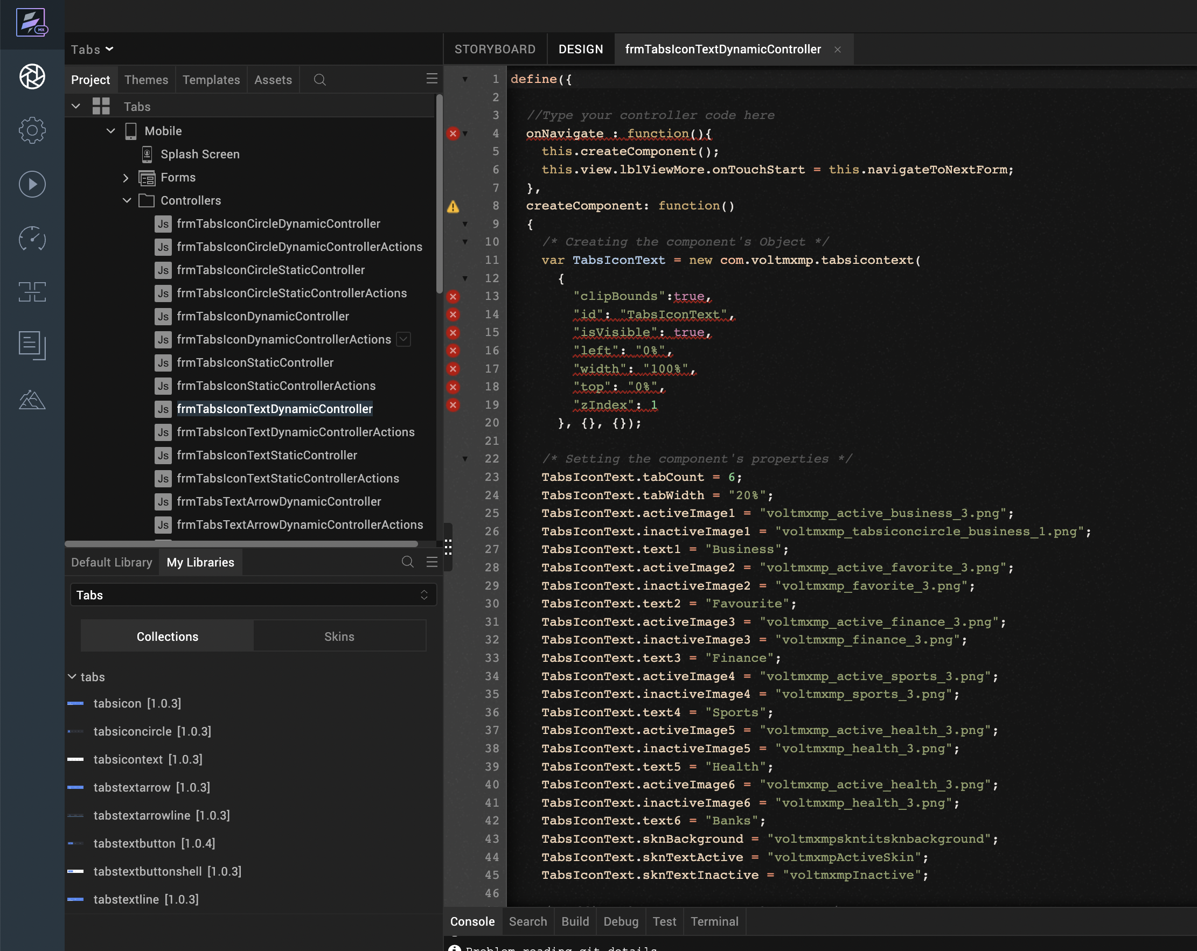
Create a function called createComponent(); and type a code inside the function to create and configure the component.
You can refer to the given sample code for more information.
/* Creating the component's Object */
var TabsIconText = new com.voltmxmp.tabsicontext(
{
"clipBounds":true,
"id": "TabsIconText",
"isVisible": true,
"left": "0%",
"width": "100%",
"top": "0%",
"zIndex": 1
}, {}, {});
/* Setting the component's properties */
TabsIconText.tabCount = 6;
TabsIconText.tabWidth = "20%";
TabsIconText.activeImage1 = "voltmxmp_active_business_3.png";
TabsIconText.inactiveImage1 = "voltmxmp_tabsiconcircle_business_1.png";
TabsIconText.text1 = "Business";
TabsIconText.activeImage2 = "voltmxmp_active_favorite_3.png";
TabsIconText.inactiveImage2 = "voltmxmp_favorite_3.png";
TabsIconText.text2 = "Favourite";
TabsIconText.activeImage3 = "voltmxmp_active_finance_3.png";
TabsIconText.inactiveImage3 = "voltmxmp_finance_3.png";
TabsIconText.text3 = "Finance";
TabsIconText.activeImage4 = "voltmxmp_active_sports_3.png";
TabsIconText.inactiveImage4 = "voltmxmp_sports_3.png";
TabsIconText.text4 = "Sports";
TabsIconText.activeImage5 = "voltmxmp_active_health_3.png";
TabsIconText.inactiveImage5 = "voltmxmp_health_3.png";
TabsIconText.text5 = "Health";
TabsIconText.activeImage6 = "voltmxmp_active_health_3.png";
TabsIconText.inactiveImage6 = "voltmxmp_health_3.png";
TabsIconText.text6 = "Banks";
TabsIconText.sknBackground = "voltmxmpskntitsknbackground";
TabsIconText.sknTextActive = "voltmxmpActiveSkin";
TabsIconText.sknTextInactive = "voltmxmpInactive";
/* Adding the component to the Form */
this.view.add(TabsIconText);

Properties
The properties provided on the Component tab allows you to customize the elements in the Tabs: Icon with Text component. These elements can be UI elements, service parameters, and so on.
You can set the properties from the Volt MX Iris Properties panel on the right-hand side. You can also configure these properties using a JavaScript code.

General

No of Tabs
Description: | Specifies the number of tabs that you want to create at the run time.
Syntax: | tabCount
Type: | Integer
Read/Write: | Write
Default Value: | 5
Range of Values: | - Minimum Value: 1  - Maximum Value: 6
Remarks: | - Make sure that you specify a value that is within the range of values and is valid. Otherwise, the component throws an INVALID_TABCOUNT exception.  - You need to provide active and inactive images for all the tabs. Otherwise, the component throws an INVALID_IMAGE_FILE exception.  - You need to provide titles for all the tabs. Otherwise, the component throws an INVALID_TAB_TITLE exception.
Example: | this.view.componentID.tabCount = 5;

Width of Tab
Description: | Specifies the width of the tab in percentage.
Syntax: | tabWidth
Type: | String
Read/Write: | Write
Default Value: | 20%
Remarks: | Make sure that you append the value with %. Otherwise, the component throws an INVALID_TABWIDTH exception.
Example: | this.view.componentID.tabWidth = "20%";

Tab 1

Active Image:
Description: | Specifies the image that you want to use as the Active Image for the first tab.
Syntax: | activeImage1
Type: | String
Read/Write: | Read+Write
Example: | this.view.componentID.activeImage1 = "voltmxmp_active_business_3.png";
Inactive Image:
Description: | Specifies the name of image that you want to use as the Inactive Image for the first tab.
Syntax: | inactiveImage1
Type: | String
Read/Write: | Write
Example: | this.view.componentID.inactiveImage1 = "voltmxmp_tabsiconcircle_business_1.png";
Text:
Description: | Specifies the text that you want to display as the title of the first tab.
Syntax: | text1
Type: | String
Read/Write: | Write
Example: | this.view.componentID.text1 = "Business";

Tab 2

Active Image:
Description: | Specifies the image that you want to use as the Active Image for the second tab.
Syntax: | activeImage2
Type: | - Image  - String
Read/Write: | Read+Write
Example: | this.view.componentID.activeImage2 = "voltmxmp_active_favorite_3.png";
Inactive Image:
Description: | Specifies the name of image that you want to use as the Inactive Image for the second tab.
Syntax: | inactiveImage2
Type: | String
Read/Write: | Write
Example: | this.view.componentID.inactiveImage2 = "voltmxmp_favorite_3.png";
Text:
Description: | Specifies the text that you want to display as the title of the Second tab.
Syntax: | text2
Type: | String
Read/Write: | Write
Example: | this.view.componentID.text2 = " Favourite";

Tab 3

Active Image:
Description: | Specifies the image that you want to use as the Active Image for the third tab.
Syntax: | activeImage3
Type: | - Image  - String
Read/Write: | Read+Write
Example: | this.view.componentID.activeImage3 = "voltmxmp_active_finance_3.png";
Inactive Image:
Description: | Specifies the name of image that you want to use as the Inactive Image for the third tab.
Syntax: | inactiveImage3
Type: | String
Read/Write: | Write
Example: | this.view.componentID.inactiveImage3 = "voltmxmp_finance_3.png";
Text:
Description: | Specifies the text that you want to display as the title of the third tab.
Syntax: | Text3
Type: | String
Read/Write: | Write
Example: | this.view.componentID.text3 = "Finance";

Tab 4

Active Image:
Description: | Specifies the image that you want to use as the Active Image for the fourth tab.
Syntax: | activeImage4
Type: | - Image  - String
Read/Write: | Read+Write
Example: | this.view.componentID.activeImage4 = "voltmxmp_active_sports_3.png";
Inactive Image:
Description: | Specifies the name of image that you want to use as the Inactive Image for the fourth tab.
Syntax: | inactiveImage4
Type: | String
Read/Write: | Write
Example: | this.view.componentID.inactiveImage4 = "voltmxmp_sports_3.png";
Text:
Description: | Specifies the text that you want to display as the title of the fourth tab.
Syntax: | text4
Type: | String
Read/Write: | Write
Example: | this.view.componentID.text4 = "Sports";

Tab 5

Active Image:
Description: | Specifies the image that you want to use as the Active Image for the fifth tab.
Syntax: | activeImage5
Type: | - Image  - String
Read/Write: | Read+Write
Example: | this.view.componentID.activeImage5 = "voltmxmp_active_health_3.png";
Inactive Image:
Description: | Specifies the name of image that you want to use as the Inactive Image for the fifth tab.
Syntax: | inactiveImage5
Type: | String
Read/Write: | Write
Example: | this.view.componentID.inactiveImage5 = "voltmxmp_health_3.png";
Text:
Description: | Specifies the text that you want to display as the title of the fifth tab.
Syntax: | text5
Type: | String
Read/Write: | Write
Example: | this.view.componentID.text5 = "Health";

Tab 6

Active Image:
Description: | Specifies the image that you want to use as the Active Image for the sixth tab.
Syntax: | activeImage6
Type: | - Image  - String
Read/Write: | Read+Write
Example: | this.view.componentID.activeImage6 = "pinb.png";
Inactive Image:
Description: | Specifies the name of image that you want to use as the Inactive Image for the sixth tab.
Syntax: | inactiveImage6
Type: | String
Read/Write: | Write
Example: | this.view.componentID.inactiveImage6 = "pinb.png";
Text:
Description: | Specifies the text that you want to display as the title of the first tab.
Syntax: | text6
Type: | String
Read/Write: | Write
Example: | this.view.componentID.text6 = "Banks";

Skins:

Tab Background
Description: | This skin links to the background of the tabs.
Syntax: | sknBackground
Widget Type: | FlexContainer
Example: | this.view.componentID.sknBackground = "voltmxmpskntitsknbackground";

Tab Text Active
Description: | This skin links to the title of the tab when it is selected (active).
Syntax: | sknTextActive
Widget Type: | Label
Example: | this.view.componentID.sknTextActive = "voltmxmpActiveSkin";

Tab Text Inactive
Description: | This skin links to the title of the tab when it is not selected (inactive).
Syntax: | sknTextInactive
Widget Type: | Label
Example: | this.view.componentID.sknTextInactive = "voltmxmpInactive";

Events
The component invokes events when its corresponding action is performed. You can configure any logic you want the component to perform whenever an event occurs. You can configure the events directly on the Actions tab or by writing a JavaScript, For more information, refer to Add Actions in the Iris User Guide.

onTabChange
Description: | Invoked when the user clicks or taps a tab.
Syntax: | onTabChange
Parameters: | eventObject [JSON] :  Information about the selected tab.  Contains the following keys:  - tabIndex [Integer] : The index of the selected tab  - text [String] : The title of the selected tab.  - activeImage [String] : The name of the active image of the selected tab  - inactiveImage [String] : The name of the inactive image of the selected tab
Example: | this.view.componentID.onTabChange = function(eventObject)  {  alert("Tab Selected: " + JSON.stringify(eventObject));  }
Sample JSON: | {  "activeImage" :"voltmxmp_active_business_3.png"; "inactiveImage" : "voltmxmp_tabsiconcircle_business_1.png";  "text" : "Business",  "tabIndex": 0  };

APIs
The following APIs pertain to the Tabs: Icon with Text component.

goToTab
Description: | Switches to the specified tab.
Syntax: | goToTab(tabIndex)
Parameters: | tabIndex [Integer] :  The index of the tab that you want to switch to.
Return Value: | None
Example: | var tabIndex = 2;  this.view.componentID.goToTab(tabIndex);

getSelectedTabIndex
Description: | Fetches the index of the tab that is currently selected.
Syntax: | getSelectedTabIndex()
Parameters: | None
Return Value: | tabIndex [Number] :  The index of the tab that is currently selected.
Example: | var tabIndex = this.view.componentID.getSelectedTabIndex();  alert("Current tab: " + tabIndex);

3. moveLeft
Description: | Switches to the tab that is on the left of the tab that is currently selected.
Syntax: | moveLeft()
Parameters: | None
Return Value: | None
Example: | this.view.componentID.moveLeft();

4. moveRight
Description: | Switches to the tab that is on the right of the tab that is currently selected.
Syntax: | moveRight()
Parameters: | None
Return Value: | None
Example: | this.view.componentID.moveRight();

5. getSelectedTabDetails
Description: | Fetches the details of the tab that is currently selected.
Syntax: | getSelectedTabDetails()
Parameters: | None
Return Value: | tabObject [JSON] :  The details of the tab that is currently selected.  Contains the following keys:  - tabIndex [Integer] : The index of the selected tab  - text [String] : The title of the selected tab  - activeImage [String] : The name of the active image of the selected tab  - inactiveImage [String] : The name of the inactive image of the selected tab
Example: | var tabObject = this.view.componentID.getSelectedTabDetails();  alert("Current tab details: " + JSON.stringify(tabObject));
Sample JSON: | {  "activeImage" :"voltmxmp_active_business_3.png"; "inactiveImage" : "voltmxmp_tabsiconcircle_business_1.png";  "text" : "Business",  "tabIndex": 0  };

6. createTabs
Description: | Creates tabs based on the specified data.
Syntax: | createTabs(tabData)
Parameters: | tabData [Array of JSON] :  The data about the tabs that you want to create.  Contains the following keys:  - activeImage [String] : The name of the image that you want to use as the active image of the tab.  - inactiveImage [String] : The name of the image that you want to use as the inactive image of the tab.  - text [String] : The text that you want to use as the title of the tab
Return Value: | None
Remarks: | - Make sure that you add the Tabs component to a form before you use the createTabs API.  - If the tabData parameter is empty, the API creates tabs by using the values of the component properties.
Example: | var tabData =  [  {  "activeImage" : "voltmxmp_active_business_3.png",  "inactiveImage" : "voltmxmp_tabsiconcircle_business_1.png",  "text" : "Business"  },  {  "activeImage" : "voltmxmp_active_favorite_3.png",  "inactiveImage" : "voltmxmp_favorite_3.png",  "text" : "Favorite"  },  {  "activeImage" : "voltmxmp_active_finance_3.png",  "inactiveImage" : "voltmxmp_finance_3.png",  "text" : "Finance"  }  ];  this.view.componentID.createTabs(tabData);

Tabs: text with Focus - arrow THEME
The Tabs: Text with focus-Arrow theme displays a title on every tab and also displays an arrow on the tab that is currently selected (active). When a tab is selected, the component highlights the title of the tab.
Note:
- If you change any property at run time, or add the component dynamically, call the createTabs API using Actions to create and display the tabs.
- If you copy the code from any example, make sure that you replace componentID with the name of your component.

Dynamic Usage:
If you want to use a component dynamically, you need to add the component to your project Templates. Follow the given steps to do so.
From the Project explorer, expand Mobile and Tablet.
Right-click forms and select New Form
From the My Libraries tab, drag and drop the component onto the form.
From the Project explorer, go to the Templates tab.
The component that you want to add should be available in the Components section.
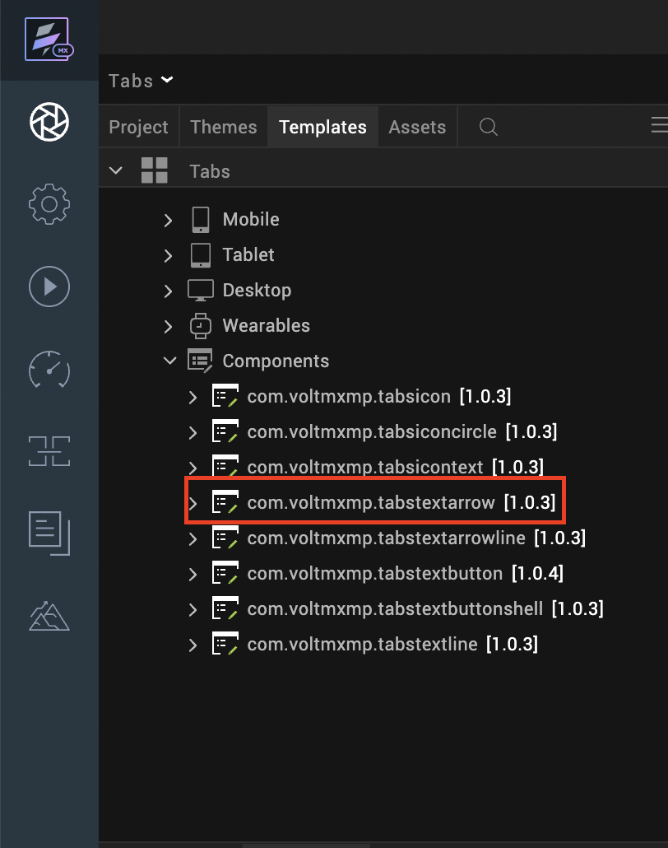

After you add the component into your project templates, follow the given steps to add the component to your app dynamically.
Access the FormController of the form you want to add the component into.
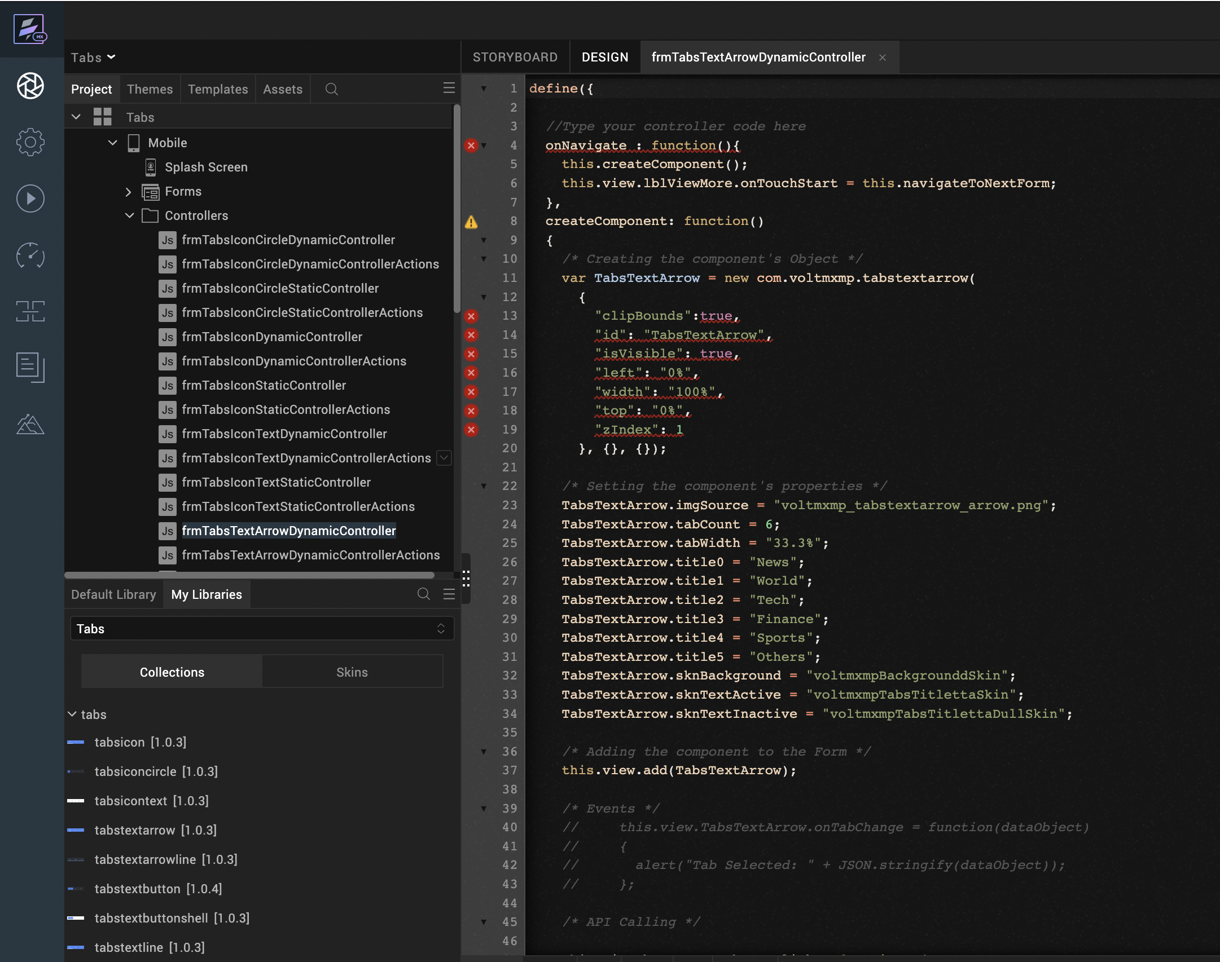
Create a function called createComponent(); and type a code inside the function to create and configure the component.
You can refer to the given sample code for more information.
/* Creating the component's Object */
var TabsTextArrow = new com.voltmxmp.tabstextarrow(
{
"clipBounds":true,
"id": "TabsTextArrow",
"isVisible": true,
"left": "0%",
"width": "100%",
"top": "0%",
"zIndex": 1
}, {}, {});

/* Setting the component's properties */
TabsTextArrow.imgSource = "voltmxmp_tabstextarrow_arrow.png";
TabsTextArrow.tabCount = 6;
TabsTextArrow.tabWidth = "33.3%";
TabsTextArrow.title0 = "News";
TabsTextArrow.title1 = "World";
TabsTextArrow.title2 = "Tech";
TabsTextArrow.title3 = "Finance";
TabsTextArrow.title4 = "Sports";
TabsTextArrow.title5 = "Others";
TabsTextArrow.sknBackground = "voltmxmpBackgrounddSkin";
TabsTextArrow.sknTextActive = "voltmxmpTabsTitlettaSkin";
TabsTextArrow.sknTextInactive = "voltmxmpTabsTitlettaDullSkin";

/* Adding the component to the Form */
this.view.add(TabsTextArrow);

Properties
The properties provided on the Component tab allows you to customize the elements in the Tabs: Text with focus-Arrow component. These elements can be UI elements, service parameters, and so on.
You can set the properties from the Volt MX Iris Properties panel on the right-hand side. You can also configure these properties using a JavaScript code.

General

Image Source
Description: | Specifies the image that you want to use as the arrow that highlights the selected tab.
Syntax: | imgSource
Type: | String
Read/Write: | Read + Write
Example: | this.view.componentID.imgSource = "voltmxmp_tabstextarrow_arrow.png";

No of Tabs
Description: | Specifies the number of tabs that you want to create at the run time.
Syntax: | tabCount
Type: | Integer
Read/Write: | Write
Default Value: | 3
Range of Values: | - Minimum Value: 1  - Maximum Value: 6
Remarks: | - Make sure that you specify a value that is within the range of values and is valid. Otherwise, the component throws an INVALID_TABCOUNT exception.  - You need to provide titles for all the tabs. Otherwise, the component throws an INVALID_TAB_TITLE exception.
Example: | this.view.componentID.tabCount = 3;

Tab Width
Description: | Specifies the width of the tab in percentage.
Syntax: | tabWidth
Type: | String
Read/Write: | Write
Default Value: | 33.3%
Remarks: | Make sure that you append the value with %. Otherwise, the component throws an INVALID_TABWIDTH exception.
Example: | this.view.componentID.tabWidth = "33.3%";

Tab 1
Description: | Specifies the title of the first tab (index : 0).
Syntax: | title0
Type: | String
Read/Write: | Write
Example: | this.view.componentID.title0 = "News";

Tab 2
Description: | Specifies the title of the second tab (index : 1).
Syntax: | title1
Type: | String
Read/Write: | Write
Example: | this.view.componentID.title1 = "World";

Tab 3
Description: | Specifies the title of the third tab (index : 2).
Syntax: | title2
Type: | String
Read/Write: | Write
Example: | this.view.componentID.title2 = "Tech";

Tab 4
Description: | Specifies the title of the fourth tab (index : 3).
Syntax: | title3
Type: | String
Read/Write: | Write
Example: | this.view.componentID.title3 = "Finance";

Tab 5
Description: | Specifies the title of the fifth tab (index : 4).
Syntax: | title4
Type: | String
Read/Write: | Write
Example: | this.view.componentID.title4 = "Sports";

Tab 6
Description: | Specifies the title of the sixth tab (index : 5).
Syntax: | title5
Type: | String
Read/Write: | Write
Example: | this.view.componentID.title5 = "Others";

Skins:

Tab Background
Description: | This skin links to the background of the tabs.
Syntax: | sknBackground
Widget Type: | FlexContainer
Example: | this.view.componentID.sknBackground = "voltmxmpBackgrounddSkin";

Tab Text Active
Description: | This skin links to the title of the tab when it is selected (active).
Syntax: | sknTextActive
Widget Type: | Label
Example: | this.view.componentID.sknTextActive = "voltmxmpTabsTitlettaSkin";

Tab Text Inactive
Description: | This skin links to the title of the tab when it is not selected (inactive).
Syntax: | sknTextInactive
Widget Type: | Label
Example: | this.view.componentID.sknTextInactive = "voltmxmpTabsTitlettaDullSkin";

Events
The component invokes events when its corresponding action is performed. You can configure any logic you want the component to perform whenever an event occurs. You can configure the events directly on the Actions tab or by writing a JavaScript, For more information, refer to Add Actions in the Iris User Guide.

onTabChange
Description: | Invoked when the user clicks or taps a tab.
Syntax: | onTabChange
Parameters: | eventObject [JSON] :  Information about the selected tab.  Contains the following keys:  - tabIndex [Integer] : The index of the selected tab  - text [String] : The title of the selected tab
Example: | this.view.componentID.onTabChange = function(eventObject)  {  alert("Tab Selected: " + JSON.stringify(eventObject));  }
Sample JSON: | {  "text" : "News",  "tabIndex": 0  };

APIs
The following APIs pertain to the Tabs: Text with focus-Arrow component.

goToTab
Description: | Switches to the specified tab.
Syntax: | goToTab(tabIndex)
Parameters: | tabIndex [Integer] :  The index of the tab that you want to switch to.
Return Value: | None
Example: | var tabIndex = 2;  this.view.componentID.goToTab(tabIndex);

getSelectedTabIndex
Description: | Fetches the index of the tab that is currently selected.
Syntax: | getSelectedTabIndex()
Parameters: | None
Return Value: | tabIndex [Number] :  The index of the tab that is currently selected.
Example: | var tabIndex = this.view.componentID.getSelectedTabIndex();  alert("Current tab: " + tabIndex);

3. moveLeft
Description: | Switches to the tab that is on the left of the tab that is currently selected.
Syntax: | moveLeft()
Parameters: | None
Return Value: | None
Example: | this.view.componentID.moveLeft();

4. moveRight
Description: | Switches to the tab that is on the right of the tab that is currently selected.
Syntax: | moveRight()
Parameters: | None
Return Value: | None
Example: | this.view.componentID.moveRight();

5. getSelectedTabDetails
Description: | Fetches the details of the tab that is currently selected.
Syntax: | getSelectedTabDetails()
Parameters: | None
Return Value: | tabObject [JSON] :  The details of the tab that is currently selected.  Contains the following keys:  - tabIndex [Integer] : The index of the selected tab  - text [String] : The title of the selected tab
Example: | var tabObject = this.view.componentID.getSelectedTabDetails();  alert("Current tab details: " + JSON.stringify(tabObject));
Sample JSON: | {  "text" : "News",  "tabIndex": 0  };

6. createTabs
Description: | Creates tabs based on the specified data.
Syntax: | createTabs(tabData)
Parameters: | data [Array of Strings] :  The titles of the tabs that you want to create.
Return Value: | None
Remarks: | - Make sure that you add the Tabs component to a form before you use the createTabs API.  - If the data parameter is empty, the API creates tabs by using the values of the component properties.
Example: | var data = ["News", "World", "Tech", "Finance", "Sports", "Others"];  this.view.componentID.createTabs(data);

Tabs: text with Focus – arrow and underline theme
The Tabs: Text with focus-Arrow and Underline theme displays a title on every tab and also displays a line on the bottom edge of the component. When a tab is selected, the component highlights the title of the tab and also displays an arrow on the selected tab.
Note:
- If you change any property at run time, or add the component dynamically, call the createTabs API using Actions to create and display the tabs.
- If you copy the code from any example, make sure that you replace componentID with the name of your component.

Dynamic Usage:
If you want to use a component dynamically, you need to add the component to your project Templates. Follow the given steps to do so.
From the Project explorer, expand Mobile and Tablet.
Right-click forms and select New Form
From the My Libraries tab, drag and drop the component onto the form.
From the Project explorer, go to the Templates tab.
The component that you want to add should be available in the Components section.
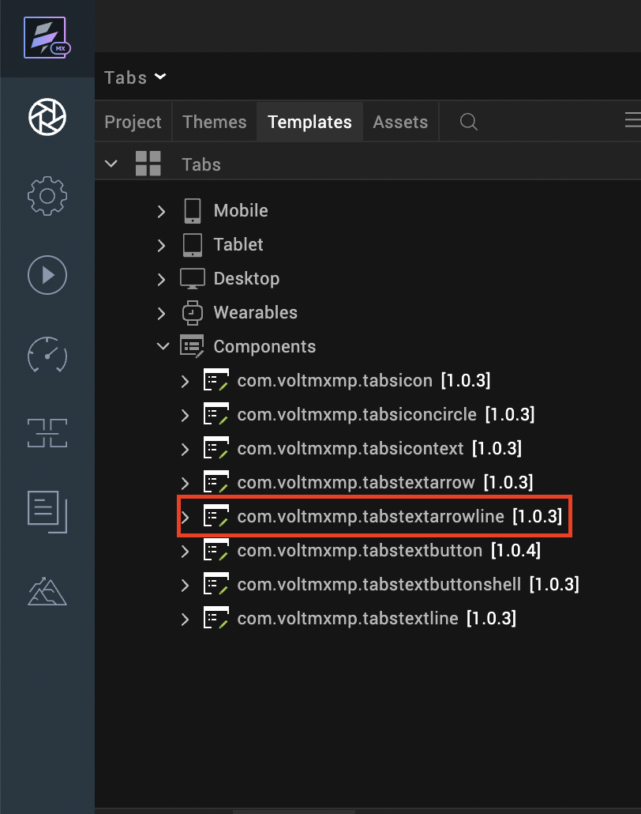

After you add the component into your project templates, follow the given steps to add the component to your app dynamically.
Access the FormController of the form you want to add the component into.
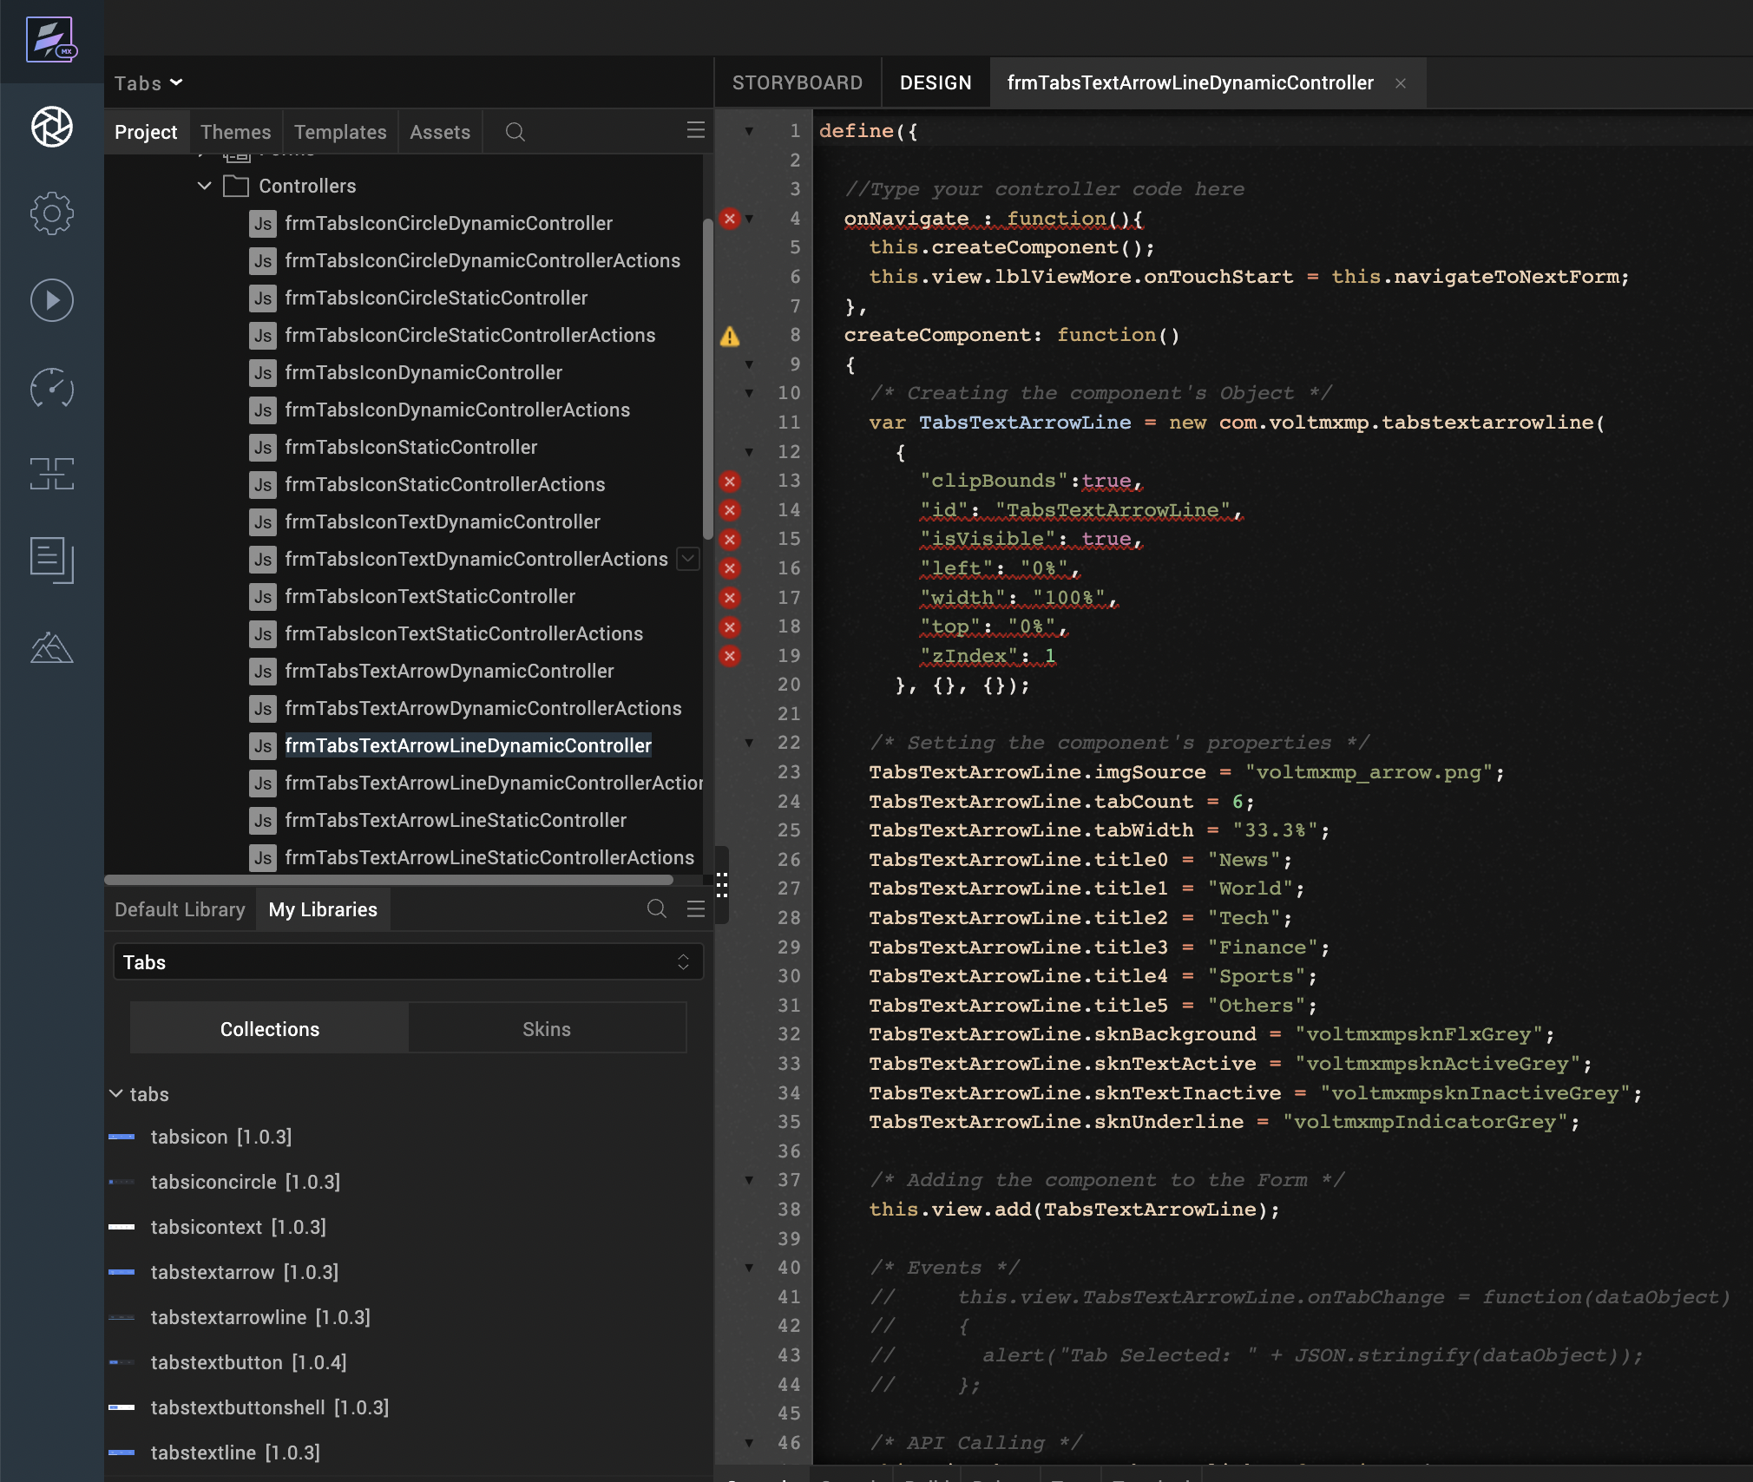
Create a function called createComponent(); and type a code inside the function to create and configure the component.
You can refer to the given sample code for more information.
/* Creating the component's Object */
var TabsTextArrowLine = new com.voltmxmp.tabstextarrowline(
{
"clipBounds":true,
"id": "TabsTextArrowLine",
"isVisible": true,
"left": "0%",
"width": "100%",
"top": "0%",
"zIndex": 1
}, {}, {});

/* Setting the component's properties */
TabsTextArrowLine.imgSource = "voltmxmp_arrow.png";
TabsTextArrowLine.tabCount = 6;
TabsTextArrowLine.tabWidth = "33.3%";
TabsTextArrowLine.title0 = "News";
TabsTextArrowLine.title1 = "World";
TabsTextArrowLine.title2 = "Tech";
TabsTextArrowLine.title3 = "Finance";
TabsTextArrowLine.title4 = "Sports";
TabsTextArrowLine.title5 = "Others";
TabsTextArrowLine.sknBackground = "voltmxmpsknFlxGrey";
TabsTextArrowLine.sknTextActive = "voltmxmpsknActiveGrey";
TabsTextArrowLine.sknTextInactive = "voltmxmpsknInactiveGrey";
TabsTextArrowLine.sknUnderline = "voltmxmpIndicatorGrey";

/* Adding the component to the Form */
this.view.add(TabsTextArrowLine);

Properties
The properties provided on the Component tab allows you to customize the elements in the Tabs: Text with focus-Arrow and Underline component. These elements can be UI elements, service parameters, and so on.
You can set the properties from the Volt MX Iris Properties panel on the right-hand side. You can also configure these properties using a JavaScript code.

General

Image Source
Description: | Specifies the image that you want to use as the arrow that highlights the selected tab.
Syntax: | imgSource
Type: | String
Read/Write: | Read + Write
Example: | this.view.componentID.imgSource = "voltmxmp_arrow.png";

No of Tabs
Description: | Specifies the number of tabs that you want to create at the run time.
Syntax: | tabCount
Type: | Integer
Read/Write: | Write
Default Value: | 3
Range of Values: | - Minimum Value: 1  - Maximum Value: 6
Remarks: | - Make sure that you specify a value that is within the range of values and is valid. Otherwise, the component throws an INVALID_TABCOUNT exception.  - You need to provide titles for all the tabs. Otherwise, the component throws an INVALID_TAB_TITLE exception.
Example: | this.view.componentID.tabCount = 3;

Tab Width
Description: | Specifies the width of the tab in percentage.
Syntax: | tabWidth
Type: | String
Read/Write: | Write
Default Value: | 33.3%
Remarks: | Make sure that you append the value with %. Otherwise, the component throws an INVALID_TABWIDTH exception.
Example: | this.view.componentID.tabWidth = "33.3%";

Tab 1
Description: | Specifies the title of the first tab (index : 0).
Syntax: | title0
Type: | String
Read/Write: | Write
Example: | this.view.componentID.title0 = "News";

Tab 2
Description: | Specifies the title of the second tab (index : 1).
Syntax: | title1
Type: | String
Read/Write: | Write
Example: | this.view.componentID.title1 = "World";

Tab 3
Description: | Specifies the title of the third tab (index : 2).
Syntax: | title2
Type: | String
Read/Write: | Write
Example: | this.view.componentID.title2 = "Tech";

Tab 4
Description: | Specifies the title of the fourth tab (index : 3).
Syntax: | title3
Type: | String
Read/Write: | Write
Example: | this.view.componentID.title3 = "Finance";

Tab 5
Description: | Specifies the title of the fifth tab (index : 4).
Syntax: | title4
Type: | String
Read/Write: | Write
Example: | this.view.componentID.title4 = "Sports";

Tab 6
Description: | Specifies the title of the sixth tab (index : 5).
Syntax: | title5
Type: | String
Read/Write: | Write
Example: | this.view.componentID.title5 = "Others";

Skins:

Tab Background
Description: | This skin links to the background of the tabs.
Syntax: | sknBackground
Widget Type: | FlexContainer
Example: | this.view.componentID.sknBackground = "voltmxmpsknFlxGrey";

Tab Text Active
Description: | This skin links to the title of the tab when it is selected (active).
Syntax: | sknTextActive
Widget Type: | Label
Example: | this.view.componentID.sknTextActive = "voltmxmpsknActiveGrey";

Tab Text Inactive
Description: | This skin links to the title of the tab when it is not selected (inactive).
Syntax: | sknTextInactive
Widget Type: | Label
Example: | this.view.componentID.sknTextInactive = "voltmxmpsknInactiveGrey";

Underline
Description: | This skin links to the underline of the selected tab.
Syntax: | sknUnderline
Widget Type: | Label
Example: | this.view.componentID.sknUnderline = "voltmxmpIndicatorGrey";

Events
The component invokes events when its corresponding action is performed. You can configure any logic you want the component to perform whenever an event occurs. You can configure the events directly on the Actions tab or by writing a JavaScript, For more information, refer to Add Actions in the Iris User Guide.

onTabChange
Description: | Invoked when the user clicks or taps a tab.
Syntax: | onTabChange
Parameters: | eventObject [JSON] :  Information about the selected tab.  Contains the following keys:  - tabIndex [Integer] : The index of the selected tab  - text [String] : The title of the selected tab
Example: | this.view.componentID.onTabChange = function(eventObject)  {  alert("Tab Selected: " + JSON.stringify(eventObject));  }
Sample JSON: | {  "text" : "News",  "tabIndex": 0  };

APIs
The following APIs pertain to the Tabs: Text with focus-Arrow and Underline component.

goToTab
Description: | Switches to the specified tab.
Syntax: | goToTab(tabIndex)
Parameters: | tabIndex [Integer] :  The index of the tab that you want to switch to.
Return Value: | None
Example: | var tabIndex = 2;  this.view.componentID.goToTab(tabIndex);

getSelectedTabIndex
Description: | Fetches the index of the tab that is currently selected.
Syntax: | getSelectedTabIndex()
Parameters: | None
Return Value: | tabIndex [Number] :  The index of the tab that is currently selected.
Example: | var tabIndex = this.view.componentID.getSelectedTabIndex();  alert("Current tab: " + tabIndex);

3. moveLeft
Description: | Switches to the tab that is on the left of the tab that is currently selected.
Syntax: | moveLeft()
Parameters: | None
Return Value: | None
Example: | this.view.componentID.moveLeft();

4. moveRight
Description: | Switches to the tab that is on the right of the tab that is currently selected.
Syntax: | moveRight()
Parameters: | None
Return Value: | None
Example: | this.view.componentID.moveRight();

5. getSelectedTabDetails
Description: | Fetches the details of the tab that is currently selected.
Syntax: | getSelectedTabDetails()
Parameters: | None
Return Value: | tabObject [JSON] :  The details of the tab that is currently selected.  Contains the following keys:  - tabIndex [Integer] : The index of the selected tab  - text [String] : The title of the selected tab
Example: | var tabObject = this.view.componentID.getSelectedTabDetails();  alert("Current tab details: " + JSON.stringify(tabObject));
Sample JSON: | {  "text" : "News",  "tabIndex": 0  };

6. createTabs
Description: | Creates tabs based on the specified data.
Syntax: | createTabs(tabData)
Parameters: | data [Array of Strings] :  The titles of the tabs that you want to create.
Return Value: | None
Remarks: | - Make sure that you add the Tabs component to a form before you use the createTabs API.  - If the data parameter is empty, the API creates tabs by using the values of the component properties.
Example: | var data = ["News", "World", "Tech", "Finance", "Sports", "Others"];  this.view.componentID.createTabs(data);

Tabs: text with Focus – button theme
The Tabs: Text with focus-Button theme displays a title on every tab. When a tab is selected (active), the component highlights the title of the tab and also displays a button-shaped highlight on the selected tab.
Note:
- If you change any property at run time, or add the component dynamically, call the createTabs API using Actions to create and display the tabs.
- If you copy the code from any example, make sure that you replace componentID with the name of your component.

Dynamic Usage:
If you want to use a component dynamically, you need to add the component to your project Templates. Follow the given steps to do so.
From the Project explorer, expand Mobile and Tablet.
Right-click forms and select New Form
From the My Libraries tab, drag and drop the component onto the form.
From the Project explorer, go to the Templates tab.
The component that you want to add should be available in the Components section.
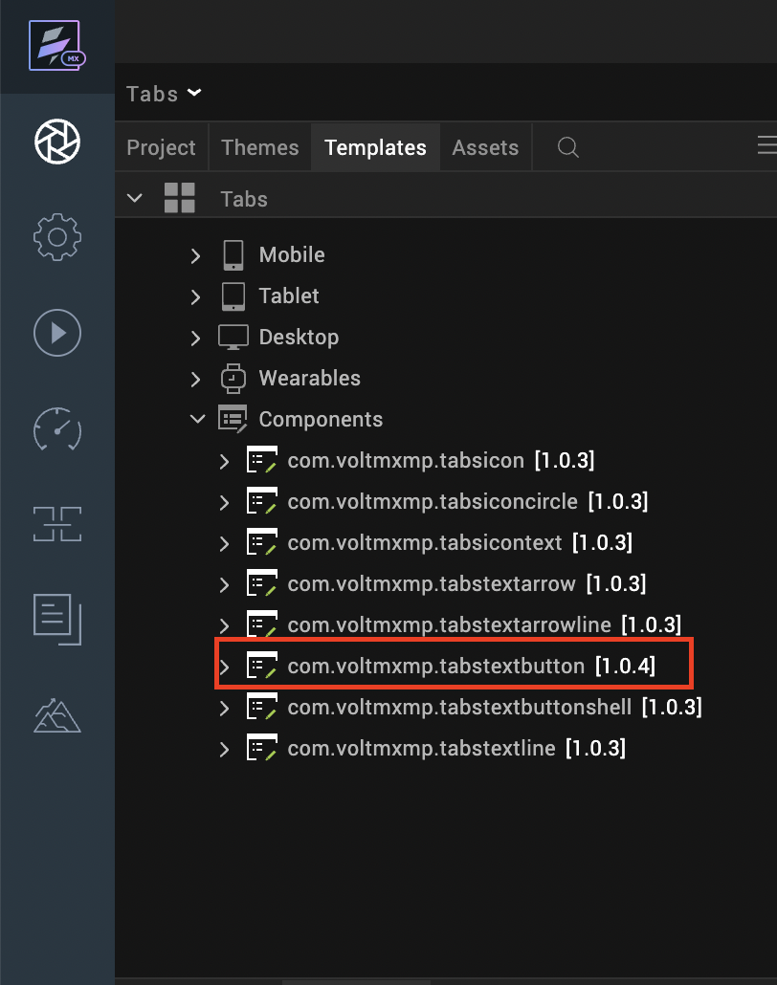

After you add the component into your project templates, follow the given steps to add the component to your app dynamically.
Access the FormController of the form you want to add the component into.
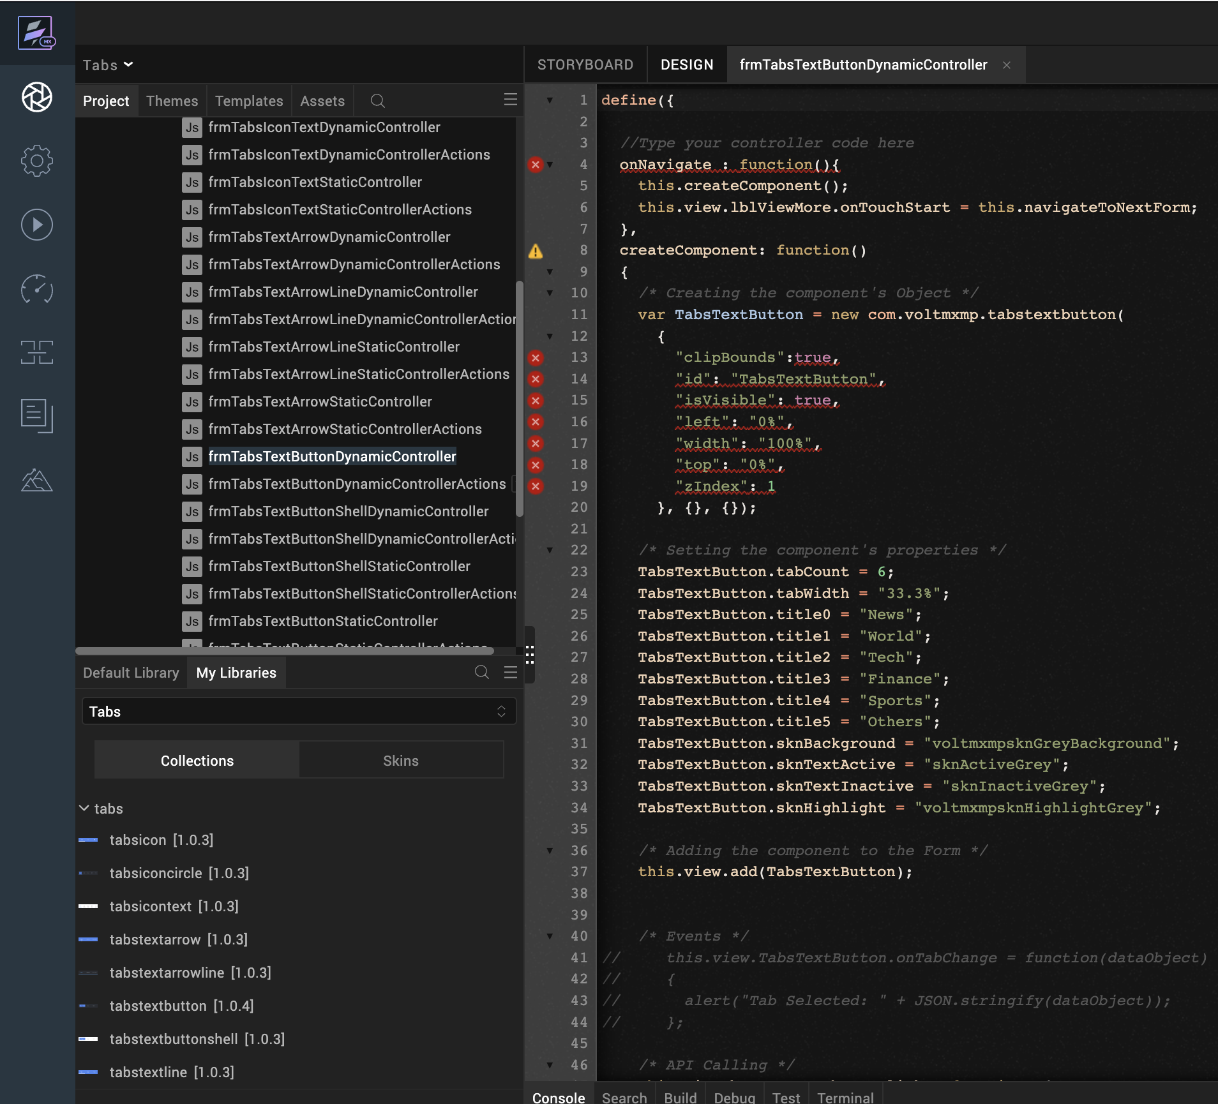
Create a function called createComponent(); and type a code inside the function to create and configure the component.
You can refer to the given sample code for more information.
/* Creating the component's Object */
var TabsTextButton = new com.voltmxmp.tabstextbutton(
{
"clipBounds":true,
"id": "TabsTextButton",
"isVisible": true,
"left": "0%",
"width": "100%",
"top": "0%",
"zIndex": 1
}, {}, {});

/* Setting the component's properties */
TabsTextButton.tabCount = 6;
TabsTextButton.tabWidth = "33.3%";
TabsTextButton.title0 = "News";
TabsTextButton.title1 = "World";
TabsTextButton.title2 = "Tech";
TabsTextButton.title3 = "Finance";
TabsTextButton.title4 = "Sports";
TabsTextButton.title5 = "Others";
TabsTextButton.sknBackground = "voltmxmpsknGreyBackground";
TabsTextButton.sknTextActive = "sknActiveGrey";
TabsTextButton.sknTextInactive = "sknInactiveGrey";
TabsTextButton.sknHighlight = "voltmxmpsknHighlightGrey";

/* Adding the component to the Form */
this.view.add(TabsTextButton);

Properties
The properties provided on the Component tab allows you to customize the elements in the Tabs: Text with focus-Button component. These elements can be UI elements, service parameters, and so on.
You can set the properties from the Volt MX Iris Properties panel on the right-hand side. You can also configure these properties using a JavaScript code.

General

No of Tabs
Description: | Specifies the number of tabs that you want to create at the run time.
Syntax: | tabCount
Type: | Integer
Read/Write: | Write
Default Value: | 3
Range of Values: | - Minimum Value: 1  - Maximum Value: 6
Remarks: | - Make sure that you specify a value that is within the range of values and is valid. Otherwise, the component throws an INVALID_TABCOUNT exception.  - You need to provide titles for all the tabs. Otherwise, the component throws an INVALID_TAB_TITLE exception.
Example: | this.view.componentID.tabCount = 3;

Tab Width
Description: | Specifies the width of the tab in percentage.
Syntax: | tabWidth
Type: | String
Read/Write: | Write
Default Value: | 33.3%
Remarks: | Make sure that you append the value with %. Otherwise, the component throws an INVALID_TABWIDTH exception.
Example: | this.view.componentID.tabWidth = "33.3%";

Tab 1
Description: | Specifies the title of the first tab (index : 0).
Syntax: | title0
Type: | String
Read/Write: | Write
Example: | this.view.componentID.title0 = "Tab1";

Tab 2
Description: | Specifies the title of the second tab (index : 1).
Syntax: | title1
Type: | String
Read/Write: | Write
Example: | this.view.componentID.title1 = "Tab2";

Tab 3
Description: | Specifies the title of the third tab (index : 2).
Syntax: | title2
Type: | String
Read/Write: | Write
Example: | this.view.componentID.title2 = "Tab3";

Tab 4
Description: | Specifies the title of the fourth tab (index : 3).
Syntax: | title3
Type: | String
Read/Write: | Write
Example: | this.view.componentID.title3 = "Tab4";

Tab 5
Description: | Specifies the title of the fifth tab (index : 4).
Syntax: | title4
Type: | String
Read/Write: | Write
Example: | this.view.componentID.title4 = "Tab5";

Tab 6
Description: | Specifies the title of the sixth tab (index : 5).
Syntax: | title5
Type: | String
Read/Write: | Write
Example: | this.view.componentID.title5 = "Tab6";

Skins:

Tab Background
Description: | This skin links to the background of the tabs.
Syntax: | sknBackground
Widget Type: | FlexContainer
Example: | this.view.componentID.sknBackground = "voltmxmpsknGreyBackground";

Tab Text Active
Description: | This skin links to the title of the tab when it is selected (active).
Syntax: | sknTextActive
Widget Type: | Label
Example: | this.view.componentID.sknTextActive = "sknActiveGrey";

Tab Text Inactive
Description: | This skin links to the title of the tab when it is not selected (inactive).
Syntax: | sknTextInactive
Widget Type: | Label
Example: | this.view.componentID.sknTextInactive = "sknInactiveGrey";

Tab Highlight
Description: | This skin links to the button-shaped highlight of the selected tab.
Syntax: | sknHighlight
Widget Type: | FlexContainer
Example: | this.view.componentID.sknHighlight= "voltmxmpsknHighlightGrey";

Events
The component invokes events when its corresponding action is performed. You can configure any logic you want the component to perform whenever an event occurs. You can configure the events directly on the Actions tab or by writing a JavaScript, For more information, refer to Add Actions in the Iris User Guide.

onTabChange
Description: | Invoked when the user clicks or taps a tab.
Syntax: | onTabChange
Parameters: | eventObject [JSON] :  Information about the selected tab.  Contains the following keys:  - tabIndex [Integer] : The index of the selected tab  - text [String] : The title of the selected tab
Example: | this.view.componentID.onTabChange = function(eventObject)  {  alert("Tab Selected: " + JSON.stringify(eventObject));  }
Sample JSON: | {  "text" : "Tab1",  "tabIndex": 0  };

APIs
The following APIs pertain to the Tabs: Text with focus-Button component.

goToTab
Description: | Switches to the specified tab.
Syntax: | goToTab(tabIndex)
Parameters: | tabIndex [Integer] :  The index of the tab that you want to switch to.
Return Value: | None
Example: | var tabIndex = 2;  this.view.componentID.goToTab(tabIndex);

getSelectedTabIndex
Description: | Fetches the index of the tab that is currently selected.
Syntax: | getSelectedTabIndex()
Parameters: | None
Return Value: | tabIndex [Number] :  The index of the tab that is currently selected.
Example: | var tabIndex = this.view.componentID.getSelectedTabIndex();  alert("Current tab: " + tabIndex);

3. moveLeft
Description: | Switches to the tab that is on the left of the tab that is currently selected.
Syntax: | moveLeft()
Parameters: | None
Return Value: | None
Example: | this.view.componentID.moveLeft();

4. moveRight
Description: | Switches to the tab that is on the right of the tab that is currently selected.
Syntax: | moveRight()
Parameters: | None
Return Value: | None
Example: | this.view.componentID.moveRight();

5. getSelectedTabDetails
Description: | Fetches the details of the tab that is currently selected.
Syntax: | getSelectedTabDetails()
Parameters: | None
Return Value: | selectedTabDetails [JSON] :  The details of the tab that is currently selected.  Contains the following keys:  - tabIndex [Integer] : The index of the selected tab  - text [String] : The title of the selected tab
Example: | var selectedTabDetails = this.view.componentID.getSelectedTabDetails();  alert("Current tab details: " + JSON.stringify(selectedTabDetails));
Sample JSON: | {  "text" : "Tab1",  "tabIndex": 0  };

6. createTabs
Description: | Creates tabs based on the specified data.
Syntax: | createTabs(tabData)
Parameters: | tabData [Array of Strings] :  The titles of the tabs that you want to create.
Return Value: | None
Remarks: | - Make sure that you add the Tabs component to a form before you use the createTabs API.  - If the tabData parameter is empty, the API creates tabs by using the values of the component properties.
Example: | var tabData = ["Tab1", "Tab2", "Tab3", "Tab4", "Tab5", "Tab6"];  this.view.componentID.createTabs(tabData);

Tabs: text with Focus – button and Shell theme
The Tabs: Text with focus-Button and Shell theme displays a title on every tab and also displays all the tabs inside a shell. When a tab is selected (active), the component highlights the title of the tab and also displays a button-shaped highlight on the selected tab.
Note:
- If you change any property at run time, or add the component dynamically, call the createTabs API using Actions to create and display the tabs.
- If you copy the code from any example, make sure that you replace componentID with the name of your component.

Dynamic Usage:
If you want to use a component dynamically, you need to add the component to your project Templates. Follow the given steps to do so.
From the Project explorer, expand Mobile and Tablet.
Right-click forms and select New Form
From the My Libraries tab, drag and drop the component onto the form.
From the Project explorer, go to the Templates tab.
The component that you want to add should be available in the Components section.
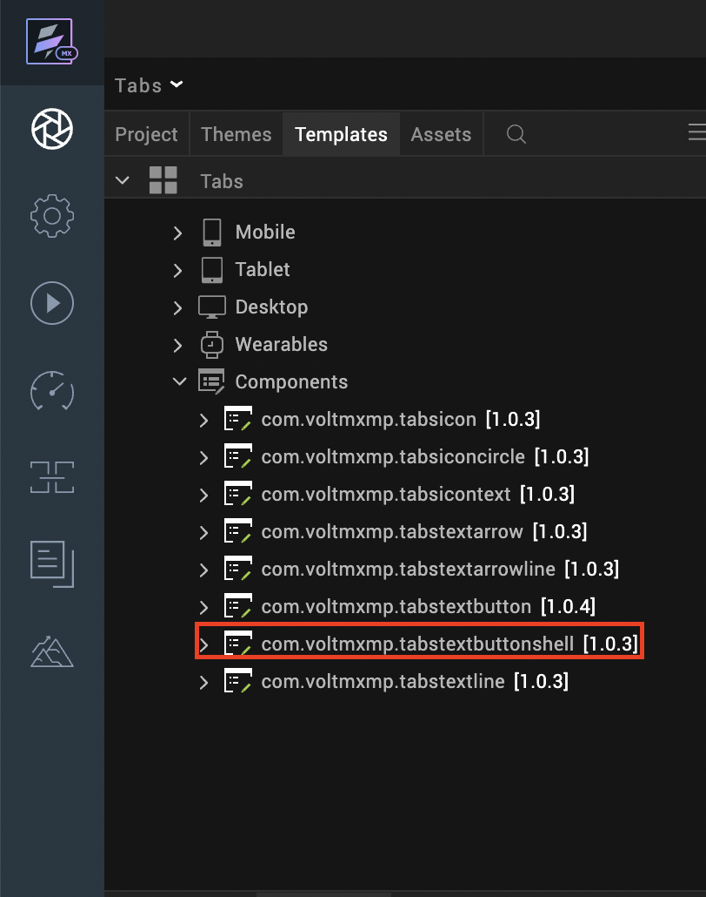

After you add the component into your project templates, follow the given steps to add the component to your app dynamically.
Access the FormController of the form you want to add the component into.
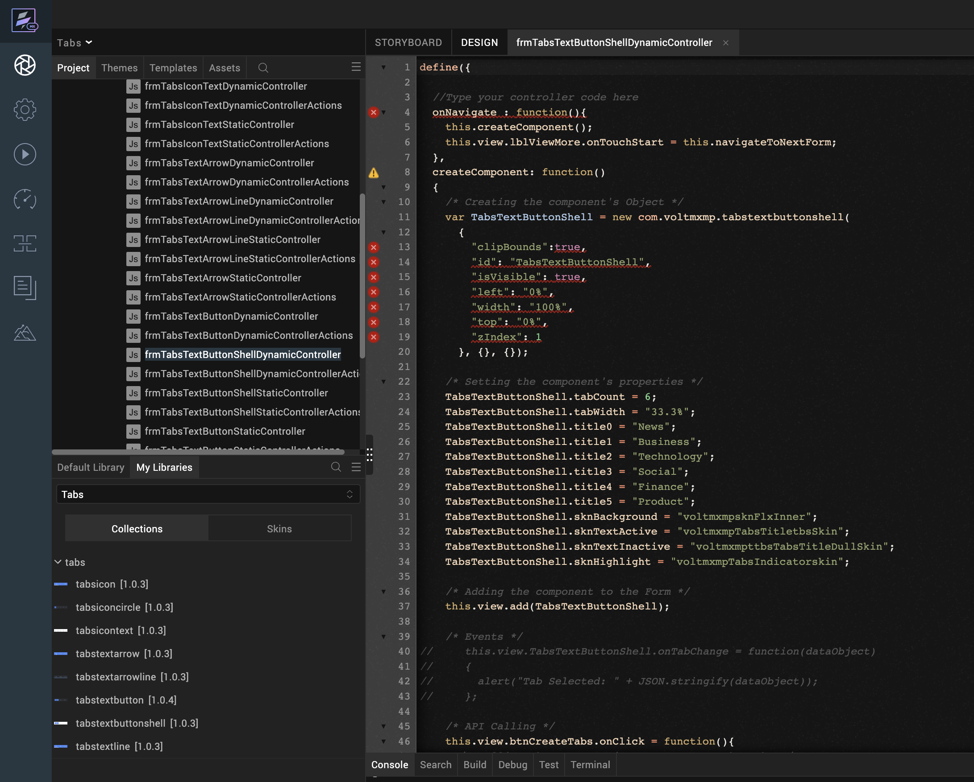
Create a function called createComponent(); and type a code inside the function to create and configure the component.
You can refer to the given sample code for more information.
/* Creating the component's Object */
var TabsTextButtonShell = new com.voltmxmp.tabstextbuttonshell(
{
"clipBounds":true,
"id": "TabsTextButtonShell",
"isVisible": true,
"left": "0%",
"width": "100%",
"top": "0%",
"zIndex": 1
}, {}, {});

/* Setting the component's properties */
TabsTextButtonShell.tabCount = 6;
TabsTextButtonShell.tabWidth = "33.3%";
TabsTextButtonShell.title0 = "News";
TabsTextButtonShell.title1 = "Business";
TabsTextButtonShell.title2 = "Technology";
TabsTextButtonShell.title3 = "Social";
TabsTextButtonShell.title4 = "Finance";
TabsTextButtonShell.title5 = "Product";
TabsTextButtonShell.sknBackground = "voltmxmpsknFlxInner";
TabsTextButtonShell.sknTextActive = "voltmxmpTabsTitletbsSkin";
TabsTextButtonShell.sknTextInactive = "voltmxmpttbsTabsTitleDullSkin";
TabsTextButtonShell.sknHighlight = "voltmxmpTabsIndicatorskin";

/* Adding the component to the Form */
this.view.add(TabsTextButtonShell);

Properties
The properties provided on the Component tab allows you to customize the elements in the Tabs: Text with focus-Button and Shell component. These elements can be UI elements, service parameters, and so on.
You can set the properties from the Volt MX Iris Properties panel on the right-hand side. You can also configure these properties using a JavaScript code.

General

No of Tabs
Description: | Specifies the number of tabs that you want to create at the run time.
Syntax: | tabCount
Type: | Integer
Read/Write: | Write
Default Value: | 3
Range of Values: | - Minimum Value: 1  - Maximum Value: 6
Remarks: | - Make sure that you specify a value that is within the range of values and is valid. Otherwise, the component throws an INVALID_TABCOUNT exception.  - You need to provide titles for all the tabs. Otherwise, the component throws an INVALID_TAB_TITLE exception.
Example: | this.view.componentID.tabCount = 3;

Tab Width
Description: | Specifies the width of the tab in percentage.
Syntax: | tabWidth
Type: | String
Read/Write: | Write
Default Value: | 33.3%
Remarks: | Make sure that you append the value with %. Otherwise, the component throws an INVALID_TABWIDTH exception.
Example: | this.view.componentID.tabWidth = "33.3%";

Tab 1
Description: | Specifies the title of the first tab (index : 0).
Syntax: | title0
Type: | String
Read/Write: | Write
Example: | this.view.componentID.title0 = "Tab1";

Tab 2
Description: | Specifies the title of the second tab (index : 1).
Syntax: | title1
Type: | String
Read/Write: | Write
Example: | this.view.componentID.title1 = "Tab2";

Tab 3
Description: | Specifies the title of the third tab (index : 2).
Syntax: | title2
Type: | String
Read/Write: | Write
Example: | this.view.componentID.title2 = "Tab3";

Tab 4
Description: | Specifies the title of the fourth tab (index : 3).
Syntax: | title3
Type: | String
Read/Write: | Write
Example: | this.view.componentID.title3 = "Tab4";

Tab 5
Description: | Specifies the title of the fifth tab (index : 4).
Syntax: | title4
Type: | String
Read/Write: | Write
Example: | this.view.componentID.title4 = "Tab5";

Tab 6
Description: | Specifies the title of the sixth tab (index : 5).
Syntax: | title5
Type: | String
Read/Write: | Write
Example: | this.view.componentID.title5 = "Tab6";

Skins:

Tab Background
Description: | This skin links to the background of the tabs.
Syntax: | sknBackground
Widget Type: | FlexContainer
Example: | this.view.componentID.sknBackground = "voltmxmpsknFlxInner";

Tab Text Active
Description: | This skin links to the title of the tab when it is selected (active).
Syntax: | sknTextActive
Widget Type: | Label
Example: | this.view.componentID.sknTextActive = "voltmxmpTabsTitletbsSkin";

Tab Text Inactive
Description: | This skin links to the title of the tab when it is not selected (inactive).
Syntax: | sknTextInactive
Widget Type: | Label
Example: | this.view.componentID.sknTextInactive = "voltmxmpttbsTabsTitleDullSkin";

Tab Highlight
Description: | This skin links to the button-shaped highlight of the selected tab.
Syntax: | sknHighlight
Widget Type: | FlexContainer
Example: | this.view.componentID.sknHighlight= "voltmxmpTabsIndicatorskin";

Events
The component invokes events when its corresponding action is performed. You can configure any logic you want the component to perform whenever an event occurs. You can configure the events directly on the Actions tab or by writing a JavaScript, For more information, refer to Add Actions in the Iris User Guide.

onTabChange
Description: | Invoked when the user clicks or taps a tab.
Syntax: | onTabChange
Parameters: | eventObject [JSON] :  Information about the selected tab.  Contains the following keys:  - tabIndex [Integer] : The index of the selected tab  - text [String] : The title of the selected tab
Example: | this.view.componentID.onTabChange = function(eventObject)  {  alert("Tab Selected: " + JSON.stringify(eventObject));  }
Sample JSON: | {  "text" : "Tab1",  "tabIndex": 0  };

APIs
The following APIs pertain to the Tabs: Text with focus-Button and Shell component.

goToTab
Description: | Switches to the specified tab.
Syntax: | goToTab(tabIndex)
Parameters: | tabIndex [Integer] :  The index of the tab that you want to switch to.
Return Value: | None
Example: | var tabIndex = 2;  this.view.componentID.goToTab(tabIndex);

getSelectedTabIndex
Description: | Fetches the index of the tab that is currently selected.
Syntax: | getSelectedTabIndex()
Parameters: | None
Return Value: | tabIndex [Number] :  The index of the tab that is currently selected.
Example: | var tabIndex = this.view.componentID.getSelectedTabIndex();  alert("Current tab: " + tabIndex);

3. moveLeft
Description: | Switches to the tab that is on the left of the tab that is currently selected.
Syntax: | moveLeft()
Parameters: | None
Return Value: | None
Example: | this.view.componentID.moveLeft();

4. moveRight
Description: | Switches to the tab that is on the right of the tab that is currently selected.
Syntax: | moveRight()
Parameters: | None
Return Value: | None
Example: | this.view.componentID.moveRight();

5. getSelectedTabDetails
Description: | Fetches the details of the tab that is currently selected.
Syntax: | getSelectedTabDetails()
Parameters: | None
Return Value: | selectedTabDetails [JSON] :  The details of the tab that is currently selected.  Contains the following keys:  - tabIndex [Integer] : The index of the selected tab  - text [String] : The title of the selected tab
Example: | var selectedTabDetails = this.view.componentID.getSelectedTabDetails();  alert("Current tab details: " + JSON.stringify(selectedTabDetails));
Sample JSON: | {  "text" : "Tab1",  "tabIndex": 0  };

6. createTabs
Description: | Creates tabs based on the specified data.
Syntax: | createTabs(tabData)
Parameters: | tabData [Array of Strings] :  The titles of the tabs that you want to create.
Return Value: | None
Remarks: | - Make sure that you add the Tabs component to a form before you use the createTabs API.  - If the tabData parameter is empty, the API creates tabs by using the values of the component properties.
Example: | var tabData = ["Tab1", "Tab2", "Tab3", "Tab4", "Tab5", "Tab6"];  this.view.componentID.createTabs(tabData);

Tabs: text with Focus – line theme
The Tabs: Text with focus-Line theme displays a title on every tab. When a tab is selected (active), the component highlights the title of the tab and also displays a line on the bottom edge of the selected tab.
Note:
- If you change any property at run time, or add the component dynamically, call the createTabs API using Actions to create and display the tabs.
- If you copy the code from any example, make sure that you replace componentID with the name of your component.

Dynamic Usage:
If you want to use a component dynamically, you need to add the component to your project Templates. Follow the given steps to do so.
From the Project explorer, expand Mobile and Tablet.
Right-click forms and select New Form
From the My Libraries tab, drag and drop the component onto the form.
From the Project explorer, go to the Templates tab.
The component that you want to add should be available in the Components section.
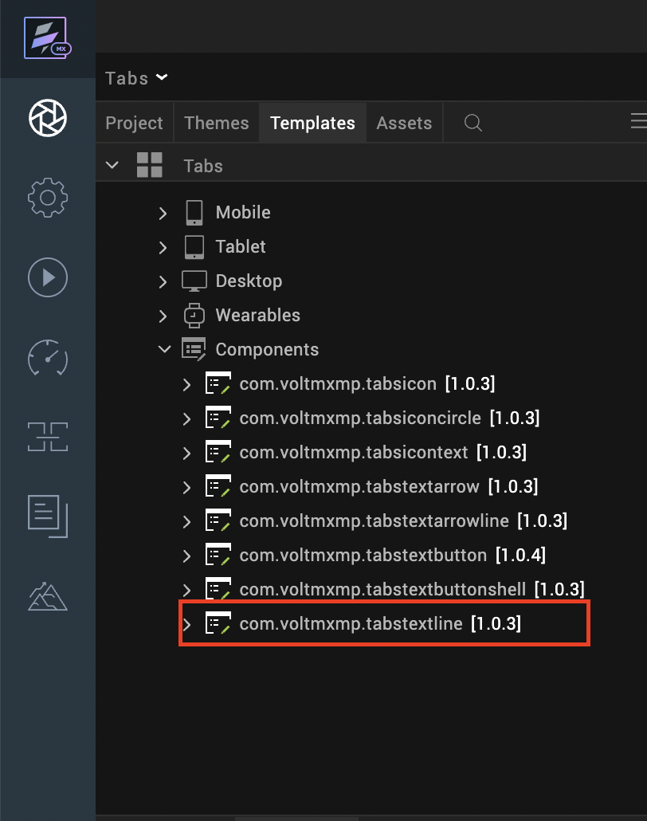

After you add the component into your project templates, follow the given steps to add the component to your app dynamically.
Access the FormController of the form you want to add the component into.
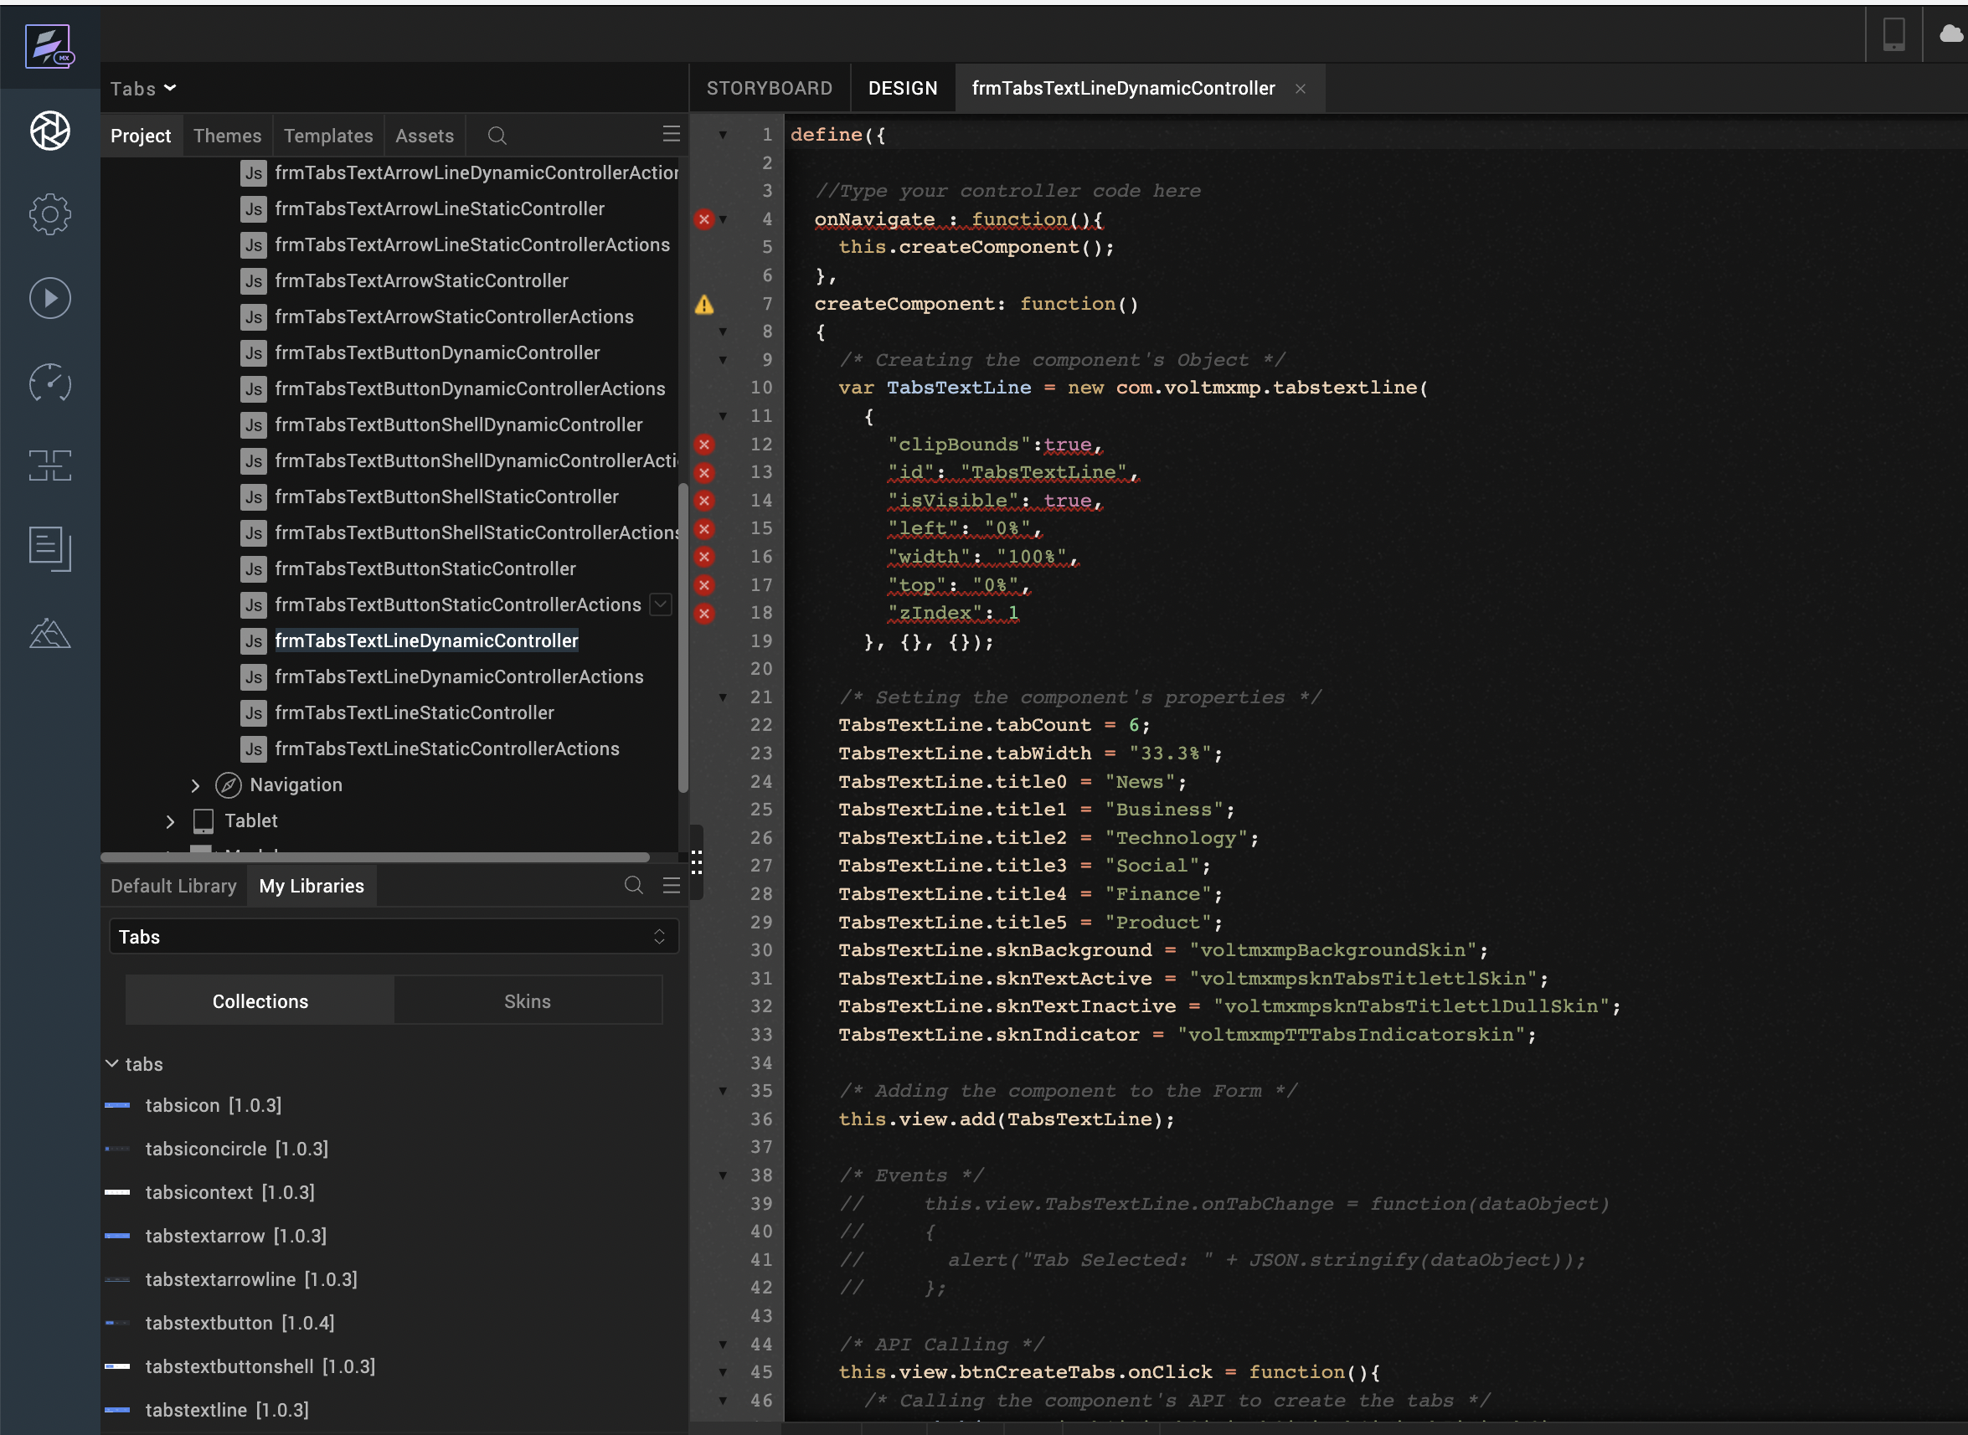
Create a function called createComponent(); and type a code inside the function to create and configure the component.
You can refer to the given sample code for more information.
/* Creating the component's Object */
var TabsTextLine = new com.voltmxmp.tabstextline(
{
"clipBounds":true,
"id": "TabsTextLine",
"isVisible": true,
"left": "0%",
"width": "100%",
"top": "0%",
"zIndex": 1
}, {}, {});

/* Setting the component's properties */
TabsTextLine.tabCount = 6;
TabsTextLine.tabWidth = "33.3%";
TabsTextLine.title0 = "News";
TabsTextLine.title1 = "Business";
TabsTextLine.title2 = "Technology";
TabsTextLine.title3 = "Social";
TabsTextLine.title4 = "Finance";
TabsTextLine.title5 = "Product";
TabsTextLine.sknBackground = "voltmxmpBackgroundSkin";
TabsTextLine.sknTextActive = "voltmxmpsknTabsTitlettlSkin";
TabsTextLine.sknTextInactive = "voltmxmpsknTabsTitlettlDullSkin";
TabsTextLine.sknIndicator = "voltmxmpTTTabsIndicatorskin";

/* Adding the component to the Form */
this.view.add(TabsTextLine);

Properties
The properties provided on the Component tab allows you to customize the elements in the Tabs: Text with focus-Line component. These elements can be UI elements, service parameters, and so on.
You can set the properties from the Volt MX Iris Properties panel on the right-hand side. You can also configure these properties using a JavaScript code.

General

No of Tabs
Description: | Specifies the number of tabs that you want to create at the run time.
Syntax: | tabCount
Type: | Integer
Read/Write: | Write
Default Value: | 3
Range of Values: | - Minimum Value: 1  - Maximum Value: 6
Remarks: | - Make sure that you specify a value that is within the range of values and is valid. Otherwise, the component throws an INVALID_TABCOUNT exception.  - You need to provide titles for all the tabs. Otherwise, the component throws an INVALID_TAB_TITLE exception.
Example: | this.view.componentID.tabCount = 3;

Tab Width
Description: | Specifies the width of the tab in percentage.
Syntax: | tabWidth
Type: | String
Read/Write: | Write
Default Value: | 33.3%
Remarks: | Make sure that you append the value with %. Otherwise, the component throws an INVALID_TABWIDTH exception.
Example: | this.view.componentID.tabWidth = "33.3%";

Tab 1
Description: | Specifies the title of the first tab (index : 0).
Syntax: | title0
Type: | String
Read/Write: | Write
Example: | this.view.componentID.title0 = "Tab1";

Tab 2
Description: | Specifies the title of the second tab (index : 1).
Syntax: | title1
Type: | String
Read/Write: | Write
Example: | this.view.componentID.title1 = "Tab2";

Tab 3
Description: | Specifies the title of the third tab (index : 2).
Syntax: | title2
Type: | String
Read/Write: | Write
Example: | this.view.componentID.title2 = "Tab3";

Tab 4
Description: | Specifies the title of the fourth tab (index : 3).
Syntax: | title3
Type: | String
Read/Write: | Write
Example: | this.view.componentID.title3 = "Tab4";

Tab 5
Description: | Specifies the title of the fifth tab (index : 4).
Syntax: | title4
Type: | String
Read/Write: | Write
Example: | this.view.componentID.title4 = "Tab5";

Tab 6
Description: | Specifies the title of the sixth tab (index : 5).
Syntax: | title5
Type: | String
Read/Write: | Write
Example: | this.view.componentID.title5 = "Tab6";

Skins:

Tab Background
Description: | This skin links to the background of the tabs.
Syntax: | sknBackground
Widget Type: | FlexContainer
Example: | this.view.componentID.sknBackground = "voltmxmpBackgroundSkin";

Tab Text Active
Description: | This skin links to the title of the tab when it is selected (active).
Syntax: | sknTextActive
Widget Type: | Label
Example: | this.view.componentID.sknTextActive = "voltmxmpsknTabsTitlettlSkin";

Tab Text Inactive
Description: | This skin links to the title of the tab when it is not selected (inactive).
Syntax: | sknTextInactive
Widget Type: | Label
Example: | this.view.componentID.sknTextInactive = "voltmxmpsknTabsTitlettlDullSkin";

Indicator
Description: | This allows the user to change the skin of the line indicator that appears below the selected tab text..
Syntax: | sknIndicator
Widget Type: | Label
Example: | this.view.componentID.sknIndicator = "voltmxmpTTTabsIndicatorskin";

Events
The component invokes events when its corresponding action is performed. You can configure any logic you want the component to perform whenever an event occurs. You can configure the events directly on the Actions tab or by writing a JavaScript, For more information, refer to Add Actions in the Iris User Guide.

onTabChange
Description: | Invoked when the user clicks or taps a tab.
Syntax: | onTabChange
Parameters: | eventObject [JSON] :  Information about the selected tab.  Contains the following keys:  - tabIndex [Integer] : The index of the selected tab  - text [String] : The title of the selected tab
Example: | this.view.componentID.onTabChange = function(eventObject)  {  alert("Tab Selected: " + JSON.stringify(eventObject));  }
Sample JSON: | {  "text" : "Tab1",  "tabIndex": 0  };

APIs
The following APIs pertain to the Tabs: Text with focus-Line component.

goToTab
Description: | Switches to the specified tab.
Syntax: | goToTab(tabIndex)
Parameters: | tabIndex [Integer] :  The index of the tab that you want to switch to.
Return Value: | None
Example: | var tabIndex = 2;  this.view.componentID.goToTab(tabIndex);

getSelectedTabIndex
Description: | Fetches the index of the tab that is currently selected.
Syntax: | getSelectedTabIndex()
Parameters: | None
Return Value: | tabIndex [Number] :  The index of the tab that is currently selected.
Example: | var tabIndex = this.view.componentID.getSelectedTabIndex();  alert("Current tab: " + tabIndex);

3. moveLeft
Description: | Switches to the tab that is on the left of the tab that is currently selected.
Syntax: | moveLeft()
Parameters: | None
Return Value: | None
Example: | this.view.componentID.moveLeft();

4. moveRight
Description: | Switches to the tab that is on the right of the tab that is currently selected.
Syntax: | moveRight()
Parameters: | None
Return Value: | None
Example: | this.view.componentID.moveRight();

5. getSelectedTabDetails
Description: | Fetches the details of the tab that is currently selected.
Syntax: | getSelectedTabDetails()
Parameters: | None
Return Value: | tabObject [JSON] :  The details of the tab that is currently selected.  Contains the following keys:  - tabIndex [Integer] : The index of the selected tab  - text [String] : The title of the selected tab
Example: | var tabObject = this.view.componentID.getSelectedTabDetails();  alert("Current tab details: " + JSON.stringify(tabObject));
Sample JSON: | {  "text" : "Tab1",  "tabIndex": 0  };

6. createTabs
Description: | Creates tabs based on the specified data.
Syntax: | createTabs(tabData)
Parameters: | tabData [Array of Strings] :  The titles of the tabs that you want to create.
Return Value: | None
Remarks: | - Make sure that you add the Tabs component to a form before you use the createTabs API.  - If the tabData parameter is empty, the API creates tabs by using the values of the component properties.
Example: | var tabData = ["News", "World", "Tech", "Finance", "Sports", "Others"];  this.view.componentID.createTabs(tabData);

Revision History
App version 1.0.1:

Known Issues

No Known Issues.

Limitations
- Tabs only supports up to six tabs.

