Date :  16-Oct-23

Strava ADAPTER (1.0.0)

# Overview

Strava adapter in Volt Foundry allows developers to access the Strava V3 API which is a publicly available interface that allows developers to access Strava data. The interface is stable and used by the Strava mobile apps.

The Strava REST API includes data on athletes, segments, routes, clubs, and gear. It is free to use. The Strava API does not allow you to get data for all Strava public athletes, as you can see on our website.

To get data on athletes, you will have to make an application and request that athletes sign in with Strava and grant your application certain permissions using OAuth 2.0. You can get data on yourself without authentication for testing purposes.

*Disclaimer: This adapter is built on using Swagger 2.0 spec of Strava API v3. Any future change in how the Strava APIs function may break the adapter and author of this adapter is not responsible for that.*

# Getting Started

## Prerequisites

* Volt Foundry
* Strava Account

## How to create a **Strava** account?

**To start developing with the Strava API, you will need to make an application.**

1. If you have not already, go to <https://www.strava.com/register> and sign up for a Strava account.
2. After you are logged in, go to <https://www.strava.com/settings/api> and create an app.
3. You should see the “My API Application” page now. Here is what everything means:
   * Category: The category you chose for your application
   * Club: Will show if you have a club associated with your application
   * Client ID: Your application ID
   * Client Secret: Your client secret (please keep this confidential)
   * Authorization token: Your authorization token which will change every six hours (please keep this confidential)
   * Your Refresh token: The token you will use to get a new authorization token (please keep this confidential)
   * Rate limits: Your current rate limit
   * Authorization Callback Domain: When building your app, change “Authorization Callback Domain” to localhost or any domain. When taking your app live, change “Authorization Callback Domain” to a real domain.

## 

## 

## Importing the adapter

**To import the Data Adapter to Volt Foundry, do the following:**

1. Sign in to the  [HCL Foundry](https://manage.hclvoltmx.com/).
2. From the left navigation menu, select **API Management**.
3. In **API Management**, select **Custom Data Adapters**.  
   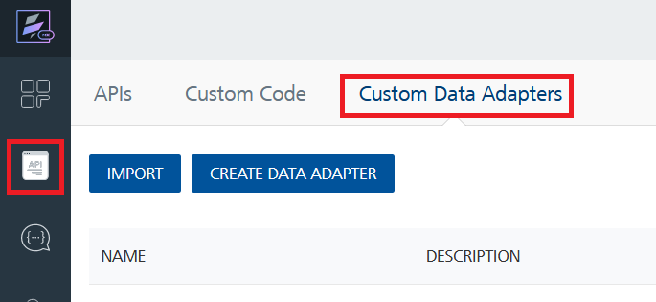
4. Click **IMPORT** to import a custom data adapter.  
   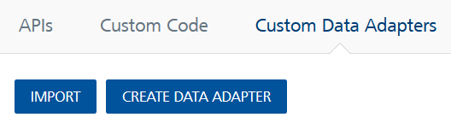
5. On the Import Data Adapter dialog box, click browser to import.  
   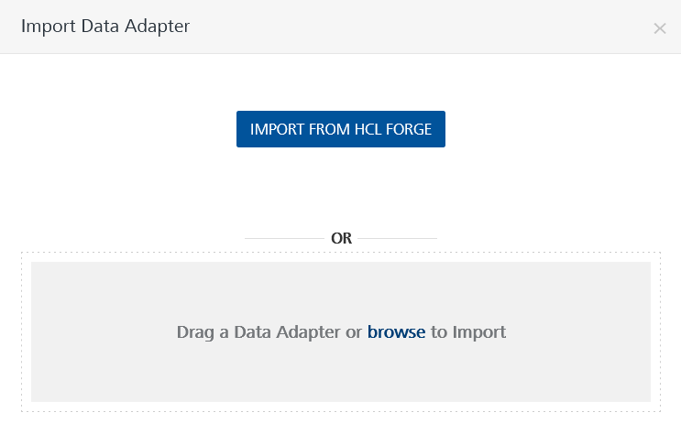
6. Select **Strava.zip** file and click **IMPORT**.

After you import the data adapter, Volt Foundry opens a window that shows the metadata of the data adapter.

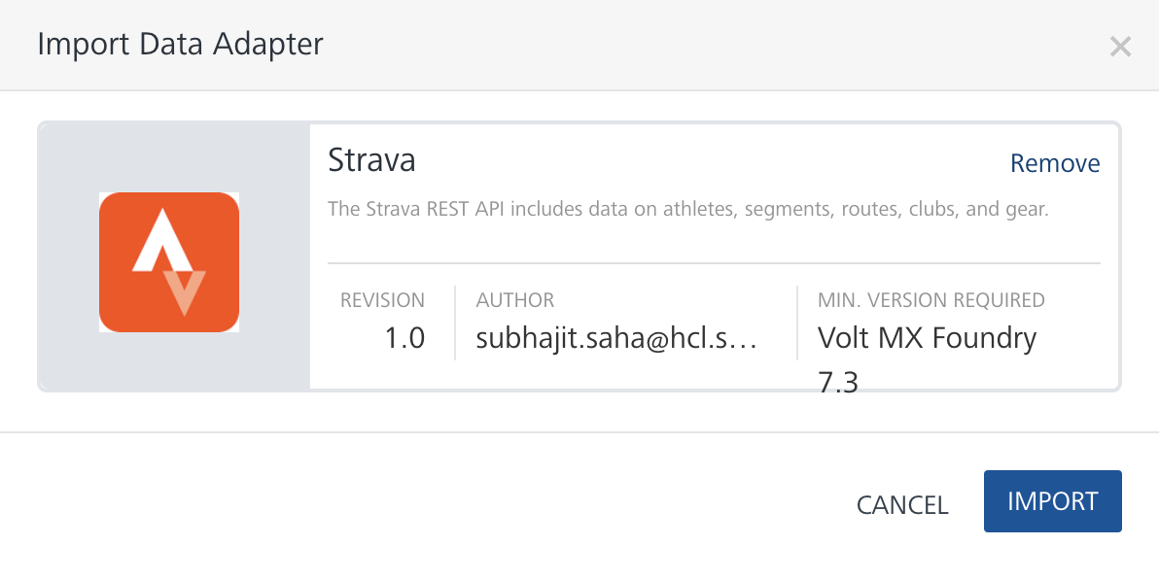

After you import the data adapter, you can view it on the Custom Data Adapters page and use it to create services on Volt Foundry.

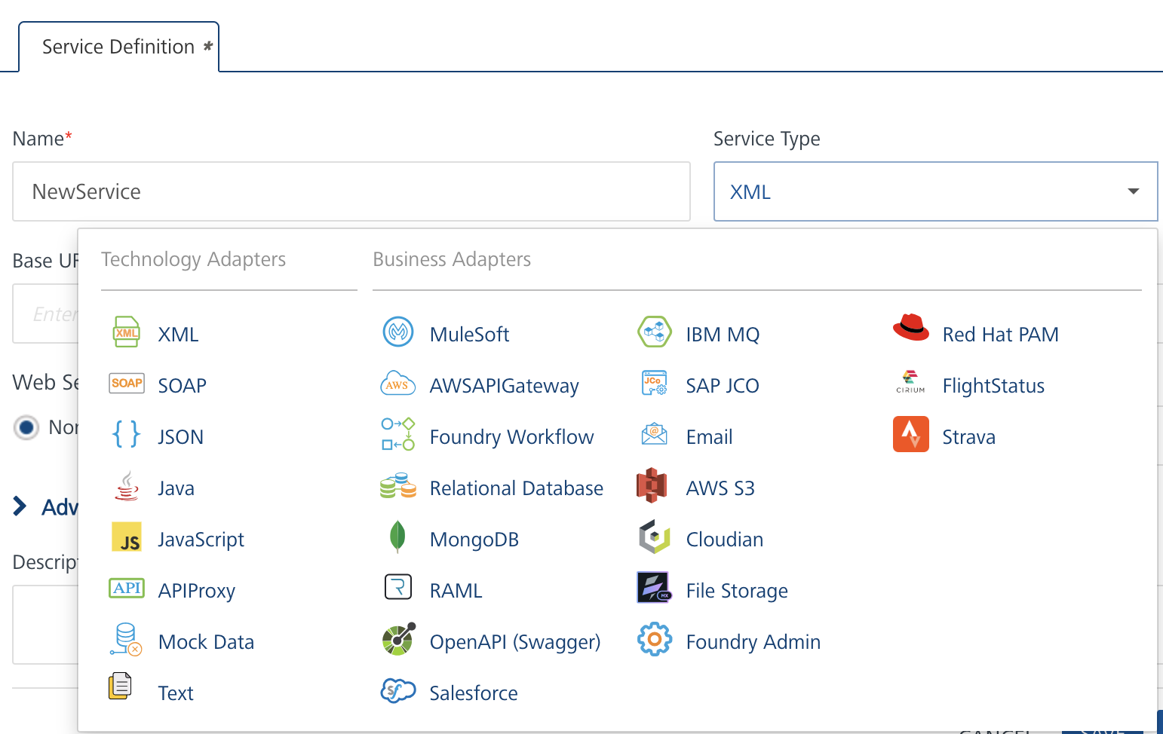

## [Creating an Integration service](javascript:void(0);)

After you import the data adapter into Volt Foundry, you can use it to create an Integration Service.

Follow the given steps to create an Integration service using the **Strava** Adapter.

1. Sign in to the [HCL Foundry](https://manage.hclvoltmx.com/).
2. From the left navigation menu, select **API Management**.
3. In **API Management**, select **Integration**.  
   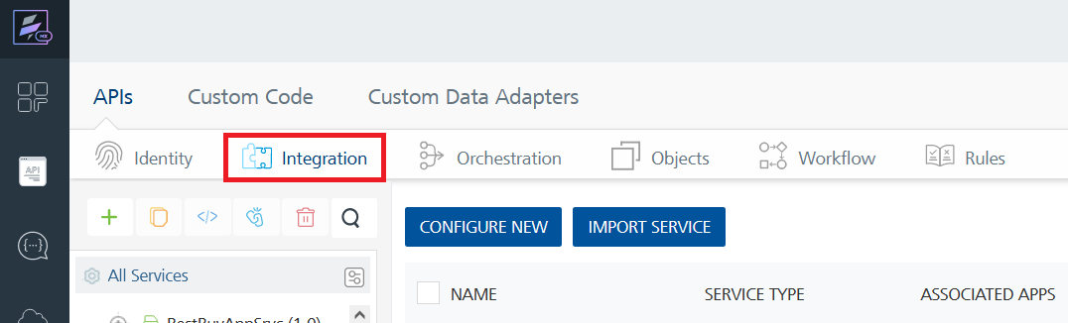
4. To create a new service, click the **+** button or the **CONFIGURE NEW** button.  
   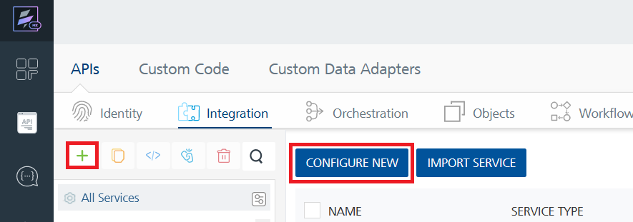
5. On the Service Definition tab, select the service type as **Strava** and click **SAVE**.  
   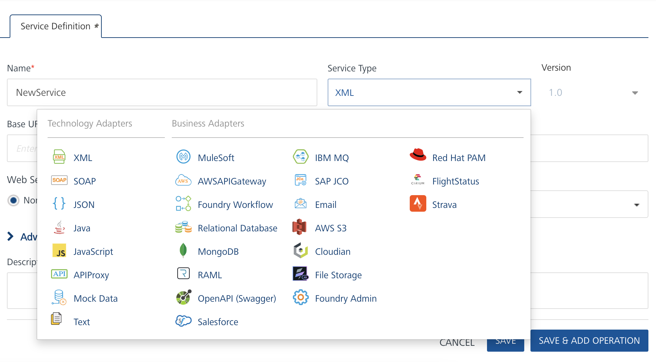

Alternatively, you can also create a Foundry app and create an Integration service inside it.

E. [Creating and Executing operations](javascript:void(0);)



After you create an integration service, you can create and execute operations using the service.

#### Creating an Operation

* In **API Management/Foundry app you created**, in the **Integration** section, select the service that you created.
* After you select the service, navigate to the **Operation List** tab.  
  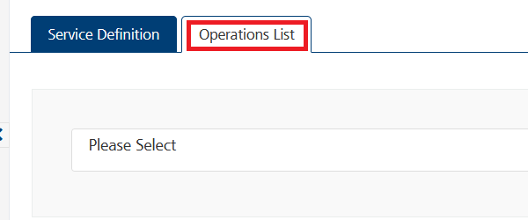
* From the drop-down list, select an operation that you want to execute, and click **ADD OPERATION**.  
  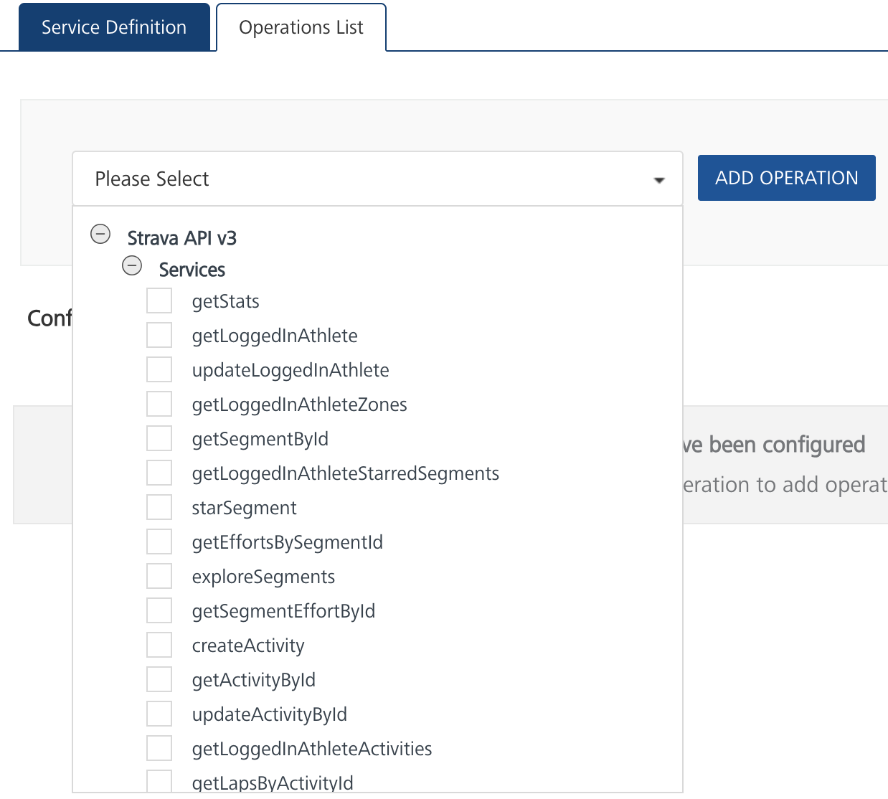

#### Executing an Operation

* From the **Operations List** tab, in the **Configured Operations** section, select the operation you want to execute.

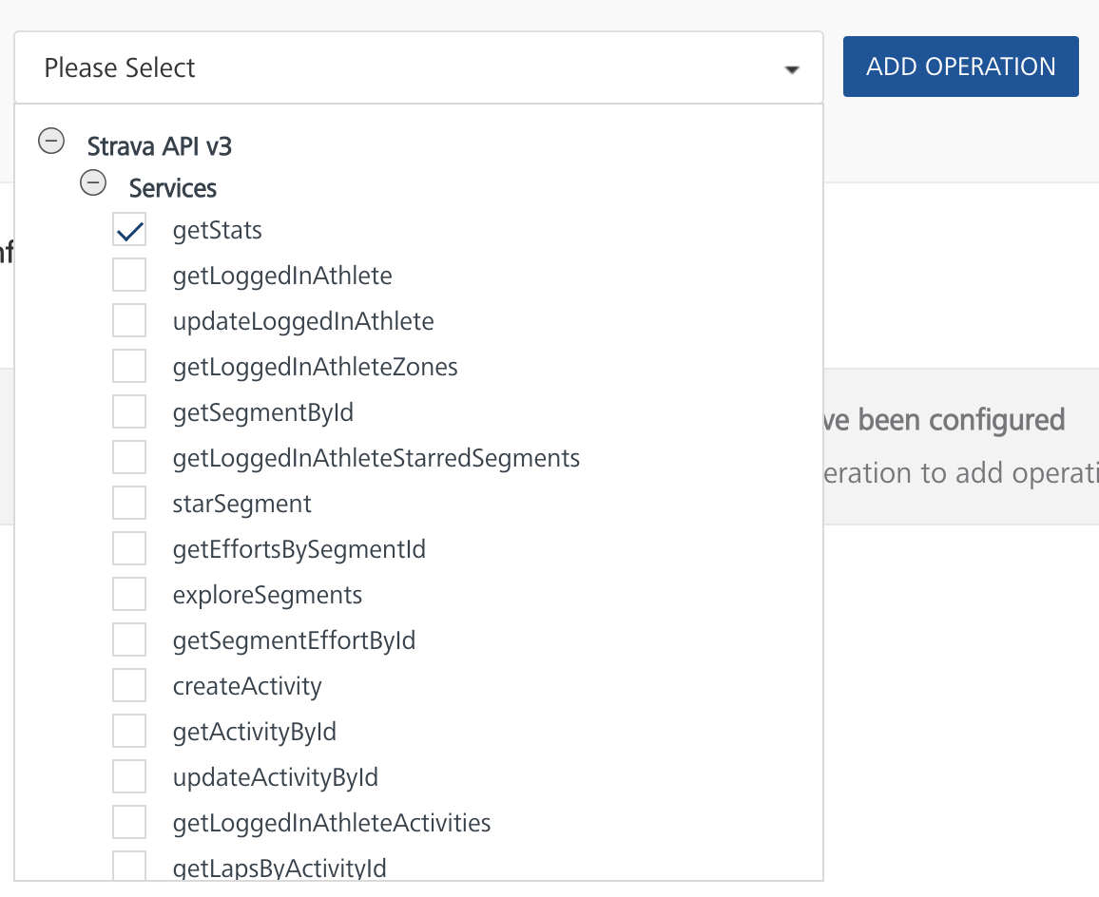

* On the Operation Page, in the Request Input tab, enter a TEST VALUE for all the fields under Body.  
  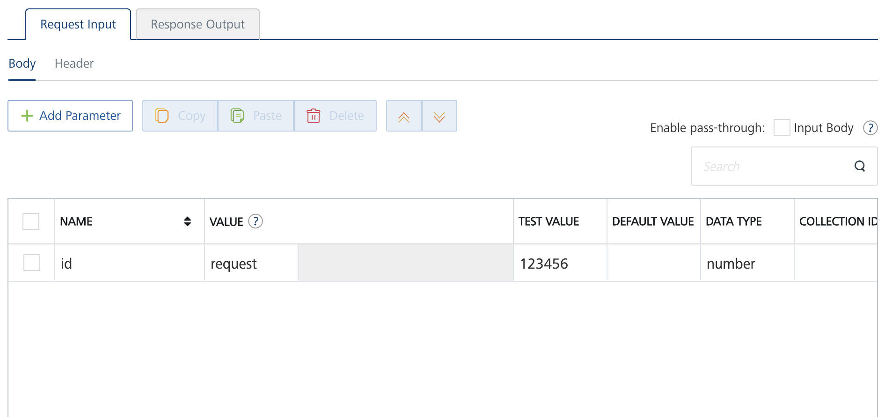
* Under the Header tab, add ***Bearer YOURACCESSTOKEN*** as value of the key “Authorization”. To get your access token, go to <https://www.strava.com/settings/api>. Access tokens expire every six hours.

Ignore the “Accept” key or delete.

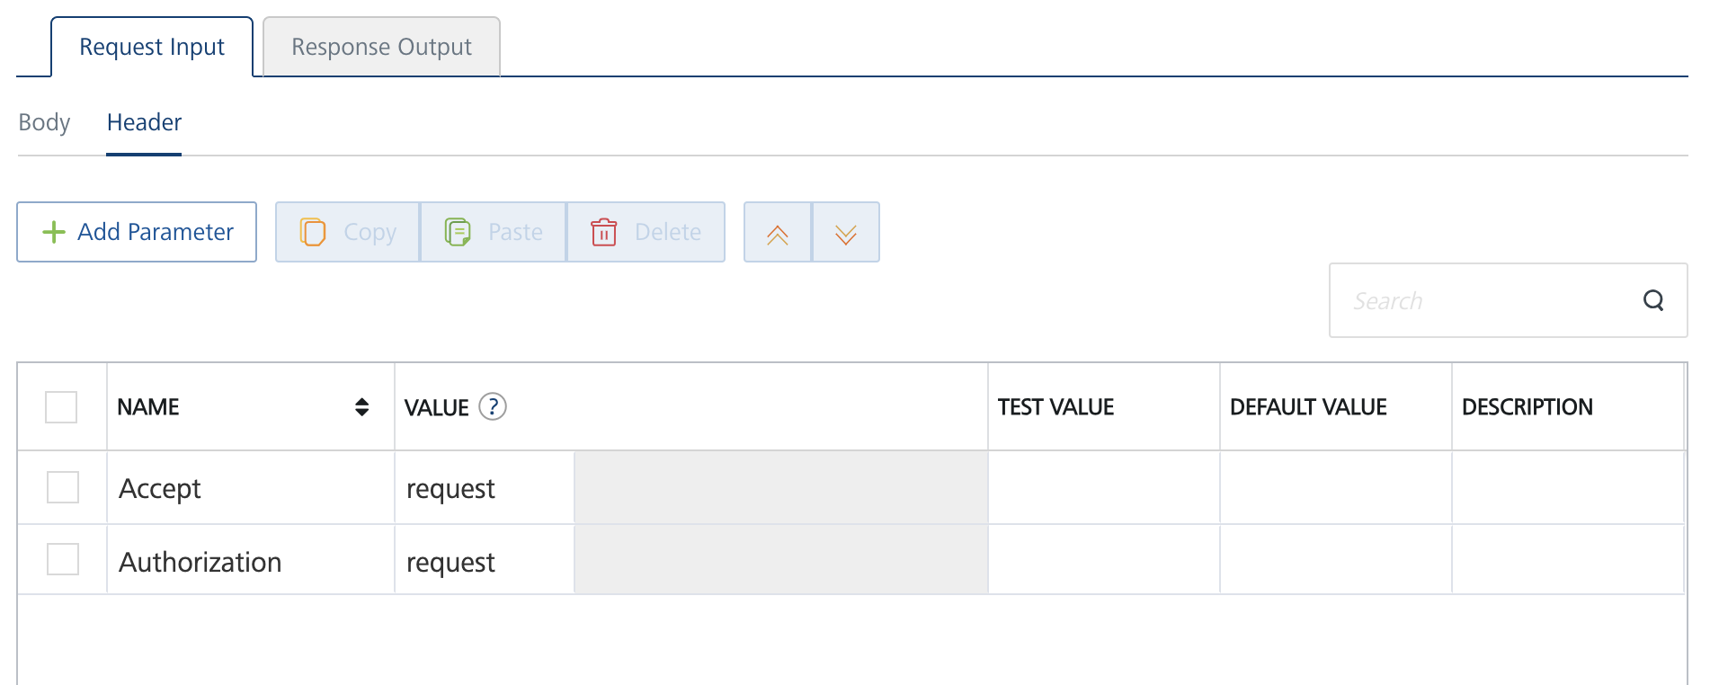

* Select a run-time environment and click **Save and Fetch Response** to get a response based on your inputs.  
  A blue rectangle with a black arrow

  Description automatically generated

## [Publishing your application](javascript:void(0);)

If you want to use the services in client applications, you need to publish an app to a run-time environment. You can create the service (as described above) in an application or import the service into an application and publish the application.

# References

## API Documentation: This Foundry adapter uses Strava APIv3 Open API spec documented at <https://developers.strava.com/docs/reference/>

## 

## 

## 

## 

## 

## Getting started with Strava API: <https://developers.strava.com/docs/getting-started/>

# Revision History

|  |  |  |  |
| --- | --- | --- | --- |
| Version | Date Uploaded | Uploaded By | Known Issues |
| 1.0.0 | 16-Oct-23 | Subhajit Saha (HCL Software) | - |