08 March 2024

horizontal bar chart – stacked bars

version: 1.1.1

- OVERVIEW
Horizontal Bar Chart – Stacked Bars (also known as Stacked Horizontal Bar Chart) component creates a chart or graph with horizontal bars stacked together based on the data that you provide. You can use the component in your mobile app to represent the comparison between distinct items or data in the form of horizontal bars. For examples, sales growth on monthly basis.
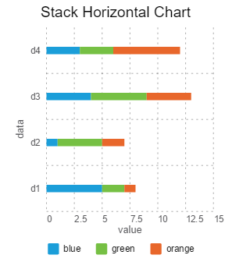

Use case:
Consider a scenario that you want to provide the stock market information in a use case in your application. In the app, you want to build a feature to represent variation in stock values of companies on monthly basis in the form of chart. You can use the Stacked Horizontal Bar Chart component to represent the variations of stock values in the form of chart with horizontal bars. To add the feature in your app, do the following:
- Import and add the Stacked Horizontal Bar Chart component in your app (created in Volt MX Iris).
- Set all required properties.
- Define a JSON array with all the required data and invoke the createChart API to generate the chart.

Features:
- Ready-to-use Chart
- Useful component for project analysis
- Easy to plug into your app
- Facility to modify the UI

Percentage of re-use:
85%-90% (Data can be customizable and skins are customized and can be changed manually).

Getting Started

Prerequisites
Before you start using the Stacked Horizontal Bar Chart component, ensure the following:
• HCL Foundry
• Volt MX Iris

Platforms Supported
- Mobile
- iOS
- Android

- PWA & Responsive Web

Importing the app

You can import the Forge components only into the apps that are of the Reference Architecture type.

To import the Stacked Horizontal Bar Chart component, do the following:

Open your app project in Volt MX Iris.
- In the Project Explorer, click the Templates tab.
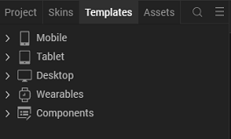
- Right-click Components, and then select Import Component. The Import Component dialog box appears.
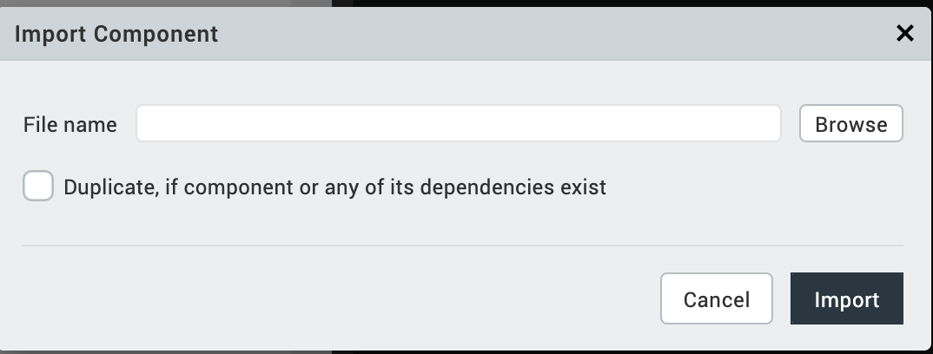
- Click Browse to navigate to the location of the component, select the component, and then click Import. The component and its associated widgets and modules are added to your project.

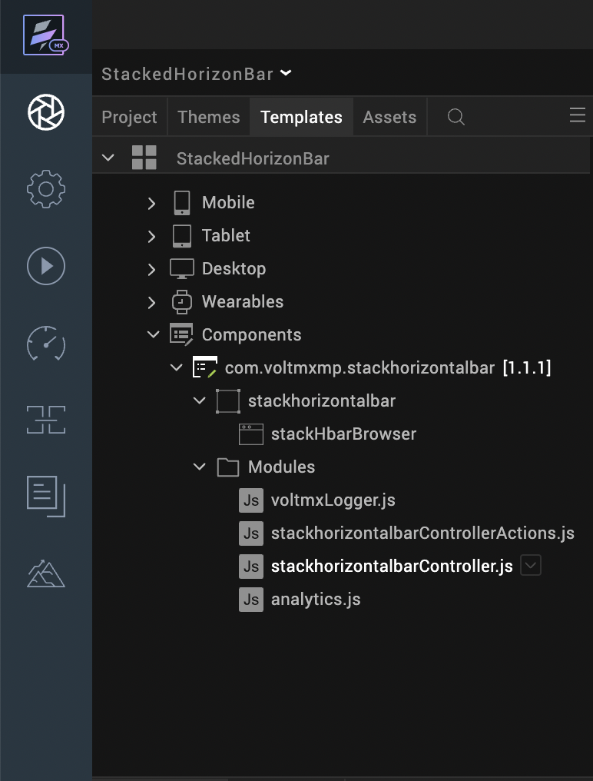
Once you have imported a component to your project, you can easily add the component to a form. For more information, refer Add a Component to a Form
Note:
- Changes made to the properties are reflected only during run time, but not during design time (Volt MX Iris Canvas).
- The createChart API must be invoked to reflect the dynamic change of any property after adding the chart to a form either by drag and drop method or dynamic creation.

Building and previewing the app
After performing all the above steps, you can build your app and run it on your device. For more information, you can refer to the Building and Viewing an Application section of the Volt MX User Guide.
You can then run your app to see the Stacked Horizontal Bar Chart work in real time.

References

Dynamic Usage
You can also add Stacked Horizontal Bar Chart component dynamically. To do so,
- In the Project Explorer, on the Projects tab, click Controllers section to access the respective Form Controller. Create a method and implement the code snippet similar to the sample code mentioned below.
/* Creating the component s object */
var stackhorizontalbar = new com.voltmxmp.stackhorizontalbar(

{

"autogrowMode": voltmx.flex.AUTOGROW_NONE,

"clipBounds": true,

"height": "100%",

"id": "stackhorizontalbar",

"isVisible": true,

"layoutType": voltmx.flex.FREE_FORM,

"left": "0%",

"masterType": constants.MASTER_TYPE_USERWIDGET,

"skin": "slFboxSkin",

"top": "5%",

"width": "100%"

}, {}, {});

/* Setting the component s properties */
stackhorizontalbar.lowValue = "0";
stackhorizontalbar.highValue = "40";
stackhorizontalbar.bgColor = "#FFFFFF";
stackhorizontalbar.enableChartAnimation = true;
stackhorizontalbar.enableStaticPreview = true;
stackhorizontalbar.xAxisTitle = "Day";
stackhorizontalbar.yAxisTitle = "Rate";
stackhorizontalbar.enableGrid = true;
stackhorizontalbar.enableGridAnimation = false;
stackhorizontalbar.enableLegends = true;
stackhorizontalbar.legendFontColor = "#000000";
stackhorizontalbar.legendFontSize = "95%";
stackhorizontalbar.chartTitle = "Stacked Horizontal Bar Chart";
stackhorizontalbar.titleFontSize = "12";
stackhorizontalbar.titleFontColor = "#000000";

stackhorizontalbar.chartData =

{

"data":

[

{

"label": "d1",

"stackValue1": "20",

"stackValue2": "2",

"stackValue3": "5",

"stackValue4": "3",

"stackValue5": "10",
},

{

"label": "d2",

"stackValue1": "15",

"stackValue2": "4",

"stackValue3": "5",

"stackValue4": "6",

"stackValue5": "5",
},

{

"label": "d3",

"stackValue1": "10",

"stackValue2": "7",

"stackValue3": "3",

"stackValue4": "1",

"stackValue5": "9",
},

{

"label": "d4",

"stackValue1": "8",

"stackValue2": "3",

"stackValue3": "6",

"stackValue4": "1",

"stackValue5": "2",
},
{

"label": "d5",

"stackValue1": "2",

"stackValue2": "1",

"stackValue3": "3",

"stackValue4": "2",

"stackValue5": "4",
},
]

};

stackhorizontalbar.stackDetails =

{

"data":

[

{"color": "#1B9ED9", "legendName": "blue"},

{"color": "#76C044", "legendName": "green"},

{"color": "#F26B29", "legendName": "orange"},

{"color": "#7A54A3", "legendName": "purple"},

{"color": "#DAA520", "legendName": "yellow"},

]

};
/* Adding the component to the form */
this.view.add(stackhorizontalbar);

In the code snippet, you can edit the properties of the component as per your requirement. For more information, see Setting Properties.
2. Save the file

Properties
The properties provided on the Component tab allows you to customize the elements in the Stacked Horizontal Bar Chart component. These elements can be UI elements, service parameters, and so on. You can set the properties from the Volt MX Iris Properties panel on the right-hand side. You can also configure these properties using a JavaScript code.
Note: If you copy code from any example, make sure that you replace componentID with the name of your component.
General Properties

- Background Color
Description: | Specifies background color of the chart.
Syntax:
  bgColor
Type: | String
Read/Write: | Write
Example: | this.view.componentID.bgColor = "#FFFFFF";

- Enable Chart Animation
Description: | Controls whether or not to enable the chart animation.
Syntax:
  enableChartAnimation
Type: | Boolean
Read/Write: | Write
Remarks: | Disabling the chart animation will also disable the grid animation.
Example: | this.view.componentID.enableChartAnimation = true;
- Low Value
Description: | Specifies the starting value on the horizontal (x) axis. The minimum value is the start index on x-axis.
Syntax:
  lowValue
Type: | String
Read/Write: | Write
Remarks: | Low and High values must be passed according to the data passed to the charts.
Example: | this.view.componentID.lowValue = "0";

- High Value
Description: | Specifies the maximum value on horizontal (x) axis. The maximum value is the end index on x-axis.
Syntax:
  highValue
Type: | String
Read/Write: | Write
Remarks: | Low and High values must be passed according to the data passed to the charts.
Example: | this.view.componentID.highValue = "50";

- Chart Data
Description: | Enables a user to provide the data to generate the chart.
Syntax:
  chartData
Type: | Data Grid
Read/Write: | Write
Remarks: | The property cannot be changed dynamically.

Description: | Enables a user to provide color codes for the stacks in the bars and their respective legend names.
Syntax:
  stackDetails
Type: | Data Grid
Read/Write: | Write
Remarks: | The property cannot be changed dynamically.
- Details of Stacks in Bars

- Enable Chart with Static Data
Description: | Controls whether or not to enable the Static data in the chart.
Syntax:
  enableStaticPreview
Type: | Boolean
Read/Write: | Write
Remarks: | The default value of the property is true.
Example:
  this.view.componentID.enableStaticPreview = true;

Axis Titles
- X-axis Title
Description: | Specifies the text to be displayed as the x-axis (horizontal axis) title.
Syntax:
  xAxisTitle
Type: | String
Read/Write: | Write
Example: | this.view.componentID.xAxisTitle = "Day";

- Y-axis Title
Description: | Specifies the text to be displayed as the y-axis (vertical axis) title.
Syntax:
  yAxisTitle
Type: | String
Read/Write: | Write
Example: | this.view.componentID.yAxisTitle = "Rate";

Grid
- Enable Grid
Description: | Controls whether or not to enable the chart grid.
Syntax:
  enableGrid
Type: | Boolean
Read/Write: | Write
Example: | this.view.componentID.enableGrid = true;

- Enable Grid Animation
Description: | Controls whether or not to enable the grid animation.
Syntax:
  enableGridAnimation
Type: | Boolean
Read/Write: | Write
Example: | this.view.componentID.enableGridAnimation = false;

Title
- Chart Title
Description: | Specifies the text to be displayed as the Chart title.
Syntax:
  chartTitle
Type: | String
Read/Write: | Write
Example: | this.view.componentID.chartTitle = "Stacked Horizontal Bar Chart";

- Title Font Size
Description: | Specifies the font size of the Chart title.
Syntax:
  titleFontSize
Type: | String
Read/Write: | Write
Example: | this.view.componentID.titleFontSize = "12";

- Title Font Color
Description: | Specifies the font color of the Chart title.
Syntax:
  titleFontColor
Type: | String
Read/Write: | Write
Example: | this.view.componentID.titleFontColor = "#000000";

Legends

- Enable Legends
Description: | Controls whether or not to enable the Legends.
Syntax:
  enableLegends
Type: | Boolean
Read/Write: | Write
Remarks: | The default value of the property is true.
Example: | this.view.componentID.enableLegends = true;

- Legend Font Color
Description: | Specifies the font color of the Chart legend.
Syntax:
  legendFontColor
Type: | String
Read/Write: | Write
Remarks: | The default value of the property is "#000000".
Example: | this.view.componentID.legendFontColor = "#000000";

- Legend Font Size
Description: | Specifies the font size of the Chart legend.
Syntax:
  legendFontSize
Type: | String
Read/Write: | Write
Remarks: | The default value of the property is "95%".  The font size must be between 95% and 120% for better UI.
Example: | this.view.componentID.legendFontSize = "95%";

Note: In few scenarios, the Legends may behave in a weird manner.

Events

None of the events are exposed.

API’s

The following API pertains to the Stacked Horizontal Bar Chart component.

createChart

Description: | The API creates a Stacked Horizontal Bar Chart.
Syntax: | createChart(data, stackDetails)
Parameters: | data:  JSON array contains the data based on which the Stacked Horizontal Bar Chart is generated. The JSON array should contain data of row names and the corresponding values to generate bars for the rows, in the key-value pair format. Here is the JSON array format:
  var chartData =
  [
  {label: "d1", stackValue1: "10", stackValue2: "20"},
  {label: "d2", stackValue1: "20", stackValue2: "30"},
  ];
In the above format, label and stackValuei are keys and they are case sensitive.
- label: The key accepts string values, so define the value within the quotation marks. You can specify upto 04 characters as a column name. For example, "lbl1". Specifying more than 04 characters results distortion in the component UI.
- stackValues: The key accepts integer values.
stackDetails:
JSON array contains the data based on which the colors are assigned to the respective legends. Here is the JSON array format:

var stackDetails =

[

{legendName: "blue", color: "#1B9ED9"},

{legendName: "green", color: "#76C044"}

];
In the above format, legendName, color key is case sensitive.
- legendName: The key accepts value for the legend names. The key accepts string values, so define the value within the quotation marks.
- color: The key accepts color code values.
The component can conveniently handle a maximum of 07 key-value pairs in the JSON array. Defining more than 07 key-value pairs results distortion in the component UI.
The component supports upto 5 stack values.

Return Value: | None
Example:
  var chartData =
  [
  {label: "d1", stackValue1: "10", stackValue2: "20"},
  {label: "d2", stackValue1: "20", stackValue2: "30"},
  ];
  var stackDetails =
  [
  {legendName: "blue", color: "#1B9ED9"},
  {legendName: "green", color: "#76C044"}
  ];
  this.view.stackhorizontalbar.chartData = {data: chartData};
  this.view.stackhorizontalbar.stackDetails = {data: stackDetails};
  this.view.stackhorizontalbar.createChart(chartData, stackDetails);

Note:
- The data must be passed in a proper format (without any missing values).
- The number of color codes which are passed must be equal to the number of stacks.
- Never pass an empty JSON for colors.

Revision History
App version 1.1.1:

Known Issues
Following are the known issues in the Stacked Horizontal Bar Chart component:
- On Android, when adding the component dynamically, the layout of the component does not show up as expected.
- Cannot handle layout properties of the component as per the device orientation. You must handle the properties at the form level.

Limitations
Following are the limitations in the Stacked Horizontal Bar Chart component:
- The label names on the horizontal axis and vertical axis must not contain more than three characters. Providing more characters will cause an overlap in the axis names.
- The maximum length of the data that can be passed to the chart is seven. Exceeding the limit leads to UI distortions.

