Date : 12-Mar-2024

social share

version: 2.0.1

Overview
This component provides sharing different media content over the internet. APIs are provided to share files with other people.

Use case:

Social share is a typical option included in a variety of applications especially e-commerce.

Features

Different options for sharing are provided when the API is called.

Sharing can be done for single/multiple files.

It works for different types of files such as images, videos, and Documents.

Percentage of re-use:
80-90%. (Data can be customizable and skins are not customized but can be changed manually)

Getting Started

Prerequisites
Before you start using the component, ensure you have the following:
- HCL Foundry
- Volt MX Iris

Platforms Supported

Mobile

iOS

Android

Tablets

iOS

Android

Importing the app
1. Open your app project in Volt MX Iris.
2. In the Project Explorer, click the Templates tab.

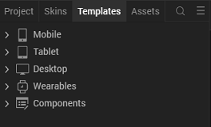

3.Right-click Components, and then select Import Component. The Import Component dialog box appears.
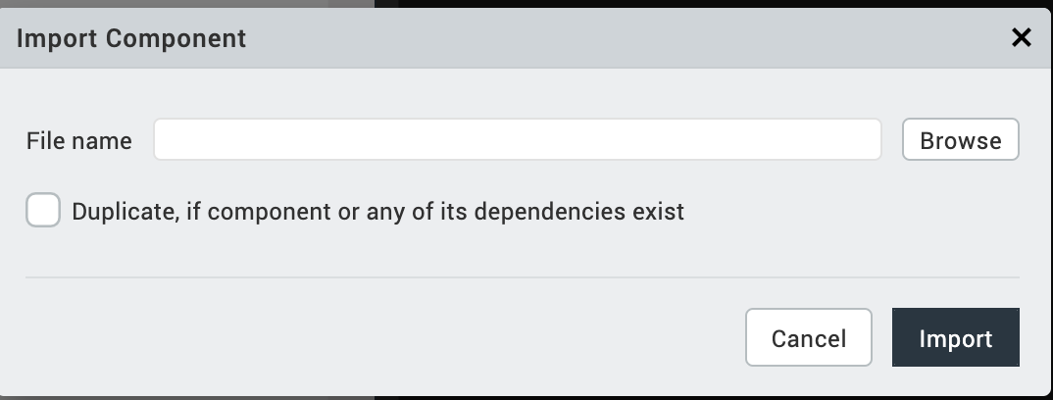
4.Click Browse to navigate to the location of the component, select the component, and then click Import. The component and its associated widgets and modules are added to your project.
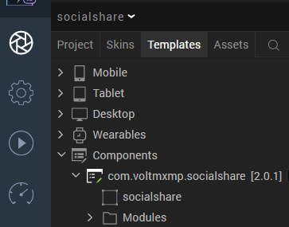

Once you have imported a component to your project, you can easily add the component to a form. For more information, refer Add a Component to a Form.

Configuring Native Settings (Android)

Configuring the Manifest file (Application Tag)
To access files that you add to your project from the device, you need to create an XML file that specifies the directories that you want to share. For more information, refer to Specifying the Sharable Directories in the XML file.
After you create the XML file, copy the file into the following folder of your project workspace: resources/mobile/native/android/xml. If the xml folder does not exist, you can create the folder.
After you copy the file to the Android folder, you need to configure the Manifest properties of the project.
Follow the given steps to configure the application tag.
- Open your Project Settings from Volt MX Iris.
- Go to the Native – Android Mobile/Tablet
- Under Android, go to tab Tags.
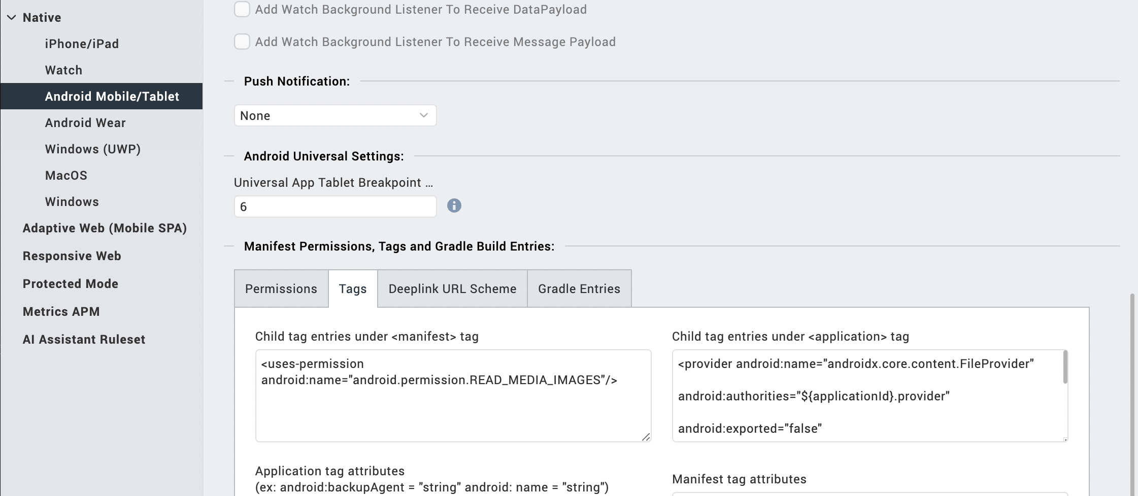
- Enter the given code snippet in Child tag entries under <application> tag.
<provider android:name="androidx.core.content.FileProvider"
android:authorities="${applicationId}.provider"
android:exported="false"
android:grantUriPermissions="true">
<meta-data android:name="android.support.FILE_PROVIDER_PATHS"
android:resource="@xml/filepaths" />
</provider>
- Enter the given snippet in Child tag entries under <manifest > tag.

<uses-permission android:name="android.permission.READ_MEDIA_IMAGES"/>

Run-time Permissions
On the Android platform, the social share component requires the WRITE_EXTERNAL_STORAGE permissions.
To enable the permissions, follow these steps:
- From the left navigation bar, select Project Settings.
- From the Project Settings window, go to Native → Android Mobile/Tablet.
- Scroll down to Manifest Permissions, Tags and Gradle Build Entries.
- Set the WRITE_EXTERNAL_STORAGE permission to true.
To set a permission to true, select the permission from the left panel and click Add >.
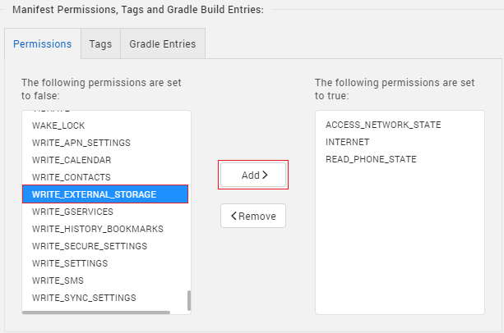
Note: Need to enable "Use Google Pay Location Services" for android in the project settings. From Project Settings window, go to Native → Android Mobile/Tablet and enable Use Google Pay Location Services.
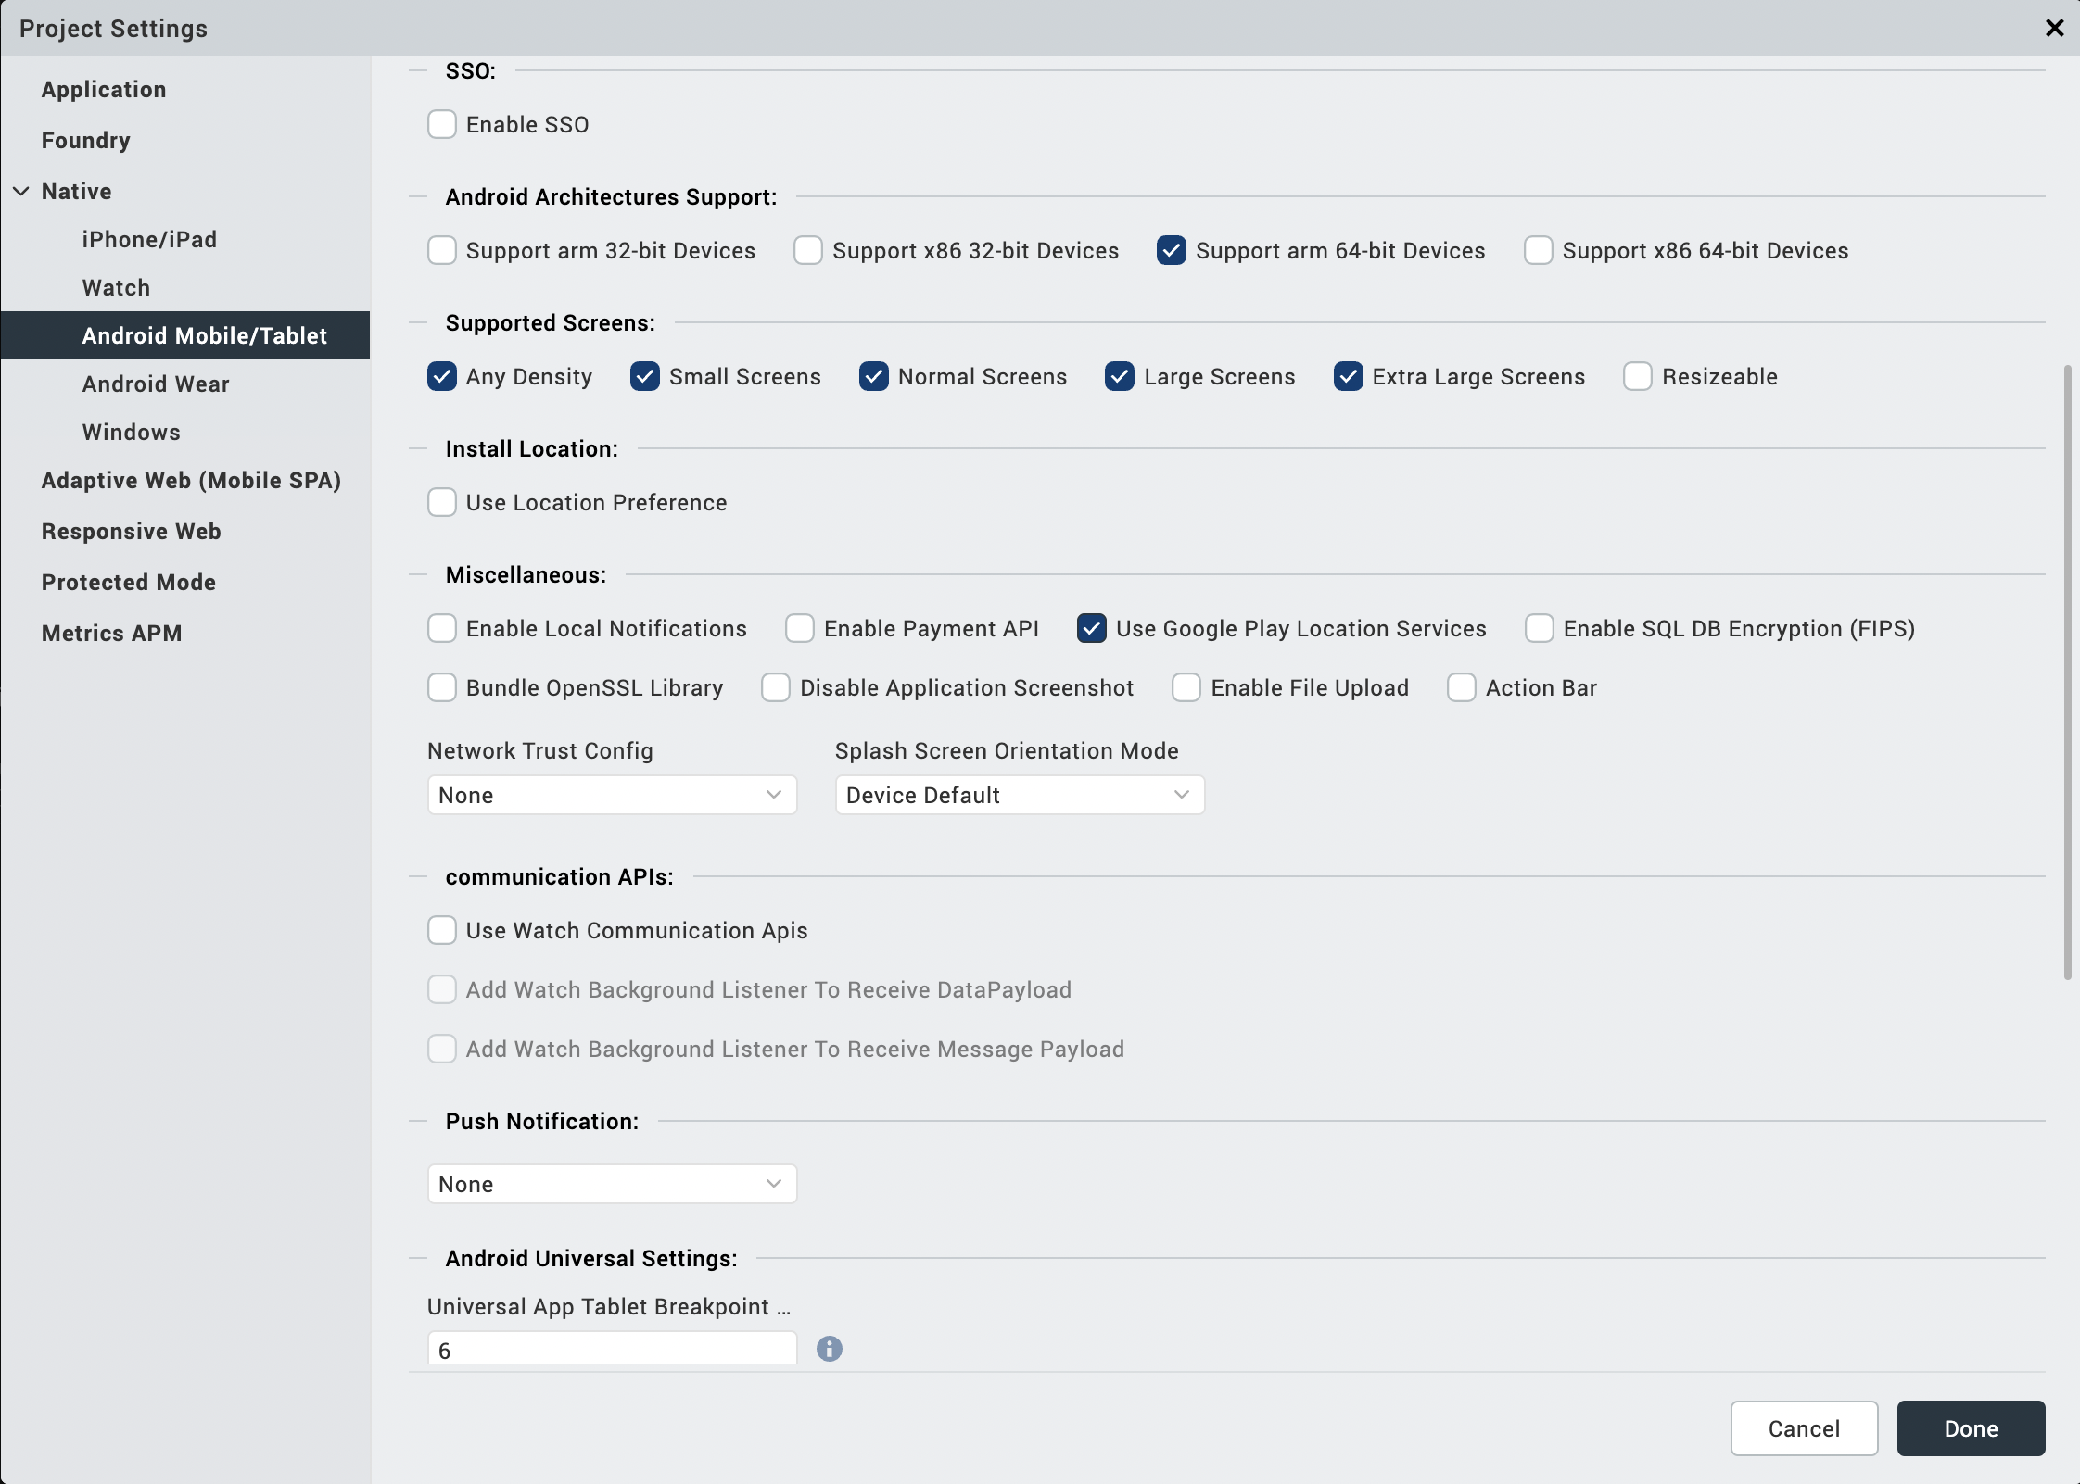

Configuring Native Settings (iOS)
Follow the given steps to enable the permissions.
- From the Project explorer, navigate to the Assets tab.
- Right click Media and select Resource Location to open the project resources folder.
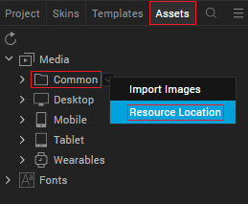
- In the browser window that opens, navigate to the common folder.
- Open the infoplist_configuration.json file with a text or code editor.
- Add the given code at the end of the file. You can replace the values with your own descriptions.
{
"NSCameraUsageDescription" : "Your Description",
"NSPhotoLibraryUsageDescription": "Your Description",
"NSPhotoLibraryAddUsageDescription”:” Your Description”
}
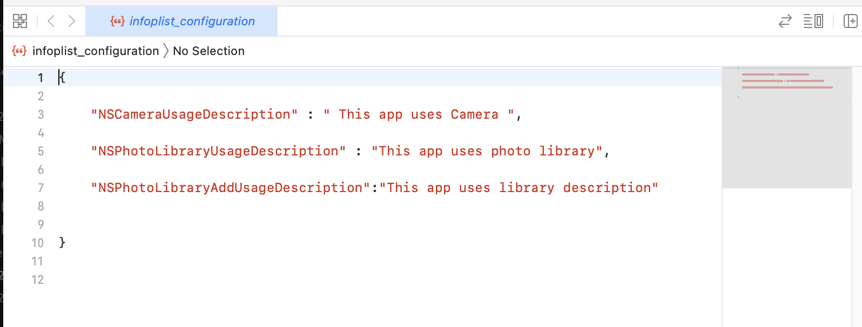
- Save the file.

Building and previewing the app

Refer to below links:

Build & Generate Native Apps

Publish Apps to Enterprise App Store

References

Dynamic Usage
- In the Project Explorer, on the Projects tab, click Controllers section to access the respective Form Controller. Create a method and implement the code snippet similar to the sample code mentioned below.
In the code snippet, you can edit the properties of the component as per your requirement. For more information, see Setting Properties.

var socialshare = new com.voltmxmp.socialshare(
{
"autogrowMode": voltmx.flex.AUTOGROW_NONE,
"clipBounds": true,
"height": "50%",
"id": "socialshare",
"isVisible": true,
"left": "0dp",
"top": "0dp",
"width": "100%"
}, {}, {});

/* Setting the component's properties */
socialshare.title = "Share To";

/* Adding the component to a form */
this.view.add(socialshare);
- Save the file.

Properties

Android

Title
Description: | Specifies the title for the share dialogue.
Syntax: | title
Type: | String
Read/Write: | Write
Default Value: | "Voltmx"
Example: | this.view.<componentID>.title = "Share To";

Events

onErrorCallback
Description: | Invoked when an error occurs in the component.
Syntax: | onErrorCallback
Parameters: | error [Object]:  Information about the error such as error type and error message.
Example: | this.view.<componentID>.onErrorCallback = function(error)  {  alert("Error: "+error);  }.bind(this);

API’s
The following APIs pertain to the Social Share component:

shareWithFilepath
Description: | Shares files using the file paths.
Syntax: | shareWithFilepath(filepaths)
Parameters: | filepaths [Array]:  Contains the paths of the files that you want to share.
Return Value: | None
Example: | var filepaths =  [  "/storage/emulated/0/sample.png",  "/storage/emulated/0/sample2.png"  ];  this.view.componentID.shareWithFilepath(filepaths);

shareWithBase64
Description: | Shares a file using the name and base64 value.
Syntax: | shareWithBase64(base64, filename)
Parameters: | base64 [String]:  The base64 value of the file that you want to share.  filename [String]:  The name of the file that you want to share.
Return Value: | None.
Example: | var base64 = this.view.imageWidget.base64;  var filename = "imageName.png";  this.view.componentID.shareWithBase64(base64, filename);

Revision History
App version 2.0.1

Known Issues

N/A

Limitations

In IOS, while sharing the Documents, can’t see Instagram in the options to share.

In Android, while sharing the documents, can’t see Facebook, Instagram in the options to share.

In IOS, we can’t share images, videos through WhatsApp.

