Date: 20-03-2025

SNOWFLAKE TABLES API

VERSION: 1.0.0

1.OVERVIEW
The Tables API enables programmatic access to table-related operations within your database system.

A. Features:
- Query Execution: Perform queries on specific tables, allowing precise data retrieval based on defined criteria.
- Metadata Retrieval: Retrieve detailed information about tables, including column names, data types, constraints, and relationships between tables.
- Table Management: Create, update, and delete tables within your database schema, enabling dynamic schema management.
- Table Structure Exploration: Access the structure of a table, including column definitions and indexes, to better understand how data is organized.

B. Percentage of re-use:
Approximately 80% of reuse.
2. Getting Started
A. Prerequisites

Volt Foundry
- Volt MX Iris
- Snowflake Account with client id and secret key.
B. Obtaining the client id and secret keys.
- Start a free trial by creating an account.
- After creating the account, we need to provide security integration in the Worksheet of snowflake by giving those voltmx callback urls etc.
create or replace security integration DEMOHUB_INT
type = oauth
enabled = true
oauth_client = custom
oauth_client_type = 'CONFIDENTIAL'
oauth_redirect_uri = 'https://100000017.auth.hclvoltmx.net/oauth2/callback'
oauth_issue_refresh_tokens = true
oauth_refresh_token_validity = 86400
;

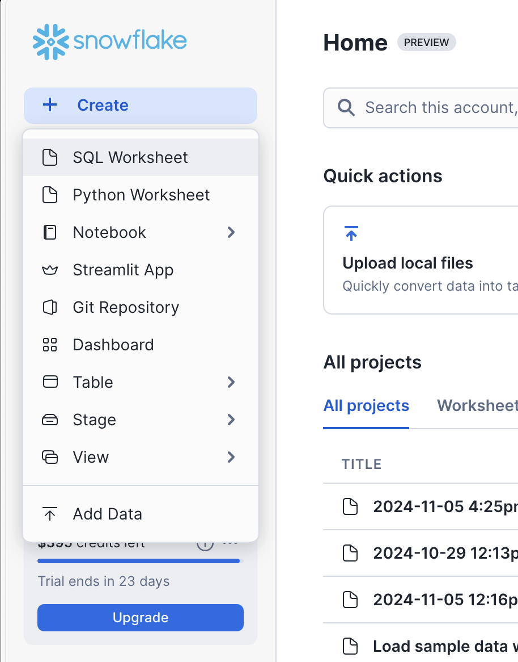

- After we need to get the keys for that we need to give this query in the worksheet. We will get client id, authorisation end point, token end point.
DESCRIBE SECURITY INTEGRATION DEMOHUB_INT;

4. After that we need to get the secret key for that we need to give this query.

select system$show_oauth_client_secrets('DEMOHUB_INT');

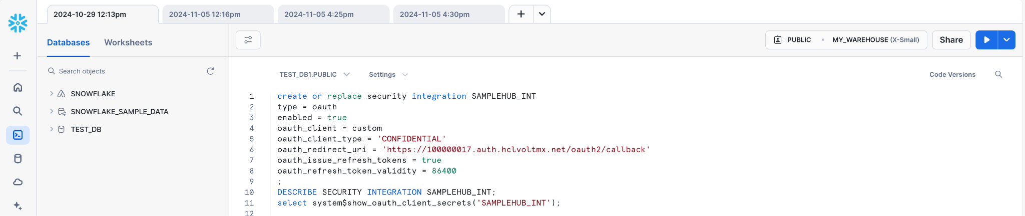

reference screenshot for using the client id, authorization end point, token end point, secret key.

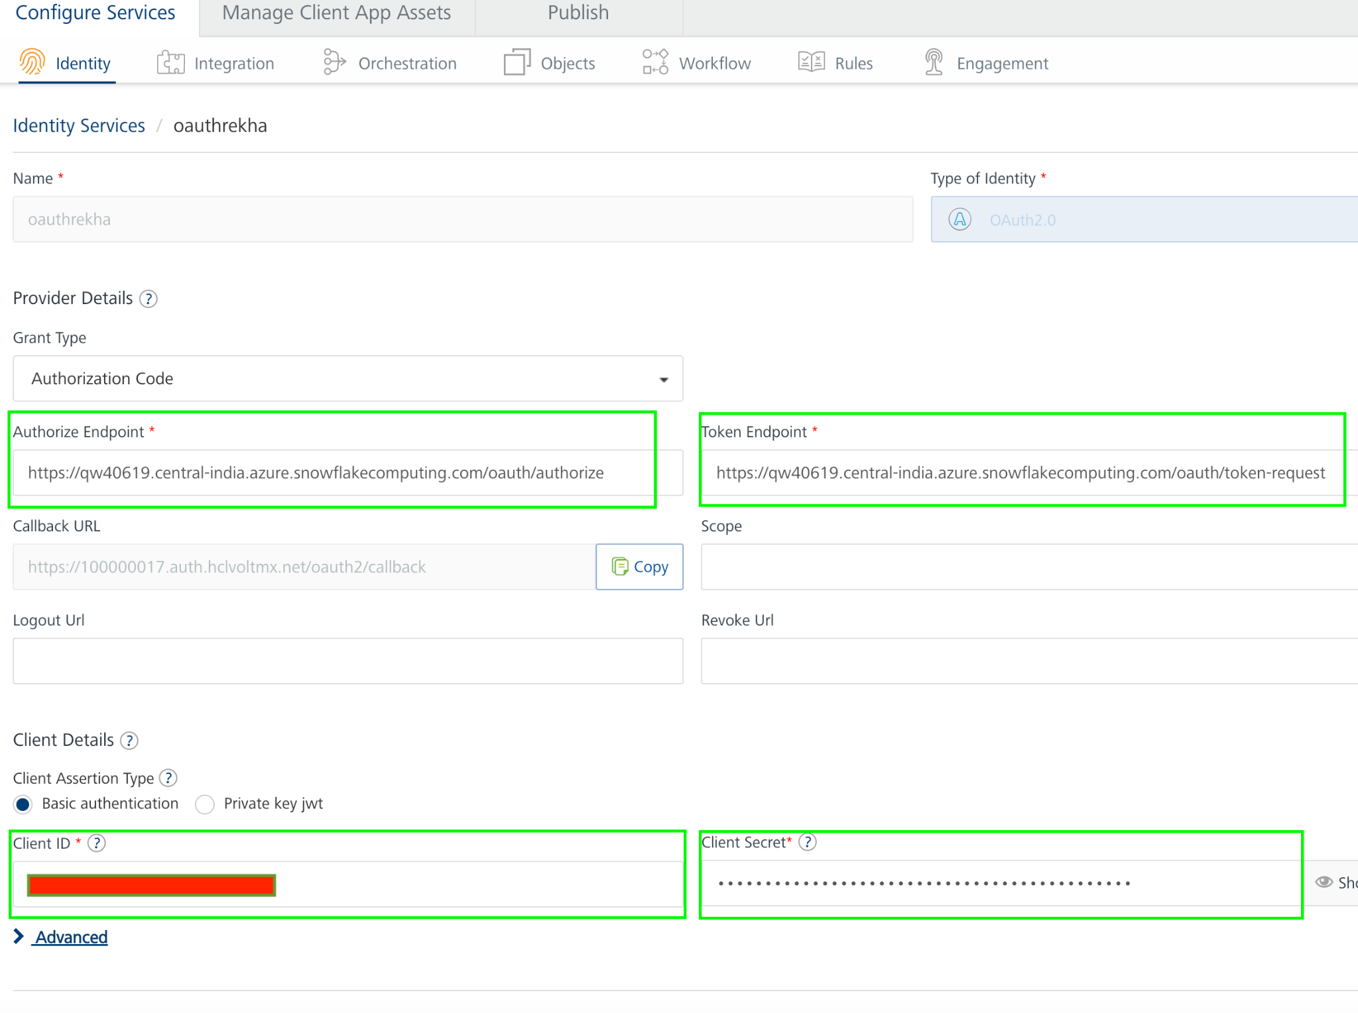

5. By using these we will create an Identity service in Foundry.
6. To get successful test login of identity service, the default role should be public in the snowflake account; the setup is as shown in the below screenshot.
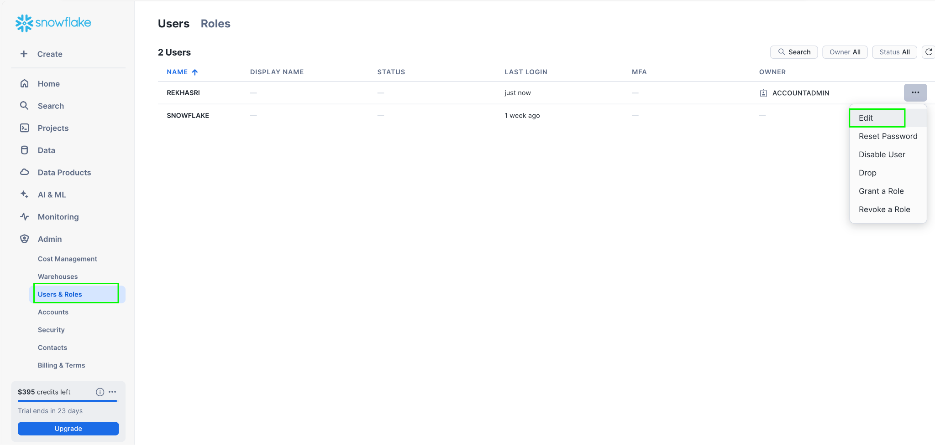

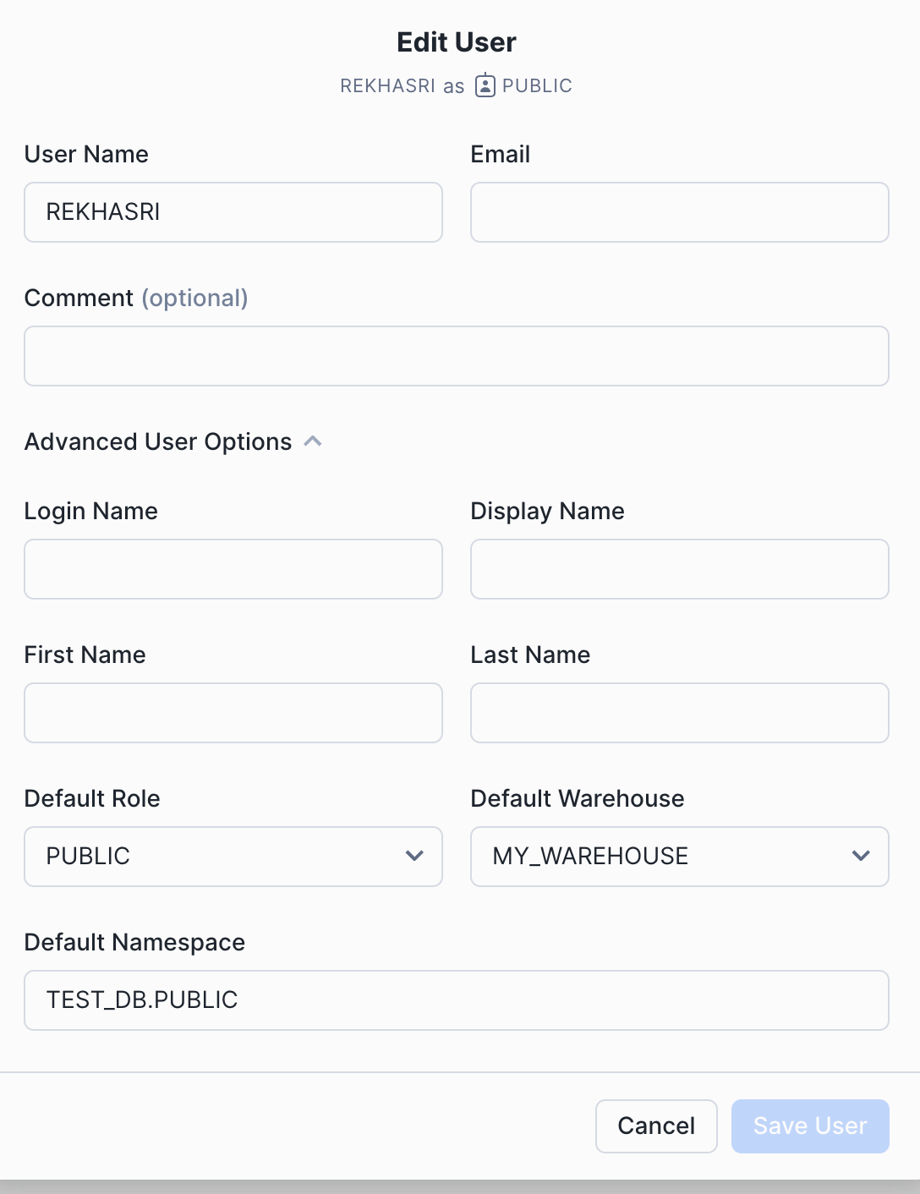
with all respective field details.
6. Reference screenshot of identity service in voltmx foundry

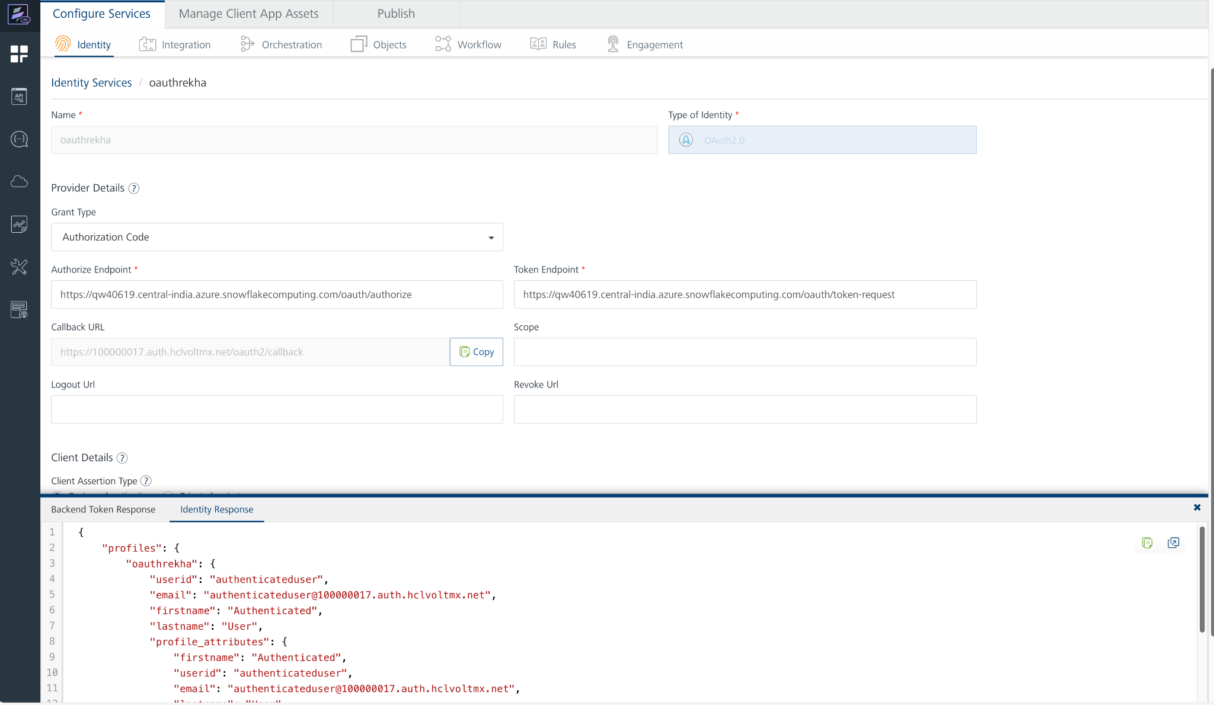
6. And then we will get a Bearer token as well after successful test login.
7. In this response we will get a claims token, that we can use as Authorization value in the header. Before value we need to add Bearer like below screenshot.
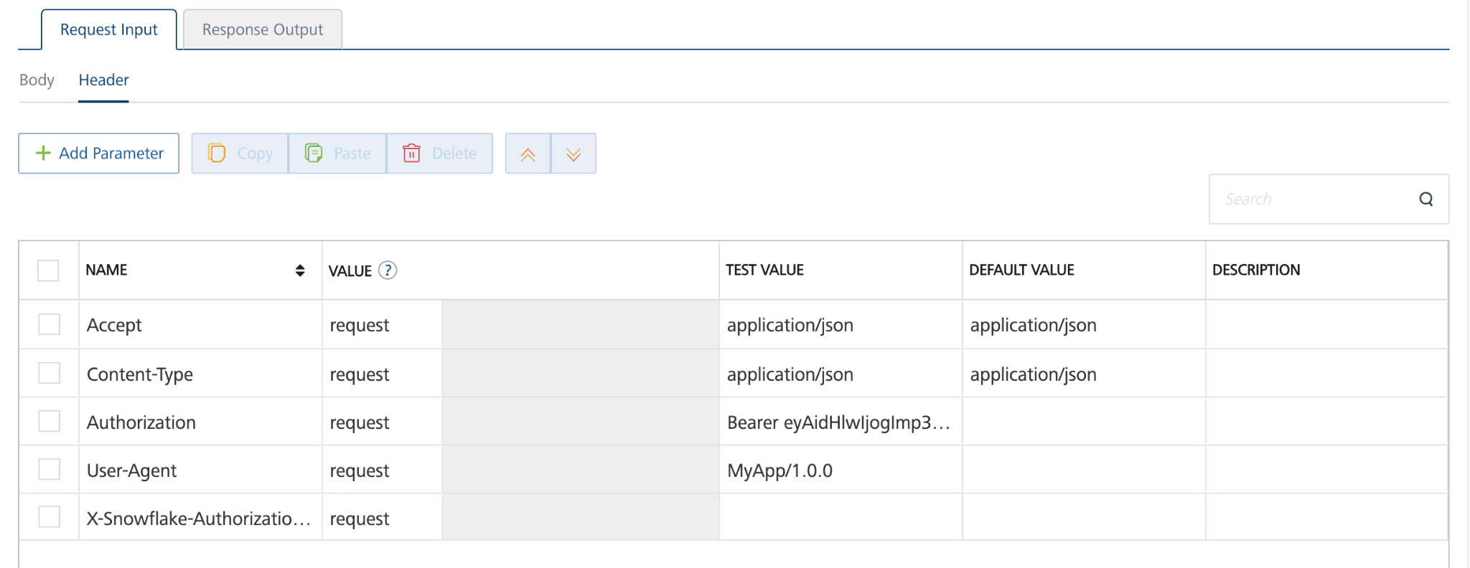
C.Importing the adapter

- Sign in to the HCL Foundry Console.
- From the left navigation menu, select API Management.
In API Management, select Custom Data Adapters.
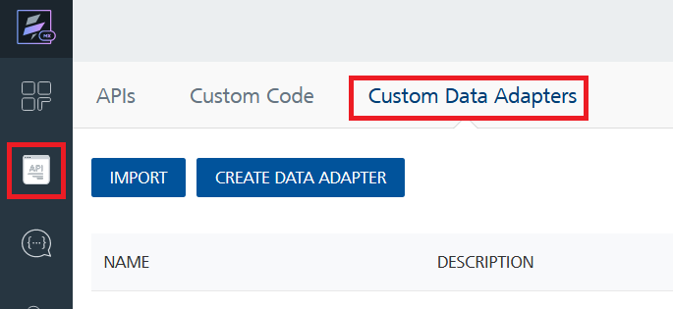

- Click IMPORT to import a custom data adapter.
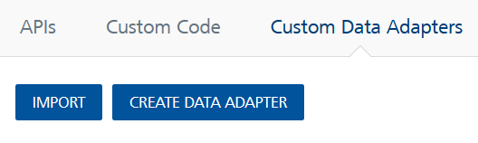

- On the Import Data Adapter dialog box, click browse to import.
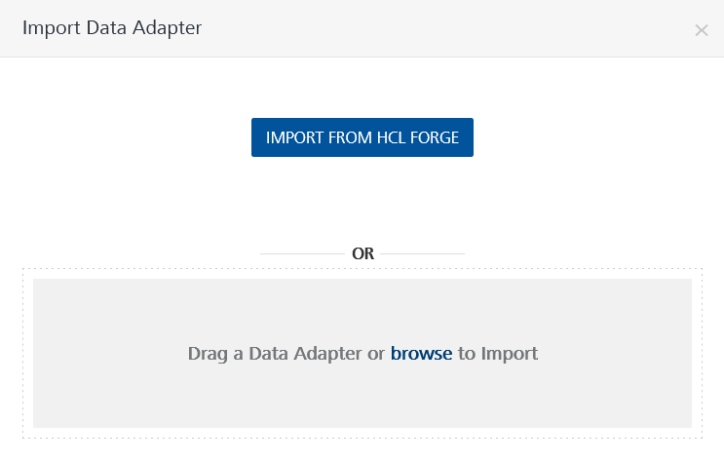
- Select data adapter zip file and click IMPORT.
- After importing the Snowflake Tables data adapter, Volt Foundry opens a window that shows the metadata of the data adapter.
- After you import the data adapter, you can view it on the Custom Data Adapters page and use it to create services on VoltMX Foundry.
- Replace the server url under connection parametres with the current url from snowflake website.
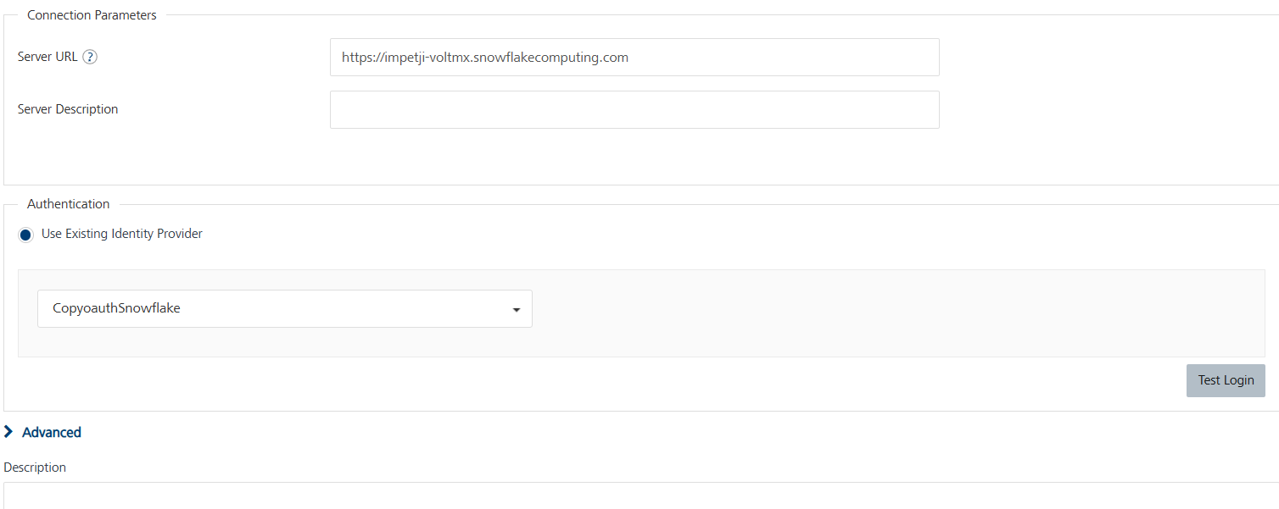

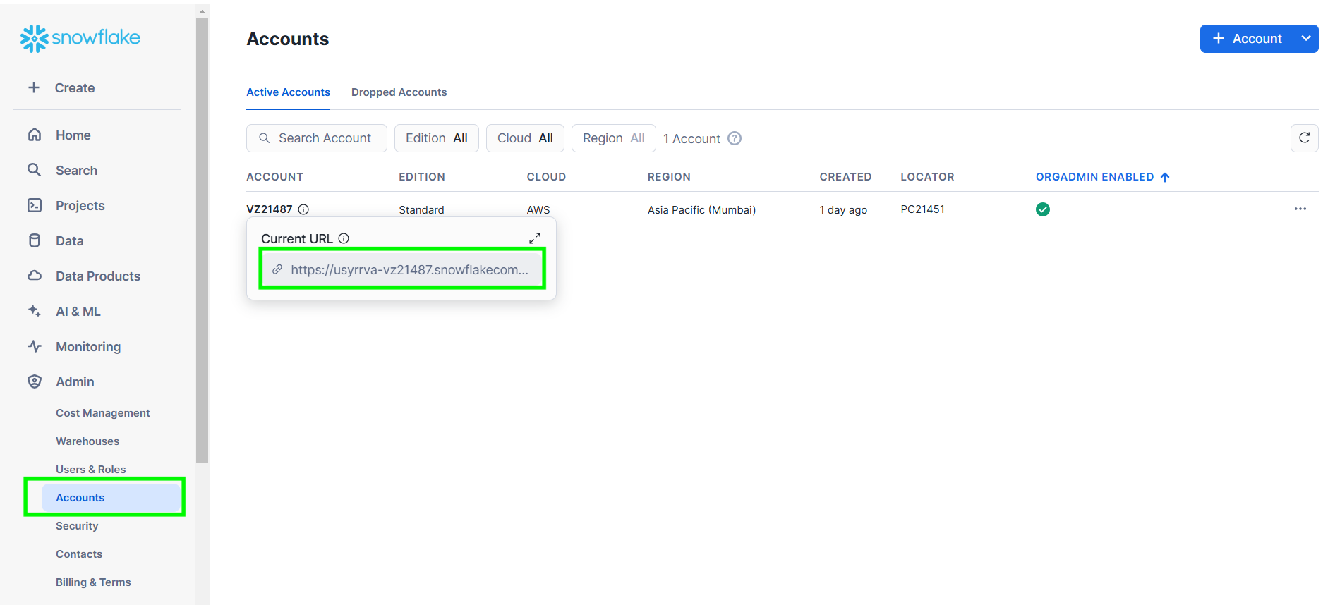

7. From the list of operations, select an operation that you want to test.
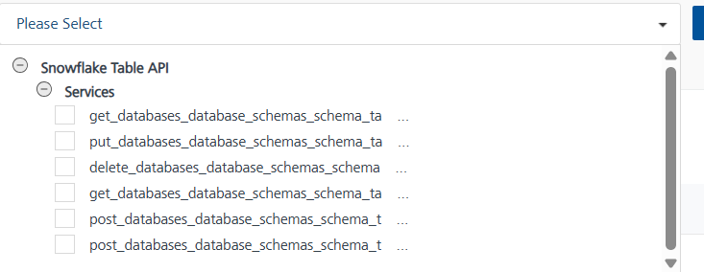
8. On the Request Input tab, enter a TEST VALUE or a DEFAULT VALUE for the parameters.
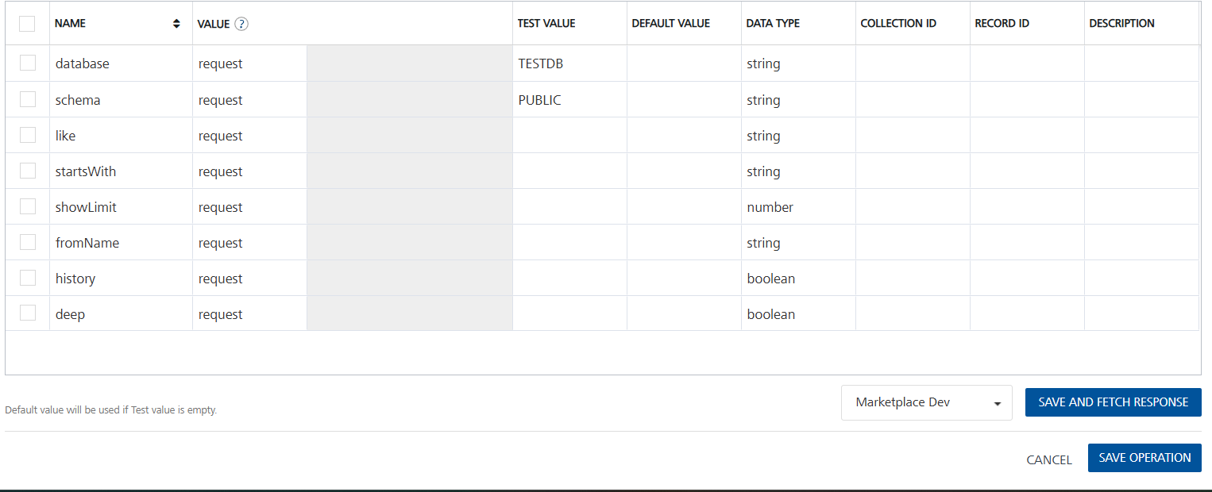
Note: To fetch the response onVolt MX Foundry, clear the Enable pass-through check box on the Response Output tab.
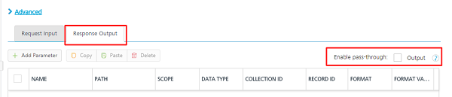
9. Select a run-time environment and click Save and Fetch Response to get a response based on your input.
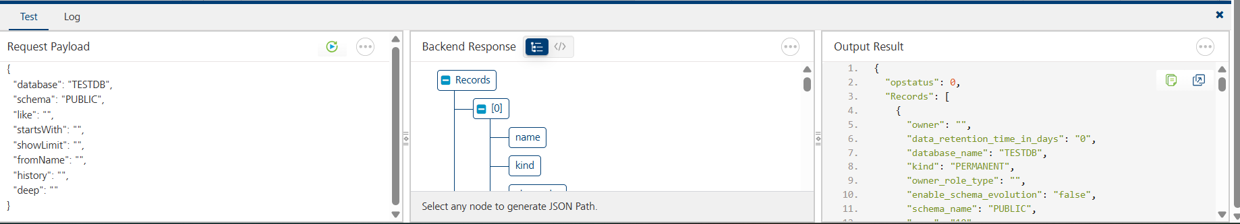
Note:
- To test the operations provided in this link Table | Snowflake Documentation I have created my own sample database with sample tables in a snowflake trial account. Adding reference screenshot for sample database, tables, respective queries to grant privileges.
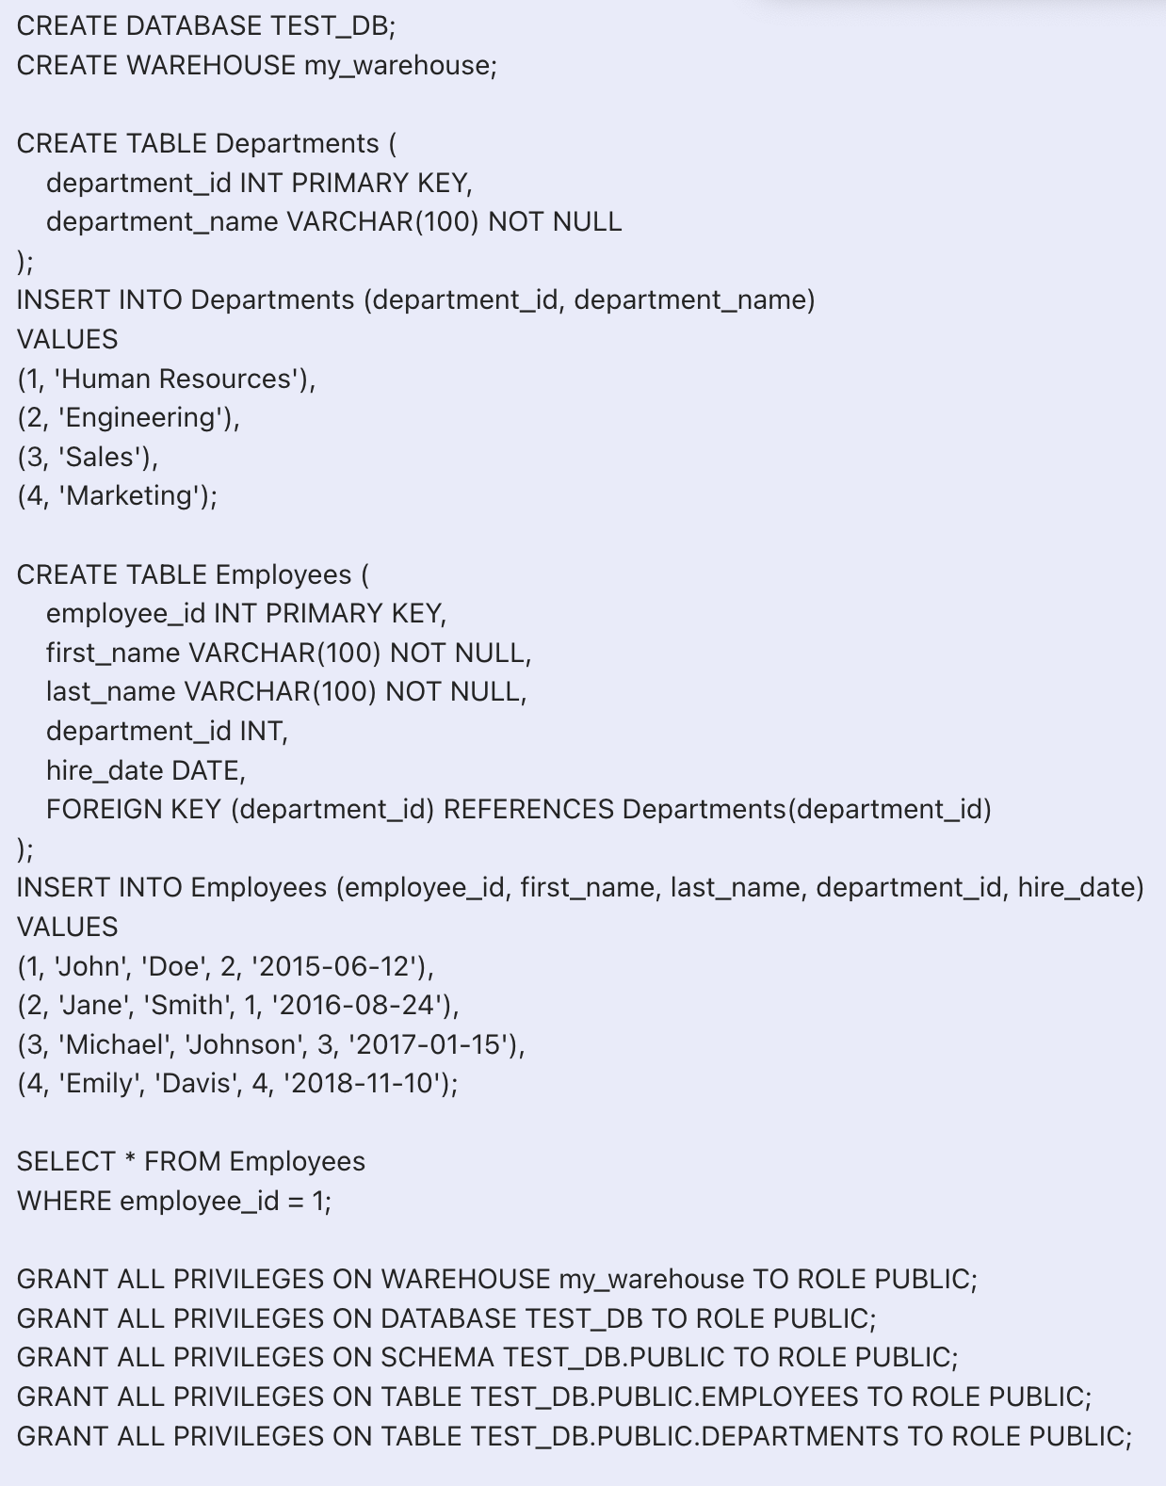
- To get successful responses in the foundry, the role should be public only in the snowflake account.

3. Publishing your application
If you want to use the services in client applications, you need to publish an app to a run-time environment. You can create the service (as described above) in an application or import the service into an application and publish the application.
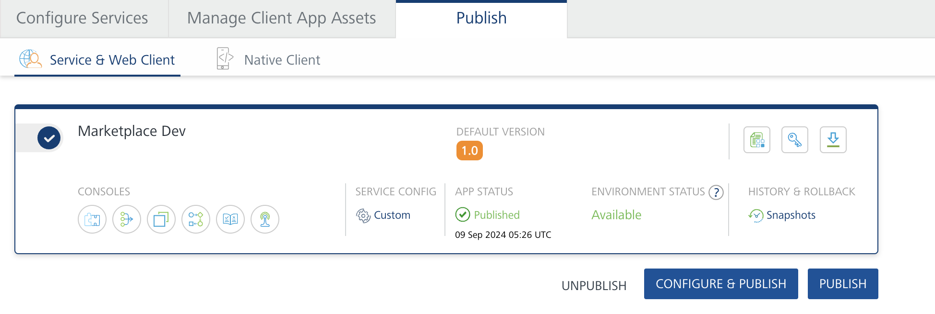

4.References

Name | Endpoint | Description
List tables | GET /api/v2/databases/{database}/schemas/{schema}/tables | Lists the tables under the database and schema.
- Create a table | POST /api/v2/databases/{database}/schemas/{schema}/tables | Create a table.
- Fetch a table | GET /api/v2/databases/{database}/schemas/{schema}/tables/{name} | Fetch a Table using the describe command output.
- Clone table | POST /api/v2/databases/{database}/schemas/{schema}/tables/{name}:clone | Create a new table by cloning from the specified resource
- Create a (or alter an existing) table | PUT /api/v2/databases/{database}/schemas/{schema}/tables/{name} | Create a (or alter an existing) table. Even if the operation is just an alter, the full property set must be provided.
- Delete a table | DELETE /api/v2/databases/{database}/schemas/{schema}/tables/{name} | Delete a table with the given name.

5. Revision History
App version 1.0.0:

- Known Issues

-
- Limitations
-

