Date : 11-April-2023

SMS - Text Message (Phone) version: 1.0.1

Overview
The SMS - Text Message (Phone) component enables you to quickly integrate native messaging capability into your app. Add 'send SMS' functionality to your app in seconds- just drag and drop the component, configure few properties- that's all! you are ready to go.

Features
- Configure all properties from VoltMX iris properties panel itself.
- Messaging application of the underlying platform is used to send the message.

Percentage of re-use:
80%

Getting Started

Prerequisites
Before you start using the SMS - Text Message (Phone) component, ensure you have the following:

- HCL Foundry
- Volt MX Iris

Platforms Supported

Mobile

iOS

Android

Importing the app
You can import the Forge components only into the apps that are of the Reference Architecture type.

To import the SMS - Text Message (Phone) component, do the following:

- Open your app project in Volt MX Iris.
- In the Project Explorer, click the Templates tab.
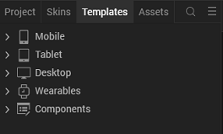

- Right-click Components, and then select Import Component. The Import Component dialog box appears.
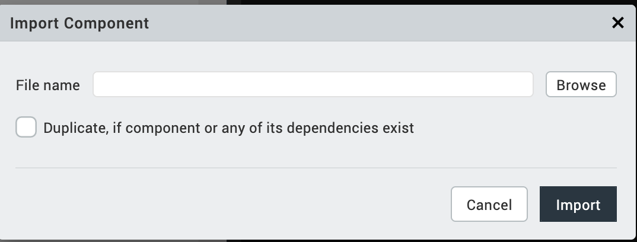

- Click Browse to navigate to the location of the component, select the component, and then click Import. The component and its associated widgets and modules are added to your project.

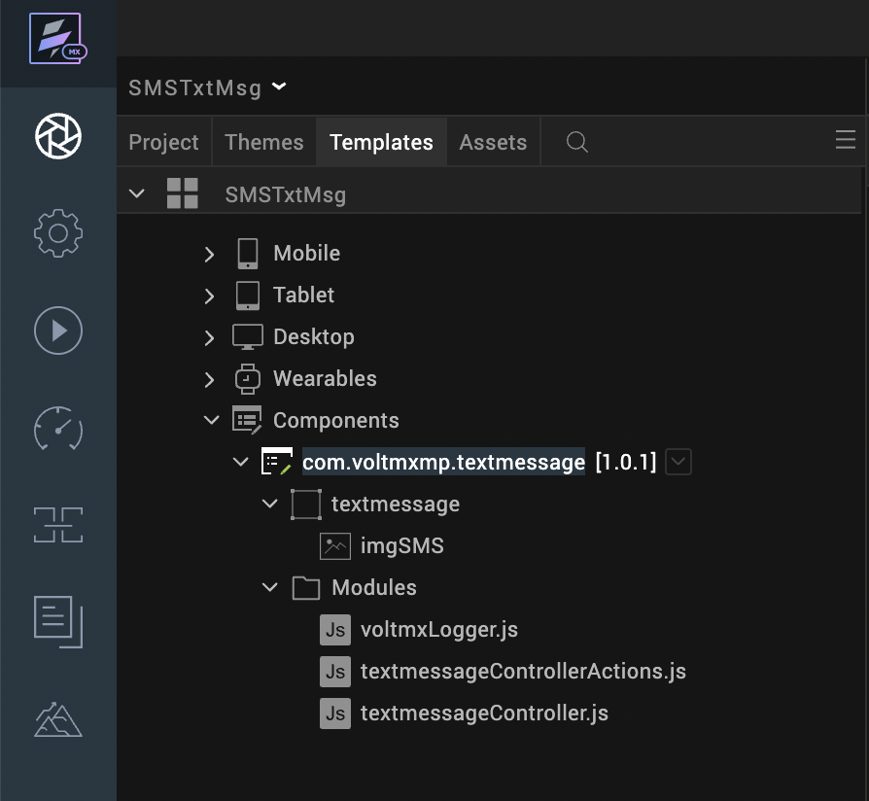

Once you have imported a component to your project, you can easily add the component to a form. For more information, refer Add a Component to a Form.
After adding a component to a form, you can configure the component the way you want it using the Look, Skin, and Action tabs on the Properties pane. Configuring the properties on the Properties pane is similar to configuring the properties of any widget in VoltMX Iris.
You can also see that a new tab, Component, is added on the Properties pane. The Component tab contains assorted properties relevant to the component that allow you to customize the component as required. The properties on the Component tab are categorized as General properties.

References

Dynamic Usage
You can also add a SMS - Text Message (Phone) component dynamically. To do so:
- In the Project Explorer, on the Projects tab, click Controllers section to access the respective formController. Create a method and implement the code snippet similar to the sample code mentioned below.
/* creating a component's Object */

var textmessage = new com.voltmxmp.textmessage({

"autogrowMode": voltmx.flex.AUTOGROW_NONE,

"clipBounds": true,

"height": "50dp",

"id": "textmessage",

"isVisible": true,

"layoutType": voltmx.flex.FREE_FORM,

"left": "0dp",

"masterType": constants.MASTER_TYPE_USERWIDGET,

"skin": "slFbox",

"top": "0dp",

"width": "50dp"

}, {}, {});
/*setting properties*/

textmessage.message = "Your Text Message";

textmessage.number = "8888888888";

textmessage.smsIconSource = "voltmx_mp_textmessage_smsicon.png";

/* adding component to form*/

this.view.add(textmessage);
In the code snippet, you can edit the properties of the component as per your requirement.
- Save the file.

Properties
The properties provided on the Component tab allow you to customize the UI elements in the SMS - Text Message (Phone) component. You can set the properties directly on the Component tab or dynamically through code. This section provides information on how to set the properties dynamically through code.

General
- Phone Number

Description: | Specifies the number to which the message is to be sent.
Syntax: | number
Type: | String
Read/Write: | Read + Write
Example: | this.view.componentId.number= "8888888888";
Remarks: | Only numbers, +, - and space are treated as valid characters.

- Message to be Sent
Description: | Specifies the message to be sent.
Syntax: | message
Type: | String
Read/Write: | Read + Write
Example: | this.view.componentId.message = "MY MESSAGE";

- SMS Icon Source
Description: | Specifies the source of message icon.
Syntax: | smsIconSource
Type: | String
Read/Write: | Read + Write
Example: | this.view.componentId.smsIconSource = "voltmx_mp_textmessage_smsicon.png";
Remarks: | Make sure the source file is present in resources.

Events
-- None of the events are exposed.

API’s
The following API pertains to the SMS - Text Message (Phone) component:
1. SendSMS
The API can be invoked to send message.
Syntax
sendSMS(number,message)
Parameters
number(String),message(String)
Return Value
None
Example
this.view.componentId.sendSMS ("8888888888", "My Message");
Remarks
Only numbers, +, - and space are treated as valid characters for number parameter.

Revision History
App version 1.0.1

Known Issues

No Known Issues

Limitations

No Limitations

