Date : 05-Feb-24
Skeleton Screen Template - Segment
version: 1.0.2

- OVERVIEW

The Skeleton Screen Template - Segment component displays a page that gradually loads information. The component creates a wireframe of the page that contains labels for text and images.
skeleton screen Template - Segment benefits the user by indicating progress, thereby shortening the perceived waiting time. You can use a skeleton screen while creating a page that loads a list of entries from backend services and to indicate the wait time of the service call.

Use case:
A Skeleton screen Template - Segment can be used as an alternative to a spinner to indicate loading progress. It gives a visual cue that things are happening immediately the skeleton of the page has been loaded and the information is gradually loading.

Features:
- Useful component when a screen takes a long time to load
- Appears if a screen is loading

C. Percentage of re-use:
Approximate 90% of reuse. It sets an expectation of how much can be used out of the box, and how much needs to be customized for a specific app.

Getting Started

Prerequisites
Before you start using the Skeleton Screen Template - Segment component, ensure the following:
- HCL Foundry
- Volt MX Iris

Platforms Supported

Mobile

Android

iOS

Tablets

PWA

Importing the Component

To import the Skeleton Screen Template - Segment component, do the following:

Open your app project in Volt MX Iris.

In the Project Explorer, click the Templates tab.
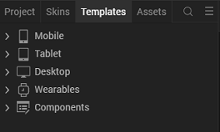
3. Right-click Components, and then select Import Component. The Import Component dialog box appears.
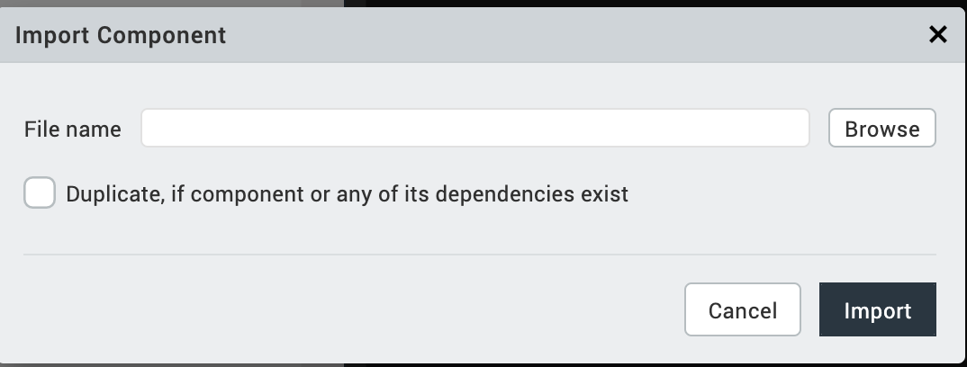

4. Click Browse to navigate to the location of the component, select the component, and then click Import. The component and its associated widgets and modules are added to your project.

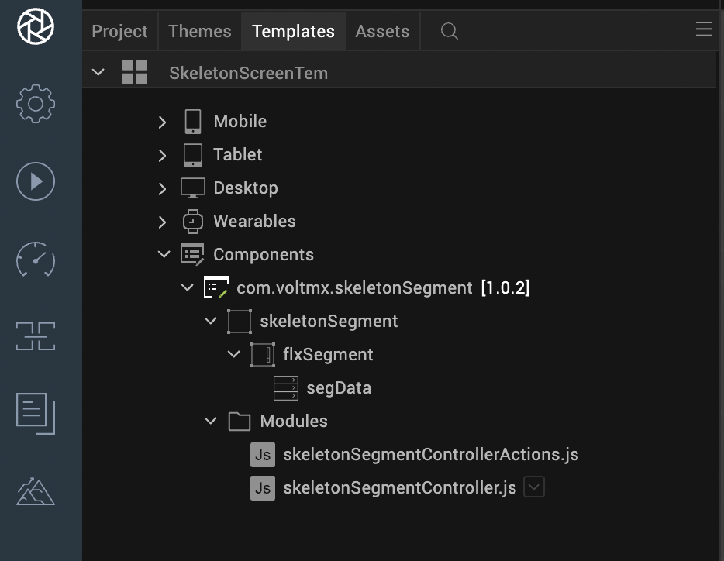

Once you have imported a component to your project, you can easily add the component to a form. For more information, refer Add a Component to a Form.

Building and previewing the app
After performing all the above steps, you can build your app and run it on your device. For more information, you can refer to the Building and Viewing an Application section of the VoltMX Iris User Guide.
You can then run your app to see the Skeleton Screen Template - Segment work in real time.

References:

A. Dynamic Usage of Skeleton Screen Template - Segment component
- In the Project Explorer, on the Projects tab, click Controllers section to access the respective Form Controller. Create a method and implement the code snippet like the sample code mentioned below.

define({

//Type your controller code here

serviceName : "BestBuySkeletonScreen",

productsOperationName : "getProducts",

currentPage: 1,

onNavigate: function(){

var productId ="pcmcat378600050009";

this.view.postShow=this.postShow(productId);

var skeletonScreen = new com.voltmx.skeletonSegment(

{

"autogrowMode": voltmx.flex.AUTOGROW_NONE,

"clipBounds": true,

"height": "100%",

"id": "skeletonScreen",

"isVisible": true,

"layoutType": voltmx.flex.FREE_FORM,

"left": "0%",

"masterType": constants.MASTER_TYPE_USERWIDGET,

"skin": "slFbox",

"top": "0%",

"width": "100%"

}, {}, {});

this.view.add(skeletonScreen);

this.view.skeletonScreen.loadMore = this.segReachEnd.bind(this, productId);

},

postShow : function(productId) {

if (voltmx.net.isNetworkAvailable(constants.NETWORK_TYPE_ANY))

{

var integrationSvc = KNYMobileFabric.getIntegrationService(this.serviceName);

var headers = {};

data = {"categoryid" : productId ,

"pageNo": this.currentPage,

"pageSize": 10};

integrationSvc.invokeOperation(this.productsOperationName, headers, data,this.initLoadSuccesscallback, this.initLoadErrorcallback);

}

else

alert("Network unavailable");

},

initLoadSuccesscallback : function (response){

if(response !==null && response.opstatus === 0){

if(response.subCatList.length > 0){

var sampleData = {lblData: "name",

imgData: "image"};

this.view.skeletonScreen.setData(response.subCatList,response.remainingResults,sampleData);

}

}

},

initLoadErrorcallback: function(){

voltmx.model.ApplicationContext.dismissLoadingScreen();

alert("Failed to fetch the products...try again");

},

segReachEnd : function(productId){

//basically postshow

//in callback, invokes adddata instead of setDta

if (voltmx.net.isNetworkAvailable(constants.NETWORK_TYPE_ANY)){

var integrationSvc = KNYMobileFabric.getIntegrationService(this.serviceName);

var headers = {};

this.currentPage=this.currentPage+1;

data = {"categoryid" : productId,

"pageNo": this.currentPage,

"pageSize": 10} ;

integrationSvc.invokeOperation(this.productsOperationName, headers, data,this.paginatedLoadSuccesscallback, this.paginatedLoadErrorcallback);

}

else

alert("Network unavailable");

},

paginatedLoadSuccesscallback : function (response) {

if(response !==null && response.opstatus === 0){

if(response.subCatList.length > 0){

this.view.skeletonScreen.addData(response.subCatList,response.remainingResults);

}

}

},

paginatedLoadErrorcallback : function(){

voltmx.model.ApplicationContext.dismissLoadingScreen();

alert("Failed to fetch the products...try again");

}

});

In the code snippet, you can edit the properties of the component as per your requirement. For more information, see Setting Properties.
- Save the file.

B. Properties
You can use a component's Properties to customize and configure the elements. These elements can be UI elements, service parameters, and so on. For more information about properties, you can refer to the Components Overview section of the VoltMX Iris User Guide.
You can set the properties from the Iris Properties panel on the right hand side. You can also configure these properties using a JavaScript code
1. General Properties
1 . widgetDataMap
Description: Specifies the label Text and images that you want to display on the skeleton screen.
Type : Array of JSON

Read/Write : Read + Write

Example: var sampleData = {lblData: "name",
imgData: "image"}; this.view.skeletonScreen.setData(response.subCatList,response.remainingResults,sampleData);

C. Events

1. loadMore

Description: To use Pagination you have to use custom event loadMore have to bind it to function which invokes the service to get future page data.
Syntax: loadMore
Example: You have to create the function to attach the loadMore event . In that function you have to invoke the service and in that success callback of the function you have to invoke addData with the list and remainingResults respectively.

this.view.skeletonScreen.loadMore = this.segReachEnd.bind(this, productId);

/* creating the function to attach loadMore Event */

segReachEnd : function(productId){

//basically postshow

/* invokes the service*/

if (voltmx.net.isNetworkAvailable(constants.NETWORK_TYPE_ANY)){

var integrationSvc = KNYMobileFabric.getIntegrationService(this.serviceName);

var headers = {};

this.currentPage=this.currentPage+1;

data = {"categoryid" : productId,

"pageNo": this.currentPage,

"pageSize": 10} ;

integrationSvc.invokeOperation(this.productsOperationName, headers, data,this.paginatedLoadSuccesscallback, this.paginatedLoadErrorcallback);

}

else

alert("Network unavailable");

},

/*in callback, function invokes adddata along with key value and remainingResults */

paginatedLoadSuccesscallback : function (response) {

if(response !==null && response.opstatus === 0){

if(response.subCatList.length > 0){

this.view.skeletonScreen.addData(response.subCatList,response.remainingResults);

}

}

},

D. APIs

1. setData

Description: To get the initial data from service or local data you have to call setData with the list of responses with the particular key value and remainingResults.

Syntax: setData(parameters);

Parameters: data

recordsRemaining

dataMap
Return Value: None

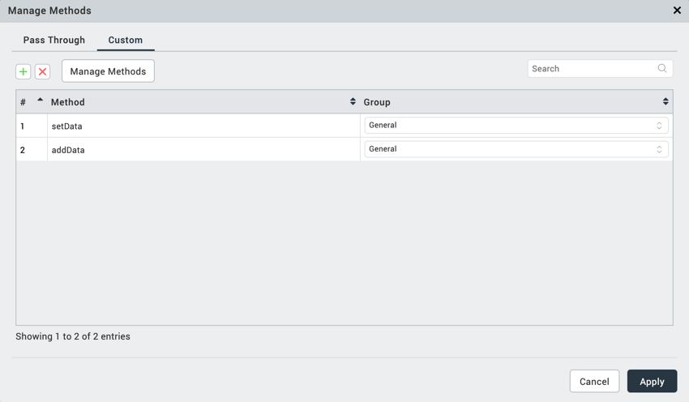

Example: this.view.skeletonScreen.setData(response.subCatList,response.remainingResults, sampleData);

2. addData

Description: To get the future page data from service or local data you have to call addData with the list of responses with the particular key value and remainingResults

Syntax: addData(parameters);

Parameters: data

recordsRemaining
Return Value: None

Example: this.view.skeletonScreen.addData(response.subCatList,response.remainingResults);

4. REVISION HISTORY

App version 1.0.2

