Date : 01-Feb-2024

Single Slider

VERSION: 1.0.1

Overview
Sliders have been around for a long time and have become the de facto standard for selecting and filtering apps. This component helps you achieve that by letting you visually select a value within a larger data set. This component incorporates the latest material design UX principles and cool animations that gives an enhanced User experience for the users.
The Single Slider component contains a slider and a handle. The component allows users to move the handle to select a specific value from a given range.

Use case:

Users can use the Single Slider component to control volume, to zoom in and out of an image, and so on.

Percentage of re-use:
80-90%.

Features:
- Slider with a single handle to select a specific value from a given range.
- Easy to achieve the single slider feature without developing it from scratch.
- Ability to define intervals on the slider.
- Facility to customize the UI as you require.

Getting Started

Prerequisites
Before you start using the Single Slider component, ensure the following:
• HCL Foundry
• Volt MX Iris

Platforms Supported

Mobile

iOS

Android

Importing the app

You can import the Forge components only into the apps that are of the Reference Architecture type.

To import the Single Slider component, do the following:

Open your app project in Volt MX Iris.

In the Project Explorer, click the Templates tab.

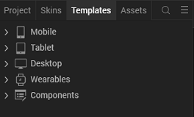

Right-click Components, and then select Import Component. The Import Component dialog box appears.

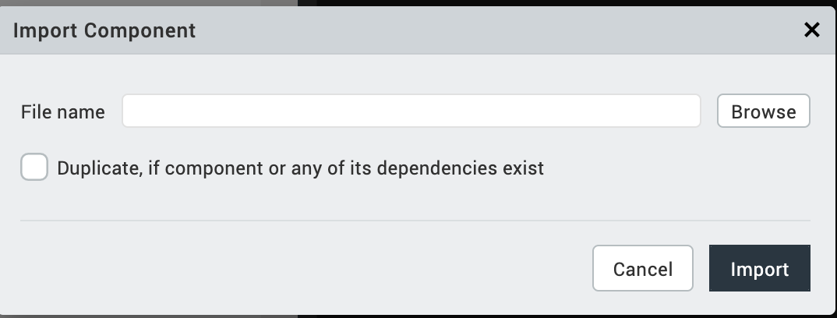

Click Browse to navigate to the location of the component, select the component, and then click Import. The component and its associated widgets and modules are added to your project.

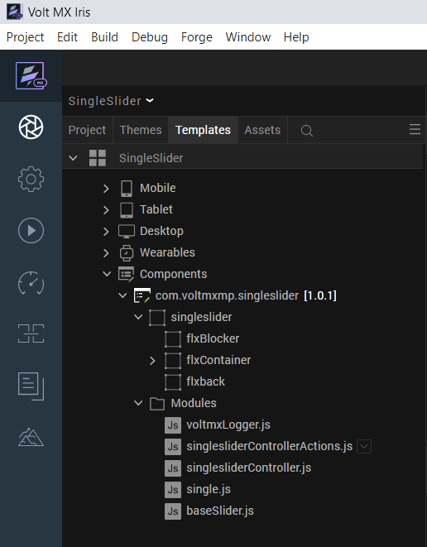

Once you have imported a component to your project, you can easily add the component to a form. For more information, refer Add a Component to a Form.

Building and previewing the app

After performing all the above steps, you can build your app and run it on your device. For more information, you can refer to the Building and Viewing an Application section of the Volt MX User Guide.

You can then run your app to see the Single Slider work in real time.

References

Dynamic Usage
You can also add Single Slider component dynamically. To do so,
1. In Project Explorer, on the Projects tab, click Controllers section to access the respective Form Controller. Create a method and implement the code snippet like the sample code mentioned below.
/* creating a component's Object */
var slider = new com.voltmxmp.singleslider({

"clipBounds": true,

"height": "15%",

"id": "slider",

"isVisible": true,

"left": "0dp",

"top": "0dp",

"width": "100%",

"zIndex": 1

}, {}, {});

/* Setting the component's properties */
slider.minValue=5;
slider.maxValue=15;
slider.intervalDisplay = true;
slider.graduations = 10;
slider.divisions = 10;
slider.endIndex = 10;

/*Adding the Single Slider component to a Form*/

this.view.add(slider);
In the code snippet, you can edit the properties of the component as per your requirement. For more information, see Setting Properties.
2. Save the file.

Properties
The properties provided on the Component tab allow you to customize the elements in the Single Slider component. These elements can be UI elements, service parameters, and so on. You can set the properties from the Volt MX Iris Properties panel on the right-hand side. You can also configure these properties using JavaScript code.

General Properties
1. Minimum Value
Description: | Specifies the minimum value of the slider. The minimum value is the start index of the slider.
Syntax: | minValue
Type: | Number
Read/Write: | Read + Write
Example: | this. view.ComponentID.minValue=5;

2. Maximum Value
Description: | Specifies the maximum value of the slider. The maximum value is the end index of the slider.
Syntax: | maxValue
Type: | Number
Read/Write: | Read + Write
Example: | this. view.ComponentID.maxValue=15;

3. Display Interval
Description: | Controls whether the interval labels are visible on the slider.
Syntax: | intervalDisplay
Type: | Boolean
Read/Write: | Write
Example: | this. view. componentID.intervalDisplay = true;
Remarks: | The default value of the property is true.

4. Steps
Description: | Specifies the number of intervals on the slider.
Syntax: | graduations
Type: | Number
Read/Write: | Read + Write
Example: | this. view. componentID.graduations = 10;
Remarks: | The values of interval points on the slider are determined based on the specified minimum and maximum values of the slider. The values are displayed in the pop-up when you move the handle on the slider.

5. Interval Count
Description: | Specifies the number of interval labels to be generated and displayed on the slider.
Syntax: | divisions
Type: | Constant
Read/Write: | Write
Example: | this. view. componentID.divisions = 10;

6. Default Selected Value
Description: | Specifies which value on the slider must be selected by default.
Syntax: | defaultIndex
Type: | Number
Read/Write: | Write
Example: | this. view. componentID.defaultIndex = 10;

Image Options
7. Slider Source
Description: | Specifies the file name of the image to be displayed as the slider icon.
Syntax: | srcSlider
Type: | Image
Read/Write: | Read + Write
Example: | this. view. componentID. sliderSource= “singleslider_point.png”;
Remarks: | - Do not add any uppercase characters in the file name of the image.  - Ensure that the image is in PNG format.  - Specify the file name of the image along with the extension

8. Pin Source
Description: | Specifies the file name of the image to be displayed as the pin indicator.
Syntax: | srcPin
Type: | Image
Read/Write: | Read + Write
Example: | this.view.componentID.pinSource=“singleslider_currentpin.png”;
Remarks: | - Do not add any uppercase characters in the file name of the image.  - Ensure that the image is in PNG format.  - Specify the file name of the image along with the extension

9. Bullet Icon Source
Description: | Specifies the file name of the image to be displayed as bullet icons.
Syntax: | srcBullet
Type: | Image
Read/Write: | Read + Write
Example: | this. view. componentID. srcLeftBullet= “point_blue.png”;  this. view. componentID. srcRightBullet= “point_grey.png”;
Remarks: | - Do not add any uppercase characters in the file name of the image.  - Ensure that the image is in PNG format.  - Specify the file name of the image along with the extension

Skin Section
10. Selected range Skin
Description: | Specifies the skin for the line which is displayed between the initial position and the slider pin.
Syntax: | sknRange
Type: | String
Read/Write: | Read + Write
Example: | this. view. componentID.sknRange= “voltmxmplblSkinRange”;
Remarks: | Before you set the property, ensure that the skin ID that you specify already exists in your app project.

11. Active Index Skin
Description: | Specifies the skin for the number displayed in the selected region.
Syntax: | sknActiveIndex
Type: | String
Read/Write: | Read + Write
Example: | this.view.componentID.sknActiveIndex=“voltmxmpnumberBlue”;
Remarks: | Before you set the property, ensure that the skin ID that you specify already exists in your app project.

12. Inactive Index Skin
Description: | Specifies the skin for the number which is not in the range of the single slider.
Syntax: | sknInactiveIndex
Type: | String
Read/Write: | Read + Write
Example: | this.view.componentID.sknInActiveIndex=  “voltmxmpnumberLineSkn”;
Remarks: | Before you set the property, ensure that the skin ID that you specify already exists in your app project.

13. Selected Index Skin
Description: | Specifies the skin that is applied to the header main text.
Syntax: | sknSelectedIndex
Type: | String
Read/Write: | Read + Write
Example: | this.view.componentID.sknSelectedIndex=  “CopysliderNumber”;
Remarks: | Before you set the property, ensure that the skin ID that you specify already exists in your app project.

14. Background Skin
Description: | Specifies the skin for the background of the single slider component.
Syntax: | sknBackground
Type: | String
Read/Write: | Read + Write
Example: | this.view.componentID.sknBackground=  “voltmxmpflxback”;
Remarks: | Before you set the property, ensure that the skin ID that you specify already exists in your app project.

APIs

The following APIs pertain to the Single Slider component.
1. getSelectedValues

Description: The API fetches the selected values.
Syntax: getSelectedValues()
Parameters: None
Return Value: Integer
Returns the selected value on the Single Slider.

Example:
var selectedValues= this.view.componentID.getSelectedValues();
var index = selectedValues;

D. Events
You can define events to be executed when an action is performed. You can configure the events directly on the Actions tab or by writing a JavaScript. To configure the events on the Actions tab, click Edit against each event. For more information, refer to Add Actions.
This section provides details about each event that help you define the actions by writing a JavaScript.

1. onChangeEnd
Description: The event is invoked when the user-touch is released from the
Slider.
Syntax: onChangeEnd(values)
Remarks: The event returns the index value of the slider where the user-touch is released at the time of event is invoked.

2. onValueChange
Description: | The event is invoked when the index is changed from one point to another.
Syntax: | onValueChange(values)
Remarks: | The event returns the changed index value.

Revision History
App version 1.0.1

Limitations
- The numbers overlap if the number of divisions are many.
- The component renders as expected only during the run time.

