Date : 23-Feb-22
Simple Sort
version: 1.0.4

Overview
The Simple Sort component shows a set of options a user can choose to sort the content in your application. These include Relevance, Low to High, High to Low, and so on.
You can use the default sort options such as Relevance and Low to High, or you can add your own options to the component and retrieve them using the provided API. You can use the component in scenarios such as a retail app, where you want to provide the option to sort a list.

Use case:

The simple sort component provides a ready-made UI template for implementing a sort functionality applications. The components lists different sort options which can be modified as required. This type of component is generally used in retail, e-commerce, and other similar scenarios

B. Features

The simple search component provides a ready-made you a template for implementing a song function in applications.

JSON input format

C. Percentage of re-use:
70-80% (Data and skins are customized and can be changed manually)

Getting Started

Prerequisites
Before you start using the Simple Sort component, ensure you have the following:
- HCL Foundry
- Volt MX Iris

Platforms Supported

Mobile

iOS

Android

Tablets

PWA

Importing the Component

You can import the Forge components only into the apps that are of the Reference Architecture type.

To import the Simple Sort component, do the following:

Open your app project in Volt MX Iris.
- In the Project Explorer, click the Templates tab.

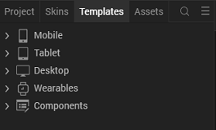

3.Right-click Components, and then select Import Component. The Import Component dialog box appears.

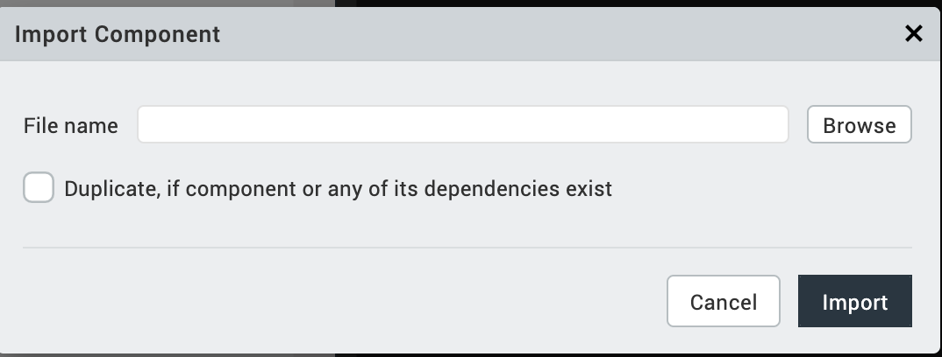

4.Click Browse to navigate to the location of the component, select the component, and then click Import. The component and its associated widgets and modules are added to your project.
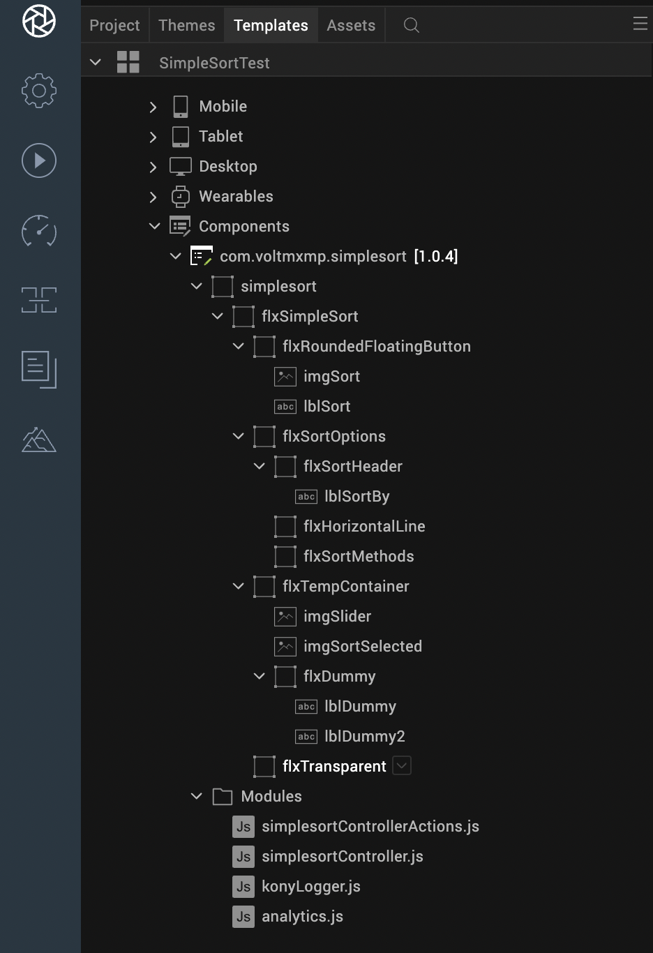

Once you have imported a component to your project, you can easily add the component to a form. For more information, refer Add a Component to a Form.

Building and previewing the app
After performing all the above steps, you can build your app and run it on your device. For more information, you can refer to the Building and Viewing an Application section of the Volt MX Iris User Guide.
You can then run your app to see the Simple Sort work in real time.

References

Dynamic Usage
If you want to use the Simple Sort component dynamically, you will need to import the component into your project Templates. Follow the given steps to do so

Download the component from HCL Volt MX Marketplace as a zip file.

Go to the Templates tab in your project explorer.

Right click on Components and select Import Component.

Navigate to where you downloaded your zip file and import it into Iris.

After you import the component into your project templates, you can add it to your app dynamically. To do so, follow the given steps

Access the FormController of the form you want to add the component into.

Create a function called createComponent(); and write the code inside it to create and configure the component.

You can refer to the given sample code for more information.
/*Creating a component's Object */
var SimpleSort=new com.voltmxmp.simplesort({
"clipBounds": true,
"height": "100%",
"id": "simplesort",
"isVisible": true,
"left": "0dp",
"top": "0dp",
"width": "100%",
"zIndex": 1

},{

},{});
//Configuring the component properties
SimpleSort.flxRoundedButtonSkn = "sknFlxRoundedBtn";
SimpleSort.sortIconSrc = "newsort.png";
SimpleSort.sortButtonText="Sort";
SimpleSort.sliderImageSrc="newdragger.png";
SimpleSort.optionSelectedSrc="acme.png";
SimpleSort.text="Sort by";
SimpleSort.optionSliderTop=30;
//creating API's
this.view.add(SimpleSort);
this.view.simplesort.getSortOptionSelected();
this.view.simplesort.sortOptions =
{
"data":
[
{"sortBy": "Relevance"},
{"sortBy": "Low-to-High"},
{"sortBy": "High-to-Low"},
{"sortBy": "What’s New"}
]
};
- Save the file.

Properties
The properties provided on the Component tab allow you to customize the UI elements in the Simple Sort component. You can set the properties directly on the Component tab or by writing a JavaScript.
1. General
1. SortByOptions (SortBy Options)

Category: | Pass Through
Description: | Specifies the sort options that you want to display on the component.
Syntax: | sortOptions
Type: | - Data Grid  - JSON
Read/Write: | Read + Write
Remarks: | By default, the component contains two options:  - Relevance  - Low to High
Example: | this.view.componentID.sortOptions =  {  "data":  [  {"sortBy": "Relevance"},  {"sortBy": "Low-to-High"}  ]  };
- Sort Icon Image (sortIconSrc)
Category: | Pass Through
Description: | Specifies the source of the image that you want to set as the icon for the Sort Button.
Syntax: | sortIconSrc
Type: | String
Read/Write: | Read + Write
Default Value: | this.view.componentID.sortIconSrc = "sort_icon.png";

- Sort Button Text(sortButtonText)
Category: | Pass Through
Description: | Specifies the text that you want to display on the Sort Button.
Syntax: | sortButtonText
Type: | String
Read/Write: | Read + Write
Default Value: | "Sort"
Example: | this.view.componentID.sortButtonText = "Sort";

- Slider Image(sliderImageSrc)
Category: | Pass Through
Description: | Specifies the source of the image that you want to use on the Slider.
Syntax: | sliderImageSrc
Type: | String
Read/Write: | Read + Write
Default Value: | this.view.componentID.sliderImgSrc = "slider_icon.png";

- Options Selected Image(optionsSelectedSrc)
Category: |  | Pass Through
Description: | Specifies the source of the image that you want to set in front of the selected option.
Syntax: | optionSelectedSrc
Type: | String
Read/Write: | Read + Write
Default Value: | "acme.png"
Remarks: | Make sure that the image that you want to set in front of the selected option exists in the workspace\resources\common directory.
Example: | this.view.componentID.optionSelectedSrc = "selected_option.png";

- Sort options Top position in percentage(optionSliderTop)
Category: |  | Pass Through
Syntax: | optionSliderTop
Type: | Integer
Read/Write: | Read + Write
Default Value: | 30
Remarks: | The component calculates this position from the top of the screen.  Therefore, if this value is 30, then the top edge of the component is at 30% distance from the top of the screen. This means that covers 70% of the screen.
Example: | this.view.componentID.optionSliderTop = 30;

Sort Dimensions
The following properties change the dimensions of the sort button.

- Center X
Description: | Specifies the Center X value that you want to set for the button. Center X determines the position of the horizontal center of the button.
Syntax: | buttonCenterX
Type: | String
Read/Write: | Read + Write
Default Value: | "50%"
Remarks: | You can specify the Center X value in Dp, Px, or %.
Example: | this.view.componentID.buttonCenterX = "50%";

- Width
Description: | Specifies the width that you want to set for the button.
Syntax: | buttonWidth
Type: | String
Read/Write: | Read + Write
Default Value: | "40%"
Remarks: | You can specify the width in Dp, Px, or %.
Example: | this.view.componentID.buttonWidth = "40%";

- Center Y
Description: | Specifies the Center Y value that you want to set for the button. Center Y determines the position of the vertical center of the button.
Syntax: | buttonCenterY
Type: | String
Read/Write: | Read + Write
Default Value: | "95%"
Remarks: | You can specify the Center Y value in Dp, Px, or %.
Example: | this.view.componentID.buttonCenterY = "95%";

- Height
Description: | Specifies the height that you want to set for the button.
Syntax: | buttonHeight
Type: | String
Read/Write: | Read + Write
Default Value: | "40dp"
Remarks: | You can specify the height in Dp, Px, or %.
Example: | this.view.componentID.buttonHeight = "40dp";

2. Skins
Skins define the appearance of a widget. You can apply and manipulate skins based on your preference. For more information, refer to the Understanding Skins and Themes section of the Volt mx iris User Guide.
Note:
Make sure that the skins that you assign to a widget are of the same widget type.

- Sort Button Skin
Description: | This skin links to the Sort Button.
Syntax: | flxRoundedButtonSkin
Widget Type: | FlexContainer
Example: | this.view.componentID.flxRoundedButtonSkin = flexSortSkin;

- Sort Text Skin
Description: | This skin links to the Sort Label.
Syntax: | sortTextSkin
Widget Type: | Label
Example: | this.view.componentID.sortTextSkin = labelSkin;

- Sort Option Flex Skin
Description: | This skin links to the background of the sort options popup.
Syntax: | flxSortOptionSkin
Widget Type: | FlexContainer
Example: | this.view.componentID.flxSortOptionSkin = backgroundSkin;

- Parent Flex Skin
Description: | This skin links to the background of the parent container.
Syntax: | sortParentFlxSkin
Widget Type: | FlexContainer
Example: | this.view.componentID.sortParentFlxSkin = flexSkin;

Events
The component invokes events when its corresponding action is performed. You can configure any logic you want the component to perform whenever an event occurs. You can configure the events directly on the Actions tab or by writing a JavaScript, For more information, refer to Add Actions in the iris User Guide.

1. onClickSortOption

Description: | Invoked when the user selects a sort option.
Syntax: | onClickSortOption
Parameters: | selectedOption [String] :  The option that the user selected.
Example: | this.view.componentID.onClickSortOption = function(selectedOption)  {  alert("Selected Sort Option: "+selectedOption);  }.bind(this);

API’s
The following APIs pertain to the Simple Sort component:
1. getSortOptionSelected

Description: | Retrieves the option that the user has selected on the component.
Syntax: | getSortOptionSelected()
Parameters: | None
Return Value: | selectedOption [String] :  The option that the user selected.
Example: | var selectedOption = this.view.componentID.getSortOptionSelected();  alert("Selected Sort Option: "+selectedOption);

Revision History
App version 1.0.4

Known Issues
No issues

B. Limitations
No limitations

