15 Nov 2021

SIGNATURE PAD (1.0.1)
- Overview
The Signature Pad Component is a custom widget that can be used for Digital Signatures and other written content.

Use case

A delivery app where the user needs to sign into the app to authorize and accept the delivery.

Features:

This component doesn’t use NFI and works on Iris Preview.

It is very lightweight to be integrated in any use case.

Percentage of re-use:
Approximate 90% of reuse.

Getting Started

Prerequisites
Before you start using the Signature Pad component, ensure the following:
• HCL Foundry
• Volt MX Iris

Platforms Supported

Mobile

iOS

Android

Tablet & iPad

PWA & Responsive Web

Importing the app

You can import the Forge components only into the apps that are of the Reference Architecture type.

To import the Signature Pad component, do the following:

Open your app project in Volt MX Iris.
2. In the Project Explorer, click the Templates tab.

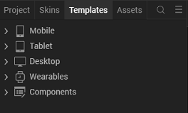
3.Right-click Components, and then select Import Component. The Import
Component dialog box appears.
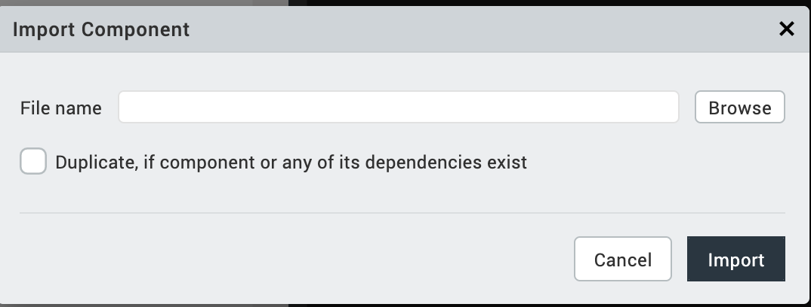
4.Click Browse to navigate to the location of the component, select the
component, and then click Import. The component and its associated widgets and
modules are added to your project.

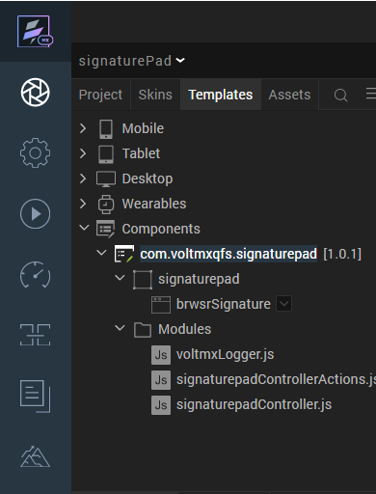
Once you have imported a component to your project, you can easily add the component to a form. For more information, refer Add a Component to a Form

Building and previewing the app
After performing all the above steps, you can build your app and run it on your device. For more information, you can refer to the Building and Viewing an Application section of the Volt MX User Guide.
You can then run your app to see the Signature Pad work in real time.

Modifying the UI of the scenes
You can modify the UI of the carousel by editing a CSS file. To access the CSS file, follow these steps:
- From the Project explorer, go to Web → Localfiles → signature_pad → css.
- From the css folder, select signature-pad.css.
- Use the text editor to edit the CSS based on your preference.
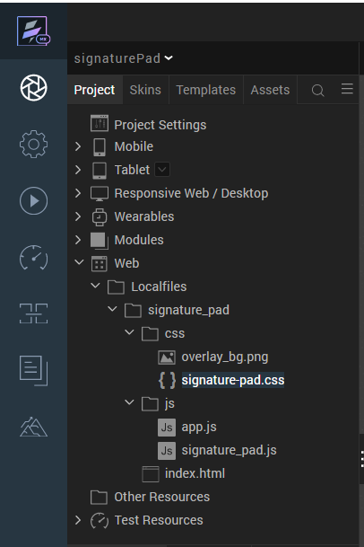

After you modify the CSS, you can Building and previewing the app to view the changes on the carousel.

References

Dynamic Usage
You can also add Signature Pad component dynamically. To do so,
- In the Project Explorer, on the Projects tab, click Controllers section to access the respective Form Controller. Create a method and implement the code snippet similar to the sample code mentioned below.
/*Creating the component's object */
var signaturePadObj = new com.voltmxqfs.signaturepad({
id: "signaturepad",
isVisible: true,
top:"0dp",
left:"0dp",
width:"100%",
height:"100%",
clipBounds: true,
layoutType: voltmx.flex.FREE_FORM,
skin: "slFbox",
zIndex:1
},{},{});
/*Adding the component to a Form*/
this.view.add(signaturePadObj);

In the code snippet, you can edit the properties of the component as per your requirement. For more information, see Setting Properties.
2. Save the file

Properties
The properties provided on the Component tab allows you to customize the elements in the Signature Pad component. These elements can be UI elements, service parameters, and so on. You can set the properties from the Volt MX Iris Properties panel on the right-hand side. You can also configure these properties using a JavaScript code.
Note: If you copy code from any example, make sure that you replace componentID with the name of your component.
General Properties
No Properties

Events

No Events

API’s

getSignature
Description: | Invoked to get signature image base64 string.
Syntax: | getSignature()
Parameters: | None
Return Value: | sgnBase64
Example: | this.view.componentID.getSignature();

Revision History
App version 1.0.1:

Known Issues

No Known Issues

Limitations
When we modify the browser size the content of the canvas is cleared.

