Date: 24 Feb 2026

SIGNATURE CAPTURE

VERSION: 2.1.0

OVERVIEW
Signature Capture is a custom widget that can capture signatures and other written content and store it as images.
For iOS, the component uses Apple’s PencilKit framework under the hood to provide a smooth and high-quality drawing experience with support for touch and Apple Pencil input.

Use case
A delivery app where the user needs to sign into the app to authorize and accept the delivery.

Features:
- The images can be stored either on the device, or on a Network File System.
- This component uses NFI and doesn’t work on Iris Preview.
- Signature canvas for capture.
- Signature saved as image (png or jpeg).
- Image can be saved on device or on network File System (NFS).
- Canvas and pen color are customizable.

Percentage of re-use:
Approximate 85% of reuse.

GETTING STARTED

Prerequisites
Before you start using the Signature Capture component, ensure the following:
- HCL Foundry
- Volt MX Iris

Platforms Supported
  - Mobile
- iOS
- Android
  - Tablet, iPad

Note:
1. While building the app for Android in Debug and Release mode, in order to save signatures to the device. You need to add READ_PHONE_STATE and WRITE_EXTERNAL_STORAGE permissions in project settings.

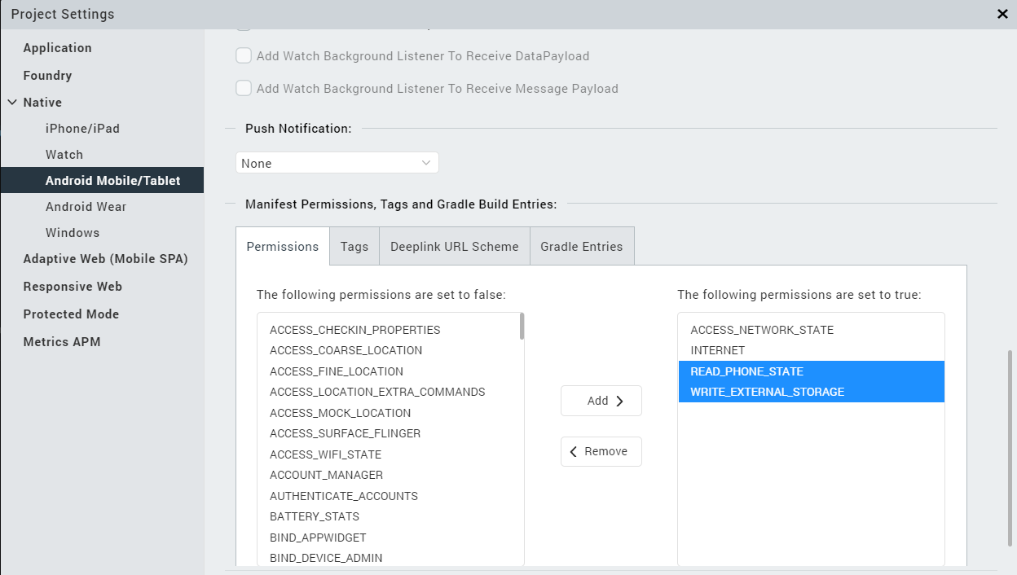
2. Enter the given snippet in Child tag entries under <manifest > tag

<uses-permission android:name="android.permission.READ_MEDIA_IMAGES" />

Configuring Native Settings (iOS)
Follow the given steps to enable the permissions.
1. From the Project explorer, navigate to the Assets tab.
2. Right click Media and select Resource Location to open the project resources folder.
3. In the browser window that opens, navigate to the common folder.
4. Open the infoplist_configuration.json file with a text or code editor.
5. Add the given code at the end of the file. You can replace the values with your own descriptions.
{
"NSPhotoLibraryUsageDescription": "To add signature to device"
}
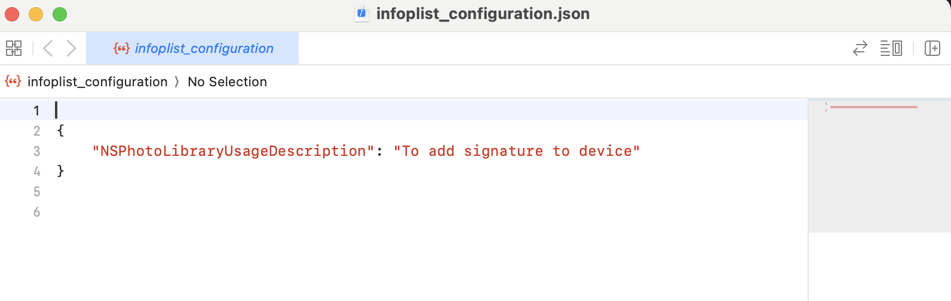
6. Save the file.

Importing the App
You can import the Forge components only into the apps that are of the Reference Architecture type.

To import the Signature Capture component, do the following:
- Open your app project in Volt MX Iris.
- In the Project Explorer, click the Templates tab.

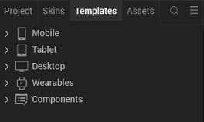
- Right-click Components, and then select Import Component. The Import
Component dialog box appears.
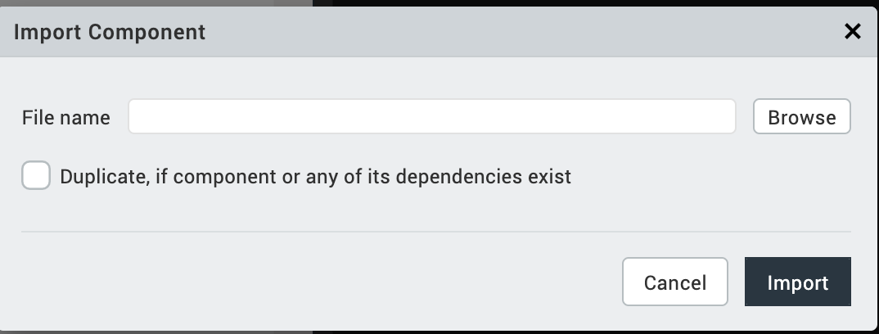
- Click Browse to navigate to the location of the component, select the component, and then click Import. The component and its associated widgets and modules are added to your project.
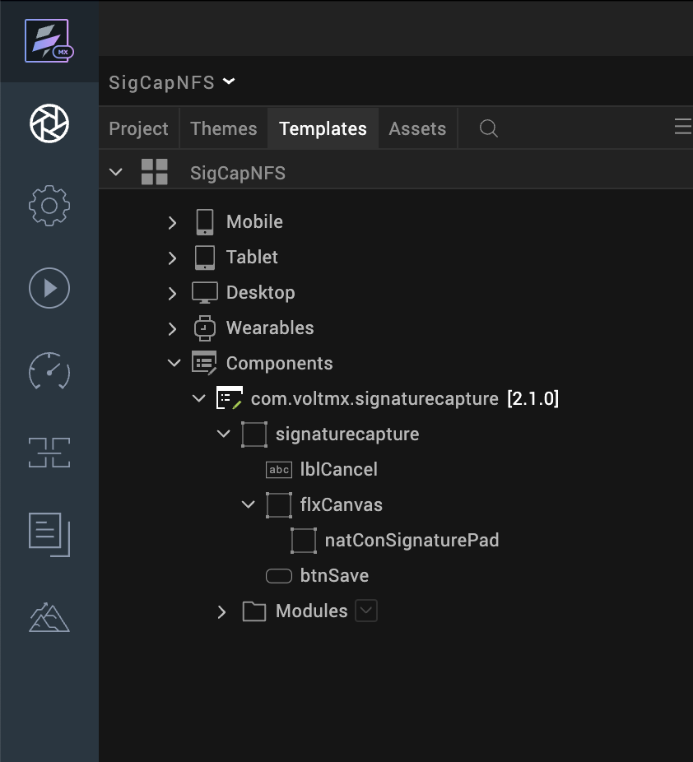

Once you have imported a component to your project, you can easily add the component to a form. For more information, refer Add a Component to a Form

Building and previewing the app
After performing all the above steps, you can build your app and run it on your device. For more information, you can refer to the Building and Viewing an Application section of the Volt MX User Guide.
You can then run your app to see the Signature Capture work in real time.

REFERENCES

Dynamic Usage
You can also add the Signature Capture component dynamically. To do so,
- In the Project Explorer, on the Projects tab, click Controllers section to access the respective Form Controller. Create a method and implement the code snippet similar to the sample code mentioned below.
- To Save the image in Network File System please change the component property save To Device as save to Network File System. In Dynamic initialization of the component the signatureCapture.saveTo property should be as Network File System (signatureCapture.saveTo = "Network File System") to save the image to NFS

/* Creating signatureCapture component instance */
var signatureCapture = new com.voltmx.signaturecapture({
id: "signaturecapture",
isVisible: true,
top:"0dp",
left:"0dp",
width:"100%",
height:"60%",
clipBounds: true,
autogrowMode: voltmx.flex.AUTOGROW_NONE,
layoutType: voltmx.flex.FLOW_VERTICAL,
skin: "slFbox",
zIndex:1
},{},{});
/* Setting component's properties */
signatureCapture.penColor = "000000";
signatureCapture.canvasBackground = "FFFFFF";
signatureCapture.saveSignature = true;
signatureCapture.saveAs = "png";
signatureCapture.saveTo = "Device";
/*Adding the Signature Capture component to a form*/
this.view.add(signatureCapture);
In the code snippet, you can edit the properties of the component as per your requirement. For more information, see Setting Properties.
- Save the file
4. For NFS call the Object service in the app init event as Follows
function initApp(){
var serviceName = "objectServiceName";
var serviceType = "online";
var currObj = voltmx.sdk.getCurrentInstance();
var objSvc = currObj.getObjectService(serviceName, {
"access": serviceType
});
var fileStorage= objSvc.getFileStorage();
this._fileStoreObj = fileStorage;
if (fileStorage === null) {
alert("File Storage Init Failed !");
} else {
//alert("File Storage Init successfull !");
}
}

Properties
The properties provided on the Component tab allows you to customize the elements in the Signature Capture component. These elements can be UI elements, service parameters, and so on. You can set the properties from the Volt MX Iris Properties panel on the right-hand side. You can also configure these properties using a JavaScript code.

General Properties
- Pen Color Hexcode (penColor)
Description: | Specifies the color of the pen that is used to draw on the canvas.
Syntax: | penColor
Type: | String
Read/Write: | Read + Write
Example: | this.view.signatureCapture.penColor= "000000";
Remarks: | The default value for the property is “000000”.

- Background Color Hexcode (canvasBackground)
Description: | Specifies the background color of the signature canvas.
Syntax: | canvasBackground
Type: | String
Read/Write: | Read + Write
Example: | this.view.signatureCapture.canvasBackground= "FFFFFF";
Remarks: | The default value for the property is “FFFFFF”.

- Canvas Width(canvasWidth)
Description: | Specifies the width of the signature canvas.
Syntax: | canvasWidth
Type: | String
Read/Write: | Read + Write
Example: | this.view.signatureCapture.canvasWidth= "94%";
Remarks: | The default value for the property is "94%".

- Canvas Height(canvasHeight)
Description: | Specifies the height of the signature canvas.
Syntax: | canvasHeight
Type: | String
Read/Write: | Read + Write
Example: | this.view.signatureCapture.canvasHeight= "75%";
Remarks: | The default value for the property is "75%".

- Save Signature as Image(saveSignature)
Description: | Specifies whether the component should save the signature.
Syntax: | saveSignature
Type: | Boolean
Read/Write: | Read + Write
Example: | this.view.signatureCapture.saveSignature = true;
Remarks: | The default value for the property is true.

- Save Button Visibility(isSaveVisibile)
Description: | Toggles the visibility of the Save Button.
Syntax: | isSaveVisibile
Type: | Boolean
Read/Write: | Read + Write
Example: | this.view.signatureCapture.isSaveVisibile= true;
Remarks: | The default value for the property is true.

- Clear Label Visibility (isCancelVisible)
Description: | Toggles the visibility of the Clear Label.
Syntax: | isCancelVisible
Type: | Boolean
Read/Write: | Read + Write
Example: | this.view.signatureCapture.isCancelVisible= true;
Remarks: | The default value for the property is true.

- Save Button Text(textSave)
Description: | Specifies the text that you want to display on the save button.
Syntax: | textSave
Type: | String
Read/Write: | Read + Write
Example: | this.view.signatureCapture.textSave= "SAVE";
Remarks: | The default value for the property is “SAVE”.
- Clear Label Text (textCancel)
Description: | Specifies the text that you want to display on the clear label.
Syntax: | textCancel
Type: | String
Read/Write: | Read + Write
Example: | this.view.signatureCapture.textCancel="Clear";
Remarks: | The default value for the property is “Clear”.

Save Properties
- Save To(saveTo)
Description: | Specifies where the component should save the image.
Syntax: | saveTo
Type: | - String  - List Selector
Read/Write: | Read + Write
Values: | - Device  - Network File System
Example: | this.view.signatureCapture.saveTo= "Device";  this.view.sigantureCapture.saveTo="Network File System";
Remarks: | On Iris, you can select this value from a drop-down list.

- Image Save Format(saveAs)
Description: | Specifies the file format of the saved image.
Syntax: | saveAs
Type: | - String  - List Selector
Read/Write: | Read + Write
Values: | - Png  - Jpeg
Example: | this.view.signatureCapture.saveAs= "png";
Remarks: | On Iris, you can select this value from a drop-down list.

Skins Section

- Save Button Skin (skinSave)
Description: | Specifies the skin of the save button.
Syntax: | skinSave

- Clear Label Skin (skinCancel)
Description: | Specifies the skin of the clear label.
Syntax: | skinCancel

Events
- On Save Image Success(onSaveImageSuccess)
Description: | Invoked when the component successfully saves an image.
Syntax: | onSaveImageSuccess
Parameters: | response[string]:  Response from the platform on which the components save the image
Example: | this.view.componentID.onSaveImageSuccess = function(response)  {  alert(response);  }.bind(this);

- On Save Image Failure(onSaveImageFailure)
Description: | Invoked when the component failed to save the image.
Syntax: | onSaveImageFailure
Parameters: | response[string]:  Information about the failure of saving the image
Example: | this.view.componentID.onSaveImageFailure = function(response)  {  alert(response);  }.bind(this);

- On Error Callback(onErrorCallback)
Description: | Invoked when an error occurs in the component.
Syntax: | onErrorCallback
Parameters: | response[string]:  Information about the exception raised by the component
Example: | this.view.componentID.onErrorCallback = function(response)  {  alert(response);  }.bind(this);

- On Check Validity(onCheckValidity)
Description: | Invoked when save signature as image property is set as false.
Syntax: | onCheckValidity
Parameters: | bool[boolean]:  Checks whether the signature is present or not.
Example: | this.view.componentID.onCheckValidity = function(bool)  {  alert(bool);  }.bind(this);
- On Click Redo(onClickRedo)
Description: | Invoked when the redo action is triggered on the signature component. This event re-applies the last undone signature stroke.  Note: This event is supported only on iOS and is available on iOS 17 and above.
Syntax: | onClickRedo
Parameters: | None
Example: | this.view.componentID.onClickRedo();
- On Click Undo(onClickUndo)
Description: | Invoked when the undo action is triggered on the signature component. This event removes the most recent signature stroke.  Note: This event is supported only on iOS and is available on iOS 17 and above.
Syntax: | onClickUndo
Parameters: | None
Example: | this.view.componentID.onClickUndo();

API’s
- getSignatureFromDevice
Description: | Fetches the decrypted base64 of the signature from the device.
Syntax: | getSignatureFromDevice
Parameters: | None
Return Value: | signature[string]:  decrypted base64 value of the signature.
Example: | this.view.signatureCapture.getSignatureFromDevice();

REVISION HISTORY
App version :2.1.0

Known Issues
- NA

Limitations
- The maximum values for the width and height of the canvas are
- Width: 338Dp or 94%
- Height: 320Dp or 75%
- onClickRedo and onClickUndo Events are supported only on iOS and are available on iOS 17 and above.
- This component is supported only on iOS 17 and above. Running the application on earlier iOS versions is not supported and may lead to unexpected behaviour (app may crash).

