05 June 2023

Horizontal Slider(1.0.0)

# Overview

Use this component within a web application to drag and drop or select a file from the local file system and then display the file selected within the browser.

## Use case

### To Select a file and then display it

## Percentage of re-use:

Approximately 90% reusable.

## Features.

Drag and drop files

Select files

Display the selected files

# Getting Started

## Prerequisites

Before you start using the Horizontal Slider component, ensure the following:

• [HCL Foundry](https://manage.hclvoltmx.com/)

• Volt MX Iris

## Platforms Supported

### PWA & Responsive Web

### Native

## Importing the app

You can import the Forge components only into the apps that are of the Reference Architecture type.

**To import the EncryptGlobal component, do the following:**

#### Open your app project in Volt MX Iris..

#### In the Project Explorer, click the **Templates** tab.

#### Right-click **Components**, and then select **Import Component**. The **Import Component** dialog box appears.

#### Click **Browse** to navigate to the location of the component, select the component, and then click **Import**. The component and its associated widgets and modules are added to your project.

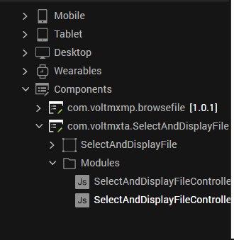

Once you have imported a component to your project, you can easily add the component to a form. For more information, refer [Add a Component to a Form](https://opensource.hcltechsw.com/volt-mx-docs/docs/documentation/Iris/iris_user_guide/Content/C_UsingComponents.html" \l "add-a-component-to-a-form)

## Exposed methods and Events and values

### File Name, File description and the Base64 value are exposed to the calling form.

### On Save Click Event is exposed so you can write your own logic on what to do with the file when the user wishes to select it

### Method displayFile also exposed so you can pass the file name and base64 value at anytime and get the file displayed in the browser

## Enhance for more file types

By default, the component handles pdf, png, gif, jpeg, jpg and doc file types. This list can be extended by adding in more file types in the method displayFile of the SelectAndDisplayFileController.js.

# Revision History

App version 1.0.0:

## Known Issues

NA

## Limitations

NA