Date : 28-Oct-21
secret FIELD
version: 2.0.1

1. OVERVIEW
Secret Field is a Volt Mx Iris component which is an input field that allows the user to toggle the value's mask on and off.

A. Use Case:
This component is ideal for use cases where the user is expected to type in information that should be kept from other people’s eyes, but which can optionally be displayed at the user’s discretion, such as passwords, secret PIN's, and 2FA/MFA verification codes from coordinate cards, tokenizer devices or received via SMS.

B. Features:

Ready to use and customizable UI.

Ready to use API.

Input Field animations can be customized.

C. Percentage of re-use:

80%

2. GETTING STARTED

Prerequisites

Before you start using the Secret Field component, ensure you have the following:
- HCL Foundry
- Volt MX Iris

Platforms Supported

Mobile

iOS

Android

Tablets

PWA

Importing the Component

You can import the Forge components only into the apps that are of the Reference Architecture type.

To import the Secret Field component, do the following:

Open your app project in Volt MX Iris.

In the Project Explorer, click the Templates tab.

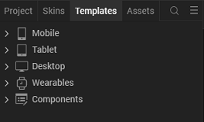

- Right-click Components, and then select Import Component. The Import Component dialog box appears.

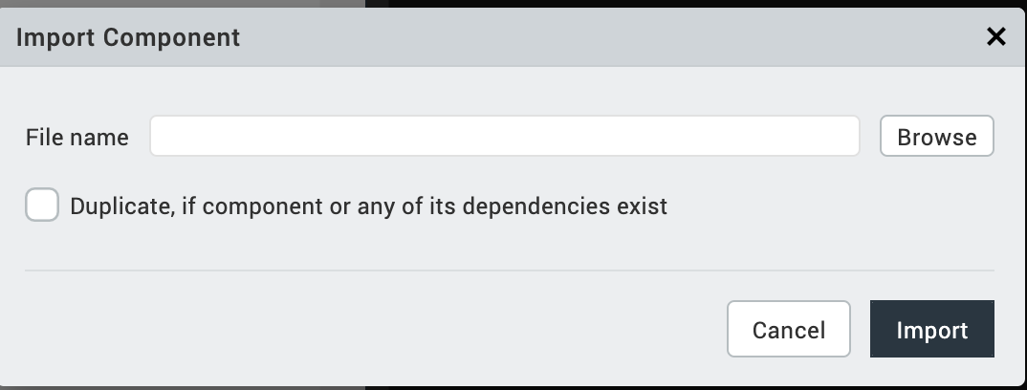

- Click Browse to navigate to the location of the component, select the component, and then click Import. The component and its associated widgets and modules are added to your project.
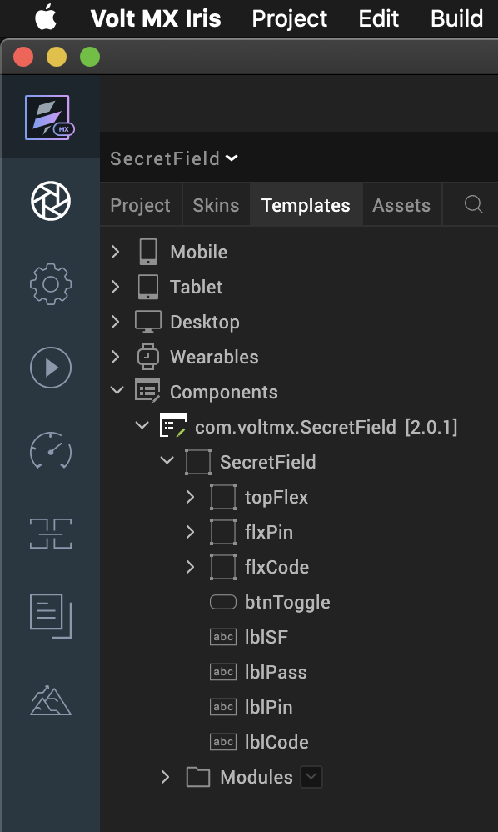

Once you have imported a component to your project, you can easily add the component to a form. For more information, refer Add a Component to a Form.

Building and previewing the app

After performing all the above steps, you can build your app and run it on your device. For more information, you can refer to the Building and Viewing an Application section of the Volt MX Iris User Guide.
You can then run your app to see the Secret-Field work in real time.

ii. Save the file.

3. References

A. Dynamic Usage
You can also add a Secret Field component dynamically. To do so:
- In the Project Explorer, on the Projects tab, click Controllers section to access the respective Form Controller. Create a method and implement the code snippet like the sample code mentioned below.
In the code snippet, you can edit the properties of the component as per your requirement. For more information, see Setting Properties.
/* Creating a component's Object */
createComponent : function(){
var secretFieldInstanse= new com.voltmx.SecretField(
{//look
"clipBounds": true,
"height": "100%",
"id": "secretFieldId",
"isVisible": true,
"layoutType": voltmx.flex.FREE_FORM,
"left": "0dp",
"masterType": constants.MASTER_TYPE_USERWIDGET,
"top": "0dp",
"width": "100%"
}, {}, {});
this.view.add(secretFieldInstanse);
/* Setting component's properties */

//password - button skin
this.view.secretFieldId.placeholder = "Password";
this.view.secretFieldId.buttonSkin = "SecretFieldButtonSkin";
this.view.secretFieldId.buttonFocusSkin = "SecretFieldButtonFocusSkin";
this.view.secretFieldId.textSkin = "SecretFieldTextBoxSkin";
this.view.secretFieldId.iconSkin = "SecretFieldIconLabelSkin";
this.view.secretFieldId.flexSkin = "SecretFieldTopFlexSkin";
this.view.secretFieldId.icon = "\uF023";
this.view.secretFieldId.buttonIcon ="\uF06E";
this.view.secretFieldId.hideIcon = "\uF070";

//pin button skin

this.view.secretFieldId.skin1 = "SecretFieldButtonSkin";
//code button skin

this.view.secretFieldId.skin2 = "SecretFieldButtonSkin";
/*Adding the component to the form*/

}

});

2. SAVE the file

B. Properties
The properties provided on the Component tab allow you to customize the UI elements in the Secret Field component. You can set the properties directly on the Component tab or by writing a JavaScript.

TextBox (textAlign)

Specifies the alignment of the text.

Hide Button (btnpadding)

Specifies the space around an element’s content.

Button

Normal Skin
Description: | Specifies the skin to be applied to the button.
Syntax: | skinShowPin
Type: | String
Read/Write: | Read + Write
Remarks: | - Before you set the property, ensure that the skin ID that you specify already exists in your app project.  - The skin ID assigned to the property must be the skin of the Label.
Example: | this.view.secretFieldId.skinShowPin = "SecretFieldButtonSkin";

Normal Skin
Description: | Specifies the skin to be applied to the button.
Syntax: | skinShowKey
Type: | String
Read/Write: | Read + Write
Remarks: | - Before you set the property, ensure that the skin ID that you specify already exists in your app project.  - The skin ID assigned to the property must be the skin of the Label.
Example: | this.view.secretFieldId.skinShowPin = "SecretFieldButtonSkin";

Icon Skin
Description: | Specifies the skin to be applied to the button.
Syntax: | iconSkin
Type: | String
Read/Write: | Read + Write
Remarks: | - Before you set the property, ensure that the skin ID that you specify already exists in your app project.  - The skin ID assigned to the property must be the skin of the Label.
Example: | this.view.secretFieldId.iconSkin = "SecretFieldIconLabelSkin";

TextBox Skin
Description: | Specifies the skin to be applied to the button.
Syntax: | textSkin
Type: | String
Read/Write: | Read + Write
Remarks: | - Before you set the property, ensure that the skin ID that you specify already exists in your app project.  - The skin ID assigned to the property must be the skin of the Label.
Example: | this.view.secretFieldId.textSkin = "SecretFieldTextBoxSkin";

Button Skin
Description: | Specifies the skin to be applied to the button.
Syntax: | buttonSkin
Type: | String
Read/Write: | Read + Write
Remarks: | - Before you set the property, ensure that the skin ID that you specify already exists in your app project.  - The skin ID assigned to the property must be the skin of the Label.
Example: | this.view.secretFieldId.buttonSkin = "SecretFieldButtonSkin";

Container Skin
Description: | Specifies the skin to be applied to the button.
Syntax: | flexSkin
Type: | String
Read/Write: | Read + Write
Remarks: | - Before you set the property, ensure that the skin ID that you specify already exists in your app project.  - The skin ID assigned to the property must be the skin of the Label.
Example: | this.view.secretFieldId.flexSkin = "SecretFieldTopFlexSkin";

Button Focus Skin
Description: | Specifies the skin to be applied to the button.
Syntax: | buttonFocusSkin
Type: | String
Read/Write: | Read + Write
Remarks: | - Before you set the property, ensure that the skin ID that you specify already exists in your app project.  - The skin ID assigned to the property must be the skin of the Label.
Example: | this.view.secretFieldId.buttonFocusSkin = "SecretFieldButtonFocusSkin";

Decorating icon
Description: | Specifies the skin to be applied to the button.
Syntax: | icon
Type: | String
Read/Write: | Read + Write
Remarks: | - Before you set the property, ensure that the skin ID that you specify already exists in your app project.  - The skin ID assigned to the property must be the skin of the Label.
Example: | this.view.secretFieldId.icon = "\uF023";

Show icon
Description: | Specifies the skin to be applied to the button.
Syntax: | buttonicon
Type: | String
Read/Write: | Read + Write
Remarks: | - Before you set the property, ensure that the skin ID that you specify already exists in your app project.  - The skin ID assigned to the property must be the skin of the Label.
Example: | this.view.secretFieldId.buttonIcon ="\uF06E";

Hide icon
Description: | Specifies the skin to be applied to the button.
Syntax: | hideicon
Type: | String
Read/Write: | Read + Write
Remarks: | - Before you set the property, ensure that the skin ID that you specify already exists in your app project.  - The skin ID assigned to the property must be the skin of the Label.
Example: | this.view.secretFieldId.hideIcon ="\uF070";

Placeholder
Description: | Specifies the skin to be applied to the button.
Syntax: | placeholder
Type: | String
Read/Write: | Read + Write
Remarks: | - Before you set the property, ensure that the skin ID that you specify already exists in your app project.  - The skin ID assigned to the property must be the skin of the Label.
Example: | this.view.secretFieldId.placeholder = "Password";

Content Alignment (textAlign)Specifies the alignment of the text.

C. Events
-- None of the events are exposed.

D. APIs
This API toggles the button in Secret Text Field. You need to click on the button to mask or unmask the entered data.
Example: | this.view.buttonID.onTouchEnd = this.toggle;

Note: The buttonID is the ID name of the specifc button. Eg: showButton, btnShowPin, btnShowKey.

4. REVISION HISTORY
App version 2.0.1
A. Limitations
- The initial version of the component does not support landscape mode.
- If browser height is minimized, then UI gets distorted.

