Date : 24-Jun-26

SCALEWAY GENERATIVE AI APPLICATION

VERSION: 1.0.0

OVERVIEW
The Scaleway Generative AI application in this Volt MX project provides a mobile-first, multimodal assistant experience backed by Scaleway GenAI services through HCL Volt MX Foundry. Users can send text prompts, attach up to four images in a single request, choose a model from settings, and receive contextual responses in a chat interface with conversation history. The current implementation invokes createChatCompletion for assistant replies and is designed to work alongside additional operations such as listModels, createEmbedding, rerankDocuments, and batch APIs for advanced enterprise workflows.

Use case:
- Mobile conversational assistant with text and image prompts (multimodal chat).
- Image understanding and detailed visual description workflows from user-uploaded photos.
- Model-driven response experiences where users switch models per conversation need.
- Knowledge-assistant scenarios using chat completions with maintained conversation context.
- Semantic retrieval pipelines using embeddings (createEmbedding) for search and matching.
- Document/result prioritization using rerankDocuments in retrieval-augmented applications.
- Cross-platform enterprise apps (Android/iOS) built in Volt MX Iris with Scaleway GenAI backend integration.

Features:
- Advanced Text and Chat Generation: Generate conversational responses using createChatCompletion and createResponse endpoints.
- Multimodal Support: Combine prompt text and image URLs in message content for visual reasoning workflows.
- Model Control: Select model per request and tune behavior through operation-specific parameters.
- Structured Outputs: Use response formats supported by selected operations for consistent downstream integration.
- Embeddings: Generate vectors through createEmbedding for semantic matching and retrieval use cases.
- Reranking: Rank candidate documents with rerankDocuments for retrieval-augmented experiences.
- Model Discovery and Batch Jobs: Use listModels, createBatch, listBatches, getBatch, and cancelBatch operations as needed.

Percentage of re-use:
80%

GETTING STARTED

Prerequisites
Before you start using this Scaleway Generative AI application, ensure you have the following:

- HCL Foundry
- Volt MX Iris
Steps to create API key:
- A Scaleway account logged into the console
- Click IAM & API keys on the top-right drop-down menu of the Scaleway console. You are taken to your Identity and Access Management dashboard.
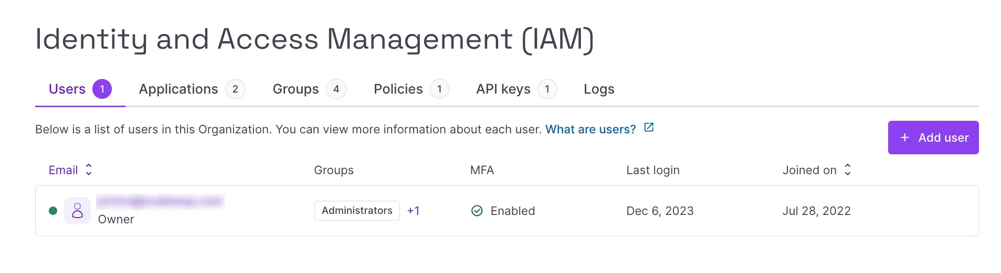
- Click the API keys tab.
- Click + Generate API key. The following screen pops up:
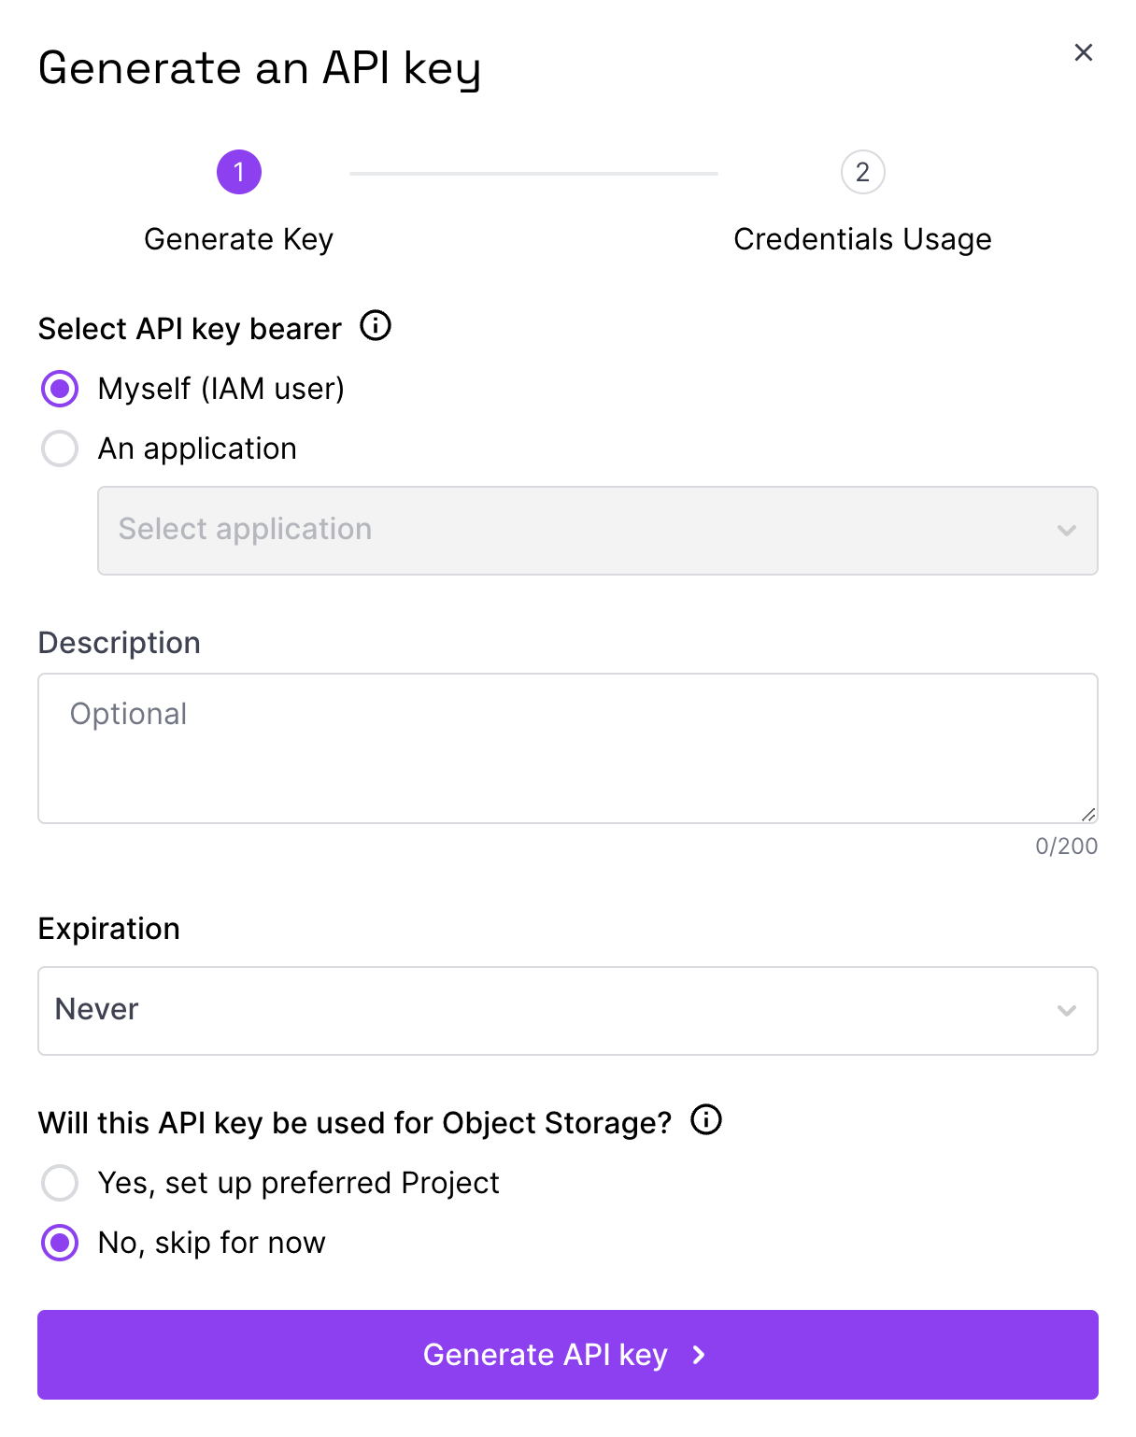
- Select the bearer of the API key. Choose between yourself (as an IAM user), or an IAM application associated with the Organization.
- Enter an optional description for the API key.
- Enter the desired expiration. Choose from:
    - Never: the API key will never expire,
    - 1 hour / week / month / year: the API key will expire at the end of the selected period,
    - Custom: you are prompted to enter a date on which the API key will expire.
- Select whether the API key will be used for Object Storage. Choose from:
    - Yes, set up preferred Project: you are prompted to select a Project that the API key will always use for Object Storage operations.
    - No, skip for now: the Project that you are currently navigating in the console (i.e. the one that is selected in your Project dashboard) will be automatically selected as the preferred Project for Object Storage.
- Click the Generate API key. A screen displays showing the access key and secret key for your new API key and reminding you that this is your only chance to securely save the secret key:
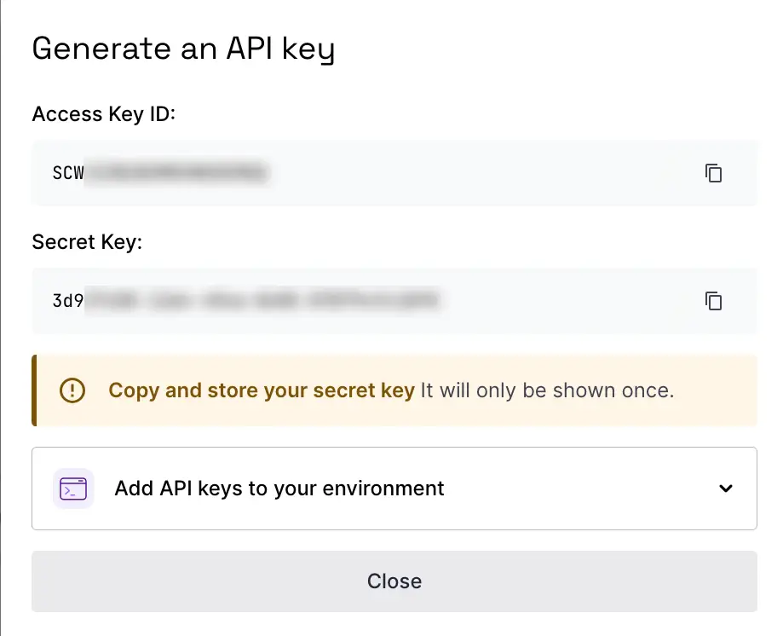
- Ensure you have securely saved the secret key, then close the window. You are returned to the API keys tab, where your new API key now appears in the list.
Note: Need to add payment method to get €100 free credit
Reference doc: How to create API keys | Scaleway Documentation

Devices
- Mobile

Platforms
- Android
- IOS

Importing the App
To import the Scaleway Generative AI App to Volt MX Iris, do the following:

To import the Scaleway Generative AI app, do the following:
- Launch Volt MX Iris.
- Click project, and then select Import. The Import dialog box appears.
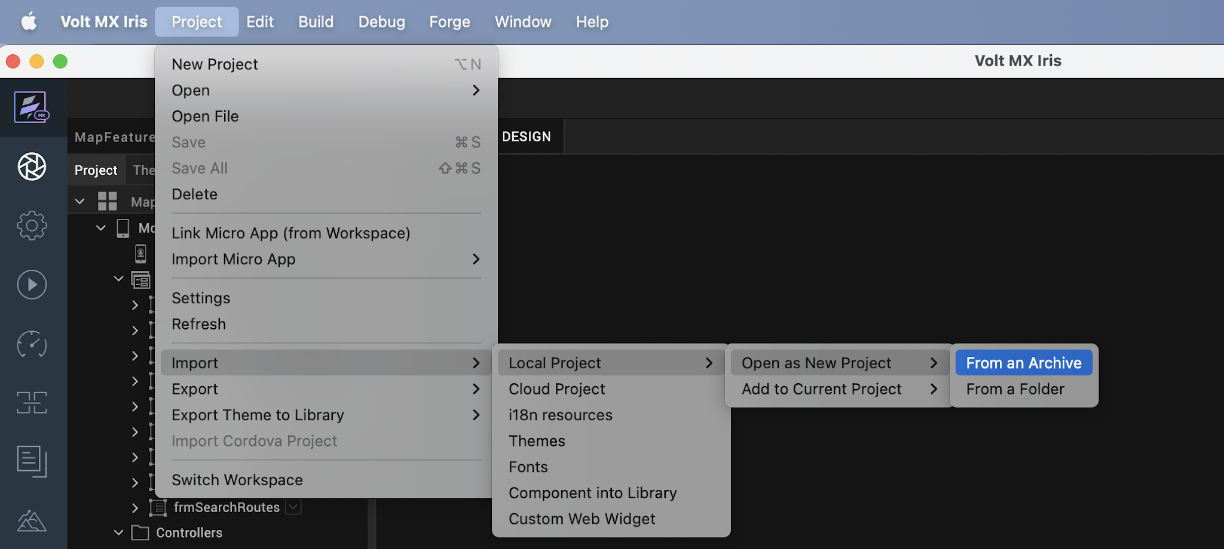

- Click From an Archive to navigate to the location of the project, select the files, and then click Import.
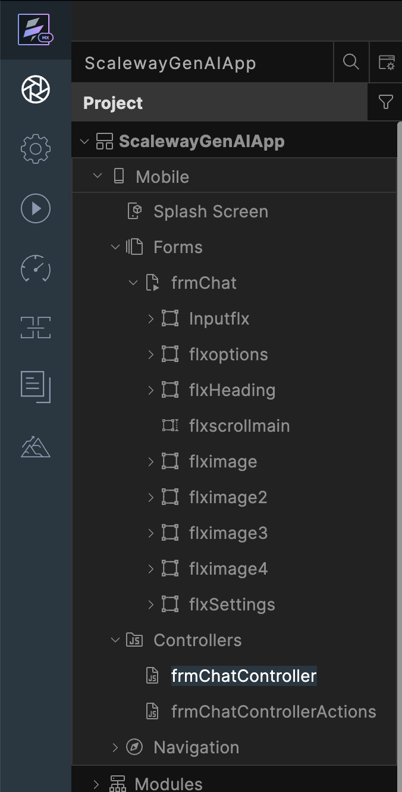
After you import the application, you can view the associated Foundry app connected at the in Data & Services section.
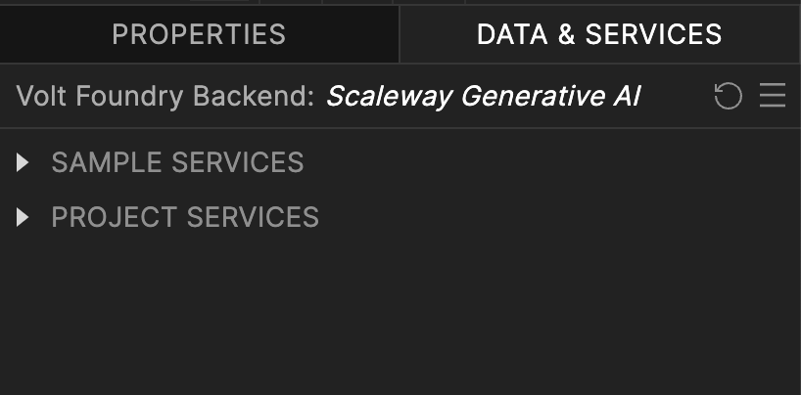

Scaleway Generative AI Volt MX Foundry Services:
When you import the application to your Volt MX Iris project, the HCL Volt MX Foundry services of the Scaleway Generative AI are added to the HCL Volt MX Foundry app, which is associated with the Volt MX Iris project. While importing the Scaleway Generative AI App to your Volt MX Iris project, if there is no HCL Volt MX Foundry app associated with the existing Volt MX Iris project, a new HCL Volt MX Foundry app is automatically added to your HCL Volt MX Foundry environment and is associated with your Volt MX Iris.
To set up the Foundry app, follow these steps:

Click the HCL Volt MX Foundry app associated with your Volt MX Iris project from the Project Explorer. Click on DATA & SERVICES.

Under the Configure Services tab, click Integration and can see the Scaleway Generative AI Integration service. Click on that Integration service to add the keys.
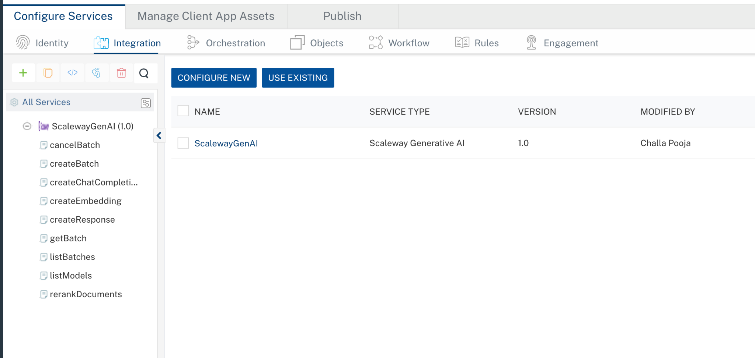

Click the Operations List tab. The Operations List tab opens with the list of operations available.
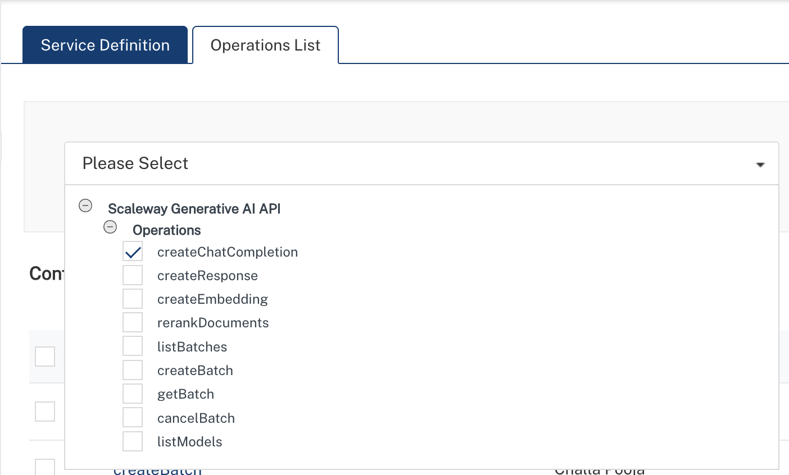

Executing an operation
Executing an operation involves making the API call by setting the necessary parameters and displaying the response. The procedure to execute any operation is the same, but the request parameters of the APIs vary. This section provides steps to execute the createChatCompletion (explained in Creating an Operation).
Steps to execute the createChatCompletion operation:
- Log on to your Hcl Foundry. The Dashboard page appears by default.
- In the left pane, click the API Management menu. The APIs tab opens by default.
- Click the Integration tab. The Integration tab opens with a list of existing integration services.
- From the list of integration services, select the integration service that you have created with service type as createChatCompletion. The Service Definition tab of the selected integration service opens by default.
- Click the Operations List tab.
- In the Name box, the name of the operation is displayed by default. If you want, you can change the name.
- On the Request Input tab, in the Body section, for the following parameters, specify the values in the respective boxes under the Test Value column.
Parameter | Description | Syntax Example
model (Required) | Specifies which AI model to use for the request. Available models depend on your Scaleway configuration. | "model": "openai/gpt-oss-120b"
messages (Required) | Array of conversation messages. Each message must include a role (system, user, or assistant) and content. | "messages": [{"role": "user", "content": "Generate a Java program to reverse a string"}]
temperature (Optional) | Controls randomness of output. Lower values produce deterministic responses; higher values increase creativity. | "temperature": 0.7
max_tokens (Optional) | Maximum number of tokens the model can generate in the response. | "max_tokens": 4096
top_p (Optional) | Nucleus sampling parameter that controls diversity by limiting token selection to a probability mass. | "top_p": 1
stream (Optional) | Enables real-time streaming response when set to true. | "stream": true
stop (Optional) | Specifies sequences where the API will stop generating further tokens. | "stop": ["\n", "###"]
presence_penalty (Optional) | Penalizes new tokens based on whether they appear in the text so far, encouraging new topics. | "presence_penalty": 0.6
frequency_penalty (Optional) | Penalizes repeated tokens based on their frequency in the text so far. | "frequency_penalty": 0.5
Note: In VoltMX Foundry, always provide values for required parameters. Optional parameters should only be included when you have valid values. Avoid sending empty strings, empty objects, or empty arrays for optional fields, as this may lead to validation errors. The request example includes all available parameters only for reference.
Additionally, the messages parameter (array of objects) must be passed completely within the messages value as a properly structured JSON array.
- Click Header sub-tab. The Header section opens.
- For Authorization, In the box under the DEFAULT VALUE column, type the API Key generated from Scaleway
Syntax: Authorization: Bearer <YOUR_API_KEY>
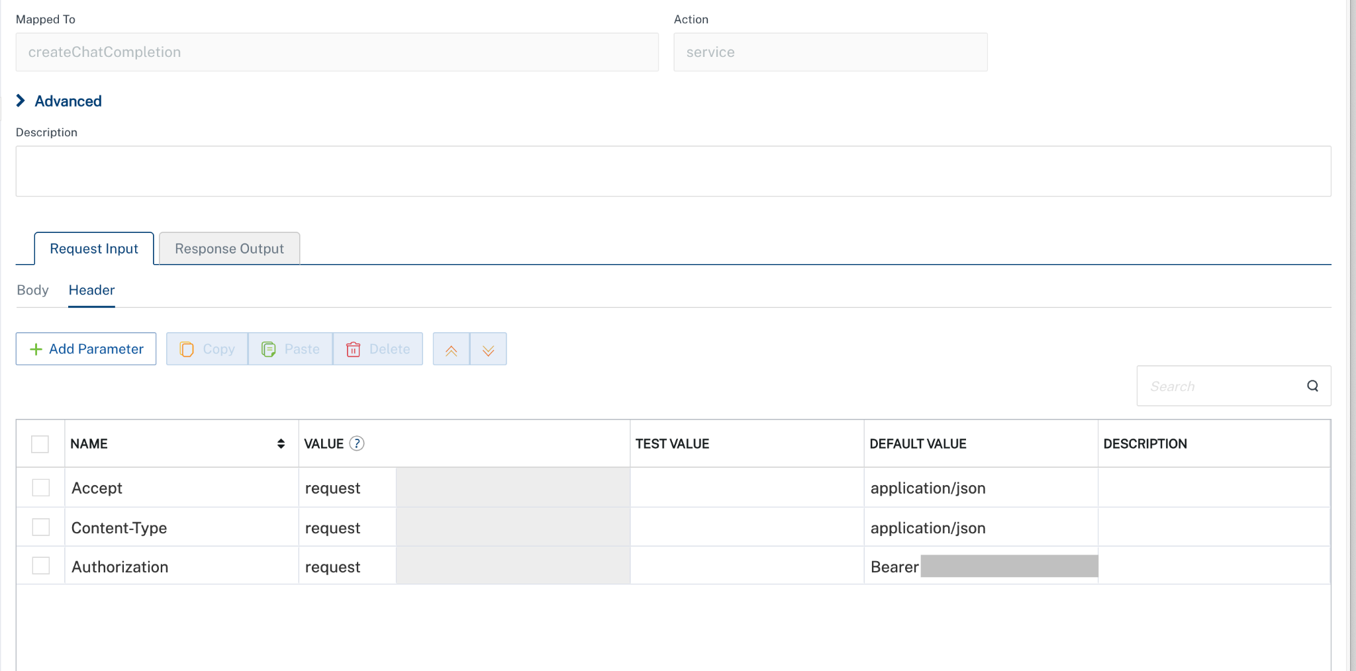
- Click SAVE AND FETCH RESPONSE. The Output Result dialog appears with the response. Otherwise, the Output Result shows an error. 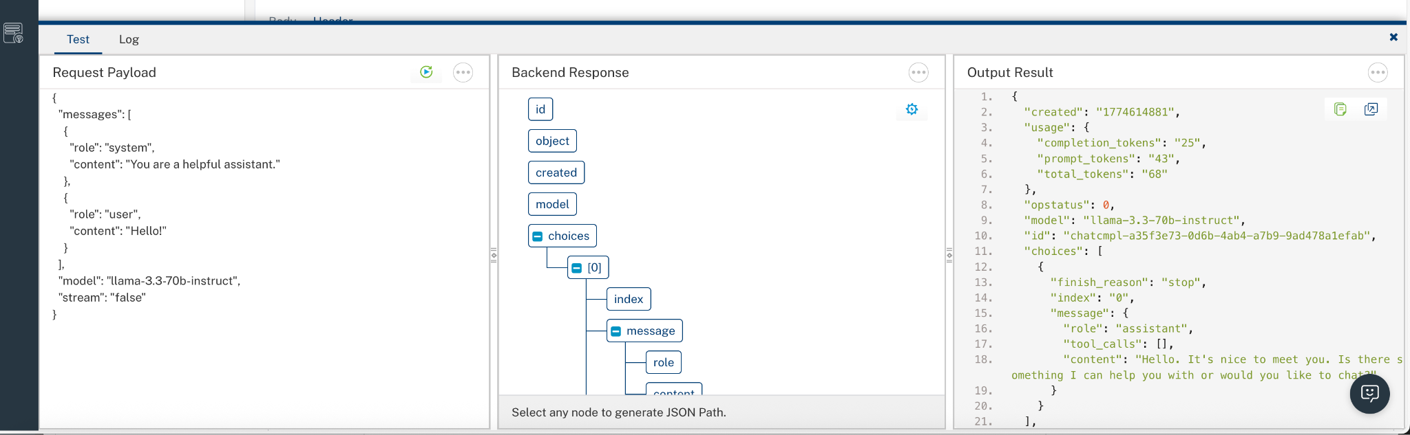

Configuring Native Settings (iOS)
To configure the native settings for iOS, follow these steps:
- From the Project explorer, go to Assets and expand Media.
- Right-click Common, and then select Resource Location. Volt MX Iris opens the common resources folder in a file explorer.
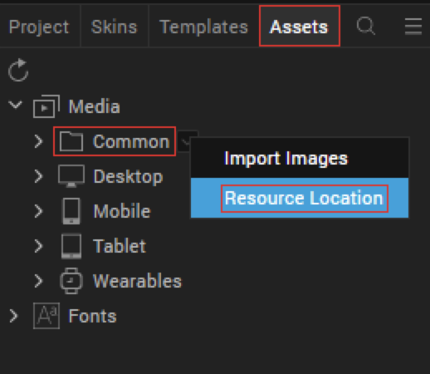
- Open the infoplist_configuration.json file with a text or code editor.
- At the end of the file, type the following code. You can change the description based on your preference.

"NSCameraUsageDescription": " This app uses Camera ",
"NSPhotoLibraryUsageDescription": "This app uses photo library"


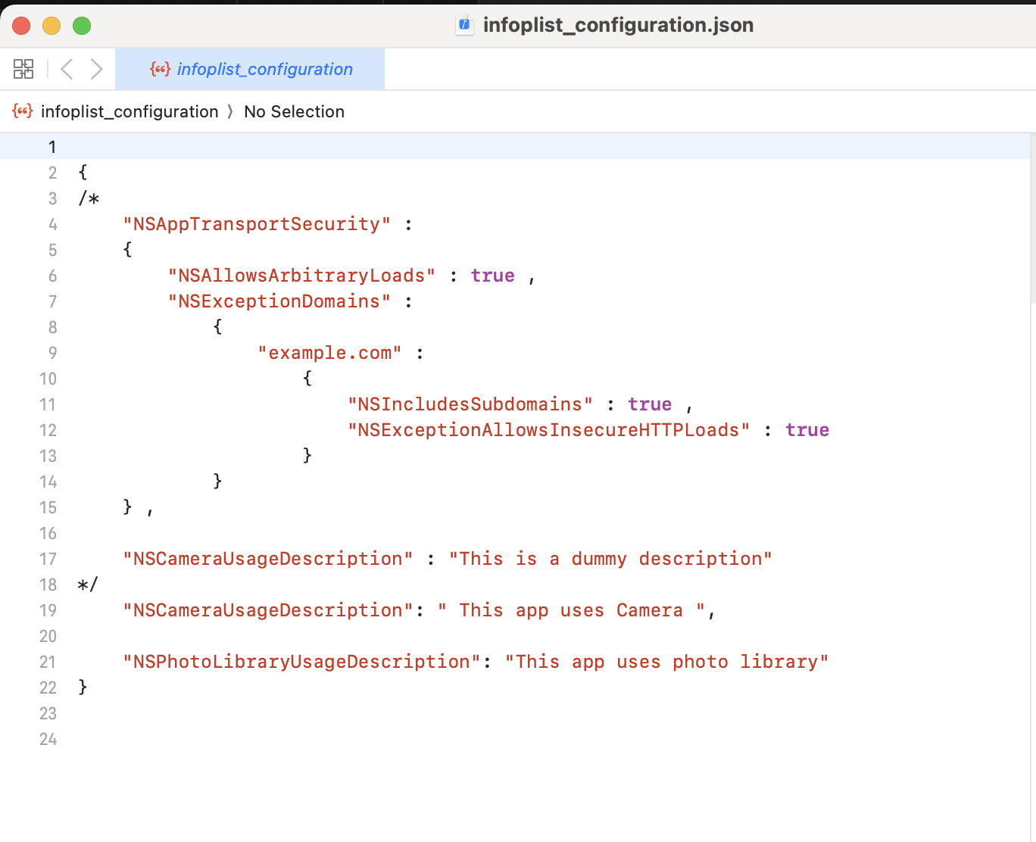
- Save the file.

Configuring Native Settings (Android)
To configure the native settings for Android, follow these steps:
- From the left navigation menu, click Project Settings.
- In the Project Settings window, go to Native → Android Mobile/Tablet.
- Set the permissions mentioned in the below image to true.
To set a permission to true, select the permission from the left panel, and then click Add.
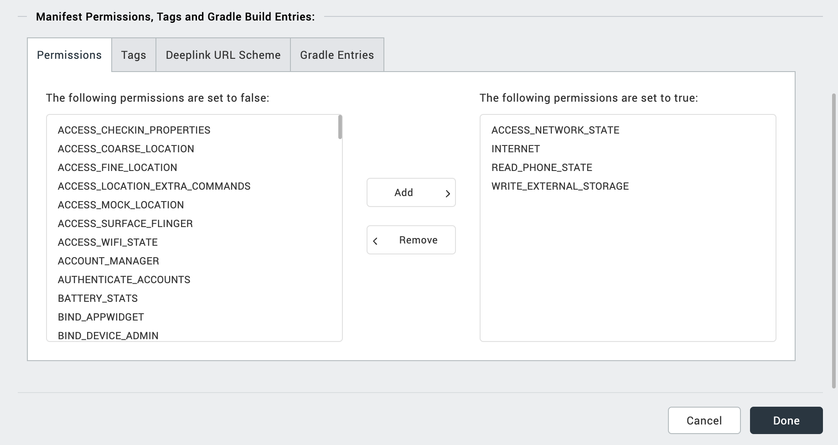
- Switch to the Tags tab.
- Add below Camera permission flag at Project Settings/Android Mobile/Tablet/Manifest Permissions, Tags and Gradle Build Entries/Tags

<uses-permission android:name="android.permission.READ_MEDIA_VISUAL_USER_SELECTED"/>
<uses-permission android:name="android.permission.READ_MEDIA_IMAGES" />
<uses-permission android:name="android.permission.READ_EXTERNAL_STORAGE" />

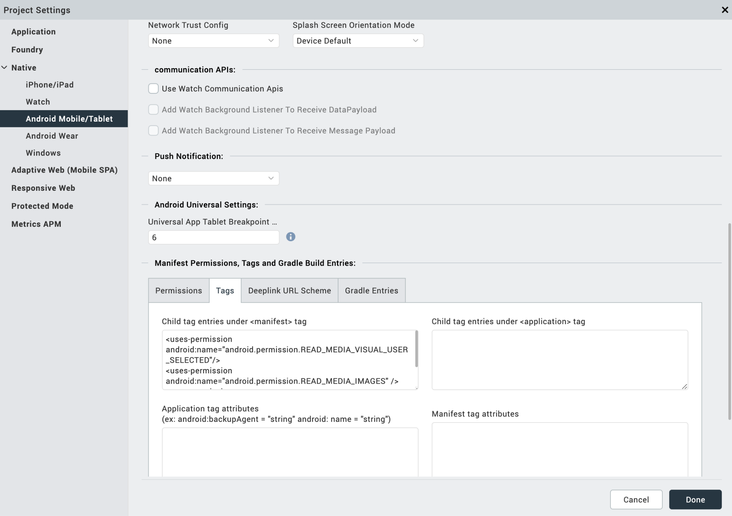
NOTE: If you do not add the gradle entries to your project, the app crashes.

PUBLISHING YOUR APPLICATION
After you set the Operation Security Level, you must publish the HCL Volt MX Foundry app. To publish the HCL Volt MX Foundry, follow these steps:

In Volt MX Iris, click DATA & SERVICES, and then click Publish Project Services to Publish to your foundry app.

Select the environment to which you want to publish your app, and then click Publish. After the app is published to your environment, the following window appears confirming the publish.

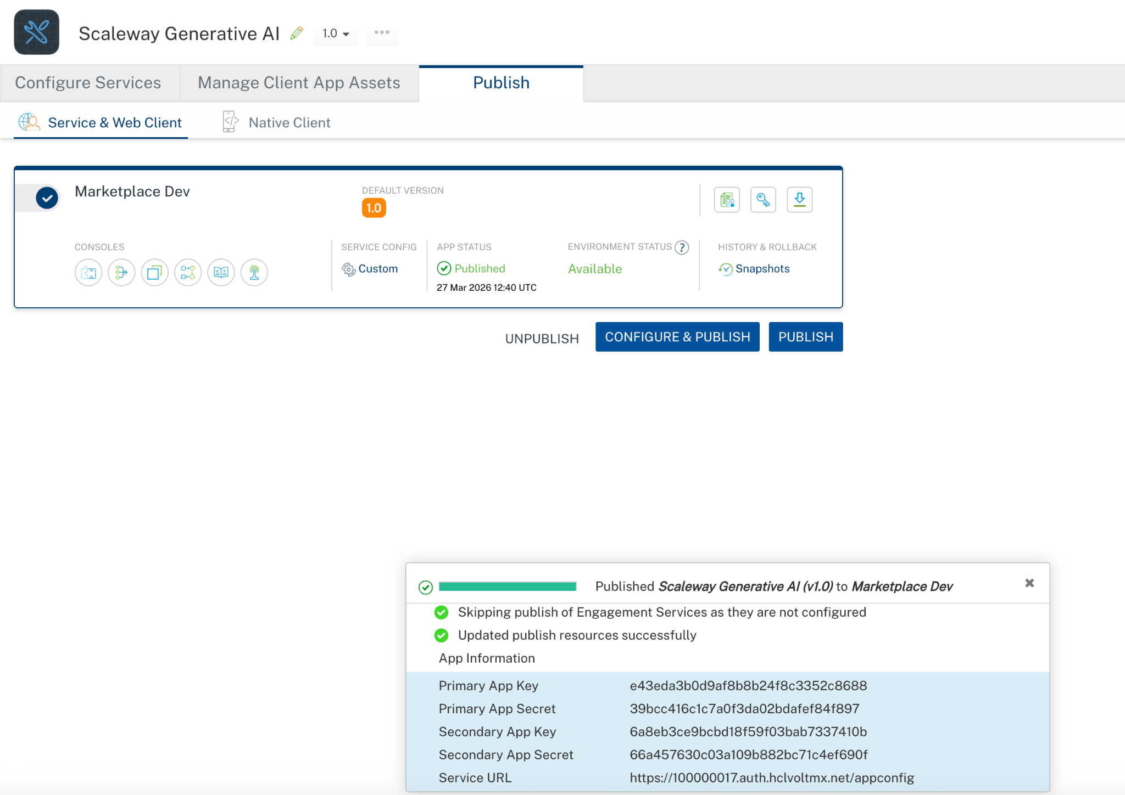

Building the app
From the menu bar, go to Build and then select Build Native Local.

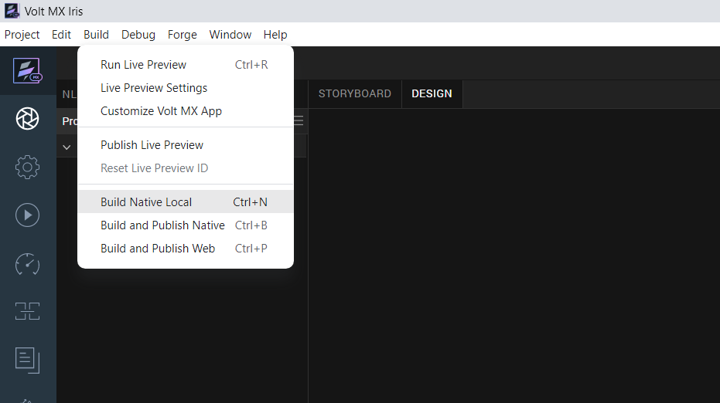

For Mobile, select Android and iOS. Click Build.
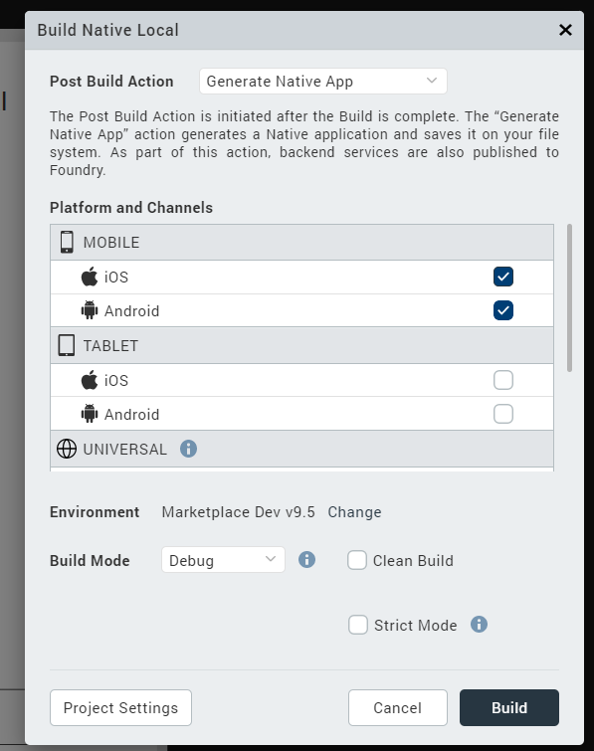

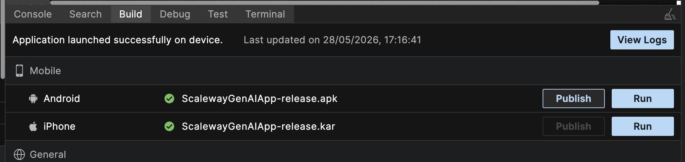

After the build is successful, run the app on your mobile device.

H. Application Flow
The landing page for the app is as follows:
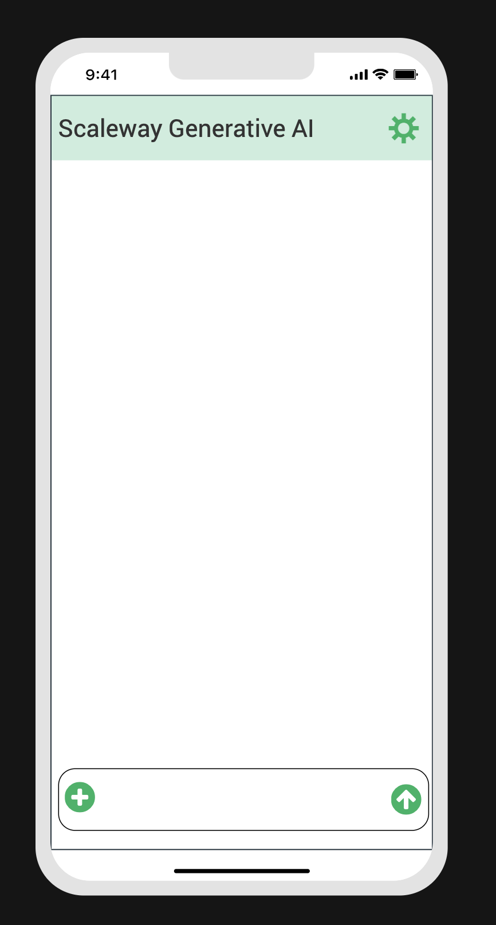

Click the + icon to upload image(s) and enter your prompt in the input field. The app supports up to 4 images per request, sends model and message content to createChatCompletion, and displays the assistant response in the chat area. Use the settings icon to change the model before sending.

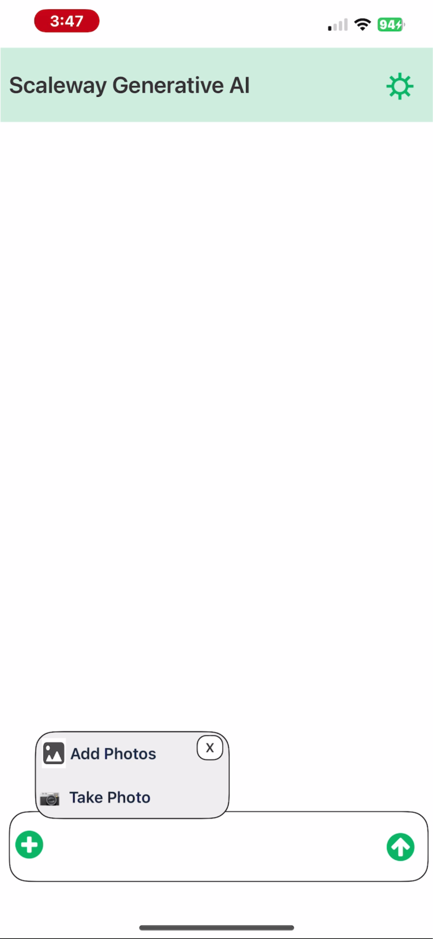
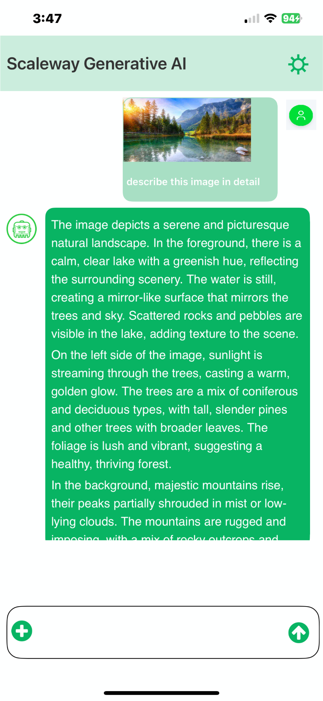

Note: Scaleway Generative AI Adapter is present in the Marketplace page.
Marketplace link: https://marketplace.hclvoltmx.com/items/scaleway-generative-ai-adapter

REFERENCES

Endpoint Documentation
- Generative APIs
- Generative APIs Documentation | Scaleway Documentation
- Supported models | Scaleway Documentation
- Generative APIs FAQ | Scaleway Documentation
- What are Rate limits with Scaleway Generative APIs | Scaleway Documentation
- Model-as-a-service Solutions Pricing

REVISION HISTORY
App version 1.0.0:
  - Known Issues
None
  - Limitations
None

