28 Mar 2023

Refresh ANIMATION (WAVE)

VERSION: 1.0.2

Overview
The Refresh Animation (Wave) component is a user defined animated UI. The refresh animation is used to fill the space when a container widget is pulled down to refresh the contents in the form.

Use case:
Consider a case that you want to develop an entertainment app that helps a user to access latest songs. In this app, you can add the Refresh Animation (Wave) component to fill the space when a list (or page) is pulled down to update the play-list. Using the APIs, you can hide the Refresh Animation component when the list refresh is complete.
The Refresh Animation (Wave) component is a ready-to-use component. You can import the Refresh Animation (Wave) component into your app (created in Voltmx iris), and achieve the Refresh Animation (Wave) feature without developing it from scratch. The Refresh Animation (Wave) component also facilitates a set of properties and APIs that helps you customize the UI elements and the functionality.

Percentage of re-use:
80-90%.

Getting Started

Prerequisites
Before you start using the Refresh Animation (Wave) component, ensure you have the following:
• HCL Foundry
• Volt MX Iris

Platforms Supported

Mobile

iOS

Android

Importing the app

You can import the Forge components only into the apps that are of the Reference Architecture type.

To import the Refresh Animation (Wave) component, do the following:

Open your app project in Volt MX Iris.

In the Project Explorer, click the Templates tab. 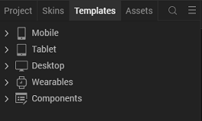

Right-click Components, and then select Import Component. The Import Component dialog box appears. 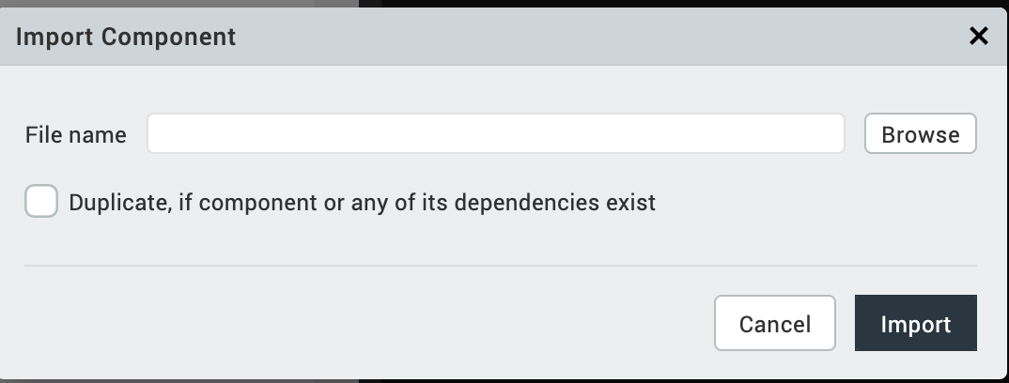

Click Browse to navigate to the location of the component, select the component and then click import. The component and its associated widgets

and modules are added to your project. 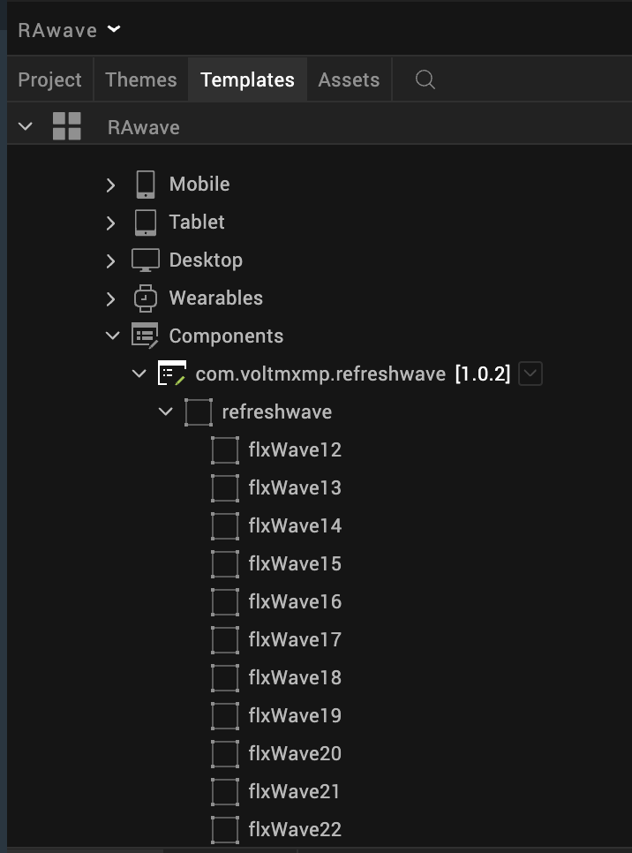

Once you have imported a component to your project, you can easily add the component to a form. For more information, refer Add a Component to a Form

Building and previewing the app
After performing all the above steps, you can build your app and run it on your device. For more information, you can refer to the Building and Viewing an Application section of the Volt MX User Guide.
You can then run your app to see the Refresh Animation (Wave) work in real time.

References

Dynamic Usage
You can also add Refresh Animation (Wave) component dynamically. To do so,
- In Project Explorer, on the Projects tab, click Controllers section to access the respective Form Controller. Create a method and implement the code snippet like the sample code mentioned below.
/* creating a component's Object */

var refreshwave = new com.voltmxmp.refreshwave({

"autogrowMode": voltmx.flex.AUTOGROW_NONE,

"clipBounds": true,

"height": "16.49%",

"id": "refreshwave",

"isVisible": true,

"layoutType": voltmx.flex.FREE_FORM,

"left": "0dp",

"masterType": constants.MASTER_TYPE_USERWIDGET,

"skin": "voltmxmprwsknFlxBackground20223c",
// "slFbox",

"top": "0dp",

"width": "100%",

"zIndex": 1

}, {}, {});

refreshwave.skinOFWave = "voltmxmprwsknFlxBlueRoundedCorner"; refreshwave.backgroundSkin = "voltmxmprwsknFlxBackground20223c";

refreshwave.durationofAnimation = "1";

this.view.add(refreshwave);
In the code snippet, you can edit the properties of the component as per your requirement. For more information, see Setting Properties.
2. Save the file

Properties
The properties provided on the Component tab allow you to customize the UI elements in the Refresh Animation (Wave) component. You can set the properties directly on the Component tab or by writing a JavaScript. This section provides information on how to set properties by writing a JavaScript.

General Properties
1. ANIMATION SPEED
Description: | Specifies the duration of the refresh animation. The duration value is specified in seconds.
Syntax: | durationOfAnimation
Type: | String
Read/Write: | Read + Write
Remarks: | The property throws an exception if you provide an invalid value. You must handle the exception.
Example: | this.view.refreshwave.durationOfAnimation = "1";

Skin

You can select skins from the Exposed Skins drop-down list on the Skin tab. This section provides information on how to set Skin by writing a JavaScript.

2. Background Skin
Description: | Specifies the skin to be set as the background of the component.
Syntax: | backgroundSkin
Type: | String
Read/Write: | Write
Remarks: | Before you set the property, ensure that the skin ID that you specify already exists in your app project. Changes made to the skin are reflected only during run time, but not during the design time
Example: | this.view.refreshwave.backgroundSkin = "skinname";

3. Wave Skin
Description: | Specifies the skin to be set as the background of the wave.
Syntax: | skinOFWave
Type: | String
Read/Write: | Write
Remarks: | - The skin must have zero percent border opacity with round corners.  - Changes made to the skin are reflected only during run time, but not during the design time.  - Before you set the property, ensure that the skin ID that you specify already exists in your app project.
Example: | this.view.refreshwave. skinOFWave= "skinname";

C. APIs
The following API pertains to the Refresh Animation (Wave) component:

i. show
Description: | The API displays the refresh animation.
Syntax: | show()
Parameter: | None
ReturnValue: | None
Example: | this. view.refreshwave.show();

ii. hide
Description: | The API hides the refresh animation.
Syntax: | hide()
Parameter: | None
ReturnValue: | None
Example: | this. view. refreshwave.hide();

iii. isShown
Description: | The API notifies whether the refresh animation is displayed or not.
Syntax: | isShown()
Parameter: | None
ReturnValue: | Boolean
Example: | Var returnValue = this.view. refreshwave.isShown()

Sample Usage of the Component

Component with the Segment Widget
Consider a use case where user pulls down a list to update the list data. You can use the Refresh Animation component to fill the space when the list (segment widget) is pulled down to refresh the data. You can achieve the use case by following the below procedure.
To use the component in the Segment Widget, do the following:
- Import the Refresh Animation component.
- Add a Flex Container Widget to the form.
- Set the Layout Type of the FlexContainer Widget to Flow Vertical.
- Drag the Refresh Animation component and the Segment Widget onto the FlexContainer Widget.
- Set the left and top margin values of the Refresh Animation component to required percent.
- In the Project Explorer, on the Projects tab, click the context menu arrow of Controllers under the respective channel, and then click FormController. The FormController JavaScript file opens in the Code Editor.
- Copy and paste the following code snippet in the Action editor:
define({
onNavigate: function(){
this.view.segment.scrollingEvents ={
onPull: this.PostShow.bind(this)
};
},
PostShow : function(){
this.view.refreshwave.setVisibility(true);
this.view.refreshwave.show();
this.view.segment.top = "24.49%";
this.view.flxmain.forceLayout();
voltmx.timer.schedule("timer4",this.hide,5, false);
},
hide:function(){
this.view.refreshwave.setVisibility(false);
this.view.segment.top = "8%";
this.view.flxmain.forceLayout();
}
});
The above code displays the Refresh animation component on triggering the onPull event of the Segment Widget.
8. Save the file.

Component with the FlexContainer Widget
To use the component in the FlexContainer Widget, do the following:
- Import the Refresh Animation (Wave) component.
- Drag the Refresh Animation (Wave) component and the FlexContainer Widget onto the Form.
- Set the left and top margin values of the Refresh Animation (Wave) component to Zero percent.
- Set the left and top margin values of the FlexContainer Widget to Zero percent.
- Define the onTouchStart, onTouchMove, and onTouchEnd events of the Form as shown in following code snippet:
/*Call the methods in the forms Action editor*/
/*onTouchStart of the Form */
this.onStart(y);
/*onTouchMove of the Form */
this.onMove(y);
/*onTouchEnd of the Form */
this.onEnd();
- In the Project Explorer, on the Projects tab, click the context menu arrow of Controllers under the respective channel, and then click FormController. The FormController JavaScript file opens in the Code Editor.
- Copy and paste the following code snippet in the FormController JavaScript file:
/* Define methods in the Form Controller */
define({
yCoordinates: "0",
_top: "0",
_started: 0,
onStart: function (yy) {
this.yCoordinates = yy;
if (this._started === 0) {
this.view.componentInstance.show();
this._started = 1;
}
},

onMove: function (y) {
this._top = y - this.yCoordinates;
if (this._top > 0) {
this.view.flexContainer.top = this._top;
} else {
this.view.flexContainer.top =
parseInt(this.view. componentInstance.height) + this._top + "dp";
}
},
onEnd: function () {
if (this._top >= 0) {
this.view.flexContainer.top = this.view.componentInstance.height;
} else {
this.view.flexContainer.top = "0dp";
this.view.componentInstance.hide();
this._started = 0;
}

}

});
The above code displays the Refresh Animation (Wave) component on triggering the Form events.
- Save the file.

Revision History
App version 1.0.2:

