28 Mar 2023

Refresh ANIMATION (SHOPPING CART)

VERSION: 1.1.2

Overview
Refresh Animation - Cart component is an animated UI that provides re-usable template to be used as a refresh animation screen. It is used by the app user to fill the space when widget is pulled down to refresh the contents in the form. The user can modify the properties to achieve the look and feel that is compliant with his/ her needs.

Use case:
Considering a case that you want to develop an e-commerce app. In this app, you can add the Refresh Animation (Shopping Cart) component to fill the available space when a list (or page) is pulled down to refresh the product list. You can hide the Refresh Animation component when the list refresh is complete.

The Refresh Animation (Shopping Cart) component is a ready-to-use component. You can import the Refresh Animation (Shopping Cart) component into your app (created in Voltmx iris), and achieve the Refresh Animation (Shopping Cart) feature without developing it from scratch. The Refresh Animation (Shopping Cart) component also facilitates a set of properties and APIs that helps you customize the UI elements and the functionality.

Percentage of re-use:
80-90%.

Getting Started

Prerequisites
Before you start using the Refresh Animation (Shopping Cart) component, ensure you have the following:
• HCL Foundry
• Volt MX Iris

Platforms Supported

Mobile

iOS

Android

Importing the app

You can import the Forge components only into the apps that are of the Reference Architecture type.

To import the Refresh Animation (Shopping Cart) component, do the following:

Open your app project in Volt MX Iris.

In the Project Explorer, click the Templates tab. 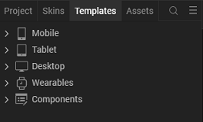

Right-click Components, and then select Import Component. The Import Component dialog box appears. 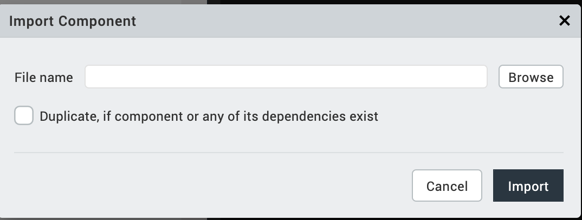

Click Browse to navigate to the location of the component, select the component and then click import. The component and its associated widgets and modules are added to your project. 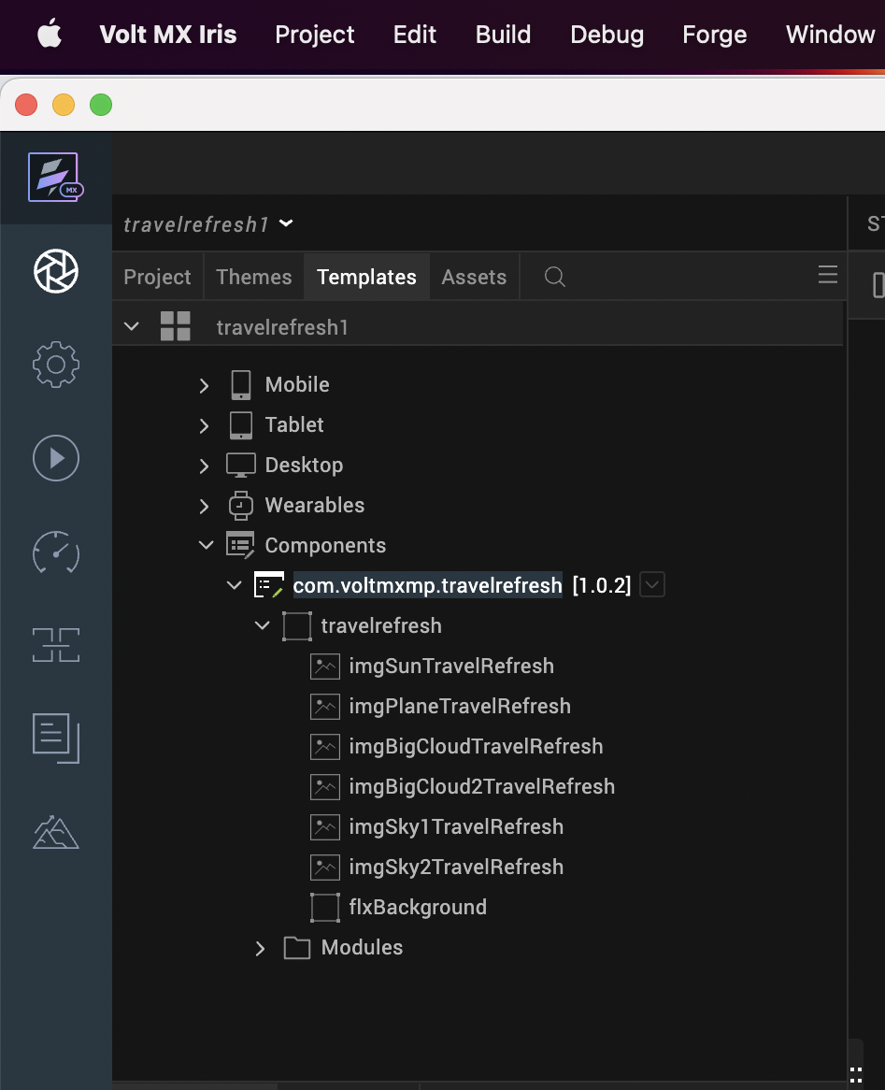
Once you have imported a component to your project, you can easily add the component to a form. For more information, refer Add a Component to a Form

Building and previewing the app
After performing all the above steps, you can build your app and run it on your device. For more information, you can refer to the Building and Viewing an Application section of the Volt MX User Guide.
You can then run your app to see the Refresh Animation (Shopping Cart) work in real time.

References

Dynamic Usage
You can also add Refresh Animation (Shopping Cart) component dynamically. To do so,
- In Project Explorer, on the Projects tab, click Controllers section to access the respective Form Controller. Create a method and implement the code snippet like the sample code mentioned below.
/* creating a component's Object */

var refreshcart = new com.voltmxmp.refreshcart({

"autogrowMode": voltmx.flex.AUTOGROW_NONE,

"clipBounds": true,

"height": "19.19%",

"id": "refreshcart",

"isVisible": true,

"layoutType": voltmx.flex.FREE_FORM,

"left": "0dp",

"masterType": constants.MASTER_TYPE_USERWIDGET,

"skin": "voltmxmprcsknflxBackground20223c",

"top": "0dp",

"width": "100%",

"zIndex": 1

}, {}, {});
refreshcart.largeLinesSource = "voltmx_mp_rc_dashlong.png";
refreshcart.mediumLinesSource = "voltmx_mp_rc_dashmid.png";
refreshcart.smallLinesSource = "voltmx_mp_rc_dashsmall.png";
refreshcart.cartSource = "voltmx_mp_rc_shape.png";
refreshcart.wheelSource = "voltmx_mp_rc_path.png";
refreshcart.backgroundSkin = "voltmxmprcsknflxBackground20223c";
refreshcart.durationOfAnimation = "1";
this.view.add(refreshcart);
In the code snippet, you can edit the properties of the component as per your requirement. For more information, see Setting Properties.
2. Save the file

Properties
The properties provided on the Component tab allow you to customize the UI elements in the Refresh Animation (Shopping Cart) component. You can set the properties directly on the Component tab or by writing a JavaScript. This section provides information on how to set properties by writing a JavaScript.

General Properties

IMAGE SOURCE
1. Large Lines Source
Description: | Specifies the file name of the image to be displayed as large lines during the refresh animation.
Syntax: | largeLinesSource
Type: | String
Read/Write: | Read + Write
Remarks: | Changes made to the property are reflected only during run time, but not during the design time (Visualizer Canvas).  Before setting the property:  - Ensure that the image file exists in the workspace\resources\common directory.  - Do not add any uppercase characters in the file name of the image.  - Ensure that the image is in PNG format.  Specify the file name of the image along with the extension.
Example: | this.view.refreshcart.largeLinesSource= "voltmx_mp_rc_dashlong.png”

2. Medium Lines Source
Description: | Specifies the file name of the image to be displayed as medium lines during the refresh animation.
Syntax: | mediumLinesSource
Type: | String
Read/Write: | Read + Write
Remarks: | Changes made to the property are reflected only during run time, but not during the design time (Visualizer Canvas).  Before setting the property:  - Ensure that the image file exists in the workspace\resources\common directory.  - Do not add any uppercase characters in the file name of the image.  - Ensure that the image is in PNG format.  Specify the file name of the image along with the extension.
Example: | this.view.refreshcart.mediumLinesSource= "voltmx_mp_rc_dashmid.png”

3. Small Lines Source
Description: | Specifies the file name of the image to be displayed as small lines during the refresh animation.
Syntax: | smallLinesSource
Type: | String
Read/Write: | Read + Write
Remarks: | Changes made to the property are reflected only during run time, but not during the design time (Visualizer Canvas).  Before setting the property:  - Ensure that the image file exists in the workspace\resources\common directory.  - Do not add any uppercase characters in the file name of the image.  - Ensure that the image is in PNG format.  Specify the file name of the image along with the extension.
Example: | this.view.refreshcart.smallLinesSource= "voltmx_mp_rc_dashsmall.png";

4. Cart Source
Description: | Specifies the file name of the image to be displayed as the cart during the refresh animation.
Syntax: | cartSource
Type: | String
Read/Write: | Read + Write
Remarks: | Before setting the property:  - Ensure that the image file exists in the workspace\resources\common directory.  - Do not add any uppercase characters in the file name of the image.  - Ensure that the image is in PNG format.  Specify the file name of the image along with the extension.
Example: | this.view.refreshcart.cartSource= "voltmx_mp_rc_shape.png";

5. Wheel Source
Description: | Specifies the file name of the image to be displayed as the wheel during the refresh animation.
Syntax: | wheelSource
Type: | String
Read/Write: | Read + Write
Remarks: | Before setting the property:  - Ensure that the image file exists in the workspace\resources\common directory.  - Do not add any uppercase characters in the file name of the image.  - Ensure that the image is in PNG format.  Specify the file name of the image along with the extension.
Example: | this.view.refreshcart.wheelSource= "voltmx_mp_rc_path.png";

Skin

You can select skins from the Exposed Skins drop-down list on the Skin tab. This section provides information on how to set Skin by writing a JavaScript.

6. Background Skin
Description: | Specifies the skin to be set as the background of the component.
Syntax: | backgroundSkin
Type: | String
Read/Write: | Read + Write
Remarks: | Before you set the property, ensure that the skin ID that you specify already exists in your app project.
Example: | this.view.refreshcart.backgroundSkin = "skinname";

7. Animation speed
Description: | Specifies the duration of the animation. The duration value is specified in seconds.
Syntax: | durationOfAnimation
Type: | String
Read/Write: | Read + Write
Remarks: | The property throws an exception if you provide an invalid value or a non-string value. User needs to handle this exception.
Example: | this.view.refreshcart.durationOfAnimation = "1";

C. APIs
The following API pertains to the Refresh Animation (Shopping Cart) component:

i. show
Description: | The API displays the refresh animation.
Syntax: | show()
Parameter: | None
ReturnValue: | None
Example: | this. view.refreshcart.show();

ii. hide
Description: | The API hides the refresh animation.
Syntax: | hide()
Parameter: | None
ReturnValue: | None
Example: | this. view. refreshcart.hide();

iii. isShown
Description: | The API notifies whether the refresh animation is displayed or not.
Syntax: | isShown()
Parameter: | None
ReturnValue: | Boolean
Example: | Var returnValue = this.view. refreshcart.isShown()

Sample Usage of the Component

Component with the Segment Widget
Consider a use case where user pulls down a list to update the list data. You can use the Refresh Animation component to fill the space when the list (segment widget) is pulled down to refresh the data. You can achieve the use case by following the below procedure.
To use the component in the Segment Widget, do the following:
- Import the Refresh Animation component.
- Add a Flex Container Widget to the form.
- Set the Layout Type of the FlexContainer Widget to Flow Vertical.
- Drag the Refresh Animation component and the Segment Widget onto the FlexContainer Widget.
- Set the left and top margin values of the Refresh Animation component to required percent.
- In the Project Explorer, on the Projects tab, click the context menu arrow of Controllers under the respective channel, and then click FormController. The FormController JavaScript file opens in the Code Editor.
- Copy and paste the following code snippet in the Action editor:
define({
onNavigate: function(){
this.view.segment.scrollingEvents ={
onPull: this.PostShow.bind(this)
};
},
PostShow : function(){
this.view.refreshcart.setVisibility(true);
this.view.refreshcart.show();
this.view.segment.top = "25.19%";
this.view.flxmain.forceLayout();
voltmx.timer.schedule("timer4",this.hide,5, false);
},
hide:function(){
this.view.refreshcart.setVisibility(false);
this.view.segment.top = "6.8%";
this.view.flxmain.forceLayout();
}
});
The above code displays the Refresh animation component on triggering the onPull event of the Segment Widget.
8. Save the file.

Component with the FlexContainer Widget
To use the component in the FlexContainer Widget, do the following:
- Import the Refresh Animation (Shopping Cart) component.
- Drag the Refresh Animation (Shopping Cart) component and the FlexContainer Widget onto the Form.
- Set the left and top margin values of the Refresh Animation (Shopping Cart) component to Zero percent.
- Set the left and top margin values of the FlexContainer Widget to Zero percent.
- Define the onTouchStart, onTouchMove, and onTouchEnd events of the Form as shown in following code snippet:
/*Call the methods in the forms Action editor*/
/*onTouchStart of the Form */
this.onStart(y);
/*onTouchMove of the Form */
this.onMove(y);
/*onTouchEnd of the Form */
this.onEnd();
- In the Project Explorer, on the Projects tab, click the context menu arrow of Controllers under the respective channel, and then click FormController. The FormController JavaScript file opens in the Code Editor.
- Copy and paste the following code snippet in the FormController JavaScript file:
/* Define methods in the Form Controller */
define({
yCoordinates: "0",
_top: "0",
_started: 0,
onStart: function (yy) {
this.yCoordinates = yy;
if (this._started === 0) {
this.view.componentInstance.show();
this._started = 1;
}
},

onMove: function (y) {
this._top = y - this.yCoordinates;
if (this._top > 0) {
this.view.flexContainer.top = this._top;
} else {
this.view.flexContainer.top =
parseInt(this.view. componentInstance.height) + this._top + "dp";
}
},
onEnd: function () {
if (this._top >= 0) {
this.view.flexContainer.top = this.view.componentInstance.height;
} else {
this.view.flexContainer.top = "0dp";
this.view.componentInstance.hide();
this._started = 0;
}

}

});
The above code displays the Refresh Animation (Shopping Cart) component on triggering the Form events.
- Save the file.

Revision History
App version 1.1.2:

