Recipients Web App

Asset Version: 1.0.1
The Recipients App is a use case to easily preview a basic banking application. The app offers configurable lists for accounts and recipients, and detail views for each recipient, with configured identity and object services.

Prerequisites – Volt MX Iris, HCL Foundry.
Devices/Platform – Web.
Published Url: https://marketplace.hclvoltmx.net/apps/RecipientsWebApp
Login Credentials for login into the app: test1@test.com/Test@999

Features:
• User Repository
• CRUD functionality
• Responsive Breakpoints

The app has the following entities:
Login: Contains key front-end capabilities typically used in a mobile or web app's login page. This screen has a configured connectivity to a User Repository.
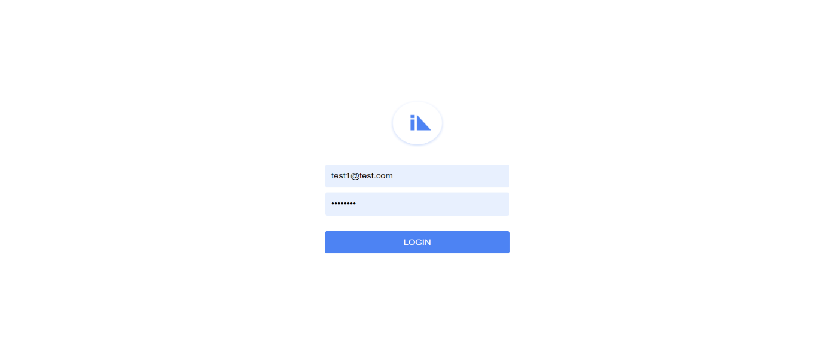

Accounts: A list of different accounts present in the User's profile, displays the name of the account along with the Balance in each account. This screen has a configured connectivity to a Storage Object service.
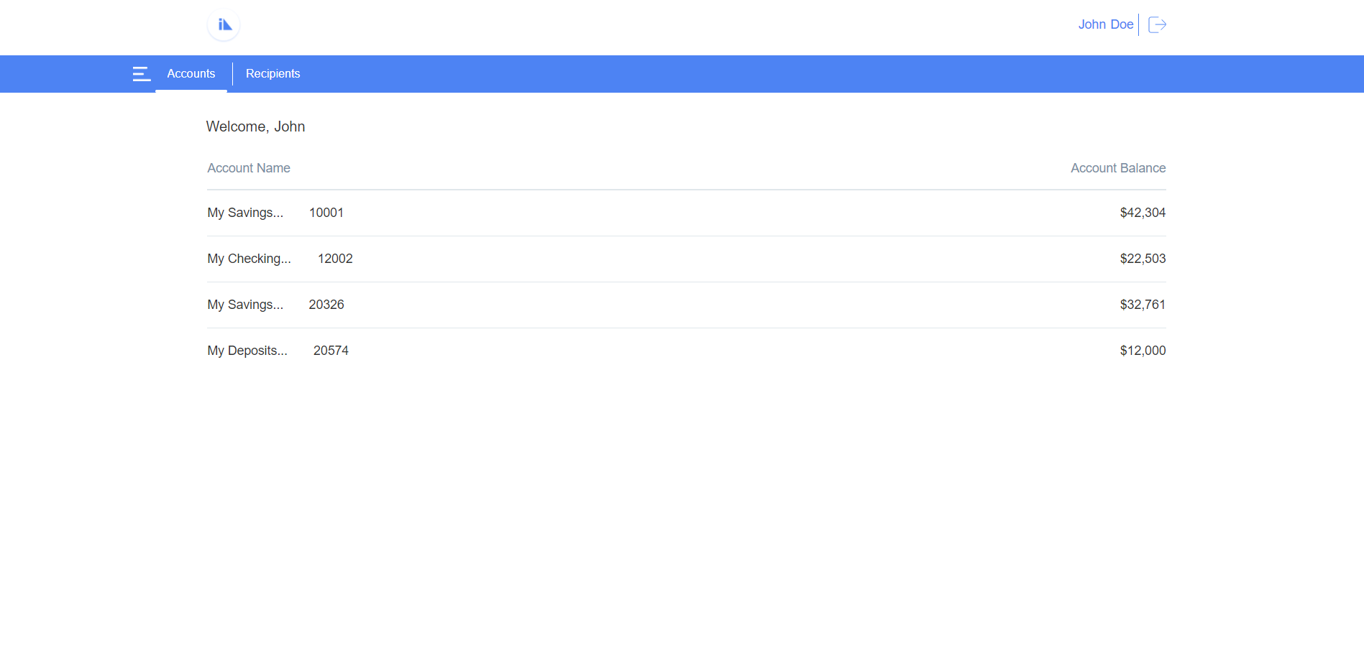

Recipients: A list of Recipients that the user has added/associated to the profile, displays the names of the recipients along with their phone numbers. This screen has a configured connectivity to a Storage Object service. In the Recipients screen, users also have an option to Add a recipient.
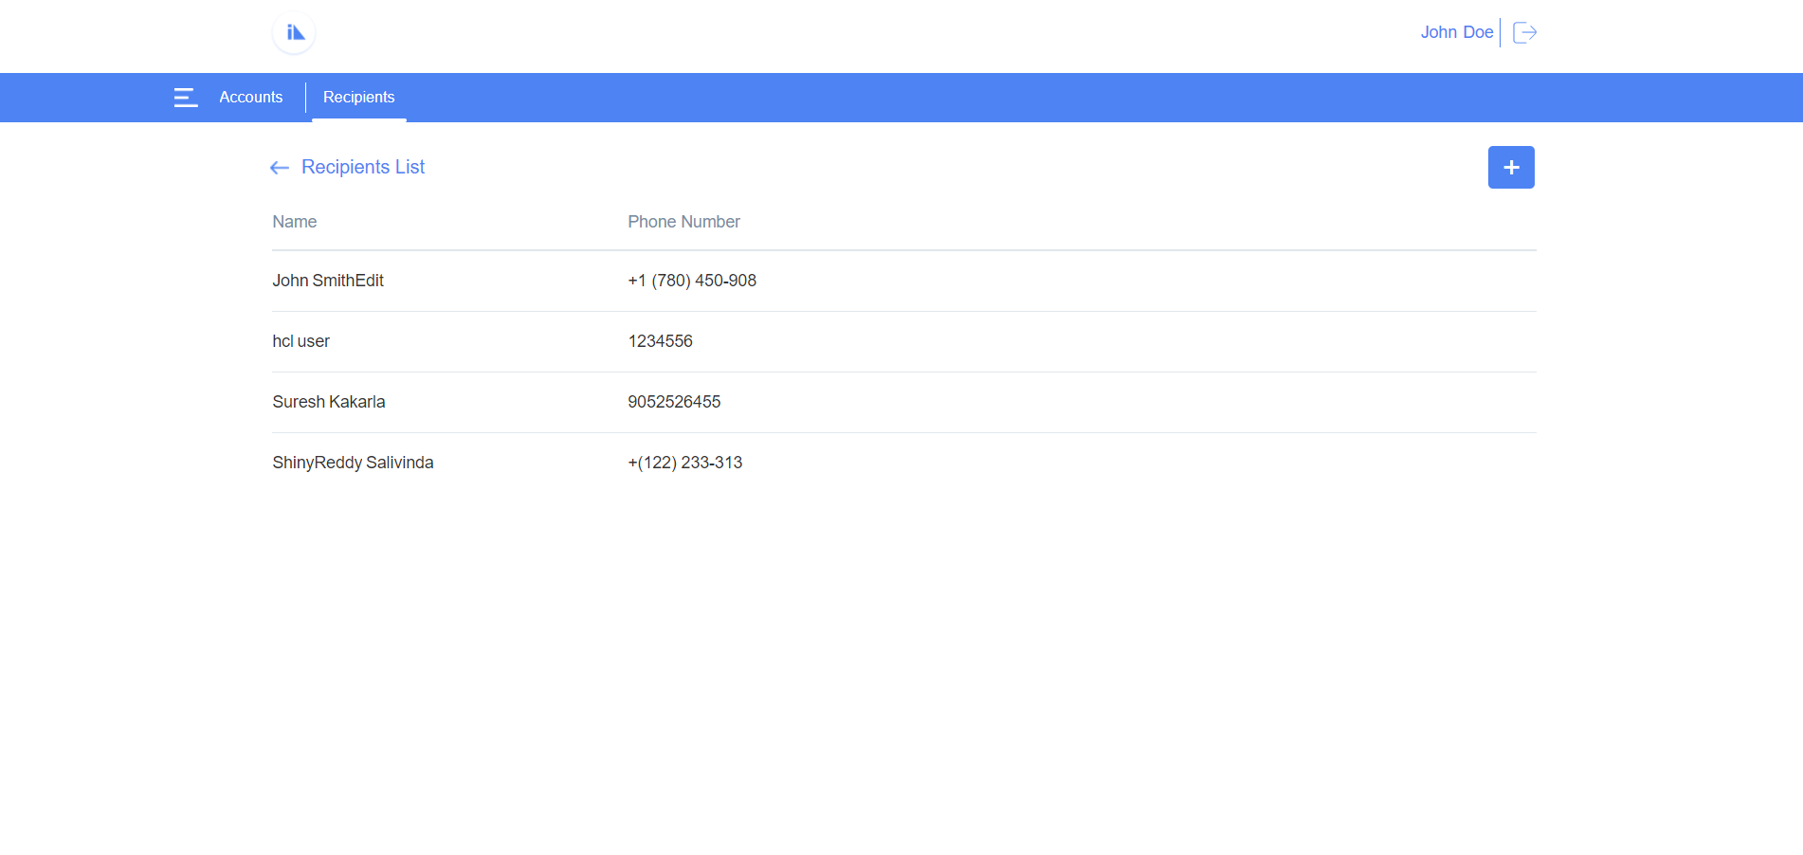

Add Recipient: A screen where new recipient can be added.
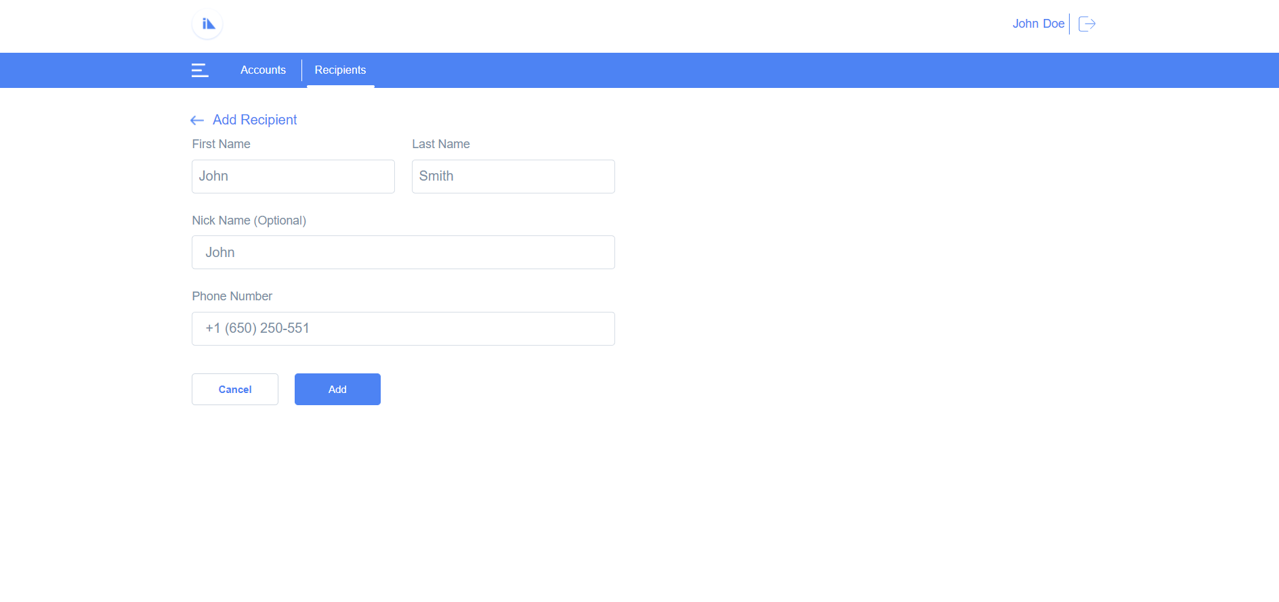

Recipient Details: A single screen detail view of the recipient details, displays all the data specific to a recipient. From the Recipient Details screen, users can edit the details of the recipient or delete the recipient.
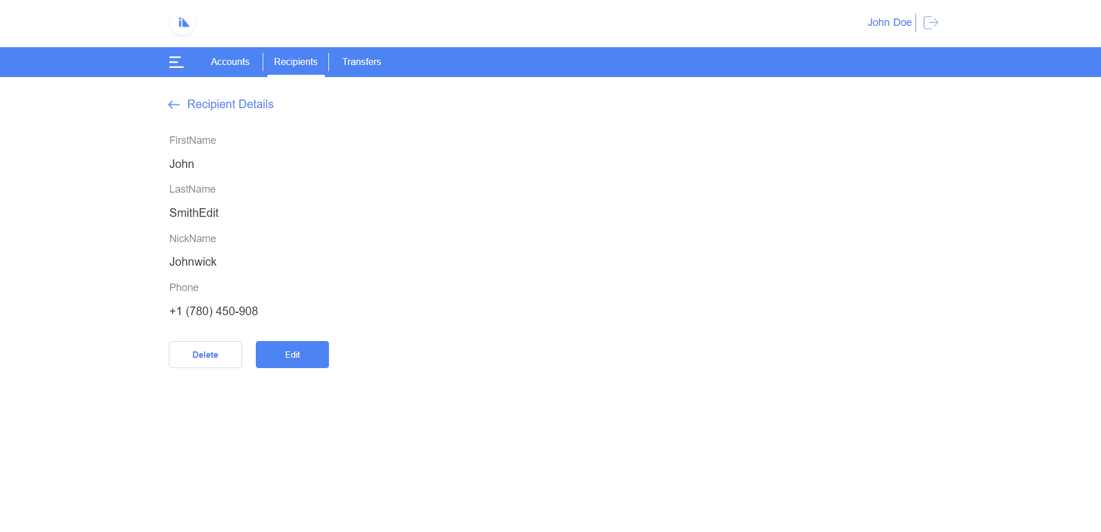

Delete Recipient: User can delete the recipient by clicking on delete button in recipient details screen.
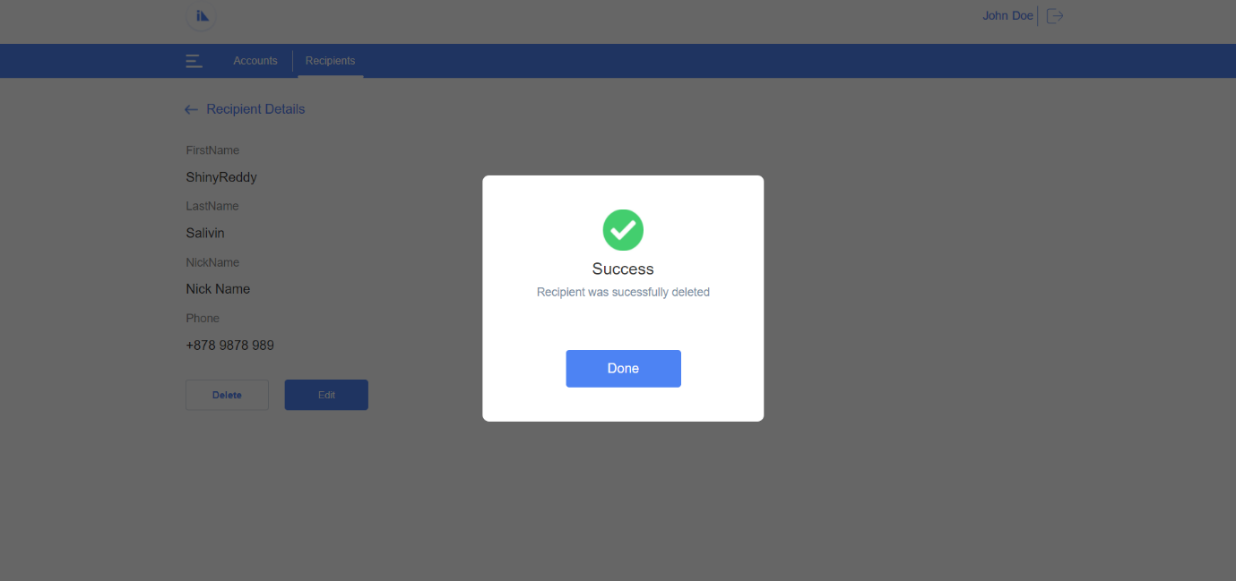

Edit Recipient: In this screen user can edit/update the recipient details.
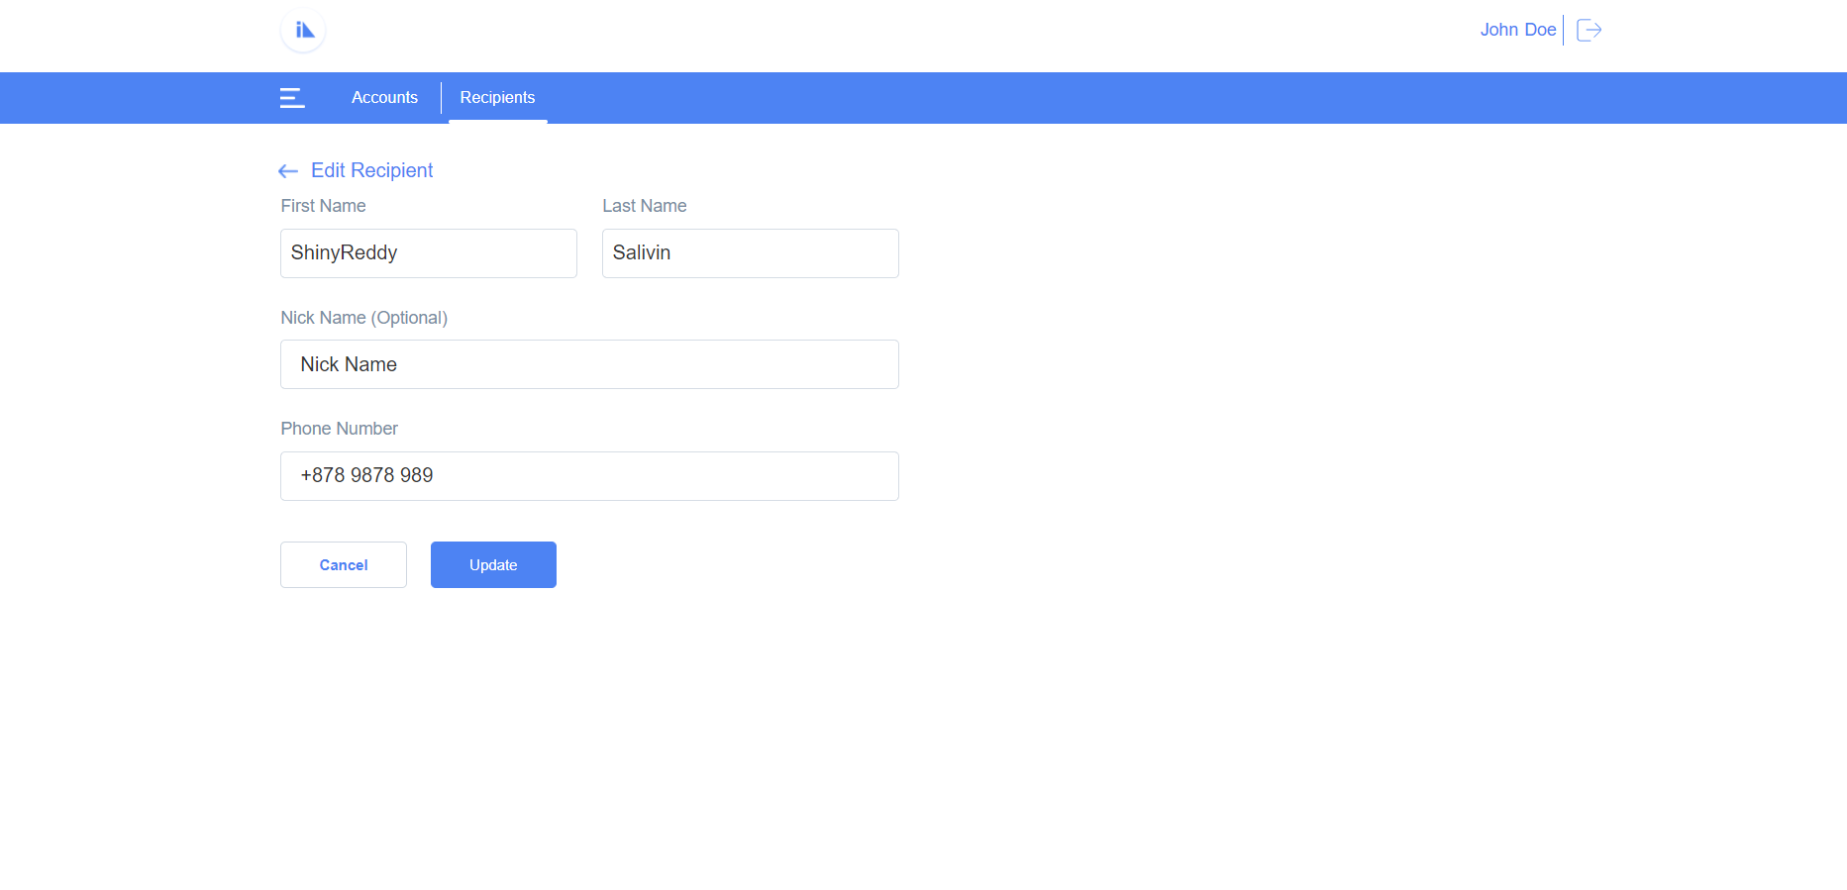

Import the App
To import the Recipients Web app into your workspace, follow these steps:
- Open Volt MX Iris
- On the main menu select Forge → Browse.
- Search for the Recipients Web app, and then click Import to Workspace. The app is imported to your workspace.
A dialog box appears, confirming that the app has been imported. Click OK.
- Switch to your project containing the Recipients Web app. To switch to your project, click File → Open → Reference Architecture → <project name>

Live Preview
After importing the Recipients Web app, you can preview the app using Live Preview.
To preview the app by using Live Preview, follow these steps:
- In Volt MX Iris Starter, click Build → Live Preview Settings from the main menu. The Live Preview Settings window opens.
Note: In Volt MX Iris Enterprise, click Preview → Run from the main menu to open the Live Preview Settings window.
- Select any application channel Responsive Web to preview the app. Click Save & Run.
After a successful preview build for the Desktop Web channel, the Iris Preview window opens displaying the Recipients Desktop Web application.

Recipients Volt MX Foundry Services:
1. The Recipient Mobile app contains an Identity Service:
Uses User Repository identity for to login into the app.
2. Recipients Mobile App Contains Object Services:
- Account Storage: By using data storage object service fetching Recipients account Details Such as name of the account along with the Balance in each account.
Operations:
- GET: Used to get the account details of Recipients

Account Storage data model contains below fields.
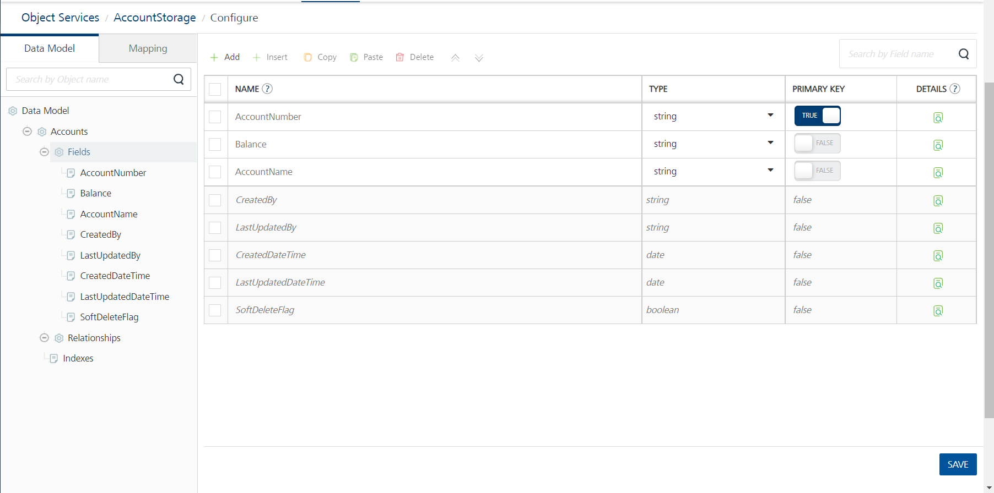

- Recipients Storage: By using data storage object service fetching Recipients Details Such as names of the recipients along with their phone numbers. And we can perform crud operation add, edit & delete functionalities.

Operations:
- GET: Used to get the Recipients details.
- PUT(Update): Used to update the Recipients details.
- POST(Create): Used to create new Recipient.
- DELETE: Used to delete a Recipient.

Recipients Storage data model contains below fields.

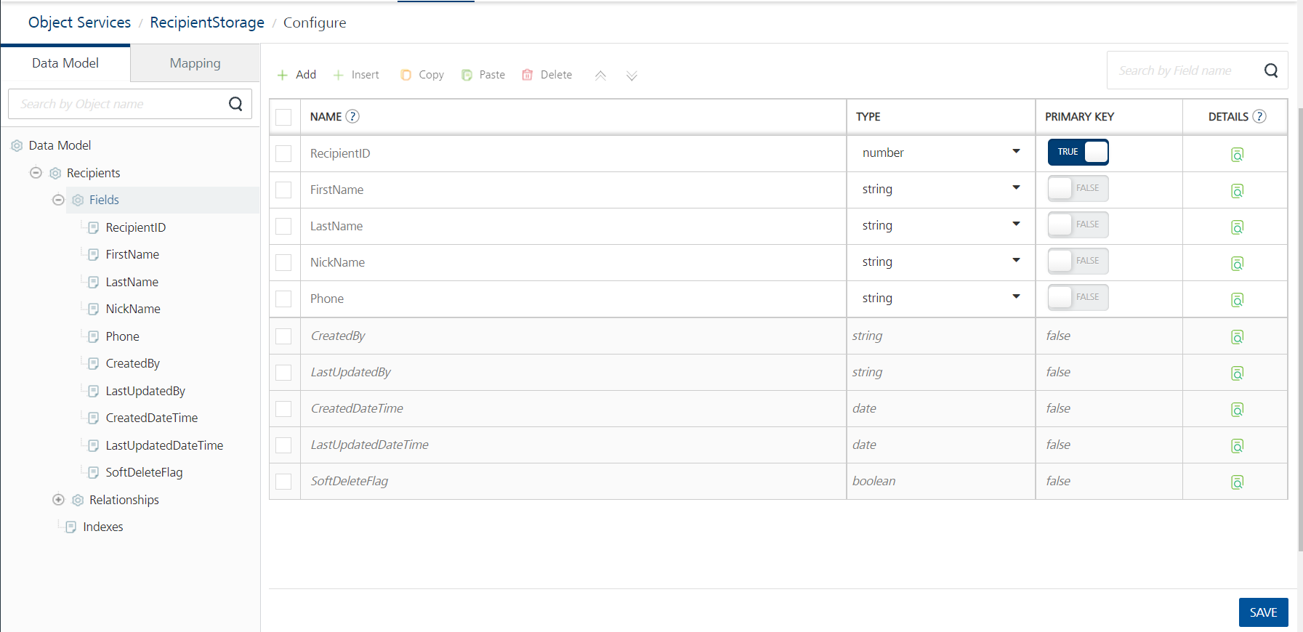

Revision History:
App version 1.0.1
Good To Have:
Max length validations for input fields in Add Recipient & Edit Recipient screens.
  - Known Issues:
NA

Limitations:
No Limitations.

