Date :  01-03-2024

Real-time product search

version: 1.0.0

# **Overview**

Fast and Comprehensive product search, offers, and reviews on Google Shopping - the largest product data aggregate in the world.

Use this API to search product offers from across the web in real-time from many major and minor stores on the web - Amazon, eBay, Walmart, Best Buy, Target and many others, all in a single API. Supports searching by keyword(s) and/or GTIN/EAN. Powered by Google Shopping.

# **Getting Started**

## **Prerequisites**

* Volt Foundry
* [**Rapid API Account**](https://rapidapi.com/letscrape-6bRBa3QguO5/api/real-time-product-search)
* X-RapidAPI-Key, X-RapidAPI-Host.

## **Importing the adapter**

**To import the Data Adapter to Volt Foundry, do the following:**

1. Sign in to the  [HCL Foundry](https://manage.hclvoltmx.com/).
2. From the left navigation menu, select **API Management**.
3. In **API Management**, select **Custom Data Adapters**.  
   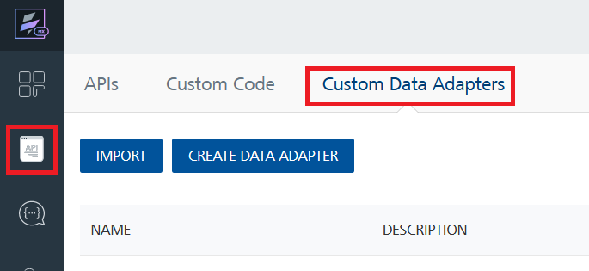
4. Click **IMPORT** to import a custom data adapter.  
   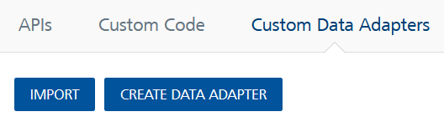
5. On the Import Data Adapter dialog box, click browser to import.  
   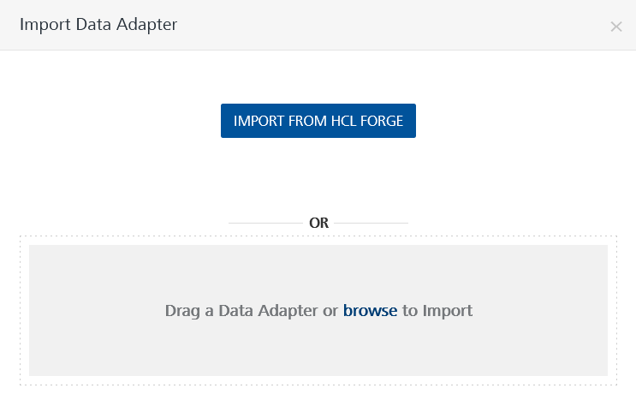
6. Select **Real-Time Product Search zip** file and click **IMPORT**.

After you import the data adapter, Volt Foundry opens a window that shows the metadata of the data adapter.

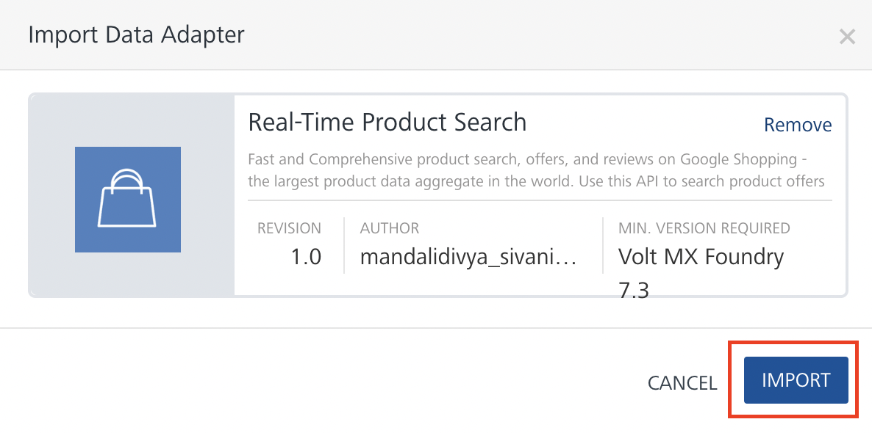

After you import the data adapter, you can view it on the Custom Data Adapters page and use it to create services on Volt Foundry.

## **Creating an Integration service**

After you import the data adapter into Volt Foundry, you can use it to create an Integration Service.

Follow the given steps to create an Integration service using the **Real-Time Product Search** Adapter.

1. Sign in to the [HCL Foundry](https://manage.hclvoltmx.com/).
2. From the left navigation menu, select **API Management**.
3. In **API Management**, select **Integration**.

1. To create a new service, click the **+** button or the **CONFIGURE NEW** button.

1. On the Service Definition tab, select the service type as**Real Time Product Search,** and click **SAVE**.

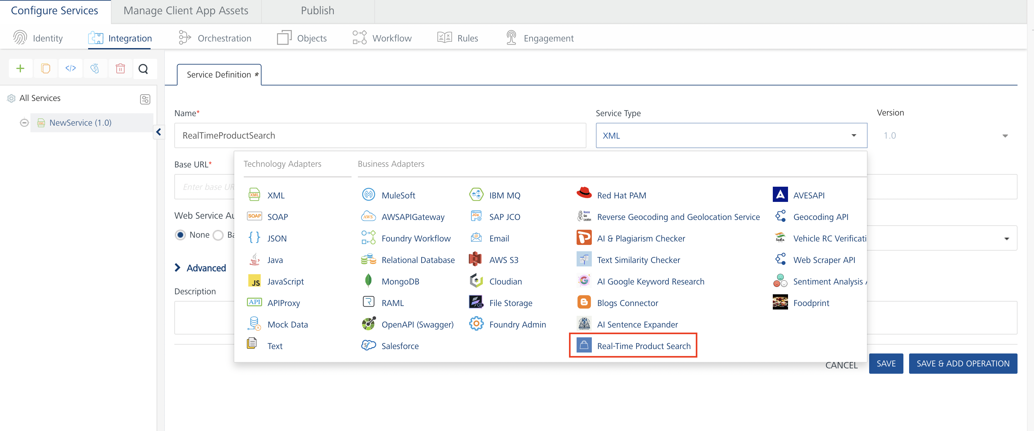

Alternatively, you can also create a Foundry app and create an Integration service inside it.

## **Creating and Executing operations**

After you create an integration service, you can create and execute operations using the service.

#### **Creating an Operation**

* In **API Management/Foundry app you created**, in the **Integration** section, select the service that you created.
* After you select the service, navigate to the **Operation List** tab.  
  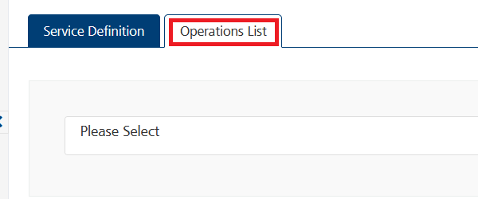
* From the drop-down list, select an operation that you want to execute, and click **ADD OPERATION**.

#### **Executing an Operation**

* From the **Operations List** tab, in the **Configured Operations** section, select the operation you want to execute.

**Note:**You can follow the same steps to create operations for other methods but ensure that you select the required API.

You can create multiple operations with required APIs and save them in the **Configured Operations** section. You can then execute the operations whenever required.

* On the Operation Page, in the **Request Input** tab, in the **Body** section, for the following parameters, specify the values in the respective boxes under the **Test Value** column.

**Mandatory Parameters**

* + **X-RapidAPI-Key, X-RapidAPI-Host [in header]:**  API Key associated with your RapidAPI account, required for authentication.

To get keys – Login in to [**Rapid API Account**](https://rapidapi.com/letscrape-6bRBa3QguO5/api/real-time-product-search)-> You can view your keys.

* + **q:** Free-form search query or GTIN/EAN

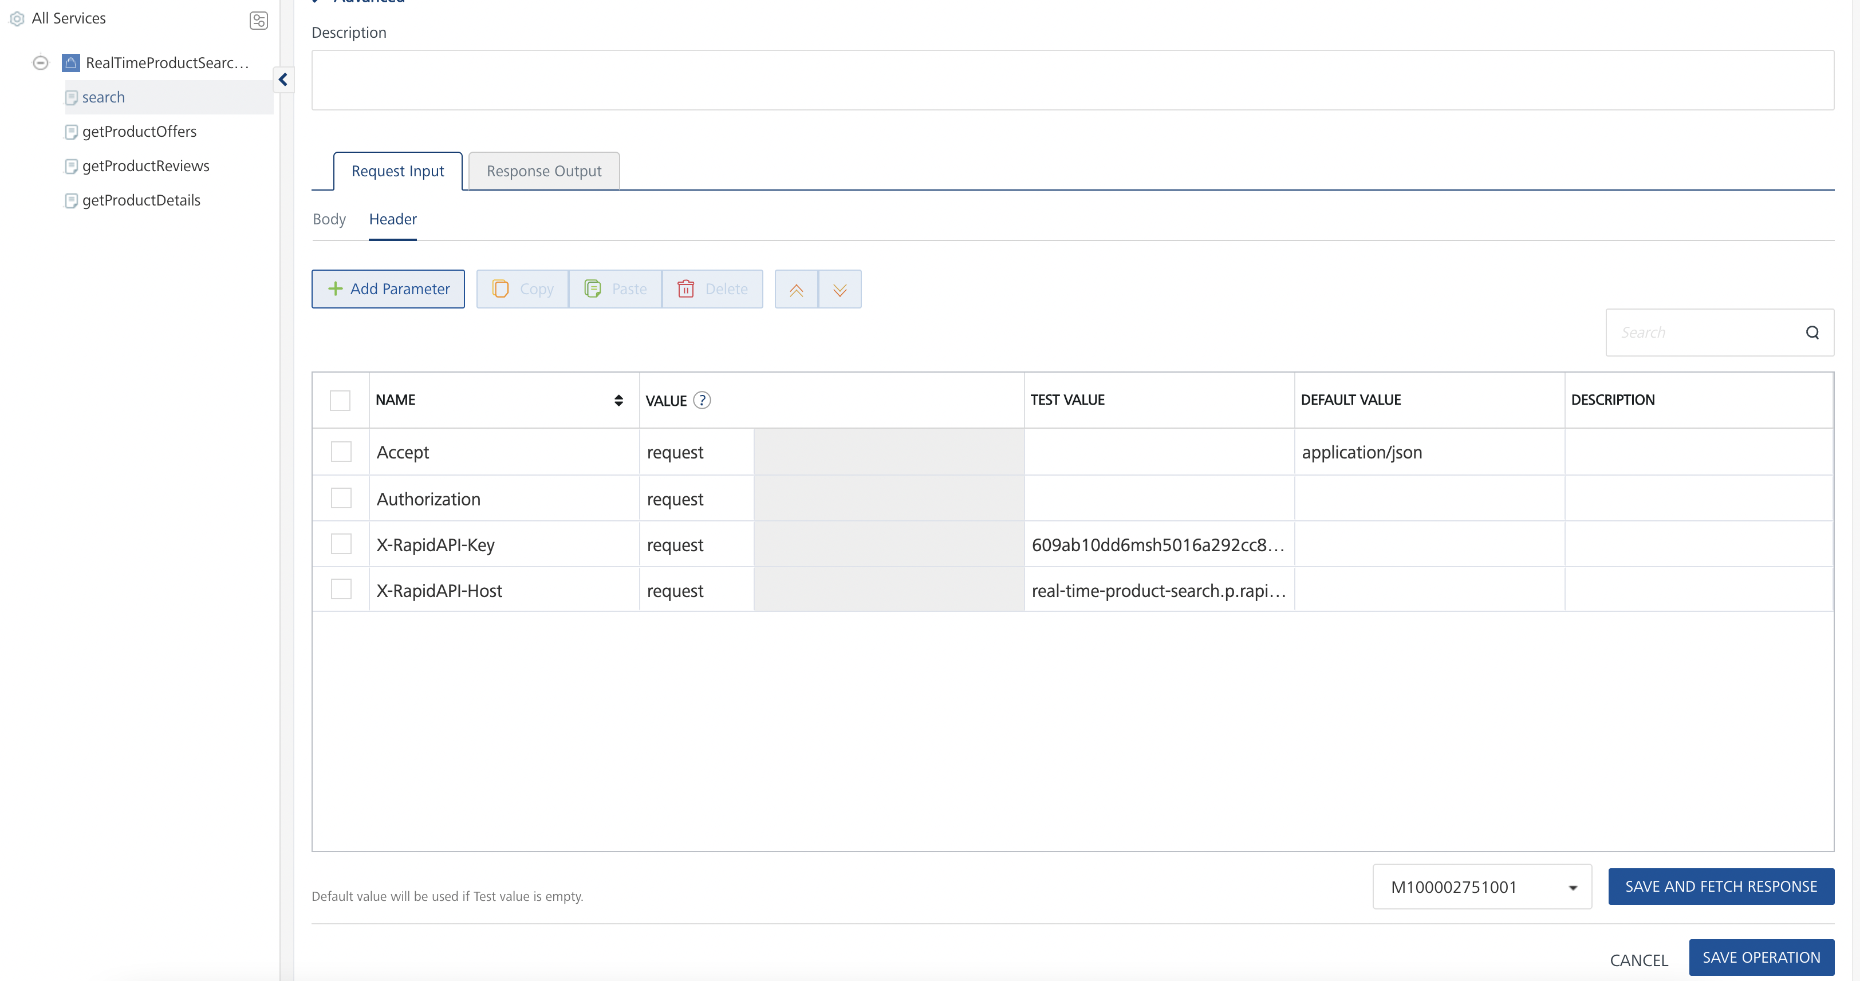

* Select a run-time environment and click **Save and Fetch Response** to get a response based on your inputs.

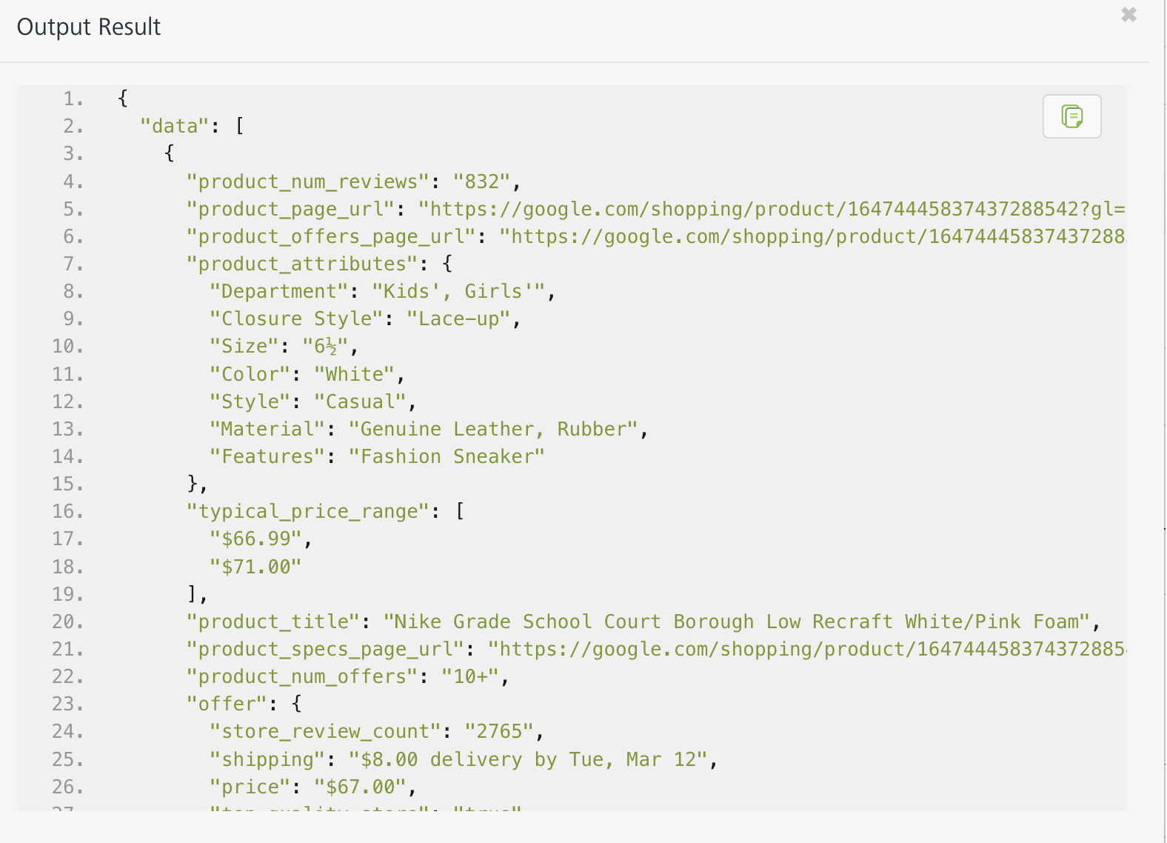

## **Publishing your application**

If you want to use the services in client applications, you need to publish an app to a run-time environment. You can create the service (as described above) in an application or import the service into an application and publish the application.

# **References**

## Endpoint Documentation

## **Requests Input Parameters for search**

|  |  |  |
| --- | --- | --- |
| **Parameter** | **Data Type** | **Description** |
| X-RapidAPI-Key | string | **[Required]** **[Header]**API Key associated with your account. |
| X-RapidAPI-Host | string | **[Required]** **[Header]** The host parameter specifies the domain name or IP address of the RapidAPI endpoint. In the context of the Real-Time Product Search, the default host is set to 'real-time-product-search.p.rapidapi.com'. This parameter is necessary for routing the request to the appropriate API endpoint. ary for routing the request to the appropriate API endpoint. |
| q | String | **[Required]** Free-form search query or GTIN/EAN |
| country | String | Country code of the region/country to return offers for. See [ISO 3166-1 alpha-2 codes](https://en.wikipedia.org/wiki/ISO_3166-1_alpha-2) for valid values. Default is "us". |
| language | String | The language of the results. See [ISO 639-1 codes](https://en.wikipedia.org/wiki/List_of_ISO_639-1_codes) for valid values. Default is "en". |
| page | Number | Results page to return. Each page contains up to 100 product results. Default is 1. |
| sort_by | Enum | Sort product offers by best match, top rated, lowest price, or highest price. Possible values: BEST_MATCH, TOP_RATED, LOWEST_PRICE, HIGHEST_PRICE. Default is BEST_MATCH. |
| min_price | Number | Only return product offers with price greater than this value. |
| max_price | Number | Only return product offers with price lower than this value. |
| product_condition | Enum | Only return products with a specific condition. Possible values: NEW, USED, REFURBISHED. |
| free_returns | Boolean | Only return product offers that offer free returns. Default is false. |
| free_shipping | Boolean | Only return product offers that offer free shipping/delivery. Default is false. |
| max_shipping_days | Number | Only return product offers that offer shipping/delivery of up to this number of days (shipping speed). |
| on_sale | Boolean | Only return product offers that are currently on sale. Default is false. |
| store_id | String | Only return product offers from specific stores. Store IDs should be comma-separated. |
| min_rating | Enum | Return products with rating greater than the specified value. Possible values: 1, 2, 3, 4. |
| other_filters | String | [EXPERIMENTAL] Other filters for dynamic filtering (e.g., by Size, Color). Values should be separated by commas when multiple values are specified. |

### **Response Output Parameters for search**

## 

|  |  |  |
| --- | --- | --- |
| **Object Property** | **Data Type** | **Description** |
| product_id | String | Unique identifier for the product. |
| product_title | String | Title of the product. |
| product_description | String | Description of the product. |
| product_photos | Array | URLs of photos of the product. |
| product_attributes | Object | Attributes of the product such as department, size, material, color, features, closure style, and style. |
| product_rating | Number | Rating of the product. |
| product_page_url | String | URL of the product page. |
| product_offers_page_url | String | URL of the product offers page. |
| product_specs_page_url | String | URL of the product specifications page. |
| product_reviews_page_url | String | URL of the product reviews page. |
| product_num_reviews | Number | Number of reviews for the product. |
| product_num_offers | String | Number of offers available for the product. |
| typical_price_range | Array | Typical price range of the product. |
| offer | Object | Offer information. |
| store_name | String | Name of the store offering the product. |
| store_rating | Number | Rating of the store. |
| offer_page_url | String | URL of the offer page. |
| store_review_count | Number | Number of reviews for the store. |
| store_reviews_page_url | String | URL of the store reviews page. |
| price | String | Price of the product. |
| shipping | String | Shipping details. |
| tax | String | Estimated tax amount. |
| on_sale | Boolean | Indicates whether the product is on sale. |
| original_price | String | Original price of the product before any discounts or sales. |
| product_condition | String | Condition of the product (e.g., NEW, USED, REFURBISHED). |
| top_quality_store | Boolean | Indicates whether the store is considered top quality. |

**Reference Document:** [Real-Time Product Search API Documentation (letscrape-6bRBa3QguO5) | RapidAPI](https://rapidapi.com/letscrape-6bRBa3QguO5/api/real-time-product-search)

# **Revision History**

Adapter version 1.0.0:

## **Known Issues**

* No Known Issues

## **Limitations**

* No limitations