Date : 03-June-24
RATING PROMPT
version: 2.1.3

- OVERVIEW
The Rating Prompt component is a custom widget that displays a prompt to provide feedback in the form of ratings and messages. You can use the component in scenarios where you want to collect feedback from a user.
The component consists of the following sections:
Rating: Contains five star icons and a message. The users can provide their rating by tapping the star icons.
Feedback: Contains a text area where the users can provide their reviews. This section is optional.
Thank You: Contains a Thank You message. The component displays this section after a user provides rating or review.

Use case:

Collect feedback from customers.

Features

Ready to use UI

Percentage of re-use:
80-90% (Data can be customizable and skins are not customized but can be changed manually)

Getting Started

Prerequisites
Before you start using the Rating Prompt component, ensure you have the following:
- HCL Foundry
- Volt MX Iris

Platforms Supported

Mobile

iOS

Android

Tablet & iPad

PWA

Importing the Component

You can import the components only into the apps that are of the Reference Architecture type.

To import the Rating Prompt component, do the following:

Open your app project in Volt MX Iris.
- In the Project Explorer, click the Templates tab.

- Right-click Components, and then select Import Component. The Import Component dialog box appears.
- Click Browse to navigate to the location of the component, select the component, and then click Import. The component and its associated widgets and modules are added to your project.
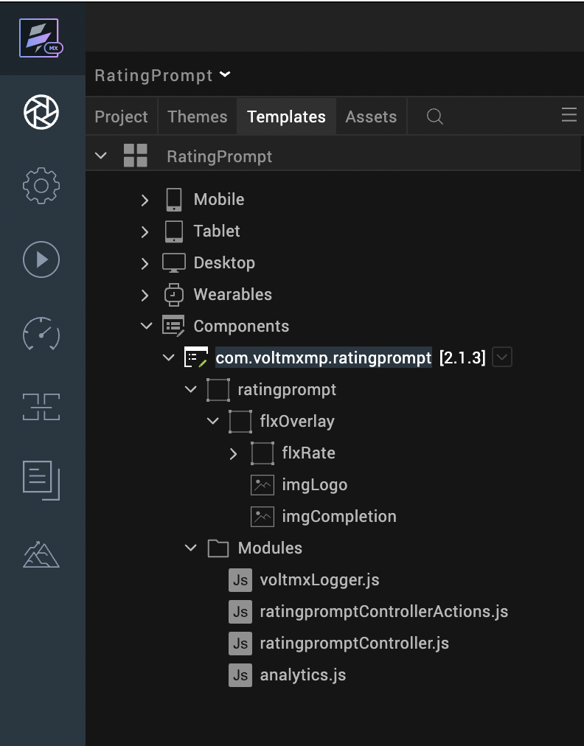

Once you have imported a component to your project, you can easily add the component to a form. For more information, refer Add a Component to a Form.

3. References

A. Dynamic Usage
You can also add a Rating Prompt component dynamically. To do so:
- In the Project Explorer, on the Projects tab, click Controllers section to access the respective Form Controller. Create a method and implement the code snippet which is like the sample code mentioned below.
In the code snippet, you can edit the properties of the component as per your requirement. For more information, see Setting Properties.
/* Creating a component's Object */
initRatingPromptComponent: function (){
var ratingprompt = new com.voltmxmp.ratingprompt(
{
"clipBounds": true,
"left": "0dp",
"top": "0dp",
"width": "100%",
"height": "100%",
"id": "ratingprompt",
"isVisible": true,
"skin": "voltmxmprpsknslFbox2",
"zIndex": 50,
}, {}, {});

/* Setting the component's properties */
ratingprompt.logoImageSrc = "voltmxmp_rp03_app_icon.png";
ratingprompt.selectedRatingImageSrc = "voltmxmp_rp03_ico_star_active4.png";
ratingprompt.unselectedRatingImageSrc = "voltmxmp_rp03_ico_star_deact.png";
ratingprompt.rateMessage = "If you enjoy using the app, would you mind taking a moment to rate it? Thanks for your support!";
ratingprompt.rateTitle = "Please Rate our App ";
ratingprompt.dismissText = "DISMISS";
ratingprompt.submitText = "SUBMIT";
ratingprompt.isFeedbackEnabled = true;
ratingprompt.thankyouMessageSrc = "voltmxmp_rp03_ico_group.png";
ratingprompt.thankyouMessage = "Some text related to Thank You page with short description";
ratingprompt.okText = "OK";
ratingprompt.invokeByDefault = true;
/*Adding the Touch ID component to a Form*/
this.view.add(ratingprompt);
},

B. Properties
The properties provided on the Component tab allow you to customize the UI elements in the Rating Prompt component. You can set the properties directly on the Component tab or by writing a JavaScript.

Invoke By Default

Category: | General
Description: | Specifies whether you want to invoke the component after launching the app.
Syntax: | invokeByDefault
Type: | Boolean
Read/Write: | Read + Write
Example: | this.view.componentID.invokeByDefault = true;

- Logo Image
Category: |  | Rating Screen
Description: |  | Specifies the source for the image that you want to set as the logo for the rating section.
Syntax: | logoImageSrc
Type: | String
Read/Write: | Read + Write
Remarks | - Make sure that the image file exists in the workspace\resources\common directory.  - Do not add any uppercase characters in the file name of the image.  - Make sure that the image is in a PNG format.  - Specify the file name of the image along with the extension.
Example: | this.view.componentID.logoImageSrc = "logo.png";

- Selected Rating Image
Category: | Rating Screen
Description: | Specifies the source for the image that you want to display as the selected star icon.
Syntax: | selectedRatingImageSrc
Type: | String
Read/Write: | Read + Write
Remarks | - Make sure that the image file exists in the workspace\resources\common directory.  - Do not add any uppercase characters in the file name of the image.  - Make sure that the image is in a PNG format.  - Specify the file name of the image along with the extension.
Example: | this.view.componentID.selectedRatingImageSrc = "activestar.png";

- Unselected Rating Image
Category: | Rating Screen
Description: | Specifies the source for the image that you want to display as the unselected star icon.
Syntax: | unselectedRatingImageSrc
Type: | String
Read/Write: | Read + Write
Remarks | - Make sure that the image file exists in the workspace\resources\common directory.  - Do not add any uppercase characters in the file name of the image.  - Make sure that the image is in a PNG format.  - Specify the file name of the image along with the extension.
Example: | this.view.componentID.unselectedRatingImageSrc = "inactivestar.png";
- Rating Prompt Message
Category: | Rating Screen
Description: | Specifies the message that you want to display in the rating section.
Syntax: | rateMessage
Type: | String
Read/Write: | Read + Write
Remarks | - To avoid UI distortions, the length of the message must not exceed 100 characters.  - If your component version is 2.1.0 or lower, and you provide an invalid value, the component throws an exception.
Example: | this.view.componentID.rateMessage =  "Would you mind taking a moment to rate the app?";
- Rating Prompt Title
Category: | Rating Screen
Description: | Specifies the title that you want to display in the rating section.
Syntax: | rateTitle
Type: | String
Read/Write: | Read + Write
Remarks | - To avoid UI distortions, the length of the title must not exceed 35 characters.  - If your component version is 2.1.0 or lower, and you provide an invalid value, the component throws an exception.
Example: | this.view.componentID.rateTitle = "Please Rate our App";

- Dismiss Text
Category: | Rating Screen
Description: | Specifies the text that you want to display on the Dismiss button.
Syntax: | dismissText
Type: | String
Read/Write: | Read + Write
Example: | this.view.componentID.dismissText= "DISMISS";

- Submit Text
Category: | Rating Screen
Description: | Specifies the text that you want to display on the Submit button.
Syntax: | submitText
Type: | String
Read/Write: | Read + Write
Example: | this.view.componentID.submitText= "SUBMIT";
- Enable Feedback
Category: | Rating Screen
Description: |  | Toggles the feedback pop-up
Syntax: |  | isFeedbackEnabled
Type: |  | Boolean
Read/Write: |  | Read + Write
Default Value |  | true
Example: |  | this.view.componentID.isFeedbackEnabled = true;

- Thankyou Image
Category | Thank you Screen
Description: | Specifies the source for the image that you want to set as the logo for the Thank You section.
Syntax: | thankyouImageSrc
Type: | String
Read/Write: | Read + Write
Remarks | - Make sure that the image file exists in the workspace\resources\common directory.  - Do not add any uppercase characters in the file name of the image.  - Make sure that the image is in a PNG format.  - Specify the file name of the image along with the extension.
Example: | this.view.componentID.thankyouImageSrc = "thankyou.png";
- Thankyou Message
Category: | Thank you Screen
Description: |  | Specifies the message that you want to display in the Thank You section.
Syntax: |  | thankyouMessage
Type: |  | String
Read/Write: |  | Read + Write
Remarks |  | - To avoid UI distortions, the length of the message must not exceed 100 characters.  - If your component version is 2.1.0 or lower, and you provide an invalid value, the component throws an exception.
Example: |  | this.view.componentID.thankyouMessage = "Thank you for your valuable feedback!";
- OK text
Category: | Thank you Screen
Description: |  | Specifies the text that you want to display on the OK button
Syntax: |  | okText
Type: |  | String
Read/Write: |  | Read + Write
Remarks: |  | - The text changes do not reflect on the foundary canvas as the Thank You section is not visible by default.
Example: |  | this.view.componentID.okText= "OK";

C. Events
- onCompletion Event
Description: | Invoked when a user clicks or taps the OK button in the Thank You section.
Syntax: | onCompletion()
Example: | this.view.componentID.onCompletion = function()  {  alert("Thank you for your feedback!");  }.bind(this);
- onDismiss Event
Description: | Invoked when a user clicks or taps the Dismiss button in the rating section.
Syntax: | onDismiss()
Example: | this.view.componentID.onDismiss = function()  {  alert("Rating Prompt dismissed.");  }.bind(this);

APIs
1. getFeedbackText
Description: | Returns the text entered by the user in the Feedback section of the Rating Prompt.
Syntax: | getFeedbackText()
Parameters: | None
Return Value: | feedbackText [ String]  The text that the user enters in the feedback section.
Remarks | - You need to invoke the Rating Prompt and enable the Feedback Popup before you call this API.  - Make sure that you validate the text that you receive from the user.
Example: | var feedbackText = this.view.componentID.getFeedbackText();  alert("User's Feedback: "+feedbackText);
2. getRatingValue
Description: | Returns the rating that the user provides in the rating section.
Syntax: | getRatingValue()
Parameters: | None
Return Value: | ratingValue [Number] :  The number of stars that the user selects in the rating section.
Example: | var ratingValue = this.view.componentID.getRatingValue();  alert("User's Rating:"+ratingValue);
3. invokeRatingPrompt
Description: |  |  |  | Invokes the Rating Prompt component.
Syntax: |  |  |  | invokeRatingPrompt()
Parameters: |  |  |  | None
Return Value: |  |  |  | None
Remarks: |  |  |  | Use this API to invoke the Rating Prompt if the Invoke by Default property is false.
Example: |  |  |  | this.view.componentID.invokeRatingPrompt();

4. Revision History
App version 2.1.3

Limitation

NA

Known Issues
Exceeding the character limit for the following properties can cause UI distortions.
- Rating Prompt Message
- Rating Prompt Title
- Thankyou Message

