5 Nov 2021

QUESTIONNAIRE SAMPLE (1.0.1)
- Overview
A Questionnaire Sample is a very common component where a user needs a checklist to verify pre-service/ post-service process compliance. A simple list of checkboxes can go a long way in determining the streamlined execution of any request.

Use case

Consider a case that you are developing a Journey Management application that allows to have user details such as name, mobile no, destination. Using Questionnaire Sample component, you can display different types of question such as Checkbox, Radio button and text type questions. User can choose accordingly.

You can import the Questionnaire Sample component into your app and make use of its features. The Questionnaire Sample component also facilitates a set of properties and events that helps you customize the fields and the functionality.

Features:
- Prompts user with check box, radio button and text box questions.
- Can add any number of questions.
- Customize the component with your own questions.

Percentage of re-use:
Approximately 80% of reuse.

Getting Started

Prerequisites
Before you start using the Questionnaire Sample component, ensure the following:
• HCL Foundry
• Volt MX Iris

Platforms Supported

Mobile

iOS

Android

Tablet & iPad

PWA & Responsive Web

Importing the app

You can import the Forge components only into the apps that are of the Reference Architecture type.

To import the Questionnaire Sample component, do the following:

Open your app project in Volt MX Iris.
2. In the Project Explorer, click the Templates tab.

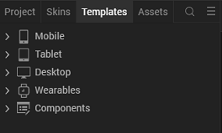
3.Right-click Components, and then select Import Component. The Import Component dialog box appears.
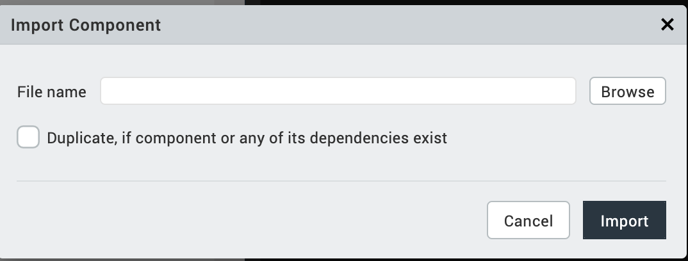
4.Click Browse to navigate to the location of the component, select the component, and then click Import. The component and its associated widgets and modules are added to your project.

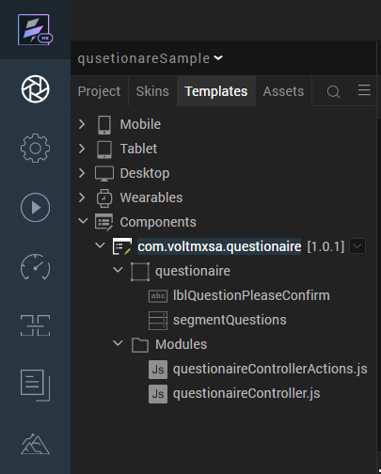
Once you have imported a component to your project, you can easily add the component to a form. For more information, refer Add a Component to a Form

Building and previewing the app
After performing all the above steps, you can build your app and run it on your device. For more information, you can refer to the Building and Viewing an Application section of the Volt MX User Guide.
You can then run your app to see the Questionnaire Sample-FS work in real time.

References

Dynamic Usage
You can also add Questionnaire Sample component dynamically. To do so,
- In the Project Explorer, on the Projects tab, click Controllers section to access the respective Form Controller. Create a method and implement the code snippet similar to the sample code mentioned below.
/* Creating Questionnaire Sample component instance */
createComponent:function(){
var questionaireInstance = new com.voltmx.questionaire ({
"clipBounds": true,
"height": "100%",
"id": "questionaire",
"isVisible": true,
"left": "0dp",
"top": "0dp",
"width": "98%",
"centerX":"50%",
"zIndex":"1"
}, {}, {
});
questionaireInstance.skinHeaderLabel="sknLblPleaseConfirm";
questionaireInstance.rowSkin="sknSegmentQuestions";
questionaireInstance.textHeaderLabel="Please Confirm";
this.view.add(questionaireInstance);
},
In the code snippet, you can edit the properties of the component as per your requirement. For more information, see Setting Properties.
2. Save the file

Properties
The properties provided on the Component tab allows you to customize the elements in the Questionnaire Sample component. These elements can be UI elements, service parameters, and so on. You can set the properties from the Volt MX Iris Properties panel on the right-hand side. You can also configure these properties using a JavaScript code.
General Properties
1. Header Label Text
Description: | Specifies the text that you want to display on the header label.
Syntax: | text
Type: | String
Read/Write: | Read + Write
Example: | this.view.questionaireInstance.textHeaderLabel="Please Confirm";
Remarks: | The default value for the property is "Please Confirm";.
Skins Section
2. Header Label Skin
Description: | Specifies the skin of the Header label.
Syntax: | SkinHeaderLabel
Example: | this.view.questionaireInstance.skinHeaderLabel="sknLblPleaseConfirm";
Remarks: | The default skin for the property is "sknLblPleaseConfirm".
3. Segment Skin
Description: | Specifies the skin of a row in segment.
Syntax: | rowSkin
Example: | this.view.questionaireInstance.rowSkin="sknSegmentQuestions”;
Remarks: | The default skin for the property is "sknSegmentQuestions ".

Events

There are no events in this Component.

API’s

setQuestions
Description: | It can be used to set custom data from controller/ Services.
Syntax: | setQuestions
Parameters: | JSON array.
Return Value: | No return value.
Example: | this.view.questionaire.setQuestions();

Revision History
App version 1.0.1:

Limitations:

No Limitations.

Known Issues:

Lines are highlighted when we select the row segment in Safari which is the default behavior.

