Date: 30-May-2024

ProgressBARs

VERSION: 1.0.1

- OVERVIEW
A Progress Bar displays the progress of a task to the user by highlighting the completed stages (or states) of the task. The Progress Bar collection library contains components of different themes (such as Travel and Shopping). You can customize the look and feel of the components, change the icons for the states, and move the progress indicator between the states using the APIs.

- Use case:
Consider a retail app, where the app updates the status of an order into stages such as: Items Selected → Order Placed → Payment Confirmed → Items Out for Delivery → Items Delivered.
The collection library contains the following components. You can visit any section for more information about the relevant component.
- Arrow Theme
- Check Theme
- Circle Theme
- Finance Theme
- Shopping Theme
- Travel Theme
- Enumerated Circle Theme
- Features
- Simple and user-friendly UI to keep the user updated on his/her progress.
- Determinate Progress bar- supports up to 8 states/steps.
- Easy to customize- use your own icons and color schemes.

- Percentage of re-use:
Approximate 80% of reuse. It sets an expectation of how much can be used out of the box, and how much needs to be customized for a specific app.

- GETTING STARTED

Prerequisites
This is a getting started section for the Progress Bar collection library. It contains information about setting up and running components from the library in an application.
Before you start using the Progress Bar collection library, make sure that you meet all the prerequisites.
• HCL Foundry
• Volt MX Iris

Platforms Supported

Mobile

iOS

Android

Tablet & iPad

PWA/Responsive Web

After you make sure that you meet all the prerequisites, you can expand any of the following drop-down sections for details about every step of getting started with the collection library.

Importing the Component
You can import the Forge components only into the apps that are of the Reference Architecture type.

Make sure that you are signed into Volt MX Iris.

You can download the collection library onto your system as a zip file from Volt MX Forge.

You can then import the zip file by selecting the Import Library option from My Libraries as shown in below.

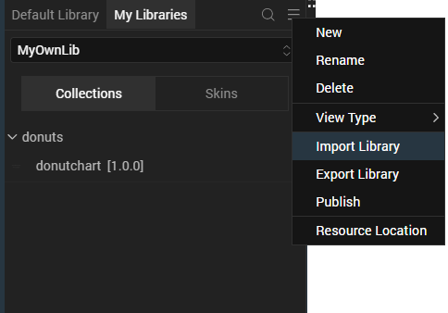

After Iris downloads the collection library, it adds the library to your workspace. You can access the library from the My Libraries tab on the lower-left panel on Iris.
After you import the collection library, you can add components from the library to your app.
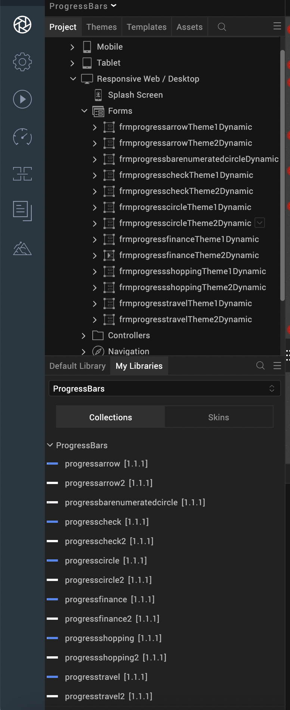

After you add the components to your form, you can Preview or Build your app.

Adding components to your app

From the lower-left panel of Iris, switch to the My Libraries tab

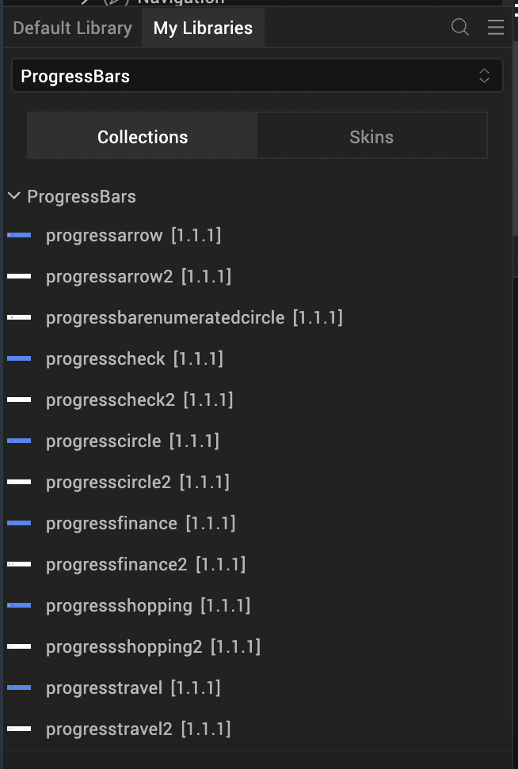

From the drop-down list, select the D3.js library that you imported from Forge.

From Collections, drag and drop a component onto your form.

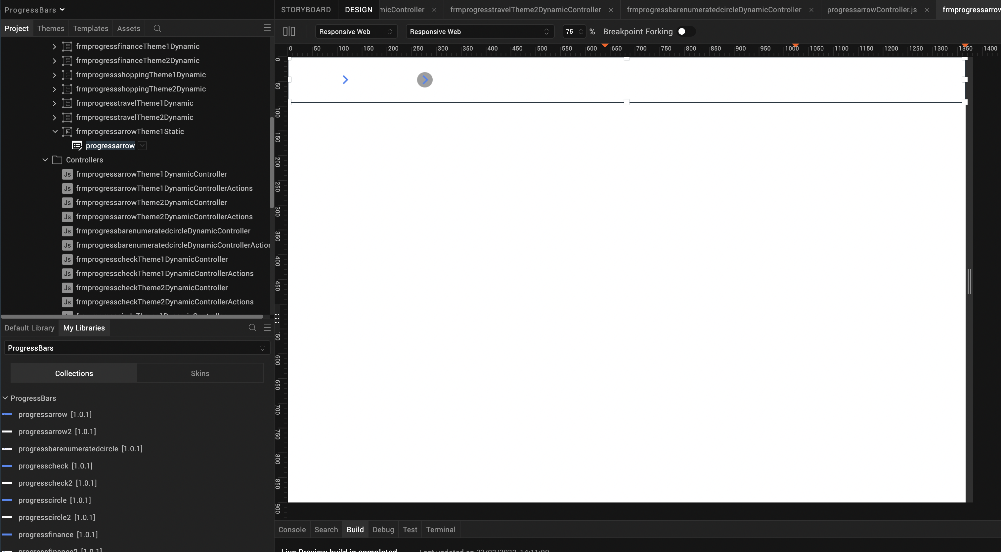

For more information on the components in the library, you can refer to the following sections of the document.
- Arrow Theme
- Check Theme
- Circle Theme
- Finance Theme
- Shopping Theme
- Travel Theme
- Enumerated Circle Theme

Building and previewing the app
After performing all the above steps, you can build your app and run it on your device. For more information, you can refer to the Building and Viewing an Application section of the Volt MX Iris User Guide.
You can then run your app to see the Progress Bar work in real time.

3. Progress Bar: Arrow
Progress Bar: Arrow displays a circle with an arrow for every state of the progress bar. When the progress moves to the next state, the component highlights the next state, and also highlights the line that connects the two states.
Progress Bar: Arrow has two themes:
Theme 1

Theme 2
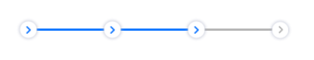
Note:
If you copy the code from any example, make sure that you replace componentID with the name of your component.

Dynamic Usage

If you want to use a component dynamically, you need to add the component to your project Templates. Follow the given steps to do so.
- From the Project explorer, expand Mobile.
- Right-click forms and select New Form
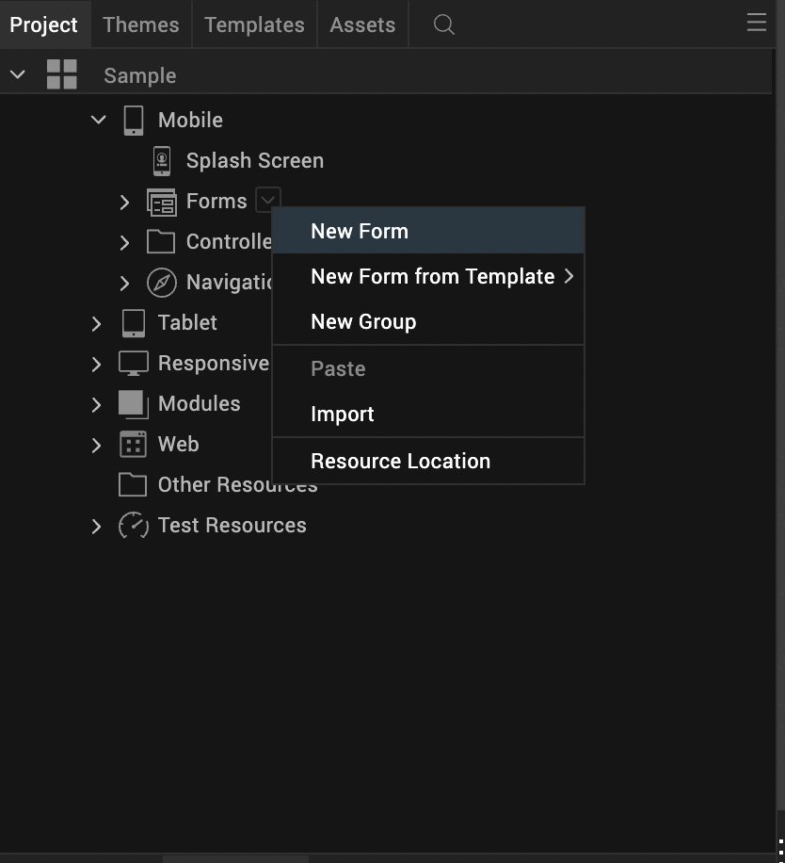
- From the My Libraries tab, drag and drop the component onto the form.
- Right-click the form that you created and select Delete.
- From the Project explorer, go to the Templates tab.
The component that you want to add should be available in the Components section.
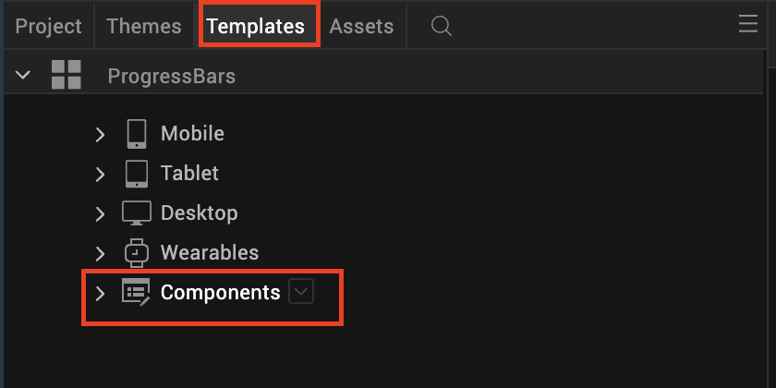
After you add the component into your project templates, follow the given steps to add the component to your app dynamically.
- From the Project explorer, select the FormController of the form to which you want to add the component.

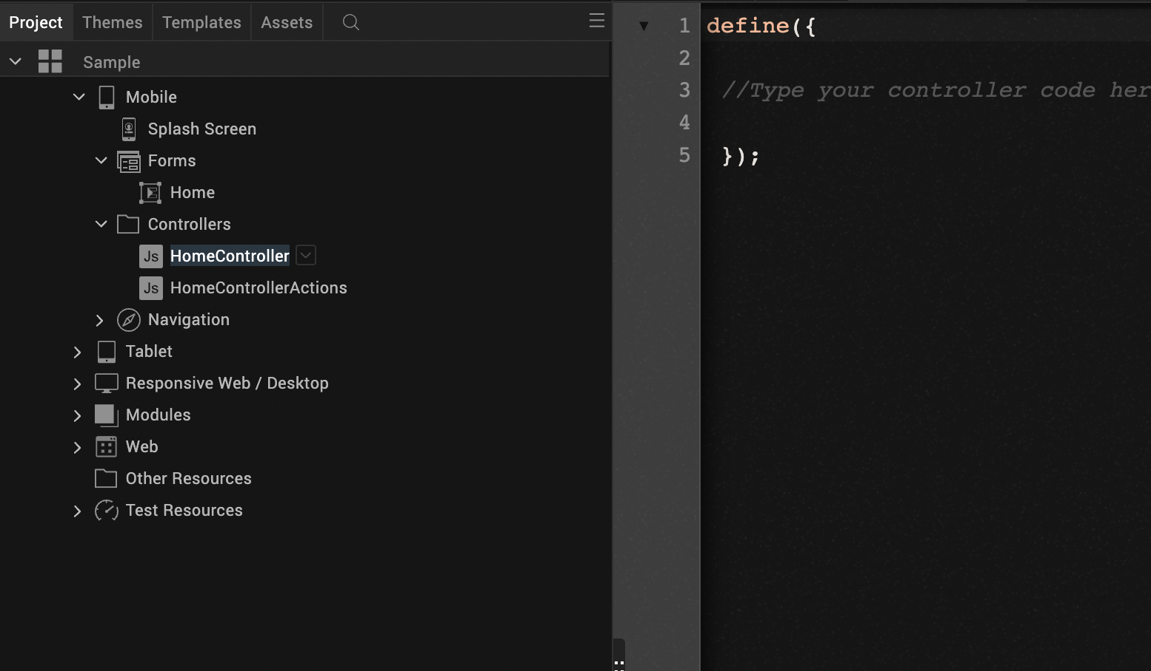

- Create a function called createComponent(); and type a code inside the function to create and configure the component.
You can refer to the given sample code for more information.

/* Creating a component's Object */
/* If you want to use Theme 2 of Progress Bar: Arrow,
Replace com.voltmxmp.progressarrow with com.voltmxmp.progressarrow2 */
var ProgressArrow = new com.voltmxmp.progressarrow(
{
"clipBounds":true,
"height": "11%",
"id": "ProgressArrow",
"isVisible": true,
"left": "0dp",
"top":"0dp",
"width": "100%",
"zIndex": 1
}, {}, {});

/* Setting the component's properties */
ProgressArrow.stateCount = "4";
ProgressArrow.bgColor = "4785F4";
ProgressArrow.activeIcon = "voltmxmp_pa_active.png";
ProgressArrow.inactiveIcon = "voltmxmp_pa_inactive.png";
ProgressArrow.separatorBaseColor = "000000";
ProgressArrow.separatorFillColor = "FFFFFF";
/* Adding the component to a Form */
this.view.add(ProgressArrow);
/* Creating the component with the specified properties */

this.view.ProgressArrow.createProgressbar();

Properties
The properties provided on the Component tab allows you to customize the elements in the Progress bar: Arrow component. These elements can be UI elements, service parameters, and so on.
You can set the properties from the Properties panel on the right side of Iris. You can also configure these properties using a JavaScript code.

1. General
1. Number of states
Description: | Specifies the number of states or steps in the Progress Bar.
Syntax: | stateCount
Type: | - List Selector  - String
Read/Write: | Read
Remarks: | - You can write data to this property only during the creation of the component.  - The number of states must be between 2 and 8.  - If you provide an invalid value, the component throws an exception that you need to handle.
Default Value: | "4"
Example: | /* During creation of the component */  this.view.componentID.stateCount = "4";

2. Image Properties

i. Active Icon

Description: | Specifies the image that you want to set for the active state of the icon.
Syntax: | voltmxmp_pa_active.png
Type: | String
Read/Write: | Read + Write
Example: | /* During creation of the component */  this.view.componentID.activeIcon = "voltmxmp_pa_active.png";

ii. Inactive Icon
Description: | Specifies the image that you want to set for the inactive state of the icon.
Syntax: | voltmxmp_pa_inactive.png
Type: | String
Read/Write: | Read + Write
Example: | /* During creation of the component */  this.view.componentID.inactiveIcon = "voltmxmp_pa_inactive.png";

3. Color Properties

i. Background Color

Description: | Specifies background color of the component in a Hexadecimal Format.
Syntax: | bgColor
Type: | String
Read/Write: | Write
Values: | You can provide two types of color codes:  - 6 digit Hexadecimal Code. For example: ffffff  - 8 digit Hexadecimal Code (with permitted alpha position). For example: ffffff00
Default Value: | "4785f4"
Remarks: | - You can write data to this property only during the creation of the component.  - Make sure that you type the Hexadecimal Code without the pound (#) symbol.  - If you provide an invalid value, the component throws an exception that you need to handle.
Example: | /* During creation of the component */  this.view.componentID.bgColor = "4785f4";

ii. Separator Base Color
Description: | Specifies the color of the Separator Line (in Hexadecimal Format) when it is inactive.
Syntax: | separatorBaseColor
Type: | String
Read/Write: | Write
Values: | You can provide two types of color codes:  - 6 digit Hexadecimal Code. For example: ffffff  - 8 digit Hexadecimal Code (with permitted alpha position). For example: ffffff00
Default Value: | "000000"
Remarks: | - You can write data to this property only during the creation of the component.  - Make sure that you type the Hexadecimal Code without the pound (#) symbol.  - If you provide an invalid value, the component throws an exception that you need to handle.
Example: | /* During creation of the component */  this.view.componentID.separatorBaseColor="000000";

iii. Separator Fill Color
Description: | Specifies the color of the Separator Line (in Hexadecimal Format) when it is active.
Syntax: | separatorFillColor
Type: | String
Read/Write: | Write
Values: | You can provide two types of color codes:  - 6 digit Hexadecimal Code. For example: ffffff  - 8 digit Hexadecimal Code (with permitted alpha position). For example: ffffff00
Default Value: | "ffffff"
Remarks: | - You can write data to this property only during the creation of the component.  - Make sure that you type the Hexadecimal Code without the pound (#) symbol.  - If you provide an invalid value, the component throws an exception that you need to handle.
Example: | /* During creation of the component */  this.view.componentID.separatorFillColor="ffffff";

Events
The component invokes events when its corresponding action is performed. You can configure any logic you want the component to perform whenever an event occurs.
You can configure the events directly on the Actions tab or by writing a JavaScript, For more information, refer to Add Actions in the Volt MX Iris User Guide.

i. errorCallback
Description: | Invoked when an error occurs within the component.
Syntax: | errorCallback(error)
Parameters: | error[JSON] :  Information about the error, such as the error code and error message.
Example: | this.view.componentID.errorCallback = function(error)  {  alert("Error: "+JSON.stringify(error));  }.bind(this);

APIs

i. goNext
Description: | Moves the progress indicator to the next state.
Syntax: | goNext()
Parameters: | None.
Return Value: | None.
Remarks: | If you call this API when the progress indicator is at the last state, the component throws an exception.
Example: | this.view.componentID.goNext();

ii. goPrev
Description: | Moves the progress indicator to the previous state.
Syntax: | goPrev()
Parameters: | None.
Return Value: | None.
Remarks: | If you call this API when the progress indicator is at the first state, the component throws an exception.
Example: | this.view.componentID.goPrev();

iii. getCurrentState
Description: | Fetches the current state of the progress indicator.
Syntax: | getCurrentState()
Parameters: | None.
Return Value: | currentState[Number] :  The index of the current state.
Example: | var currentState = this.view.componentID.getCurrentState();

iv. createProgressBar
Description: | Creates or refreshes the component.
Syntax: | createProgressBar()
Parameters: | None.
Return Value: | None.
Remarks: | Use this API to create or refresh the component in the following scenarios:  - After you dynamically add the component to a form.  - After you change the width of the component at run time.  - After a breakpoint change, to enable responsive behaviour.
Example: | var currentState = this.view.componentID.createProgressBar();

4. Progress Bar: Check
Progress Bar: Check displays a check mark for every state of the progress bar. When the progress moves to the next state, the component highlights the next state, and also highlights the line that connects the two states.
Progress Bar: Check has two themes:
Theme 1
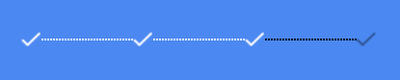
Theme 2
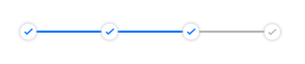
Note:
If you copy the code from any example, make sure that you replace componentID with the name of your component.

A. Dynamic Usage
If you want to use a component dynamically, you need to add the component to your project Templates. Follow the given steps to do so.
- From the Project explorer, expand Mobile.
- Right-click forms and select New Form
- From the My Libraries tab, drag and drop the component onto the form.
- Right-click the form that you created and select Delete.
- From the Project explorer, go to the Templates tab.
The component that you want to add should be available in the Components section.
After you add the component into your project templates, follow the given steps to add the component to your app dynamically.
- From the Project explorer, select the FormController of the form to which you want to add the component.

- Create a function called createComponent(); and type a code inside the function to create and configure the component.
You can refer to the given sample code for more information.
/* Creating a component's Object */
/* If you want to use Theme 2 of Progress Bar: Check,
Replace com.voltmxmp.progresscheck with com.voltmxmp.progresscheck2 */
var ProgressCheck = new com.voltmxmp.progresscheck(
{
"clipBounds":true,
"height": "11%",
"id": "ProgressCheck",
"isVisible": true,
"left": "0dp",
"top":"0dp",
"width": "100%",
"zIndex": 1
}, {}, {});

/* Setting the component's properties */
ProgressCheck.stateCount = "4";
ProgressCheck.bgColor = "4785F4";
ProgressCheck.activeIcon = "voltmxmp_pck_active.png";
ProgressCheck.inactiveIcon = "voltmxmp_pck_inactive.png";
ProgressCheck.separatorBaseColor = "000000";
ProgressCheck.separatorFillColor = "FFFFFF";

/* Adding the component to a Form */
this.view.add(ProgressCheck);
/* Creating the component with the specified properties */
this.view.ProgressCheck.createProgressbar()

B. Properties
The properties provided on the Component tab allows you to customize the elements in the Progress bar: Check component. These elements can be UI elements, service parameters, and so on.

You can set the properties from the Properties panel on the right side of Iris. You can also configure these properties using a JavaScript code.

1. General
1. Number of states
Description: | Specifies the number of states or steps in the Progress Bar.
Syntax: | stateCount
Type: | - List Selector  - String
Read/Write: | Read
Remarks: | - You can write data to this property only during the creation of the component.  - The number of states must be between 2 and 8.  - If you provide an invalid value, the component throws an exception that you need to handle.
Default Value: | "4"
Example: | /* During creation of the component */  this.view.componentID.stateCount = "4";

2. Image Properties

i. Active Icon

Description: | Specifies the image that you want to set for the active state of the icon.
Syntax: | voltmxmp_pck_active.png
Type: | String
Read/Write: | Read + Write
Example: | /* During creation of the component */  this.view.componentID.activeIcon = "voltmxmp_pck_active.png";

ii. Inactive Icon
Description: | Specifies the image that you want to set for the inactive state of the icon.
Syntax: | voltmxmp_pck_inactive.png
Type: | String
Read/Write: | Read + Write
Example: | /* During creation of the component */  this.view.componentID.inactiveIcon = "voltmxmp_pck_inactive.png";

3. Color Properties

i. Background Color

Description: | Specifies background color of the component in a Hexadecimal Format.
Syntax: | bgColor
Type: | String
Read/Write: | Write
Values: | You can provide two types of color codes:  - 6 digit Hexadecimal Code. For example: ffffff  - 8 digit Hexadecimal Code (with permitted alpha position). For example: ffffff00
Default Value: | "4785f4"
Remarks: | - You can write data to this property only during the creation of the component.  - Make sure that you type the Hexadecimal Code without the pound (#) symbol.  - If you provide an invalid value, the component throws an exception that you need to handle.
Example: | /* During creation of the component */  this.view.componentID.bgColor = "4785f4";

ii. Separator Base Color

Description: | Specifies the color of the Separator Line (in Hexadecimal Format) when it is inactive.
Syntax: | separatorBaseColor
Type: | String
Read/Write: | Write
Values: | You can provide two types of color codes:  - 6 digit Hexadecimal Code. For example: ffffff  - 8 digit Hexadecimal Code (with permitted alpha position). For example: ffffff00
Default Value: | "000000"
Remarks: | - You can write data to this property only during the creation of the component.  - Make sure that you type the Hexadecimal Code without the pound (#) symbol.  - If you provide an invalid value, the component throws an exception that you need to handle.
Example: | /* During creation of the component */  this.view.componentID.separatorBaseColor="000000";

iii. Separator Fill Color
Description: | Specifies the color of the Separator Line (in Hexadecimal Format) when it is active.
Syntax: | separatorFillColor
Type: | String
Read/Write: | Write
Values: | You can provide two types of color codes:  - 6 digit Hexadecimal Code. For example: ffffff  - 8 digit Hexadecimal Code (with permitted alpha position). For example: ffffff00
Default Value: | "ffffff"
Remarks: | - You can write data to this property only during the creation of the component.  - Make sure that you type the Hexadecimal Code without the pound (#) symbol.  - If you provide an invalid value, the component throws an exception that you need to handle.
Example: | /* During creation of the component */  this.view.componentID.separatorFillColor="ffffff";

C. Events
The component invokes events when its corresponding action is performed. You can configure any logic you want the component to perform whenever an event occurs.
You can configure the events directly on the Actions tab or by writing a JavaScript, For more information, refer to Add Actions in the Volt MX Iris User Guide.

i. errorCallback
Description: | Invoked when an error occurs within the component.
Syntax: | errorCallback(error)
Parameters: | error[JSON] :  Information about the error, such as the error code and error message.
Example: | this.view.componentID.errorCallback = function(error)  {  alert("Error: "+JSON.stringify(error));  }.bind(this);

D. APIs

i. goNext
Description: | Moves the progress indicator to the next state.
Syntax: | goNext()
Parameters: | None.
Return Value: | None.
Remarks: | If you call this API when the progress indicator is at the last state, the component throws an exception.
Example: | this.view.componentID.goNext();

ii.goPrev
Description: | Moves the progress indicator to the previous state.
Syntax: | goPrev()
Parameters: | None.
Return Value: | None.
Remarks: | If you call this API when the progress indicator is at the first state, the component throws an exception.
Example: | this.view.componentID.goPrev();

iii.getCurrentState
Description: | Fetches the current state of the progress indicator.
Syntax: | getCurrentState()
Parameters: | None.
Return Value: | currentState[Number] :  The index of the current state.
Example: | var currentState = this.view.componentID.getCurrentState();

iv.createProgressBar
Description: | Creates or refreshes the component.
Syntax: | createProgressBar()
Parameters: | None.
Return Value: | None.
Remarks: | Use this API to create or refresh the component in the following scenarios:  - After you dynamically add the component to a form.  - After you change the width of the component at run time.  - After a breakpoint change, to enable responsive behaviour.
Example: | var currentState = this.view.componentID.createProgressBar();

5. Progress Bar: Circle
Progress Bar: Circle displays a circle with a dot for every state of the progress bar. When the progress moves to the next state, the component highlights the next state, and also highlights the line that connects the two states.
Progress Bar: Circle has two themes:
Theme 1

Theme 2
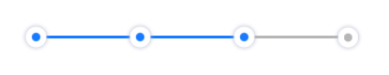

Note:
If you copy the code from any example, make sure that you replace componentID with the name of your component.

A. Dynamic Usage
If you want to use a component dynamically, you need to add the component to your project Templates. Follow the given steps to do so.
- From the Project explorer, expand Mobile.
- Right-click forms and select New Form
- From the My Libraries tab, drag and drop the component onto the form.
- Right-click the form that you created and select Delete.
- From the Project explorer, go to the Templates tab.
The component that you want to add should be available in the Components section.

After you add the component into your project templates, follow the given steps to add the component to your app dynamically.
- From the Project explorer, select the FormController of the form to which you want to add the component.

- Create a function called createComponent(); and type a code inside the function to create and configure the component.
You can refer to the given sample code for more information.
/* Creating a component's Object */
/* If you want to use Theme 2 of Progress Bar: Circle,
Replace com.voltmxmp.progresscircle with com.voltmxmp.progresscircle2 */

var ProgressCircle = new com.voltmxmp.progresscircle(
{
"clipBounds":true,
"height": "11%",
"id": "ProgressCircle",
"isVisible": true,
"left": "0dp",
"top":"0dp",
"width": "100%",
"zIndex": 1
}, {}, {});

/* Setting the component's properties */
ProgressCircle.stateCount = "4";
ProgressCircle.bgColor = "4785F4";
ProgressCircle.activeIcon = "voltmxmp_pcl_active.png";
ProgressCircle.inactiveIcon = "voltmxmp_pcl_inactive.png";
ProgressCircle.separatorBaseColor = "000000";
ProgressCircle.separatorFillColor = "FFFFFF";

/* Adding the component to a Form */
this.view.add(ProgressCircle);

/* Creating the component with the specified properties */
this.view.ProgressCircle.createProgressbar();

B. Properties
The properties provided on the Component tab allows you to customize the elements in the Progress bar: Circle component. These elements can be UI elements, service parameters, and so on.
You can set the properties from the Properties panel on the right side of Iris. You can also configure these properties using a JavaScript code.

1. General
1. Number of states
Description: | Specifies the number of states or steps in the Progress Bar.
Syntax: | stateCount
Type: | - List Selector  - String
Read/Write: | Read
Remarks: | - You can write data to this property only during the creation of the component.  - The number of states must be between 2 and 8.  - If you provide an invalid value, the component throws an exception that you need to handle.
Default Value: | "4"
Example: | /* During creation of the component */  this.view.componentID.stateCount = "4";

2. Image Properties

i. Active Icon
Description: | Specifies the image that you want to set for the active state of the icon.
Syntax: | voltmxmp_pcl_active.png
Type: | String
Read/Write: | Read + Write
Example: | /* During creation of the component */  this.view.componentID.activeIcon = "voltmxmp_pcl_active.png";

ii. Inactive Icon
Description: | Specifies the image that you want to set for the inactive state of the icon.
Syntax: | voltmxmp_pcl_inactive.png
Type: | String
Read/Write: | Read + Write
Example: | /* During creation of the component */  this.view.componentID.inactiveIcon = "voltmxmp_pcl_inactive.png";

3. Color Properties

i. Background Color

Description: | Specifies background color of the component in a Hexadecimal Format.
Syntax: | bgColor
Type: | String
Read/Write: | Write
Values: | You can provide two types of color codes:  - 6 digit Hexadecimal Code. For example: ffffff  - 8 digit Hexadecimal Code (with permitted alpha position). For example: ffffff00
Default Value: | "4785f4"
Remarks: | - You can write data to this property only during the creation of the component.  - Make sure that you type the Hexadecimal Code without the pound (#) symbol.  - If you provide an invalid value, the component throws an exception that you need to handle.
Example: | /* During creation of the component */  this.view.componentID.bgColor = "4785f4";

ii. Separator Base Color
Description: | Specifies the color of the Separator Line (in Hexadecimal Format) when it is inactive.
Syntax: | separatorBaseColor
Type: | String
Read/Write: | Write
Values: | You can provide two types of color codes:  - 6 digit Hexadecimal Code. For example: ffffff  - 8 digit Hexadecimal Code (with permitted alpha position). For example: ffffff00
Default Value: | "000000"
Remarks: | - You can write data to this property only during the creation of the component.  - Make sure that you type the Hexadecimal Code without the pound (#) symbol.  - If you provide an invalid value, the component throws an exception that you need to handle.
Example: | /* During creation of the component */  this.view.componentID.separatorBaseColor="000000";

iii. Separator Fill Color
Description: | Specifies the color of the Separator Line (in Hexadecimal Format) when it is active.
Syntax: | separatorFillColor
Type: | String
Read/Write: | Write
Values: | You can provide two types of color codes:  - 6 digit Hexadecimal Code. For example: ffffff  - 8 digit Hexadecimal Code (with permitted alpha position). For example: ffffff00
Default Value: | "ffffff"
Remarks: | - You can write data to this property only during the creation of the component.  - Make sure that you type the Hexadecimal Code without the pound (#) symbol.  - If you provide an invalid value, the component throws an exception that you need to handle.
Example: | /* During creation of the component */  this.view.componentID.separatorFillColor="ffffff";

C. Events
The component invokes events when its corresponding action is performed. You can configure any logic you want the component to perform whenever an event occurs.
You can configure the events directly on the Actions tab or by writing a JavaScript, For more information, refer to Add Actions in the Volt MX Iris User Guide.

i. errorCallback
Description: | Invoked when an error occurs within the component.
Syntax: | errorCallback(error)
Parameters: | error[JSON] :  Information about the error, such as the error code and error message.
Example: | this.view.componentID.errorCallback = function(error)  {  alert("Error: "+JSON.stringify(error));  }.bind(this);

D. APIs

i. goNext
Description: | Moves the progress indicator to the next state.
Syntax: | goNext()
Parameters: | None.
Return Value: | None.
Remarks: | If you call this API when the progress indicator is at the last state, the component throws an exception.
Example: | this.view.componentID.goNext();

ii.goPrev
Description: | Moves the progress indicator to the previous state.
Syntax: | goPrev()
Parameters: | None.
Return Value: | None.
Remarks: | If you call this API when the progress indicator is at the first state, the component throws an exception.
Example: | this.view.componentID.goPrev();

iii.getCurrentState
Description: | Fetches the current state of the progress indicator.
Syntax: | getCurrentState()
Parameters: | None.
Return Value: | currentState[Number] :  The index of the current state.
Example: | var currentState = this.view.componentID.getCurrentState();

iv. createProgressBar
Description: | Creates or refreshes the component.
Syntax: | createProgressBar()
Parameters: | None.
Return Value: | None.
Remarks: | Use this API to create or refresh the component in the following scenarios:  - After you dynamically add the component to a form.  - After you change the width of the component at run time.  - After a breakpoint change, to enable responsive behaviour.
Example: | var currentState = this.view.componentID.createProgressBar();

6. Progress Bar: Finance
Progress Bar: Finance displays a dollar symbol for every state of the progress bar. When the progress moves to the next state, the component highlights the next state, and also highlights the line that connects the two states.
Progress Bar: Finance has two themes:
Theme 1

Theme 2
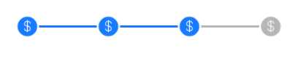
Note:
If you copy the code from any example, make sure that you replace componentID with the name of your component.

A. Dynamic Usage
If you want to use a component dynamically, you need to add the component to your project Templates. Follow the given steps to do so.
  - From the Project explorer, expand Mobile.
  - Right-click forms and select New Form
  - From the My Libraries tab, drag and drop the component onto the form.
  - Right-click the form that you created and select Delete.
  - From the Project explorer, go to the Templates tab.
The component that you want to add should be available in the Components section.

After you add the component into your project templates, follow the given steps to add the component to your app dynamically.
  - From the Project explorer, select the FormController of the form to which you want to add the component.

  - Create a function called createComponent(); and type a code inside the function to create and configure the component.
You can refer to the given sample code for more information.
/* Creating a component's Object */
/* If you want to use Theme 2 of Progress Bar: Finance,
Replace com.voltmxmp.progressfinance with com.voltmxmp.progressfinance2 */

var ProgressFinance = new com.voltmxmp.progressfinance(
{
"clipBounds":true,
"height": "11%",
"id": "ProgressFinance",
"isVisible": true,
"left": "0dp",
"top":"0dp",
"width": "100%",
"zIndex": 1
}, {}, {});

/* Setting the component's properties */
ProgressFinance.stateCount = "4";
ProgressFinance.bgColor = "4785F4";
ProgressFinance.activeIcon = "voltmxmp_pm_active.png";
ProgressFinance.inactiveIcon = "voltmxmp_pm_inactive.png";
ProgressFinance.separatorBaseColor = "000000";
ProgressFinance.separatorFillColor = "FFFFFF";

/* Adding the component to a Form */
this.view.add(ProgressFinance);

/* Creating the component with the specified properties */
this.view.ProgressFinance.createProgressbar();

B. Properties
The properties provided on the Component tab allows you to customize the elements in the Progress bar: Finance component. These elements can be UI elements, service parameters, and so on.
You can set the properties from the Properties panel on the right side of Iris. You can also configure these properties using a JavaScript code.

1. General
1. Number of states
Description: | Specifies the number of states or steps in the Progress Bar.
Syntax: | stateCount
Type: | - List Selector  - String
Read/Write: | Read
Remarks: | - You can write data to this property only during the creation of the component.  - The number of states must be between 2 and 8.  - If you provide an invalid value, the component throws an exception that you need to handle.
Default Value: | "4"
Example: | /* During creation of the component */  this.view.componentID.stateCount = "4";

2. Image Properties

i. Active Icon
Description: | Specifies the image that you want to set for the active state of the icon.
Syntax: | voltmxmp_pm_active.png
Type: | String
Read/Write: | Read + Write
Example: | /* During creation of the component */  this.view.componentID.activeIcon = "voltmxmp_pm_active.png";

ii. Inactive Icon
Description: | Specifies the image that you want to set for the inactive state of the icon.
Syntax: | voltmxmp_pm_inactive.png
Type: | String
Read/Write: | Read + Write
Example: | /* During creation of the component */  this.view.componentID.inactiveIcon = "voltmxmp_pm_inactive.png";

3. Color Properties

i. Background Color

Description: | Specifies background color of the component in a Hexadecimal Format.
Syntax: | bgColor
Type: | String
Read/Write: | Write
Values: | You can provide two types of color codes:  - 6 digit Hexadecimal Code. For example: ffffff  - 8 digit Hexadecimal Code (with permitted alpha position). For example: ffffff00
Default Value: | "4785f4"
Remarks: | - You can write data to this property only during the creation of the component.  - Make sure that you type the Hexadecimal Code without the pound (#) symbol.  - If you provide an invalid value, the component throws an exception that you need to handle.
Example: | /* During creation of the component */  this.view.componentID.bgColor = "4785f4";

ii. Separator Base Color
Description: | Specifies the color of the Separator Line (in Hexadecimal Format) when it is inactive.
Syntax: | separatorBaseColor
Type: | String
Read/Write: | Write
Values: | You can provide two types of color codes:  - 6 digit Hexadecimal Code. For example: ffffff  - 8 digit Hexadecimal Code (with permitted alpha position). For example: ffffff00
Default Value: | "000000"
Remarks: | - You can write data to this property only during the creation of the component.  - Make sure that you type the Hexadecimal Code without the pound (#) symbol.  - If you provide an invalid value, the component throws an exception that you need to handle.
Example: | /* During creation of the component */  this.view.componentID.separatorBaseColor="000000";

iii. Separator Fill Color
Description: | Specifies the color of the Separator Line (in Hexadecimal Format) when it is active.
Syntax: | separatorFillColor
Type: | String
Read/Write: | Write
Values: | You can provide two types of color codes:  - 6 digit Hexadecimal Code. For example: ffffff  - 8 digit Hexadecimal Code (with permitted alpha position). For example: ffffff00
Default Value: | "ffffff"
Remarks: | - You can write data to this property only during the creation of the component.  - Make sure that you type the Hexadecimal Code without the pound (#) symbol.  - If you provide an invalid value, the component throws an exception that you need to handle.
Example: | /* During creation of the component */  this.view.componentID.separatorFillColor="ffffff";

C. Events
The component invokes events when its corresponding action is performed. You can configure any logic you want the component to perform whenever an event occurs.
You can configure the events directly on the Actions tab or by writing a JavaScript, For more information, refer to Add Actions in the Volt MX Iris User Guide.

i. errorCallback
Description: | Invoked when an error occurs within the component.
Syntax: | errorCallback(error)
Parameters: | error[JSON] :  Information about the error, such as the error code and error message.
Example: | this.view.componentID.errorCallback = function(error)  {  alert("Error: "+JSON.stringify(error));  }.bind(this);

D. APIs

i. goNext
Description: | Moves the progress indicator to the next state.
Syntax: | goNext()
Parameters: | None.
Return Value: | None.
Remarks: | If you call this API when the progress indicator is at the last state, the component throws an exception.
Example: | this.view.componentID.goNext();

ii. goPrev
Description: | Moves the progress indicator to the previous state.
Syntax: | goPrev()
Parameters: | None.
Return Value: | None.
Remarks: | If you call this API when the progress indicator is at the first state, the component throws an exception.
Example: | this.view.componentID.goPrev();

iii. getCurrentState
Description: | Fetches the current state of the progress indicator.
Syntax: | getCurrentState()
Parameters: | None.
Return Value: | currentState[Number] :  The index of the current state.
Example: | var currentState = this.view.componentID.getCurrentState();

iv. createProgressBar
Description: | Creates or refreshes the component.
Syntax: | createProgressBar()
Parameters: | None.
Return Value: | None.
Remarks: | Use this API to create or refresh the component in the following scenarios:  - After you dynamically add the component to a form.  - After you change the width of the component at run time.  - After a breakpoint change, to enable responsive behaviour.
Example: | var currentState = this.view.componentID.createProgressBar();

7. Progress Bar: Shopping
Progress Bar: Shopping displays a shopping bag (or a shopping cart) symbol for every state of the progress bar. When the progress moves to the next state, the component highlights the next state, and also highlights the line that connects the two states.
Progress Bar: Shopping has two themes:
Theme 1

Theme 2

Note:
If you copy the code from any example, make sure that you replace componentID with the name of your component.

A. Dynamic Usage
If you want to use a component dynamically, you need to add the component to your project Templates. Follow the given steps to do so.
  - From the Project explorer, expand Mobile..
  - Right-click forms and select New Form
  - From the My Libraries tab, drag and drop the component onto the form.
  - Right-click the form that you created and select Delete.
  - From the Project explorer, go to the Templates tab.
The component that you want to add should be available in the Components section.

After you add the component into your project templates, follow the given steps to add the component to your app dynamically.
  - From the Project explorer, select the FormController of the form to which you want to add the component.

  - Create a function called createComponent(); and type a code inside the function to create and configure the component.
You can refer to the given sample code for more information.
/* Creating a component's Object */
/* If you want to use Theme 2 of Progress Bar: Shopping,
Replace com.voltmxmp.progressshopping with com.voltmxmp.progressshopping2 */

var ProgressShopping = new com.voltmxmp.progressshopping(
{
"clipBounds":true,
"height": "11%",
"id": "ProgressShopping",
"isVisible": true,
"left": "0dp",
"top":"0dp",
"width": "100%",
"zIndex": 1
}, {}, {});

/* Setting the component's properties */
ProgressShopping.stateCount = "4";
ProgressShopping.bgColor = "4785F4";
ProgressShopping.activeIcon = "voltmxmp_ps_cartactive.png";
ProgressShopping.inactiveIcon = "voltmxmp_ps_cartinactive.png";
ProgressShopping.separatorBaseColor = "000000";
ProgressShopping.separatorFillColor = "FFFFFF";

/* Adding the component to a Form */
this.view.add(ProgressShopping);

/* Creating the component with the specified properties */
this.view.ProgressShopping.createProgressbar();

B. Properties
The properties provided on the Component tab allows you to customize the elements in the Progress bar: Shopping component. These elements can be UI elements, service parameters, and so on.
You can set the properties from the Properties panel on the right side of Iris. You can also configure these properties using a JavaScript code.

1. General
1. Number of states
Description: | Specifies the number of states or steps in the Progress Bar.
Syntax: | stateCount
Type: | - List Selector  - String
Read/Write: | Read
Remarks: | - You can write data to this property only during the creation of the component.  - The number of states must be between 2 and 8.  - If you provide an invalid value, the component throws an exception that you need to handle.
Default Value: | "4"
Example: | /* During creation of the component */  this.view.componentID.stateCount = "4";

2. Image Properties

i. Active Icon

Description: | Specifies the image that you want to set for the active state of the icon.
Syntax: | voltmxmp_ps_cartactive.png
Type: | String
Read/Write: | Read + Write
Example: | /* During creation of the component */  this.view.componentID.activeIcon = "voltmxmp_ps_cartactive.png";

ii. Inactive Icon
Description: | Specifies the image that you want to set for the inactive state of the icon.
Syntax: | voltmxmp_ps_cartinactive.png
Type: | String
Read/Write: | Read + Write
Example: | /* During creation of the component */  this.view.componentID.inactiveIcon = "voltmxmp_ps_cartinactive.png";

3. Color Properties

i. Background Color

Description: | Specifies background color of the component in a Hexadecimal Format.
Syntax: | bgColor
Type: | String
Read/Write: | Write
Values: | You can provide two types of color codes:  - 6 digit Hexadecimal Code. For example: ffffff  - 8 digit Hexadecimal Code (with permitted alpha position). For example: ffffff00
Default Value: | "4785f4"
Remarks: | - You can write data to this property only during the creation of the component.  - Make sure that you type the Hexadecimal Code without the pound (#) symbol.  - If you provide an invalid value, the component throws an exception that you need to handle.
Example: | /* During creation of the component */  this.view.componentID.bgColor = "4785f4";

ii. Separator Base Color
Description: | Specifies the color of the Separator Line (in Hexadecimal Format) when it is inactive.
Syntax: | separatorBaseColor
Type: | String
Read/Write: | Write
Values: | You can provide two types of color codes:  - 6 digit Hexadecimal Code. For example: ffffff  - 8 digit Hexadecimal Code (with permitted alpha position). For example: ffffff00
Default Value: | "000000"
Remarks: | - You can write data to this property only during the creation of the component.  - Make sure that you type the Hexadecimal Code without the pound (#) symbol.  - If you provide an invalid value, the component throws an exception that you need to handle.
Example: | /* During creation of the component */  this.view.componentID.separatorBaseColor="000000";

iii. Separator Fill Color
Description: | Specifies the color of the Separator Line (in Hexadecimal Format) when it is active.
Syntax: | separatorFillColor
Type: | String
Read/Write: | Write
Values: | You can provide two types of color codes:  - 6 digit Hexadecimal Code. For example: ffffff  - 8 digit Hexadecimal Code (with permitted alpha position). For example: ffffff00
Default Value: | "ffffff"
Remarks: | - You can write data to this property only during the creation of the component.  - Make sure that you type the Hexadecimal Code without the pound (#) symbol.  - If you provide an invalid value, the component throws an exception that you need to handle.
Example: | /* During creation of the component */  this.view.componentID.separatorFillColor="ffffff";

C. Events
The component invokes events when its corresponding action is performed. You can configure any logic you want the component to perform whenever an event occurs.
You can configure the events directly on the Actions tab or by writing a JavaScript, For more information, refer to Add Actions in the Volt MX Iris User Guide.

i. errorCallback
Description: | Invoked when an error occurs within the component.
Syntax: | errorCallback(error)
Parameters: | error[JSON] :  Information about the error, such as the error code and error message.
Example: | this.view.componentID.errorCallback = function(error)  {  alert("Error: "+JSON.stringify(error));  }.bind(this);

D. APIs

i. goNext
Description: | Moves the progress indicator to the next state.
Syntax: | goNext()
Parameters: | None.
Return Value: | None.
Remarks: | If you call this API when the progress indicator is at the last state, the component throws an exception.
Example: | this.view.componentID.goNext();

ii. goPrev
Description: | Moves the progress indicator to the previous state.
Syntax: | goPrev()
Parameters: | None.
Return Value: | None.
Remarks: | If you call this API when the progress indicator is at the first state, the component throws an exception.
Example: | this.view.componentID.goPrev();

iii. getCurrentState
Description: | Fetches the current state of the progress indicator.
Syntax: | getCurrentState()
Parameters: | None.
Return Value: | currentState[Number] :  The index of the current state.
Example: | var currentState = this.view.componentID.getCurrentState();

iv. createProgressBar
Description: | Creates or refreshes the component.
Syntax: | createProgressBar()
Parameters: | None.
Return Value: | None.
Remarks: | Use this API to create or refresh the component in the following scenarios:  - After you dynamically add the component to a form.  - After you change the width of the component at run time.  - After a breakpoint change, to enable responsive behaviour.
Example: | var currentState = this.view.componentID.createProgressBar();

8. Progress Bar: Travel
Progress Bar: Travel displays an airplane (or a map pin) symbol for every state of the progress bar. When the progress moves to the next state, the component highlights the next state, and also highlights the line that connects the two states. Progress Bar: Travel Theme 1 replaces the icon of the completed states with a check mark.
Progress Bar: Travel has two themes:
Theme 1

Theme 2


Note:
If you copy the code from any example, make sure that you replace componentID with the name of your component.

A. Dynamic Usage
If you want to use a component dynamically, you need to add the component to your project Templates. Follow the given steps to do so.
  - From the Project explorer, expand Mobile.
  - Right-click forms and select New Form
  - From the My Libraries tab, drag and drop the component onto the form.
  - Right-click the form that you created and select Delete.
  - From the Project explorer, go to the Templates tab.
The component that you want to add should be available in the Components section.

After you add the component into your project templates, follow the given steps to add the component to your app dynamically.
  - From the Project explorer, select the FormController of the form to which you want to add the component.

  - Create a function called createComponent(); and type a code inside the function to create and configure the component.
You can refer to the given sample code for more information.

/* Creating a component's Object */
/* If you want to use Theme 2 of Progress Bar: Travel,
Replace com.voltmxmp.progresstravel with com.voltmxmp.progresstravel2 */
var ProgressTravel = new com.voltmxmp.progresstravel(
{
"clipBounds":true,
"height": "11%",
"id": "ProgressTravel",
"isVisible": true,
"left": "0dp",
"top":"0dp",
"width": "100%",
"zIndex": 1
}, {}, {});

/* Setting the component's properties */
ProgressTravel.stateCount = "4";
ProgressTravel.bgColor = "4785F4";
ProgressTravel.activeIcon = "voltmxmp_pt_plane_active.png";
ProgressTravel.doneIcon = "voltmxmp_pck_active_1.png";
ProgressTravel.inactiveIcon = "voltmxmp_pt_plane_inactive.png";
ProgressTravel.separatorBaseColor = "000000";
ProgressTravel.separatorFillColor = "FFFFFF";
/* Adding the component to a Form */
this.view.add(ProgressTravel);
/* Creating the component with the specified properties */
this.view.ProgressTravel.createProgressbar();

B. Properties
The properties provided on the Component tab allows you to customize the elements in the Progress bar: Travel component. These elements can be UI elements, service parameters, and so on.
You can set the properties from the Properties panel on the right side of Iris. You can also configure these properties using a JavaScript code.

1. General
1. Number of states
Description: | Specifies the number of states or steps in the Progress Bar.
Syntax: | stateCount
Type: | - List Selector  - String
Read/Write: | Read
Remarks: | - You can write data to this property only during the creation of the component.  - The number of states must be between 2 and 8.  - If you provide an invalid value, the component throws an exception that you need to handle.
Default Value: | "4"
Example: | /* During creation of the component */  this.view.componentID.stateCount = "4";

2. Image Properties

i. Active Icon

Description: | Specifies the image that you want to set for the active state of the icon.
Syntax: | voltmxmp_pt_plane_active.png
Type: | String
Read/Write: | Read + Write
Example: | /* During creation of the component */  this.view.componentID.activeIcon = "voltmxmp_pt_plane_active.png";

ii. Inactive Icon
Description: | Specifies the image that you want to set for the inactive state of the icon.
Syntax: | voltmxmp_pt_plane_inactive.png
Type: | String
Read/Write: | Read + Write
Example: | /* During creation of the component */  this.view.componentID.inactiveIcon = "voltmxmp_pt_plane_inactive.png";

iii. Done Icon

Description: | Specifies the image that you want to set for the done state of the icon.
Syntax: | voltmxmp_pck_active_1.png
Type: | String
Read/Write: | Read + Write
Example: | /* During creation of the component */  this.view.componentID.activeIcon = "voltmxmp_pck_active_1.png";

3. Color Properties

i. Background Color

Description: | Specifies background color of the component in a Hexadecimal Format.
Syntax: | bgColor
Type: | String
Read/Write: | Write
Values: | You can provide two types of color codes:  - 6 digit Hexadecimal Code. For example: ffffff  - 8 digit Hexadecimal Code (with permitted alpha position). For example: ffffff00
Default Value: | "4785f4"
Remarks: | - You can write data to this property only during the creation of the component.  - Make sure that you type the Hexadecimal Code without the pound (#) symbol.  - If you provide an invalid value, the component throws an exception that you need to handle.
Example: | /* During creation of the component */  this.view.componentID.bgColor = "4785f4";

ii. Separator Base Color
Description: | Specifies the color of the Separator Line (in Hexadecimal Format) when it is inactive.
Syntax: | separatorBaseColor
Type: | String
Read/Write: | Write
Values: | You can provide two types of color codes:  - 6 digit Hexadecimal Code. For example: ffffff  - 8 digit Hexadecimal Code (with permitted alpha position). For example: ffffff00
Default Value: | "000000"
Remarks: | - You can write data to this property only during the creation of the component.  - Make sure that you type the Hexadecimal Code without the pound (#) symbol.  - If you provide an invalid value, the component throws an exception that you need to handle.
Example: | /* During creation of the component */  this.view.componentID.separatorBaseColor="000000";

iii. Separator Fill Color
Description: | Specifies the color of the Separator Line (in Hexadecimal Format) when it is active.
Syntax: | separatorFillColor
Type: | String
Read/Write: | Write
Values: | You can provide two types of color codes:  - 6 digit Hexadecimal Code. For example: ffffff  - 8 digit Hexadecimal Code (with permitted alpha position). For example: ffffff00
Default Value: | "ffffff"
Remarks: | - You can write data to this property only during the creation of the component.  - Make sure that you type the Hexadecimal Code without the pound (#) symbol.  - If you provide an invalid value, the component throws an exception that you need to handle.
Example: | /* During creation of the component */  this.view.componentID.separatorFillColor="ffffff";

C. Events
The component invokes events when its corresponding action is performed. You can configure any logic you want the component to perform whenever an event occurs.
You can configure the events directly on the Actions tab or by writing a JavaScript, For more information, refer to Add Actions in the Volt MX Iris User Guide.

i. errorCallback
Description: | Invoked when an error occurs within the component.
Syntax: | errorCallback(error)
Parameters: | error[JSON] :  Information about the error, such as the error code and error message.
Example: | this.view.componentID.errorCallback = function(error)  {  alert("Error: "+JSON.stringify(error));  }.bind(this);

D. APIs

i. goNext
Description: | Moves the progress indicator to the next state.
Syntax: | goNext()
Parameters: | None.
Return Value: | None.
Remarks: | If you call this API when the progress indicator is at the last state, the component throws an exception.
Example: | this.view.componentID.goNext();

ii. goPrev
Description: | Moves the progress indicator to the previous state.
Syntax: | goPrev()
Parameters: | None.
Return Value: | None.
Remarks: | If you call this API when the progress indicator is at the first state, the component throws an exception.
Example: | this.view.componentID.goPrev();

iii. getCurrentState
Description: | Fetches the current state of the progress indicator.
Syntax: | getCurrentState()
Parameters: | None.
Return Value: | currentState[Number] :  The index of the current state.
Example: | var currentState = this.view.componentID.getCurrentState();

iv. createProgressBar
Description: | Creates or refreshes the component.
Syntax: | createProgressBar()
Parameters: | None.
Return Value: | None.
Remarks: | Use this API to create or refresh the component in the following scenarios:  - After you dynamically add the component to a form.  - After you change the width of the component at run time.  - After a breakpoint change, to enable responsive behaviour.
Example: | var currentState = this.view.componentID.createProgressBar();

9. Progress Bar: Enumerated Circle
Progress Bar: Enumerated Circle displays a circle and the sequence number for every state of the progress bar. When the progress moves to the next state, the component highlights the next state, replaces the icon of the completed state with a check mark, and also highlights the line that connects the two states.

Note:
If you copy the code from any example, make sure that you replace componentID with the name of your component.

A. Dynamic Usage
If you want to use a component dynamically, you need to add the component to your project Templates. Follow the given steps to do so.
  - From the Project explorer, expand Mobile.
  - Right-click forms and select New Form
  - From the My Libraries tab, drag and drop the component onto the form.
  - Right-click the form that you created and select Delete.
  - From the Project explorer, go to the Templates tab.
The component that you want to add should be available in the Components section.

After you add the component into your project templates, follow the given steps to add the component to your app dynamically.
  - From the Project explorer, select the FormController of the form to which you want to add the component.

  - Create a function called createComponent(); and type a code inside the function to create and configure the component.
You can refer to the given sample code for more information.

/* Creating a component's Object */
var ProgressEnumeratedCircle = new com.voltmxmp.progressbarenumeratedcircle(
{
"clipBounds":true,
"height": "11%",
"id": "ProgressEnumeratedCircle",
"isVisible": true,
"left": "0dp",
"top":"0dp",
"width": "100%",
"zIndex": 1
}, {}, {});

/* Setting the component's properties */
ProgressEnumeratedCircle.stateCount = 4;
ProgressEnumeratedCircle.activeIcon = "step_done.png";
ProgressEnumeratedCircle.inactiveIcon = "oval.png";

/* Adding the component to a Form */
this.view.add(ProgressEnumeratedCircle);

/* Creating the component with the specified properties */
this.view.ProgressEnumeratedCircle.createProgressBar();

B. Properties
The properties provided on the Component tab allows you to customize the elements in the Progress bar: Enumerated Circle component. These elements can be UI elements, service parameters, and so on.
You can set the properties from the Properties panel on the right side of Iris. You can also configure these properties using a JavaScript code.

1. General
1. Number of states
Description: | Specifies the number of states or steps in the Progress Bar.
Syntax: | stateCount
Type: | - List Selector  - String
Read/Write: | Read
Remarks: | - You can write data to this property only during the creation of the component.  - The number of states must be between 2 and 8.  - If you provide an invalid value, the component throws an exception that you need to handle.
Default Value: | "4"
Example: | /* During creation of the component */  this.view.componentID.stateCount = "4";

2. Image Properties

i. Active Icon

Description: | Specifies the image that you want to set for the active state of the icon.
Syntax: | step_done.png
Type: | String
Read/Write: | Read + Write
Example: | /* During creation of the component */  this.view.componentID.activeIcon = "step_done.png.png";

ii. Inactive Icon
Description: | Specifies the image that you want to set for the inactive state of the icon.
Syntax: | oval.png
Type: | String
Read/Write: | Read + Write
Example: | /* During creation of the component */  this.view.componentID.inactiveIcon = "oval.png";

C. Events
The component invokes events when its corresponding action is performed. You can configure any logic you want the component to perform whenever an event occurs.
You can configure the events directly on the Actions tab or by writing a JavaScript, For more information, refer to Add Actions in the Volt MX Iris User Guide.

i. errorCallback
Description: | Invoked when an error occurs within the component.
Syntax: | errorCallback(error)
Parameters: | error[JSON] :  Information about the error, such as the error code and error message.
Example: | this.view.componentID.errorCallback = function(error)  {  alert("Error: "+JSON.stringify(error));  }.bind(this);

D. APIs

i. goNext
Description: | Moves the progress indicator to the next state.
Syntax: | goNext()
Parameters: | None.
Return Value: | None.
Remarks: | If you call this API when the progress indicator is at the last state, the component throws an exception.
Example: | this.view.componentID.goNext();

ii. goPrev
Description: | Moves the progress indicator to the previous state.
Syntax: | goPrev()
Parameters: | None.
Return Value: | None.
Remarks: | If you call this API when the progress indicator is at the first state, the component throws an exception.
Example: | this.view.componentID.goPrev();

iii. getCurrentState
Description: | Fetches the current state of the progress indicator.
Syntax: | getCurrentState()
Parameters: | None.
Return Value: | currentState[Number] :  The index of the current state.
Example: | var currentState = this.view.componentID.getCurrentState();

iv. createProgressBar
Description: | Creates or refreshes the component.
Syntax: | createProgressBar()
Parameters: | None.
Return Value: | None.
Remarks: | Use this API to create or refresh the component in the following scenarios:  - After you dynamically add the component to a form.  - After you change the width of the component at run time.  - After a breakpoint change, to enable responsive behaviour.
Example: | var currentState = this.view.componentID.createProgressBar();

10. Revision History
App version 1.0.1

Known Issues
  - No Known issues

Limitations
- The progress bar collection library components does not support landscape mode.
- The progress bar collection library components does not provide an option to control the speed of animation.

