June-2023

Profile Header
Version: 1.0.0

Description
This component can be used to display user profile with Photo, Name, Subtitle, Favorite indicator.
Once imported in Volt Iris, this component can be further customized to suit developer’s needs.
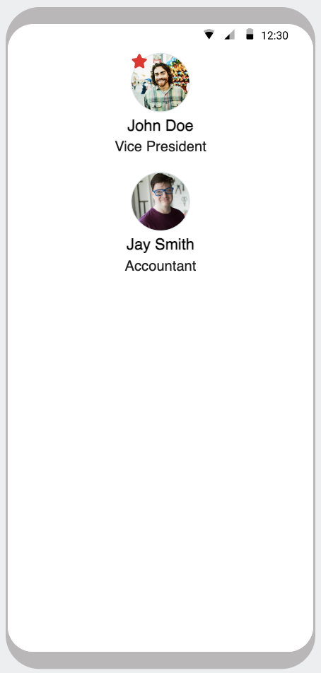

Properties / Events / Methods

Properties
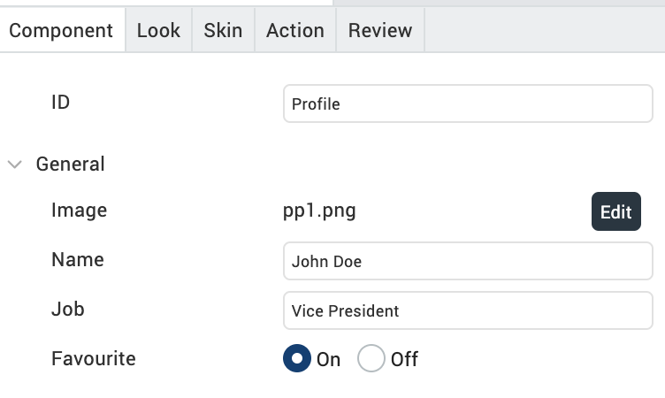
**Preferred image dimension: 200 x 200

Events Exposed

None

**Note: Developer can expose properties / events / methods as required, after importing the component in Volt Iris.

