14 Nov 2024

**PLACES DATA (GOOGLE)**

**version: 1.0.1**

# **Overview**

Quickly connect your app with Google's database of 100 million+ places across a wide range of categories.

## **Use case:**

Places Data (Google) is a set of readily configured integration services using which you can quickly connect your app with Google's database of 100 million+ places across a wide range of categories.

## **Features**

* Preconfigured back-end service that helps your app to connect with Google database instantly.
* Facilitates to invoke services easily from Google Places and Google Maps APIs.
* Provides secure interaction with Google services using the authentic API key, generated specific to your login.
* Easy to attain details through simple interaction directly fromVoltMX Foundry.

## **Percentage of re-use:**

70% (Data can be customizable and customers need to implement UI by themselves).

# **GETTING STARTED**

## **Prerequisites**

Before you start using the Places Data (Google), ensure you have the following:

* [HCL Foundry](https://manage.hclvoltmx.com/)
* Volt MX Iris

## **Importing the Places Data (Google)**

1. Log on to your [HCL Foundry](https://manage.hclvoltmx.com/). The Dashboard page appears by default.
2. In the left pane, click the **Apps** menu. The **Custom Apps** page appears.
3. Click **Import**. The **Import** dialog appears.  
   A screenshot of a computer

   Description automatically generated
4. Drag the zip file into the **Import App** dialog.

Alternatively, click **browse**. The **Open** dialog appears. Navigate to the location where you downloaded the data model (zip file) on your computer, select the zip file, and click **Open**. The zip file is selected, and the **Import App** dialog appears as shown in the following figure:

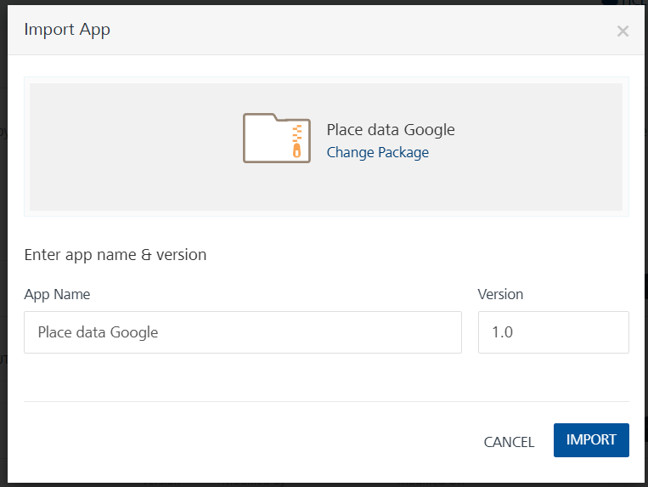

**Note:**If the selected component is not the one that you want to import, click Change Binary.

1. In the **App Name** box, the **PlaceAppDataModel** is displayed by default. You can change the name, if required.
2. Click **Import as new** to create a new Foundry app. If there is an app exists with the same app name and if you want to overwrite it, click **Overwrite existing app**.
3. Click **Import**. The **PlaceAppDataModel** app is listed on the **Custom Apps** page.

**Note:**If you changed the name in the App Name box, the app with the updated name is listed on the Custom Apps page.

## **GENERATING GOOGLE PLACES/MAPS API KEYS**

To use Google Services generate an API key. To generate the API key visit [Google Places](https://developers.google.com/maps/documentation/places/web-service/search) or [Google Maps](https://developers.google.com/maps/documentation/) and select the appropriate service and generate a key for the selected service. Provide the Places key or the Maps key based on the type of request placed to fetch the responses.

**To view the object service, do the following:**

1. Log on to your [Google Places](https://developers.google.com/places/web-service/search). The **Google Places API** page appears by default.
2. Select the required service from the left pane.
3. In the top-right pane, click the **GET A KEY** button.
4. The following confirmation message along with your generated API key appears.

# **TESTING THE EXISTING BACK END SERVICE**

Testing an operation involves making the service call by setting the necessary parameters and displaying the response. The procedure to execute any operation is the same, but the request parameters of the services change.

This section provides steps to test the **voltmxmpPlgetGoogleAutoComplete** operation.

**To execute the voltmxmpPlgetGoogleAutoComplete operation, do the following:**

1. Log on to your [VoltMX Foundry](https://manage.hclvoltmx.com/oauth/authorize?oauth_token=7e9b41447aaaceda4dabb148206d89ef7aa53697). The **Dashboard** page appears by default.
2. In the left pane, click the **Apps** menu. The **Apps** tab opens by default.
3. Click the **Integration** tab. The **Integration** tab opens with a list of existing integration services.
4. From the list of integration services, select the integration service. The **Service Definition** tab of the selected integration service opens by default.
5. Select the **Operations List** tab.
6. Under the **Configured Operations** section, click the **voltmxmpPlgetGoogleAutoComplete** operation. The **voltmxmpPlgetGoogleAutoComplete** tab opens with the **Request Input** sub-tab opened by default.
7. The **Name** box displays a default operation name. You can change the name, if required.
8. In the **Request Input** tab, in the **Body** section, for the following mandatory parameters, specify the values in the respective boxes under the **Test Value** column.
   * **key:** Accepts string value. Google Places or Map API key.
   * **input:** The parameter takes strings as input and returns additional values.
9. Click **SAVE AND FETCH RESPONSE**.  
     
   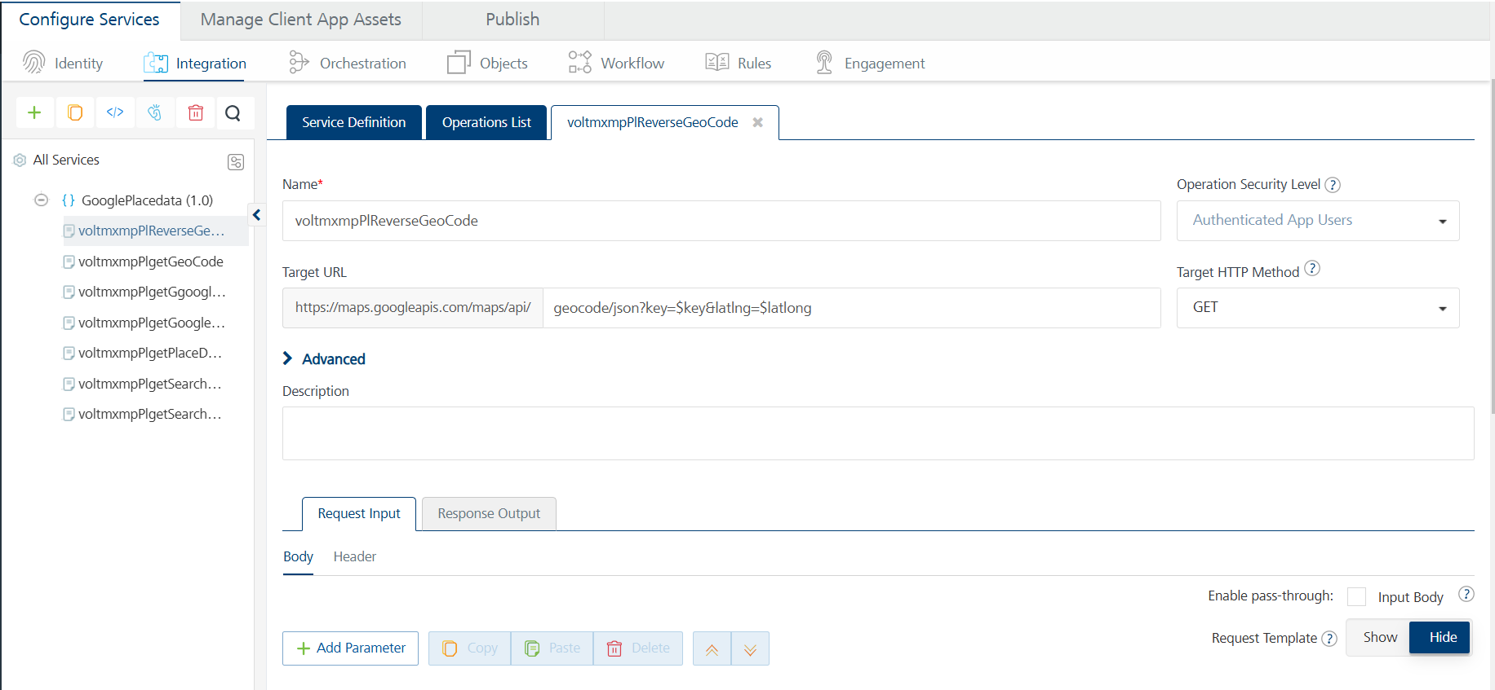  
     
   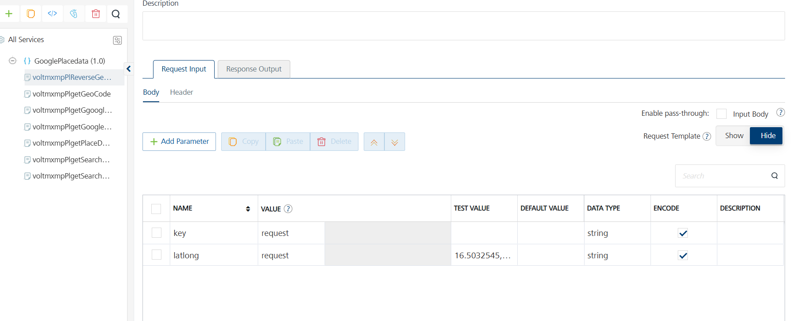
10. The **Output Result** dialog appears with the response. Otherwise, the **Output Result** shows an error.

## **INVOKING THE BACK END SERVICES ON A FRONT END APP**

**To link theVoltMX Foundry app to your Visualizer project, do the following:**

1. Open VoltMx Iris. Expand the **Project Settings** tab.
2. Under the **Project Settings** tab, right-clickVoltMX Foundry. Select the **Use Existing App** option.
3. TheVoltMX Foundry **Applications** window appears. Search for the **Places Data Google**VoltMX Foundry app and click **Associate**.  
   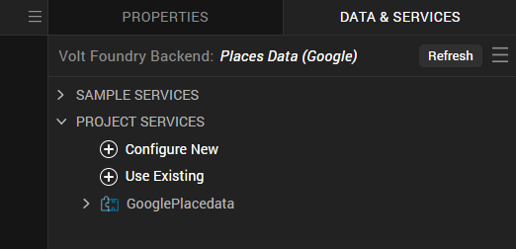
4. TheVoltMX Foundry app is now linked to your front end application.

# **INVOKING SERVICES**

The **Invoke** functionality remains the same for all services. There is a change only in the parameters and their values. Select appropriate parameters and values while invoking the required services. The following sample code snippet shows how the services are invoked using code.  
  
// Code to invoke parent integration service should be present to use below code.

operationName = "voltmxmpPlplaceDetails";

data= {"key": "<place-holder>","place_id": "<place-holder>"};,

headers= {};

integrationObj.invokeOperation(operationName, headers, data, operationSuccess, operationFailure);

function operationSuccess(res){

//code for success call back

}

function operationSuccess(res){

//code for success call back }

**7. DEFINING SERVICES  
  
Services for Places Data (Google).**

**1. voltmxmpPlplaceDetails**

| **Category** | Google Places |
| --- | --- |
| **Description:** | A Place Details request returns more comprehensive information about the indicated place, such as its complete address, phone number, user rating, and reviews. To know more about the Place Details service, [click here](https://developers.google.com/places/web-service/details#PlaceDetailsRequests). |
| **Mandatory Parameters**: | **key, place_id** |
| **Remarks:** | You can also configure **optional parameters** in yourVoltMX Foundry app under **Input Parameter** tab. To know more about the **optional parameters**, [click here](https://developers.google.com/places/web-service/details#PlaceDetailsRequests). |

**2. voltmxmpPlsearchPlaceBasedOnQuery**

| **Category** | Google Places |
| --- | --- |
| **Description:** | The Google Places API Text Search is a web service that returns information about a set of places based on a string. The service responds with a list of places matching the text string and any location bias that has been set. To know more about the Google Places API Text Search service, [click here](https://developers.google.com/places/web-service/search#TextSearchRequests). |
| **Mandatory Parameters**: | **key, address** |
| **Remarks:** | You can also configure **optional parameters** in yourVoltMX Foundry app under **Input Parameter** tab. To know more about the **optional parameters**, [click here](https://developers.google.com/places/web-service/search#TextSearchRequests). |

**3. voltmxmpPlsearchPlaceBasedOnLocation**

| **Category** | Google Places |
| --- | --- |
| **Description:** | A Nearby Search lets you search for places within a specified area. You can refine your search request by entering keywords or by specifying the type of place you are searching for. To know more about the Nearby Search service, [click here](https://developers.google.com/places/web-service/search#PlaceSearchRequests). |
| **Mandatory Parameters**: | **key, location, radius, type,keyword** |
| **Remarks:** | You can also configure **optional parameters** in yourVoltMX Foundry app under **Input Parameter** tab. To know more about the **optional parameters**, [click here](https://developers.google.com/places/web-service/search#PlaceSearchRequests). |

**4. voltmxmpPlGoogleAutoComplete**

| **Category** | Google Places |
| --- | --- |
| **Description:** | The Place Autocomplete is a web service that returns place predictions in response to an HTTP request. The HTTP request specifies a textual search string and optional geographic bounds. To know more about the Place Autocomplete service, [click here](https://developers.google.com/places/web-service/autocomplete). |
| **Mandatory Parameters**: | **key, input** |
| **Remarks:** | You can also configure **optional parameters** in yourVoltMX Foundry app under **Input Parameter** tab. To know more about the **optional parameters** [click here](https://developers.google.com/places/web-service/autocomplete). |

**5. voltmxmpPlgoogleDistanceMatrix**

| **Category** | Google Maps |
| --- | --- |
| **Description:** | The Google Maps Distance Matrix API is a web service that provides travel distance and time for a matrix of origins and destinations, based on the recommended route between the start and end points. To know more about the Google Maps Distance Matrix API service, [click here](https://developers.google.com/maps/documentation/distance-matrix/start). |
| **Mandatory Parameters**: | **units, origins, destinations, key** |
| **Remarks:** | You can also configure **optional parameters** in yourVoltMX Foundry app under **Input Parameter** tab. To know more about the **optional parameters** [click here](https://developers.google.com/maps/documentation/distance-matrix/start). |

**6. voltmxmpPlgetGeocoding**

| **Category** | Google Maps |
| --- | --- |
| **Description:** | The Google Maps Geocoding API is a web service that provides geocoding of addresses. To know more about the Google Maps Geocoding API service, [click here](https://developers.google.com/maps/documentation/geocoding/start#geocoding-request-and-response-latitudelongitude-lookup). |
| **Mandatory Parameters**: | **key, latlong** |

**7. voltmxmpPlgetReverseGeocoding**

| **Category** | Google Maps |
| --- | --- |
| **Description:** | The Google Maps Geocoding API is a web service that provides reverse geocoding of addresses. To know more about the Google Maps Geocoding API service, [click here](https://developers.google.com/maps/documentation/geocoding/start#reverse). |
| **Mandatory Parameters**: | **key, address** |

# **REVISION HISTORY**

App version 1.1.0

## **Known Issues**

## N/A

## **Limitations**

## N/A