Date : 1 June 2024

Place App Data Model

version: 1.1.0

# **Overview**

Place App Data Model aims to provide a quick start point for building mobile apps dealing with place. The data model contains multiple objects and fields describing place details.

## **Use case:**

The Place App Data model aims to provide a quick starting point for building mobile apps dealing with place. You can easily extend/ reduce/ modify the App Data Model based on your use-case. You can also map the App Data Model to any backend data source.

## **Features**

### Quick reference app data model- Extend/ Reduce/ Modify based on your requirement.

* Easily map business objects and terms to back-end data sources.
* Flexible to map with any back-end data source

## **Map to any backend data source**

The following diagram illustrates the objects in the app data model and relationships among them.

When you import the app data model into VoltMX Foundry, the app data model is created as an object service. Using the VoltMX Foundry console, you can modify the fields and relationships of the objects in the app data model. For example, you can add new fields to objects and define new relationships between objects.

You can also map Place App Data Model to any back-end data source. For example, if you are using Oracle database to store the place details, using the VoltMX Foundry console, you can connect Place App Data Model with the Oracle database and map the fields of each object in the app data model with the fields of the Oracle database.

## **Percentage of re-use:**

70% (Data can be customizable and customer need to implement UI by themselves).

# **Getting Started**

## **Prerequisites**

Before you start using the Place App Data Model, ensure you have the following:

* [HCL Foundry](https://manage.hclvoltmx.com/)
* Volt MX Iris

## **Importing the Place App Data Model**

1. Log on to your [HCL Foundry](https://manage.hclvoltmx.com/). The Dashboard page appears by default.
2. In the left pane, click the **Apps** menu. The **Custom Apps** page appears.
3. Click **Import**. The **Import** dialog appears.  
   A screenshot of a computer

   Description automatically generated
4. Drag the zip file into the **Import App** dialog.

Alternatively, click **browse**. The **Open** dialog appears. Navigate to the location where you downloaded the data model (zip file) on your computer, select the zip file, and click **Open**. The zip file is selected, and the **Import App** dialog appears as shown in the following figure:

**Note:**If the selected component is not the one that you want to import, click Change Binary.

1. In the **App Name** box, the **PlaceAppDataModel** is displayed by default. You can change the name, if required.
2. Click **Import as new** to create a new Foundry app. If there is an app exists with the same app name and if you want to overwrite it, click **Overwrite existing app**.
3. Click **Import**. The **PlaceAppDataModel** app is listed on the **Custom Apps** page.

**Note:**If you changed the name in the App Name box, the app with the updated name is listed on the Custom Apps page.

# **VIEWING THE OBJECT SERVICE**

When you import PlaceApp App Data Model into Foundry, the app data model is created as an object service. In the object service, you can view all the objects of the data model and the default fields and relationships of each object.

**To view the object service, do the following:**

1. Log on to your [HCL Foundry](https://manage.hclvoltmx.com/). The **Dashboard** page appears by default.
2. In the left pane, click the **Apps** menu. The **Custom Apps** page appears.
3. Find and click the **PlaceAppDataModel** app. The **PlaceAppDataModel** page appears along with the **Configure Services** tab and the **Identity** sub-tab opened by default.

**Note:**If you changed the name of the app while importing the app data model, find and click the app name that you specified using the search box on the **Custom Apps** page.

1. Click the **Objects** sub-tab. The **Objects** sub-tab opens along with the **PlaceDataSchema**objectservicelisted.  
   A screenshot of a computer

   Description automatically generated
2. Click **PlaceDataSchema**. The **Configure** page appears with all objects in the app data model.   
   A screenshot of a computer

   Description automatically generated

# **MAPPING PLACE APP DATA MODEL WITH A BACK-END DATA SOURCE**

By default, the Place App Data Model is mapped with the Foundry storage. You can easily decouple the app data model with the Foundry storage and map it with other back-end data source.

**To map with a back-end data source, do the following:**

1. On the **PlaceAppDataModel** page, Click the **Configure Services** tab, and then click **Objects** sub-tab. The **Objects** sub-tab opens along with the **PlaceDataSchema** object service listed.
2. Click the context menu icon of  **PlaceDataSchema** as shown in the following figure. The context menu opens.  
   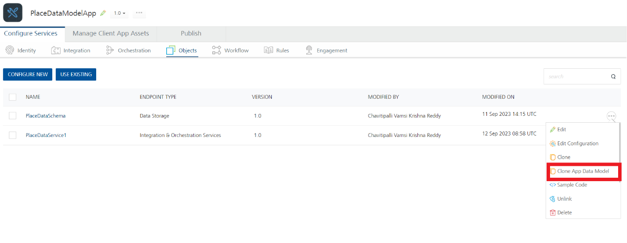
3. Click **Clone App Data Model**. A copy of PlaceApp Data Model is created and the **New Object Service** page appears.  
   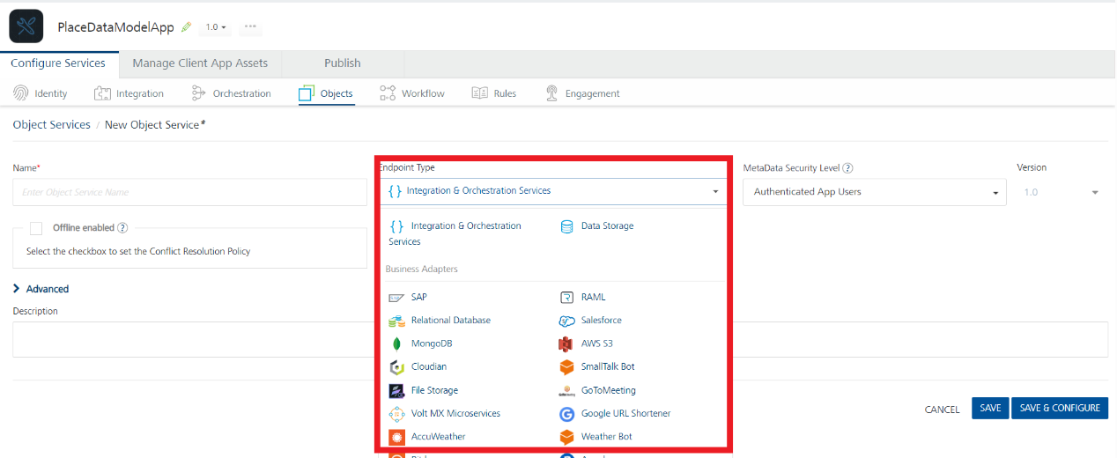
4. In the **Name** box, type a name for a copy of PlaceApp Data Model.
5. Click the context menu arrow to expand the **Endpoint Type** list. A drop-down list opens.
6. Select the required back-end data source that you want to map and click **SAVE & CONFIGURE**.

# **mODIFYING PLACE APP DATA MODEL**

The PlaceApp Data Model comes with a default set of objects. Every object in the data model contains a set of fields and a relationship with at least one object. The **PlaceDataSchema** object service allows you to modify the app data model as you require. Every object in the object service contains the following sections:

**Fields**

In the Fields section of an object, you can add new fields and edit and delete the fields associated with the object. Every object has a set of fields that you cannot edit or delete. For example, the **createdBy** and **CreatedDataTime** fields of the **Technician** object cannot be modified.

**Relationships**

In the Relationships section of an object, you can define new relationships with other objects and edit and delete existing relationships of the object.

For more information, refer to [Object Services](https://opensource.hcltechsw.com/volt-mx-docs/docs/documentation/Foundry/voltmx_foundry_user_guide/Content/Objectservices.html).

# **Publishing the App in VoltMX Foundry**

After adding the **Place App Data Model** to your app and configuring the necessary configurations, you must publish the app to VoltMX Foundry. For more information, refer to [Publish a Project to VoltMX Foundry.](https://opensource.hcltechsw.com/volt-mx-docs/docs/documentation/Iris/iris_user_guide/Content/PublishVoltMXFoundryServicesApp.html)

# **Revision History**

App version 1.1.0

## **Known Issues**

## N/A

## **Limitations**

## N/A