05 June 2023

Photoroll(2.0.1)

# Overview

PhotoRoll is a component to take and then display the captured images using a horizontal scroll, the photo’s can be removed by a conveniently place cancel icon in the top right hand corner and a function to return an array of the base64 data of the photo’s.

## Use case

### Capture, view and cancel photo’s in a horizonal scroll container.

## Percentage of re-use:

Approximately 95% reusable.

## Features.

Button to capture new photo’s

Cancel any unwanted photo’s

Scroll horizontally to display all captured photo’s

Function to return an array of the base64 data of each captured photo.

# Getting Started

## Prerequisites

Before you start using the PhotoRoll component, ensure the following:

• [HCL Foundry](https://manage.hclvoltmx.com/)

• Volt MX Iris

## Platforms Supported

### PWA & Responsive Web

### Native

## Importing the app

You can import the Forge components only into the apps that are of the Reference Architecture type.

**To import the PhotoRoll component, do the following:**

#### Open your app project in Volt MX Iris..

#### In the Project Explorer, click the **Templates** tab.

#### Right-click **Components**, and then select **Import Component**. The **Import Component** dialog box appears.

#### Click **Browse** to navigate to the location of the component, select the component, and then click **Import**. The component and its associated widgets and modules are added to your project.

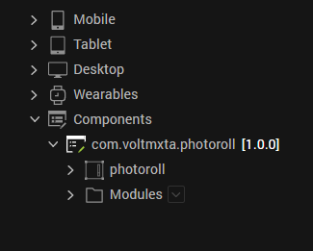

Once you have imported a component to your project, you can easily add the component to a form. For more information, refer [Add a Component to a Form](https://opensource.hcltechsw.com/volt-mx-docs/docs/documentation/Iris/iris_user_guide/Content/C_UsingComponents.html" \l "add-a-component-to-a-form)

## Add Permissions

## For Android make sure to add the permission for the camera to the project settings:

## 

## Building and previewing the app

After performing all the above steps, you can build your app and run .For more information, you can refer to the [Building and Viewing an Application](https://opensource.hcltechsw.com/volt-mx-docs/docs/documentation/Iris/iris_user_guide/Content/Cloud_Build_in_VoltMX_Iris.html#cloud) section of the Volt MX User Guide.

You can then run your app to see the PhotoRoll work in real time

# get base64 images

# To get the base64 data of the capture images there is a function call getImages() that returns an array of Base64 data for each captured photo.

# Sample code: *this.view.photoroll.getImages()*

# Revision History

App version 2.0.1:

## Known Issues

NA

## Limitations

NA